Practial-Week3
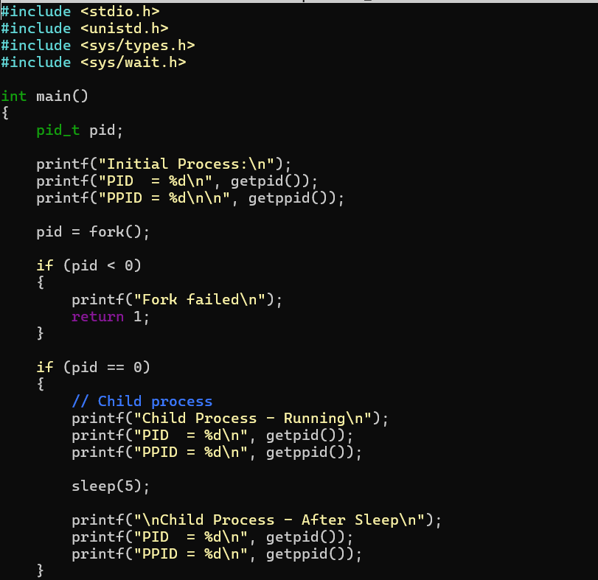
- Develop a C program using fork() that creates a parent and child process. Display the Process ID (PID), Parent Process ID (PPID), and process states at different stages of execution

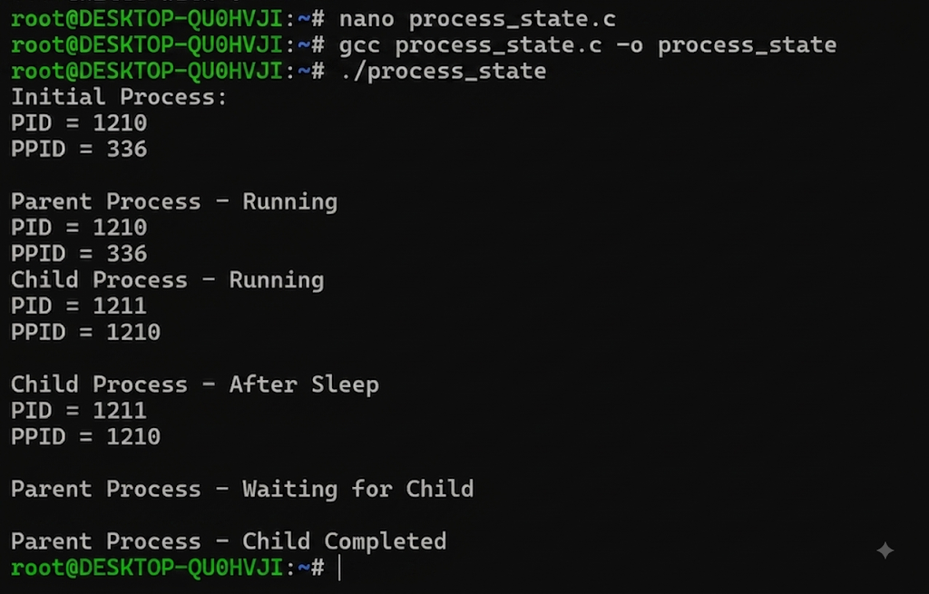

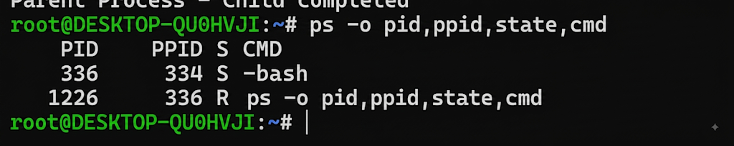

Report: I ran process_state.c, which forked a child (PID 1329) from the parent (PID 1328), with correct PPID linkage. The parent waited while the child ran, then completed. ps -o pid,ppid,state,cmd confirmed correct PID/PPID relationships and process states (S for sleeping, R for running). This confirms fork() correctly creates a child process with proper parent-child linkage.

- Design an experiment to observe process state transitions (Ready, Running, Waiting, Terminated) using Linux monitoring tools such as ps, top, and /proc. Document the observations.

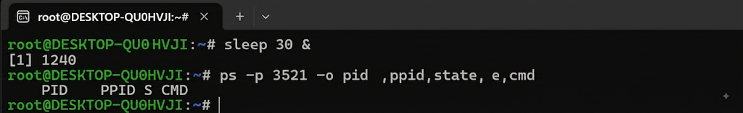

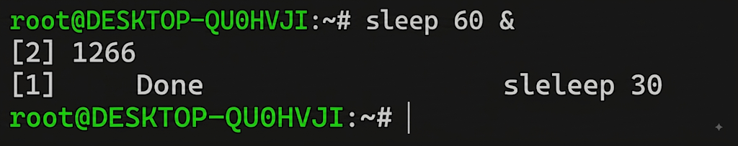

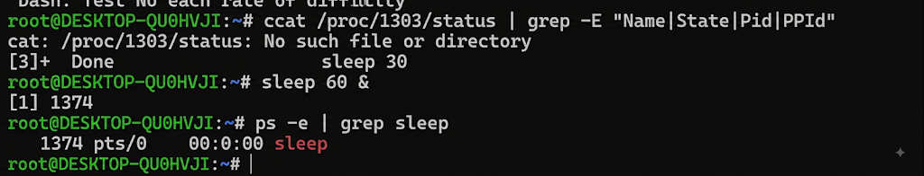

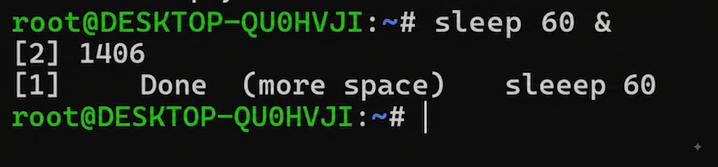

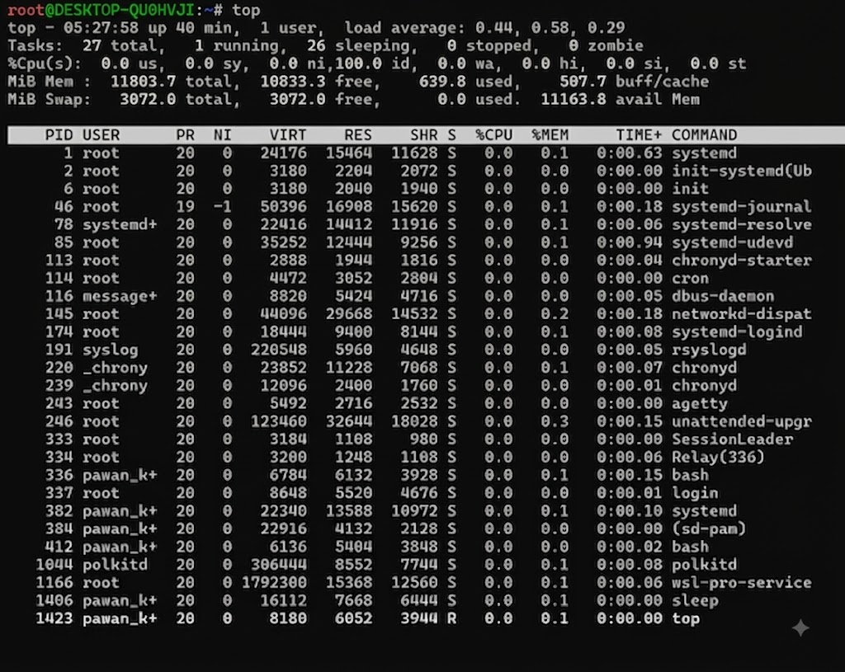

Report: I ran sleep 60 C as a background process and inspected it using/proc/PID/status, ps, and top. /proc/1536/status showed State: S (sleeping) with correct PID (1536) and PPID (1458) linkage, and ps -p 1536 confirmed the same sleeping state (S) with the sleep 60 command. top showed the overall system process list, with most processes in state S (sleeping) and one in state R (running). This confirms that background processes can be tracked consistently across /proc, ps, and top, all agreeing on process state and parent-child relationships.

