The Morning Press
Coffee Shop · Instagram Campaign
Config A — Sequential Pipeline
Strategy Agent → Content Agent (baseline)
7 posts · Instagram · August 2026

Day 1 · Instagram
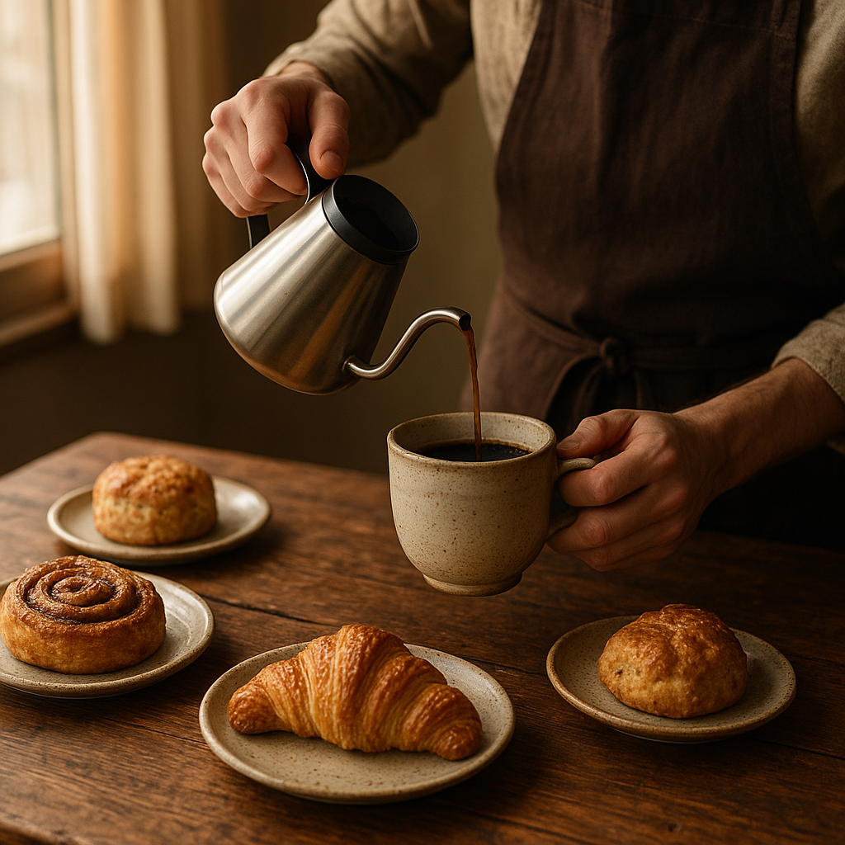
Welcome to your new favourite corner for craft coffee and cosy moments. At The Morning Press, every cup is a story of flavour and every pastry a promise of delight. Whether you're here to work or unwind, find your perfect brew with us today.
#PourOverPerfection #ThirdSpaceHaven #CraftCoffeeLove #ManchesterCafes #RemoteWorkVibes

Day 2 · Instagram

Good morning, coffee dreamers! Discovering the perfect pour-over has begun. Whether you're diving into a new project or simply exploring the world one sip at a time, let our single-origin brews and freshly baked pastries be your companions today. Find your cosy corner, and let the aroma of craft coffee inspire your morning.
#TheMorningPress #CoffeeLoversUnite #ManchesterCoffee #PourOverPerfection #RemoteWorkVibes #CozyCafeDays

Day 3 · Instagram

Finding your perfect brew. Swing by The Morning Press for a single-origin pour-over that tastes like a warm hug. Our baristas are ready to craft your coffee moment, paired perfectly with a freshly baked pastry. Your cosy corner awaits!
#RemoteWorkBliss #CoffeeLoversParadise #ManchesterCafe #ThirdSpaceSerenity #PourOverPerfection #CozyVibesOnly #FreshlyBaked

Day 4 · Instagram

Finding your perfect pour-over. Whether you're diving into a project or savouring a quiet moment, our cosy corner is your haven. Pair it with our freshly baked pastries for a match made in coffee heaven. Come for the craft, stay for the serenity.
#RemoteWorkPerks #CoffeeLoversDelight #PourOverParadise #ManchesterCoffee #CozyCorner #SpecialtyCoffee #ThirdSpaceVibes

Day 5 · Instagram

Good morning, Manchester! Step into The Morning Press and let the aroma of freshly brewed single-origin pour-overs and warm pastries embrace your senses. Whether you're here to dive into your next big project or to simply savour a moment of peace, our cosy corners await.
#PourOverPerfection #ThirdSpaceSanctuary #CoffeeLovers #ManchesterCafes #RemoteWorkHaven

Day 6 · Instagram

Welcome to serene sips and cosy moments at The Morning Press! Our single-origin pour-overs are crafted with love, offering a perfect escape from the hustle and bustle. Settle in with a warm mug and a freshly baked pastry — your new favourite nook awaits.
#ThirdPlaceComfort #PourOverMagic #ManchesterCoffee #RemoteWorkVibes #CafeCulture #CoffeeLovers

Day 7 · Instagram

Where every pour is a story waiting to be sipped. Dive into the rich aromas of our single-origin pour-overs, crafted with care and passion just for you. Whether you're here to work, unwind, or simply savour a moment of peace, The Morning Press is your cosy corner in the heart of Manchester. Come join us for a cup and a freshly baked treat.
#ManchesterCoffee #SingleOrigin #CoffeeLovers #RemoteWorkVibes #ThirdSpace #CraftCoffee #MorningPress

Generated by AI Content Calendar MVP · MSc Research · Config A — Sequential Pipeline
Brand: "The Morning Press — cosy specialty coffee shop, Manchester. Single-origin pour-overs, freshly baked pastries."

