The Morning Press
Coffee Shop · Instagram Campaign
Config B — Hierarchical Pipeline
Orchestrator → Parallel Platform Sub-Agents
7 posts · Instagram · August 2026

Day 1 · Instagram

Welcome to your new favourite corner in the heart of Manchester! Whether you're pouring over your latest project or just need a serene escape, The Morning Press is here to serve you the perfect cup of single-origin coffee and a warm pastry to brighten your day. Feel the gentle buzz of creativity, savour the aroma of expertly brewed coffee, and let every sip inspire your next great idea.
#SingleOriginMagic #CoffeeLoversUnite

Day 2 · Instagram
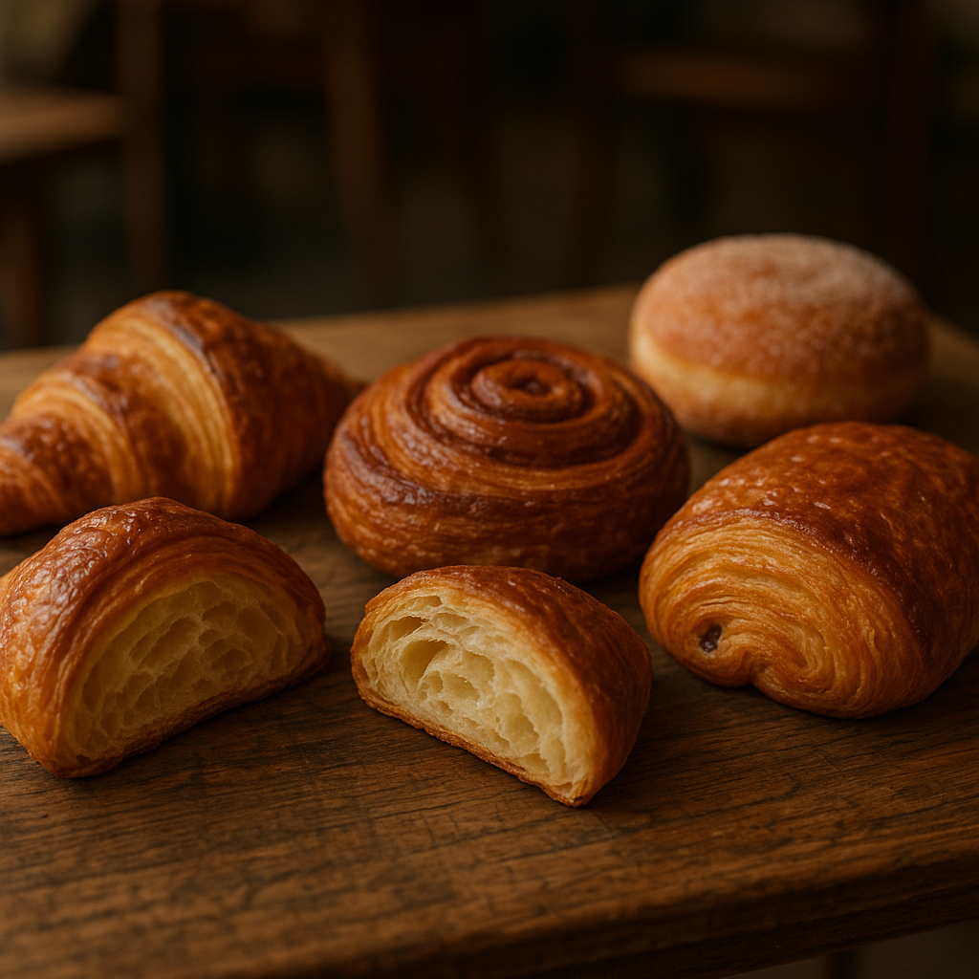
Day 2 of finding your perfect pour-over! Whether you're diving into deep work or taking a mindful break, The Morning Press is your daily retreat. Indulge in the rich aromas of our single-origin coffees and let our cosy corner of Manchester be your haven. Sink into a comfy nook, savour a freshly baked pastry, and let the world melt away.
#MorningPress #ManchesterCoffee #ThirdSpace #CoffeeLovers #RemoteWorkFriendly #CozyVibes

Day 3 · Instagram

Day 3 at The Morning Press: Dive into the serene world of specialty coffee with us. From our single-origin pour-overs to our warm pastries, every detail is crafted for your enjoyment. Whether you're seeking focus or simply a moment of peace, our cosy corner in Manchester is your haven. Find us nestled in the heart of Manchester and let the aroma guide you to your perfect brew.
#MorningRitual #CoffeeLoversUnite #SpecialtyCoffee #RemoteWorkHaven #ManchesterCafes #PourOverPerfection

Day 4 · Instagram
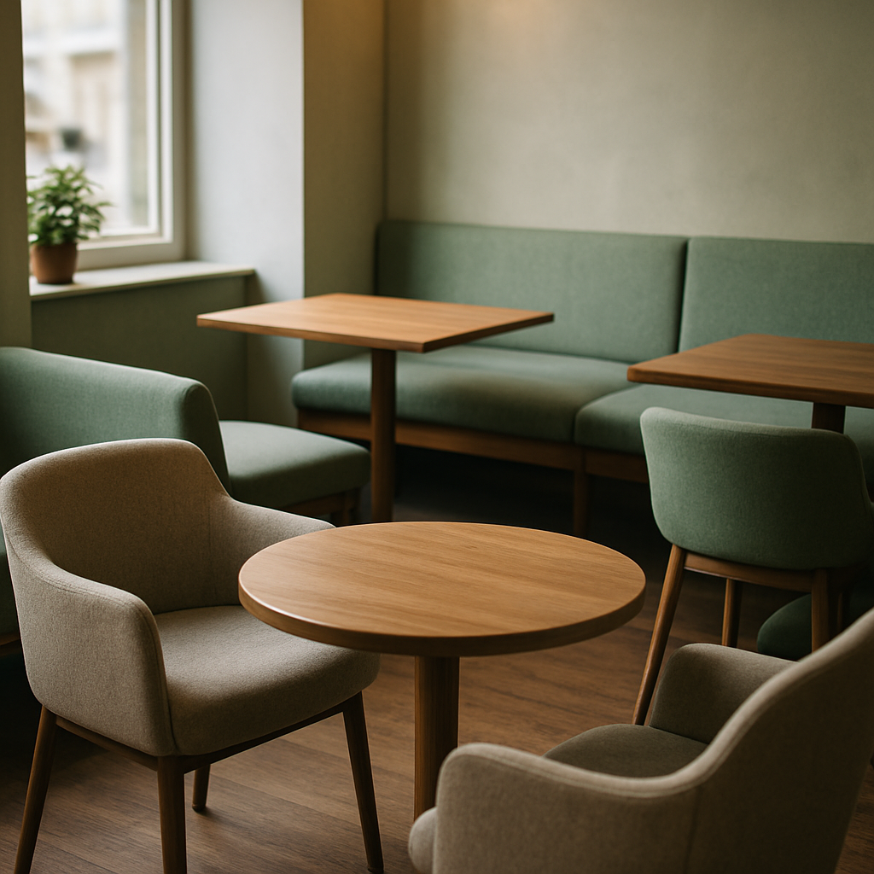
Day 4 of finding your perfect pour-over spot! Escape the hustle and bustle and join us at The Morning Press, where every cup tells a story of its own. From the gentle aroma of freshly ground beans to the first comforting sip, our cosy corner in Manchester is your sanctuary for focus and relaxation. Whether you're here to work, dream, or simply savour the moment, our doors are wide open.
#PourOverLove #CoffeeMoments #TheMorningPress #SpecialtyCoffee #RemoteWorkFriendly #ManchesterCoffee #CalmVibes #CoffeeLovers

Day 5 · Instagram
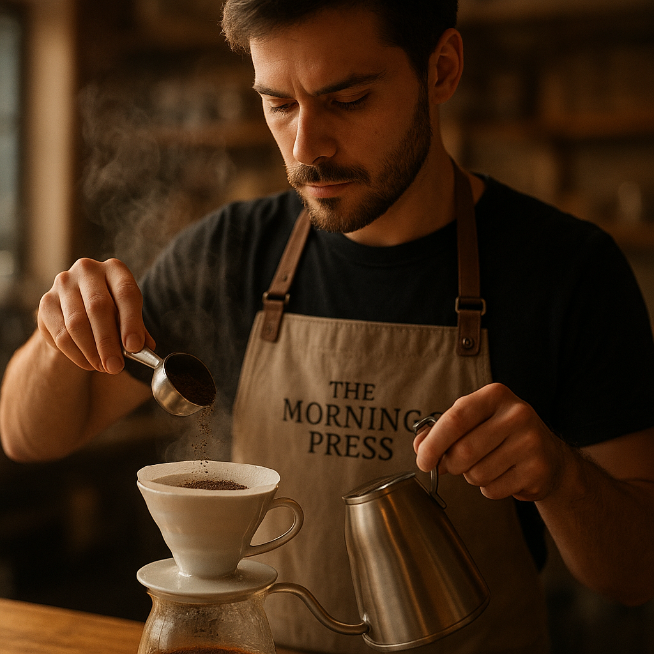
Start your day with a moment of tranquillity at The Morning Press. Our hand-poured, single-origin coffees paired with freshly baked pastries are the perfect companions for your remote workday. Find your cosy corner and let the rich aromas inspire your creativity.
#MorningRitual #CraftCoffee #ManchesterEats #CoffeeLovers #RemoteWork #CozyCorner #SingleOrigin

Day 6 · Instagram
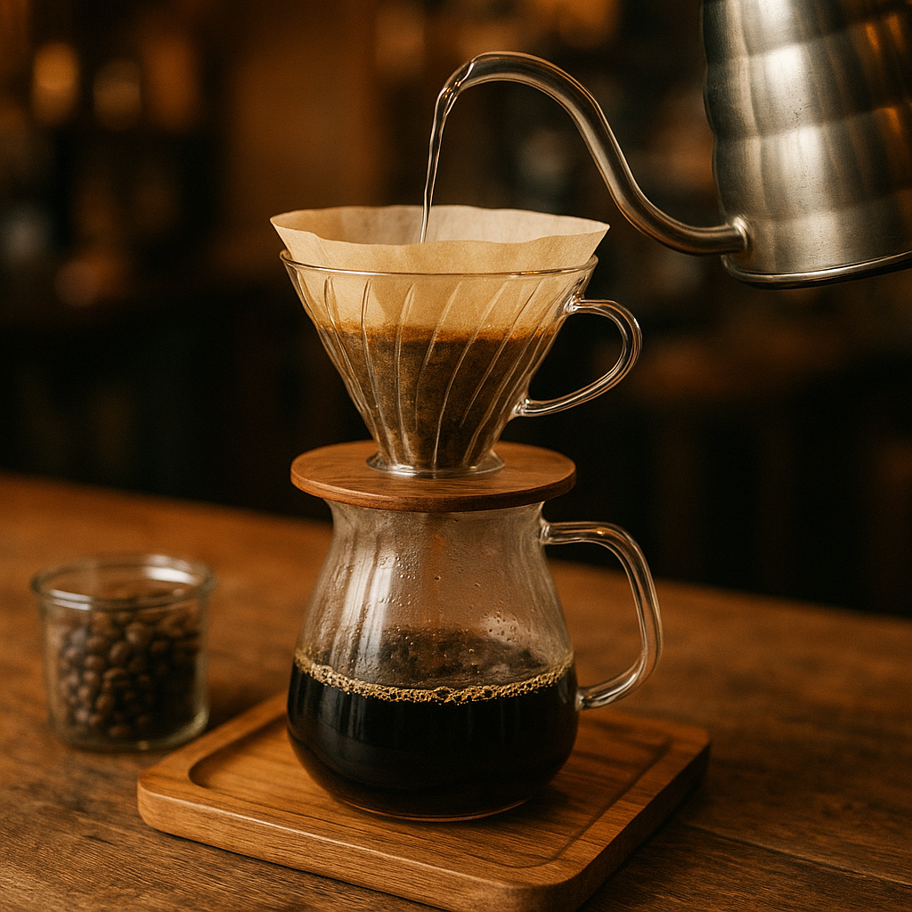
Day 6: Escape the hustle and bustle with a pour-over that transports you to coffee bliss. At The Morning Press, every cup is a little ritual, crafted with care and love. Join us for a cosy moment and savour the tranquil vibe, perfect for remote work or simply unwinding. Let the aroma guide you to your new favourite spot in Manchester.
#CoffeeSanctuary #PourOverPerfection #CozyVibes #ManchesterCoffee #ThirdSpaceHaven #RemoteWorkBliss #CraftCoffee

Day 7 · Instagram
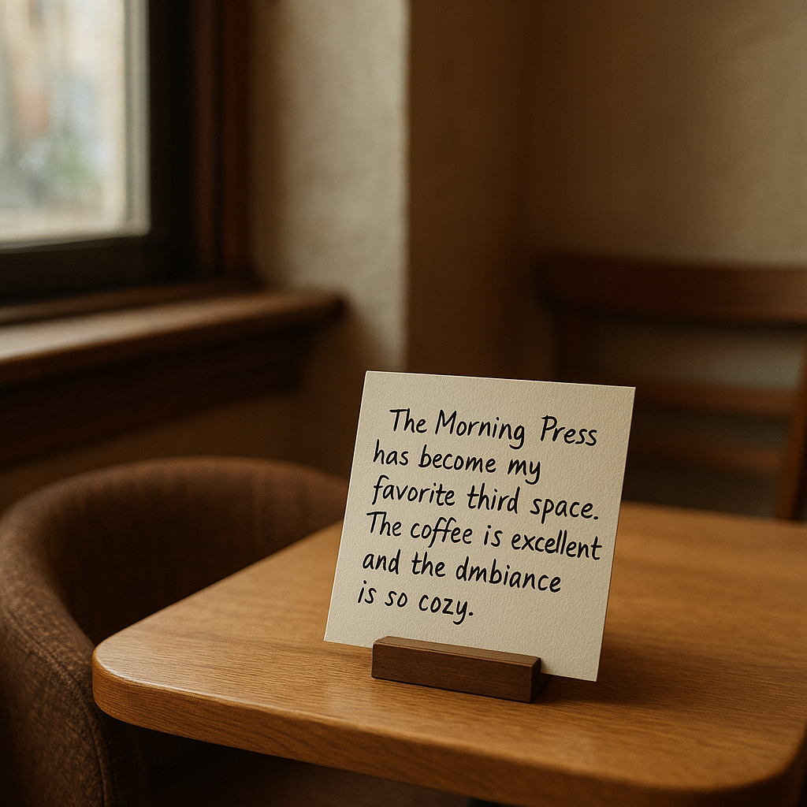
Rise and grind, Manchester! Day 7 at The Morning Press is all about savouring the slow moments. Join us for a tranquil retreat with our exquisite single-origin pour-overs and freshly baked pastries. Perfect for those seeking a peaceful corner to work or unwind. Let the aroma of craft coffee be your muse today.
#TheMorningPress #ManchesterCoffee #PourOverLovers #RemoteWorkHaven #ArtisanBrew #CoffeeCulture

Generated by AI Content Calendar MVP · MSc Research · Config B — Hierarchical Pipeline
Brand: "The Morning Press — cosy specialty coffee shop, Manchester. Single-origin pour-overs, freshly baked pastries."

