CHAPTER-1

INTRODUCTION
1.1 Description
The project is based on calculating the soil moisture contents and detecting the real time weather condition like temperature and sends it to the farmer zone using wireless communication i.e. Zig-Bee. The module will send a digital signal to the farmer for defining the weather condition suitable for the field which will be displayed in the LCD screen.
For wireless communication we are using is zig-bee module for digital signal processing of the data. The farmer will get the real time information about the farm via zig-bee communication. The farmer is free to take any decision to control the condition of the environment in the farm when he gets the information about it. The environment of the farm can be controlled by using the sprinklers present over there. The microcontroller will automatically adjust the water level required for the crop to grow properly. We are going to use two sensors which will tell the microcontroller about the environmental situation of the farm and according to that the microcontroller will take its decision to on or off the sprinklers in the farm. When the environment condition is under control then the microcontroller will maintain the condition unless or until any other factor affects it. As soon as the condition varies it will take the action against it to grow the crop firmly. All this information will be send to the farmer at his place via zig-bee. The farmer is provided with four control levels of the farm environment out of which at a time one is selected and according to that the microcontroller will work.
1.2 Project basics
The main parts of our project are the farmer at its farmer zone and the farm of the farmer where the project actually works. The communication between these two is done by using zig-bee communication. But here the question arises that why we are using zig-bee communication instead of using any other type of communication? The answer is that the zig-bee communication works for a long distance, we can connect a number of zig-bee to form a network, very fast data transfer rate and many more. The communication link between the farm and the farmer is responsible for the working of the project so a zig-bee communication is best suited to this type of work. Basically, we are using two AVR ATMega32 microcontroller and two display units with one zig-bee pair, one for the farmer and another in the farm. The sensors which we are using are temperature sensor and soil moisture sensor. These sensors will be present at the farm and provide information to the microcontroller. The AVR ATMega32 microcontroller receives that information and processes the given parameters according to condition. The water motor operates via the microcontroller to control the water level of the farm. The temperature sensor LM35 is a very sensitive temperature sensor which we are using for our project. The sensitivity of the LM35 varies for a minimum of 0.1°C. The sensor shows us the real time temperature at a refresh rate 30 millisecond.

CHAPTER-2
LITERATURE SURVEY
2.1 Overview
During the experiment we observe that temperature and humidity are the two basic parameters which affect the quality of the crop which is being grown in the farm. If can control these two factors properly then we can get a good production of crop from a farm. So we have decided to work on these parameters. Basically, temperature and humidity are inversely proportional i.e. if the temperature increases then the humidity will decreases and if temperature decreases then the humidity will increase. So we have decided to control these parameters by using automation technique. For the fulfillment of this purpose we assumed two zones i.e. transmitter zone and another is receiver zone. The transmitter zone is located in the farm field and the receiver is located at the farmer residence. In transmitter zone collects the analog information regarding real time humidity and temperature. And the collected information will be sent to the farmer using high speed zig-bee communication technology. We are using LM35 as temperature and SY-HS-230 as the humidity sensor. The microcontroller continuously monitors the temperature and humidity using the sensors to irrigate the farm. This information is displayed on the LCD display unit which is present at both the zones. We can operate the motor to pump the water into the farm by using the microcontroller in different conditions and hence the soil moisture can be maintained in the farm which is sufficient for the proper growth of the plant and prevent the wastage of water in the farm unnecessarily.
In the receiver zone the status of the farm is continuously updated to give the information of the farm to the farmer. The information is displayed on the LCD display unit present in the receiver zone. And hence the farmer will continuously aware about the temperature and humidity of the farm. In this project we can observe that the two parameters are controlled automatically without any human interference which reduces the human efforts. This project can not only be used in the farms but we can also use this in many other applications like industries, large mass storage purpose etc. The project can work in various fields where these two factors plays an important role in changing the environmental condition of the field.
CHAPTER-3
PROJECT OVERVIEW
3.1 Description
This project proposed an embedded system for automatic farming which has a wireless sensor network for real time infield sensing and control of an irrigation system. This wireless system supports the farm field which has both plain and slope areas. Too much watering causes diseases to the crop. This system provides uniform and required level of water for both plain and slope areas and therefore it avoids the water overflow at the slope areas which saves the plant and also water in the farm. This system has software for real-time in-field sensing and control of an irrigation system. Field conditions were site-specifically monitored by in-field sensor stations distributed across the field and then wirelessly transmitted to a base station. Communication signals from the sensor network and irrigation controller to the base station interfaced using Zig-bee communication and this technology is a low-cost, low-power wireless sensor network. The modules operate within the 2.4 GHz frequency band and outdoor RF line-of-sight range up to 4000 ft. (1200 m) and RF Data Rate 250,000 bps. The communication between these two is done by using zig-bee communication.
In this project we can observe that the two parameters are controlled automatically without any human interference which reduces the human efforts. This project can not only be used in the farms but we can also use this in many other applications like industries, large mass storage purpose etc. We can use multiple numbers of sensors for a huge farm field and we can also form a mesh to communicate between the transmitter and the receiver section.
We have given three separate seasons to project in which the microcontroller is going to switch. When the temperature exceeds these values then the microcontroller will operate the motor to decrease the temperature of the farm. At the same time the farmer will receive the message that the water motor has been operated and the temperature and soil moisture will be displayed on the display which is present in the farm zone and also at the farm. The microcontroller will automatically adjust the water level required for the crop to grow properly. We can use multiple numbers of sensors for a huge farm field and we can also form a mesh to make the communication between the transmitter and the receiver section.
3.2 Flow Chart
3.2.1 Flowchart of transmitter
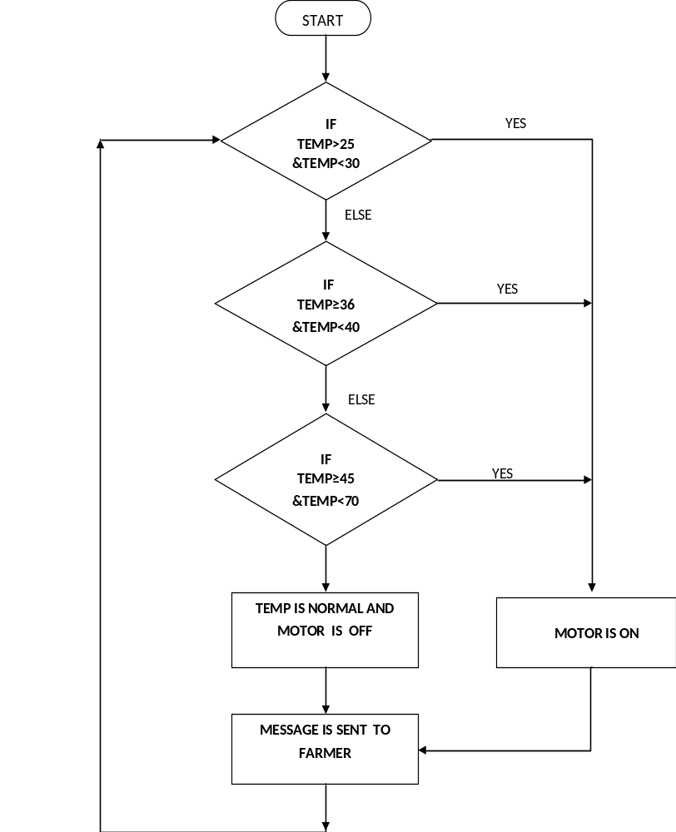
In transmitter section we give three cases for the temperature is in between 25°C to 30°C, 36°C to 40°C and 45°C to above temperature. When the temperature is in between 25°C to 30°C, the water pump is automatically turned on and a message is send to the farmer that the temperature in the farm increases. Likewise for the remaining two cases, when the temperature on the farm is normal, the water pump is automatically turned off and a message is send to the farmer that the temperature in the farm is normal.
3.2.2 Flowchart of receiver
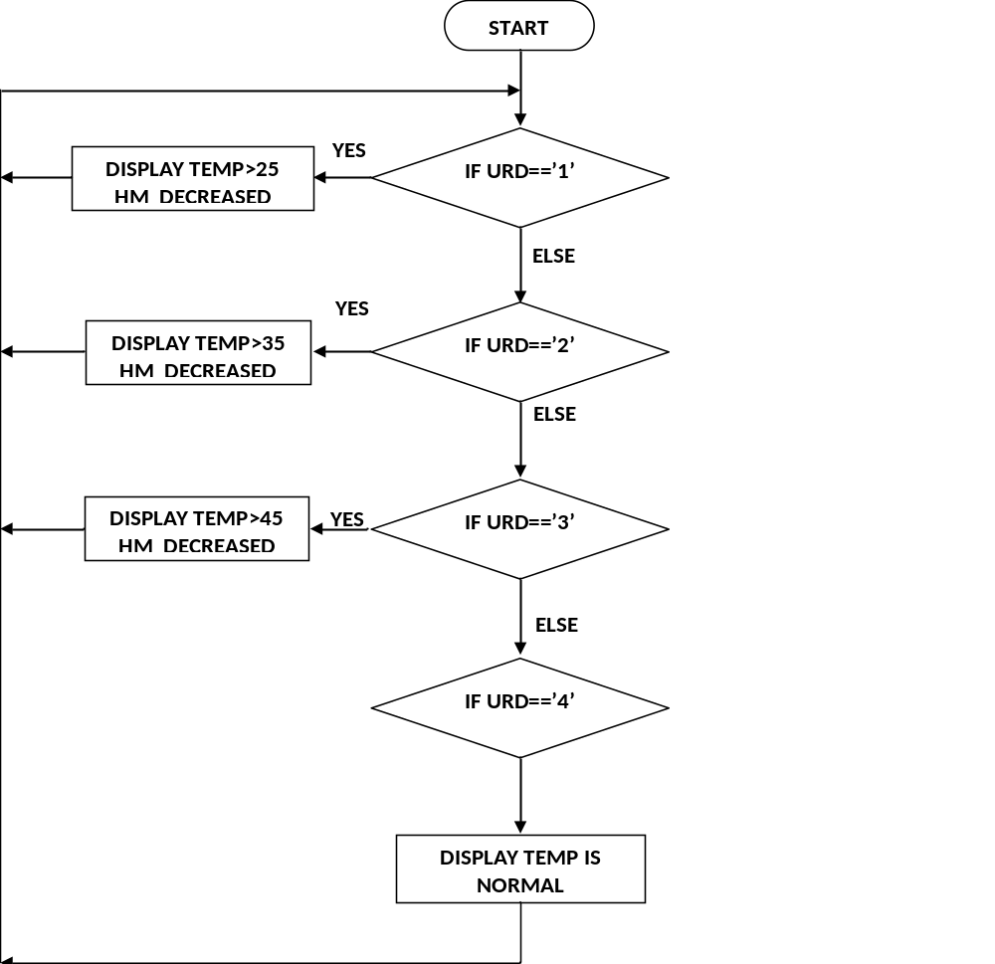
The received value from the transmitter is stored in the URD register of the receiver microcontroller and it checks for the value of the register. If it comes “1” then the microcontroller will show temp is greater than 25°C, when the register gets the value “2” then it will show temp is greater than 35°C, when it will receive “3”, it will show that the temperature is greater than 45 °C and when the URD register gets the value “4” then it will show that the temperature is normal.
3.3 Block diagram
3.3.1 Soil moisture sensor

Moisture Sensor

Microcontroller

Amplifier IC
Water motor

Fig1: Module of soil moisture sensor
This module will be attached at the farming zone, where humidity sensor will detect the moisture content of the soil, and send it to the microcontroller for its decision and control. If the moisture content in the soil is less, then controller will send a digital signal to turn on the water pump in the field.
3.3.2 Modules present for detecting the weather condition
Humidity sensor

Temperature sensor LM35
Microcontroller
ATMeaga32

Zig-bee Module

LCD Display
16X2

Fig2: Weather condition detection module
It is clear from the block diagram that the LM35 sensor will send an analog signal to the microcontroller for decision and control and display the real time temperature in the LCD Screen parallel it will process all the records by using zig-bee module to the remote location.
3.3.3 Farmer zone

Receiver Module

Decoder IC
HT12D

Microcontroller

LCD Display
16x2

Fig3: Farmer zone module
Here the receiver module will detect the digital signal sent from the farm field and will be decoded by the microcontroller. The microcontroller attached with the display unit shows display on the LCD Screen. The display is 16x2 HD4478U display which has the capacity to display 32 characters at a time.

CHAPTER-4
AVR MICROCONTROLLER
4.1 Overview
The ATmega32 is a low-power CMOS 8-bit microcontroller based on the AVR enhanced RISC architecture. By executing powerful instructions in a single clock cycle, the ATmega32 achieves throughputs approaching 1 MIPS per MHz allowing the system designed to optimize power consumption versus processing speed. The AVR core combines a rich instruction set with 32 general purpose working registers. All the 32 registers are directly connected to the Arithmetic Logic Unit (ALU), allowing two independent registers to be accessed in one single instruction executed in one clock cycle. The resulting architecture is more code efficient while achieving throughputs up to ten times faster than conventional CISC microcontrollers.
The ATmega32 provides the following features: 32K bytes of In-System Programmable Flash Program memory with Read-While-Write capabilities, 1024 bytes EEPROM, 2K byte SRAM, 32 general purpose I/O lines, 32 general purpose working registers, a JTAG interface for Boundary-scan, On-chip Debugging support and programming, three flexible Timer/Counters with compare modes, Internal and External Interrupts, a serial programmable USART, a byte oriented Two-wire Serial Interface, an 8-channel, 10-bit ADC with optional differential input stage with programmable gain (TQFP package only), a programmable Watchdog Timer with Internal Oscillator, an SPI serial port, and six software selectable power saving modes. The Idle mode stops the CPU while allowing the USART, Two-wire interface, A/D Converter, SRAM, Timer/Counters, SPI port, and interrupt system to continue functioning. The Power-down mode saves the register contents but freezes the Oscillator, disabling all other chip functions until the next External Interrupt or Hardware Reset. In Power-save mode, the Asynchronous Timer continues to run, allowing the user to maintain a timer base while the rest of the device is sleeping. The ADC Noise Reduction mode stops the CPU and all I/O modules except Asynchronous Timer and ADC, to minimize switching noise during ADC conversions. In Standby mode, the crystal/resonator Oscillator is running while the rest of the device is sleeping.
This allows very fast start-up combined with low-power consumption. In Extended Standby mode, both the main Oscillator and the Asynchronous Timer continue to run. The device is manufactured using Atmel’s high density nonvolatile memory technology. The On-chip ISP Flash allows the program memory to be reprogrammed in-system through an SPI serial interface, by a conventional nonvolatile memory programmer, or by an On-chip Boot program running on the AVR core. The boot program can use any interface to download the application program in the Application Flash memory. Software in the Boot Flash section will continue to run while the Application Flash section is updated, providing true Read-While-Write operation. By combining an 8-bit RISC CPU with In-System Self-Programmable Flash on a monolithic chip, the Atmel ATmega32 is a powerful microcontroller that provides a highly-flexible and cost-effective solution to many embedded control applications. The ATmega32 AVR is supported with a full suite of program and system development tools including: C compilers, macro assemblers, program debugger/simulators, in-circuit emulators, and evaluation kits.
4.2 Features of ATMega32 microcontroller
- High-performance, Low-power AVR 8-bit Microcontroller.
- Advanced RISC Architecture.
  - 131 Powerful Instructions – Most Single-clock Cycle Execution.
  - 32 x 8 General Purpose Working Registers.
  - Fully Static Operation.
  - Up to 16 MIPS Throughput at 16 MHz
  - On-chip 2-cycle Multiplier.
- Nonvolatile Program and Data Memories.
  - 32K Bytes of In-System Self-Programmable Flash.
  - Endurance: 10,000 Write/Erase Cycles.
  - Optional Boot Code Section with Independent Lock Bits.
  - In-System Programming by On-chip Boot Program.
  - True Read-While-Write Operation.
  - 1024 Bytes EEPROM.
  - Endurance: 100,000 Write/Erase Cycles.
  - 2 Kilo Byte Internal SRAM.
  - Programming Lock for Software Security.
- JTAG (IEEE std. 1149.1 Compliant) Interface.
  - Boundary-scan Capabilities According to the JTAG Standard.
  - Extensive On-chip Debug Support.
  - Programming of Flash, EEPROM, Fuses, and Lock Bits through the JTAG Interface.
- Peripheral Features.
  - Two 8-bit Timer/Counters with Separate Prescalers and Compare Modes.
  - One 16-bit Timer/Counter with Separate Prescaler, Compare Mode, and Capture.
- Mode.
  - Real Time Counter with Separate Oscillator.
  - Four PWM Channels.
  - 8-channel, 10-bit ADC.
  - 8 Single-ended Channels.
  - 7 Differential Channels in TQFP Package Only.
- Differential Channels with Programmable Gain at 1x, 10x, or 200x.
  - Byte-oriented Two-wire Serial Interface.
  - Programmable Serial USART.
  - Master/Slave SPI Serial Interface.
  - Programmable Watchdog Timer with Separate On-chip Oscillator.
  - On-chip Analog Comparator.
- Special Microcontroller Features.
  - Power-on Reset and Programmable Brown-out Detection.
  - Internal Calibrated RC Oscillator.
  - External and Internal Interrupt Sources.
  - Six Sleep Modes: Idle, ADC Noise Reduction, Power-save, and Power -down.
- I/O and Packages.
  - 32 Programmable I/O Lines.
  - 40-pin PDIP, 44-lead TQFP, and 44-pad MLF.
- Operating Voltages.
  - 2.7 - 5.5V for ATmega32L.
  - 4.5 - 5.5V for ATmega32.
- Speed Grades
  - 0 - 8 MHz for ATmega32L.
  - 0 - 16 MHz for ATmega32.
- Power Consumption at 1 MHz, 3V, 25C for ATmega32L.
  - Active: 1.1 mA.
  - Idle Mode: 0.35 mA.
  - Power-down Mode: < 1 µA.
4.3 Pin description
The ATMega32 microcontroller is a 14 pin IC which has four ports i.e. port A, port B, port C, port D,, ground, Vcc, Aref, reset, XTAL1, XTAL2. All these pins together work for the microcontroller to operate it in the farm.
VCC Digital supply voltage. The voltage for the operation of the microcontroller IC is provided by this pin.
GND Ground. This pin provide the ground signal to the microcontroller IC for its operation
PORT A(PA7-PA0) Port A serves as the analog inputs to the A/D Converter. Port A also serves as an 8-bit bi-directional I/O port, if the A/D Converter is not used. Port pins can provide internal pull-up resistors (selected for each bit). The Port A output buffers have symmetrical drive characteristics with both high sink and source capability. When pins PA0 to PA7 are used as inputs and are externally pulled low, they will source current if the internal pull-up resistors are activated. The Port A pins are tri-stated when a reset condition becomes active, even if the clock is not running. This port also work as an analog to digital converter for the microcontroller.
PORT B(PB7- PB0) Port B is an 8-bit bi-directional I/O port with internal pull-up resistors (selected for each bit). The Port B output buffers have symmetrical drive characteristics with both high sink and source capability. As inputs, Port B pins that are externally pulled low will source current if the pull-up resistors are activated. The Port B pins are tri-stated when a reset condition becomes active, even if the clock is not running. The port pins start from the 1st pin of the microcontroller IC and ends on the pin number 8.
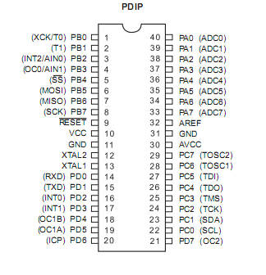
Fig4: PIN Diagram of ATmega32
PORT C(PC7-PC0) Port C is an 8-bit bi-directional I/O port with internal pull-up resistors (selected for each bit). The Port C output buffers have symmetrical drive characteristics with both high sink and source capability. As inputs, Port C pins that are externally pulled low will source current if the pull-up resistors are activated. The Port C pins are tri-stated when a reset condition becomes active, even if the clock is not running. If the JTAG interface is enabled, the pull-up resistors on pins PC5 (TDI), PC3 (TMS) and PC2 (TCK) will be activated even if a reset occurs. The TD0 pin is tri-stated unless TAP states that shift out data are entered.
PORT D(PD7-PD0) Port D is an 8-bit bi-directional I/O port with internal pull-up resistors (selected for each bit). The Port D output buffers have symmetrical drive characteristics with both high sink and source capability. As inputs, Port D pins that are externally pulled low will source current if the pull-up resistors are activated. The Port D pins are tri-stated when a reset condition becomes active, even if the clock is not running.
RESET Reset Input. A low level on this pin for longer than the minimum pulse length will generate a reset, even if the clock is not running. Input to the inverting Oscillator amplifier and input to the internal clock operating circuit.
XTAL1 Input to the inverting oscillator and input to the internal clock operating circuit. This pin works as an input clock signal for the microcontroller IC if any external clock is required for its operation in the program.
XTAL2 Output from the inverting oscillator amplifier. This pin gives the clock signal for the inverting oscillator amplifier whenever a clock pulse is required to any external device for the operation. This clock pulse which is provided by the microcontroller is same as the clock pulse of the microcontroller.
AREF AREF is the analog reference pin for the A/D Converter. This pin gives the reference voltage to the microcontroller to convert the analog signal to digital signal. If the analog signal is not provided then it takes 0 as the reference value.
This allows very fast start-up combined with low-power consumption. In Extended Standby mode, both the main Oscillator and the Asynchronous Timer continue to run. The device is manufactured using Atmel’s high density nonvolatile memory technology. The On-chip ISP Flash allows the program memory to be reprogrammed in-system through an SPI serial interface, by a conventional nonvolatile memory programmer, or by an On-chip Boot program running on the AVR core. Software in the Boot Flash section will continue to run while the Application Flash section is updated, providing true Read-While-Write operation. By combining an 8-bit RISC CPU with In-System Self-Programmable Flash on a monolithic chip, the Atmel ATmega32 is a powerful microcontroller that provides a highly-flexible and cost-effective solution to many embedded control applications.
4.4 Block Diagram

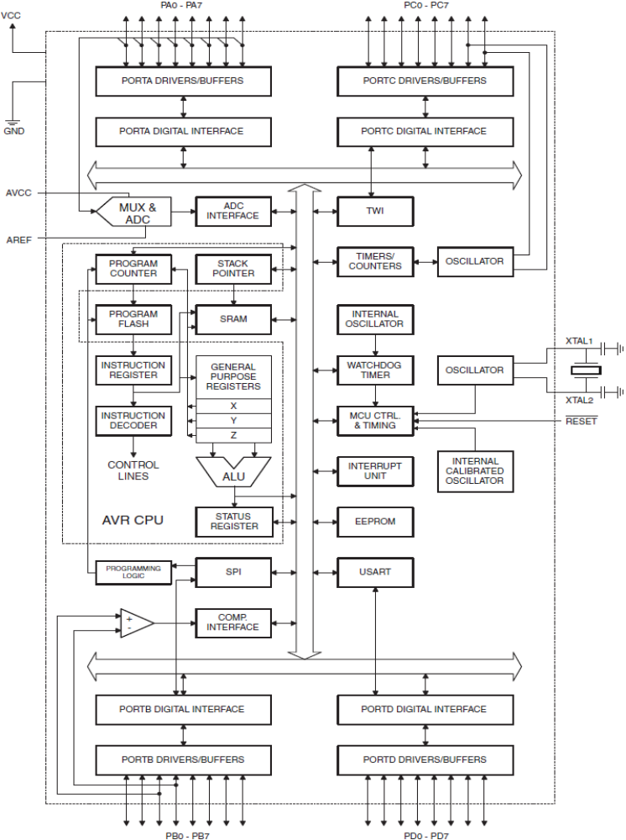

Fig5: Block diagram of ATmega32
CHAPTER-5
ZIG-BEE COMMUNICATION
5.1 Description
Zig-Bee is a specification for a suite of high level communication protocols using small, low-power digital radios based on an IEEE 802 standard for personal area networks. Zig-Bee devices are often used in mesh network form to transmit data over longer distances, passing data through intermediate devices to reach more distant ones. This allows Zig-Bee networks to be formed ad-hoc, with no centralized control or high-power transmitter/receiver able to reach all of the devices. Any Zig-Bee device can be tasked with running the network.
Zig-Bee is targeted at applications that require a low data rate, long battery life, and secure networking. Zig-Bee has a defined rate of 250 Kbit/s, best suited for periodic or intermittent data or a single signal transmission from a sensor or input device. Applications include wireless light switches, electrical meters with in-home-displays, traffic management systems, and other consumer and industrial equipment that requires short-range wireless transfer of data at relatively low rates. The technology defined by the Zig-Bee specification is intended to be simpler and less expensive than other WPANs, such as Bluetooth or Wi-Fi.
5.2 Overview
Zig-Bee is a low-cost, low-power, wireless mesh network standard. The low cost allows the technology to be widely deployed in wireless control and monitoring applications. Low power-usage allows longer life with smaller batteries. Mesh networking provides high reliability and more extensive range. Zig-Bee chip vendors typically sell integrated radios and microcontrollers with between 60 KB and 256 KB flash memory.
Zig-Bee operates in the industrial, scientific and medical (ISM) radio bands; 868 MHz in Europe, 915 MHz in the USA and Australia and 2.4 GHz in most jurisdictions worldwide. Data transmission rates vary from 20 to 250 kilobits/second.
The Zig-Bee network layer natively supports both star and tree typical networks, and generic mesh networks. Every network must have one coordinator device, tasked with its creation, the control of its parameters and basic maintenance. Within star networks, the coordinator must be the central node. Both trees and meshes allows the use of Zig-Bee routers to extend communication at the network level.
5.3 Zig-Bee protocol stack
Zig-Bee builds upon the physical layer and medium access control defined in IEEE standard 802.15.4 (2003 version) for low-rate WPANs. The specification goes on to complete the standard by adding four main components: network layer, application layer, Zig-Bee device objects (ZDOs) and manufacturer-defined application objects which allow for customization and favor total integration.
Besides adding two high-level network layers to the underlying structure, the most significant improvement is the introduction of ZDOs. These are responsible for a number of tasks, which include keeping of device roles, management of requests to join a network, device discovery and security.
Zig-Bee is not intended to support power line networking but to interface with it at least for smart metering and smart appliance purposes. Because Zig-Bee nodes can go from sleep to active mode in 30 ms or less, the latency can be low and devices can be responsive, particularly compared to Bluetooth wake-up delays, which are typically around three seconds. Because Zig-Bee nodes can sleep most of the time, average power consumption can be low, resulting in long battery life.
5.3.1 History
Zig-Bee-style networks began to be conceived around 1998, when many installers realized that both Wi-Fi and Bluetooth were going to be unsuitable for many applications. In particular, many engineers saw a need for self-organizing ad-hoc digital radio networks. The IEEE 802.15.4-2003 standard was completed in May 2003 and has been superseded by the publication of IEEE 802.15.4-2006. In the summer of 2003, Philips Semiconductors, a major mesh network supporter, ceased the investment. Philips Lighting has, however, continued Philips' participation, and Philips remains a promoter member on the Zig-Bee Alliance Board of Directors.
The Zig-Bee Alliance announced in October 2004 that the membership had more than doubled in the preceding year and had grown to more than 100 member companies, in 22 countries. By April 2005 membership had grown to more than 150 companies, and by December 2005 membership had passed 200 companies.
The Zig-Bee specifications were ratified on 14 December 2004. The Zig-Bee Alliance announced availability of Specification 1.0 on 13 June 2005, known as Zig-Bee 2004 Specification. In September 2006, Zig-Bee 2006 Specification is announced. In 2007, Zig-Bee, the enhanced Zig-Bee specification was finalized.
The first stack release is now called Zig-Bee 2004. The second stack release is called Zig-Bee 2006, and mainly replaces the MSG/KVP (Message/Key Value Pair) structure used in 2004 with a "cluster library". The 2004 stack is now more or less obsolete. Zig-Bee 2007, now the current stack release, contains two stack profiles, stack profile 1 (simply called Zig-Bee), for home and light commercial use, and stack profile 2 (called Zig-Bee PRO). Zig-Bee PRO offers more features, such as multi-casting, many-to-one routing and high security with Symmetric-Key Key Exchange (SKKE), while Zig-Bee (stack profile 1) offers a smaller footprint in RAM and flash. Both offer full mesh networking and work with all Zig-Bee application profiles.
Zig-Bee 2007 is fully backward compatible with Zig-Bee 2006 devices: A Zig-Bee 2007 device may join and operate on a Zig-Bee 2006 network and vice versa. Due to differences in routing options, Zig-Bee PRO devices must become non-routing Zig-Bee End-Devices (ZEDs) on a Zig-Bee 2006 network, the same as for Zig-Bee 2006 devices on a Zig-Bee 2007 network must become ZEDs on a Zig-Bee PRO network. The applications running on those devices work the same, regardless of the stack profile beneath them.
The Zig-Bee 1.0 specification was ratified on 14 December 2004 and is available to members of the Zig-Bee Alliance. Most recently, the Zig-Bee 2007 specification was posted on 30 October 2007. The first Zig-Bee Application Profile, Home Automation, was announced 2 November 2007.
5.3.2 Uses
Zig-Bee protocols are intended for embedded applications requiring low data rates and low power consumption. The resulting network will use very small amounts of power — individual devices must have a battery life of at least two years to pass Zig-Bee certification.
Typical application areas include.
- Home Entertainment and Control — Home automation, smart lighting. advanced temperature control, safety and security, movies and music
- Wireless sensor network — Starting with individual sensors like Telosb/Tmote and Iris from Memsic
- Industrial control
- Embedded sensing
- Medical data collection
- Smoke and intruder warning
- Building automation
5.4 Standard and profiles
The Zig-Bee Alliance is a group of companies that maintain and publish the Zig-Bee standard. The term Zig-Bee is a registered trademark of this group, not a single technical standard. The Alliance publishes application profiles that allow multiple OEM vendors to create interoperable products. The relationship between IEEE 802.15.4 and Zig-Bee is similar to that between IEEE 802.11 and the Wi-Fi Alliance.
For non-commercial purposes, the Zig-Bee specification is available free to the general public. An entry level membership in the Zig-Bee Alliance, called Adopter, provides access to the as-yet unpublished specifications and permission to create products for market using the specifications.
The requirements for membership in the Zig-Bee Alliance cause problems for open-source developers because the annual fee conflicts with the GNU General Public License. The requirement for the developer to join the Zig-Bee Alliance similarly conflicts with most other free software licenses.

5.5 Application profiles
The current list of application profiles either published, or in the works are:
- Released specifications
  - Zig-Bee Home Automation
  - Zig-Bee Smart Energy 1.0
  - Zig-Bee Telecommunication Services
  - Zig-Bee Health Care
  - Zig-Bee RF4CE – Remote Control
  - Zig-Bee RF4CE – Input Device
  - Zig-Bee Light Link
- Specifications under development
  - Zig-Bee Smart Energy 2.0
  - Zig-Bee Building Automation
  - Zig-Bee Retail Services
The Zig-Bee Smart Energy V2.0 specifications define an IP-based protocol to monitor, control, inform and automate the delivery and use of energy and water. It is an enhancement of the Zig-Bee Smart Energy version 1 specifications, adding services for plug-in electric vehicle (PEV) charging, installation, configuration and firmware download, prepay services, user information and messaging, load control, demand response and common information and application profile interfaces for wired and wireless networks. It is being developed by partners including:
- Home grid Forum responsible for marketing and certifying ITU-T G.hn technology and products
- Home Plug Power line Alliance
- International Society of Automotive Engineers SAE International
- IPSO Alliance
- SunSpec Alliance
- Wi-Fi Alliance.
In 2009 the RF4CE (Radio Frequency for Consumer Electronics) Consortium and Zig-Bee Alliance agreed to jointly deliver a standard for radio frequency remote controls. Zig-Bee RF4CE is designed for a wide range of consumer electronics products, such as TVs and set-top boxes. It promises many advantages over existing remote control solutions, including richer communication and increased reliability, enhanced features and flexibility, interoperability, and no line-of-sight barrier. The Zig-Bee RF4CE specification lifts off some networking weight and does not support all the mesh features, which is traded for smaller memory configurations for lower cost devices, such as remote control of consumer electronics.
With the introduction of the second Zig-Bee RF4CE application profile in 2012 and increased momentum in MSO market, the Zig-Bee RF4CE team provides an overview on current status of the standard, applications, and future of the technology.
5.6 Radio hardware
The radio design used by Zig-Bee has been carefully optimized for low cost in large scale production. It has few analog stages and uses digital circuits wherever possible. Though the radios themselves are inexpensive, the Zig-Bee Qualification Process involves a full validation of the requirements of the physical layer. All radios derived from the same validated semiconductor mask set would enjoy the same RF characteristics. An uncertified physical layer that malfunctions could cripple the battery lifespan of other devices on a Zig-Bee network. Zig-Bee radios have very tight constraints on power and bandwidth. Thus, radios are tested with guidance given by Clause 6 of the 802.15.4-2006 Standard. Most vendors plan to integrate the radio and microcontroller onto a single chip getting smaller devices.
This standard specifies operation in the unlicensed 2.4 GHz (worldwide), 915 MHz (Americas and Australia) and 868 MHz (Europe) ISM bands. Sixteen channels are allocated in the 2.4 GHz band, with each channel requiring 5 MHz of bandwidth. The radios use direct-sequence spread spectrum coding, which is managed by the digital stream into the modulator. Binary phase-shift keying (BPSK) is used in the 868 and 915 MHz bands, and offset quadrature phase-shift keying (OQPSK) that transmits two bits per symbol is used in the 2.4 GHz band.
The raw, over-the-air data rate is 250 Kbit/s per channel in the 2.4 GHz band, 40 Kbit/s per channel in the 915 MHz band, and 20 Kbit/s in the 868 MHz band. The actual data throughput will be less than the maximum specified bit rate due to the packet overhead and processing delays. Transmission range is between 10 and 75 meters (33 and 246 feet) and up to 1500 meters for Zig-Bee PRO although it is heavily dependent on the particular environment. The output power of the radios is generally 0-20 dBm (1-100 mW).
5.7 Device types and operating modes
Zig-Bee devices are of three types:
- Zig-Bee Co-ordinator (ZC): The most capable device, the Co-ordinator forms the root of the network tree and might bridge to other networks. There is exactly one Zig-Bee Co-ordinator in each network since it is the device that started the network originally (the Zig-Bee LightLink specification also allows operation without a Zig-Bee Co-ordinator, making it more usable for over-the-shelf home products). It stores information about the network, including acting as the Trust Center & repository for security keys.
- Zig-Bee Router (ZR): As well as running an application function, a Router can act as an intermediate router, passing on data from other devices.
- Zig-Bee End Device (ZED): Contains just enough functionality to talk to the parent node (either the Co-ordinator or a Router); it cannot relay data from other devices. This relationship allows the node to be asleep a significant amount of the time thereby giving long battery life. A ZED requires the least amount of memory, and therefore can be less expensive to manufacture than a ZR or ZC.
The current Zig-Bee protocols support beacon and non-beacon enabled networks. In non-beacon-enabled networks, an unslotted CSMA/CA channel access mechanism is used. In this type of network, Zig-Bee Routers typically have their receivers continuously active, requiring a more robust power supply. However, this allows for heterogeneous networks in which some devices receive continuously, while others only transmit when an external stimulus is detected. The typical example of a heterogeneous network is a wireless light switch: The Zig-Bee node at the lamp may receive constantly, since it is connected to the mains supply, while a battery-powered light switch would remain asleep until the switch is thrown. The switch then wakes up, sends a command to the lamp, receives an acknowledgment, and returns to sleep. In such a network the lamp node will be at least a Zig-Bee Router, if not the Zig-Bee Coordinator; the switch node is typically a Zig-Bee End Device.
In beacon-enabled networks, the special network nodes called Zig-Bee Routers transmit periodic beacons to confirm their presence to other network nodes. Nodes may sleep between beacons, thus lowering their duty cycle and extending their battery life. Beacon intervals depend on data rate; they may range from 15.36 milliseconds to 251.65824 seconds at 250 Kbit/s, from 24 milliseconds to 393.216 seconds at 40 Kbit/s and from 48 milliseconds to 786.432 seconds at 20 Kbit/s. However, low duty cycle operation with long beacon intervals requires precise timing, which can conflict with the need for low product cost.
In general, the Zig-Bee protocols minimize the time the radio is on, so as to reduce power use. In beaconing networks, nodes only need to be active while a beacon is being transmitted. In non-beacon-enabled networks, power consumption is decidedly asymmetrical: some devices are always active, while others spend most of their time sleeping. Except for the Smart Energy Profile 2.0, Zig-Bee devices are required to conform to the IEEE 802.15.4-2003 Low-Rate Wireless Personal Area Network (LR-WPAN) standard. The standard specifies the lower protocol layers—the physical layer (PHY), and the media access control portion of the data link layer (DLL). The basic channel access mode is "carrier sense, multiple access/collision avoidance" (CSMA/CA). That is, the nodes talk in the same way that people converse; they briefly check to see that no one is talking before they start, with three notable exceptions. Beacons are sent on a fixed timing schedule, and do not use CSMA. Message acknowledgments also do not use CSMA. Finally, devices in beacon-enabled networks that have low latency real-time requirements may also use Guaranteed Time Slots (GTS), which by definition do not use CSMA.

5.8 Network layer
The main functions of the network layer are to enable the correct use of the MAC sublayer and provide a suitable interface for use by the next upper layer, namely the application layer. Its capabilities and structure are those typically associated to such network layers, including routing.
On the one hand, the data entity creates and manages network layer data units from the payload of the application layer and performs routing according to the current topology. On the other hand, there is the layer control, which is used to handle configuration of new devices and establish new networks: it can determine whether a neighboring device belongs to the network and discovers new neighbors and routers. The control can also detect the presence of a receiver, which allows direct communication and MAC synchronization.
The routing protocol used by the Network layer is AODV. In order to find the destination device, it broadcasts out a route request to all of its neighbors. The neighbors then broadcast the request to their neighbors, etc. until the destination is reached. Once the destination is reached, it sends its route reply via unicast transmission following the lowest cost path back to the source. Once the source receives the reply, it will update its routing table for the destination address with the next hop in the path and the path cost.

5.9 Application layer
The application layer is the highest-level layer defined by the specification, and is the effective interface of the Zig-Bee system to its end users. It comprises the majority of components added by the Zig-Bee specification: both ZDO and its management procedures, together with application objects defined by the manufacturer, are considered part of this layer.

5.10 Main components
The ZDO is responsible for defining the role of a device as either coordinator or end device, as mentioned above, but also for the discovery of new (one-hop) devices on the network and the identification of their offered services. It may then go on to establish secure links with external devices and reply to binding requests accordingly.
The application support sublayer (APS) is the other main standard component of the layer, and as such it offers a well-defined interface and control services. It works as a bridge between the network layer and the other components of the application layer: it keeps up-to-date binding tables in the form of a database, which can be used to find appropriate devices depending on the services that are needed and those the different devices offer. As the union between both specified layers, it also routes messages across the layers of the protocol stack. The collections of objects that form the network communicate using the facilities provided by APS, supervised by ZDO interfaces. The application layer data service follows a typical request-confirm/indication-response structure. Within a single device, up to 240 application objects can exist, numbered in the range 1-240. 0 is reserved for the ZDO data interface and 255 for broadcast; the 241-254 range is not currently in use but may be in the future.

5.11 Communication models
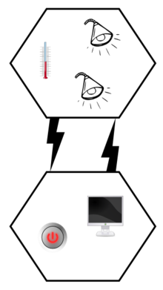
Fig6:- Communication model
An application may consist of communicating objects which cooperate to carry out the desired tasks. The focus of Zig-Bee is to distribute work among many different devices which reside within individual Zig-Bee nodes which in turn form a network (said work will typically be largely local to each device, for instance the control of each individual household appliance).
The collections of objects that form the network communicate using the facilities provided by APS, supervised by ZDO interfaces. The application layer data service follows a typical request-confirm/indication-response structure. Within a single device, up to 240 application objects can exist, numbered in the range 1-240. 0 is reserved for the ZDO data interface and 255 for broadcast; the 241-254 range is not currently in use but may be in the future.
Two services are available for application objects to use (in Zig-Bee 1.0):
- The key-value pair service (KVP) is meant for configuration purposes. It enables description, request and modification of object attributes through a simple interface based on get/set and event primitives, some allowing a request for response. Configuration uses compressed XML (full XML can be used) to provide an adaptable and elegant solution.
- The message service is designed to offer a general approach to information treatment, avoiding the necessity to adapt application protocols and potential overhead incurred on by KVP. It allows arbitrary payloads to be transmitted over APS frames.
Addressing is also part of the application layer. A network node consists of an 802.15.4-conformant radio transceiver and one or more device descriptions (basically collections of attributes which can be polled or set, or which can be monitored through events). The transceiver is the base for addressing, and devices within a node are specified by an endpoint identifier in the range 1-240.

5.12 Communication and device discovery
In order for applications to communicate, their comprising devices must use a common application protocol (types of messages, formats and so on); these sets of conventions are grouped in profiles. Furthermore, binding is decided upon by matching input and output cluster identifiers, unique within the context of a given profile and associated to an incoming or outgoing data flow in a device.
Depending on the available information, device discovery may follow different methods. When the network address is known, the IEEE address can be requested using unicast communication. When it is not, petitions are broadcast (the IEEE address being part of the response payload). End devices will simply respond with the requested address, while a network coordinator or a router will also send the addresses of all the devices associated with it.
This extended discovery protocol permits external devices to find out about devices in a network and the services that they offer, which endpoints can report when queried by the discovering device (which has previously obtained their addresses). Matching services can also be used.
The use of cluster identifiers enforces the binding of complementary entities by means of the binding tables, which are maintained by Zig-Bee coordinators, as the table must be always available within a network and coordinators are most likely to have a permanent power supply. Backups, managed by higher-level layers, may be needed by some applications. Binding requires an established communication link; after it exists, whether to add a new node to the network is decided, according to the application and security policies.
Communication can happen right after the association. Direct addressing uses both radio address and endpoint identifier, whereas indirect addressing uses every relevant field (address, endpoint, cluster and attribute) and requires that they be sent to the network coordinator, which maintains associations and translates requests for communication. Indirect addressing is particularly useful to keep some devices very simple and minimize their need for storage. Besides these two methods, broadcast to all endpoints in a device is available, and group addressing is used to communicate with groups of endpoints belonging to a set of devices.
5.13 Security services
As one of its defining features, Zig-Bee provides facilities for carrying out secure communications, protecting establishment and transport of cryptographic keys, cyphering frames and controlling devices. It builds on the basic security framework defined in IEEE 802.15.4. This part of the architecture relies on the correct management of symmetric keys and the correct implementation of methods and security policies. Binding table contain source and destination pairs.

5.13.1 Basic security model
The basic mechanism to ensure confidentiality is the adequate protection of all keying material. Trust must be assumed in the initial installation of the keys, as well as in the processing of security information. In order for an implementation to globally work, its general conformance to specified behaviors is assumed.
Keys are the cornerstone of the security architecture; as such their protection is of paramount importance, and keys are never supposed to be transported through an insecure channel. A momentary exception to this rule occurs during the initial phase of the addition to the network of a previously unconfigured device. The Zig-Bee network model must take particular care of security considerations, as ad hoc networks may be Within the protocol stack, different network layers are not cryptographically separated, so access policies are needed and correct design assumed. The open trust model within a device allows for key sharing, which notably decreases potential cost. Nevertheless, the layer which creates a frame is responsible for its security. If malicious devices may exist, every network layer payload must be ciphered, so unauthorized traffic can be immediately cut off. The exception, again, is the transmission of the network key, which confers a unified security layer to the network, to a new connecting device.

5.13.2 Security architecture
Zig-Bee uses 128-bit keys to implement its security mechanisms. A key can be associated either to a network, being usable by both Zig-Bee layers and the MAC sublayer, or to a link, acquired through pre-installation, agreement or transport. Establishment of link keys is based on a master key which controls link key correspondence. Ultimately, at least the initial master key must be obtained through a secure medium (transport or pre-installation), as the security of the whole network depends on it. Link and master keys are only visible to the application layer. Different services use different one-way variations of the link key in order to avoid leaks and security risks.
Key distribution is one of the most important security functions of the network. A secure network will designate one special device which other devices trust for the distribution of security keys: the trust center. Ideally, devices will have the trust center address and initial master key preloaded; if a momentary vulnerability is allowed, it will be sent as described above. Typical applications without special security needs will use a network key provided by the trust center (through the initially insecure channel) to communicate.
Thus, the trust center maintains both the network key and provides point-to-point security. Devices will only accept communications originating from a key provided by the trust center, except for the initial master key. The security architecture is distributed among the network layers as follows:
- The MAC sublayer is capable of single-hop reliable communications. As a rule, the security level it is to use is specified by the upper layers.
- The network layer manages routing, processing received messages and being capable of broadcasting requests. Outgoing frames will use the adequate link key according to the routing, if it is available; otherwise, the network key will be used to protect the payload from external devices.
- The application layer offers key establishment and transport services to both ZDO and applications. It is also responsible for the propagation across the network of changes in devices within it, which may originate in the devices themselves (for instance, a simple status change) or in the trust manager (which may inform the network that a certain device is to be eliminated from it). It also routes requests from devices to the trust center and network key renewals from the trust center to all devices. Besides this, the ZDO maintains the security policies of the device.
The security levels infrastructure is based on CCM, which adds encryption- and integrity-only features to CCM.

CHAPTER-6
TEMPERATURE SENSOR LM35
6.1 General Description
The LM35 series are precision integrated-circuit temperature sensors, whose output voltage is linearly proportional to the Celsius (Centigrade) temperature. The LM35 thus has an advantage over linear temperature sensors calibrated in˚ Kelvin, as the user is not required to subtract a large constant voltage from its output to obtain convenient Centigrade scaling. The LM35 does not require any external calibration or trimming to provide typical accuracies of ±1⁄4˚C at room temperature and ±3⁄4˚C over a full −55 to +150˚C temperature range. Low cost is assured by trimming and calibration at the wafer level. The LM35’s low output impedance, linear output, and precise inherent calibration make interfacing to readout or control circuitry especially easy. It can be used with single power supplies, or with plus and minus supplies. As it draws only 60 µA from its supply, it has very low self-heating, less than 0.1˚C in still air. The LM35 is rated to operate over a −55˚ to +150˚C temperature range, while the LM35C is rated for a −40˚ to +110˚C range (−10˚ with improved accuracy). The LM35 series is available pack aged in hermetic TO-46 transistor packages, while the LM35C, LM35CA, and LM35D are also available in the plastic TO-92 transistor package. The LM35D is also available in an 8-lead surface mount small outline package and a plastic TO-220 package.
6.2 Features
- Calibrated directly in ˚ Celsius (Centigrade)
- Linear + 10.0 mV/˚C scale factor
- 0.5˚C accuracy guarantee able (at +25˚C)
- Rated for full −55˚ to +150˚C range
- Suitable for remote applications
- Low cost due to wafer-level trimming
- Operates from 4 to 30 volts
- Less than 60 µA current drain
- Low self-heating, 0.08˚C in still air
- Nonlinearity only ±1⁄4˚C typical
- Low impedance output, 0.1 Ω for 1 mA load
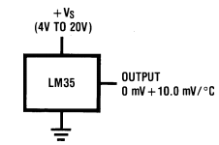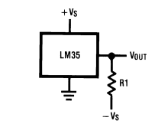

Fig7: Basic centigrade temperature sensor
6.3 Connection Diagram

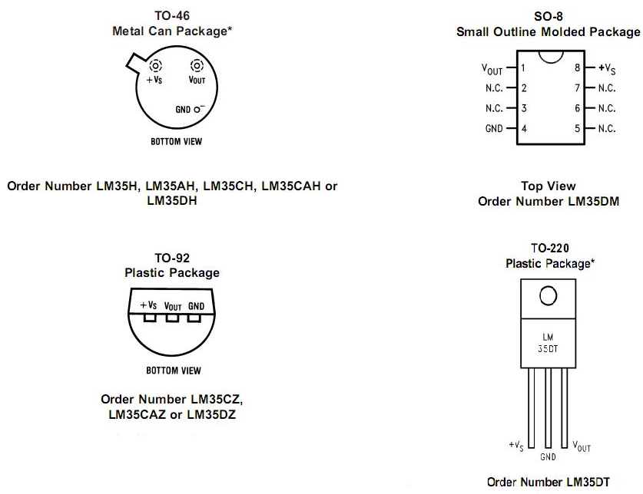

Fig8:-Connection diagram of temperature sensor
The LM35 is rated to operate over a −55˚ to +150˚C temperature range, while the LM35C is rated for a −40˚ to +110˚C range (−10˚ with improved accuracy).
6.4 Applications

The LM35 can be applied easily in the same way as other integrated-circuit temperature sensors. It can be glued or cemented to a surface and its temperature will be within about 0.01˚C of the surface temperature. This presumes that the ambient air temperature is almost the same as the surface temperature; if the air temperature were much higher or lower than the surface temperature, the actual temperature of the LM35 die would be at an intermediate temperature between the surface temperature and the air temperature. This is especially true for the TO-92 plastic package, where the copper leads are the principal thermal path to carry heat into the device, so its temperature might be closer to the air temperature than to the surface temperature. To minimize this problem, be sure that the wiring to the LM35, as it leaves the device, is held at the same temperature as the surface of interest. The easiest way to do this is to cover up these wires with a bead of epoxy which will insure that the leads and wires are all at the same temperature as the surface, and that the LM35 die’s temperature will not be affected by the air temperature.
The TO-46 metal package can also be soldered to a metal surface or pipe without damage. Of course, in that case the V−terminal of the circuit will be grounded to that metal. Alternatively, the LM35 can be mounted inside a sealed-end metal tube, and can then be dipped into a bath or screwed into a threaded hole in a tank. As with any IC, the LM35 and accompanying wiring and circuits must be kept insulated and dry, to avoid leakage and corrosion. This is especially true if the circuit may operate at cold temperatures where condensation can occur. Printed-circuit coatings and varnishes such as Humiseal and epoxy paints or dips are often used to insure that moisture cannot corrode the LM35 or its connections.
These devices are sometimes soldered to a small light-weight heat fin, to decrease the thermal time constant and speed up the response in slowly-moving air. On the other hand, a small thermal mass may be added to the sensor, to give the steadiest reading despite small deviations in the air temperature.

CHAPTER-7
HUMIDITY SENSOR
7.1 Description
Humidity sensor is a device which senses the humidity from soil as well as from air. In our project we are using the SY-HS-230 humidity sensor which is an analog device i.e. it senses the humidity and gives the output in analog form and provide it to the microcontroller which converts the analog values to digital values using ADC, which is already in the microcontroller. And then the microcontroller displays the result on the LCD. The phenomenon of the device is that the electrons present in the electrodes starts conducting when the moisture level increases in the atmosphere. As conductivity of the electrons depends upon the amount of humidity or water content present in the air or soil so the sensor conducts as the humidity increases.
7.2 Specifications
Items | SY-HS-230
Rated voltage | DC 5.0V
Rated power | ≤3.0mA
Operating temperature | 0-60°C
Operating humidity | 10-90%RH
Storage humidity | Within 95%RH
Storage temperature | -30-85°C
Accuracy | ±5%RH (at 25°C, 60%RH)
Remarks | PCB unit containing thermistor or diode for temperature compensation

Table no1:- Humidity sensor specifications
As conductivity of the electrons depends upon the amount of humidity or water content present in the air or soil so the sensor conducts as the humidity increases.
7.3 Characteristic curve (at 25°C)
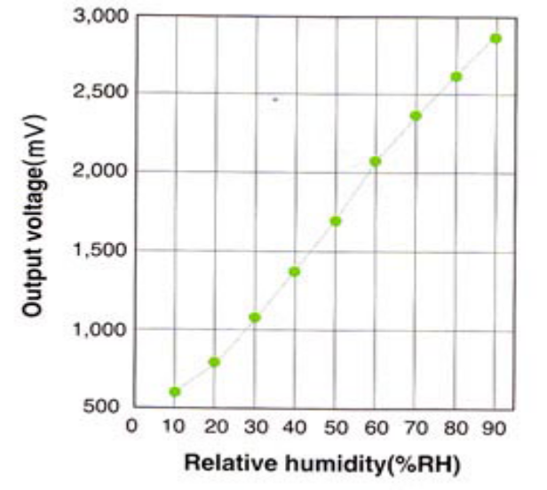
Fig9:-Characteristic curve
7.4 Standard Characteristic
%RH | Specification SY-HS-230
10 | 580
20 | 760
30 | 1030
40 | 1360
50 | 1700
60 | 2040
70 | 2350
80 | 2620
90 | 2870

Table no.2:- Standard characteristics of humidity sensor

CHAPTER-8
16×2 LCD DISPLAY
8.1 Description
The HD44780U dot-matrix liquid crystal display controller and driver LSI displays alphanumeric, Japanese kana characters, and symbols. It can be configured to drive a dot-matrix liquid crystal display under the control of a 4- or 8-bit microprocessor. Since all the functions such as display RAM, character generator, and liquid crystal driver, required for driving a dot-matrix liquid crystal display are internally provided on one chip, a minimal system can be interfaced with this controller/driver. A single HD44780U can display up to one 8-character line or two 8-character lines.
The HD44780U has pin function compatibility with the HD44780S which allows the user to easily replace an LCD-II with an HD44780U. The HD44780U character generator ROM is extended to generate 208 5  8 dot character fonts and 32 5  10 dot character fonts for a total of 240 different character fonts. The low power supply (2.7V to 5.5V) of the HD44780U is suitable for any portable battery-driven product requiring low power dissipation.
8.2 Features
• 5 ⋅ 8 and 5 ⋅ 10 dot matrix possible
• Low power operation support:
 2.7 to 5.5V
• Wide range of liquid crystal display driver power
 3.0 to 11V
• Liquid crystal drive waveform
 A (One line frequency AC waveform)
• Correspond to high speed MPU bus interface
 2 MHz (when V_{CC} = 5V)
• 4-bit or 8-bit MPU interface enabled
• 80 ⋅ 8-bit display RAM (80 characters max.)
• 9,920-bit character generator ROM for a total of 240 character fonts
 208 character fonts (5 ⋅ 8 dot)
 32 character fonts (5 ⋅ 10 dot)
• 64 ⋅ 8-bit character generator RAM
 8 character fonts (5 ⋅ 8 dot)
 4 character fonts (5 ⋅ 10 dot)
• 16-common ⋅ 40-segment liquid crystal display driver
• Programmable duty cycles
 1/8 for one line of 5 ⋅ 8 dots with cursor
 1/11 for one line of 5 ⋅ 10 dots with cursor
 1/16 for two lines of 5 ⋅ 8 dots with cursor
• Wide range of instruction functions:
 Display clear, cursor home, display on/off, cursor on/off, display character blink, cursor shift, display shift
• Pin function compatibility with HD44780S
• Automatic reset circuit that initializes the controller/driver after power on
• Internal oscillator with external resistors
• Low power consumption
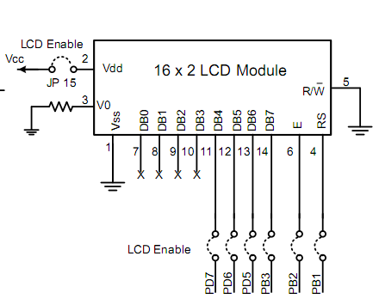

Fig10: PIN Diagram of LCD Display

CHAPTER-9
VOLTAGE REGULATOR
9.1 Description
A voltage regulator is designed to automatically maintain a constant voltage level. A voltage regulator may be a simple "feed-forward" design or may include negative feedback control loops. It may use an electromechanical mechanism, or electronic components. Depending on the design, it may be used to regulate one or more AC or DC voltages.
Electronic voltage regulators are found in devices such as computer power supplies where they stabilize the DC voltages used by the processor and other elements. In automobile alternators and central power station generator plants, voltage regulators control the output of the plant. In an electric power distribution system, voltage regulators may be installed at a substation or along distribution lines so that all customers receive steady voltage independent of how much power is drawn from the line.
9.2 Measures of regulator quality
The output voltage can only be held roughly constant; the regulation is specified by two measurements:
- Load regulation is the change in output voltage for a given change in load current (for example: "typically 15 mV, maximum 100 mV for load currents between 5 mA and 1.4 A, at some specified temperature and input voltage").
- Line regulation or input regulation is the degree to which output voltage changes with input (supply) voltage changes - as a ratio of output to input change (for example "typically 13 mV/V"), or the output voltage change over the entire specified input voltage range (for example "plus or minus 2% for input voltages between 90 V and 260 V, 50-60 Hz").
Other important parameters are:
- Temperature coefficient of the output voltage is the change with temperature (perhaps averaged over a given temperature range of the value of the temperature sensor). In automobile alternators and central power station generator plants, voltage regulators control the output of the plant. A voltage regulator is designed to automatically maintain a constant voltage level.
- Initial accuracy of a voltage regulator (or simply "the voltage accuracy") reflects the error in output voltage for a fixed regulator without taking into account temperature or aging effects on output accuracy.
- Dropout voltage is the minimum difference between input voltage and output voltage for which the regulator can still supply the specified current. A low drop-out (LDO) regulator is designed to work well even with an input supply only a volt or so above the output voltage. The input-output differential at which the voltage regulator will no longer maintain regulation is the dropout voltage. Further reduction in input voltage will result in reduced output voltage. This value is dependent on load current and junction temperature.
- Absolute maximum ratings are defined for regulator components, specifying the continuous and peak output currents that may be used (sometimes internally limited), the maximum input voltage, maximum power dissipation at a given temperature, etc.
- Output noise (thermal white noise) and output dynamic impedance may be specified as graphs versus frequency, while output ripple noise (mains "hum" or switch-mode "hash" noise) may be given as peak-to-peak or RMS voltages, or in terms of their spectra.
- Quiescent current in a regulator circuit is the current drawn internally, not available to the load, normally measured as the input current while no load is connected (and hence a source of inefficiency; some linear regulators are, surprisingly, more efficient at very low current loads than switch-mode designs because of this).
- Transient response is the reaction of a regulator when a (sudden) change of the load current (called the load transient) or input voltage (called the line transient) occurs. Some regulators will tend to oscillate or have a slow response time which in some cases might lead to undesired results. This value is different from the regulation parameters, as that is the stable situation definition. The transient response shows the behavior of the regulator on a change. This data is usually provided in the technical documentation of a regulator and is also dependent on output capacitance.
- Mirror-image insertion protection means that a regulator is designed for use when a voltage, usually not higher than the maximum input voltage of the regulator, is applied to its output pin while its input terminal is at a low voltage, volt-free or grounded. Some regulators can continuously withstand this situation; others might only manage it for a limited time such as 60 seconds, as usually specified in the datasheet. This situation can occur when a three terminal regulator is incorrectly mounted for example on a PCB, with the output terminal connected to the unregulated DC input and the input connected to the load. Mirror-image insertion protection is also important when a regulator circuit is used in battery charging circuits, when external power fails or is not turned on and the output terminal remains at battery voltage.
9.3 Types of regulator
9.3.1 Electronic voltage regulators
A simple voltage regulator can be made from a resistor in series with a diode (or series of diodes). Due to the logarithmic shape of diode V-I curves, the voltage across the diode changes only slightly due to changes in current drawn or changes in the input. When precise voltage control and efficiency are not important, this design may work fine.
Feedback voltage regulators operate by comparing the actual output voltage to some fixed reference voltage. Any difference is amplified and used to control the regulation element in such a way as to reduce the voltage error. This forms a negative feedback control loop; increasing the open-loop gain tends to increase regulation accuracy but reduce stability (avoidance of oscillation, or ringing during step changes). There will also be a trade-off between stability and the speed of the response to changes. If the output voltage is too low (perhaps due to input voltage reducing or load current increasing), the regulation element is commanded, up to a point, to produce a higher output voltage–by dropping less of the input voltage (for linear series regulators and buck switching regulators), or to draw input current for longer periods (boost-type switching regulators); if the output voltage is too high, the regulation element will normally be commanded to produce a lower voltage. However, many regulators have over-current protection, so that they will entirely stop sourcing current (or limit the current in some way) if the output current is too high, and some regulators may also shut down if the input voltage is outside a given range (see also: crowbar circuits). Due to the logarithmic shape of diode V-I curves, the voltage across the diode changes only slightly due to changes in current drawn or changes in the input. When precise voltage control and efficiency are not important, this design may work fine.
9.3.2 Electromechanical regulators
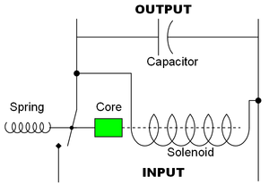
Fig11:- Circuit design for a simple electromechanical voltage regulator

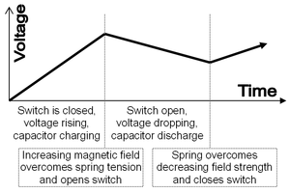
Fig12:- Graph of voltage output on a time scale.
In electromechanical regulators, voltage regulation is easily accomplished by coiling the sensing wire to make an electromagnet. The magnetic field produced by the current attracts a moving ferrous core held back under spring tension or gravitational pull. As voltage increases, so does the current, strengthening the magnetic field produced by the coil and pulling the core towards the field. The magnet is physically connected to a mechanical power switch, which opens as the magnet moves into the field. As voltage decreases, so does the current, releasing spring tension or the weight of the core and causing it to retract. This closes the switch and allows the power to flow once more.
If the mechanical regulator design is sensitive to small voltage fluctuations, the motion of the solenoid core can be used to move a selector switch across a range of resistances or transformer windings to gradually step the output voltage up or down, or to rotate the position of a moving-coil AC regulator.
Early automobile generators and alternators had a mechanical voltage regulator using one, two, or three relays and various resistors to stabilize the generator's output at slightly more than 6 or 12 V, independent of the engine's rpm or the varying load on the vehicle's electrical system. Essentially, the relay(s) employed pulse width modulation to regulate the output of the generator, controlling the field current reaching the generator (or alternator) and in this way controlling the output voltage produced. The regulators used for DC generators (but not alternators) also disconnect the generator when it was not producing electricity, thereby preventing the battery from discharging back into the generator and attempting to run it as a motor. The rectifier diodes in an alternator automatically perform this function so that a specific relay is not required; this appreciably simplified the regulator design. More modern designs now use solid state technology (transistors) to perform the same function that the relays perform in electromechanical regulators.
The ferroresonant approach is attractive due to its lack of active components, relying on the square loop saturation characteristics of the tank circuit to absorb variations in average input voltage. Saturating transformers provide a simple rugged method to stabilize an AC power supply.
9.3.2 Coil-rotation AC voltage regulator

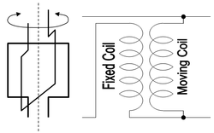
Fig13:- Basic design principle and circuit diagram for the rotating-coil alternating current voltage regulator.
This is an older type of regulator used in the 1920s that uses the principle of a fixed-position field coil and a second field coil that can be rotated on an axis in parallel with the fixed coil, similar to a variocoupler.
When the movable coil is positioned perpendicular to the fixed coil, the magnetic forces acting on the movable coil balance each other out and voltage output is unchanged. Rotating the coil in one direction or the other away from the center position will increase or decrease voltage in th Rotating the coil in one direction or the other away from the center position will increase or decrease voltage in the secondary movable coil.
This type of regulator can be automated via a servo control mechanism to advance the movable coil position in order to provide voltage increase or decrease. A braking mechanism or high ratio gearing is used to hold the rotating coil in place against the powerful magnetic forces acting on the moving coil.

9.3.4 Transistor regulator
In the simplest case emitter follower is used, the base of the regulating transistor is directly connected to the voltage reference:
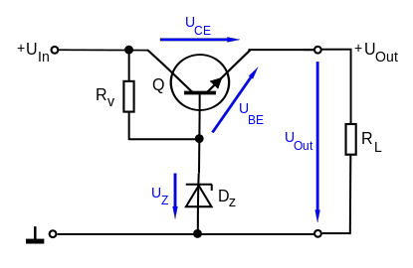
Fig14:-Circuit of transistor regulator
The stabilizer uses the power source, having voltage U_{in} that may vary over time. It delivers the relatively constant voltage U_{out}. The output load R_{L} can also vary over time. For such a device to work properly the input voltage must be larger than the output voltage and Voltage drop must not exceed the limits of the transistor used.
The output voltage of the stabilizer is equal to U_{Z} - U_{BE} where U_{BE} is about 0.7 V and depends on the load current. If the output voltage drops below that limit, this increases the voltage difference between the base and emitter (U_{be}), opening the transistor and delivering more current. Delivering more current through the same output resistor R_{L} increases the voltage again. When the output voltage increases, due to the reduced base-emitter voltage the BJT will conduct less and the regulation will be maintained. R_{v} value limits the maximum output current I_{out}, therefore has a upper limit. R_{v} (as a rough estimate) should not be larger than (U_{In} - U_{z}) / I_{B}, where I_{B} is maximum I_{out} divides transistor's current amplification ratio.

9.3.5 Regulator with an operational amplifier
The stability of the output voltage can be significantly increased by using an operational amplifier.
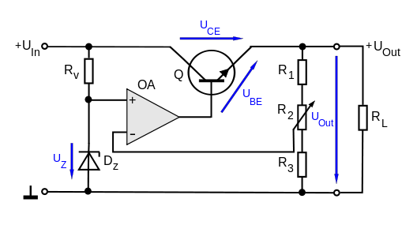
Fig15:- Circuit of regulator with OP-Amp
In this case, the operational amplifier drives the transistor with more current if the voltage at its inverting input drops below the output of the voltage reference at the non-inverting input. Using the voltage divider (R1, R2 and R3) allows choice of the arbitrary output voltage between U_{z} and U_{in}.

CHAPTER-10
AMPLIFIER IC
10.1 Description
The most common method to drive DC motors in two directions under control of a computer is with an H-bridge motor driver. H-bridges can be built from scratch with bi-polar junction transistors (BJT) or with field effect transistors (FET), or can be purchased as an integrated unit in a single integrated circuit package such as the L293. The L293 is simplest and inexpensive for low current motors, for high current motors, it is less expensive to build your own H-bridge from scratch.
ITP Physical Computing has a terrific tutorial on using an Arduino and an L293 to control a bi-directional motor. The Twin Cities Robotics Club has an *excellent* tutorial on H-bridges, and complete detail on how to build your own $5.00 H-bridge good for several amps. From the same source is a detailed tech note on PWM speed control of a motor using an H-bridge and a PIC microcontroller.
The L293 is an integrated circuit motor driver that can be used for simultaneous, bi-directional control of two small motors small means small. The L293 is limited to 600 mA, but in reality can only handle much small currents unless you have done some serious heat sinking to keep the case temperature down. Unsure about whether the L293 will work with your motor? Hook up the circuit and run your motor while keeping your finger on the chip. If it gets too hot to touch, you can't use it with your motor. (Note to ME2011 students: The L293 should be OK for your small motor but is not OK for your gear motor.)
The L293 comes in a standard 16-pin, dual-in line integrated circuit package. There is an L293 and an L293D part number. Pick the "D" version because it has built in fly back diodes to minimize inductive voltage spikes. The L293D can be purchased for somewhere between 2 and 3 (quantity one) from (PN 511-L293D) or (PN 296-9518-5-ND). For complete information, consult the Unitrode L293 data sheet.A more recent, improved specification, pin-for-pin compatible chip is recommended for new designs: the TI SN754410NE motor driver. Available from mouser.com, Mouser part number 595-SN754410NE data sheet. The pinout for the L293 in the 16-pin package is shown below intop view. Pin 1 is at the top left when the notch in the package faces up. Note that the names for pin functions may be slightly different than what is shown in the following diagrams.
Connection diagram
DIL-16 (TOP VIEW)
N Package, SP Package
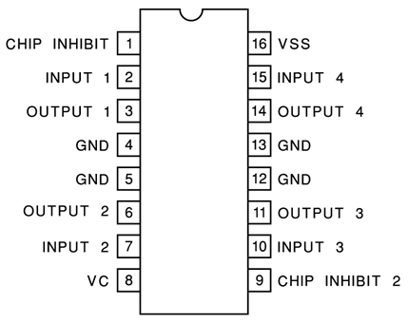
Fig16:- Pin diagram of amplifier IC
The following schematic shows how to connect the L293 to your motor and the Arduino. Each motor takes 3 Arduino pins. (See notes below for a two Arduino pin solution.) If you are only using one motor, leave L293 pins 9, 10, 11, 12, 13, 14, and 15 empty. The L293 and L293D are quadruple high-current half-H drivers. The L293 is designed to provide bidirectional drive currents of up to 1 A at voltages from 4.5 V to 36 V. The L293D is designed to provide bidirectional drive currents of up to600-mA at voltages from 4.5 V to 36 V. Both devices are designed to drive inductive loads such as relays, solenoids, dc and bipolar stepping motors, as well as their high-current/high-voltage loads in positive-supply applications. The L293 comes in a standard 16-pin, dual-in line integrated circuit package. There is an L293 and an L293D part number. Pick the "D" version because it has built in fly back diodes to minimize inductive voltage spikes. The L293D can be purchased for somewhere between 2 and 3 (quantity one) from (PN 511-L293D) or (PN 296-9518-5-ND). For complete information, consult the Unitrode L293 data sheet more recent, improved specification, pin-for-pin compatible chip is recommended for new designs.
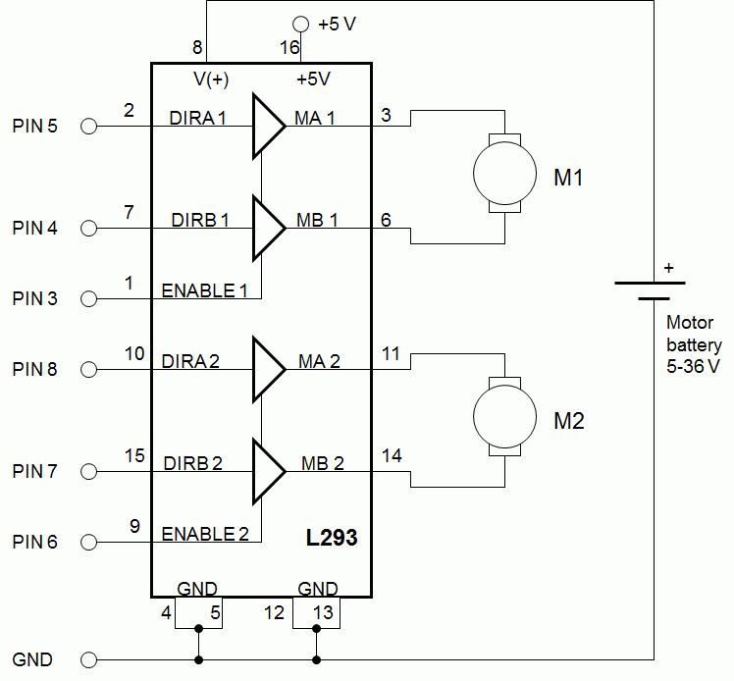
Fig17:- Internal connection of amplifier IC
In above circuit we assume that only one motor connected with the enable tied to Arduino Pin 3, and the two direction controls tied to Arduino Pins 4 and 5 and the ground is provided by pin no.4 and 5. The L293 is limited to 600 mA, but in reality can only handle much small currents unless you have done some serious heat sinking to keep the case temperature down.
10.2 Specifications
- Featuring Unit rode L293 and L293D
- Products Now From Texas Instruments
- Wide Supply-Voltage Range: 4.5 V to 36 V
- Separate Input-Logic Supply
- Internal ESD Protection
- Thermal Shutdown
- High-Noise-Immunity Inputs
- Functional Replacements for SGS L293 and
- SGS L293D
- Output Current 1 A Per Channel
- (600 mA for L293D)
- Peak Output Current 2 A Per Channel
- (1.2 A for L293D)
- Output Clamp Diodes for Inductive
- Transient Suppression (L293D)

CHAPTER-11
RELAY
11.1 Description
A relay is an electrically operated switch. Many relays use an electromagnet to operate a switching mechanism mechanically, but other operating principles are also used. Relays are used where it is necessary to control a circuit by a low-power signal (with complete electrical isolation between control and controlled circuits), or where several circuits must be controlled by one signal. The first relays were used in long distance telegraph circuits, repeating the signal coming in from one circuit and re-transmitting it to another. Relays were used extensively in telephone exchanges and early computers to perform logical operations.
`A type of relay that can handle the high power required to directly control an electric motor or other loads is called a contractor. Solid-state relays control power circuits with no moving parts, instead using a semiconductor device to perform switching. Relays with calibrated operating characteristics and sometimes multiple operating coils are used to protect electrical circuits from overload or faults; in modern electric power systems these functions are performed by digital instruments still called "protective relays". If the coil is designed to be energized with alternating current (AC), a small copper "shading ring" can be crimped to the end of the solenoid, creating a small out-of-phase current which increases the minimum pull on the armature during the AC cycle. Usually this force is provided by a spring, but gravity is also used commonly in industrial motor starters for the switching of the relay circuits. Relays were used extensively in telephone exchanges and early computers to perform logical operations.
11.2 Features
- 5A,10A Contact operating capacity
- With 1H,1Z Forms
- Small size, standard PCB Terminal
- With plastic package and none plastic
- Package
- Instant switching
11.3 Contact ratings
Contact Ratings | 1H/1Z
Contact Resistance | 100m∧(1A 6VDC)
Contact Material | AgCdO, AgNi
Contact capacity | 5A 240VAC/30VDC10A 240VAC/28VDC
Table no.3:- Contact rating of relay
11.4 Basic design and operation
Small "cradle" relay often used in electronics. The "cradle" term refers to the shape of the relay's armature. A simple electromagnetic relay consists of a coil of wire wrapped around a soft iron core, an iron yoke which provides a low reluctance path for magnetic flux, a movable iron armature, and one or more sets of contacts (there are two in the relay pictured). The armature is hinged to the yoke and mechanically linked to one or more sets of moving contacts. It is held in place by a spring so that when the relay is de-energized there is an air gap in the magnetic circuit. In this condition, one of the two sets of contacts in the relay pictured is closed, and the other set is open. Other relays may have more or fewer sets of contacts depending on their function. The relay in the picture also has a wire connecting the armature to the yoke. This ensures continuity of the circuit between the moving contacts on the armature, and the circuit track on the printed circuit board (PCB) via the yoke, which is soldered to the PCB.
When an electric current is passed through the coil it generates a magnetic field that activates the armature and the consequent movement of the movable contact either makes or breaks (depending upon construction) a connection with a fixed contact. If the set of contacts was closed when the relay was de-energized, then the movement opens the contacts and breaks the connection, and vice versa if the contacts were open. When the current to the coil is switched off, the armature is returned by a force, approximately half as strong as the magnetic force, to its relaxed position. Usually this force is provided by a spring, but gravity is also used commonly in industrial motor starters. Most relays are manufactured to operate quickly. In a low-voltage application this reduces noise; in a high voltage or current application it reduces arcing.
When the coil is energized with direct current, a diode is often placed across the coil to dissipate the energy from the collapsing magnetic field at deactivation, which would otherwise generate a voltage spike dangerous to semiconductor circuit components. Some automotive relays include a diode inside the relay case. Alternatively, a contact protection network consisting of a capacitor and resistor in series (snubber circuit) may absorb the surge. If the coil is designed to be energized with alternating current (AC), a small copper "shading ring" can be crimped to the end of the solenoid, creating a small out-of-phase current which increases the minimum pull on the armature during the AC cycle.
A solid-state relay uses a thyristor or other solid-state switching device, activated by the control signal, to switch the controlled load, instead of a solenoid. An optocoupler (a light-emitting diode (LED) coupled with a photo transistor) can be used to isolate control and controlled circuits.

CHAPTER-12
EMBEDDED SYSTEM
12.1 Description
An embedded system is a computer system designed for specific control functions within a larger system, often with real-time computing constraints. It is embedded as part of a complete device often including hardware and mechanical parts. By contrast, a general-purpose computer, such as a personal computer (PC), is designed to be flexible and to meet a wide range of end-user needs. Embedded systems control many devices in common use today.
Embedded systems contain processing cores that are either microcontrollers or digital signal processors (DSP). A processor is an important unit in the embedded system hardware. It is the heart of the embedded system. The key characteristic, however, is being dedicated to handle a particular task. Since the embedded system is dedicated to specific tasks, design engineers can optimize it to reduce the size and cost of the product and increase the reliability and performance. Some embedded systems are mass-produced, benefiting from economies of scale.
Physically, embedded systems range from portable devices such as digital watches and MP3 players, to large stationary installations like traffic lights, factory controllers, and largely complex systems like hybrid vehicles, MRI, and avionics. Complexity varies from low, with a single microcontroller chip, to very high with multiple units, peripherals and networks mounted inside a large chassis or enclosure.
12.2 Variety of embedded systems
Embedded systems are widespread in consumer, industrial, commercial and military applications. Telecommunications systems employ numerous embedded systems from telephone switches for the network to mobile phones at the end-user. Computer networking uses dedicated routers and network bridges to route data.
Consumer electronics include personal digital assistants (PDAs), mp3 players, mobile phones, videogame consoles, digital cameras, DVD players, GPS receivers, and printers. Many household appliances, such as microwave ovens, washing machines and dishwashers, include embedded systems to provide flexibility, efficiency and features. Advanced HVAC systems use networked thermostats to more accurately and efficiently control temperature that can change by time of day and season. Home automation uses wired- and wireless-networking that can be used to control lights, climate, security, audio/visual, surveillance, etc., all of which use embedded devices for sensing and controlling.
Transportation systems from flight to automobiles increasingly use embedded systems. New airplanes contain advanced avionics such as inertial guidance systems and GPS receivers that also have considerable safety requirements. Various electric motors — brushless DC motors, induction motors and DC motors — use electric/electronic motor controllers. Automobiles, electric vehicles, and hybrid vehicles increasingly use embedded systems to maximize efficiency and reduce pollution. Other automotive safety systems include anti-lock braking system (ABS), Electronic Stability Control (ESC/ESP), traction control (TCS) and automatic four-wheel drive.
Medical equipment uses embedded systems for vital signs monitoring, electronic stethoscopes for amplifying sounds, and various medical imaging (PET, SPE, CT, CT, and MRI) for non-invasive internal inspections. Embedded systems within medical equipment are often powered by industrial computers.
Embedded systems are used in transportation, fire safety, safety and security, medical applications and life critical systems as these systems can be isolated from hacking and thus be more reliable. For fire safety, the systems can be designed to have greater ability to handle higher temperatures and continue to operate. In dealing with security, the embedded systems can be self-sufficient and be able to deal with cut electrical and communication systems.
A new class of miniature wireless devices called motes is quickly gaining popularity as the field of wireless sensor networking rises. Wireless sensor networking, WSN, makes use of miniaturization made possible by advanced IC design to couple full wireless subsystems to sophisticated sensors, enabling people and companies to measure a myriad of things in the physical world and act on this information through IT monitoring and control systems. These motes are completely self contained, and will typically run off a battery source for many years before the batteries need to be changed or charged. Embedded Wi-Fi modules provide a simple means of wirelessly enabling any device which communicates via a serial port.
12.3 History
One of the first recognizably modern embedded systems was the Apollo Guidance Computer, developed by Charles Stark Draper at the MIT Instrumentation Laboratory. At the project's inception, the Apollo guidance computer was considered the riskiest item in the Apollo project as it employed the then newly developed monolithic integrated circuits to reduce the size and weight. An early mass-produced embedded system was the Automatics D-17 guidance computer for the Minuteman missile, released in 1961. When the Minuteman II went into production in 1966, the D-17 was replaced with a new computer that was the first high-volume use of integrated circuits. This program alone reduced prices on quad nand gate ICs from $1000/each to $3/each, permitting their use in commercial products.
Since these early applications in the 1960s, embedded systems have come down in price and there has been a dramatic rise in processing power and functionality. The first microprocessor for example, the Intel 4004, was designed for calculators and other small systems but still required many external memory and support chips. In 1978 National Engineering Manufacturers Association released a "standard" for programmable microcontrollers, including almost any computer-based controllers, such as single board computers, numerical, and event-based controllers.
As the cost of microprocessors and microcontrollers fell it became feasible to replace expensive knob-based analog components such as potentiometers and variable capacitors with up/down buttons or knobs read out by a microprocessor even in consumer products. By the early 1980's, memory, input and output system components had been integrated into the same chip as the processor forming a microcontroller. Microcontrollers find applications where a general-purpose computer would be too costly.
A comparatively low-cost microcontroller may be programmed to fulfill the same role as a large number of separate components. Although in this context an embedded system is usually more complex than a traditional solution, most of the complexity is contained within the microcontroller itself. Very few additional components may be needed and most of the design effort is in the software. Software prototype and test can be quicker compared with the design and construction of a new circuit not using an embedded processor compared with the design and construction of a new circuit not using an embedded processor.
12.4 Characteristics
Gumstix Overo COM, a tiny, OMAP-based embedded computer-on-module with Wifi and Bluetooth. Embedded systems are designed to do some specific task, rather than be a general-purpose computer for multiple tasks. Some also have real-time performance constraints that must be met, for reasons such as safety and usability; others may have low or no performance requirements, allowing the system hardware to be simplified to reduce costs.
Embedded systems are not always standalone devices. Many embedded systems consist of small, computerized parts within a larger device that serves a more general purpose. For example, the Gibson Robot Guitar features an embedded system for tuning the strings, but the overall purpose of the Robot Guitar is, of course, to play music. Similarly, an embedded system in an automobile provides a specific function as a subsystem of the car itself.
The program instructions written for embedded systems are referred to as firmware, and are stored in read-only memory or Flash memory chips. They run with limited computer hardware resources: little memory, small or non-existent keyboard or screen.

12.5 User interface
Embedded systems range from no user interface at all — dedicated only to one task to complex graphical user interfaces that resemble modern computer desktop operating systems. Simple embedded devices use buttons, LEDs, graphic or character LCDs (for example popular HD44780 LCD) with a simple menu system.
More sophisticated devices which use a graphical screen with touch sensing or screen-edge buttons provide flexibility while minimizing space used: the meaning of the buttons can change with the screen, and selection involves the natural behavior of pointing at what's desired. Handheld systems often have a screen with a "joystick button" for a pointing device.
Some systems provide user interface remotely with the help of a serial (e.g. RS-232, USB, I²C, etc.) or network (e.g. Ethernet) connection. This approach gives several advantages: extends the capabilities of embedded system, avoids the cost of a display, simplifies BSP, allows us to build rich user interface on the PC. A good example of this is the combination of an embedded web server running on an embedded device (such as an IP camera) or a network routers. The user interface is displayed in a web browser on a PC connected to the device, therefore needing no bespoke software to be installed.

12.6 Processors in embedded systems
Embedded processors can be broken into two broad categories. Ordinary microprocessors (μP) use separate integrated circuits for memory and peripherals. Microcontrollers (μC) have many more peripherals on chip, reducing power consumption, size and cost. In contrast to the personal computer market, many different basic CPU architectures are used, since software is custom-developed for an application and is not a commodity product installed by the end user. Both Von Neumann as well as various degrees of Harvard architectures are used. RISC as well as non-RISC processors are found. Word lengths vary from 4-bit to 64-bits and beyond, although the most typical remain 8/16-bit. Most architecture comes in a large number of different variants and shapes, many of which are also manufactured by several different companies.
Numerous microcontrollers have been developed for embedded systems use. General-purpose microprocessors are also used in embedded systems, but generally require more support circuitry than microcontrollers.

12.7 Readymade computer boards
PC/104 and PC/104+ are examples of standards for ready made computer boards intended for small, low-volume embedded and ruggedized systems, mostly x86-based. These are often physically small compared to a standard PC, although still quite large compared to most simple (8/16-bit) embedded systems. They often use MSDOS, Linux, NetBSD, or an embedded real-time operating system such as MicroC/OS-II, QNX or VxWorks. Sometimes these boards use non-x86 processors.
In certain applications, where small size or power efficiency are not primary concerns, the components used may be compatible with those used in general purpose x86 personal computers. Boards such as the VIA EPIA range help to bridge the gap by being PC-compatible but highly integrated, physically smaller or have other attributes making them attractive to embedded engineers. The advantage of this approach is that low-cost commodity components may be used along with the same software development tools used for general software development. Systems built in this way are still regarded as embedded since they are integrated into larger devices and fulfill a single role. Examples of devices that may adopt this approach are ATMs and arcade machines, which contain code specific to the application.
However, most ready-made embedded systems boards are not PC-centered and do not use the ISA or PCI busses. When a System-on-a-chip processor is involved, there may be little benefit to having a standardized bus connecting discrete components, and the environment for both hardware and software tools may be very different.
One common design style uses a small system module, perhaps the size of a business card, holding high density BGA chips such as an ARM-based System-on-a-chip processor and peripherals, external flash memory for storage, and DRArM for runtime memory. The module vendor will usually provide boot software and make sure there is a selection of operating systems, usually including Linux and some real time choices. These modules can be manufactured in high volume, by organizations familiar with their specialized testing issues, and combined with much lower volume custom main-boards with application-specific external peripherals. Gumstix product lines are a Linux-centric example of this model.

12.8 ASIC and FPGA solutions
A common array of n configuration for very-high-volume embedded systems is the system on a chip (SoC) which contains a complete system consisting of multiple processors, multipliers, caches and interfaces on a single chip. SoCs can be implemented as an application-specific integrated circuit (ASIC) or using a field-programmable gate array (FPGA). The advantage of this approach is that low-cost commodity components may be used along with the same software development tools used for general software development. Systems built in this way are still regarded as embedded since they are integrated into larger devices and fulfill a single role. The advantage of this approach is that low-cost commodity components may be used along with the same software development tools used for general software development.

12.9 Peripherals
Embedded Systems talk with the outside world via peripherals, such as:
- Serial Communication Interfaces (SCI): RS-232, RS-422, RS-485 etc.
- Synchronous Serial Communication Interface: I2C, SPI, SSC and ESSI (Enhanced Synchronous Serial Interface)
- Universal Serial Bus (USB)
- Multi Media Cards (SD Cards, Compact Flash etc.)
- Networks: Ethernet, LonWorks, etc.
- Fieldbuses: CAN-Bus, LIN-Bus, PRrOFIBUS, etc.
- Timers: PLL(s), Capture/Compare and Time Processirng Units
- Discrete IO: aka General Purpose Input/Output (GPIO)
- Analog to Digital/Digital to Analog (ADC/DAC)
- Debugging: JTAG, ISP, ICSP, BDM Port, BITP, and DP9 ports.

12.10 Tools
As with other software, embedded system designers use compilers, assemblers, and debuggers to develop embedded system software. However, they may also use some more specific tools:
- In circuit debuggers or emulators (see next section).
- Utilities to add a checksum or CRC to a program, so the embedded system can check if the program is valid.
- For systems using digital signal processing, developers may use a math workbench such as Scilab / Scicos, MATLAB / Simulink, EICASLAB, MathCad, Mathematica,or FlowStone DSP to simulate the mathematics. They might also use libraries for both the host and target which eliminates developing DSP routines as done in DSPnano RTOS and Unison Operating System.
- A model based development tool like VisSim lets you create and simulate graphical data flow and UML State chart diagrams of components like digital filters, motor controllers, communication protocol decoding and multi-rate tasks. Interrupt handlers can also be created graphically. After simulation, you can automatically generate C-code to the VisSim RTOS which handles the main control task and preemption of background tasks, as well as automatic setup and programming of on-chip peripherals.
- Custom compilers and linkers may be used to optimize specialized hardware.
- An embedded system may have its own special language or design tool, or add enhancements to an existing language such as Forth or Basic so that the use of embedded system is increased.
- Another alternative is to add a real-time operating system or embedded operating system, which may have DSP capabilities like DSPnano RTOS.
- Modeling and code generating tools often based on state machines
Software tools can come from several sources:
- Software companies that specialize in the embedded market
- Ported from the GNU software development tools
- Sometimes, development tools for a personal computer can be used if the embedded processor is a close relative to a common PC processor
As the complexity of embedded systems grows, higher level tools and operating systems are migrating into machinery where it makes sense. For example, cell phones, personal digital assistants and other consumer computers often need significant software that is purchased or provided by a person other than the manufacturer of the electronics. In these systems, an open programming environment such as Linux, NetBSD, OSGi or Embedded Java is required so that the third-party software provider can sell to a large market.

12.10.1 Debugging
Embedded debugging may be performed at different levels, depending on the facilities available. From simplest to most sophisticate they can be roughly grouped into the following areas:
- Interactive resident debugging, using the simple shell provided by the embedded operating system (e.g. Forth and Basic)
- External debugging using logging or serial port output to trace operation using either a monitor in flash or using a debug server like the Remedy Debugger which even works for heterogeneous multicore systems.
- An in-circuit debugger (ICD), a hardware device that connects to the microprocessor via a JTAG or Nexus interface. This allows the operation of the microprocessor to be controlled externally, but is typically restricted to specific debugging capabilities in the processor.
- An in-circuit emulator (ICE) replaces the microprocessor with a simulated equivalent, providing full control over all aspects of the microprocessor.
- A complete emulator provides a simulation of all aspects of the hardware, allowing all of it to be controlled and modified, and allowing debugging on a normal PC. The downsides are expense and slow operation, in some cases up to 100X slower than the final system.
- For SoC designs, the typical approach is to verify and debug the design on an FPGA prototype board. Tools such as Certus are used to insert probes in the FPGA RTL that make signals available for observation. This is used to debug hardware, firmware and software interactions across multiple FPGA with capabilities similar to a logic analyzer.
Unless restricted to external debugging, the programmer can typically load and run software through the tools, view the code running in the processor, and start or stop its operation. The view of the code may be as HLL source-code, assembly code or mixture of both.
Because an embedded system is often composed of a wide variety of elements, the debugging strategy may vary. For instance, debugging a software- (and microprocessor-) centric embedded system is different from debugging an embedded system where most of the processing is performed by peripherals (DSP, FPGA, co-processor). An increasing number of embedded systems today use more than one single processor core. A common problem with multi-core development is the proper synchronization of software execution. In such a case, the embedded system design may wish to check the data traffic on the busses between the processor cores, which requires very low-level debugging, at signal/bus level, with a logic analyzer, for instance.

12.10.2 Tracing
Real-time operating systems (RTOS) often supports tracing of operating system events. A graphical view is presented by a host PC tool, based on a recording of the system behavior. The trace recording can be performed in software, by the RTOS, or by special tracing hardware. RTOS tracing allows developers to understand timing and performance issues of the software system and gives a good understanding of the high-level system behavior. Commercial tools like RTXC Quadros or IAR Systems exist.

12.10.3 Reliability
Embedded systems often reside in machines that are expected to run continuously for years without errors and in some cases recover by them if an error occurs. Therefore the software is usually developed and tested more carefully than that for personal computers, and unreliable mechanical software is usually developed and tested more carefully than that for personal computers, and unreliable mechanical moving parts such as disk drives, switches or buttons are avoided.
Specific reliability issues may include:
- The system cannot safely be shut down for repair, or it is too inaccessible to repair. Examples include space systems, undersea cables, navigational beacons, bore-hole systems, and automobiles.
- The system must be kept running for safety reasons. "Limp modes" are less tolerable. Often backups are selected by an operator. Examples include aircraft navigation, reactor control systems, safety-critical chemical factory controls, train signals.
- The system will lose large amounts of money when shut down: Telephone switches, factory controls, bridge and elevator controls, funds transfer and market making, automated sales and service.
A variety of techniques are used, sometimes in combination, to recover from errors—both software bugs such as memory leaks, and also soft errors in the hardware:
- watchdog timer that resets the computer unless the software periodically notifies the watchdog
- subsystems with redundant spares that can be switched over to
- software "limp modes" that provide partial function
- Designing with a Trusted Computing Base (TCB) architecture ensures a highly secure & reliable system environment
- An Embedded Hypervisor is able to provide secure encapsulation for any subsystem component, so that a compromised software component cannot interfere with other subsystems, or privileged-level system software. This encapsulation keeps faults from propagating from one subsystem to another, improving reliability. This may also allow a subsystem to be automatically shut down and restarted on fault detection.
- Immunity Aware Programming the trace recording can be performed in software, by the RTOS, or by special tracing hardware. RTOS tracing allows developers to understand timing and performance issues of the software system and gives a good understanding of the high-level system behavior. Commercial tools like RTXC Quadros or IAR Systems exist.

12.10.4 High vs low volume
For high volume systems such as portable music players or mobile phones, minimizing cost is usually the primary design consideration. Engineers typically select hardware that is just “good enough” to implement the necessary functions.
For low-volume or prototype embedded systems, general purpose computers may be adapted by limiting the programs or by replacing the operating system with a real-time operating system.

12.10.5 Simple control loop
In this design, the software simply has a loop. The loop calls subroutines, each of which manages a part of the hardware or software.

12.10.6 Interrupt controlled system
Some embedded systems are predominantly interrupting controlled. This means that tasks performed by the system are triggered by different kinds of events. An interrupt could be generated for example by a timer in a predefined frequency, or by a serial port controller receiving a byte. These kinds of systems are used if event handlers need low latency and the event handlers are short and simple.
Usually these kinds of systems run a simple task in a main loop also, but this task is not very sensitive to unexpected delays. Sometimes the interrupt handler will add longer tasks to a queue structure. Later, after the interrupt handler has finished, these tasks are executed by the main loop. These kinds of systems are used if event handlers need low latency and the event handlers are short and simple. This method brings the system close to a multitasking kernel with discrete processes. An interrupt could be generated for example by a timer in a predefined frequency, or by a serial port controller receiving a byte. This encapsulation keeps faults from propagating from one subsystem to another, improving reliability.

12.10.7 Cooperative multitasking
A nonpreemptive multitasking system is very similar to the simple control loop scheme, except that the loop is hidden in an API. The programmer defines a series of tasks, and each task gets its own environment to “run” in. When a task is idle, it calls an idle routine, usually called “pause”, “wait”, “yield”, “nop” (stands for no operation), etc.
The advantages and disadvantages are to the control loop, except that adding new software is easier, by simply writing a new task, or adding to the queue

12.10.8 Preemptive multitasking or multi-threading
In this type of system, a low-level piece of code switches between tasks or threads based on a timer (connected to an interrupt). This is the level at which the system is generally considered to have an "operating system" kernel. Depending on how much functionality is required, it introduces more or less of the complexities of managing multiple tasks running conceptually in parallel.
As any code can potentially damage the data of another task (except in larger systems using an MMU) programs must be carefully designed and tested, and access to shared data must be controlled by some synchronization strategy, such as message queues, semaphores or a non-blocking synchronization scheme.
Because of these complexities, it is common for organizations to use a real-time operating system (RTOS), allowing the application programmers to concentrate on device functionality rather than operating system services, at least for large systems; smaller systems often cannot afford the overhead associated with a generic real time system, due to limitations regarding memory size, performance, or battery life. The choice that an RTOS is required brings in its own issues however as the selection must be done prior to starting to the application development process. This timing forces developers to choose the embedded operating system for their device based upon current requirements and so restricts future options to a large extent. The restriction of future options becomes more of an issue as product life decreases. Additionally the level of complexity is continuously growing as devices are required to manage many variables such as serial, USB, TCP/IP, Bluetooth, Wireless LAN, trunk radio, multiple channels, data and voice, enhanced graphics, multiple states, multiple threads, numerous wait states and so on. These trends are leading to the uptake of embedded middleware in addition to a real time operating system.
A microkernel is a logical step up from a real-time OS. The usual arrangement is that the operating system kernel allocates memory and switches the CPU to different threads of execution.
In general, microkernels succeed when the task switching and intertask communication is fast, and fail when they are slow. Exokernels communicate efficiently by normal subroutine calls. The hardware and all the software in the system are available to, and extensible by application programmers.

12.11 Monolithic kernels
In this case, a relatively large kernel with sophisticated capabilities is adapted to suit an embedded environment. This gives programmers an environment similar to a desktop operating system like Linux or Microsoft Windows, and is therefore very productive for development; on the downside, it requires considerably more hardware resources, is often more expensive, and because of the complexity of these kernels can be less predictable and reliable.
Common examples of embedded monolithic kernels are Embedded Linux and Windows CE. Despite the increased cost in hardware, this type of embedded system is increasing in popularity, especially on the more powerful embedded devices such as Wireless Routers and GPS Navigation Systems. Here are some of the reasons:
- Ports to common embedded chip sets are available.
- They permit re-use of publicly available code for Device Drivers, Web Servers, Firewalls, and other code.
- Development systems can start out with broad feature-sets, and then the distribution can be configured to exclude unneeded functionality, and save the expense of the memory that it would consume.
- Many engineers believe that running application code in user mode is more reliable, easier to debug and that therefore the development process is easier and the code more portable.
- Many embedded systems lack the tight real time requirements of a control system. Although a system such as Embedded Linux may be fast enough in order to respond to many other applications.
- Features requiring faster response than can be guaranteed can often be placed in hardware. Common examples of embedded monolithic kernels are Embedded Linux and Windows CE. In this case, a relatively large kernel with sophisticated capabilities is adapted to suit an embedded environment.

12.12 Exotic custom operating systems
A small fraction of embedded systems require safe, timely, reliable or efficient behavior unobtainable with any of the above architectures. In this case an organization builds a system to suit. In some cases, the system may be partitioned into a "mechanism controller" using special techniques, and a "display controller" with a conventional operating system. A communication system passes data between the two.

12.13 Additional software components
In addition to the core operating system, many embedded systems have additional upper-layer software components. These components consist of networking protocol stacks like CAN, TCP/IP, FTP, HTTP, and HTTPS, and also included storage capabilities like FAT and flash memory management systems. If the embedded devices has audio and video capabilities, then the appropriate drivers and codecs will be present in the system. In the case of the monolithic kernels, many of these software layers are included. In the RTOS category, the availability of the additional software components depends upon the commercial offering.If the embedded devices has audio and video capabilities, then the appropriate drivers and codecs will be present in the system. In the case of the monolithic kernels, many of these software layers are included. In the category, the availability of the additional software components depends upon the commercial offering.

CHAPTER-13
CONCLUSION
Embedded system for automatic irrigation of a farm field offers a potential solution to support site-specific irrigation management that allows producers to maximize their productivity while saving the water. This project is designed using microcontroller. The temperature and humidity sensors detect the field temperature and field humidity, the moisture sensor detects the soil moisture and then the sensor values are sent to the farmer zone. The microcontroller checks the conditions for irrigation and performs automatic irrigation. Field conditions were site-specifically monitored by in-field sensor stations distributed across the farm field, based on high, low, sloppy and flat areas. This irrigation system updates motor status automatically according to the maximum and minimum values of temperature, humidity and moisture in the control system for a proper irrigation. Field system are wirelessly communicates with a farmer zone by Zig-bee technology. The modules operate within the 2.4 GHz frequency band and outdoor RF line-of-sight range up to 4000 ft. (1200 m) with RF data rate of 250,000 bps.
Agricultural automation is a continual development. The current research technologies give rise to the possibility of developing a completely new mechanization system to support the cropping system based on small smart machines. This system replaces blanket energy over application with intelligently targeted inputs thus reducing the cost of the inputs while increasing the level of care. This can improve the economics of crop production as well as having less environmental impact.

CHAPTER-14
APPLICATIONS

- This technology is applicable to detect the real time environmental condition.

- It is useful for farmers, go-downs or mass storage places, etc.

- This system can also be used in industrial applications where temperature sensing is required.

- It can be also used to preserve pharmaceutical and drugs which are used for medical purpose.

- This system is best for green-house farming.

- System is also applicable to maintain the temperature in aquariums.

CHAPTER-15
ADVANTAGES

- It is economical as compared other technology.

- Single Device can communicate with the other distant located devices.

- It is working on precision value of temperature.

- Fast response due to AVR ATmega32 microcontroller.

- Required less human effort.

- High speed data transfer between the zones.

- Mesh formation is possible using Zig-Bee.

- Secure and fast communication is possible.

- Very less hardware is required.

CHAPTER-15
FUTURE SCOPE

- Smart field monitoring by wireless nano technology.

- Soilnet – a zig-bee based soil moisture network.

- SIM300 can be used as a future communication system for the project.

