ANNEXTURE-A
PROGRAM CODING
- PROGRAMMING OF TRANSMITTER SECTION
#include<avr/io.h>
#include<util/delay.h>
#include <multiutil.h>
#include <uart.h>

void main()
{

Baud_Rate();
Receiver_Enable();
Transmit_Enable();

DDRC=0b11000011;
PORTC=0b00000000;
lcd_init();
init_adc();
uint16_t temp,hm1,hm2;
int adc_value1,adc_value2;

while(1)
{

adc_value1=read_adc(1);
adc_value2=read_adc(2);
lcd_clrscr();
temp = (adc_value1*49) ;

lcd_goto(0,1);
lcd_prints("Temp=");
lcd_goto(6,1);
lcd_put_i ( adc_value1*49 , 2, 5) ;
lcd_goto(10,1);
lcd_printc(0xDF);
lcd_printc('C');
_delay_ms(300);
hm1=adc_value2/17;
_delay_ms(300);
hm2=hm1/13;
_delay_ms(100);

lcd_goto(0,2);
lcd_prints("Humd=");
lcd_goto(6,2);
lcd_printi(hm1);
_delay_ms(100);
lcd_goto(9,2);
lcd_prints("PER");
_delay_ms(100);

if(temp>2500 && temp<3000)
{
Usart_Transmit('1');
_delay_ms(100);
Usart_Transmit('1');
_delay_ms(100);
Usart_Transmit('1');
_delay_ms(100);
Usart_Transmit('1');
_delay_ms(100);

_delay_ms(100);
PORTC=0b11000011;
_delay_ms(100);

}
else if(temp>=3600 && temp<4000)
{
Usart_Transmit('2');
_delay_ms(100);
Usart_Transmit('2');
_delay_ms(100);
Usart_Transmit('2');
_delay_ms(100);
Usart_Transmit('2');
_delay_ms(100);

_delay_ms(100);
PORTC=0b11000011;
_delay_ms(100);

}
else if(temp>=4500 && temp<=7000)
{
Usart_Transmit('3');
_delay_ms(100);
Usart_Transmit('3');
_delay_ms(100);
Usart_Transmit('3');
_delay_ms(100);
Usart_Transmit('3');
_delay_ms(100);

_delay_ms(100);
PORTC=0b11000011;
_delay_ms(100);

}
else
{
Usart_Transmit('4');
_delay_ms(100);
Usart_Transmit('4');
_delay_ms(100);
Usart_Transmit('4');
_delay_ms(100);
Usart_Transmit('4');
_delay_ms(100);

_delay_ms(100);
PORTC=0b00000000;
_delay_ms(100);
}
}
}

- PROGRAMMING OF RECIEVER SECTION
#include<avr/io.h>
#include<util/delay.h>
#include<multiutil.h>
#include<uart.h>

void main()
{

Baud_Rate();
Receiver_Enable();
Transmit_Enable();
lcd_init();
_delay_ms(30);
while(1)
{

Usart_Receive();
_delay_ms(100);

if(UDR=='1')
{
_delay_ms(100);
lcd_clrscr();
lcd_goto(0,1);
lcd_prints(" **temp>25 c**");
lcd_goto(0,2);
lcd_prints("HM DECREASED");
_delay_ms(100);
}
else if(UDR=='2')
{
_delay_ms(100);
lcd_clrscr();
lcd_goto(0,1);
lcd_prints(" **temp>35 c**");
lcd_goto(0,2);
lcd_prints("HM DECREASED");
_delay_ms(100);
}
else if(UDR=='3')
{
_delay_ms(100);
lcd_clrscr();
lcd_goto(0,1);
lcd_prints(" **temp>45 c**");
lcd_goto(0,2);
lcd_prints("HM DECREASED");
_delay_ms(100);
}
else if(UDR=='4')
{
_delay_ms(100);
lcd_clrscr();
lcd_goto(0,1);
lcd_prints(" **NORMAL**");
lcd_goto(0,2);
lcd_prints("**************");
_delay_ms(100);
}
}
}

ANNEXTURE-B
RESULT
Embedded system for automatic irrigation of a farm field offers a potential solution to support site-specific irrigation management that allows producers to maximize their productivity while saving the water. This project is designed using microcontroller. The temperature and humidity sensors detect the field temperature and field humidity, the moisture sensor detects the soil moisture and then the sensor values are sent to the farmer zone. The microcontroller checks the conditions for irrigation and performs automatic irrigation. Field conditions were site-specifically monitored by in-field sensor stations distributed across the farm field, based on high, low, sloppy and flat areas. This irrigation system updates motor status automatically according to the maximum and minimum values of temperature, humidity and moisture in the control system for a proper irrigation. Field system are wirelessly communicates with a farmer zone by Zig-bee technology. The modules operate within the 2.4 GHz frequency band and outdoor RF line-of-sight range up to 4000 ft. (1200 m) with RF data rate of 250,000 bps.
Agricultural automation is a continual development. The current research technologies give rise to the possibility of developing a completely new mechanization system to support the cropping system based on small smart machines. This system replaces blanket energy over application with intelligently targeted inputs thus reducing the cost of the inputs while increasing the level of care. This can improve the economics of crop production as well as having less environmental impact. This project proposed an embedded system for automatic farming which has a wireless sensor network for real time infield sensing and control of an irrigation system. This wireless system supports the farm field which has both plain and slope areas. Too much watering causes diseases to the crop. This system provides uniform and required level of water for both plain and slope areas and therefore it avoids the water overflow at the slope areas which saves the plant and also water. This system has software for real-time in-field sensing and control of an irrigation system. Field conditions were site-specifically monitored by in-field sensor stations distributed across the field and then wirelessly transmitted to a base station. This system has software for real-time in-field sensing and control of an irrigation system.
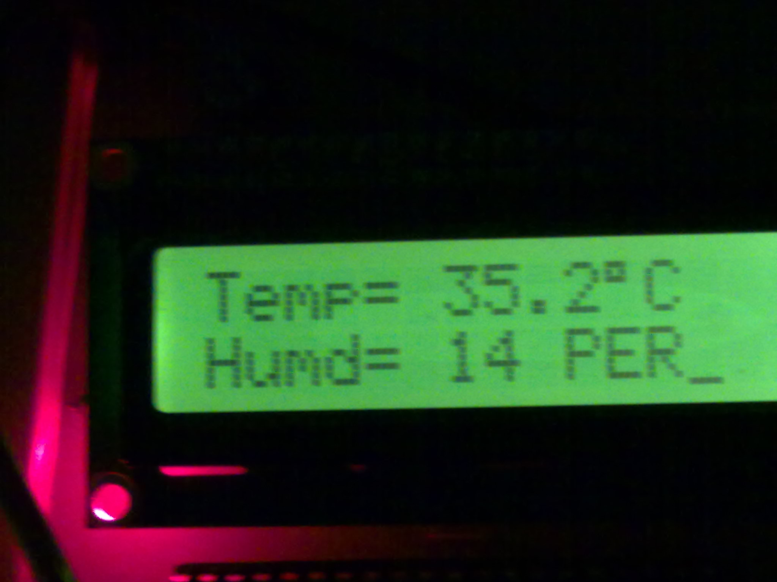
Fig1:- LCD display at transmitter section
The above picture shows a normal output of 35.2ᴼC and a humidity level of 14 percent in the farm. At this temperature the water pump will not get operated. The range from 31ᴼC to 35ᴼC is normal for the farm. At this temperature the crop will be properly grown in the farm.
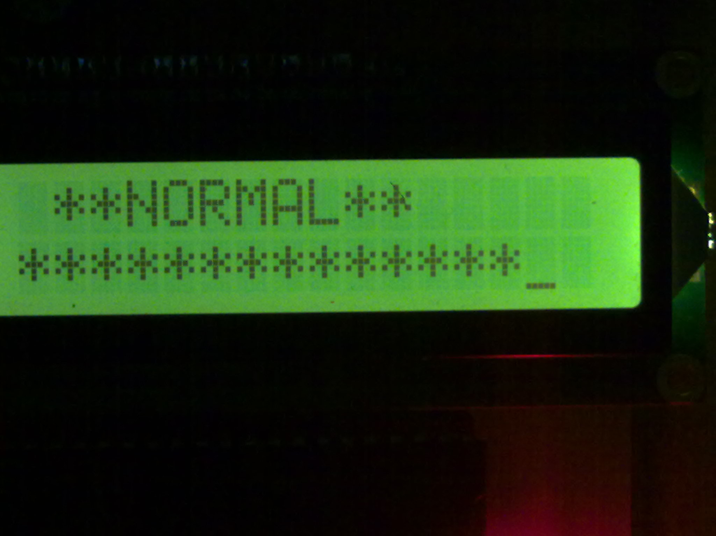
Fig2:- LCD display at normal temperature on receiver section
Figure 2 shows the display at the output terminal i.e. at the farmer zone in which the status of the farm is shown. This result is taken at 35.2ᴼC which is normal for the farm so the receiver section is showing NORMAL in the farmer zone.
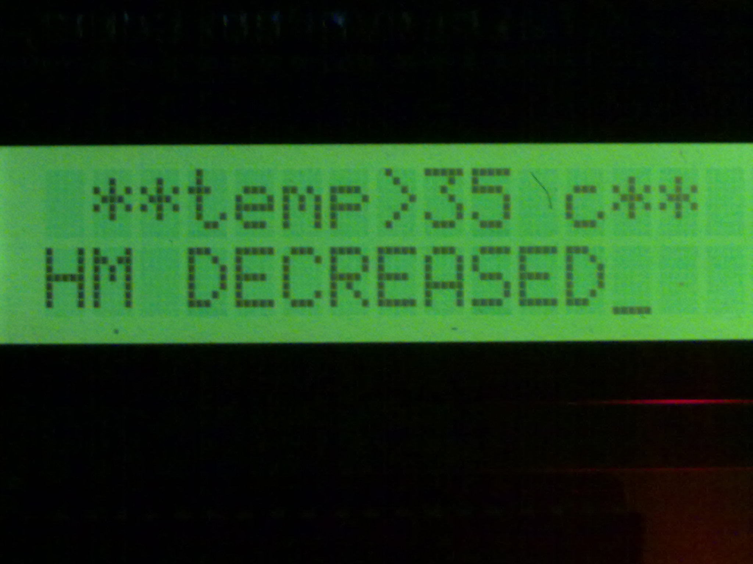
Fig3:- LCD display when temperature exceed 35ᴼC
When the temperature increases and reaches at more than 36ᴼC then the microcontroller will switch in the motor and the message is send via zig-bee to the farmer that the pump has been operated in the farm and the temperature is more than 35ᴼC. the above picture shows the result on the LCD when temperature rises more than 35ᴼC in the farm.

ANNEXTURE-C
BIBLIOGRAPHY
Books
[1] K. NirmalKumar, P.Ranjith, R.Prabakaran “Real time paddy crop field monitoring using zigbee network” proceedings of icetect 2011.
[2] Spices Board, Ministry of Commerce and Industry , Government of India, “Cultivation practices for cardamom”, January 2009.
[3] Zhang Feng “Research on water-saving irrigation automatic control system based on internet of things” 978-1-4244-8039-5/11/2011 IEEE.
[4] Cheng Wang, Chunjiang Zhao, XinZhang, XiaojunQiao, Yinghua he “Research and exploitation of precise irrigation-fertilization controller” National engineering research center for information technology in agriculture, beijing, china.
[5] Yan Xijun, Lu Limei, XuLizhong “The application of wireless sensor network in the irrigation area- automatic system”, International conference on networks security, wireless communications and trusted computing, 2009.
[6] Liang Chen, Jiancheng Shi, Lingmei Jiang “Physically based estimation soil moisture from l-band radiometer” 2008 international workshop on earth observation and remote sensing applications.
[7] Yandong Zhao, Jinfeng Guan, Junfu Zhang, Weilun Yin “Study on precision water-saving irrigation automatic control system by plant physiology” 978-1-4244-2800-7/09/2009 IEEE.
[8] Yandong Zhao ” Study on soil water content real-time measuring method and sensor structure” 978-1-4244-2800-7/09/2009 IEEE.
[9] Yunseop (James) Kim, member, IEEE, Robert G. Evans, and William M. Iversen “Remote sensing and control of an irrigation system using a distributed wireless sensor network” IEEE transactions on instrumentation and measurement, vol. 57, no. 7, July 2008.
[10] AlkaKalra, Rajiv Chechi, Dr. Rajesh Khanna “Role of zigbee technology in agriculture sector” ncci 2010 -National conference on computational instrumentation csiochandigarh, india, 19-20 march 2010.
[11] Anonymous , Cardamom in Karnataka. UAS Tech. Series No. 14. University of Agricultural Sciences. Hebbal, Bangalore, p. 5, 1976.
[12] Anonymous, Condiments and spices. In Handbook of Agriculture, ICAR, New Delhi, 1982.
[13] Korikanthimath, V.S. , Shade management for high productivity in cardamom (Elettaria cardamomum Maton). Spice India, 4(2), 15–21, 1991.
[14] Mohanchandran, K, Planting for plantations – a study on cardamom. ISS, IISR, Calicut, Cardamom J, 17(11), pp. 172–176, 1984.
[15]Reference website
  - http://www.silabs.com/Support%20Documents/TechnicalDocs/ZigBee-based-HANs-for-Energy-Management.pdf
  - http://www.atmel.com/Images/doc2503.pdf
  - http://www.autoshop101.com/forms/hweb2.pdf
  - http://www.google.co.in/url?sa=t&rct=j&q=relay&source=web&cd=1&cad=rja&ved=0CF0QFjAA&url=http%3A%2F%2Fen.wikipedia.org%2Fwiki%2FRelay&ei=JOgvUPrAIsPtrQeZhYDIDg&usg=AFQjCNHbLASP8AVzJS4FPFE-XAxGaUdETw
  - http://www.google.co.in/url?sa=t&rct=j&q=future%20scope%20of%20zigbee%20technology&source=web&cd=2&cad=rja&ved=0CEkQFjAB&url=http%3A%2F%2Fwiki.answers.com%2FQ%2FWhat_is_the_future_scope_of_zigbee_technology&ei=agvUOnWKMS3rAe_ioCQCw&usg=AFQjCNEJos8xow1CwN7Kg7p1LNBFDls4Ww
  - http://www.google.co.in/url?sa=t&rct=j&q=future%20scope%20of%20zigbee%20technology&source=web&cd=1&cad=rja&ved=0CEcQFjAA&url=http%3A%2F%2Fwww.ijcst.com%2Fvol31%2F2%2Fgurpreet.pdf&ei=agvUOnWKMS3rAe_ioCQCw&usg=AFQjCNFxcbItoZrBtIY4hsI24Ry8MjjXZw
  - http://en.wikipedia.org/wiki/Embedded_system

