Tasks_01
Sub WelcomeMessage()
MsgBox "Welcome to VBA Programming!"
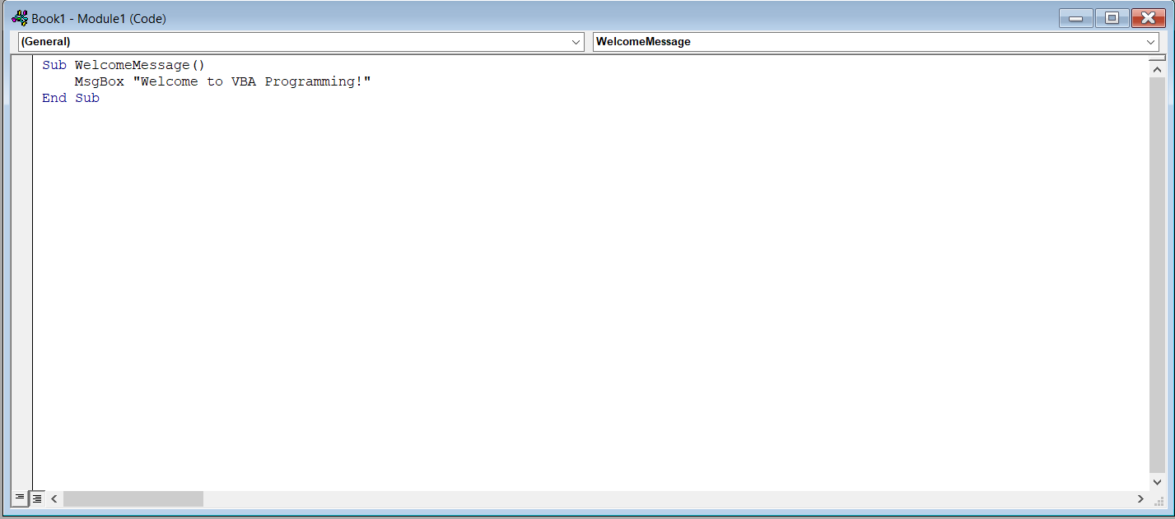
End Sub
Output:

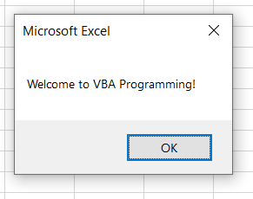

Tasks_02
Sub DisplayUserDetails()
Dim userName As String
Dim orderCount As Integer
Dim isPremiumUser As Boolean

userName = "Hitesh"
orderCount = 25
isPremiumUser = True

MsgBox "User Name: " & userName & vbCrLf & _
"Order Count: " & orderCount & vbCrLf & _
"Premium User: " & isPremiumUser End Sub
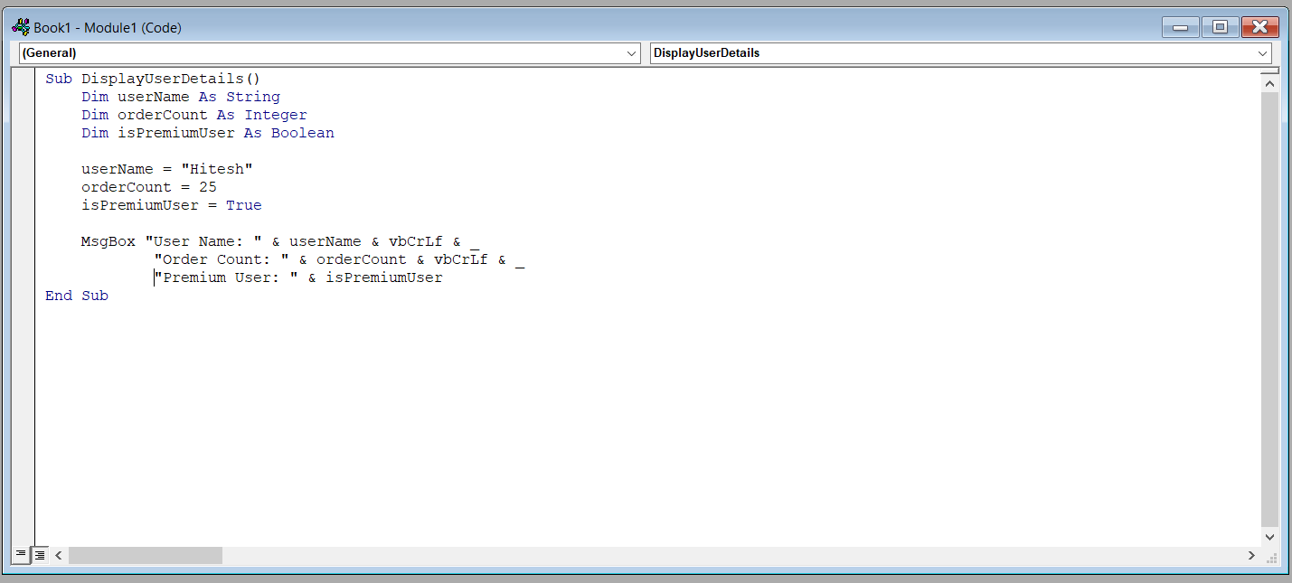
Output:
