Section A — Concept Application
Table of Contents
SCENARIO 01: 2
SCENARIO 02: 3
SCENARIO 03: 4
SCENARIO 04: 6
SCENARIO 05: 9
SCENARIO 06: 11

SCENARIO 01: You are building a food delivery app that tracks four values per order: the order total (Rs 499.50), the delivery distance (7.3 km), the payment method ('UPI'), and whether the restaurant is currently accepting orders (True).
Question: Identify the correct Python data type for each of the four values above. Then explain why assigning the wrong type — for example, storing Rs 499.50 as an integer — would cause an incorrect result when applying a 10% discount calculation.
Answer:
Python Program with output:
Value | Example | Python Data Type
Order total | 499.5 | Float
Delivery distance | 7.3 | Float
Payment method | "UPI" | String
Restaurant accepting orders | TRUE | Boolean
Programming:
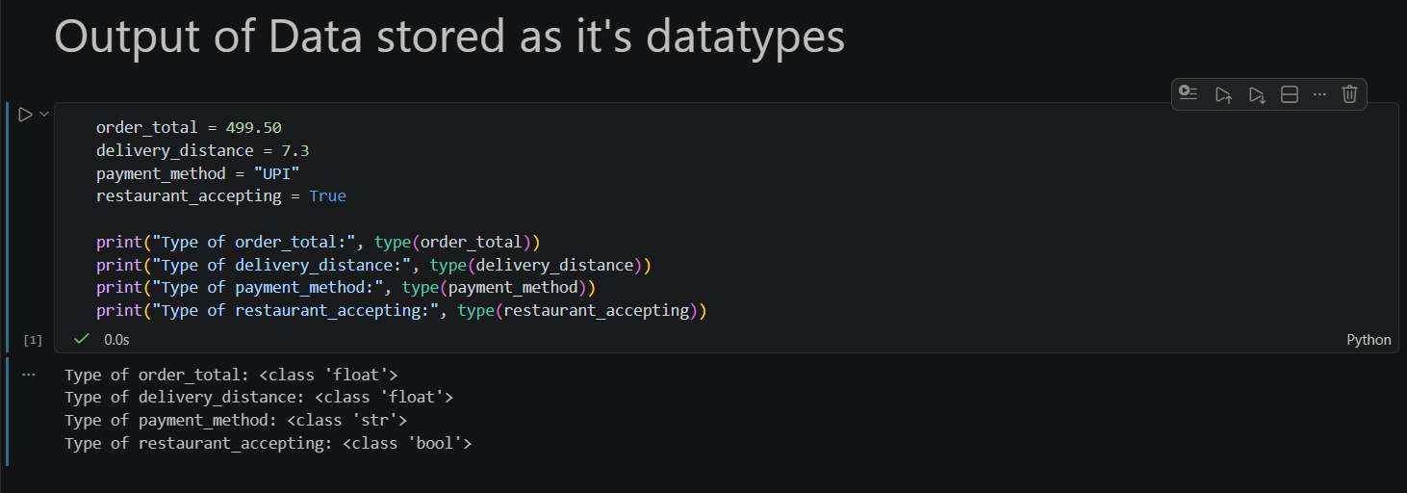

- If we store the 490.50 Data as a integer instead of float then the original amount will be lost the value “.50” which affect further every calculation which were based on this.

SCENARIO 02: You are developing a restaurant menu system. A teammate suggests storing the menu as a list of tuples like [('Paneer Burger', 180, 'Snacks'), ('Masala Dosa', 90, 'Breakfast')], while you prefer a dictionary where each dish name is the key.
Question: Compare these two data structures for looking up a dish price by name. Which gives faster and more readable access, and why? Describe one limitation of the list-of-tuples approach that the dictionary design solves.
Answer:
- A dictionary is faster and more readable than a list of tuples.
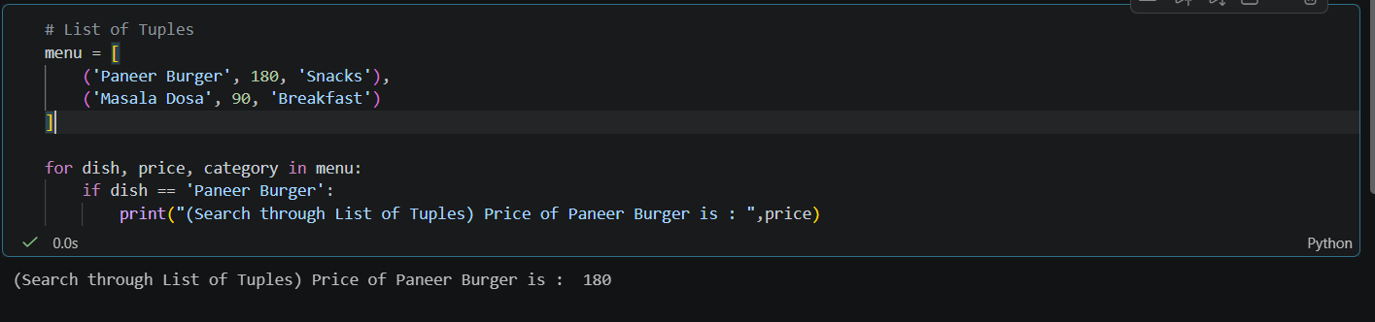

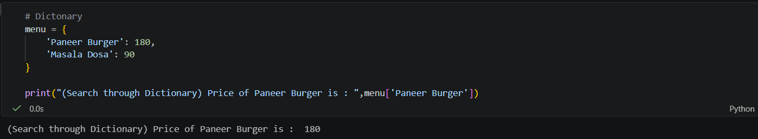

- For searching the price of specific dish we have to iterate/search through each and every tuple in the list of tuples and this search can take a lot of time if the List of tuples is very large.
- Limitation solved by dictionaries:
  - With a list of tuples, searching for a dish requires manually iterating through the list, and the lookup becomes slower as the menu grows. A dictionary solves this by using the dish name as a key, allowing direct and efficient access to its price.

Conclusion:
- For a restaurant menu where dishes are frequently looked up by name, a dictionary is the better choice because it provides faster lookup and clearer, more readable code.
SCENARIO 03: You are writing a delivery fee calculator that applies three different fee rules: no charge if the order value is Rs 500 or more, Rs 30 fee if distance is 5 km or less, and Rs 60 fee for distances above 5 km. A colleague proposes writing this as a single lambda function.
Question: Explain why a named function defined with def is more appropriate than a lambda for this multi-condition fee logic. Then describe one specific situation inside this same app where a lambda would genuinely be the better choice.
Answer:
- A named function defined with def is more appropriate for this delivery fee calculator because the logic contains multiple conditions and rules.
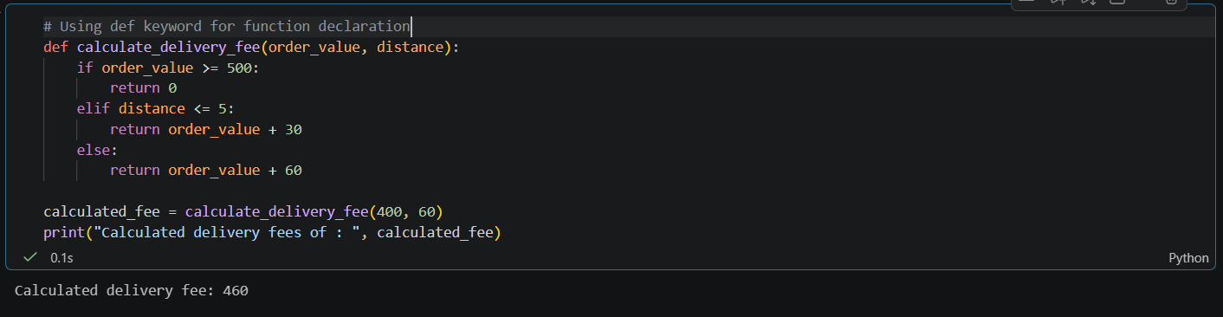

- What is Lambda Function :
  - Is a small, anonymous function—meaning it is defined without a name. Unlike standard functions created using the def keyword, lambda functions are written in a single line of code and are designed for short-lived, simple operations
- Lambda functions are mainly intended for small, simple, one-expression operations. Using a lambda for complex conditional logic would make the code harder to read and maintain.

- A lambda would genuinely be better in the same app when performing a simple operation, such as sorting delivery orders by distance:
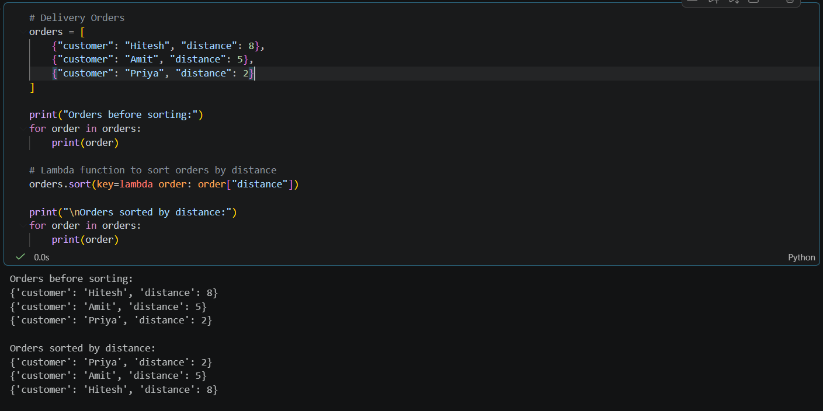

- Here, the lambda performs one small task—getting the distance value for sorting—so it is concise and easy to understand.

Conclusion:
- Use def for the multi-condition delivery fee calculation because it improves readability and maintainability. Use lambda for short, simple operations such as sorting or filtering data

SCENARIO 04: You are working on an order history feature that must save completed delivery orders to a JSON file so the system can reload all orders when the app restarts.
Question: Describe the complete Python sequence to write a single order dictionary to a JSON file and read it back. What exception is raised if the file does not exist at read time, and how should your program handle it so the app starts cleanly on its first run?
Answer:

1. Import the JSON Module
- import json
- The json module provides functions such as:
  - json.dump() – writes Python data to a JSON file.
  - json.load() – reads JSON data from a file.

2. Create the Order Dictionary
- For example:
order = {
"order_id": 1001,
"customer_name": "Hitesh",
"restaurant": "Spice Villa",
"amount": 650,
"status": "Completed"
}
- This is a normal Python dictionary containing the order information.

3. Write the Order to a JSON File
- with open("orders.json", "w") as file:
  - json.dump(order, file, indent=4)
- Here:
  - "orders.json" is the file where the order will be stored.
  - "w" opens the file in write mode.
  - json.dump() converts the Python dictionary into JSON format.
  - indent=4 makes the JSON file easier to read.

- The resulting JSON file will look like:
{
"order_id": 1001,
"customer_name": "Hitesh",
"restaurant": "Spice Villa",
"amount": 650,
"status": "Completed"
}

4. Read the JSON File
- To load the order when the application starts:
with open("orders.json", "r") as file:
order = json.load(file)

print(order)
- The JSON data is converted back into a Python dictionary.

5. Handle a Missing File
- If orders.json does not exist, Python raises:
  - FileNotFoundError
- For example:
try:
with open("orders.json", "r") as file:
order = json.load(file)

except FileNotFoundError:
order = {}
print("No previous order history found. Starting with an empty order history.")
- This allows the application to start normally on its first run, even though the JSON file has not been created yet.

Complete Example
import json

order = {
"order_id": 1001,
"customer_name": "Hitesh",
"restaurant": "Spice Villa",
"amount": 650,
"status": "Completed"
}

# Write order to JSON file
with open("orders.json", "w") as file:
json.dump(order, file, indent=4)

# Read order from JSON file
try:
with open("orders.json", "r") as file:
saved_order = json.load(file)

print("Order loaded successfully:")
print(saved_order)

except FileNotFoundError:
saved_order = {}
print("No order history found. Starting with an empty order history.")

Exception Handling

Situation | Exception | Handling
JSON file does not exist | FileNotFoundError | Start with an empty order history
JSON file contains invalid JSON | json.JSONDecodeError | Handle corrupted/invalid data appropriately
File is successfully read | No exception | Load the order normally

Conclusion
The complete sequence is:
Create dictionary → Open file in write mode → json.dump() → Close file → Open file in read mode → json.load() → Use the dictionary.
If the JSON file does not exist during the first application run, Python raises FileNotFoundError. The program should catch this exception using try-except and initialize an empty order history so that the application starts cleanly.
SCENARIO 05: You are designing a delivery tracking system. Each delivery must store the rider's name, current GPS location, assigned order ID, and status (e.g. 'on the way'). It must also support actions such as updating the location and marking the delivery as complete.
Question: Justify why a class is a better design choice here than storing all of this data in separate variables or a plain dictionary. Identify at least two OOP principles your class design would apply and explain what each one achieves.
Answer:
- A class is a better design choice for a delivery tracking system because each delivery contains related data and actions.
- Instead of keeping the rider's name, GPS location, order ID and status in separate variables, a class groups all of them into one reusable object.
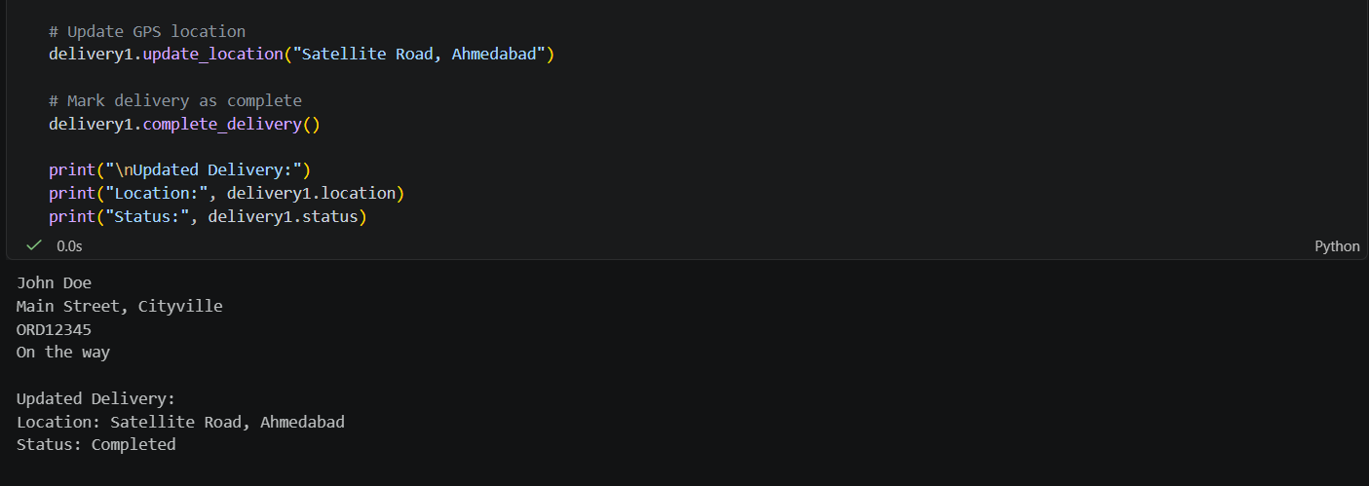
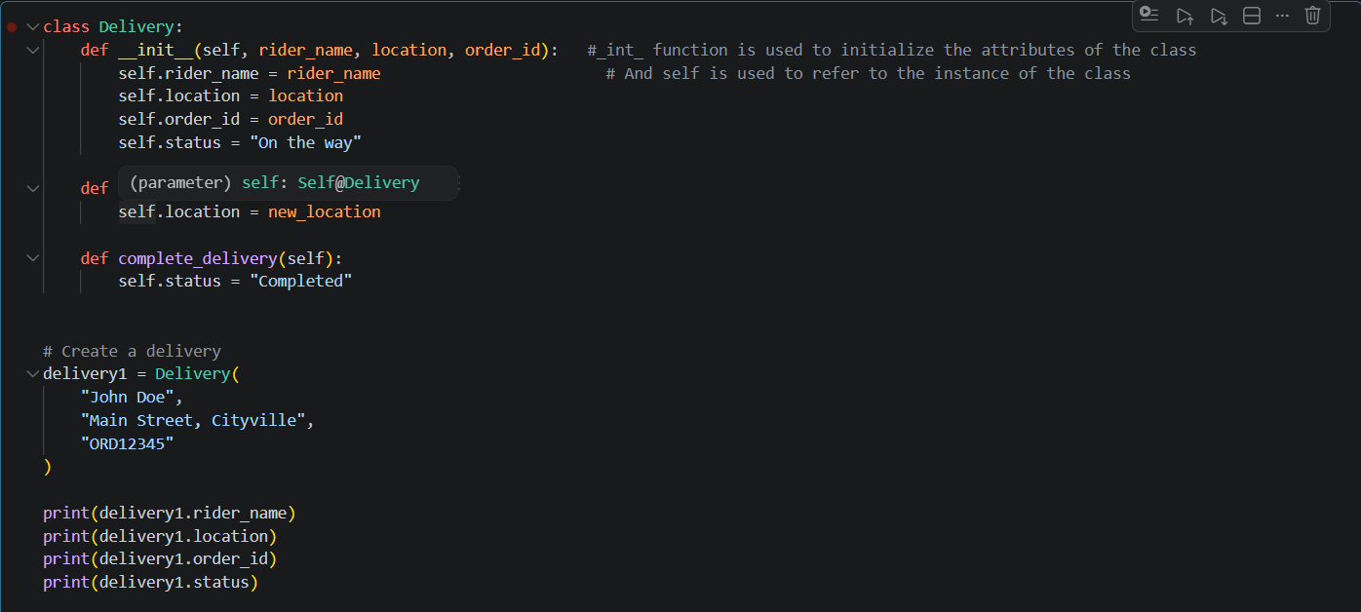

- Why is a class better?

  - With separate variables, We can store all the data as separate variables but as the application grows, managing information for many deliveries becomes difficult.
  - A class allows us to create multiple delivery objects easily:
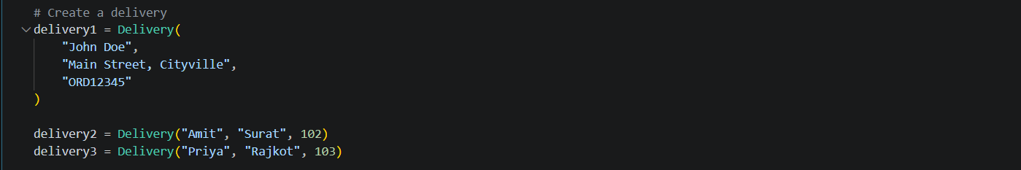

- OOP Principles Used:

  - Encapsulation
    - Encapsulation means keeping related data and methods together inside a class.

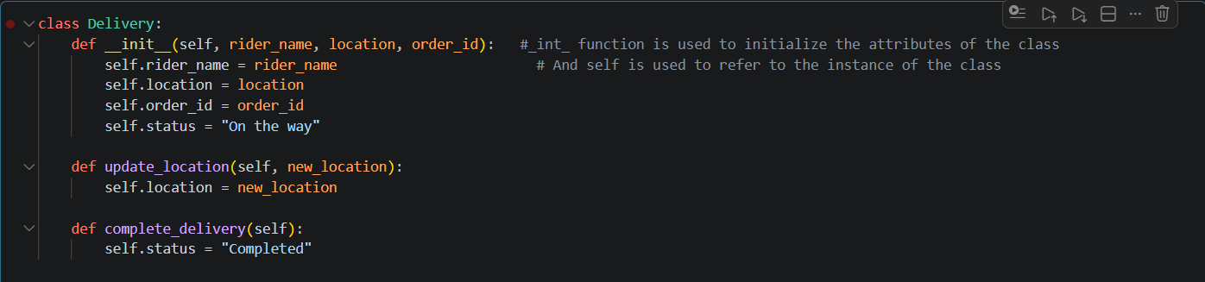

  - Abstraction
    - The user does not need to know how the location or status is internally changed. They can simply call:
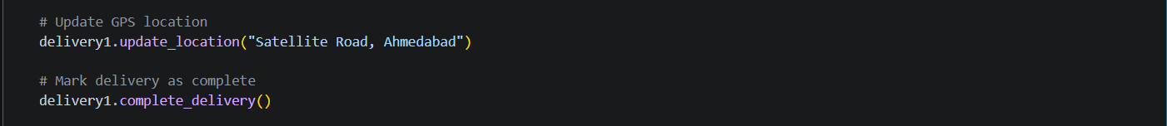

Conclusion:
- A class is preferable because it combines delivery data and related actions into a single reusable structure. It makes the system more organized, maintainable, and scalable.
- The main OOP principles demonstrated are Encapsulation, which groups data and methods together, and Abstraction, which hides implementation details behind simple methods

SCENARIO 06: You are debugging a delivery cost calculator. When a user types “two hundred” instead of a number for the order amount, the program crashes with an unhandled exception.
Question: Describe how you would use a try-except block to handle this error gracefully. Name the specific exception type you would catch, and explain how you would structure the code so the program asks the user to re-enter the value instead of terminating.
Answer:
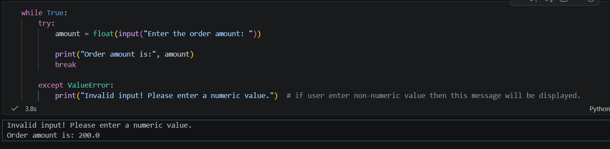
- We can handle this using a try-except block. Since the user enters “two hundred” and the program expects a number, Python will raise a ValueError when you try to convert it using Int () or float ().
- How it works
  - Try block
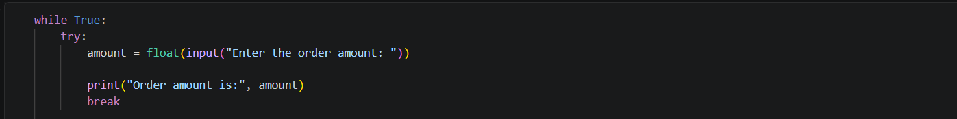
    - Put the code that might cause an error inside try.
  - ValueError
    - If the user enters: two hundred
    - Then Python cannot convert it to a float, so it raises: ValueError

  - except ValueError
    - Instead of crashing, the program catches the error:
  - While True
    - The loop makes the program ask again until the user enters a valid number.

- Specific exception: ValueError
- Purpose: It occurs when a value has the correct general type but cannot be converted to the required numeric format, such as converting "two hundred" to float.

