Section B: Practical Coding Tasks
Table of Contents
Task 1: Delivery Fee Calculator 2
Task 2: Restaurant Menu Manager 4
Task 3: Order History File Logger 8
Task 4: Delivery Rider OOP System 11

Task 1: Delivery Fee Calculator
Build a console program that calculates and displays the final bill for a food delivery order based on order value and delivery distance.
- Prompt the user to enter the order value (Rs ) and delivery distance (km) as separate inputs.
- Apply these fee rules using conditional statements: free delivery if order value >= Rs 500; Rs 30 fee if distance <= 5 km; Rs 60 fee if distance > 5 km.
- Display the item total, delivery fee, and final amount payable in a clearly formatted output.
- Handle the case where the user enters a negative distance or negative order value by printing an appropriate error message and stopping execution.

Answer:

# Get input from the user
Order_Value = float(input("Enter the order value: "))
Distance_of_Delivery = float(input("Enter the distance of delivery: "))

# Check for negative values
if Order_Value < 0 or Distance_of_Delivery < 0:
print("Error: Order value and delivery distance cannot be negative.")
else:
# Calculate delivery fee
if Order_Value >= 500:
delivery_fee = 0
elif Distance_of_Delivery <= 5:
delivery_fee = 30
else:
delivery_fee = 60

# Calculate final amount
final_amount = Order_Value + delivery_fee

# Display bill
print("\n----- Delivery Bill -----")
print(f"Item Total : Rs {Order_Value:.2f}")
print(f"Delivery Fee : Rs {delivery_fee:.2f}")
print(f"Final Amount : Rs {final_amount:.2f}")

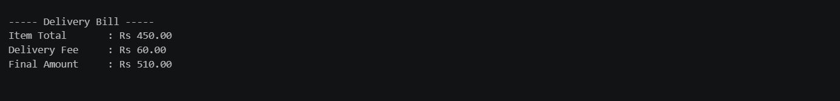
Output:

Task 2: Restaurant Menu Manager
Build a menu management program that stores a restaurant's menu in a dictionary and lets the user interact with it through a looped console interface.
- Store at least 6 menu items in a dictionary; each item maps a dish name (key) to a nested dictionary with keys: price and category.
- Provide three options in a loop: (1) View all items formatted as a numbered table, (2) Filter items by category, (3) Search for a dish by name and display its price.
- Define a separate function for each of the three operations; call them from the main loop.
- Keep the loop running until the user enters '0' to exit.
Answer:

# Task 2: Restaurant Menu Manager

# Restaurant menu
menu = {
"Pizza": {
"price": 250,
"category": "Main Course"
},
"Burger": {
"price": 150,
"category": "Main Course"
},
"Pasta": {
"price": 200,
"category": "Main Course"
},
"French Fries": {
"price": 100,
"category": "Starter"
},
"Cold Coffee": {
"price": 120,
"category": "Beverage"
},
"Ice Cream": {
"price": 80,
"category": "Dessert"
}
}

# Function 1: View all menu items
def view_menu():
print("\n----------- MENU OF RESTAURANT -----------")
print(f"{'No.':<5}{'Dish Name':<20}{'Price':<10}{'Category'}")
print("-" * 50)

number = 1

for dish, details in menu.items():
print(f"{number:<5}{dish:<20}Rs {details['price']:<7}{details['category']}")
number += 1

# Function 2: Filter menu by category
def filter_category():
category = input("\nEnter category: ")

print(f"\nItems in category: {category}")
found = False

for dish, details in menu.items():
if details["category"].lower() == category.lower():
print(f"{dish} - Rs {details['price']}")
found = True

if not found:
print("No items found in this category.")

# Function 3: Search for a dish
def search_dish():
dish_name = input("\nEnter dish name: ")

found = False

for dish, details in menu.items():
if dish.lower() == dish_name.lower():
print(f"\nDish: {dish}")
print(f"Price: Rs {details['price']}")
found = True
break

if not found:
print("Dish not found.")

# Main loop
while True:

print("\n===== Restaurant Menu Manager =====")
print("1. View All Items")
print("2. Filter Items by Category")
print("3. Search for a Dish")
print("0. Exit")

choice = input("Enter your choice: ")

if choice == "1":
view_menu()

elif choice == "2":
filter_category()

elif choice == "3":
search_dish()

elif choice == "0":
print("Thank you! Program ended.")
break

else:
print("Invalid choice. Please try again.")

Output:
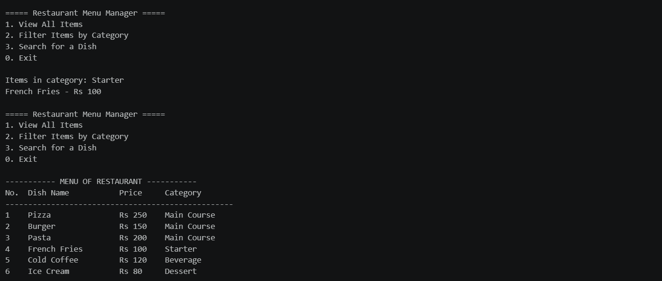
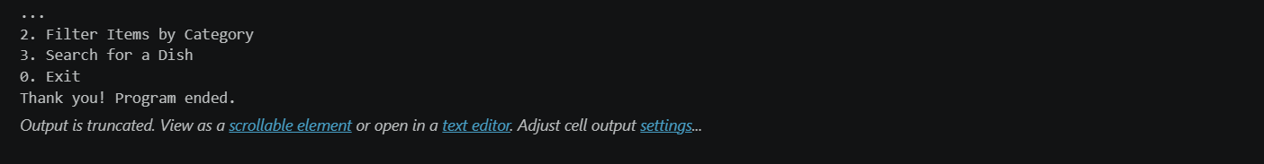

Task 3: Order History File Logger
Build a program that records food delivery orders to a JSON file and lets the user view all past orders, demonstrating file handling and exception handling together.
- Accept the following order details from the user: customer name, list of items (comma-separated input converted to a Python list), total amount, and order status.
- Load the existing orders list from orders.json before adding the new order, then save the updated list back to the file — so all orders accumulate across runs.
- Provide a 'View Orders' option that reads orders.json and prints each order in a readable format.
- Use a try-except block to handle FileNotFoundError (first run, no file yet) and ValueError (non-numeric total amount).
Answer:

import json

FILE_NAME = "orders.json"

def load_orders():
try:
with open(FILE_NAME, "r") as file:
return json.load(file)

except FileNotFoundError:
return []

def save_orders(orders):
with open(FILE_NAME, "w") as file:
json.dump(orders, file, indent=4)

def add_order():
try:
customer_name = input("Enter customer name: ")

items_input = input("Enter items (comma-separated): ")
items = [item.strip() for item in items_input.split(",")]

total_amount = float(input("Enter total amount: "))

order_status = input("Enter order status: ")

# Load existing orders
orders = load_orders()

# Create new order
new_order = {
"customer_name": customer_name,
"items": items,
"total_amount": total_amount,
"order_status": order_status
}

# Add new order
orders.append(new_order)

# Save updated orders
save_orders(orders)

print("\nOrder added successfully!")

except ValueError:
print("\nError: Total amount must be a numeric value.")

def view_orders():
try:
with open(FILE_NAME, "r") as file:
orders = json.load(file)

if not orders:
print("\nNo orders found.")
return

print("\n========== ORDER HISTORY ==========")

for i, order in enumerate(orders, start=1):
print(f"\nOrder {i}")
print("-" * 30)
print(f"Customer Name : {order['customer_name']}")
print(f"Items : {', '.join(order['items'])}")
print(f"Total Amount : ₹{order['total_amount']:.2f}")
print(f"Order Status : {order['order_status']}")

except FileNotFoundError:
print("\nNo order history found. orders.json does not exist yet.")

def main():
while True:
print("\n========== FOOD DELIVERY SYSTEM ==========")
print("1. Add Order")
print("2. View Orders")
print("3. Exit")

choice = input("Enter your choice: ")

if choice == "1":
add_order()

elif choice == "2":
view_orders()

elif choice == "3":
print("Thank you!")
break

else:
print("Invalid choice. Please try again.")

main()
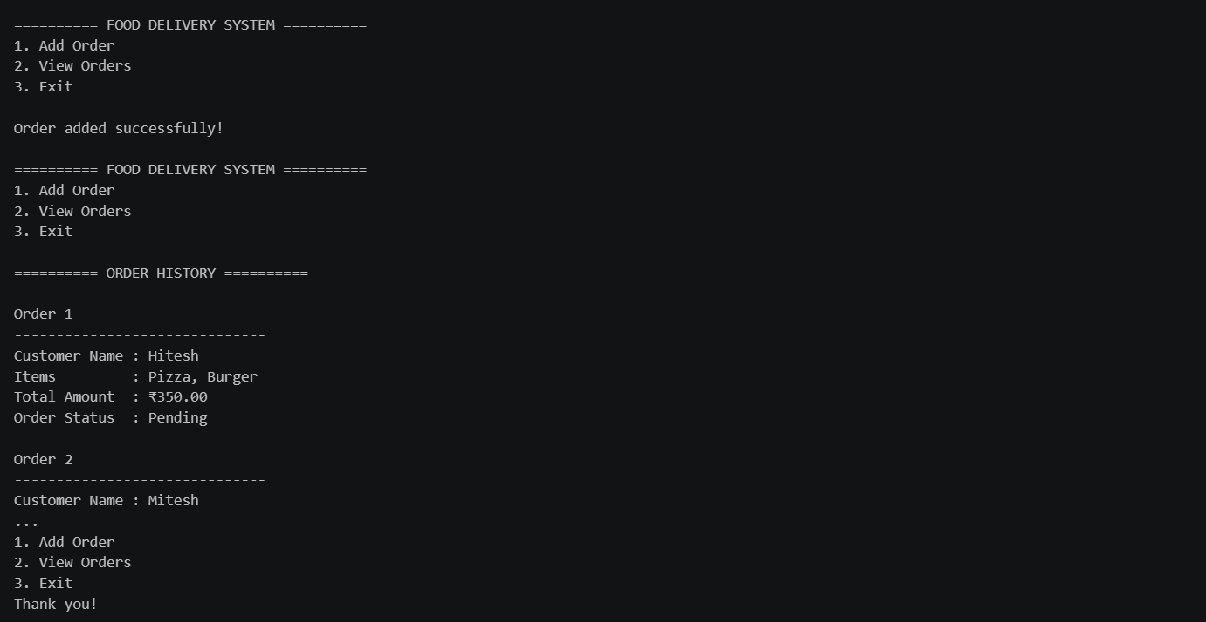
Output:

Task 4: Delivery Rider OOP System
Build an object-oriented system that models delivery riders using a class, stores multiple rider objects in a list, and persists their data to a CSV file.
- Create a Rider class with instance attributes: rider_id, name, status (default 'Available'), and total_deliveries (default 0).
- Implement three methods: assign_order(order_id) — sets status to 'On Delivery' and prints a confirmation; complete_delivery() — increments total_deliveries, resets status to 'Available'; display_info() — prints all rider details.
- In the main program, create at least three Rider objects and provide a simple numbered menu to assign and complete orders for any rider selected by ID.
- Save all rider data to riders.csv using the csv module when the user exits, and reload it at program start if the file exists
Answer:
import csv
import os

# -----------------------------
# Rider Class
# -----------------------------

class Rider:

def __init__(self, rider_id, name, status="Available", total_deliveries=0):
self.rider_id = rider_id
self.name = name
self.status = status
self.total_deliveries = total_deliveries

def assign_order(self, order_id):
self.status = "On Delivery"
print(
f"Order {order_id} assigned to Rider "
f"{self.rider_id} - {self.name}"
)
print("Rider status: On Delivery")

def complete_delivery(self):
self.total_deliveries += 1
self.status = "Available"

print(f"Delivery completed by {self.name}.")
print(f"Total deliveries: {self.total_deliveries}")
print("Rider status: Available")

def display_info(self):
print("-" * 35)
print(f"Rider ID : {self.rider_id}")
print(f"Name : {self.name}")
print(f"Status : {self.status}")
print(f"Total Deliveries : {self.total_deliveries}")
print("-" * 35)

# -----------------------------
# Load Riders from CSV
# -----------------------------

def load_riders():
riders = []

if os.path.exists("riders.csv"):

with open("riders.csv", "r", newline="") as file:

reader = csv.DictReader(file)

for row in reader:
rider = Rider(
row["rider_id"],
row["name"],
row["status"],
int(row["total_deliveries"])
)

riders.append(rider)

print("Rider data loaded from riders.csv.")

else:
# Create at least three riders on first run
riders.append(Rider("R001", "Rahul"))
riders.append(Rider("R002", "Amit"))
riders.append(Rider("R003", "Hitesh"))

print("No riders.csv found.")
print("Created 3 default riders.")

return riders

# -----------------------------
# Save Riders to CSV
# -----------------------------

def save_riders(riders):

with open("riders.csv", "w", newline="") as file:

fieldnames = [
"rider_id",
"name",
"status",
"total_deliveries"
]

writer = csv.DictWriter(
file,
fieldnames=fieldnames
)

writer.writeheader()

for rider in riders:

writer.writerow({
"rider_id": rider.rider_id,
"name": rider.name,
"status": rider.status,
"total_deliveries": rider.total_deliveries
})

print("\nRider data saved successfully to riders.csv.")

# -----------------------------
# Find Rider by ID
# -----------------------------

def find_rider(riders, rider_id):

for rider in riders:

if rider.rider_id == rider_id:
return rider

return None

# -----------------------------
# Main Program
# -----------------------------

def main():

riders = load_riders()

while True:

print("\n========== DELIVERY RIDER SYSTEM ==========")
print("1. Display All Riders")
print("2. Assign Order")
print("3. Complete Delivery")
print("4. Exit")

choice = input("Enter your choice: ")

# -------------------------
# Display Riders
# -------------------------

if choice == "1":

print("\n========== RIDER DETAILS ==========")

for rider in riders:
rider.display_info()

# -------------------------
# Assign Order
# -------------------------

elif choice == "2":

rider_id = input("Enter Rider ID: ")
order_id = input("Enter Order ID: ")

rider = find_rider(riders, rider_id)

if rider:

if rider.status == "Available":
rider.assign_order(order_id)
else:
print(
f"Rider {rider_id} is currently "
f"{rider.status}."
)

else:
print("Rider not found.")

# -------------------------
# Complete Delivery
# -------------------------

elif choice == "3":

rider_id = input("Enter Rider ID: ")

rider = find_rider(riders, rider_id)

if rider:

if rider.status == "On Delivery":
rider.complete_delivery()
else:
print(
"This rider does not have an active delivery."
)

else:
print("Rider not found.")

# -------------------------
# Exit
# -------------------------

elif choice == "4":

save_riders(riders)

print("Thank you for using the Delivery Rider System.")
break

else:

print("Invalid choice. Please try again.")

# Run program
main()
Output:
