Section C: Mini Capstone Project

Mini Project: Food Delivery Order Management Console
Objective:
Build a console-based food delivery order management system that combines OOP, file handling, functions, and exception handling into a single working application. The system must allow a user to place orders, view all past orders, and search for a specific order — with all data saved to and reloaded from a JSON file.
Your project must:
- The program must be menu-driven with at least four options: (1) Place New Order, (2) View All Orders, (3) Search Order by ID, (4) Exit.
- Define a class Order with attributes: order_id (auto-generated), customer_name, items (list), total_amount, and status ('Pending' by default).
- On startup, load all existing orders from orders. json; save the updated orders list back to the file after every new order is placed.
- Validate all user inputs — catch non-numeric amounts, empty name fields, and missing file errors — and display a clear message without crashing.
- Display all orders in a formatted table showing order ID, customer name, item count, total amount, and status; highlight orders with status 'Delivered' differently in the output.

Answer:
import json
import os

FILE_NAME = "orders.json"

# ==========================================
# Order Class
# ==========================================

class Order:

def __init__(
self,
order_id,
customer_name,
items,
total_amount,
status="Pending"
):
self.order_id = order_id
self.customer_name = customer_name
self.items = items
self.total_amount = total_amount
self.status = status

def to_dict(self):
"""Convert Order object into dictionary."""
return {
"order_id": self.order_id,
"customer_name": self.customer_name,
"items": self.items,
"total_amount": self.total_amount,
"status": self.status
}

@classmethod
def from_dict(cls, data):
"""Create Order object from dictionary."""
return cls(
data["order_id"],
data["customer_name"],
data["items"],
data["total_amount"],
data.get("status", "Pending")
)

# ==========================================
# Load Orders from JSON
# ==========================================

def load_orders():

try:

if not os.path.exists(FILE_NAME):
print("No existing order file found.")
print("Starting with an empty order list.\n")
return []

with open(FILE_NAME, "r") as file:
data = json.load(file)

orders = []

for order_data in data:
order = Order.from_dict(order_data)
orders.append(order)

print(f"{len(orders)} existing order(s) loaded successfully.\n")

return orders

except FileNotFoundError:

print("Error: orders.json file was not found.")
return []

except json.JSONDecodeError:

print("Error: orders.json contains invalid JSON.")
return []

# ==========================================
# Save Orders to JSON
# ==========================================

def save_orders(orders):

try:

data = []

for order in orders:
data.append(order.to_dict())

with open(FILE_NAME, "w") as file:
json.dump(data, file, indent=4)

print("Orders saved successfully.")

except OSError as e:

print(f"Error while saving orders: {e}")

# ==========================================
# Generate Order ID
# ==========================================

def generate_order_id(orders):

if not orders:
return "ORD001"

highest_number = 0

for order in orders:

try:
number = int(order.order_id.replace("ORD", ""))

if number > highest_number:
highest_number = number

except ValueError:
continue

return f"ORD{highest_number + 1:03d}"

# ==========================================
# Place New Order
# ==========================================

def place_order(orders):

print("\n========== PLACE NEW ORDER ==========")

# Customer Name Validation
while True:

customer_name = input("Enter customer name: ").strip()

if customer_name == "":
print("Error: Customer name cannot be empty.")
else:
break

# Items Input
while True:

items_input = input(
"Enter items (comma-separated): "
).strip()

if items_input == "":
print("Error: Please enter at least one item.")
else:

items = [
item.strip()
for item in items_input.split(",")
if item.strip()
]

if len(items) == 0:
print("Error: Please enter valid items.")
else:
break

# Total Amount Validation
while True:

try:

amount_input = input(
"Enter total amount: ₹"
).strip()

total_amount = float(amount_input)

if total_amount <= 0:
print("Error: Amount must be greater than 0.")
else:
break

except ValueError:

print(
"Error: Total amount must be a numeric value."
)

# Generate Order ID
order_id = generate_order_id(orders)

# Create Order Object
new_order = Order(
order_id,
customer_name,
items,
total_amount
)

# Add to list
orders.append(new_order)

# Save immediately
save_orders(orders)

print("\nOrder placed successfully!")
print(f"Order ID: {order_id}")
print(f"Customer: {customer_name}")
print(f"Items: {', '.join(items)}")
print(f"Total Amount: ₹{total_amount:.2f}")
print(f"Status: {new_order.status}")

# ==========================================
# View All Orders
# ==========================================

def view_all_orders(orders):

print("\n========== ALL ORDERS ==========")

if not orders:
print("No orders available.")
return

# Table Header
print(
f"{'Order ID':<10}"
f"{'Customer Name':<20}"
f"{'Items':<10}"
f"{'Amount':<15}"
f"{'Status':<15}"
)

print("-" * 70)

for order in orders:

# Highlight Delivered Orders
if order.status.lower() == "delivered":

print(
f"✓ {order.order_id:<8}"
f"{order.customer_name:<20}"
f"{len(order.items):<10}"
f"₹{order.total_amount:<14.2f}"
f"{order.status:<15}"
)

else:

print(
f"{order.order_id:<10}"
f"{order.customer_name:<20}"
f"{len(order.items):<10}"
f"₹{order.total_amount:<14.2f}"
f"{order.status:<15}"
)

print("-" * 70)
print("✓ = Delivered Order")

# ==========================================
# Search Order
# ==========================================

def search_order(orders):

print("\n========== SEARCH ORDER ==========")

order_id = input(
"Enter Order ID: "
).strip().upper()

if order_id == "":
print("Error: Order ID cannot be empty.")
return

for order in orders:

if order.order_id.upper() == order_id:

print("\nOrder Found!")
print("-" * 40)
print(f"Order ID : {order.order_id}")
print(f"Customer Name : {order.customer_name}")
print(f"Items : {', '.join(order.items)}")
print(f"Item Count : {len(order.items)}")
print(f"Total Amount : ₹{order.total_amount:.2f}")
print(f"Status : {order.status}")
print("-" * 40)

return

print(f"No order found with ID: {order_id}")

# ==========================================
# Main Program
# ==========================================

def main():

print("=" * 50)
print(" FOOD DELIVERY ORDER MANAGEMENT")
print("=" * 50)

# Load existing orders when program starts
orders = load_orders()

while True:

print("\n========== MAIN MENU ==========")
print("1. Place New Order")
print("2. View All Orders")
print("3. Search Order by ID")
print("4. Exit")

choice = input("Enter your choice: ").strip()

if choice == "1":

place_order(orders)

elif choice == "2":

view_all_orders(orders)

elif choice == "3":

search_order(orders)

elif choice == "4":

print("\nSaving orders before exit...")
save_orders(orders)

print("Thank you for using the system!")
print("Program closed.")
break

else:

print(
"Invalid choice. Please select "
"a number between 1 and 4."
)

# ==========================================
# Start Program
# ==========================================

main()

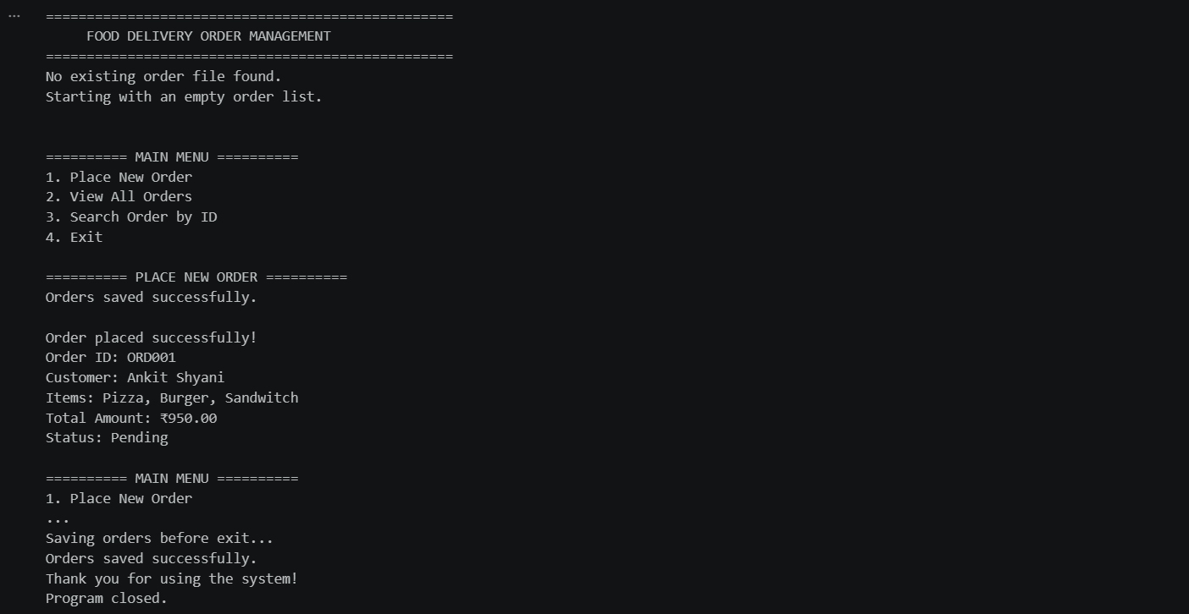
Output:

