Section B - Practical Coding Tasks

Task 01: Menu & Order Explorer
Write a series of SELECT queries on a food delivery orders table to retrieve, filter, and sort data using core SQL clauses.
- Create a table named food_orders with columns: order_id, customer_name, restaurant_name, item_ordered, quantity, price_per_item, order_date, and city. Insert at least 8 rows spanning at least 3 cities.
- Write a query to retrieve all orders placed in the city of 'Mumbai', sorted by price_per_item in descending order.
- Write a query to return all distinct restaurant names that have received at least one order.
- Write a query to list the top 5 most expensive individual orders using ORDER BY and LIMIT.

Answer:

Tasks_1.1
CREATE TABLE food_orders (
order_id INT PRIMARY KEY,
customer_name VARCHAR(50),
restaurant_name VARCHAR(50),
item_ordered VARCHAR(50),
quantity INT,
price_per_item DECIMAL(8,2),
order_date DATE,
city VARCHAR(30)
);
INSERT INTO food_orders
(order_id, customer_name, restaurant_name, item_ordered, quantity, price_per_item, order_date, city)
VALUES
(1, 'Rahul Mehta', 'Spice Villa', 'Paneer Butter Masala', 2, 280.00, '2026-10-01', 'Mumbai'),
(2, 'Priya Shah', 'Pizza Hub', 'Margherita Pizza', 1, 350.00, '2026-10-01', 'Ahmedabad'),
(3, 'Amit Verma', 'Biryani House', 'Chicken Biryani', 3, 320.00, '2026-10-02', 'Delhi'),
(4, 'Sneha Patel', 'Spice Villa', 'Dal Tadka', 2, 180.00, '2026-10-02', 'Mumbai'),
(5, 'Karan Singh', 'Burger Point', 'Cheese Burger', 4, 150.00, '2026-10-03', 'Bengaluru'),
(6, 'Neha Joshi', 'Pizza Hub', 'Farmhouse Pizza', 2, 450.00, '2026-10-04', 'Mumbai'),
(7, 'Rohan Desai', 'Biryani House', 'Veg Biryani', 1, 260.00, '2026-10-05', 'Ahmedabad'),
(8, 'Anjali Rao', 'Burger Point', 'Veg Burger', 3, 120.00, '2026-10-05', 'Bengaluru'),
(9, 'Vikram Nair', 'Spice Villa', 'Butter Naan', 6, 50.00, '2026-10-06', 'Delhi'),
(10, 'Meera Iyer', 'Tandoor Tales', 'Tandoori Chicken', 2, 520.00, '2026-10-07', 'Mumbai');

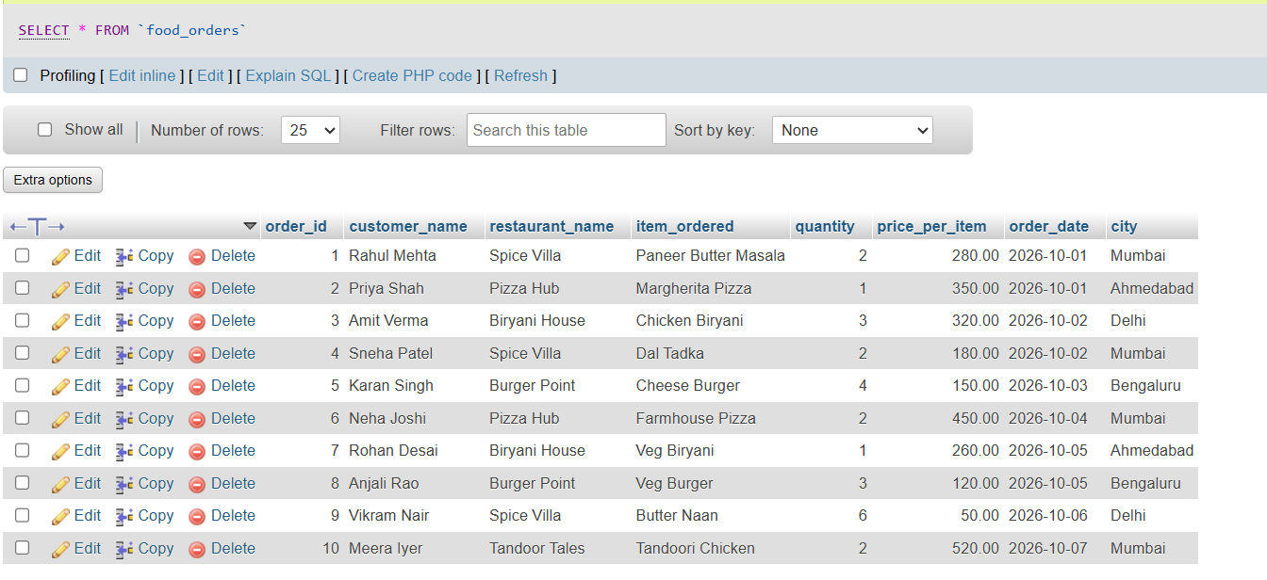
Task_1.2
SELECT *
FROM food_orders
WHERE city = 'Mumbai'
ORDER BY price_per_item DESC;
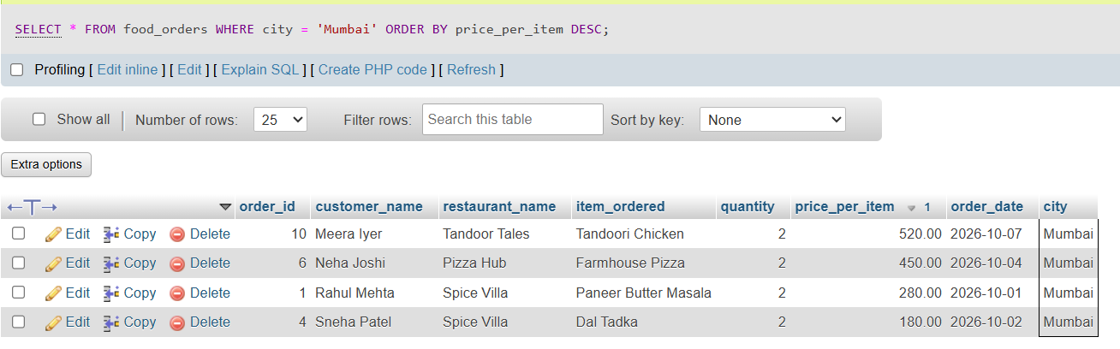

Tasks_1.3
SELECT order_id,
customer_name,
restaurant_name,
item_ordered,
quantity,
price_per_item,
(quantity * price_per_item) AS total_order_value
FROM food_orders
ORDER BY total_order_value DESC
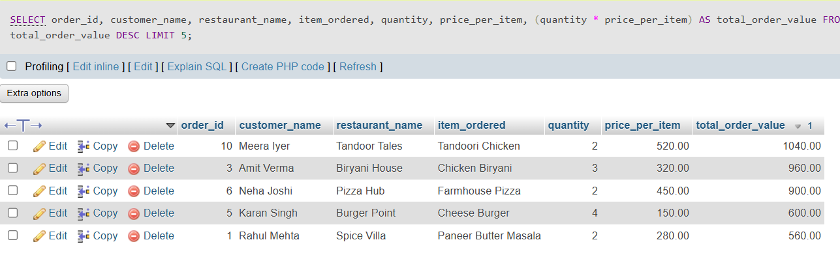
LIMIT 5;

Task 02: Restaurant Revenue Summary
Use aggregate functions and GROUP BY with HAVING to produce a restaurant-level revenue
and order-count summary from a delivery orders table.
- Create a table named delivery_orders with columns: order_id, restaurant_name, city, total_amount, order_status, and order_date. Insert at least 10 rows covering at least 4 different restaurants.
- Write a query using SUM, COUNT, and AVG to calculate total revenue, total orders, and average order value per restaurant.
- Add a HAVING clause to return only restaurants whose total revenue exceeds Rs 5,000.
- Extend the SELECT list with a CASE WHEN expression that labels each qualifying restaurant as 'High Revenue' if total revenue is above Rs 10,000, or 'Moderate Revenue' otherwise.

Answer:

Tasks_2.1
CREATE TABLE delivery_orders (
order_id INT PRIMARY KEY,
restaurant_name VARCHAR(50),
city VARCHAR(30),
total_amount DECIMAL(10,2),
order_status VARCHAR(20),
order_date DATE
);
INSERT INTO delivery_orders
(order_id, restaurant_name, city, total_amount, order_status, order_date)
VALUES
(1, 'Spice Villa', 'Mumbai', 4200.00, 'Delivered', '2026-10-01'),
(2, 'Pizza Hub', 'Ahmedabad', 3500.00, 'Delivered', '2026-10-01'),
(3, 'Biryani House', 'Delhi', 4000.00, 'Delivered', '2026-10-02'),
(4, 'Spice Villa', 'Mumbai', 3800.00, 'Delivered', '2026-10-02'),
(5, 'Burger Point', 'Bengaluru', 1500.00, 'Delivered', '2026-10-03'),
(6, 'Tandoor Tales', 'Mumbai', 6000.00, 'Delivered', '2026-10-03'),
(7, 'Pizza Hub', 'Ahmedabad', 2800.00, 'Delivered', '2026-10-04'),
(8, 'Spice Villa', 'Mumbai', 5100.00, 'Delivered', '2026-10-05'),
(9, 'Burger Point', 'Bengaluru', 1800.00, 'Cancelled', '2026-10-05'),
(10, 'Biryani House', 'Delhi', 3300.00, 'Delivered', '2026-10-06'),
(11, 'Tandoor Tales', 'Mumbai', 5500.00, 'Delivered', '2026-10-06'),
(12, 'Pizza Hub', 'Ahmedabad', 1200.00, 'Delivered', '2026-10-07'),
(13, 'Burger Point', 'Bengaluru', 900.00, 'Delivered', '2026-10-07');

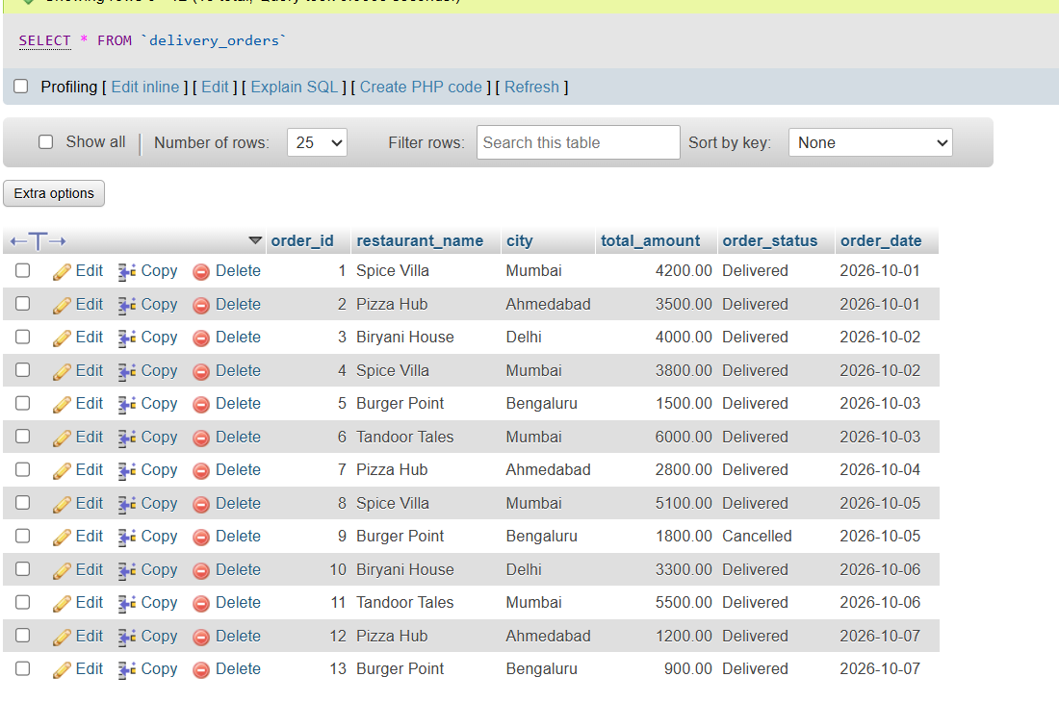
Tasks_2.2
SELECT restaurant_name,
SUM(total_amount) AS total_revenue,
COUNT(order_id) AS total_orders,
ROUND(AVG(total_amount), 2) AS avg_order_value
FROM delivery_orders
GROUP BY restaurant_name
ORDER BY total_revenue DESC;
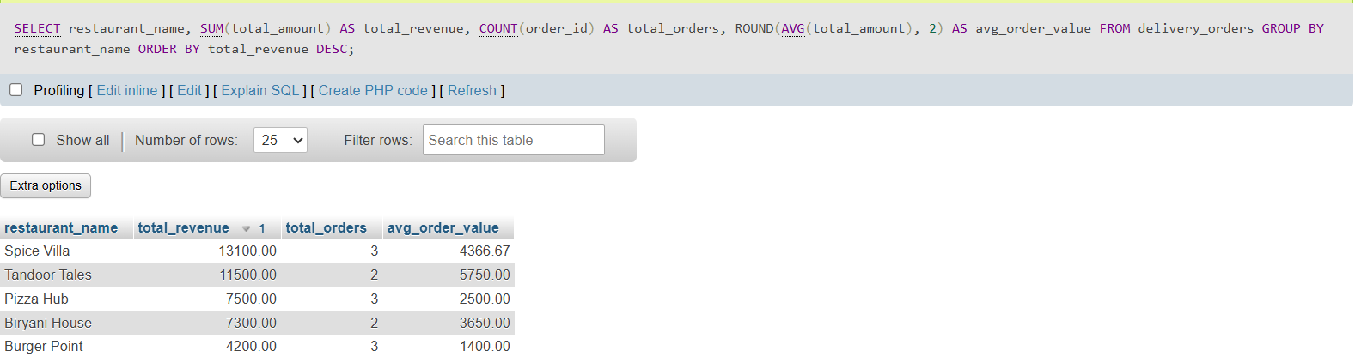

Tasks_2.3
SELECT restaurant_name,
SUM(total_amount) AS total_revenue,
COUNT(order_id) AS total_orders,
ROUND(AVG(total_amount), 2) AS avg_order_value
FROM delivery_orders
GROUP BY restaurant_name
HAVING SUM(total_amount) > 5000
ORDER BY total_revenue DESC;

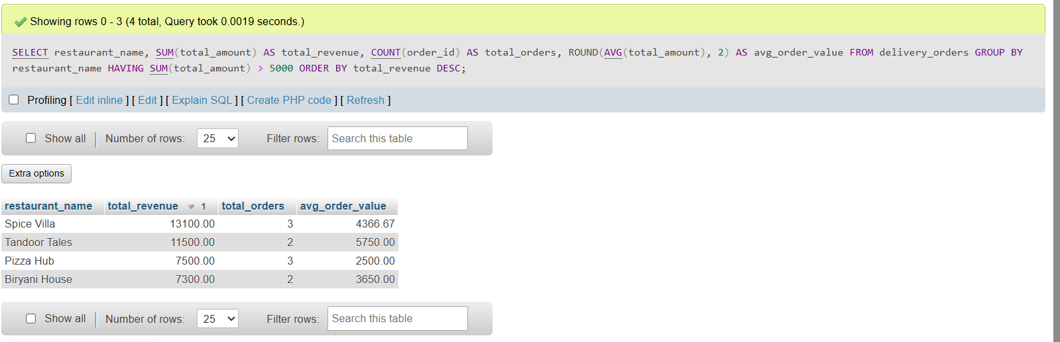
Tasks_2.4
SELECT restaurant_name,
SUM(total_amount) AS total_revenue,
COUNT(order_id) AS total_orders,
ROUND(AVG(total_amount), 2) AS avg_order_value,
CASE
WHEN SUM(total_amount) > 10000 THEN 'High Revenue'
ELSE 'Moderate Revenue'
END AS revenue_category
FROM delivery_orders
GROUP BY restaurant_name
HAVING SUM(total_amount) > 5000
ORDER BY total_revenue DESC;

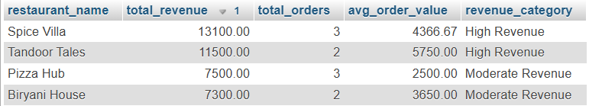

Task 03: Customer–Order–Restaurant Joined Report
Write JOIN queries across three related tables — customers, restaurants, and orders — to produce a combined order report that handles missing records gracefully.
- Create three tables: customers (customer_id, name, city, phone), restaurants (restaurant_id, name, cuisine_type, city), and orders (order_id, customer_id, restaurant_id, amount, order_date). Insert at least 6 rows per table and intentionally include at least 2 customers who have placed no orders.
- Write an INNER JOIN query to list each order alongside the placing customer's name and the fulfilling restaurant's name.
- Write a LEFT JOIN query to list all customers — including those with no orders — with NULL appearing in order columns where no order exists.
- Add a WHERE condition to the joined result to show only orders where both the customer and the restaurant belong to the same city.

Answer:

Tasks_3.1
CREATE TABLE customers (
customer_id INT PRIMARY KEY,
name VARCHAR(50),
city VARCHAR(30),
phone VARCHAR(15)
);

CREATE TABLE restaurants (
restaurant_id INT PRIMARY KEY,
name VARCHAR(50),
cuisine_type VARCHAR(30),
city VARCHAR(30)
);

CREATE TABLE orders (
order_id INT PRIMARY KEY,
customer_id INT,
restaurant_id INT,
amount DECIMAL(10,2),
order_date DATE,
FOREIGN KEY (customer_id) REFERENCES customers(customer_id),
FOREIGN KEY (restaurant_id) REFERENCES restaurants(restaurant_id)
);
INSERT INTO customers (customer_id, name, city, phone) VALUES
(1, 'Rahul Mehta', 'Mumbai', '9876500001'),
(2, 'Priya Shah', 'Ahmedabad', '9876500002'),
(3, 'Amit Verma', 'Delhi', '9876500003'),
(4, 'Sneha Patel', 'Mumbai', '9876500004'),
(5, 'Karan Singh', 'Bengaluru', '9876500005'),
(6, 'Neha Joshi', 'Ahmedabad', '9876500006'),
(7, 'Rohan Desai', 'Delhi', '9876500007'),
(8, 'Meera Iyer', 'Mumbai', '9876500008');
INSERT INTO restaurants (restaurant_id, name, cuisine_type, city) VALUES
(1, 'Spice Villa', 'North Indian', 'Mumbai'),
(2, 'Pizza Hub', 'Italian', 'Ahmedabad'),
(3, 'Biryani House', 'Mughlai', 'Delhi'),
(4, 'Burger Point', 'Fast Food', 'Bengaluru'),
(5, 'Tandoor Tales', 'North Indian', 'Mumbai'),
(6, 'Dosa Corner', 'South Indian', 'Ahmedabad');
INSERT INTO orders (order_id, customer_id, restaurant_id, amount, order_date) VALUES
(101, 1, 1, 560.00, '2026-10-01'),
(102, 2, 2, 350.00, '2026-10-01'),
(103, 3, 3, 960.00, '2026-10-02'),
(104, 4, 2, 450.00, '2026-10-02'),
(105, 5, 4, 600.00, '2026-10-03'),
(106, 6, 5, 1040.00, '2026-10-04'),
(107, 1, 5, 780.00, '2026-10-05'),
(108, 2, 6, 240.00, '2026-10-05'),
(109, 3, 1, 520.00, '2026-10-06'),
(110, 6, 6, 300.00, '2026-10-07');
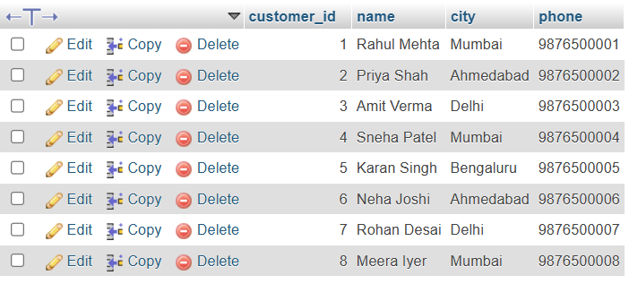

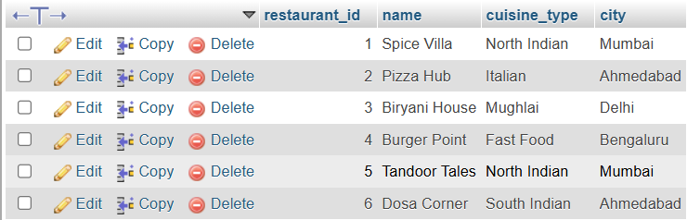
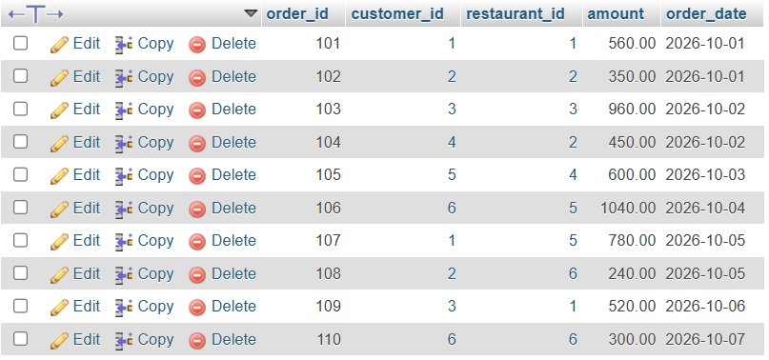
Tasks_3.2
SELECT orders.order_id,
customers.name AS customer_name,
restaurants.name AS restaurant_name,
orders.amount,
orders.order_date
FROM orders
INNER JOIN customers ON orders.customer_id = customers.customer_id
INNER JOIN restaurants ON orders.restaurant_id = restaurants.restaurant_id
ORDER BY orders.order_id;

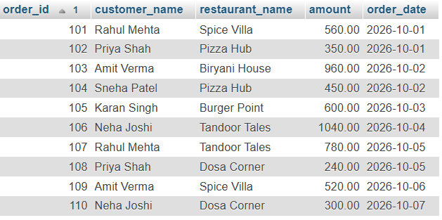
Tasks_3.3
SELECT customers.customer_id,
customers.name AS customer_name,
customers.city,
orders.order_id,
orders.restaurant_id,
orders.amount,
orders.order_date
FROM customers
LEFT JOIN orders ON customers.customer_id = orders.customer_id
ORDER BY customers.customer_id, orders.order_id;
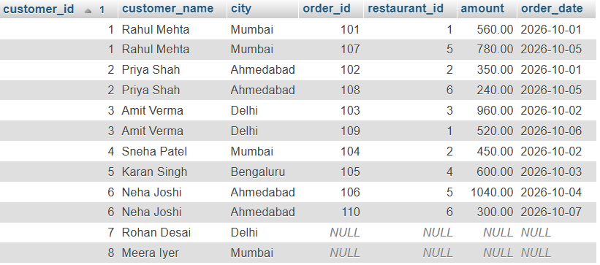

Tasks_3.4
SELECT orders.order_id,
customers.name AS customer_name,
restaurants.name AS restaurant_name,
customers.city AS city,
orders.amount
FROM orders
INNER JOIN customers ON orders.customer_id = customers.customer_id
INNER JOIN restaurants ON orders.restaurant_id = restaurants.restaurant_id
WHERE customers.city = restaurants.city
ORDER BY orders.order_id;
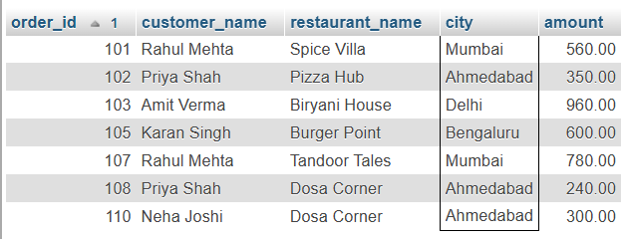

Task 4: Delivery Agent Performance Ranking
Use a CTE, window functions, and a subquery together to rank delivery agents by speed and flag those performing below the platform average.
- Create a table named deliveries with columns: delivery_id, agent_name, restaurant_name, delivery_time_mins, and order_date. Insert at least 10 rows across at least 4 delivery agents, with varied delivery times.
- Write a CTE named agent_stats that calculates each agent's average delivery time across all their deliveries.
- Using the CTE result, apply RANK() OVER (ORDER BY avg_delivery_time ASC) to rank agents from fastest to slowest.
- Add a scalar subquery to compute the overall platform average delivery time, then use CASE WHEN in the final SELECT to label each agent 'On Track' if their average is at or below the platform average, or 'Needs Improvement' if it is above.

Answer:

Tasks_4.1
CREATE TABLE deliveries (
delivery_id INT PRIMARY KEY,
agent_name VARCHAR(50),
restaurant_name VARCHAR(50),
delivery_time_mins INT,
order_date DATE
);
INSERT INTO deliveries
(delivery_id, agent_name, restaurant_name, delivery_time_mins, order_date)
VALUES
(1, 'Ravi Kumar', 'Spice Villa', 22, '2026-10-01'),
(2, 'Sanjay Patel', 'Pizza Hub', 35, '2026-10-01'),
(3, 'Imran Khan', 'Biryani House', 28, '2026-10-02'),
(4, 'Deepa Nair', 'Burger Point', 18, '2026-10-02'),
(5, 'Ravi Kumar', 'Tandoor Tales', 26, '2026-10-03'),
(6, 'Arjun Mehta', 'Dosa Corner', 42, '2026-10-03'),
(7, 'Sanjay Patel', 'Spice Villa', 38, '2026-10-04'),
(8, 'Imran Khan', 'Pizza Hub', 31, '2026-10-05'),
(9, 'Deepa Nair', 'Biryani House', 24, '2026-10-05'),
(10, 'Arjun Mehta', 'Burger Point', 45, '2026-10-06'),
(11, 'Ravi Kumar', 'Dosa Corner', 20, '2026-10-07'),
(12, 'Sanjay Patel', 'Tandoor Tales', 32, '2026-10-07');

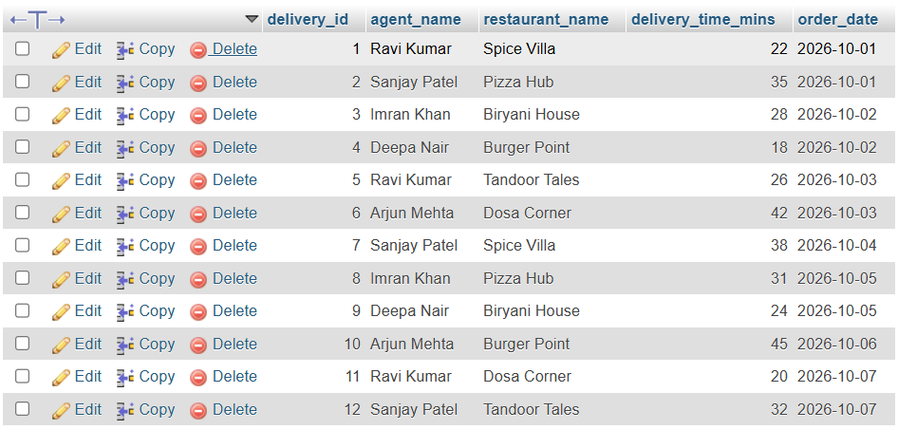
Tasks_4.2
WITH agent_stats AS (
SELECT agent_name,
COUNT(*) AS total_deliveries,
ROUND(AVG(delivery_time_mins), 2) AS avg_delivery_time
FROM deliveries
GROUP BY agent_name
)
SELECT * FROM agent_stats;
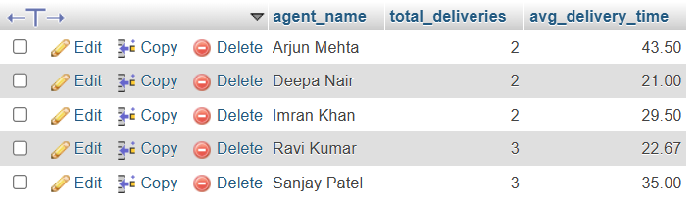

Tasks_4.3
WITH agent_stats AS (
SELECT agent_name,
COUNT(*) AS total_deliveries,
ROUND(AVG(delivery_time_mins), 2) AS avg_delivery_time
FROM deliveries
GROUP BY agent_name
)
SELECT agent_name,
total_deliveries,
avg_delivery_time,
RANK() OVER (ORDER BY avg_delivery_time ASC) AS speed_rank
FROM agent_stats
ORDER BY speed_rank;
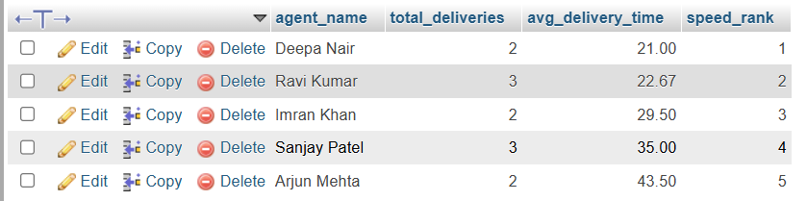

Tasks_4.4
WITH agent_stats AS (
SELECT agent_name,
COUNT(*) AS total_deliveries,
ROUND(AVG(delivery_time_mins), 2) AS avg_delivery_time
FROM deliveries
GROUP BY agent_name
)
SELECT agent_name,
total_deliveries,
avg_delivery_time,
RANK() OVER (ORDER BY avg_delivery_time ASC) AS speed_rank,
ROUND((SELECT AVG(delivery_time_mins) FROM deliveries), 2) AS platform_avg,
CASE
WHEN avg_delivery_time <= (SELECT AVG(delivery_time_mins) FROM deliveries)
THEN 'On Track'
ELSE 'Needs Improvement'
END AS performance_status
FROM agent_stats
ORDER BY speed_rank;

