Section C - Mini Capstone Project
Objective:
Build a complete SQL backend for a food delivery analytics system by designing a multi-table schema and writing a suite of queries that combines JOINs, aggregations, window functions, CASE WHEN classification, CTEs, and a saved View to answer real business questions.
- Design a schema with at least four related tables: customers, restaurants, orders, and delivery_agents. Define appropriate PRIMARY KEY and FOREIGN KEY constraints and insert at least 10 rows per table with realistic food delivery data across at least 3 cities.
- Write a revenue report query using GROUP BY, HAVING, and aggregate functions (SUM, COUNT, AVG) that returns total orders and total revenue per restaurant, filtered to include only restaurants with more than 3 orders.
- Write a customer segmentation query using CASE WHEN to classify each customer as 'Platinum' (spend above Rs 5,000), 'Gold' (Rs 2,000–Rs 5,000), or 'Standard' (below Rs 2,000) based on their total spend, ordered from highest to lowest spender.
- Write a window function query using DENSE_RANK() OVER (PARTITION BY city ORDER BY total_revenue DESC) to identify the top 3 performing restaurants in each city, and a separate query using ROW_NUMBER() to find each customer's single most recent order.
- Create a SQL VIEW named vw_daily_order_summary that JOINs all four tables and returns: order_date, customer_name, restaurant_name, agent_name, order_amount, and delivery_time_mins. Query the view to display only orders placed in the last 7 days.

Answer:

Task_1.1
CREATE DATABASE food_delivery_database;
CREATE TABLE customers (
customer_id INT PRIMARY KEY,
customer_name VARCHAR(50) NOT NULL,
city VARCHAR(30) NOT NULL,
phone VARCHAR(15)
);
CREATE TABLE restaurants (
restaurant_id INT PRIMARY KEY,
restaurant_name VARCHAR(50) NOT NULL,
cuisine_type VARCHAR(30),
city VARCHAR(30) NOT NULL
);

CREATE TABLE delivery_agents (
agent_id INT PRIMARY KEY,
agent_name VARCHAR(50) NOT NULL,
city VARCHAR(30) NOT NULL,
phone VARCHAR(15)
);
CREATE TABLE orders (
order_id INT PRIMARY KEY,
customer_id INT NOT NULL,
restaurant_id INT NOT NULL,
agent_id INT NOT NULL,
order_amount DECIMAL(10,2) NOT NULL,
order_date DATE NOT NULL,
delivery_time_mins INT,
CONSTRAINT fk_orders_customer FOREIGN KEY (customer_id) REFERENCES customers(customer_id),
CONSTRAINT fk_orders_restaurant FOREIGN KEY (restaurant_id) REFERENCES restaurants(restaurant_id),
CONSTRAINT fk_orders_agent FOREIGN KEY (agent_id) REFERENCES delivery_agents(agent_id)
);
INSERT INTO customers (customer_id, customer_name, city, phone) VALUES
(1, 'Rahul Mehta', 'Mumbai', '9876500001'),
(2, 'Priya Shah', 'Ahmedabad', '9876500002'),
(3, 'Amit Verma', 'Delhi', '9876500003'),
(4, 'Sneha Patel', 'Mumbai', '9876500004'),
(5, 'Karan Singh', 'Bengaluru', '9876500005'),
(6, 'Neha Joshi', 'Ahmedabad', '9876500006'),
(7, 'Rohan Desai', 'Delhi', '9876500007'),
(8, 'Meera Iyer', 'Bengaluru', '9876500008'),
(9, 'Vikram Nair', 'Mumbai', '9876500009'),
(10, 'Anjali Rao', 'Ahmedabad', '9876500010');
INSERT INTO restaurants (restaurant_id, restaurant_name, cuisine_type, city) VALUES
(1, 'Spice Villa', 'North Indian', 'Mumbai'),
(2, 'Tandoor Tales', 'Tandoori', 'Mumbai'),
(3, 'Sea Breeze', 'Seafood', 'Mumbai'),
(4, 'Chaat Corner', 'Street Food', 'Mumbai'),
(5, 'Pizza Hub', 'Italian', 'Ahmedabad'),
(6, 'Dosa Corner', 'South Indian', 'Ahmedabad'),
(7, 'Garden Thali', 'Gujarati', 'Ahmedabad'),
(8, 'Biryani House', 'Mughlai', 'Delhi'),
(9, 'Punjabi Dhaba', 'North Indian', 'Delhi'),
(10, 'Burger Point', 'Fast Food', 'Bengaluru');

INSERT INTO delivery_agents (agent_id, agent_name, city, phone) VALUES
(1, 'Ravi Kumar', 'Mumbai', '9123400001'),
(2, 'Sanjay Patel', 'Ahmedabad', '9123400002'),
(3, 'Imran Khan', 'Delhi', '9123400003'),
(4, 'Deepa Nair', 'Bengaluru', '9123400004'),
(5, 'Arjun Mehta', 'Mumbai', '9123400005'),
(6, 'Kiran Rao', 'Bengaluru', '9123400006'),
(7, 'Manoj Yadav', 'Delhi', '9123400007'),
(8, 'Faisal Sheikh', 'Mumbai', '9123400008'),
(9, 'Hardik Parmar', 'Ahmedabad', '9123400009'),
(10, 'Suresh Reddy', 'Bengaluru', '9123400010');
INSERT INTO orders (order_id, customer_id, restaurant_id, agent_id, order_amount, order_date, delivery_time_mins)
VALUES
(1, 1, 1, 1, 1400.00, '2026-10-01', 24),
(2, 2, 5, 2, 900.00, '2026-10-01', 35),
(3, 3, 8, 3, 1500.00, '2026-10-02', 28),
(4, 6, 5, 2, 1200.00, '2026-10-02', 34),
(5, 4, 1, 8, 700.00, '2026-10-03', 23),
(6, 2, 6, 9, 700.00, '2026-10-03', 38),
(7, 1, 2, 5, 1800.00, '2026-10-04', 31),
(8, 5, 10, 4, 500.00, '2026-10-04', 18),
(9, 3, 9, 7, 1300.00, '2026-10-05', 33),
(10, 9, 2, 1, 750.00, '2026-10-05', 30),
(11, 6, 7, 9, 1100.00, '2026-10-06', 30),
(12, 4, 4, 1, 600.00, '2026-10-06', 19),
(13, 2, 7, 2, 1000.00, '2026-10-07', 29),
(14, 7, 8, 7, 600.00, '2026-10-07', 31),
(15, 1, 3, 8, 1200.00, '2026-10-08', 27),
(16, 8, 10, 4, 400.00, '2026-10-08', 19),
(17, 3, 8, 3, 1600.00, '2026-10-09', 30),
(18, 5, 10, 6, 450.00, '2026-10-09', 22),
(19, 10, 6, 9, 350.00, '2026-10-09', 33),
(20, 6, 5, 2, 950.00, '2026-10-10', 36),
(21, 9, 3, 8, 800.00, '2026-10-10', 26),
(22, 4, 3, 5, 650.00, '2026-10-11', 28),
(23, 1, 1, 1, 900.00, '2026-10-12', 22),
(24, 7, 9, 3, 600.00, '2026-10-12', 27),
(25, 2, 5, 9, 850.00, '2026-10-13', 32),
(26, 9, 4, 5, 650.00, '2026-10-13', 20),
(27, 3, 9, 7, 1200.00, '2026-10-14', 26),
(28, 8, 10, 6, 500.00, '2026-10-14', 23),
(29, 4, 3, 8, 500.00, '2026-10-14', 24),
(30, 1, 2, 5, 1100.00, '2026-10-15', 29),
(31, 5, 10, 10, 550.00, '2026-10-15', 24),
(32, 10, 7, 2, 250.00, '2026-10-15', 28),
(33, 9, 2, 5, 500.00, '2026-10-15', 28),
(34, 6, 6, 9, 800.00, '2026-10-16', 25),
(35, 4, 4, 8, 550.00, '2026-10-16', 21),
(36, 1, 1, 1, 650.00, '2026-10-16', 25),
(37, 3, 8, 3, 700.00, '2026-10-16', 29),
(38, 7, 9, 7, 300.00, '2026-10-16', 28);
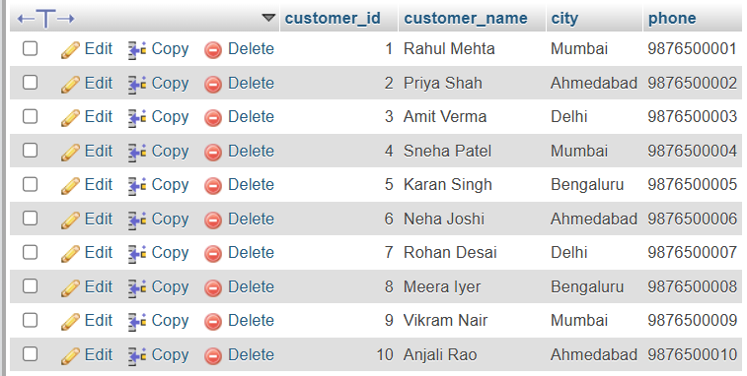
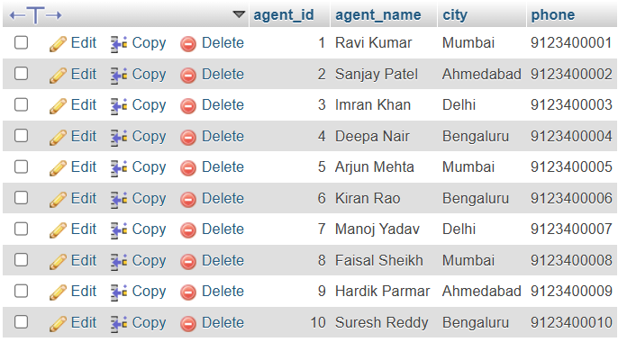
Customers

Delivery Agents

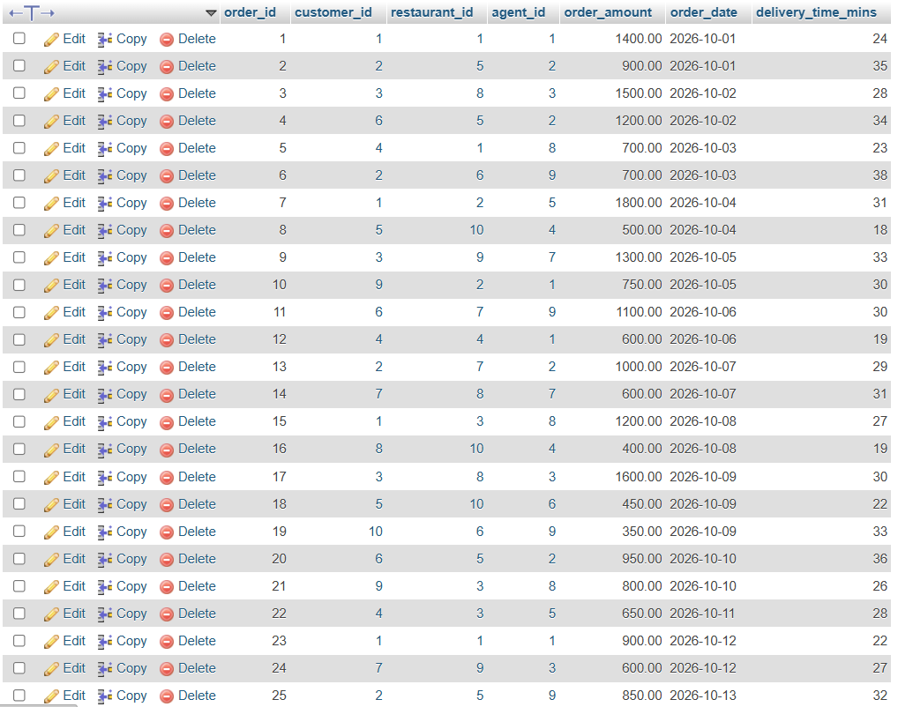
Orders
Restaurants
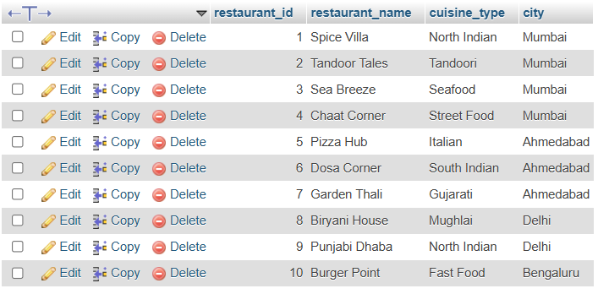

Tasks_1.2: Revenue report (GROUP BY + HAVING)
SELECT restaurants.restaurant_name,
restaurants.city,
COUNT(orders.order_id) AS total_orders,
SUM(orders.order_amount) AS total_revenue,
ROUND(AVG(orders.order_amount),2) AS avg_order_value
FROM restaurants
INNER JOIN orders ON restaurants.restaurant_id = orders.restaurant_id
GROUP BY restaurants.restaurant_id, restaurants.restaurant_name, restaurants.city
HAVING COUNT(orders.order_id) > 3
ORDER BY total_revenue DESC;
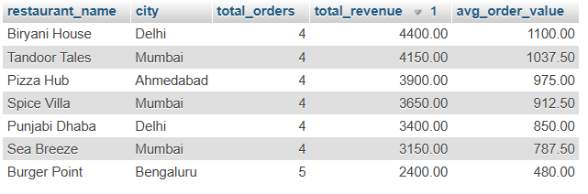

Tasks_1.3: Customer segmentation (CASE WHEN)
SELECT customers.customer_name,
customers.city,
COUNT(orders.order_id) AS total_orders,
COALESCE(SUM(orders.order_amount), 0) AS total_spend,
CASE
WHEN COALESCE(SUM(orders.order_amount), 0) > 5000 THEN 'Platinum'
WHEN COALESCE(SUM(orders.order_amount), 0) >= 2000 THEN 'Gold'
ELSE 'Standard'
END AS customer_segment
FROM customers
LEFT JOIN orders ON customers.customer_id = orders.customer_id
GROUP BY customers.customer_id, customers.customer_name, customers.city
ORDER BY total_spend DESC, customers.customer_name;
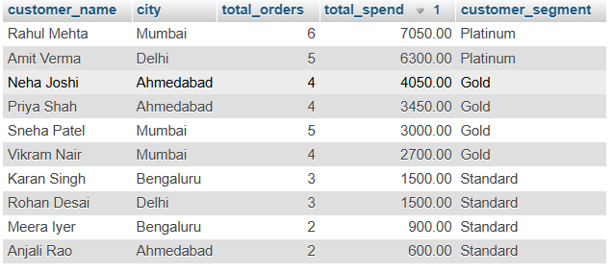

Tasks_1.4: Top 3 restaurants per city (DENSE_RANK)
WITH restaurant_revenue AS (
SELECT restaurants.restaurant_id,
restaurants.restaurant_name,
restaurants.city,
COUNT(orders.order_id) AS total_orders,
COALESCE(SUM(orders.order_amount), 0) AS total_revenue
FROM restaurants
LEFT JOIN orders ON restaurants.restaurant_id = orders.restaurant_id
GROUP BY restaurants.restaurant_id, restaurants.restaurant_name, restaurants.city
),
ranked AS (
SELECT restaurant_name,
city,
total_orders,
total_revenue,
DENSE_RANK() OVER (PARTITION BY city ORDER BY total_revenue DESC) AS city_rank
FROM restaurant_revenue
)
SELECT city, restaurant_name, total_orders, total_revenue, city_rank
FROM ranked
WHERE city_rank <= 3
ORDER BY city, city_rank;
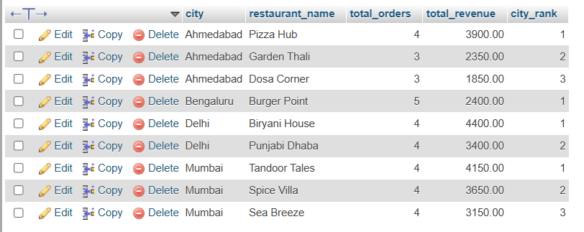

Tasks_1.5: Each customer’s most recent order (ROW_NUMBER)
WITH numbered_orders AS (
SELECT orders.order_id,
orders.customer_id,
orders.restaurant_id,
orders.order_amount,
orders.order_date,
ROW_NUMBER() OVER (
PARTITION BY orders.customer_id
ORDER BY orders.order_date DESC, orders.order_id DESC
) AS rn
FROM orders
)
SELECT customers.customer_name,
numbered_orders.order_id,
restaurants.restaurant_name,
numbered_orders.order_amount,
numbered_orders.order_date
FROM numbered_orders
INNER JOIN customers ON numbered_orders.customer_id = customers.customer_id
INNER JOIN restaurants ON numbered_orders.restaurant_id = restaurants.restaurant_id
WHERE numbered_orders.rn = 1
ORDER BY customers.customer_name;

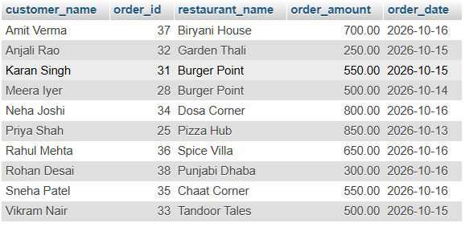

Tasks_1.6: Create the view
CREATE VIEW vw_daily_order_summary AS
SELECT orders.order_date,
customers.customer_name,
restaurants.restaurant_name,
delivery_agents.agent_name,
orders.order_amount,
orders.delivery_time_mins
FROM orders
INNER JOIN customers ON orders.customer_id = customers.customer_id
INNER JOIN restaurants ON orders.restaurant_id = restaurants.restaurant_id
INNER JOIN delivery_agents ON orders.agent_id = delivery_agents.agent_id;
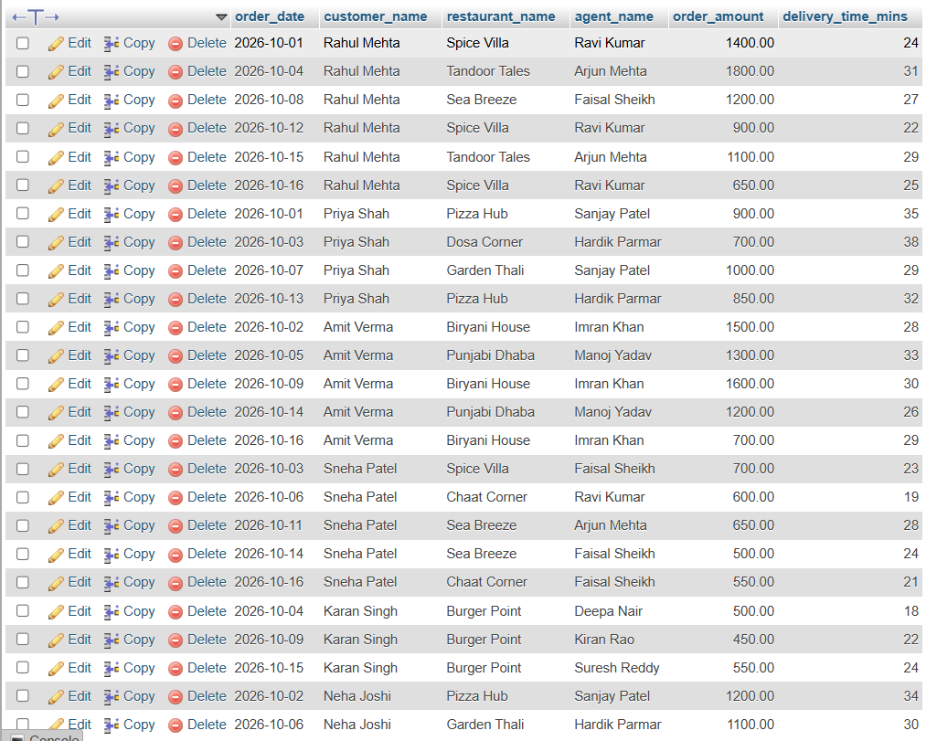

Tasks_1.7: Query the view for the last 7 days
SELECT *
FROM vw_daily_order_summary
WHERE order_date >= CURDATE() - INTERVAL 7 DAY
ORDER BY order_date DESC, customer_name;
