Section D: AI-Augmented Learning
STEP 1 · BUILD WITH AI
Use an AI tool of your choice (ChatGPT, Claude, GitHub Copilot, etc.) to help you write a SQL query that:
- Finds the top 3 delivery agents per city for a food delivery platform, ranked by number of completed orders, using window functions.
- Includes a column showing each agent's average delivery time alongside their rank.
- Filters the result to include only agents who have completed more than 5 orders in that city.
- Returns the final output sorted by city name alphabetically, then by rank ascending.
STEP 2 · TEST & DEBUG (WITHOUT AI)
Then, working without AI, test the query against your own schema. Find at least one bug, logical error, or edge-case gap in the AI's solution — common issues include: applying the HAVING/WHERE filter after ranking instead of before (causing wrong ranks), using the wrong PARTITION BY column, or failing to handle NULL delivery times. Fix it yourself.

Answer:

AI-generated query
WITH agent_stats AS (
SELECT delivery_agents.agent_id,
delivery_agents.agent_name,
delivery_agents.city,
COUNT(orders.order_id) AS completed_orders,
ROUND(AVG(orders.delivery_time_mins),2) AS avg_delivery_time
FROM orders
INNER JOIN delivery_agents ON orders.agent_id = delivery_agents.agent_id
GROUP BY delivery_agents.agent_id, delivery_agents.agent_name, delivery_agents.city
),
ranked AS (
SELECT *,
DENSE_RANK() OVER (PARTITION BY city ORDER BY completed_orders DESC) AS agent_rank
FROM agent_stats
)

SELECT city, agent_rank, agent_name, completed_orders, avg_delivery_time
FROM ranked
WHERE agent_rank <= 3
AND completed_orders > 5
ORDER BY city, agent_rank;

Test and debug
ALTER TABLE orders ADD COLUMN order_status VARCHAR(20) NOT NULL DEFAULT 'Delivered';

INSERT INTO orders
(order_id, customer_id, restaurant_id, agent_id, order_amount, order_date, delivery_time_mins, order_status)
VALUES
(39, 1, 1, 1, 500.00, '2026-10-16', 20, 'Delivered'),
(40, 4, 2, 1, 450.00, '2026-10-16', NULL, 'Delivered'), -- NULL delivery time
(41, 9, 3, 1, 300.00, '2026-10-16', 25, 'Cancelled'), -- must not count
(42, 1, 2, 5, 600.00, '2026-10-16', 27, 'Delivered'),
(43, 4, 1, 5, 400.00, '2026-10-16', 30, 'Delivered'),
(44, 1, 3, 8, 350.00, '2026-10-16', 25, 'Delivered'),
(46, 2, 5, 2, 400.00, '2026-10-16', 33, 'Delivered');

Fixed query
WITH agent_city_stats AS (
SELECT restaurants.city,
delivery_agents.agent_id,
delivery_agents.agent_name,
COUNT(*) AS completed_orders,
ROUND(AVG(orders.delivery_time_mins),2) AS avg_delivery_time
FROM orders
INNER JOIN delivery_agents ON orders.agent_id = delivery_agents.agent_id
INNER JOIN restaurants ON orders.restaurant_id = restaurants.restaurant_id
WHERE orders.order_status = 'Delivered' -- fix 1
GROUP BY restaurants.city, delivery_agents.agent_id, delivery_agents.agent_name -- fix 3
HAVING COUNT(*) > 5 -- fix 4
),
ranked AS (
SELECT city,
agent_name,
completed_orders,
avg_delivery_time,
DENSE_RANK() OVER (
PARTITION BY city
ORDER BY completed_orders DESC,
(avg_delivery_time IS NULL), -- fix 5: NULLs last
avg_delivery_time ASC -- fix 2: tie-breaker
) AS agent_rank
FROM agent_city_stats
)
SELECT city,
agent_rank,
agent_name,
completed_orders,
avg_delivery_time
FROM ranked
WHERE agent_rank <= 3
ORDER BY city ASC, agent_rank ASC;

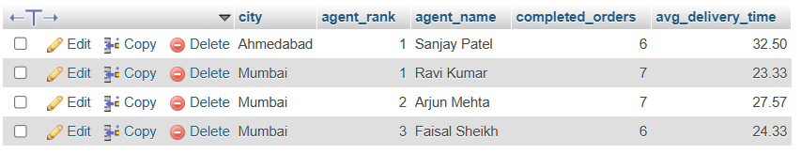
Final Output

