Excel + SQL Server: Power Query Tasks
Restaurants table: connect, parameterize, refresh and dashboard
About the data: the Restaurants table below is sample data (14 rows, 5 cuisines) created for this exercise. The outputs were checked by running the equivalent filters on this data. The Excel screens themselves are described step by step, and the bar chart is drawn from the same data rather than captured from Excel.
Sample table (run in SQL Server Management Studio)
CREATE TABLE Restaurants (
restaurant_id INT PRIMARY KEY,
name VARCHAR(50),
cuisine VARCHAR(30),
rating DECIMAL(2,1)
);

INSERT INTO Restaurants (restaurant_id, name, cuisine, rating) VALUES
(1,'Golden Dragon','Chinese',4.3), (2,'Wok Express','Chinese',3.8),
(3,'Chopsticks','Chinese',4.0), (4,'Mandarin House','Chinese',4.6),
(5,'Dosa Plaza','South Indian',4.2), (6,'Udupi Delight','South Indian',3.9),
(7,'Madras Cafe','South Indian',4.5), (8,'Idli Junction','South Indian',3.4),
(9,'Punjabi Tadka','North Indian',4.1), (10,'Tandoor Nights','North Indian',3.7),
(11,'Pasta Bella','Italian',4.4), (12,'Pizza Forno','Italian',3.6),
(13,'Garden Thali','Gujarati',5.0), (14,'Swad Gujarati','Gujarati',3.5);

Task 1: Connect Excel to SQL Server and Load Restaurants
- Open a new Excel workbook and go to Data > Get Data > From Database > From SQL Server Database.
- Enter the Server (for example localhost or .\SQLEXPRESS) and the Database name. Leave Import selected and click OK.
- Choose the authentication type (Windows or Database), sign in and click Connect.
- In the Navigator, tick the Restaurants table and click Transform Data to open Power Query.
- Set the rating column type to Decimal Number, then click Close & Load To... > Table > New worksheet.
- Rename the worksheet to Restaurants.
Output: new worksheet with 14 rows (name, cuisine, rating)
name | cuisine | rating
Golden Dragon | Chinese | 4.3
Wok Express | Chinese | 3.8
Chopsticks | Chinese | 4.0
Mandarin House | Chinese | 4.6
Dosa Plaza | South Indian | 4.2
Udupi Delight | South Indian | 3.9
Madras Cafe | South Indian | 4.5
Idli Junction | South Indian | 3.4
Punjabi Tadka | North Indian | 4.1
Tandoor Nights | North Indian | 3.7
Pasta Bella | Italian | 4.4
Pizza Forno | Italian | 3.6
Garden Thali | Gujarati | 5.0
Swad Gujarati | Gujarati | 3.5

Task 2: Parameterized Query by Cuisine (Cell Value)
- On a new sheet named Parameters, type Cuisine in A1 and Chinese in A2. Select A1:A2 and press Ctrl + T to make a table. Name it tblParams in Table Design.
- Select the table and choose Data > From Table/Range. In Power Query, right-click the cell value Chinese and choose Drill Down. Rename this query pCuisine and click Close & Load To... > Only Create Connection.
- Create a new blank query (Get Data > From Other Sources > Blank Query), open Advanced Editor and paste:
let
Source = Sql.Database("localhost", "YourDatabase"),
Result = Value.NativeQuery(
Source,
"SELECT name, cuisine, rating FROM Restaurants WHERE cuisine = @cuisine",
[cuisine = pCuisine],
[EnableFolding = true]
)
in
Result
- Name the query RestaurantsByCuisine, set rating to Decimal Number and load it to a new worksheet. Approve the Native Database Query prompt with Run.
- To change the filter, edit the cell A2 on the Parameters sheet (for example South Indian) and click Data > Refresh All.
Manage Parameters option: Home > Manage Parameters > New Parameter also creates a parameter, but its value is typed inside Power Query, not in a cell. Linking it to a worksheet cell needs the Drill Down step above. Value.NativeQuery with @cuisine passes the value as a real SQL parameter, so quotes in the text cannot break or inject into the query.
Output: A2 = Chinese (4 rows)
name | cuisine | rating
Mandarin House | Chinese | 4.6
Golden Dragon | Chinese | 4.3
Chopsticks | Chinese | 4.0
Wok Express | Chinese | 3.8
Output: A2 = South Indian (4 rows)
name | cuisine | rating
Madras Cafe | South Indian | 4.5
Dosa Plaza | South Indian | 4.2
Udupi Delight | South Indian | 3.9
Idli Junction | South Indian | 3.4

Task 3: Dynamic Refresh When New Records Arrive
- Right-click any query in the Queries & Connections pane and choose Properties.
- Tick Enable background refresh, Refresh every 10 minutes (optional) and Refresh data when opening the file. Click OK.
- Add a new record in SQL Server:
INSERT INTO Restaurants (restaurant_id, name, cuisine, rating)
VALUES (15, 'Dragon Wok', 'Chinese', 3.9);
- In Excel, click Data > Refresh All (or press Ctrl + Alt + F5). All connected sheets update with one click.
Output
The Restaurants sheet grows from 14 rows to 15 rows, and the new row appears at the bottom:
name | cuisine | rating
Dragon Wok | Chinese | 3.9
If you set A2 to Chinese, the RestaurantsByCuisine sheet now shows 5 rows. Desktop Excel only refreshes while the workbook is open.

Task 4: Rating Above 4.0 and Dashboard Sheet
- Open the Restaurants query in Power Query (double-click it in Queries & Connections).
- Click the filter arrow on rating, choose Number Filters > Greater Than, enter 4.0 and click OK. Or edit the connection to use SQL:
SELECT name, cuisine, rating
FROM Restaurants
WHERE rating > 4.0
ORDER BY rating DESC;
- Click Close & Load To... > Table > New worksheet and name the sheet Dashboard.
- Click inside the table and choose Insert > Bar Chart > Clustered Bar. Add a chart title, show data labels and place the chart to the right of the table.
- Optional: Table Design > Insert Slicer on cuisine for interactive filtering.
> 4.0 excludes a rating of exactly 4.0, so Chopsticks (4.0) is not shown.
Output: dashboard table (7 rows)
name | cuisine | rating
Garden Thali | Gujarati | 5.0
Mandarin House | Chinese | 4.6
Madras Cafe | South Indian | 4.5
Pasta Bella | Italian | 4.4
Golden Dragon | Chinese | 4.3
Dosa Plaza | South Indian | 4.2
Punjabi Tadka | North Indian | 4.1
Output: bar chart (drawn from the same data; not an Excel screenshot)
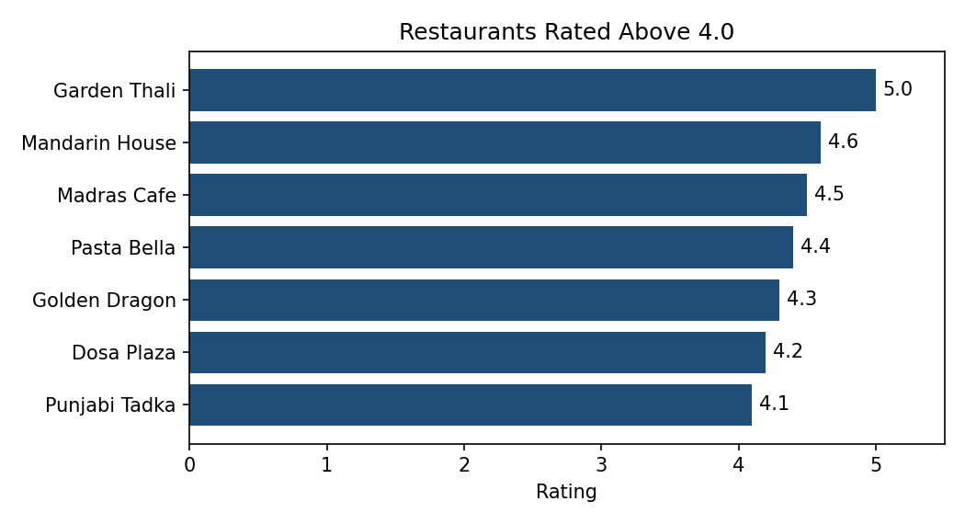

Task 5: AI-Assisted Rating Range Query
Prompt given to the AI tool (ChatGPT, Copilot or Claude)
Write a parameterized SQL Server query for Power Query (M language) that
returns restaurants from the Restaurants table (name, cuisine, rating)
with a rating between a minimum and a maximum value. The min and max
must come from Excel cells, not be typed into the SQL.
Query produced
- On the Parameters sheet add a second table tblRange with headers MinRating and MaxRating and values 3.5 and 5.0.
- Load each value as a connection-only query using From Table/Range and Drill Down (named pMin and pMax). Set both to Decimal Number.
- Create a blank query RestaurantsByRating with this code:
let
Source = Sql.Database("localhost", "YourDatabase"),
Result = Value.NativeQuery(
Source,
"SELECT name, cuisine, rating
FROM Restaurants
WHERE rating BETWEEN @minRating AND @maxRating
ORDER BY rating DESC, name",
[minRating = pMin, maxRating = pMax],
[EnableFolding = true]
)
in
Result
- Load it to a new worksheet and click Refresh All.
Test results (15 rows in the table after the Task 3 insert)
- 3.5 to 5.0: returns 14 rows, shown below. Ratings of exactly 3.5 (Swad Gujarati) and 5.0 (Garden Thali) are included because BETWEEN is inclusive.
- Changing the cells to 4.0 and 4.5: the sheet refreshes to show only restaurants rated from 4.0 to 4.5.
- Idli Junction (3.4) is correctly left out because it is below the minimum.
Output: 3.5 to 5.0
name | cuisine | rating
Garden Thali | Gujarati | 5.0
Mandarin House | Chinese | 4.6
Madras Cafe | South Indian | 4.5
Pasta Bella | Italian | 4.4
Golden Dragon | Chinese | 4.3
Dosa Plaza | South Indian | 4.2
Punjabi Tadka | North Indian | 4.1
Chopsticks | Chinese | 4.0
Dragon Wok | Chinese | 3.9
Udupi Delight | South Indian | 3.9
Wok Express | Chinese | 3.8
Tandoor Nights | North Indian | 3.7
Pizza Forno | Italian | 3.6
Swad Gujarati | Gujarati | 3.5
Checks to record from your own test
- Set MinRating higher than MaxRating: the query returns 0 rows. This is an edge case you could mention or guard with Excel data validation.
- Note which AI tool you used and anything you changed from its first answer.

