SQL + Python Integration Tasks
pandas, Jupyter SQL magic, EDA and charts (SQLite)
About the data: all tasks use one SQLite file, food_app.db, built by the setup cell in the Appendix. The tables hold sample data (made-up movies and orders; IPL-style match pairs), not real records. The code in Tasks 1, 3, 4 and 5 was run on this data and the outputs below are the actual results. Task 2 uses %sql, which only works inside Jupyter, so its output comes from running the same SQL query with pandas.
Run the Appendix cell once before the tasks. Every task starts with this cell:
import sqlite3
import pandas as pd

conn = sqlite3.connect("food_app.db")

Task 1: read_sql() on the restaurants table
df = pd.read_sql("SELECT name, cuisine, rating FROM restaurants", conn)
df.head()
Output (first 5 of 10 rows)
 | name | cuisine | rating
0 | Golden Dragon | Chinese | 4.3
1 | Wok Express | Chinese | 3.8
2 | Dosa Plaza | South Indian | 4.2
3 | Madras Cafe | South Indian | 4.5
4 | Punjabi Tadka | North Indian | 4.1
read_sql() returns a DataFrame. head() shows 5 rows by default; use head(n) for another number.

Task 2: %sql magic, movies rated above 8
# Cell 1: install and load the extension (once)
%pip install jupysql
%load_ext sql
%sql sqlite:///food_app.db
%%sql
SELECT title, genre, rating
FROM movies
WHERE rating > 8
ORDER BY rating DESC;
Output (4 rows)
title | genre | rating
The Last Monsoon | Drama | 8.9
Midnight Tiffin | Comedy | 8.6
Silent Harbor | Drama | 8.4
Orbit Seven | Sci-Fi | 8.2
%sql runs one line of SQL and %%sql runs the whole cell as SQL. jupysql is the maintained successor of ipython-sql and uses the same commands. Save a result as a DataFrame with result = %sql SELECT ... then result.DataFrame().

Task 3: Top 3 most ordered food items in the last 100 orders
orders = pd.read_sql(
"SELECT * FROM orders ORDER BY order_date DESC, order_id DESC LIMIT 100",
conn
)
print(len(orders), "orders loaded")

top3 = orders["food_item"].value_counts().head(3)
print(top3)
Output
100 orders loaded (order_id 51 to 150, dated 2026-08-17 to 2026-09-19)
food_item | times ordered
Chicken Biryani | 20
Veg Biryani | 15
Veg Burger | 14

Variation: to rank by total quantity instead of number of orders, use orders.groupby("food_item")["quantity"].sum().nlargest(3). Result: Chicken Biryani (39), Veg Biryani (30), Veg Burger (25). The order of the top 3 stays the same here.
ORDER BY order_date DESC, order_id DESC is needed before LIMIT 100. Without it, SQL does not guarantee which 100 rows come back.

Task 4: Bar chart of matches played per team
import matplotlib.pyplot as plt

matches = pd.read_sql("SELECT * FROM matches", conn)

# A team can be team1 or team2, so stack both columns, then count
all_teams = pd.concat([matches["team1"], matches["team2"]])
counts = all_teams.groupby(all_teams).size().sort_values()

counts.plot(kind="barh", color="#1F4E79", figsize=(7.5, 4))
plt.title("Matches Played by Each Team")
plt.xlabel("Matches")
plt.tight_layout()
plt.show()
Output: bar chart (24 matches, 10 teams)
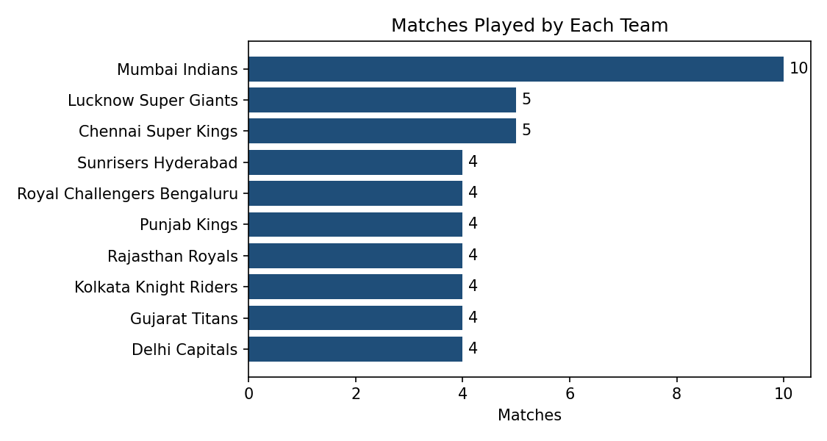
Mumbai Indians played the most matches (10). The counts add up to 48, which is 24 matches x 2 teams. Counting only team1 would give wrong totals, so both columns are combined.

Task 5: AI-assisted notebook cell for users with more than 5 orders
Prompt given to the AI tool (ChatGPT, Copilot or Claude)
Write a Jupyter Notebook cell that connects to a SQLite database,
runs a SQL query to fetch all users who have placed more than 5 orders
(users table: user_id, name, city; orders table: order_id, user_id, ...),
and loads the result into a pandas DataFrame. Pass the "5" as a parameter.
Cell produced
import sqlite3
import pandas as pd

min_orders = 5

query = """
SELECT u.user_id, u.name, u.city, COUNT(o.order_id) AS total_orders
FROM users u
JOIN orders o ON u.user_id = o.user_id
GROUP BY u.user_id, u.name, u.city
HAVING COUNT(o.order_id) > ?
ORDER BY total_orders DESC, u.name
"""

with sqlite3.connect("food_app.db") as conn:
frequent_users = pd.read_sql(query, conn, params=(min_orders,))

frequent_users
Output (7 users)
user_id | name | city | total_orders
3 | Amit Verma | Delhi | 35
1 | Rahul Mehta | Mumbai | 35
2 | Priya Shah | Ahmedabad | 24
6 | Neha Joshi | Ahmedabad | 20
4 | Sneha Patel | Mumbai | 15
8 | Meera Iyer | Bengaluru | 9
7 | Rohan Desai | Delhi | 8
Test notes
- Karan Singh has exactly 4 orders, so he is correctly left out. Setting min_orders = 4 brings him in, which shows the filter is strictly greater than.
- HAVING filters after grouping. WHERE COUNT(...) > 5 would raise an error because aggregates cannot be used in WHERE.
- Rahul Mehta and Amit Verma tie at 35, so u.name is added to ORDER BY to keep the order the same on every run.
- Record which AI tool you used and anything you changed from its first answer.

Appendix: Setup Cell (run once)
Creates food_app.db with the restaurants, movies, users, orders and matches tables. The random seed is fixed, so everyone gets identical data and the outputs above.
import sqlite3, random
random.seed(42)
con = sqlite3.connect("food_app.db")
con.executescript("""
DROP TABLE IF EXISTS restaurants; DROP TABLE IF EXISTS movies; DROP TABLE IF EXISTS users;
DROP TABLE IF EXISTS orders; DROP TABLE IF EXISTS matches;
CREATE TABLE restaurants (restaurant_id INTEGER PRIMARY KEY, name TEXT, cuisine TEXT, rating REAL);
CREATE TABLE movies (movie_id INTEGER PRIMARY KEY, title TEXT, genre TEXT, rating REAL);
CREATE TABLE users (user_id INTEGER PRIMARY KEY, name TEXT, city TEXT);
CREATE TABLE orders (order_id INTEGER PRIMARY KEY, user_id INTEGER, food_item TEXT, quantity INTEGER, order_date TEXT);
CREATE TABLE matches (match_id INTEGER PRIMARY KEY, team1 TEXT, team2 TEXT, winner TEXT);
""")
con.executemany("INSERT INTO restaurants VALUES (?,?,?,?)", [
(1,"Golden Dragon","Chinese",4.3),(2,"Wok Express","Chinese",3.8),(3,"Dosa Plaza","South Indian",4.2),
(4,"Madras Cafe","South Indian",4.5),(5,"Punjabi Tadka","North Indian",4.1),(6,"Tandoor Nights","North Indian",3.7),
(7,"Pasta Bella","Italian",4.4),(8,"Pizza Forno","Italian",3.6),(9,"Garden Thali","Gujarati",4.8),(10,"Mandarin House","Chinese",4.6)])
con.executemany("INSERT INTO movies VALUES (?,?,?,?)", [
(1,"Silent Harbor","Drama",8.4),(2,"Neon Alley","Thriller",7.6),(3,"The Last Monsoon","Drama",8.9),
(4,"Paper Kingdoms","Fantasy",7.9),(5,"Orbit Seven","Sci-Fi",8.2),(6,"Laughing Gas","Comedy",6.8),
(7,"Iron Dust","Action",7.2),(8,"Quiet Rivers","Drama",8.0),(9,"Midnight Tiffin","Comedy",8.6),(10,"Glass Mountain","Adventure",7.5)])
con.executemany("INSERT INTO users VALUES (?,?,?)", [
(1,"Rahul Mehta","Mumbai"),(2,"Priya Shah","Ahmedabad"),(3,"Amit Verma","Delhi"),(4,"Sneha Patel","Mumbai"),
(5,"Karan Singh","Bengaluru"),(6,"Neha Joshi","Ahmedabad"),(7,"Rohan Desai","Delhi"),(8,"Meera Iyer","Bengaluru")])
items = ["Paneer Butter Masala","Chicken Biryani","Masala Dosa","Margherita Pizza","Veg Burger","Butter Naan","Veg Biryani","Chole Bhature"]
user_pool = [1,1,1,1,2,2,2,3,3,3,4,4,5,6,6,7,8] # some users order more often
orders = []
for i in range(1, 151):
day = 1 + (i - 1) // 3 # 3 orders per day, from 1 Aug 2026
orders.append((i, random.choice(user_pool), random.choice(items), random.randint(1, 3), f"2026-08-{day:02d}" if day <= 31 else f"2026-09-{day-31:02d}"))
con.executemany("INSERT INTO orders VALUES (?,?,?,?,?)", orders)
pairs = [("Kolkata Knight Riders","Royal Challengers Bengaluru","Kolkata Knight Riders"),("Sunrisers Hyderabad","Rajasthan Royals","Sunrisers Hyderabad"),
("Chennai Super Kings","Mumbai Indians","Chennai Super Kings"),("Delhi Capitals","Lucknow Super Giants","Delhi Capitals"),
("Gujarat Titans","Punjab Kings","Punjab Kings"),("Rajasthan Royals","Kolkata Knight Riders","Kolkata Knight Riders"),
("Sunrisers Hyderabad","Lucknow Super Giants","Lucknow Super Giants"),("Royal Challengers Bengaluru","Chennai Super Kings","Royal Challengers Bengaluru"),
("Gujarat Titans","Mumbai Indians","Gujarat Titans"),("Rajasthan Royals","Chennai Super Kings","Rajasthan Royals"),
("Mumbai Indians","Kolkata Knight Riders","Mumbai Indians"),("Lucknow Super Giants","Punjab Kings","Punjab Kings"),
("Lucknow Super Giants","Mumbai Indians","Mumbai Indians"),("Mumbai Indians","Royal Challengers Bengaluru","Royal Challengers Bengaluru"),
("Delhi Capitals","Chennai Super Kings","Delhi Capitals"),("Rajasthan Royals","Mumbai Indians","Mumbai Indians"),
("Kolkata Knight Riders","Sunrisers Hyderabad","Sunrisers Hyderabad"),("Mumbai Indians","Delhi Capitals","Mumbai Indians"),
("Gujarat Titans","Delhi Capitals","Gujarat Titans"),("Mumbai Indians","Punjab Kings","Mumbai Indians"),
("Chennai Super Kings","Sunrisers Hyderabad","Chennai Super Kings"),("Mumbai Indians","Gujarat Titans","Mumbai Indians"),
("Punjab Kings","Mumbai Indians","Punjab Kings"),("Lucknow Super Giants","Royal Challengers Bengaluru","Royal Challengers Bengaluru")]
con.executemany("INSERT INTO matches VALUES (?,?,?,?)", [(i+1,*p) for i,p in enumerate(pairs)])
con.commit(); con.close()
print("food_app.db created")

