Correlation Analysis
Data Analytics Assignment: solutions with Python (pandas, scipy, seaborn)

Task 1: Pearson Correlation (Danceability vs Popularity)

Problem
Create a small dataset of 10-15 songs with features like danceability, energy and popularity (CSV), then calculate the Pearson correlation coefficient between danceability and popularity using pandas.

Solution
- Dataset: songs.csv with 12 tracks (illustrative values for fictional tracks, created manually). Danceability and energy range from 0 to 1, popularity from 0 to 100.

Song | Danceability | Energy | Popularity
Track 01 | 0.82 | 0.75 | 74
Track 02 | 0.65 | 0.60 | 55
Track 03 | 0.71 | 0.68 | 70
Track 04 | 0.54 | 0.80 | 62
Track 05 | 0.90 | 0.85 | 85
Track 06 | 0.48 | 0.45 | 50
Track 07 | 0.77 | 0.70 | 66
Track 08 | 0.60 | 0.55 | 48
Track 09 | 0.86 | 0.88 | 78
Track 10 | 0.42 | 0.50 | 52
Track 11 | 0.69 | 0.62 | 68
Track 12 | 0.58 | 0.72 | 45

- pandas: songs["danceability"].corr(songs["popularity"]) uses the Pearson method by default.
- Result: r = 0.860 (scipy check: p = 0.0003). r² = 0.74, so danceability accounts for about 74% of the variation in popularity in this sample.
Interpretation: a very strong positive linear relationship. More danceable songs tend to be more popular in this sample. With only 12 songs and made-up data this is a demonstration, not evidence about real music.

Final answer
Pearson r (danceability, popularity) = 0.860, a very strong positive correlation.

Python code
import os
import pandas as pd
from scipy import stats

HERE = os.path.dirname(os.path.abspath(__file__)) if "__file__" in globals() else os.getcwd()

# Sample dataset created manually (illustrative values, fictional tracks)
songs = pd.DataFrame({
"song": [f"Track {i:02d}" for i in range(1, 13)],
"danceability": [0.82, 0.65, 0.71, 0.54, 0.90, 0.48, 0.77, 0.60, 0.86, 0.42, 0.69, 0.58],
"energy": [0.75, 0.60, 0.68, 0.80, 0.85, 0.45, 0.70, 0.55, 0.88, 0.50, 0.62, 0.72],
"popularity": [74, 55, 70, 62, 85, 50, 66, 48, 78, 52, 68, 45],
})
path = os.path.join(HERE, "songs.csv")
songs.to_csv(path, index=False)
songs = pd.read_csv(path) # read it back, as you would with a downloaded dataset

print(songs.to_string(index=False), "\n")

# Pearson correlation using pandas
r = songs["danceability"].corr(songs["popularity"]) # method="pearson" is the default
print(f"Pearson correlation (danceability, popularity) = {r:.4f}")

# Optional check: significance with scipy
r_s, p = stats.pearsonr(songs["danceability"], songs["popularity"])
print(f"scipy check: r = {r_s:.4f}, p-value = {p:.5f}")

strength = "very strong" if abs(r) >= 0.8 else "strong" if abs(r) >= 0.6 else "moderate" if abs(r) >= 0.4 else "weak"
print(f"\nInterpretation: a {strength} {'positive' if r > 0 else 'negative'} linear relationship "
f"(r^2 = {r ** 2:.2f}, so danceability explains about {r ** 2:.0%} of the variation in popularity in this sample).")

Output
song danceability energy popularity
Track 01 0.82 0.75 74
Track 02 0.65 0.60 55
Track 03 0.71 0.68 70
Track 04 0.54 0.80 62
Track 05 0.90 0.85 85
Track 06 0.48 0.45 50
Track 07 0.77 0.70 66
Track 08 0.60 0.55 48
Track 09 0.86 0.88 78
Track 10 0.42 0.50 52
Track 11 0.69 0.62 68
Track 12 0.58 0.72 45

Pearson correlation (danceability, popularity) = 0.8601
scipy check: r = 0.8601, p-value = 0.00033

Interpretation: a very strong positive linear relationship (r^2 = 0.74, so danceability explains about 74% of the variation in popularity in this sample).

Task 2: Spearman Correlation (IPL Runs vs Followers)

Problem
Given IPL players with total runs and Instagram followers, use scipy.stats.spearmanr to calculate the Spearman correlation and interpret whether higher runs generally mean more followers.

Solution
- Dataset: ipl_players.csv with 12 anonymised players (illustrative values, not real statistics). Spearman is a good choice because follower counts are very skewed and the test uses ranks, not raw values.

Player | Total runs | Followers (millions)
Player 01 | 7000 | 40
Player 02 | 6500 | 55
Player 03 | 5800 | 12
Player 04 | 5200 | 30
Player 05 | 4800 | 8
Player 06 | 4300 | 22
Player 07 | 3900 | 15
Player 08 | 3500 | 9
Player 09 | 3000 | 18
Player 10 | 2600 | 5
Player 11 | 2200 | 7
Player 12 | 1800 | 3

- Result: Spearman ρ = 0.797, p = 0.0019 (Pearson r on the raw values = 0.781).
Interpretation: ρ = 0.80 is a strong positive rank correlation and is statistically significant (p < 0.05), so players with more runs generally rank higher in followers. It is not perfect: Player 03 has 5800 runs but only 12 million followers, while Player 09 has 3000 runs and 18 million. Runs help, but other factors (team, fame, endorsements, social media activity) also matter, and correlation alone does not show that runs cause followers.

Final answer
ρ = 0.797, p = 0.0019: higher runs generally go with more followers (strong positive, not perfect).

Python code
import os
import pandas as pd
from scipy import stats

HERE = os.path.dirname(os.path.abspath(__file__)) if "__file__" in globals() else os.getcwd()

# Illustrative data for 12 anonymised players (not real statistics)
players = pd.DataFrame({
"player": [f"Player {i:02d}" for i in range(1, 13)],
"total_runs": [7000, 6500, 5800, 5200, 4800, 4300, 3900, 3500, 3000, 2600, 2200, 1800],
"followers_millions": [40, 55, 12, 30, 8, 22, 15, 9, 18, 5, 7, 3],
})
players.to_csv(os.path.join(HERE, "ipl_players.csv"), index=False)
print(players.to_string(index=False), "\n")

rho, p_value = stats.spearmanr(players["total_runs"], players["followers_millions"])
print(f"Spearman correlation (rho) = {rho:.4f}")
print(f"p-value = {p_value:.4f}")

# For comparison: Pearson on the raw values
r = players["total_runs"].corr(players["followers_millions"])
print(f"Pearson r on raw values = {r:.4f}\n")

print("Interpretation:")
print(f" rho = {rho:.2f} is a strong positive rank correlation: players with more runs tend to rank higher in followers.")
print(f" p = {p_value:.4f} < 0.05, so the relationship is statistically significant in this sample.")
print(" It is not perfect (rho < 1): e.g. Player 03 has 5800 runs but only 12M followers, Player 09 has 3000 runs but 18M.")
print(" So higher runs GENERALLY go with more followers, but runs alone do not determine followers.")

Output
player total_runs followers_millions
Player 01 7000 40
Player 02 6500 55
Player 03 5800 12
Player 04 5200 30
Player 05 4800 8
Player 06 4300 22
Player 07 3900 15
Player 08 3500 9
Player 09 3000 18
Player 10 2600 5
Player 11 2200 7
Player 12 1800 3

Spearman correlation (rho) = 0.7972
p-value = 0.0019
Pearson r on raw values = 0.7808

Interpretation:
rho = 0.80 is a strong positive rank correlation: players with more runs tend to rank higher in followers.
p = 0.0019 < 0.05, so the relationship is statistically significant in this sample.
It is not perfect (rho < 1): e.g. Player 03 has 5800 runs but only 12M followers, Player 09 has 3000 runs but 18M.
So higher runs GENERALLY go with more followers, but runs alone do not determine followers.

Task 3: Correlation Matrix (Flipkart Products)

Problem
Create a correlation matrix for three Flipkart product features (price, user rating, number of reviews) using pandas corr() and display the result.

Solution
- Dataset: flipkart_products.csv with 30 simulated products. corr_matrix = products[["price", "user_rating", "num_reviews"]].corr()

 | price | user_rating | num_reviews
price | 1.000 | 0.373 | -0.743
user_rating | 0.373 | 1.000 | 0.027
num_reviews | -0.743 | 0.027 | 1.000

- price and num_reviews: r = −0.74, a strong negative correlation. Cheaper products in this data have more reviews.
- price and user_rating: r = 0.37, a weak-to-moderate positive correlation. Pricier products are rated slightly higher.
- user_rating and num_reviews: r = 0.03, essentially no linear relationship.

Final answer
The 3 × 3 correlation matrix above (strongest relationship: price vs number of reviews, r = −0.74).

Python code
import os
import numpy as np
import pandas as pd

HERE = os.path.dirname(os.path.abspath(__file__)) if "__file__" in globals() else os.getcwd()
rng = np.random.default_rng(seed=3)

# Simulated data for 30 products
n = 30
price = rng.integers(300, 5000, n)
rating = np.clip(3.4 + 0.00005 * price + rng.normal(0, 0.35, n), 1, 5).round(1)
reviews = np.clip(2500 - 0.35 * price + 450 * (rating - 3.5) + rng.normal(0, 300, n), 20, None).round()
products = pd.DataFrame({"product_id": [f"P{i:02d}" for i in range(1, n + 1)],
"price": price, "user_rating": rating, "num_reviews": reviews.astype(int)})
products.to_csv(os.path.join(HERE, "flipkart_products.csv"), index=False)

print("First 5 products:")
print(products.head().to_string(index=False), "\n")

corr_matrix = products[["price", "user_rating", "num_reviews"]].corr() # Pearson by default
print("Correlation matrix:")
print(corr_matrix.round(3).to_string())

print("\nReading the matrix:")
for a, b in [("price", "user_rating"), ("price", "num_reviews"), ("user_rating", "num_reviews")]:
print(f" {a} vs {b}: r = {corr_matrix.loc[a, b]:.3f}")

Output
First 5 products:
product_id price user_rating num_reviews
P01 4114 3.5 1044
P02 702 3.6 2721
P03 1143 3.4 2279
P04 1413 3.8 2199
P05 1152 3.4 2385

Correlation matrix:
price user_rating num_reviews
price 1.000 0.373 -0.743
user_rating 0.373 1.000 0.027
num_reviews -0.743 0.027 1.000

Reading the matrix:
price vs user_rating: r = 0.373
price vs num_reviews: r = -0.743
user_rating vs num_reviews: r = 0.027

Task 4: Seaborn Heatmap of the Correlation Matrix

Problem
Visualise the correlation matrix from Task 3 as a heatmap using seaborn’s heatmap(), with annotations and a colour bar.

Solution
- sns.heatmap(corr_matrix, annot=True, fmt=".2f", cmap="coolwarm", vmin=-1, vmax=1, cbar=True, ...)
- annot=True prints each coefficient in its cell; cmap="coolwarm" shows positive correlations in red and negative ones in blue; vmin and vmax fix the scale from −1 to 1; cbar=True with a label adds the colour bar.
- The diagonal is always 1.00 because every feature correlates perfectly with itself. The strong blue cell (−0.74) shows price and number of reviews moving in opposite directions.

Final answer
Heatmap created with annotations and a colour bar (shown below and saved as heatmap.png).

Python code
import os
import pandas as pd
import matplotlib
if "__file__" in globals(): # plain script: save to file; notebook: show inline
matplotlib.use("Agg")
import matplotlib.pyplot as plt
import seaborn as sns

HERE = os.path.dirname(os.path.abspath(__file__)) if "__file__" in globals() else os.getcwd()
products = pd.read_csv(os.path.join(HERE, "flipkart_products.csv"))
corr_matrix = products[["price", "user_rating", "num_reviews"]].corr()

plt.figure(figsize=(6, 5))
sns.heatmap(corr_matrix, annot=True, fmt=".2f", cmap="coolwarm", vmin=-1, vmax=1,
linewidths=0.5, square=True, cbar=True, cbar_kws={"label": "Pearson correlation (r)"})
plt.title("Flipkart products: correlation heatmap")
plt.tight_layout()
plt.savefig(os.path.join(HERE, "heatmap.png"), dpi=150)
if "__file__" not in globals():
plt.show()
print("Heatmap saved to heatmap.png")
print(corr_matrix.round(2).to_string())

Output
Heatmap saved to heatmap.png
price user_rating num_reviews
price 1.00 0.37 -0.74
user_rating 0.37 1.00 0.03
num_reviews -0.74 0.03 1.00

Heatmap
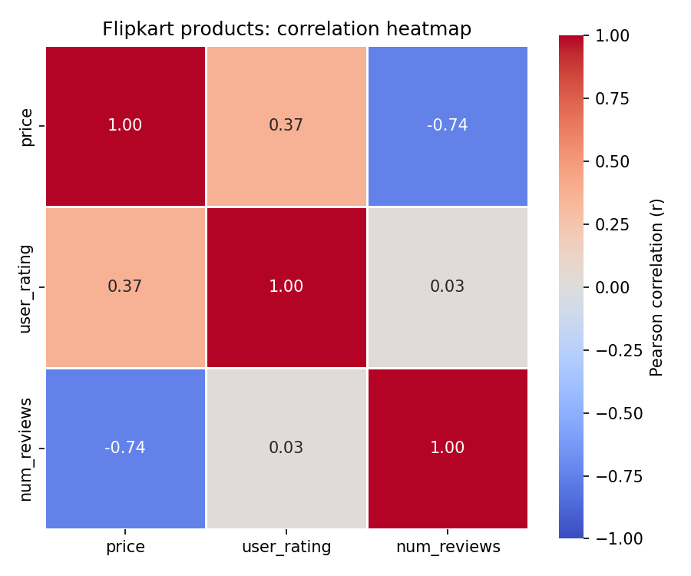

Task 5: Pitfalls When Interpreting Correlation

Problem
List two potential pitfalls when interpreting correlation coefficients in data from real apps like Zomato or YouTube, and give a short example for each showing how correlation can be misleading.

Solution

Pitfall 1: Correlation does not mean causation (hidden confounder)
Example (Zomato): on rainy days both soup orders and delivery delays go up, so the two are strongly correlated (r = 0.79 in the simulation). It would be wrong to say that soup orders cause late deliveries or to cut soup from the menu to speed things up. Rainfall is the hidden third variable driving both. After controlling for rainfall the correlation drops to about zero (r = −0.02).

Pitfall 2: Pearson r only measures straight-line relationships and is distorted by outliers
Example (YouTube): video length and engagement can have a strong inverted-U relationship, with engagement rising up to about 10 minutes and then falling. Pearson r for this is about 0.01, which wrongly suggests that length does not matter. Outliers cause the opposite problem: for 15 ordinary videos, views and likes are unrelated (r = 0.00), but adding one viral video with 2 million views and 90,000 likes pushes Pearson r to 1.00. Always plot the data first, and consider Spearman correlation (ρ = 0.19 with the same outlier) when outliers or non-linear patterns are likely.

Final answer
Two pitfalls: (1) correlation is not causation because a hidden variable such as rain can drive both; (2) Pearson r misses non-linear patterns and is distorted by outliers.

Python code
import numpy as np
import pandas as pd
from scipy import stats

rng = np.random.default_rng(seed=5)

# ---------- Pitfall 1: correlation is not causation (hidden confounder) - Zomato ----------
print("PITFALL 1: Correlation does not prove causation (confounding variable)")
days = 200
rain = rng.uniform(0, 50, days) # daily rainfall in mm (hidden third variable)
soup_orders = 300 + 6 * rain + rng.normal(0, 40, days) # rain -> more soup orders
delivery_delay = 20 + 0.5 * rain + rng.normal(0, 4, days) # rain -> slower deliveries
zom = pd.DataFrame({"rain": rain, "soup_orders": soup_orders, "delay": delivery_delay})

r_raw = zom["soup_orders"].corr(zom["delay"])
# Partial correlation: remove the effect of rain from both variables, then correlate residuals
res_soup = zom["soup_orders"] - np.polyval(np.polyfit(zom["rain"], zom["soup_orders"], 1), zom["rain"])
res_delay = zom["delay"] - np.polyval(np.polyfit(zom["rain"], zom["delay"], 1), zom["rain"])
r_partial = np.corrcoef(res_soup, res_delay)[0, 1]
print(f" Correlation(soup orders, delivery delay) = {r_raw:.2f} (looks strong)")
print(f" Same correlation after controlling for rainfall = {r_partial:.2f} (about zero)")
print(" Rain drives both, so soup orders do not cause the delays.\n")

# ---------- Pitfall 2: Pearson only measures LINEAR relationships (and is outlier-sensitive) - YouTube ----------
print("PITFALL 2: Pearson r misses non-linear patterns and is distorted by outliers")
length = np.linspace(1, 20, 60) # video length in minutes
engagement = -(length - 10.5) ** 2 + 100 + rng.normal(0, 4, 60) # engagement peaks at about 10 minutes
r_len = np.corrcoef(length, engagement)[0, 1]
print(f" Video length vs engagement (inverted U): Pearson r = {r_len:.2f} (near zero)")
print(" Yet length clearly affects engagement: it rises up to about 10 minutes, then falls.\n")

views = rng.normal(10_000, 2_000, 15)
likes = rng.normal(500, 100, 15)
likes = likes - np.polyval(np.polyfit(views, likes, 1), views) + likes.mean() # make likes unrelated to views
r_before = np.corrcoef(views, likes)[0, 1]
views_out, likes_out = np.append(views, 2_000_000), np.append(likes, 90_000) # one viral video
r_after = np.corrcoef(views_out, likes_out)[0, 1]
print(f" 15 ordinary videos (views vs likes, unrelated): r = {r_before:.2f}")
print(f" Add ONE viral video (2M views, 90k likes): r = {r_after:.2f} (outlier creates a 'strong' link)")
rho_after = stats.spearmanr(views_out, likes_out)[0]
print(f" Spearman rho with the same outlier included: rho = {rho_after:.2f} (more robust)")

Output
PITFALL 1: Correlation does not prove causation (confounding variable)
Correlation(soup orders, delivery delay) = 0.79 (looks strong)
Same correlation after controlling for rainfall = -0.02 (about zero)
Rain drives both, so soup orders do not cause the delays.

PITFALL 2: Pearson r misses non-linear patterns and is distorted by outliers
Video length vs engagement (inverted U): Pearson r = 0.01 (near zero)
Yet length clearly affects engagement: it rises up to about 10 minutes, then falls.

15 ordinary videos (views vs likes, unrelated): r = -0.00
Add ONE viral video (2M views, 90k likes): r = 1.00 (outlier creates a 'strong' link)
Spearman rho with the same outlier included: rho = 0.19 (more robust)

