Simple Linear Regression
Data Analytics Assignment: solutions with Python (pandas, numpy, scikit-learn, matplotlib)

Task 1: Dependent and Independent Variables

Problem
For a dataset of YouTube influencers with number of followers and average monthly brand deals, identify which variable is dependent and which is independent, and explain your reasoning in 2-3 sentences.

Solution
- Dataset: influencers.csv, 10 anonymised creators (illustrative values).

Influencer | Followers (thousands) | Avg monthly brand deals
Creator 01 | 50 | 1
Creator 02 | 120 | 1
Creator 03 | 200 | 2
Creator 04 | 350 | 2
Creator 05 | 500 | 3
Creator 06 | 800 | 4
Creator 07 | 1200 | 5
Creator 08 | 1800 | 6
Creator 09 | 2500 | 8
Creator 10 | 4000 | 10

- Independent variable (X, predictor): number of followers.
- Dependent variable (Y, outcome): average monthly brand deals.
Reasoning: Brands decide which creators to sponsor mainly by their reach, so the number of brand deals depends on the number of followers. The follower count is the input we use to explain or predict, and brand deals is the result we want to predict. The data agree with this direction: followers and brand deals have a strong positive correlation (r = 0.98).

Final answer
Independent variable = number of followers; dependent variable = average monthly brand deals.

Python code
import os
import pandas as pd

HERE = os.path.dirname(os.path.abspath(__file__)) if "__file__" in globals() else os.getcwd()

# Illustrative dataset of 10 anonymised YouTube influencers
influencers = pd.DataFrame({
"influencer": [f"Creator {i:02d}" for i in range(1, 11)],
"followers_thousands": [50, 120, 200, 350, 500, 800, 1200, 1800, 2500, 4000],
"avg_monthly_brand_deals": [1, 1, 2, 2, 3, 4, 5, 6, 8, 10],
})
influencers.to_csv(os.path.join(HERE, "influencers.csv"), index=False)
print(influencers.to_string(index=False), "\n")

independent = "followers_thousands"
dependent = "avg_monthly_brand_deals"
print(f"Independent variable (X, predictor): {independent}")
print(f"Dependent variable (Y, outcome) : {dependent}\n")

# How does Y change as X changes? (quick check of the direction of the relationship)
r = influencers[independent].corr(influencers[dependent])
print(f"Correlation between X and Y = {r:.3f} -> more followers go with more brand deals")
print("Reasoning: brands choose creators for their reach, so the number of brand deals DEPENDS on the "
"number of followers, not the other way round.")

Output
influencer followers_thousands avg_monthly_brand_deals
Creator 01 50 1
Creator 02 120 1
Creator 03 200 2
Creator 04 350 2
Creator 05 500 3
Creator 06 800 4
Creator 07 1200 5
Creator 08 1800 6
Creator 09 2500 8
Creator 10 4000 10

Independent variable (X, predictor): followers_thousands
Dependent variable (Y, outcome) : avg_monthly_brand_deals

Correlation between X and Y = 0.980 -> more followers go with more brand deals
Reasoning: brands choose creators for their reach, so the number of brand deals DEPENDS on the number of followers, not the other way round.

Task 2: Scatter Plot with Line of Best Fit (Myntra)

Problem
Plot a scatter plot of Myntra ad spend (in lakhs) vs number of app downloads for 10 sample data points, and visually draw the line of best fit.

Solution
- Data: 10 illustrative points saved as myntra_ads.csv.

Ad spend (lakhs) | App downloads
5 | 38,000
8 | 42,000
12 | 61,000
15 | 63,000
20 | 82,000
24 | 88,000
28 | 108,000
33 | 112,000
38 | 135,000
45 | 150,000

- The scatter plot uses plt.scatter(); the line of best fit is the least-squares line from np.polyfit(x, y, 1) drawn in red with plt.plot().
- Line of best fit: downloads = 2,861 × ad spend + 22,665, with correlation r = 0.995.
The points lie very close to a straight upward line, so more ad spend goes with more downloads. On average, each extra lakh of ad spend is associated with about 2,861 more downloads.

Final answer
Scatter plot with the red best-fit line shown below (saved as myntra_scatter.png): downloads ≈ 2,861 × ad spend + 22,665.

Python code
import os
import numpy as np
import pandas as pd
import matplotlib
if "__file__" in globals(): # plain script: save to file; notebook: show inline
matplotlib.use("Agg")
import matplotlib.pyplot as plt

HERE = os.path.dirname(os.path.abspath(__file__)) if "__file__" in globals() else os.getcwd()

# 10 sample data points (illustrative)
myntra = pd.DataFrame({
"ad_spend_lakhs": [5, 8, 12, 15, 20, 24, 28, 33, 38, 45],
"app_downloads": [38000, 42000, 61000, 63000, 82000, 88000, 108000, 112000, 135000, 150000],
})
myntra.to_csv(os.path.join(HERE, "myntra_ads.csv"), index=False)
print(myntra.to_string(index=False), "\n")

x, y = myntra["ad_spend_lakhs"], myntra["app_downloads"]
slope, intercept = np.polyfit(x, y, 1) # least-squares line y = slope * x + intercept
print(f"Line of best fit: downloads = {slope:,.0f} x ad_spend + {intercept:,.0f}")
print(f"Correlation r = {x.corr(y):.3f}")

plt.figure(figsize=(7, 4.5))
plt.scatter(x, y, color="#2a6f97", s=60, label="Sample data (10 points)", zorder=3)
xs = np.linspace(x.min(), x.max(), 100)
plt.plot(xs, slope * xs + intercept, color="red", lw=2, label=f"Best fit: y = {slope:,.0f}x + {intercept:,.0f}")
plt.xlabel("Myntra ad spend (lakhs)")
plt.ylabel("App downloads")
plt.title("Myntra: ad spend vs app downloads")
plt.legend()
plt.grid(alpha=0.3)
plt.tight_layout()
plt.savefig(os.path.join(HERE, "myntra_scatter.png"), dpi=150)
if "__file__" not in globals():
plt.show()
print("Plot saved to myntra_scatter.png")

Output
ad_spend_lakhs app_downloads
5 38000
8 42000
12 61000
15 63000
20 82000
24 88000
28 108000
33 112000
38 135000
45 150000

Line of best fit: downloads = 2,861 x ad_spend + 22,665
Correlation r = 0.995
Plot saved to myntra_scatter.png

Plot
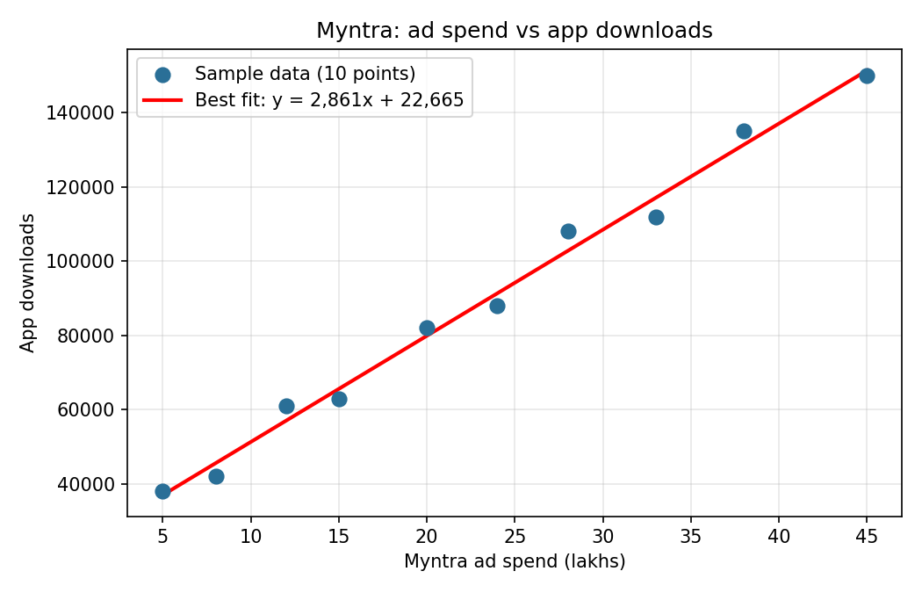

Task 3: Simple Linear Regression with scikit-learn (Swiggy)

Problem
Fit a simple linear regression with scikit-learn to predict average daily Swiggy orders from daily advertising spend. Print the slope and intercept and explain what each means in this context.

Solution
- Data: 15 simulated days saved as swiggy_ads.csv (ad spend in lakhs, orders per day).

Ad spend (lakhs) | Daily orders
2 | 16,805
3 | 25,707
3 | 16,804
4 | 19,764
4 | 18,497
5 | 22,363
5 | 20,118
6 | 25,194
8 | 25,900
9 | 32,065
10 | 29,023
11 | 31,861
14 | 35,037
14 | 35,530
15 | 36,362

- Model: LinearRegression() fitted with X = ad spend (as a 2-D table) and y = daily orders.
- Slope (coefficient) = 1,478.84. Intercept = 14,928.06. Fitted line: daily orders = 14,928 + 1,479 × ad spend (lakhs).
Slope in my own words: for every extra lakh rupees spent on ads in a day, Swiggy gets about 1,479 more orders per day on average. It is the extra orders each additional lakh of advertising is associated with.
Intercept in my own words: it is the predicted number of daily orders (about 14,928) when ad spend is zero, which can be read as the baseline demand that comes from regular customers and word of mouth. The data only covers ad spend between 2 and 15 lakhs, so the intercept is an extrapolation beyond the observed range and should not be over-trusted.

Final answer
Slope = 1,478.84 orders per extra lakh of ad spend; intercept = 14,928.06 baseline orders per day.

Python code
import os
import numpy as np
import pandas as pd
from sklearn.linear_model import LinearRegression

HERE = os.path.dirname(os.path.abspath(__file__)) if "__file__" in globals() else os.getcwd()
rng = np.random.default_rng(seed=3)

# Simulated data for 15 days: ad spend in lakhs, orders per day
spend = rng.integers(2, 17, size=15)
orders = (12000 + 1800 * spend + rng.normal(0, 2500, size=15)).round().astype(int)
swiggy = pd.DataFrame({"ad_spend_lakhs": spend, "daily_orders": orders}).sort_values("ad_spend_lakhs")
swiggy.to_csv(os.path.join(HERE, "swiggy_ads.csv"), index=False)
print(swiggy.to_string(index=False), "\n")

X = swiggy[["ad_spend_lakhs"]] # scikit-learn needs a 2-D feature table
y = swiggy["daily_orders"]

model = LinearRegression()
model.fit(X, y)

print(f"Slope (coefficient) = {model.coef_[0]:.2f} orders per extra lakh of ad spend")
print(f"Intercept = {model.intercept_:.2f} orders per day when ad spend is 0")
print(f"\nModel: daily_orders = {model.intercept_:.0f} + {model.coef_[0]:.0f} x ad_spend_lakhs")

print("\nExample predictions:")
for s in (5, 10, 20):
print(f" Ad spend {s:>2} lakhs -> about {model.predict(pd.DataFrame({'ad_spend_lakhs': [s]}))[0]:,.0f} orders/day")

Output
ad_spend_lakhs daily_orders
2 16805
3 25707
3 16804
4 19764
4 18497
5 22363
5 20118
6 25194
8 25900
9 32065
10 29023
11 31861
14 35037
14 35530
15 36362

Slope (coefficient) = 1478.84 orders per extra lakh of ad spend
Intercept = 14928.06 orders per day when ad spend is 0

Model: daily_orders = 14928 + 1479 x ad_spend_lakhs

Example predictions:
Ad spend 5 lakhs -> about 22,322 orders/day
Ad spend 10 lakhs -> about 29,716 orders/day
Ad spend 20 lakhs -> about 44,505 orders/day

Task 4: R-squared of the Swiggy Model

Problem
Calculate the R-squared value for the regression model from Task 3 and interpret what it says about the relationship between Swiggy’s ad spend and daily orders.

Solution
- Calculated with sklearn.metrics.r2_score (identical to model.score) and checked by hand: R² = 1 − SSE / SST = 1 − 78,657,341 / 672,930,985 = 0.8831.
- For simple regression, R² is the square of the correlation: r = 0.9397. The typical prediction error (RMSE) is about 2,290 orders per day.
Interpretation: R² = 0.88 is close to 1, so the model fits well. About 88% of the day-to-day variation in Swiggy’s daily orders is explained by ad spend, and the remaining 12% comes from other factors (weather, festivals, offers, restaurant availability) and random noise. This indicates a strong linear relationship and fairly accurate predictions, but with only 15 days of simulated data it does not prove that ad spend causes the extra orders.

Final answer
R² = 0.8831: ad spend explains about 88% of the variation in daily orders (a strong fit, close to 1).

Python code
import os
import numpy as np
import pandas as pd
from sklearn.linear_model import LinearRegression
from sklearn.metrics import r2_score

HERE = os.path.dirname(os.path.abspath(__file__)) if "__file__" in globals() else os.getcwd()
swiggy = pd.read_csv(os.path.join(HERE, "swiggy_ads.csv"))
X, y = swiggy[["ad_spend_lakhs"]], swiggy["daily_orders"]

model = LinearRegression().fit(X, y)
pred = model.predict(X)

r2 = r2_score(y, pred) # same as model.score(X, y)
print(f"R-squared (r2_score) = {r2:.4f}")
print(f"R-squared (model.score) = {model.score(X, y):.4f}")

# Manual calculation: R^2 = 1 - SSE / SST
sse = ((y - pred) ** 2).sum() # unexplained variation (residuals)
sst = ((y - y.mean()) ** 2).sum() # total variation around the mean
print(f"\nSSE (unexplained) = {sse:,.0f}")
print(f"SST (total) = {sst:,.0f}")
print(f"R-squared = 1 - SSE/SST = 1 - {sse / sst:.4f} = {1 - sse / sst:.4f}")
print(f"Correlation r = {np.sqrt(r2):.4f} (R-squared is r squared for simple regression)")
print(f"Average prediction error (RMSE) = {np.sqrt(sse / len(y)):,.0f} orders/day")

print(f"\nInterpretation: R-squared = {r2:.2f}, which is close to 1. About {r2:.0%} of the variation in daily "
f"orders is explained by ad spend; the remaining {1 - r2:.0%} is due to other factors and random noise.")

Output
R-squared (r2_score) = 0.8831
R-squared (model.score) = 0.8831

SSE (unexplained) = 78,657,341
SST (total) = 672,930,985
R-squared = 1 - SSE/SST = 1 - 0.1169 = 0.8831
Correlation r = 0.9397 (R-squared is r squared for simple regression)
Average prediction error (RMSE) = 2,290 orders/day

Interpretation: R-squared = 0.88, which is close to 1. About 88% of the variation in daily orders is explained by ad spend; the remaining 12% is due to other factors and random noise.

