Conditional Probability & Bayes’ Theorem
Data Analytics Assignment: solutions with Python (pandas, numpy, matplotlib)

Task 1: P(Phone | Accessories)

Problem
Out of 500 users, 120 bought phone accessories, 80 bought a phone, and 50 bought both. Calculate P(Phone | Accessories).

Approach
- P(Accessories) = 120 / 500 = 0.24
- P(Phone and Accessories) = 50 / 500 = 0.10
- P(Phone | Accessories) = P(A and B) / P(B) = 0.10 / 0.24 = 0.4167

Python code (task1_conditional_probability.py)
import os
import pandas as pd
import matplotlib
matplotlib.use("Agg")
import matplotlib.pyplot as plt

OUT = os.path.join(os.path.dirname(os.path.abspath(__file__)), "charts")
os.makedirs(OUT, exist_ok=True)

# Build a 500-user dataset that matches the given counts
# Both = 50, Accessories only = 120-50 = 70, Phone only = 80-50 = 30, Neither = 350
users = pd.DataFrame(
[(1, 1)] * 50 + [(1, 0)] * 70 + [(0, 1)] * 30 + [(0, 0)] * 350,
columns=["bought_accessories", "bought_phone"],
)
assert len(users) == 500

# Contingency table (counts)
table = pd.crosstab(users["bought_accessories"], users["bought_phone"],
margins=True, margins_name="Total")
print("Contingency table (rows = accessories, cols = phone):")
print(table, "\n")

n = len(users)
p_acc = users["bought_accessories"].mean() # P(B)
p_both = ((users["bought_accessories"] == 1) &
(users["bought_phone"] == 1)).mean() # P(A and B)
p_phone_given_acc = p_both / p_acc # P(A|B)

# Same answer straight from pandas by filtering the accessories buyers
check = users.loc[users["bought_accessories"] == 1, "bought_phone"].mean()

print(f"P(Accessories) = {p_acc:.4f}")
print(f"P(Phone and Acc.) = {p_both:.4f}")
print(f"P(Phone | Accessories) = {p_phone_given_acc:.4f} ({p_phone_given_acc:.2%})")
print(f"Pandas filter check = {check:.4f}")

# Chart: unconditional vs conditional probability of buying a phone
p_phone = users["bought_phone"].mean()
fig, ax = plt.subplots(figsize=(6, 4))
bars = ax.bar(["P(Phone)", "P(Phone | Accessories)"],
[p_phone, p_phone_given_acc], color=["#9bb7d4", "#2a6f97"])
for b in bars:
ax.text(b.get_x() + b.get_width() / 2, b.get_height() + 0.01,
f"{b.get_height():.2%}", ha="center")
ax.set_ylim(0, 0.6)
ax.set_ylabel("Probability")
ax.set_title("Accessory buyers are more likely to buy a phone")
plt.tight_layout()
plt.savefig(os.path.join(OUT, "task1.png"), dpi=150)

Output
Contingency table (rows = accessories, cols = phone):
bought_phone 0 1 Total
bought_accessories
0 350 30 380
1 70 50 120
Total 420 80 500

P(Accessories) = 0.2400
P(Phone and Acc.) = 0.1000
P(Phone | Accessories) = 0.4167 (41.67%)
Pandas filter check = 0.4167

Chart
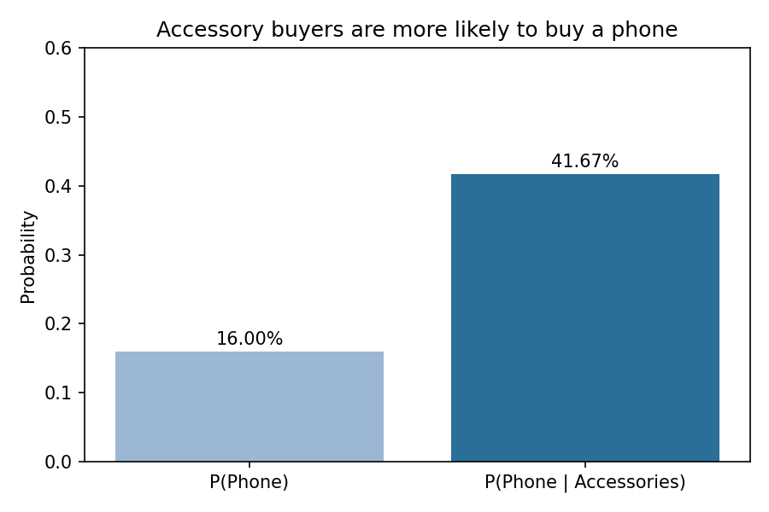

Final answer
P(Phone | Accessories) = 0.4167 (about 41.67%).

Task 2: P(Smartphone | Headphones)

Problem
30% of Flipkart users buy headphones, and among those 40% later buy a smartphone. Find the conditional probability that a user buys a smartphone given they bought headphones.

Approach
- P(Headphones) = 0.30
- P(Smartphone and Headphones) = 0.30 x 0.40 = 0.12
- P(Smartphone | Headphones) = 0.12 / 0.30 = 0.40

Python code (task2_headphones_smartphone.py)
import os
import numpy as np
import pandas as pd
import matplotlib
matplotlib.use("Agg")
import matplotlib.pyplot as plt

OUT = os.path.join(os.path.dirname(os.path.abspath(__file__)), "charts")
os.makedirs(OUT, exist_ok=True)

# ---- Exact calculation ----
p_headphones = 0.30 # P(B)
p_phone_given_hp = 0.40 # given in the question
p_both = p_headphones * p_phone_given_hp # P(A and B) = 0.12
p_cond = p_both / p_headphones # P(A|B) = P(A and B) / P(B)
print(f"P(Headphones) = {p_headphones:.2f}")
print(f"P(Smartphone and Headphones) = {p_both:.2f}")
print(f"P(Smartphone | Headphones) = {p_cond:.2f} ({p_cond:.0%})\n")

# ---- Simulation with 100,000 users to verify ----
rng = np.random.default_rng(42)
n = 100_000
headphones = rng.random(n) < p_headphones
# Smartphone rate for non-headphone users is NOT given; 0.20 is an illustrative
# assumption and does not affect the answer.
smartphone = np.where(headphones, rng.random(n) < 0.40, rng.random(n) < 0.20)

df = pd.DataFrame({"headphones": headphones, "smartphone": smartphone})
sim_p_b = df["headphones"].mean()
sim_p_ab = (df["headphones"] & df["smartphone"]).mean()
sim_cond = sim_p_ab / sim_p_b

print("Simulation (100,000 users):")
print(f" P(Headphones) = {sim_p_b:.4f}")
print(f" P(Smartphone and Headphones) = {sim_p_ab:.4f}")
print(f" P(Smartphone | Headphones) = {sim_cond:.4f}")
print(f" Groupby check:\n{df.groupby('headphones')['smartphone'].mean().round(4)}")

# Chart
fig, ax = plt.subplots(figsize=(6, 4))
vals = [p_cond, sim_cond]
bars = ax.bar(["Exact", "Simulated"], vals, color=["#2a6f97", "#9bb7d4"])
for b in bars:
ax.text(b.get_x() + b.get_width() / 2, b.get_height() + 0.01,
f"{b.get_height():.3f}", ha="center")
ax.set_ylim(0, 0.55)
ax.set_ylabel("P(Smartphone | Headphones)")
ax.set_title("Exact vs simulated conditional probability")
plt.tight_layout()
plt.savefig(os.path.join(OUT, "task2.png"), dpi=150)

Output
P(Headphones) = 0.30
P(Smartphone and Headphones) = 0.12
P(Smartphone | Headphones) = 0.40 (40%)

Simulation (100,000 users):
P(Headphones) = 0.2994
P(Smartphone and Headphones) = 0.1217
P(Smartphone | Headphones) = 0.4067
Groupby check:
headphones
False 0.1996
True 0.4067
Name: smartphone, dtype: float64

Chart
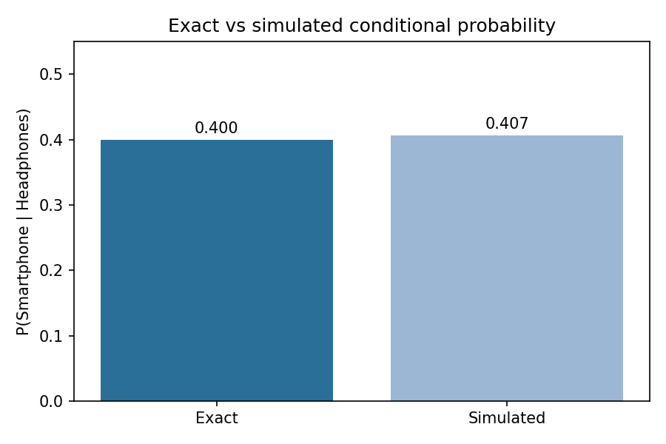

Final answer
P(Smartphone | Headphones) = 0.40 (40%). A 100,000-user simulation gives about 0.407, confirming it.

Task 3: Bayes Churn Function

Problem
Write bayes_churn_probability(prior_churn, prob_email_given_churn, prob_email) using Bayes’ Theorem and test it with 0.15, 0.6, 0.25.

Approach
- P(Churn | Email) = P(Email | Churn) x P(Churn) / P(Email)
- = (0.6 x 0.15) / 0.25 = 0.36
- The script also builds a pandas sensitivity table showing how the posterior changes with P(Email | Churn).

Python code (task3_bayes_churn.py)
import os
import numpy as np
import pandas as pd
import matplotlib
matplotlib.use("Agg")
import matplotlib.pyplot as plt

OUT = os.path.join(os.path.dirname(os.path.abspath(__file__)), "charts")
os.makedirs(OUT, exist_ok=True)

def bayes_churn_probability(prior_churn, prob_email_given_churn, prob_email):
"""P(Churn | Email) = P(Email | Churn) * P(Churn) / P(Email)"""
if not (0 <= prior_churn <= 1 and 0 <= prob_email_given_churn <= 1
and 0 < prob_email <= 1):
raise ValueError("Probabilities must be in [0, 1] and prob_email must be > 0.")
posterior = (prob_email_given_churn * prior_churn) / prob_email
if posterior > 1:
raise ValueError("Inputs are inconsistent: resulting probability exceeds 1.")
return posterior

# ---- Test with the given values ----
result = bayes_churn_probability(prior_churn=0.15,
prob_email_given_churn=0.6,
prob_email=0.25)
print(f"P(Churn | Email) = {result:.4f} ({result:.0%})\n")

# ---- Sensitivity table: how the answer changes with P(Email | Churn) ----
likelihoods = np.array([0.30, 0.40, 0.50, 0.60, 0.70, 0.80])
table = pd.DataFrame({
"P(Email|Churn)": likelihoods,
"P(Churn|Email)": [bayes_churn_probability(0.15, l, 0.25) for l in likelihoods],
})
print("Sensitivity analysis (prior = 0.15, P(Email) = 0.25):")
print(table.round(4).to_string(index=False))

# ---- Chart: prior vs posterior ----
fig, ax = plt.subplots(figsize=(6.5, 4))
ax.plot(table["P(Email|Churn)"], table["P(Churn|Email)"], marker="o", color="#2a6f97")
ax.axhline(0.15, ls="--", color="grey", label="Prior P(Churn) = 0.15")
ax.scatter([0.6], [result], color="red", zorder=5, label=f"Given case = {result:.2f}")
ax.set_xlabel("P(Email | Churn)")
ax.set_ylabel("P(Churn | Email)")
ax.set_title("Posterior churn probability vs likelihood")
ax.legend()
plt.tight_layout()
plt.savefig(os.path.join(OUT, "task3.png"), dpi=150)

Output
P(Churn | Email) = 0.3600 (36%)

Sensitivity analysis (prior = 0.15, P(Email) = 0.25):
P(Email|Churn) P(Churn|Email)
0.3 0.18
0.4 0.24
0.5 0.30
0.6 0.36
0.7 0.42
0.8 0.48

Chart
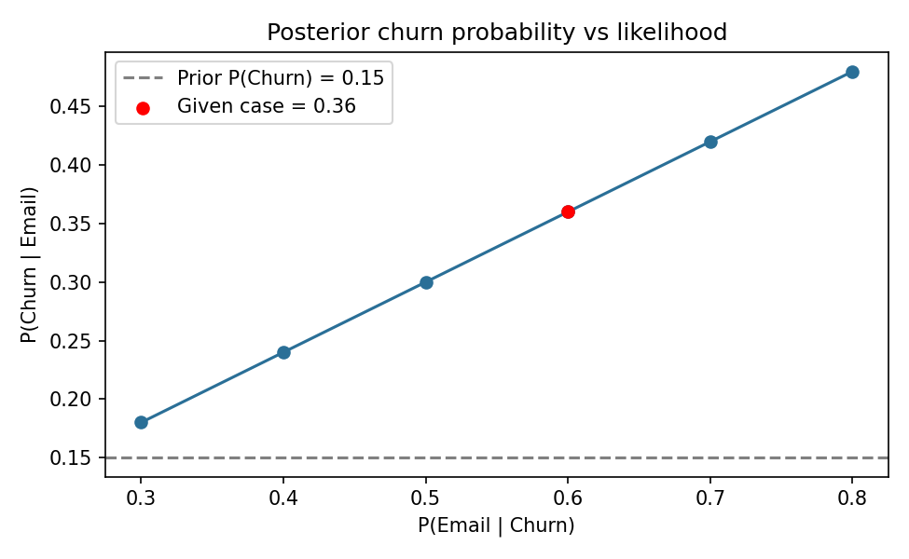

Final answer
P(Churn | Email) = 0.36 (36%), up from the 15% prior.

Task 4: Fraud Detection with Bayes’ Theorem

Problem
2% of transactions are fraudulent. The alert flags 90% of fraud and falsely flags 5% of normal transactions. Find P(Fraud | Alert).

Approach
- F = fraud, A = alert. P(F) = 0.02, P(A | F) = 0.90, P(A | not F) = 0.05
- P(A) = 0.90 x 0.02 + 0.05 x 0.98 = 0.067
- P(F | A) = 0.018 / 0.067 = 0.2687

Python code (task4_fraud_detection.py)
import os
import numpy as np
import pandas as pd
import matplotlib
matplotlib.use("Agg")
import matplotlib.pyplot as plt

OUT = os.path.join(os.path.dirname(os.path.abspath(__file__)), "charts")
os.makedirs(OUT, exist_ok=True)

p_fraud = 0.02 # P(F)
tpr = 0.90 # P(A|F)
fpr = 0.05 # P(A|not F)

def p_fraud_given_alert(p_f, tpr, fpr):
p_alert = tpr * p_f + fpr * (1 - p_f) # law of total probability
return (tpr * p_f) / p_alert, p_alert

posterior, p_alert = p_fraud_given_alert(p_fraud, tpr, fpr)
print(f"P(A) = 0.90*0.02 + 0.05*0.98 = {p_alert:.4f}")
print(f"P(F | A) = {posterior:.4f} ({posterior:.2%})\n")

# ---- Confusion matrix for 100,000 transactions ----
N = 100_000
fraud = int(N * p_fraud)
normal = N - fraud
cm = pd.DataFrame(
{"Alert": [round(fraud * tpr), round(normal * fpr)],
"No alert": [round(fraud * (1 - tpr)), round(normal * (1 - fpr))]},
index=["Fraud", "Normal"],
)
cm["Total"] = cm.sum(axis=1)
cm.loc["Total"] = cm.sum()
print("Confusion matrix (100,000 transactions):")
print(cm)
print(f"\nPrecision from counts = {cm.loc['Fraud', 'Alert'] / cm.loc['Total', 'Alert']:.4f}")

# ---- Base-rate sweep ----
rates = np.linspace(0.001, 0.20, 200)
post = [p_fraud_given_alert(r, tpr, fpr)[0] for r in rates]
fig, ax = plt.subplots(figsize=(6.5, 4))
ax.plot(rates * 100, np.array(post) * 100, color="#2a6f97")
ax.scatter([2], [posterior * 100], color="red", zorder=5,
label=f"2% fraud -> {posterior:.1%}")
ax.set_xlabel("Fraud rate (%)")
ax.set_ylabel("P(Fraud | Alert) (%)")
ax.set_title("Base-rate effect on alert precision")
ax.legend()
plt.tight_layout()
plt.savefig(os.path.join(OUT, "task4.png"), dpi=150)

Output
P(A) = 0.90*0.02 + 0.05*0.98 = 0.0670
P(F | A) = 0.2687 (26.87%)

Confusion matrix (100,000 transactions):
Alert No alert Total
Fraud 1800 200 2000
Normal 4900 93100 98000
Total 6700 93300 100000

Precision from counts = 0.2687

Chart
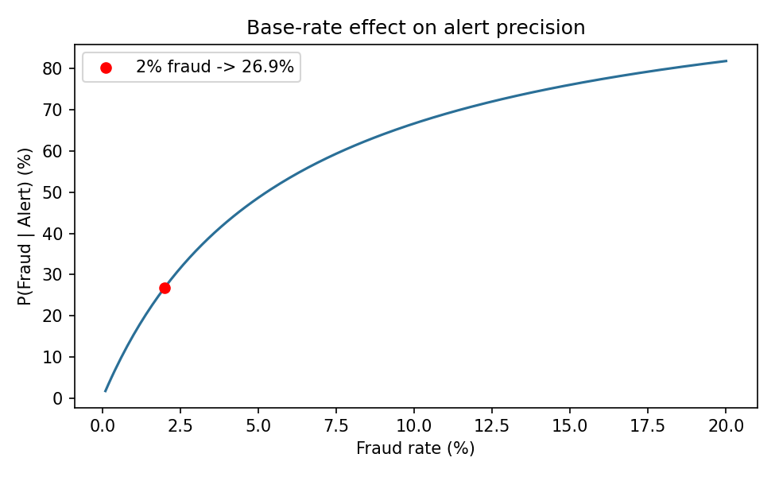

Final answer
P(Fraud | Alert) = 0.2687 (about 26.87%). Fraud is rare, so false alarms on normal transactions outnumber true catches (base-rate effect).

Task 5: Food Delivery Scenario and Bayes’ Theorem

Problem
Use an AI tool to generate a real-world conditional probability scenario for a food delivery app (Zomato/Swiggy), explain how Bayes’ Theorem improves recommendations, paste the output, and add one sentence of your own analysis.

AI prompt used
"Generate a real-world scenario where conditional probability is used in a food delivery app like Zomato or Swiggy, and explain how Bayes’ Theorem could help improve their recommendation system."

AI output (generated by Claude)
Scenario: A user opens Swiggy at 9:30 PM on a Friday. The app wants to decide whether to show biryani restaurants at the top. Historically 20% of Friday-night orders are biryani, so P(Biryani) = 0.20. Among users who ordered biryani, 70% had searched for non-veg items that day, so P(Searched non-veg | Biryani) = 0.70. Overall 35% of users searched non-veg, so P(Searched non-veg) = 0.35. This user searched for non-veg.
Bayes’ Theorem: P(Biryani | Searched non-veg) = (0.70 x 0.20) / 0.35 = 0.40. The probability rises from 20% to 40% after seeing the user’s behaviour, so biryani restaurants should be ranked higher for this user.
How Bayes improves recommendations: Instead of showing the same popular items to everyone, the system starts with a prior (overall popularity) and updates it with each new signal such as search terms, time of day, past orders, weather, location and cart contents. Each signal sharpens the probability, so recommendations become personalised. The prior also covers new users with little history (the cold-start problem), and the model keeps improving as more behaviour data arrives.

Python code (task5_food_delivery_bayes.py)
import os
import pandas as pd
import matplotlib
matplotlib.use("Agg")
import matplotlib.pyplot as plt

OUT = os.path.join(os.path.dirname(os.path.abspath(__file__)), "charts")
os.makedirs(OUT, exist_ok=True)

# Illustrative dataset of 10,000 Friday-night sessions
# Biryani & searched non-veg = 1400, Biryani & not searched = 600
# Other & searched non-veg = 2100, Other & not searched = 5900
rows = ([("Biryani", 1)] * 1400 + [("Biryani", 0)] * 600 +
[("Other", 1)] * 2100 + [("Other", 0)] * 5900)
sessions = pd.DataFrame(rows, columns=["ordered", "searched_nonveg"])

print(pd.crosstab(sessions["ordered"], sessions["searched_nonveg"],
margins=True, margins_name="Total"), "\n")

is_b = sessions["ordered"] == "Biryani"
is_s = sessions["searched_nonveg"] == 1

p_b = is_b.mean() # prior P(Biryani)
p_s = is_s.mean() # evidence P(Searched)
p_s_given_b = is_s[is_b].mean() # likelihood P(Searched | Biryani)

posterior = p_s_given_b * p_b / p_s # Bayes' Theorem
direct = is_b[is_s].mean() # direct conditional probability from data

print(f"Prior P(Biryani) = {p_b:.2f}")
print(f"Likelihood P(Searched | Biryani) = {p_s_given_b:.2f}")
print(f"Evidence P(Searched) = {p_s:.2f}")
print(f"Posterior P(Biryani | Searched) = {posterior:.2f}")
print(f"Direct check from data = {direct:.2f}")

# Chart: prior vs posterior
fig, ax = plt.subplots(figsize=(6, 4))
bars = ax.bar(["Prior\nP(Biryani)", "Posterior\nP(Biryani | Searched non-veg)"],
[p_b, posterior], color=["#9bb7d4", "#2a6f97"])
for b in bars:
ax.text(b.get_x() + b.get_width() / 2, b.get_height() + 0.01,
f"{b.get_height():.0%}", ha="center")
ax.set_ylim(0, 0.55)
ax.set_ylabel("Probability")
ax.set_title("Bayes update from one user signal")
plt.tight_layout()
plt.savefig(os.path.join(OUT, "task5.png"), dpi=150)

Output
searched_nonveg 0 1 Total
ordered
Biryani 600 1400 2000
Other 5900 2100 8000
Total 6500 3500 10000

Prior P(Biryani) = 0.20
Likelihood P(Searched | Biryani) = 0.70
Evidence P(Searched) = 0.35
Posterior P(Biryani | Searched) = 0.40
Direct check from data = 0.40

Chart
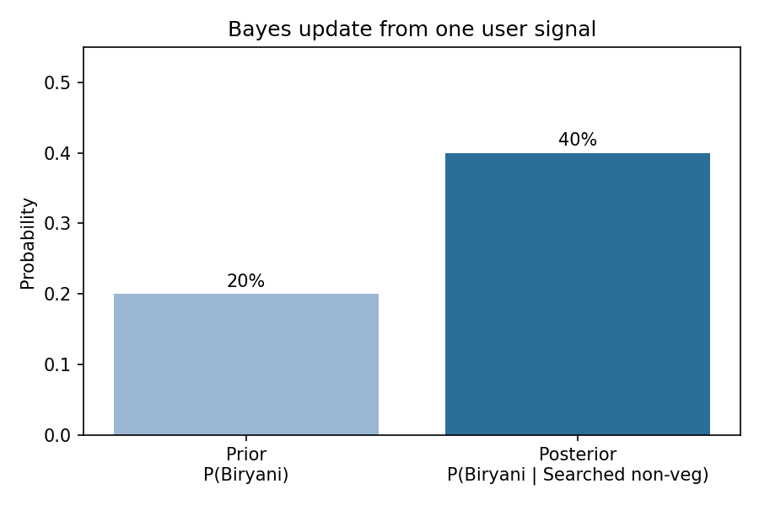

Verification with pandas
The synthetic 10,000-session dataset gives the same posterior from Bayes’ formula and from a direct conditional probability (0.40), which confirms the calculation.

My analysis
Bayes’ Theorem lets a food delivery app turn small behavioural signals, like a single search, into a measurable jump in order probability, so recommendations become personalised and less dependent on generic popularity.

