Sampling Techniques
Data Analytics Assignment: solutions with Python (pandas, numpy, matplotlib)

Task 1: Random Sample of 20 Users from 200

Problem
Generate a random sample of 20 users from a list of 200 user IDs, simulating how a music app like Spotify might select users for a feedback survey.

Approach
- Create 200 user IDs (U001 to U200).
- Use numpy’s random generator to pick 20 positions without replacement, so no user is chosen twice.
- Every user has the same chance of selection: 20 / 200 = 10%. A fixed seed makes the result reproducible.

Python code (task1_random_sample_users.py)
import os
import numpy as np
import pandas as pd
import matplotlib
matplotlib.use("Agg")
import matplotlib.pyplot as plt

OUT = os.path.join(os.path.dirname(os.path.abspath(__file__)), "charts")
os.makedirs(OUT, exist_ok=True)

rng = np.random.default_rng(seed=7) # seed makes the demo reproducible

# 200 user IDs: U001 ... U200
users = pd.DataFrame({"user_id": [f"U{i:03d}" for i in range(1, 201)]})

# Simple random sampling WITHOUT replacement: every user has the same chance (20/200 = 10%)
picked_idx = rng.choice(users.index, size=20, replace=False)
sample = users.loc[np.sort(picked_idx)].reset_index(drop=True)

print(f"Population size : {len(users)}")
print(f"Sample size : {len(sample)}")
print(f"Unique IDs : {sample['user_id'].nunique()} (no duplicates)")
print(f"Selection chance: {len(sample) / len(users):.0%} per user\n")
print("Selected user IDs:")
print(sample["user_id"].to_list())

# Chart: 10 x 20 grid of all users, selected ones highlighted
fig, ax = plt.subplots(figsize=(8, 3.6))
rows, cols = np.divmod(np.arange(200), 20)
chosen = np.isin(np.arange(200), picked_idx)
ax.scatter(cols[~chosen], -rows[~chosen], s=60, color="#c9d6e2", label="Not selected")
ax.scatter(cols[chosen], -rows[chosen], s=90, color="#d1495b", label="Selected for survey (20)")
ax.set_axis_off()
ax.set_title("Random sample of 20 from 200 users")
ax.legend(loc="upper center", bbox_to_anchor=(0.5, 0.0), ncol=2, frameon=False)
plt.tight_layout()
plt.savefig(os.path.join(OUT, "task1.png"), dpi=150)

Output
Population size : 200
Sample size : 20
Unique IDs : 20 (no duplicates)
Selection chance: 10% per user

Selected user IDs:
['U002', 'U011', 'U024', 'U026', 'U043', 'U055', 'U058', 'U094', 'U098', 'U107', 'U114', 'U126', 'U145', 'U156', 'U158', 'U161', 'U166', 'U168', 'U172', 'U177']

Chart
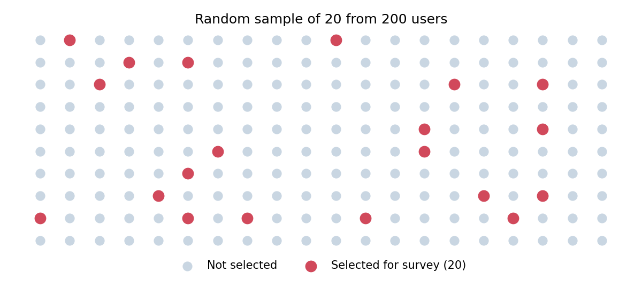

Final answer
20 unique user IDs were selected by simple random sampling (see output above).

Task 2: Stratified Sample of 60 Orders by City

Problem
From 1000 Flipkart orders labelled by city, generate a stratified sample of 60 orders with each city proportionally represented.

Approach
- Calculate each city’s share of the 1000 orders (Ahmedabad 34%, Surat 26%, Vadodara 21%, Rajkot 12%, Bhavnagar 7%).
- Multiply each share by 60 to get the quota: 20.4, 15.6, 12.6, 7.2, 4.2.
- Round with the largest-remainder method so the quotas add up to exactly 60: 20, 16, 13, 7, 4.
- Randomly draw that many orders from each city.

Python code (task2_stratified_orders.py)
import os
import numpy as np
import pandas as pd
import matplotlib
matplotlib.use("Agg")
import matplotlib.pyplot as plt

OUT = os.path.join(os.path.dirname(os.path.abspath(__file__)), "charts")
os.makedirs(OUT, exist_ok=True)

rng = np.random.default_rng(seed=11)

# ---- Build 1000 orders labelled by city ----
city_counts = {"Ahmedabad": 340, "Surat": 260, "Vadodara": 210, "Rajkot": 120, "Bhavnagar": 70}
cities = np.repeat(list(city_counts.keys()), list(city_counts.values()))
orders = pd.DataFrame({"order_id": [f"FK{i:04d}" for i in range(1, 1001)],
"city": rng.permutation(cities)})
SAMPLE_SIZE = 60

# ---- Step 1: proportion of orders per city ----
proportion = orders["city"].value_counts(normalize=True)

# ---- Step 2: quota per city (largest-remainder method so quotas add up to exactly 60) ----
exact = proportion * SAMPLE_SIZE
quota = exact.astype(int) # whole part
shortfall = SAMPLE_SIZE - quota.sum() # seats left to hand out
extra = (exact - quota).sort_values(ascending=False).index[:shortfall]
quota.loc[extra] += 1

summary = pd.DataFrame({"orders": orders["city"].value_counts(),
"proportion_%": (proportion * 100).round(1),
"exact_quota": exact.round(2),
"final_quota": quota})
print(summary, "\n")

# ---- Step 3: draw that many random orders from each city ----
parts = [orders[orders["city"] == c].sample(n=q, random_state=int(rng.integers(1_000_000)))
for c, q in quota.items()]
sample = pd.concat(parts).sort_values("order_id").reset_index(drop=True)

print(f"Sample size: {len(sample)}")
print("Sample count by city:")
print(sample["city"].value_counts().to_string(), "\n")

check = pd.DataFrame({"population_%": proportion * 100,
"sample_%": sample["city"].value_counts(normalize=True) * 100}).round(1)
print("Population vs sample share:")
print(check)

# ---- Chart ----
fig, ax = plt.subplots(figsize=(7, 4))
x = np.arange(len(check))
ax.bar(x - 0.2, check["population_%"], 0.4, label="Population (1000 orders)", color="#9bb7d4")
ax.bar(x + 0.2, check["sample_%"], 0.4, label="Sample (60 orders)", color="#2a6f97")
ax.set_xticks(x)
ax.set_xticklabels(check.index)
ax.set_ylabel("Share of orders (%)")
ax.set_title("Stratified sample mirrors the population")
ax.legend()
plt.tight_layout()
plt.savefig(os.path.join(OUT, "task2.png"), dpi=150)

Output
orders proportion_% exact_quota final_quota
city
Ahmedabad 340 34.0 20.4 20
Surat 260 26.0 15.6 16
Vadodara 210 21.0 12.6 13
Rajkot 120 12.0 7.2 7
Bhavnagar 70 7.0 4.2 4

Sample size: 60
Sample count by city:
city
Ahmedabad 20
Surat 16
Vadodara 13
Rajkot 7
Bhavnagar 4

Population vs sample share:
population_% sample_%
city
Ahmedabad 34.0 33.3
Surat 26.0 26.7
Vadodara 21.0 21.7
Rajkot 12.0 11.7
Bhavnagar 7.0 6.7

Chart
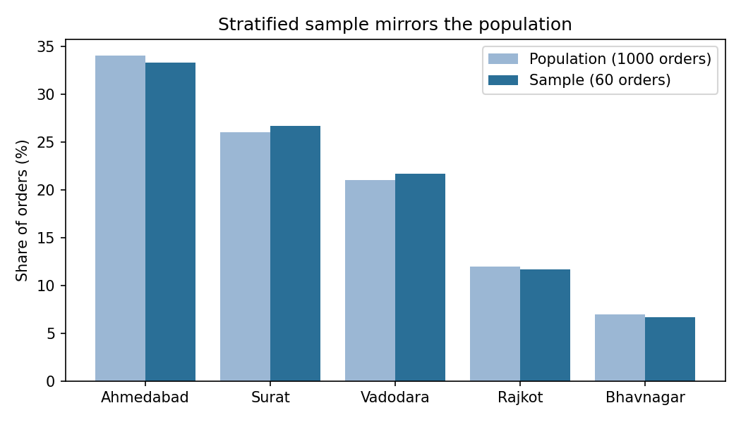

Final answer
The sample has 60 orders: Ahmedabad 20, Surat 16, Vadodara 13, Rajkot 7, Bhavnagar 4. Each city’s share is within 1 percentage point of its population share.

Task 3: Systematic Sampling of Zomato Reviews

Problem
Write a function to perform systematic sampling on a list of 500 Zomato restaurant reviews, selecting every 10th review.

Approach
- Sampling interval k = N / n = 500 / 50 = 10.
- The function systematic_sample(reviews, step=10, start=None) uses slicing reviews[start::step]. By default start = step - 1, which picks the 10th, 20th, 30th ... review.
- An optional random start (0 to 9) is supported, which is the more rigorous form of systematic sampling.

Python code (task3_systematic_reviews.py)
import os
import numpy as np
import pandas as pd
import matplotlib
matplotlib.use("Agg")
import matplotlib.pyplot as plt

OUT = os.path.join(os.path.dirname(os.path.abspath(__file__)), "charts")
os.makedirs(OUT, exist_ok=True)

def systematic_sample(reviews, step=10, start=None):
"""Return every `step`-th item. Default: the 10th, 20th, 30th ... review.

start : 0-based index of the first pick. None -> step - 1 (i.e. the 10th review).
Pass a random number in range(step) for a random-start systematic sample.
"""
if step < 1:
raise ValueError("step must be >= 1")
if start is None:
start = step - 1
return reviews.iloc[start::step] if isinstance(reviews, pd.DataFrame) else reviews[start::step]

# ---- 500 Zomato-style reviews ----
rng = np.random.default_rng(seed=3)
reviews = pd.DataFrame({
"review_id": np.arange(1, 501),
"rating": rng.choice([1, 2, 3, 4, 5], size=500, p=[0.06, 0.09, 0.20, 0.37, 0.28]),
})

sample = systematic_sample(reviews, step=10)

print(f"Population: {len(reviews)} reviews | Sample: {len(sample)} reviews")
print("Selected review IDs:", sample["review_id"].to_list(), "\n")

# Random-start version for comparison
random_start = int(rng.integers(0, 10))
sample_rs = systematic_sample(reviews, step=10, start=random_start)
print(f"Random-start variant (start index {random_start}): first IDs = "
f"{sample_rs['review_id'].head(5).to_list()} ... total {len(sample_rs)}\n")

print(f"Average rating - population: {reviews['rating'].mean():.2f}")
print(f"Average rating - sample : {sample['rating'].mean():.2f}")

# ---- Chart: rating distribution, population vs sample ----
dist = pd.DataFrame({
"Population": reviews["rating"].value_counts(normalize=True).sort_index() * 100,
"Sample": sample["rating"].value_counts(normalize=True).sort_index() * 100,
}).fillna(0)
ax = dist.plot(kind="bar", figsize=(7, 4), color=["#9bb7d4", "#2a6f97"], rot=0)
ax.set_xlabel("Rating")
ax.set_ylabel("Share of reviews (%)")
ax.set_title("Every-10th-review sample vs all 500 reviews")
plt.tight_layout()
plt.savefig(os.path.join(OUT, "task3.png"), dpi=150)

Output
Population: 500 reviews | Sample: 50 reviews
Selected review IDs: [10, 20, 30, 40, 50, 60, 70, 80, 90, 100, 110, 120, 130, 140, 150, 160, 170, 180, 190, 200, 210, 220, 230, 240, 250, 260, 270, 280, 290, 300, 310, 320, 330, 340, 350, 360, 370, 380, 390, 400, 410, 420, 430, 440, 450, 460, 470, 480, 490, 500]

Random-start variant (start index 0): first IDs = [1, 11, 21, 31, 41] ... total 50

Average rating - population: 3.71
Average rating - sample : 3.82

Chart
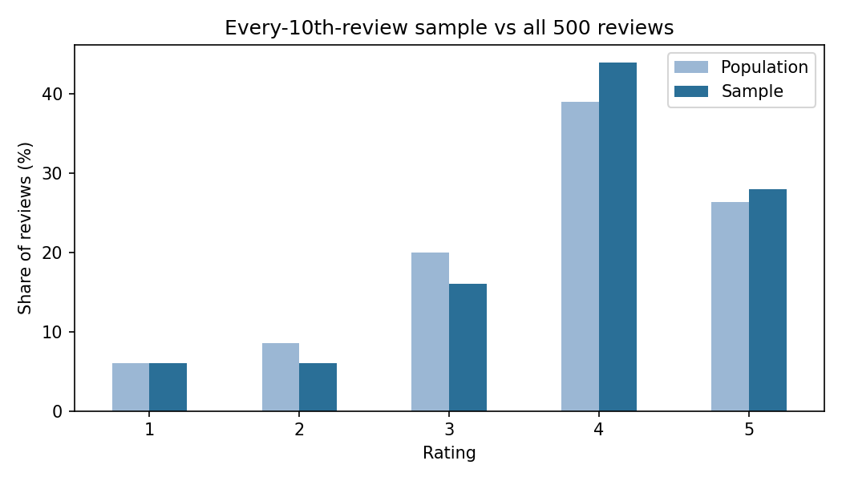

Final answer
The function returns 50 reviews (IDs 10, 20, 30, ... 500).

Task 4: Sample Size and Accuracy (Swiggy Delivery Time)

Problem
Estimate the average Swiggy delivery time in your city from 10,000 delivery records when you can only sample 50, 200 or 500 records. Explain with calculations how sample size affects accuracy.

Approach
- Population (simulated): N = 10,000, mean = 31.95 min, standard deviation s = 7.93 min.
- Standard error with finite population correction: SE = (s / √n) × √((N − n) / (N − 1)). Margin of error (95%) = 1.96 × SE.
- n = 50: SE = 7.93 / 7.071 × 0.9975 = 1.119 min, so margin = ±2.19 min.
- n = 200: SE = 7.93 / 14.142 × 0.9900 = 0.555 min, so margin = ±1.09 min.
- n = 500: SE = 7.93 / 22.361 × 0.9747 = 0.346 min, so margin = ±0.68 min.
- Error shrinks with the square root of n: 4 times the data (50 to 200) halves the margin (factor 2.02), and 10 times the data (50 to 500) cuts it by 3.24, not 10.
- Check by experiment: drawing 2000 samples of each size, the real spread of the sample means (1.131, 0.544, 0.346) matches the theoretical SE, and about 95% of sample means fell within the margin.

Python code (task4_sample_size_accuracy.py)
import os
import numpy as np
import pandas as pd
import matplotlib
matplotlib.use("Agg")
import matplotlib.pyplot as plt

OUT = os.path.join(os.path.dirname(os.path.abspath(__file__)), "charts")
os.makedirs(OUT, exist_ok=True)

rng = np.random.default_rng(seed=21)

# ---- 10,000 delivery records (minutes); right-skewed like real delivery times ----
N = 10_000
times = rng.gamma(shape=16, scale=2.0, size=N) # mean about 32 min
pop_mean, pop_sd = times.mean(), times.std(ddof=1)
print(f"Population: N = {N}, mean = {pop_mean:.2f} min, SD = {pop_sd:.2f} min\n")

rows = []
for n in (50, 200, 500):
# Theory: standard error with finite population correction (sampling w/o replacement)
se = pop_sd / np.sqrt(n) * np.sqrt((N - n) / (N - 1))
moe = 1.96 * se # 95% margin of error

# Experiment: draw 2000 different samples of size n and see how much the means vary
means = np.array([rng.choice(times, size=n, replace=False).mean() for _ in range(2000)])
errors = np.abs(means - pop_mean)
coverage = np.mean(errors <= moe)

rows.append({"n": n, "SE (min)": se, "95% margin (+/- min)": moe,
"Empirical SD of means": means.std(ddof=1),
"Mean abs error (min)": errors.mean(),
"Within margin %": coverage * 100})
if n == 50:
means_50 = means
elif n == 200:
means_200 = means
else:
means_500 = means

res = pd.DataFrame(rows).set_index("n").round(3)
print(res.to_string(), "\n")

print(f"Going 50 -> 200 (4x data): margin shrinks by factor {res.loc[50, '95% margin (+/- min)'] / res.loc[200, '95% margin (+/- min)']:.2f}")
print(f"Going 50 -> 500 (10x data): margin shrinks by factor {res.loc[50, '95% margin (+/- min)'] / res.loc[500, '95% margin (+/- min)']:.2f}")

# One concrete sample of each size
print("\nOne example sample of each size:")
for n in (50, 200, 500):
s = rng.choice(times, size=n, replace=False)
m = s.mean()
e = 1.96 * s.std(ddof=1) / np.sqrt(n) * np.sqrt((N - n) / (N - 1))
print(f" n = {n:>3}: mean = {m:.2f}, 95% CI = ({m - e:.2f}, {m + e:.2f})")

# ---- Charts ----
fig, axes = plt.subplots(1, 2, figsize=(10, 4))
axes[0].bar([str(n) for n in res.index], res["95% margin (+/- min)"], color="#2a6f97")
axes[0].set_xlabel("Sample size")
axes[0].set_ylabel("95% margin of error (+/- min)")
axes[0].set_title("Bigger sample, smaller error")
axes[1].boxplot([means_50, means_200, means_500], tick_labels=["50", "200", "500"])
axes[1].axhline(pop_mean, color="red", ls="--", label=f"True mean {pop_mean:.1f}")
axes[1].set_xlabel("Sample size")
axes[1].set_ylabel("Sample mean (min)")
axes[1].set_title("Spread of 2000 sample means")
axes[1].legend()
plt.tight_layout()
plt.savefig(os.path.join(OUT, "task4.png"), dpi=150)

Output
Population: N = 10000, mean = 31.95 min, SD = 7.93 min

SE (min) 95% margin (+/- min) Empirical SD of means Mean abs error (min) Within margin %
n
50 1.119 2.193 1.131 0.911 94.70
200 0.555 1.088 0.544 0.432 95.80
500 0.346 0.677 0.346 0.277 95.25

Going 50 -> 200 (4x data): margin shrinks by factor 2.02
Going 50 -> 500 (10x data): margin shrinks by factor 3.24

One example sample of each size:
n = 50: mean = 32.79, 95% CI = (30.18, 35.40)
n = 200: mean = 31.96, 95% CI = (30.91, 33.01)
n = 500: mean = 32.25, 95% CI = (31.58, 32.92)

Chart
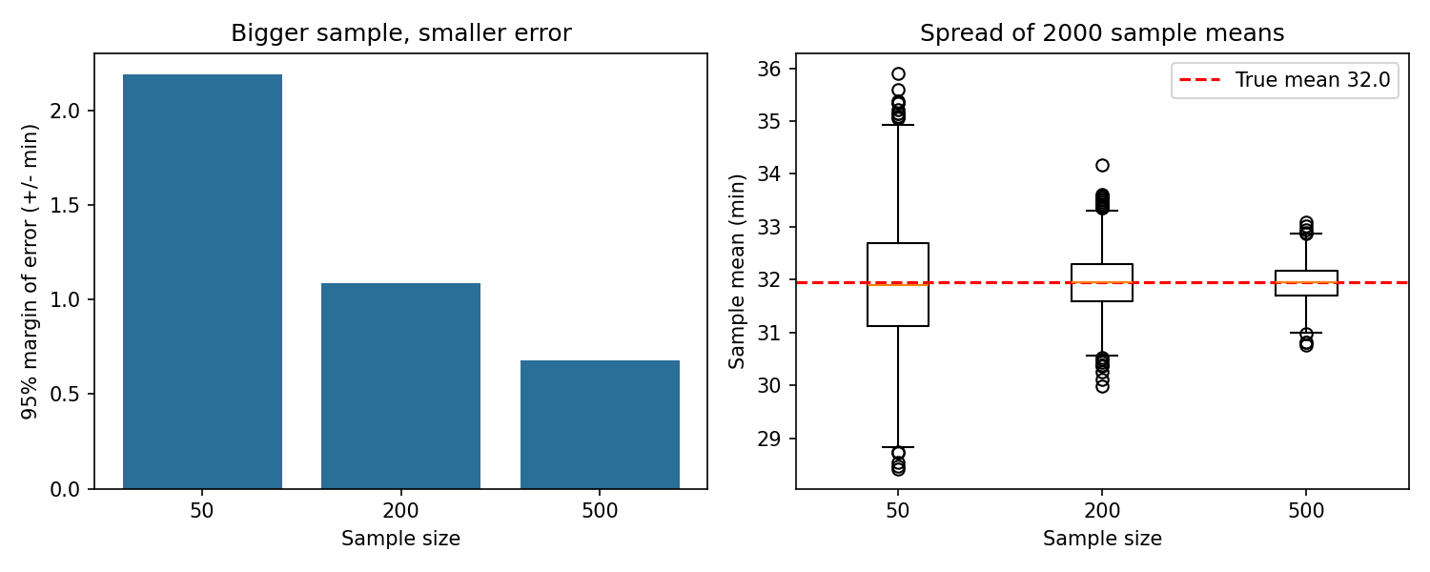

Final answer
Larger samples give a more accurate estimate: roughly ±2.2 min at n = 50, ±1.1 min at n = 200 and ±0.7 min at n = 500, with diminishing returns because accuracy grows only with √n.

Task 5: Stratified Sample of 40 IPL Fans by Favourite Team

Problem
Modify the stratified sampling demo: use a dataset of IPL cricket fans grouped by favourite team and generate a stratified sample of 40 fans, with each team represented proportionally. Constraint: write your own grouping and sampling logic.

Approach
- Create 1000 fans across 10 teams (CSK 210, MI 190, RCB 180, KKR 110, SRH 80, DC 70, RR 60, GT 50, PBKS 30, LSG 20).
- Own logic: a custom allocate_quotas() function takes the floor of each team’s exact share of 40, then gives the leftover seats to the largest fractional parts (ties go to the larger team).
- Sampling uses numpy index arrays: find the row positions of each team and choose that many at random without replacement. It does not use groupby().sample().
- The class demo was not available to me, so this is written independently from scratch.

Python code (task5_ipl_stratified_fans.py)
import os
import numpy as np
import pandas as pd
import matplotlib
matplotlib.use("Agg")
import matplotlib.pyplot as plt

OUT = os.path.join(os.path.dirname(os.path.abspath(__file__)), "charts")
os.makedirs(OUT, exist_ok=True)

rng = np.random.default_rng(seed=2026)

# ---- 1000 IPL fans, each with a favourite team ----
team_sizes = {"CSK": 210, "MI": 190, "RCB": 180, "KKR": 110, "SRH": 80,
"DC": 70, "RR": 60, "GT": 50, "PBKS": 30, "LSG": 20}
fans = pd.DataFrame({
"fan_id": [f"F{i:04d}" for i in range(1, 1001)],
"fav_team": rng.permutation(np.repeat(list(team_sizes), list(team_sizes.values()))),
})
TARGET = 40

def allocate_quotas(sizes, total):
"""Hamilton method: floor of each exact share, then give leftover seats to biggest fractions."""
teams = list(sizes)
pop = np.array([sizes[t] for t in teams], dtype=float)
exact = pop / pop.sum() * total
base = np.floor(exact).astype(int)
left = total - base.sum()
# biggest fractional part first; ties go to the larger team
order = sorted(range(len(teams)), key=lambda i: (-(exact[i] - base[i]), -pop[i]))
for i in order[:left]:
base[i] += 1
return dict(zip(teams, base)), dict(zip(teams, exact))

actual_sizes = fans["fav_team"].value_counts().to_dict()
quota, exact = allocate_quotas(actual_sizes, TARGET)

# ---- Draw: for each team pick row positions at random without replacement ----
team_col = fans["fav_team"].to_numpy()
chosen_rows = []
for team, q in quota.items():
positions = np.flatnonzero(team_col == team) # rows belonging to this team
chosen_rows.extend(rng.choice(positions, size=q, replace=False))
sample = fans.iloc[sorted(chosen_rows)].reset_index(drop=True)

report = pd.DataFrame({
"fans": pd.Series(actual_sizes),
"population_%": pd.Series(actual_sizes) / len(fans) * 100,
"exact_quota": pd.Series(exact),
"sample_n": pd.Series(quota),
}).sort_values("fans", ascending=False)
report["sample_%"] = report["sample_n"] / TARGET * 100
print(report.round(2).to_string(), "\n")
print(f"Total sampled: {len(sample)} (target {TARGET})")
print("First 5 sampled fans:")
print(sample.head().to_string(index=False))

# ---- Chart ----
fig, ax = plt.subplots(figsize=(7.5, 4.2))
y = np.arange(len(report))
ax.barh(y + 0.2, report["population_%"], 0.4, color="#9bb7d4", label="Population (1000 fans)")
ax.barh(y - 0.2, report["sample_%"], 0.4, color="#2a6f97", label="Sample (40 fans)")
ax.set_yticks(y)
ax.set_yticklabels(report.index)
ax.invert_yaxis()
ax.set_xlabel("Share (%)")
ax.set_title("IPL fans: stratified sample vs population")
ax.legend()
plt.tight_layout()
plt.savefig(os.path.join(OUT, "task5.png"), dpi=150)

Output
fans population_% exact_quota sample_n sample_%
CSK 210 21.0 8.4 9 22.5
MI 190 19.0 7.6 8 20.0
RCB 180 18.0 7.2 7 17.5
KKR 110 11.0 4.4 4 10.0
SRH 80 8.0 3.2 3 7.5
DC 70 7.0 2.8 3 7.5
RR 60 6.0 2.4 2 5.0
GT 50 5.0 2.0 2 5.0
PBKS 30 3.0 1.2 1 2.5
LSG 20 2.0 0.8 1 2.5

Total sampled: 40 (target 40)
First 5 sampled fans:
fan_id fav_team
F0024 MI
F0066 CSK
F0080 CSK
F0084 MI
F0107 KKR

Chart
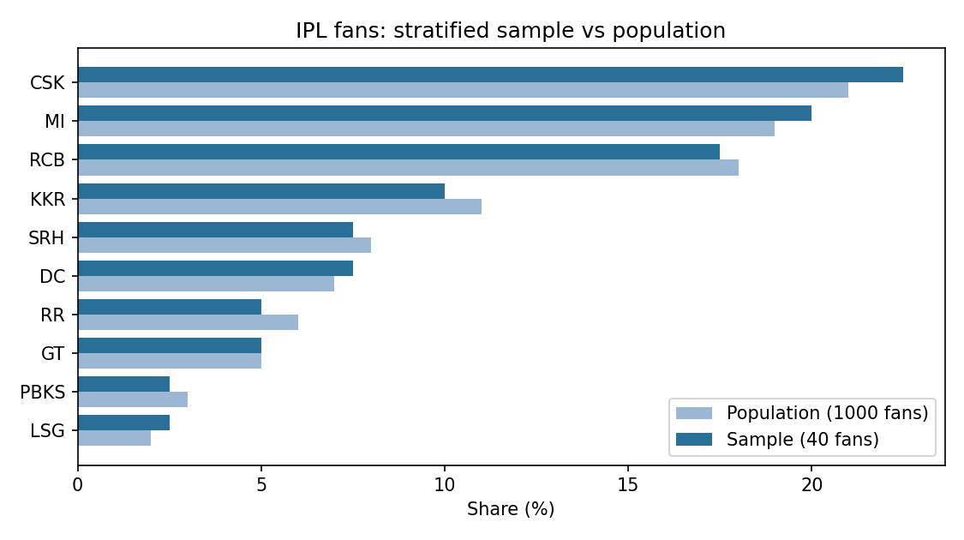

Final answer
The 40-fan sample has CSK 9, MI 8, RCB 7, KKR 4, SRH 3, DC 3, RR 2, GT 2, PBKS 1, LSG 1. Every team is within 1.5 percentage points of its population share.

