Central Limit Theorem
Data Analytics Assignment: solutions with Python (numpy, pandas, scipy, matplotlib)

Task 1: CLT Simulation with Instagram Likes

Problem
Take 1000 random samples (size 30) from a skewed dataset such as Instagram post likes, calculate the mean of each sample, and plot a histogram of the sample means using matplotlib.

Approach
- Create a right-skewed population of 100,000 posts with a lognormal distribution (most posts get few likes, a few go viral).
- Draw 1000 random samples of 30 posts each and calculate the mean of every sample.
- Plot the population histogram next to the histogram of the 1000 sample means, with the theoretical normal curve on top.

Python code (task1_clt_simulation.py)
import os
import numpy as np
import pandas as pd
from scipy import stats
import matplotlib
matplotlib.use("Agg")
import matplotlib.pyplot as plt

OUT = os.path.join(os.path.dirname(os.path.abspath(__file__)), "charts")
os.makedirs(OUT, exist_ok=True)
rng = np.random.default_rng(seed=1)

# ---- Skewed population: likes on 100,000 Instagram posts (most posts low, a few go viral) ----
likes = np.round(rng.lognormal(mean=5.0, sigma=0.8, size=100_000))
pop_mean, pop_sd = likes.mean(), likes.std()

# ---- 1000 random samples of size 30 -> mean of each ----
N_SAMPLES, n = 1000, 30
sample_means = np.array([rng.choice(likes, size=n, replace=False).mean() for _ in range(N_SAMPLES)])

summary = pd.DataFrame({
"Population (likes)": [pop_mean, pop_sd, stats.skew(likes)],
f"1000 sample means (n={n})": [sample_means.mean(), sample_means.std(ddof=1), stats.skew(sample_means)],
}, index=["Mean", "Std deviation", "Skewness"]).round(2)
print(summary.to_string(), "\n")
print(f"Theory: SD of sample means = sigma / sqrt(n) = {pop_sd:.2f} / {np.sqrt(n):.3f} = {pop_sd / np.sqrt(n):.2f}")

# ---- Plots ----
fig, axes = plt.subplots(1, 2, figsize=(11, 4))
axes[0].hist(likes, bins=60, color="#9bb7d4", edgecolor="white")
axes[0].set_title("Population: likes per post (right-skewed)")
axes[0].set_xlabel("Likes")
axes[0].set_ylabel("Number of posts")

axes[1].hist(sample_means, bins=30, density=True, color="#2a6f97", edgecolor="white", label="Sample means")
x = np.linspace(sample_means.min(), sample_means.max(), 300)
axes[1].plot(x, stats.norm.pdf(x, pop_mean, pop_sd / np.sqrt(n)), "r-", lw=2, label="Normal curve (theory)")
axes[1].axvline(pop_mean, color="black", ls="--", label=f"Population mean {pop_mean:.0f}")
axes[1].set_title(f"Distribution of 1000 sample means (n = {n})")
axes[1].set_xlabel("Sample mean of likes")
axes[1].set_ylabel("Density")
axes[1].legend()
plt.tight_layout()
plt.savefig(os.path.join(OUT, "task1.png"), dpi=150)

Output
Population (likes) 1000 sample means (n=30)
Mean 203.50 202.69
Std deviation 194.38 35.47
Skewness 3.82 0.72

Theory: SD of sample means = sigma / sqrt(n) = 194.38 / 5.477 = 35.49

Chart
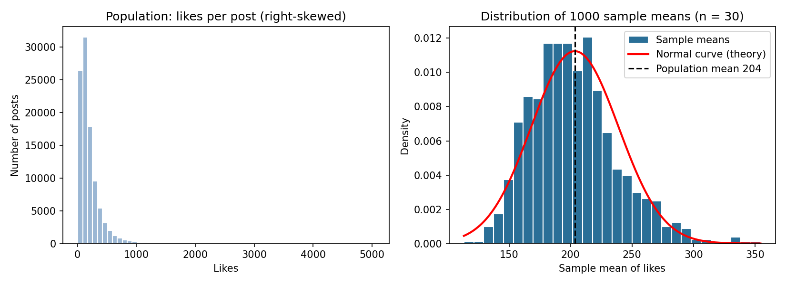

Observation
The population is strongly right-skewed (skewness 3.82), but the histogram of sample means is much more symmetric and bell-shaped (skewness 0.72). The mean of the sample means (202.7) is almost the population mean (203.5), and their standard deviation (35.47) matches the theory value σ/√n = 35.49.

Final answer
With n = 30, the sample means cluster symmetrically around the true mean (about 203 likes) even though the original likes data is heavily skewed.

Task 2: Why the Sampling Distribution Becomes Normal

Problem
Explain in your own words why the sampling distribution of the mean becomes approximately normal even if the original data is not, using an example from an app you use daily.

Approach
- Use Zomato order amounts as the example: they are right-skewed because most orders are small and a few party orders are very large.
- Simulate the average of n = 1, 2, 5 and 30 orders (5000 repeats each) and watch how the shape changes.

Explanation in my own words
Think of Zomato order amounts. Most orders are around Rs 300 to 500, but now and then someone orders for a big party and the amount jumps to Rs 2000 or more. So the histogram of single orders is not a bell curve: it has a long tail on the right.
Now suppose I do not look at one order but take the average of 30 random orders. A huge order can still appear in my 30, but it is usually balanced by many ordinary ones, so the average stays close to the middle. Averages that are far above or far below the typical value need many big orders or many tiny orders at the same time, which is rare. Most averages therefore land near the true mean, and extreme averages become rare on both sides. That is exactly the shape of a bell curve.
The more orders I put in each average, the stronger this balancing effect becomes, so the long tail fades and the curve gets narrower. The simulation shows this: the skewness drops from 1.77 for single orders to 0.33 for averages of 30, and the spread of the averages follows σ/√n (Rs 243 for one order, about Rs 44 for 30). This is the Central Limit Theorem: whatever the shape of the original data, the distribution of sample means approaches a normal distribution as the sample size grows.

Python code (task2_zomato_clt_explained.py)
import os
import numpy as np
import pandas as pd
from scipy import stats
import matplotlib
matplotlib.use("Agg")
import matplotlib.pyplot as plt

OUT = os.path.join(os.path.dirname(os.path.abspath(__file__)), "charts")
os.makedirs(OUT, exist_ok=True)
rng = np.random.default_rng(seed=2)

# Skewed population: Zomato order amounts in rupees (many small orders, few very large party orders)
orders = rng.lognormal(mean=6.0, sigma=0.5, size=100_000)
mu, sigma = orders.mean(), orders.std()
print(f"Population of order amounts: mean = Rs {mu:.0f}, SD = Rs {sigma:.0f}, skewness = {stats.skew(orders):.2f}\n")

# Average of n orders, repeated 5000 times, for growing n
sizes = [1, 2, 5, 30]
rows = []
fig, axes = plt.subplots(1, 4, figsize=(14, 3.6), sharex=True)
for ax, n in zip(axes, sizes):
means = rng.choice(orders, size=(5000, n)).mean(axis=1)
rows.append({"n (orders averaged)": n, "Mean of means": means.mean(),
"SD of means": means.std(ddof=1), "Theory sigma/sqrt(n)": sigma / np.sqrt(n),
"Skewness": stats.skew(means)})
ax.hist(means, bins=40, color="#2a6f97", edgecolor="white")
ax.set_title(f"n = {n}")
ax.set_xlabel("Average order (Rs)")
axes[0].set_ylabel("Frequency")
fig.suptitle("Average of n Zomato orders: skew fades and the shape turns bell-like as n grows")
plt.tight_layout()
plt.savefig(os.path.join(OUT, "task2.png"), dpi=150)

print(pd.DataFrame(rows).round(2).to_string(index=False))

Output
Population of order amounts: mean = Rs 457, SD = Rs 243, skewness = 1.77

n (orders averaged) Mean of means SD of means Theory sigma/sqrt(n) Skewness
1 459.56 249.24 243.10 1.77
2 456.96 167.16 171.90 1.09
5 458.65 110.91 108.72 0.86
30 457.20 44.68 44.38 0.33

Chart
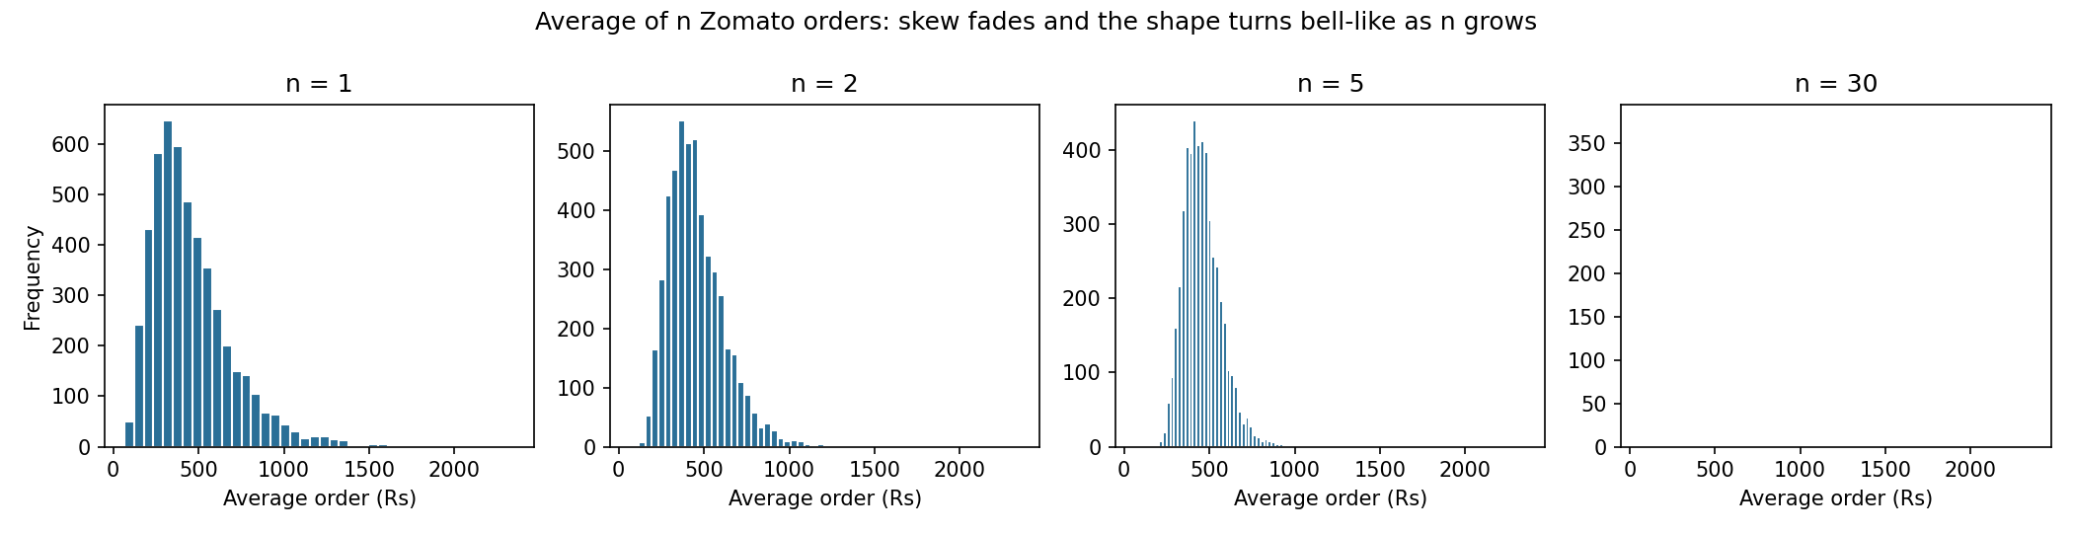

Final answer
Averaging cancels out extreme values, so sample means pile up around the true mean in a symmetric bell shape, and this gets stronger as n increases.

Task 3: CLT in Business Decisions (Flipkart)

Problem
Pick a real-world scenario from Flipkart, Swiggy or IRCTC where the Central Limit Theorem could help in analytics or business decisions, and describe how it would be useful.

Approach
- Scenario: Flipkart tests a new checkout page that suggests “frequently bought together” items, and wants to know if it raises the average order value (AOV).
- Order values are skewed, but with 400 orders per group the CLT lets us treat each group’s sample mean as approximately normal, so we can build confidence intervals and a z-test.
- The script also uses the same idea to plan how many orders are needed.

Short paragraph
Flipkart order values are not normally distributed because a few expensive purchases create a long right tail. When the team tests a new checkout page, they only have a sample of orders, not every future order. Thanks to the Central Limit Theorem, the average order value of a sample of a few hundred orders is approximately normally distributed, so the team can calculate a standard error, build a 95% confidence interval for the average order value, and run a z-test to check whether the difference between the old and new page is real or just random variation. The same idea tells them how many orders to collect before making a decision, and prevents costly choices based on too little data.

Observation from the simulation
The new page showed a higher mean AOV (Rs 855 vs Rs 815), but the 95% CI for the difference (−Rs 35 to +Rs 115) includes zero and p = 0.29, so with 400 orders per group the gain cannot be called significant. To estimate AOV within ±Rs 30, about 1300 orders are needed. This shows how CLT-based reasoning protects a business from acting on noise.

Python code (task3_flipkart_ab_test.py)
import os
import numpy as np
import pandas as pd
from scipy import stats
import matplotlib
matplotlib.use("Agg")
import matplotlib.pyplot as plt

OUT = os.path.join(os.path.dirname(os.path.abspath(__file__)), "charts")
os.makedirs(OUT, exist_ok=True)
rng = np.random.default_rng(seed=3)

# Order values are skewed, yet CLT lets us treat the SAMPLE MEAN as approximately normal.
control = rng.lognormal(mean=6.50, sigma=0.60, size=400) # old checkout page
variant = rng.lognormal(mean=6.50, sigma=0.60, size=400) * 1.06 # new page with "frequently bought together"

def mean_ci(x, z=1.96):
m, se = x.mean(), x.std(ddof=1) / np.sqrt(len(x))
return m, se, (m - z * se, m + z * se)

m_c, se_c, ci_c = mean_ci(control)
m_v, se_v, ci_v = mean_ci(variant)
diff = m_v - m_c
se_diff = np.sqrt(se_c ** 2 + se_v ** 2)
z = diff / se_diff
p_value = 2 * (1 - stats.norm.cdf(abs(z)))

print(pd.DataFrame({"n": [400, 400], "Mean AOV (Rs)": [m_c, m_v], "SE": [se_c, se_v],
"95% CI low": [ci_c[0], ci_v[0]], "95% CI high": [ci_c[1], ci_v[1]]},
index=["Control", "New checkout"]).round(1).to_string(), "\n")
print(f"Difference in mean AOV = Rs {diff:.1f} (SE = {se_diff:.1f})")
print(f"95% CI for difference = ({diff - 1.96 * se_diff:.1f}, {diff + 1.96 * se_diff:.1f})")
print(f"z = {z:.2f}, p-value = {p_value:.4f} -> "
f"{'significant' if p_value < 0.05 else 'not significant'} at 5%\n")

# Sample-size planning: orders needed to estimate AOV within +/- Rs 30 at 95% confidence
sigma_hat = control.std(ddof=1)
for margin in (50, 30, 20):
need = int(np.ceil((1.96 * sigma_hat / margin) ** 2))
print(f"Margin +/- Rs {margin}: need about {need} orders")

# Chart: mean AOV with 95% CI
fig, ax = plt.subplots(figsize=(5.5, 4))
ax.bar(["Control", "New checkout"], [m_c, m_v], yerr=[1.96 * se_c, 1.96 * se_v],
capsize=8, color=["#9bb7d4", "#2a6f97"])
ax.set_ylabel("Average order value (Rs)")
ax.set_title("Flipkart AOV with 95% CI (CLT-based)")
plt.tight_layout()
plt.savefig(os.path.join(OUT, "task3.png"), dpi=150)

Output
n Mean AOV (Rs) SE 95% CI low 95% CI high
Control 400 815.4 27.6 761.3 869.4
New checkout 400 855.3 26.2 803.9 906.7

Difference in mean AOV = Rs 39.9 (SE = 38.1)
95% CI for difference = (-34.7, 114.5)
z = 1.05, p-value = 0.2940 -> not significant at 5%

Margin +/- Rs 50: need about 468 orders
Margin +/- Rs 30: need about 1300 orders
Margin +/- Rs 20: need about 2923 orders

Chart
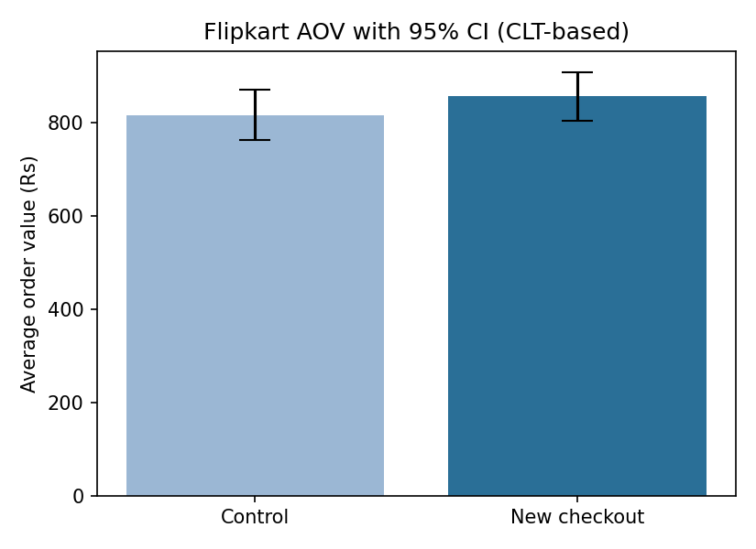

Final answer
CLT lets Flipkart use sample averages to build confidence intervals, test changes (A/B tests) and plan sample sizes even though individual order values are skewed.

Task 4: Comparing n = 5 and n = 30

Problem
Modify the CLT simulation to use a much smaller sample size (n = 5) and compare the histogram of sample means with the one for n = 30.

Approach
- Reuse the same skewed Instagram likes population.
- Run the simulation twice (n = 5 and n = 30, 1000 samples each) and plot both histograms on the same axes so spread and shape can be compared fairly.
- Compare standard deviation, skewness and a Shapiro-Wilk normality test.
- Note: the random draws differ from Task 1, so the n = 30 numbers differ slightly from Task 1. The pattern is the same.

Python code (task4_sample_size_comparison.py)
import os
import numpy as np
import pandas as pd
from scipy import stats
import matplotlib
matplotlib.use("Agg")
import matplotlib.pyplot as plt

OUT = os.path.join(os.path.dirname(os.path.abspath(__file__)), "charts")
os.makedirs(OUT, exist_ok=True)
rng = np.random.default_rng(seed=1)

likes = np.round(rng.lognormal(mean=5.0, sigma=0.8, size=100_000))
pop_mean, pop_sd = likes.mean(), likes.std()

def simulate(n, n_samples=1000):
return np.array([rng.choice(likes, size=n, replace=False).mean() for _ in range(n_samples)])

results = {n: simulate(n) for n in (5, 30)}

rows = []
for n, m in results.items():
rows.append({"Sample size n": n, "Mean of means": m.mean(), "SD of means": m.std(ddof=1),
"Theory sigma/sqrt(n)": pop_sd / np.sqrt(n), "Skewness": stats.skew(m),
"Shapiro-Wilk p": stats.shapiro(m).pvalue})
print(f"Population mean = {pop_mean:.1f}, SD = {pop_sd:.1f}\n")
print(pd.DataFrame(rows).round(3).to_string(index=False))
print("\n(Shapiro-Wilk p > 0.05 would mean 'no evidence against normality'; lower = less normal.)")

# Same x-axis for both so the spread can be compared fairly
lo = min(m.min() for m in results.values())
hi = max(m.max() for m in results.values())
fig, axes = plt.subplots(1, 2, figsize=(11, 4), sharex=True, sharey=True)
for ax, (n, m) in zip(axes, results.items()):
ax.hist(m, bins=35, range=(lo, hi), density=True, color="#2a6f97", edgecolor="white")
x = np.linspace(lo, hi, 300)
ax.plot(x, stats.norm.pdf(x, pop_mean, pop_sd / np.sqrt(n)), "r-", lw=2, label="Normal curve (theory)")
ax.axvline(pop_mean, color="black", ls="--")
ax.set_title(f"n = {n} (skewness {stats.skew(m):.2f})")
ax.set_xlabel("Sample mean of likes")
axes[0].set_ylabel("Density")
axes[0].legend()
plt.tight_layout()
plt.savefig(os.path.join(OUT, "task4.png"), dpi=150)

Output
Population mean = 203.5, SD = 194.4

Sample size n Mean of means SD of means Theory sigma/sqrt(n) Skewness Shapiro-Wilk p
5 200.457 81.672 86.929 1.178 0.0
30 202.101 34.704 35.489 0.492 0.0

(Shapiro-Wilk p > 0.05 would mean 'no evidence against normality'; lower = less normal.)

Chart
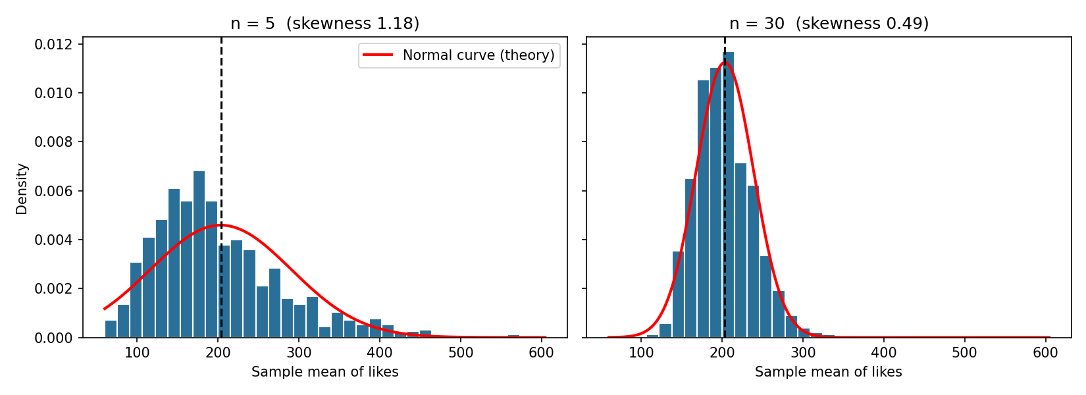

Observations
Spread: for n = 5 the sample means have a standard deviation of about 81.7, versus about 34.7 for n = 30. Larger samples give a narrower histogram, as predicted by σ/√n (86.9 vs 35.5).
Shape: for n = 5 the histogram is still clearly right-skewed (skewness 1.18) with a long tail to the right. For n = 30 it is closer to a bell curve (skewness 0.49), although a small right tail remains because this population is heavily skewed.
Centre: both histograms are centred near the true mean (about 203), so sample size changes the precision and shape, not the centre.

Final answer
A small sample (n = 5) gives a wide, skewed distribution of means; n = 30 gives a narrower and much more bell-shaped one. The Shapiro-Wilk test still flags slight non-normality at n = 30 for this very skewed data, so a larger n would be needed for a closer fit.

Task 5: CLT with an Exponential Distribution

Problem
Use an AI tool to generate Python code that demonstrates the CLT using random samples from a non-normal distribution (e.g., exponential). Run the code, paste the output plot, and briefly describe what you observe.

AI prompt used
"Write Python code that demonstrates the Central Limit Theorem using random samples from a non-normal distribution such as the exponential distribution."

AI used
The code below was generated by Claude (an AI assistant) and then run and checked.

Python code (task5_exponential_clt.py)
import os
import numpy as np
from scipy import stats
import matplotlib
matplotlib.use("Agg")
import matplotlib.pyplot as plt

OUT = os.path.join(os.path.dirname(os.path.abspath(__file__)), "charts")
os.makedirs(OUT, exist_ok=True)
rng = np.random.default_rng(seed=5)

scale = 2.0 # exponential with mean = SD = 2
mu, sigma = scale, scale
sizes = [1, 5, 30, 100]
n_samples = 5000

fig, axes = plt.subplots(1, 4, figsize=(15, 3.8))
print(f"Exponential(scale={scale}): mean = {mu}, SD = {sigma}, skewness = 2.0\n")
print(f"{'n':>4} {'mean of means':>14} {'SD of means':>12} {'sigma/sqrt(n)':>14} {'skewness':>9}")
for ax, n in zip(axes, sizes):
means = rng.exponential(scale, size=(n_samples, n)).mean(axis=1)
print(f"{n:>4} {means.mean():>14.3f} {means.std(ddof=1):>12.3f} {sigma / np.sqrt(n):>14.3f} {stats.skew(means):>9.3f}")
ax.hist(means, bins=40, density=True, color="#2a6f97", edgecolor="white")
x = np.linspace(means.min(), means.max(), 300)
ax.plot(x, stats.norm.pdf(x, mu, sigma / np.sqrt(n)), "r-", lw=2)
ax.set_title(f"n = {n}")
ax.set_xlabel("Sample mean")
axes[0].set_ylabel("Density")
fig.suptitle("CLT with an exponential distribution (red = normal curve predicted by CLT)")
plt.tight_layout()
plt.savefig(os.path.join(OUT, "task5.png"), dpi=150)

Output
Exponential(scale=2.0): mean = 2.0, SD = 2.0, skewness = 2.0

n mean of means SD of means sigma/sqrt(n) skewness
1 1.954 1.979 2.000 1.918
5 1.983 0.886 0.894 0.858
30 1.999 0.365 0.365 0.336
100 2.003 0.202 0.200 0.184

Output plot
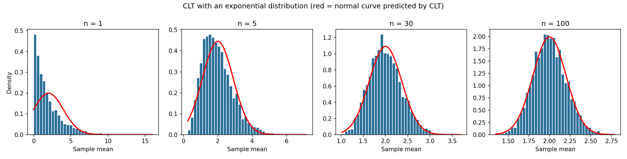

What I observe
A single exponential value (n = 1) has a very skewed histogram (skewness about 1.9). As the sample size grows to 5, 30 and 100, the histogram of sample means becomes more symmetric (skewness 0.86, 0.34, 0.18) and fits the red normal curve better. The standard deviation of the means shrinks as σ/√n (1.98, 0.89, 0.37, 0.20 for σ = 2), and every histogram stays centred at the true mean of 2.

Final answer
Even though the exponential distribution is far from normal, the distribution of sample means becomes approximately normal as n increases.

