Normal Distribution
Data Analytics Assignment: solutions with Python (numpy, scipy, matplotlib)

Task 1: Random Numbers from a Normal Distribution

Problem
Write a Python script that generates 1000 random numbers following a normal distribution with mean 500 and standard deviation 100, then plot the distribution using matplotlib.

Solution
- np.random.default_rng(seed=1).normal(loc=500, scale=100, size=1000) generates the numbers; plt.hist() plots them as a density histogram and the red curve is the theoretical normal curve.
- The sample mean is 494.57 and the sample standard deviation is 98.68, both close to the targets of 500 and 100.
- 69.9% of the values are within 1 standard deviation of the mean (theory 68.3%) and 95.5% are within 2 standard deviations (theory 95.4%).
The histogram is bell-shaped and symmetric around 500. It does not match the red curve exactly because 1000 random values always show some random variation.

Final answer
Histogram of 1000 values from Normal(500, 100), shown below and saved as normal_distribution.png.

Python code
import os
import numpy as np
import matplotlib
if "__file__" in globals(): # plain script: save to file; notebook: show inline
matplotlib.use("Agg")
import matplotlib.pyplot as plt
from scipy import stats

HERE = os.path.dirname(os.path.abspath(__file__)) if "__file__" in globals() else os.getcwd()

mu, sigma, n = 500, 100, 1000
rng = np.random.default_rng(seed=1)
data = rng.normal(loc=mu, scale=sigma, size=n)

print(f"Generated {n} numbers from Normal(mean = {mu}, SD = {sigma})")
print(f"First 10 values : {np.round(data[:10], 1).tolist()}")
print(f"Sample mean = {data.mean():.2f} (target {mu})")
print(f"Sample SD = {data.std(ddof=1):.2f} (target {sigma})")
print(f"Min / Max = {data.min():.1f} / {data.max():.1f}")
within1 = np.mean(np.abs(data - mu) <= sigma)
within2 = np.mean(np.abs(data - mu) <= 2 * sigma)
print(f"Within 1 SD of the mean: {within1:.1%} (theory 68.3%)")
print(f"Within 2 SD of the mean: {within2:.1%} (theory 95.4%)")

plt.figure(figsize=(8, 4.5))
plt.hist(data, bins=30, density=True, color="#9bb7d4", edgecolor="white", label="1000 random numbers")
x = np.linspace(data.min(), data.max(), 300)
plt.plot(x, stats.norm.pdf(x, mu, sigma), color="red", lw=2, label="Normal curve (mean 500, SD 100)")
plt.axvline(mu, color="black", ls="--", label="Mean = 500")
plt.xlabel("Value")
plt.ylabel("Density")
plt.title("1000 random numbers from a normal distribution")
plt.legend()
plt.tight_layout()
plt.savefig(os.path.join(HERE, "normal_distribution.png"), dpi=150)
if "__file__" not in globals():
plt.show()
print("Plot saved to normal_distribution.png")

Output
Generated 1000 numbers from Normal(mean = 500, SD = 100)
First 10 values : [534.6, 582.2, 533.0, 369.7, 590.5, 544.6, 446.3, 558.1, 536.5, 529.4]
Sample mean = 494.57 (target 500)
Sample SD = 98.68 (target 100)
Min / Max = 145.1 / 875.2
Within 1 SD of the mean: 69.9% (theory 68.3%)
Within 2 SD of the mean: 95.5% (theory 95.4%)
Plot saved to normal_distribution.png

Plot
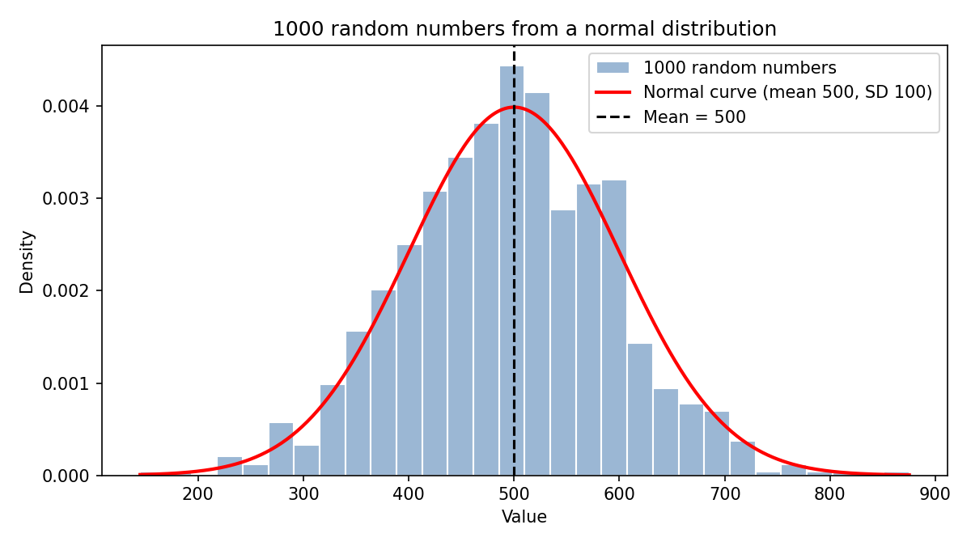

Task 2: Z-Score of a 9500-Step Day

Problem
Calculate the Z-score for a day where the user walked 9500 steps in a fitness app, assuming a mean of 8000 and a standard deviation of 1200. (Hint: Z = (X − μ) / σ)

Solution
- Z = (X − μ) / σ = (9500 − 8000) / 1200 = 1500 / 1200 = 1.25.
- The script also applies the same formula to an array of 14 daily step counts, which includes the 9500-step day.
Interpretation: the 9500-step day is 1.25 standard deviations above the user’s average. About 89.4% of days have fewer steps and only about 10.6% have more, so it is a good day but not unusual (unusual would be |Z| above 2).

Final answer
Z = 1.25 (the 9500-step day is 1.25 standard deviations above the mean, around the 89th percentile).

Python code
import numpy as np
from scipy.stats import norm

mu, sigma = 8000, 1200
x = 9500

# Z = (X - mu) / sigma
z = (x - mu) / sigma
print(f"Z = (X - mu) / sigma = ({x} - {mu}) / {sigma} = {z:.2f}")
print(f"The 9500-step day is {z:.2f} standard deviations above the mean.")
print(f"Percentile: {norm.cdf(z):.1%} of days have fewer steps than this day "
f"(only {norm.sf(z):.1%} of days are higher).\n")

# The same formula applied to a whole array of daily step counts (14 days)
steps = np.array([7200, 8100, 6500, 9500, 8800, 7600, 10200, 5900, 8400, 9100, 7000, 8000, 9900, 6800])
z_scores = (steps - mu) / sigma
print("Day Steps Z-score")
for day, (s, zz) in enumerate(zip(steps, z_scores), start=1):
flag = " <-- the 9500-step day" if s == x else ""
print(f"{day:>3} {s:>5} {zz:>6.2f}{flag}")

print(f"\nCheck: the 9500-step row in the table has Z = {z_scores[steps == x][0]:.2f}, matching the single calculation above.")
print("Rule of thumb: |Z| > 2 is unusual, |Z| > 3 is very unusual. Z = 1.25 is a good but ordinary day.")

Output
Z = (X - mu) / sigma = (9500 - 8000) / 1200 = 1.25
The 9500-step day is 1.25 standard deviations above the mean.
Percentile: 89.4% of days have fewer steps than this day (only 10.6% of days are higher).

Day Steps Z-score
1 7200 -0.67
2 8100 0.08
3 6500 -1.25
4 9500 1.25 <-- the 9500-step day
5 8800 0.67
6 7600 -0.33
7 10200 1.83
8 5900 -1.75
9 8400 0.33
10 9100 0.92
11 7000 -0.83
12 8000 0.00
13 9900 1.58
14 6800 -1.00

Check: the 9500-step row in the table has Z = 1.25, matching the single calculation above.
Rule of thumb: |Z| > 2 is unusual, |Z| > 3 is very unusual. Z = 1.25 is a good but ordinary day.

Task 3: Standard Normal Curve with Shaded Area

Problem
Plot a standard normal curve (mean 0, standard deviation 1) using matplotlib and shade the area between Z = −1 and Z = 1 to visualise the probability of values within one standard deviation.

Solution
- The curve is drawn with scipy.stats.norm.pdf(z) and the region between −1 and 1 is filled with plt.fill_between().
- The shaded area is P(−1 < Z < 1) = cdf(1) − cdf(−1) = 0.8413 − 0.1587 = 0.6827.
So about 68.27% of values in a normal distribution lie within one standard deviation of the mean. This is the first part of the 68-95-99.7 rule.

Final answer
Shaded plot below (saved as standard_normal.png): P(−1 < Z < 1) = 0.6827, about 68.27%.

Python code
import os
import numpy as np
import matplotlib
if "__file__" in globals():
matplotlib.use("Agg")
import matplotlib.pyplot as plt
from scipy.stats import norm

HERE = os.path.dirname(os.path.abspath(__file__)) if "__file__" in globals() else os.getcwd()

z = np.linspace(-4, 4, 500)
pdf = norm.pdf(z, loc=0, scale=1)

area = norm.cdf(1) - norm.cdf(-1) # P(-1 < Z < 1)
print(f"P(-1 < Z < 1) = cdf(1) - cdf(-1) = {norm.cdf(1):.4f} - {norm.cdf(-1):.4f} = {area:.4f} ({area:.2%})")

plt.figure(figsize=(8, 4.5))
plt.plot(z, pdf, color="black", lw=2)
mask = (z >= -1) & (z <= 1)
plt.fill_between(z[mask], pdf[mask], color="#2a6f97", alpha=0.6, label=f"P(-1 < Z < 1) = {area:.2%}")
plt.axvline(-1, color="red", ls="--")
plt.axvline(1, color="red", ls="--")
plt.text(0, 0.17, f"{area:.2%}", ha="center", fontsize=14, color="white", fontweight="bold")
plt.xlabel("Z (standard deviations from the mean)")
plt.ylabel("Probability density")
plt.title("Standard normal curve: area within one standard deviation")
plt.legend()
plt.tight_layout()
plt.savefig(os.path.join(HERE, "standard_normal.png"), dpi=150)
if "__file__" not in globals():
plt.show()
print("Plot saved to standard_normal.png")

Output
P(-1 < Z < 1) = cdf(1) - cdf(-1) = 0.8413 - 0.1587 = 0.6827 (68.27%)
Plot saved to standard_normal.png

Plot
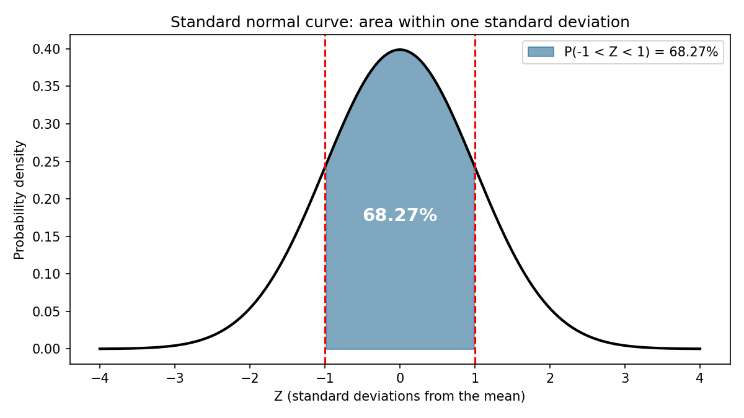

Task 4: Probability of a Delivery Under 25 Minutes

Problem
Zomato delivery times are normally distributed with mean 30 and standard deviation 5 minutes. Find the probability that a randomly selected delivery takes less than 25 minutes. (Hint: scipy.stats.norm.cdf())

Solution
- Z = (25 − 30) / 5 = −1.00.
- P(X < 25) = norm.cdf(25, loc=30, scale=5) = norm.cdf(−1) = 0.1587.
So about 15.87% of deliveries take less than 25 minutes. By symmetry the same share (15.87%) takes more than 35 minutes, and 68.27% fall between 25 and 35 minutes. Also, 90% of deliveries are completed within 36.4 minutes.

Final answer
P(delivery time < 25 minutes) = 0.1587 (about 15.87%).

Python code
from scipy.stats import norm

mu, sigma = 30, 5

# P(X < 25) with scipy.stats.norm.cdf
p = norm.cdf(25, loc=mu, scale=sigma)
z = (25 - mu) / sigma
print(f"Z for 25 minutes = (25 - {mu}) / {sigma} = {z:.2f}")
print(f"P(delivery time < 25 min) = norm.cdf(25, {mu}, {sigma}) = {p:.4f} ({p:.2%})")
print(f"Check with the standard normal: norm.cdf({z:.0f}) = {norm.cdf(z):.4f}\n")

print("A few related probabilities:")
print(f" P(time > 35 min) = {norm.sf(35, mu, sigma):.4f}")
print(f" P(25 < time < 35 min) = {norm.cdf(35, mu, sigma) - norm.cdf(25, mu, sigma):.4f}")
print(f" Time that 90% of deliveries beat = {norm.ppf(0.90, mu, sigma):.1f} minutes")

Output
Z for 25 minutes = (25 - 30) / 5 = -1.00
P(delivery time < 25 min) = norm.cdf(25, 30, 5) = 0.1587 (15.87%)
Check with the standard normal: norm.cdf(-1) = 0.1587

A few related probabilities:
P(time > 35 min) = 0.1587
P(25 < time < 35 min) = 0.6827
Time that 90% of deliveries beat = 36.4 minutes

Task 5: Why the Normal Distribution Matters (AI Explanation)

Problem
Use an AI tool to explain why the normal distribution is important for analysing real-world app data like sales, delivery times or user ratings. Paste your prompt and the AI’s answer.

Solution
- AI used: Claude (an AI assistant). If your instructions require ChatGPT, run the same prompt there and paste its answer instead.

Prompt
"Explain in simple words why the normal distribution is important for analysing real-world app data like sales, delivery times or user ratings."

AI answer
The normal distribution (the bell curve) matters for three main reasons.
1. Many real measurements are the sum of lots of small, independent effects. A delivery time is made up of restaurant preparation time, rider speed, traffic and weather. When many small effects add up, the total tends to follow a bell shape, with most values near the average and few at the extremes.
2. Averages are approximately normal even when the raw data is not (the Central Limit Theorem). Individual order values are skewed because a few large orders pull the tail to the right, but the average of 30 or 40 orders is close to normal. This is what makes confidence intervals, t-tests and A/B tests on average sales or ratings valid.
3. Its properties are known exactly, so we can turn data into probabilities. About 68% of values lie within 1 standard deviation of the mean, 95% within 2 and 99.7% within 3. With Z-scores we can say how unusual a value is: a 52-minute delivery when the average is 30 with SD 5 has Z = 4.4 and should be investigated. We can also set targets, such as promising delivery within 36.4 minutes for 90% of orders.
A caution: not all app data is normal. Order values are skewed, delivery times have a long right tail, and ratings are limited to 1-5. Always check the shape with a histogram. Even then, the normal distribution still helps because the averages of such data are close to normal.

My analysis (draft in my own words)
The normal distribution is useful in app analytics because it lets us describe typical values and unusual values with probabilities, and because, thanks to the Central Limit Theorem, averages of messy data like sales or delivery times behave normally. In my supporting script, the skewness of raw order values (2.21) dropped to 0.32 for averages of 40 orders.

Final answer
The normal distribution matters because many measurements are bell-shaped, sample averages become normal (CLT), and its known properties let us compute probabilities, Z-scores and unusual-value alerts.

Python code
import numpy as np
from scipy import stats

rng = np.random.default_rng(seed=5)

# 1) The 68-95-99.7 rule on delivery times (normal, mean 30, SD 5)
times = rng.normal(30, 5, 100_000)
print("1) Empirical rule on simulated delivery times (mean 30, SD 5):")
for k, theory in [(1, 68.27), (2, 95.45), (3, 99.73)]:
share = np.mean(np.abs(times - 30) <= k * 5) * 100
print(f" within {k} SD ({30 - 5 * k}-{30 + 5 * k} min): {share:.2f}% (theory {theory}%)")

# 2) Z-scores flag unusual orders
sample = np.array([28, 31, 29, 33, 27, 30, 52, 32, 29, 31])
z = (sample - 30) / 5
print("\n2) Z-scores flag unusual delivery times (|Z| > 3):")
for t, zz in zip(sample, z):
print(f" {t:>3} min -> Z = {zz:>5.1f}{' <-- unusual, investigate' if abs(zz) > 3 else ''}")

# 3) Averages become normal even when the raw data is skewed (Central Limit Theorem)
orders = rng.lognormal(mean=6, sigma=0.6, size=200_000) # skewed order values
means = rng.choice(orders, size=(5000, 40)).mean(axis=1) # 5000 samples of 40 orders
print("\n3) Skewed order values vs the averages of 40 orders:")
print(f" skewness of raw order values = {stats.skew(orders):.2f}")
print(f" skewness of sample averages = {stats.skew(means):.2f} (much closer to 0, the normal shape)")
print(" This is why confidence intervals and hypothesis tests on averages work for sales data.")

Output
1) Empirical rule on simulated delivery times (mean 30, SD 5):
within 1 SD (25-35 min): 68.29% (theory 68.27%)
within 2 SD (20-40 min): 95.50% (theory 95.45%)
within 3 SD (15-45 min): 99.74% (theory 99.73%)

2) Z-scores flag unusual delivery times (|Z| > 3):
28 min -> Z = -0.4
31 min -> Z = 0.2
29 min -> Z = -0.2
33 min -> Z = 0.6
27 min -> Z = -0.6
30 min -> Z = 0.0
52 min -> Z = 4.4 <-- unusual, investigate
32 min -> Z = 0.4
29 min -> Z = -0.2
31 min -> Z = 0.2

3) Skewed order values vs the averages of 40 orders:
skewness of raw order values = 2.21
skewness of sample averages = 0.32 (much closer to 0, the normal shape)
This is why confidence intervals and hypothesis tests on averages work for sales data.

