Probability Distributions
Data Analytics Assignment: solutions with Python (numpy, scipy, matplotlib)

Task 1: Bernoulli Trials (Zomato Login)

Problem
Simulate a Bernoulli trial in Python to model whether a user successfully logs into their Zomato account (success = 1, failure = 0) with success probability p = 0.85. Run the simulation 20 times and print the results.

Solution
- A Bernoulli trial has exactly two outcomes: success (1) with probability p and failure (0) with probability 1 − p. Each login attempt is one trial with p = 0.85.
- The code draws a random number between 0 and 1 for each attempt and records 1 if it is below 0.85 (np.random.Generator.random() < p). scipy.stats.bernoulli.rvs gives the same kind of result.
- Results of the 20 simulated attempts: [1, 0, 1, 0, 1, 1, 1, 1, 1, 1, 1, 1, 1, 1, 1, 1, 1, 1, 1, 1], which is 18 successes and 2 failures.
The observed success rate is 0.90, close to the theoretical 0.85. It will not match exactly in only 20 trials, and it moves closer to 0.85 as the number of trials grows.

Final answer
18 successes and 2 failures in 20 simulated logins (observed rate 0.90 vs p = 0.85).

Python code
import numpy as np

p = 0.85 # probability of a successful login
n_trials = 20
rng = np.random.default_rng(seed=1)

# Each trial is a Bernoulli(p): 1 = success, 0 = failure
results = (rng.random(n_trials) < p).astype(int)

print(f"Bernoulli simulation: p = {p}, {n_trials} login attempts")
print("Results:", results.tolist())
for i, r in enumerate(results, start=1):
print(f" Attempt {i:>2}: {'success (1)' if r == 1 else 'failure (0)'}")

print(f"\nSuccesses = {results.sum()}, failures = {n_trials - results.sum()}")
print(f"Observed success rate = {results.mean():.2f} (theoretical p = {p})")

# Optional: the same experiment with scipy's Bernoulli distribution
from scipy import stats
results2 = stats.bernoulli.rvs(p, size=n_trials, random_state=1)
print("\nscipy.stats.bernoulli.rvs gives:", results2.tolist())

Output
Bernoulli simulation: p = 0.85, 20 login attempts
Results: [1, 0, 1, 0, 1, 1, 1, 1, 1, 1, 1, 1, 1, 1, 1, 1, 1, 1, 1, 1]
Attempt 1: success (1)
Attempt 2: failure (0)
Attempt 3: success (1)
Attempt 4: failure (0)
Attempt 5: success (1)
Attempt 6: success (1)
Attempt 7: success (1)
Attempt 8: success (1)
Attempt 9: success (1)
Attempt 10: success (1)
Attempt 11: success (1)
Attempt 12: success (1)
Attempt 13: success (1)
Attempt 14: success (1)
Attempt 15: success (1)
Attempt 16: success (1)
Attempt 17: success (1)
Attempt 18: success (1)
Attempt 19: success (1)
Attempt 20: success (1)

Successes = 18, failures = 2
Observed success rate = 0.90 (theoretical p = 0.85)

scipy.stats.bernoulli.rvs gives: [1, 1, 1, 1, 1, 1, 1, 1, 1, 1, 1, 1, 1, 0, 1, 1, 1, 1, 1, 1]

Task 2: Binomial Probability (Paytm UPI Payments)

Problem
Write a Python function that uses the binomial distribution to calculate the probability of exactly 3 successful UPI payments out of 5 attempts on Paytm if the success rate per payment is 0.9. (Hint: scipy.stats.binom.pmf)

Solution
- Each payment is an independent success/failure trial with p = 0.9, and the number of successes in n = 5 attempts follows Binomial(5, 0.9).
- The function binomial_probability(k, n, p) returns scipy.stats.binom.pmf(k, n, p).
- By hand: P(X = 3) = C(5,3) × 0.9³ × 0.1² = 10 × 0.729 × 0.01 = 0.0729.
It is unlikely to get exactly 3 successes because failures are rare: the most likely outcomes are 5 successes (59.05%) and 4 successes (32.81%).

Final answer
P(exactly 3 successful payments out of 5) = 0.0729 (about 7.29%).

Python code
from math import comb
from scipy.stats import binom

def binomial_probability(k, n, p):
"""P(X = k) for X ~ Binomial(n, p), using scipy.stats.binom.pmf."""
return binom.pmf(k, n, p)

n, k, p = 5, 3, 0.9
prob = binomial_probability(k, n, p)
print(f"P(exactly {k} successes out of {n} attempts, p = {p}) = {prob:.4f} ({prob:.2%})")

# Manual check with the formula C(n, k) * p^k * (1 - p)^(n - k)
manual = comb(n, k) * p ** k * (1 - p) ** (n - k)
print(f"Manual check: C({n},{k}) x {p}^{k} x {1 - p:.1f}^{n - k} = {comb(n, k)} x {p ** k:.3f} x {(1 - p) ** (n - k):.2f} = {manual:.4f}")

print("\nFull distribution of successful payments out of 5:")
for x in range(n + 1):
print(f" P(X = {x}) = {binomial_probability(x, n, p):.4f}")
print(f"\nMean = n x p = {n * p}, variance = n x p x (1 - p) = {n * p * (1 - p):.2f}")

Output
P(exactly 3 successes out of 5 attempts, p = 0.9) = 0.0729 (7.29%)
Manual check: C(5,3) x 0.9^3 x 0.1^2 = 10 x 0.729 x 0.01 = 0.0729

Full distribution of successful payments out of 5:
P(X = 0) = 0.0000
P(X = 1) = 0.0004
P(X = 2) = 0.0081
P(X = 3) = 0.0729
P(X = 4) = 0.3281
P(X = 5) = 0.5905

Mean = n x p = 4.5, variance = n x p x (1 - p) = 0.45

Task 3: Poisson Probability (Spotify Playlists)

Problem
The average number of new playlist creations per minute on Spotify is 4. Use the Poisson distribution to calculate the probability that exactly 6 playlists are created in a given minute. (Hint: scipy.stats.poisson.pmf)

Solution
- The number of events in a fixed time interval at a constant average rate follows a Poisson distribution, here with λ = 4 per minute.
- Formula: P(X = k) = e^(−λ) × λ^k / k!, so P(X = 6) = e^(−4) × 4⁶ / 6! = 0.01832 × 4096 / 720 = 0.1042.
- scipy.stats.poisson.pmf(6, 4) gives the same value. As an extra, P(X ≥ 7) = 0.1107.
So in about 10.4% of minutes exactly 6 playlists are created, even though the average is 4.

Final answer
P(exactly 6 playlists in a minute) = 0.1042 (about 10.42%).

Python code
from math import exp, factorial
from scipy.stats import poisson

lam, k = 4, 6
prob = poisson.pmf(k, lam)
print(f"P(exactly {k} playlists in a minute | lambda = {lam}) = {prob:.4f} ({prob:.2%})")

# Manual check with the formula e^(-lambda) * lambda^k / k!
manual = exp(-lam) * lam ** k / factorial(k)
print(f"Manual check: e^-{lam} x {lam}^{k} / {k}! = {exp(-lam):.5f} x {lam ** k} / {factorial(k)} = {manual:.4f}")

print("\nProbabilities for 0 to 10 playlists per minute:")
for x in range(11):
print(f" P(X = {x:>2}) = {poisson.pmf(x, lam):.4f}")
print(f"\nP(X >= 7) = {poisson.sf(6, lam):.4f} (more than 6 in a minute)")

Output
P(exactly 6 playlists in a minute | lambda = 4) = 0.1042 (10.42%)
Manual check: e^-4 x 4^6 / 6! = 0.01832 x 4096 / 720 = 0.1042

Probabilities for 0 to 10 playlists per minute:
P(X = 0) = 0.0183
P(X = 1) = 0.0733
P(X = 2) = 0.1465
P(X = 3) = 0.1954
P(X = 4) = 0.1954
P(X = 5) = 0.1563
P(X = 6) = 0.1042
P(X = 7) = 0.0595
P(X = 8) = 0.0298
P(X = 9) = 0.0132
P(X = 10) = 0.0053

P(X >= 7) = 0.1107 (more than 6 in a minute)

Task 4: Simulating Poisson Review Counts (Flipkart)

Problem
Flipkart receives an average of 10 product reviews per hour. Write code to simulate and plot the number of reviews received in 12 randomly selected hours using the Poisson distribution. (Hint: numpy.random.poisson and matplotlib)

Solution
- np.random.poisson(lam=10, size=12) draws the review count for each of 12 hours.
- Simulated counts: 12, 21, 7, 13, 6, 6, 11, 12, 10, 6, 10, 9. The sample mean is 10.25, very close to the average rate of 10.
- The plot is a bar chart of the 12 hourly counts with a dashed line at the average rate of 10.
Counts vary a lot from hour to hour (from 6 to 21), which is typical of a Poisson process. In a Poisson distribution the variance equals the mean (10); the sample variance here is 17.84, higher only because 12 hours is a small sample that happened to include one busy hour of 21 reviews.

Final answer
Bar chart of reviews in 12 simulated hours (shown below and saved as reviews_poisson.png); mean = 10.25 reviews per hour.

Python code
import os
import numpy as np
import matplotlib
if "__file__" in globals(): # plain script: save to file; notebook: show inline
matplotlib.use("Agg")
import matplotlib.pyplot as plt

HERE = os.path.dirname(os.path.abspath(__file__)) if "__file__" in globals() else os.getcwd()

lam, n_hours = 10, 12
np.random.seed(4)
reviews = np.random.poisson(lam=lam, size=n_hours) # reviews received in each of 12 hours

print(f"Poisson simulation: average rate = {lam} reviews/hour, {n_hours} randomly selected hours")
for h, r in enumerate(reviews, start=1):
print(f" Hour {h:>2}: {r} reviews")
print(f"\nSample mean = {reviews.mean():.2f} (theoretical {lam}), sample variance = {reviews.var(ddof=1):.2f} (theoretical {lam})")
print(f"Minimum = {reviews.min()}, maximum = {reviews.max()}")

plt.figure(figsize=(8, 4.5))
plt.bar(range(1, n_hours + 1), reviews, color="#2a6f97", zorder=3, label="Reviews in that hour")
plt.axhline(lam, color="red", ls="--", lw=2, label=f"Average rate = {lam}")
for h, r in enumerate(reviews, start=1):
plt.text(h, r + 0.2, str(r), ha="center")
plt.xticks(range(1, n_hours + 1))
plt.xlabel("Randomly selected hour")
plt.ylabel("Number of reviews")
plt.title("Flipkart product reviews per hour (Poisson simulation)")
plt.legend()
plt.grid(axis="y", alpha=0.3, zorder=0)
plt.tight_layout()
plt.savefig(os.path.join(HERE, "reviews_poisson.png"), dpi=150)
if "__file__" not in globals():
plt.show()
print("Plot saved to reviews_poisson.png")

Output
Poisson simulation: average rate = 10 reviews/hour, 12 randomly selected hours
Hour 1: 12 reviews
Hour 2: 21 reviews
Hour 3: 7 reviews
Hour 4: 13 reviews
Hour 5: 6 reviews
Hour 6: 6 reviews
Hour 7: 11 reviews
Hour 8: 12 reviews
Hour 9: 10 reviews
Hour 10: 6 reviews
Hour 11: 10 reviews
Hour 12: 9 reviews

Sample mean = 10.25 (theoretical 10), sample variance = 17.84 (theoretical 10)
Minimum = 6, maximum = 21
Plot saved to reviews_poisson.png

Plot
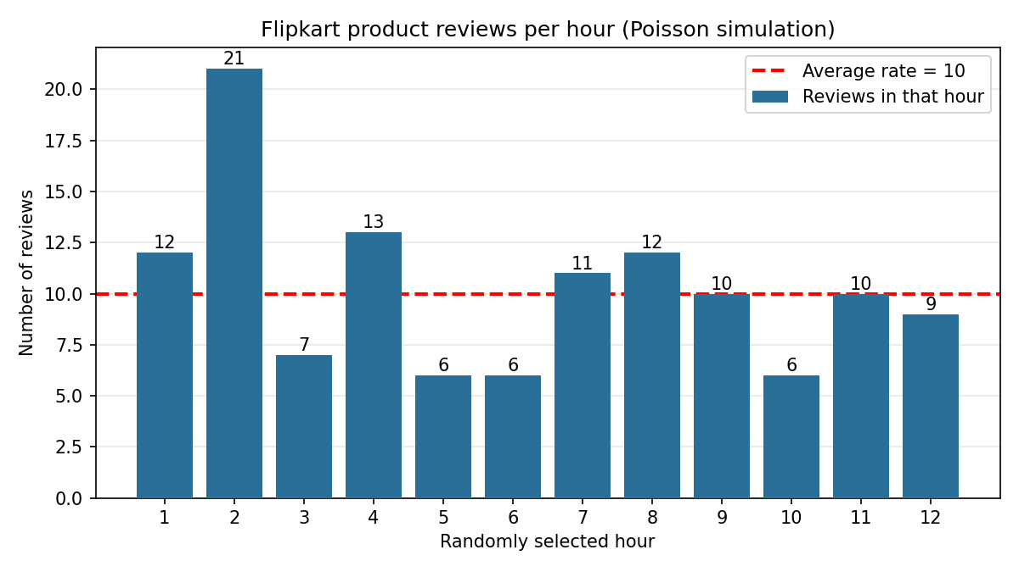

Task 5: Real-World Use-Case from an Indian App

Problem
Pick one of the Bernoulli, Binomial or Poisson distributions and use an AI tool to generate a real-world analytics use-case from a popular Indian app (Swiggy, BookMyShow or IRCTC). Paste the use-case and explain in 2-3 lines why the distribution fits.

Solution
- Distribution chosen: Poisson.
- AI prompt used: "Generate a real-world analytics use-case for the Poisson distribution from a popular Indian app such as Swiggy, BookMyShow or IRCTC."
- AI used: Claude (an AI assistant) wrote the use-case below. If your instructions require ChatGPT, run the same prompt there and paste its answer instead.

Use-case (AI output)
Swiggy: kitchen staffing at a busy restaurant. During the dinner rush, a popular biryani outlet receives on average 6 Swiggy orders in every 10-minute window. Orders arrive randomly and independently, so the number of orders per window can be modelled as Poisson with λ = 6. Swiggy’s analytics team can use this to (1) estimate the chance of a rush of more than 10 orders in one window (4.3%), (2) recommend that the kitchen prepare for up to 10 orders per window to cover 95% of windows, and (3) trigger an alert to assign extra delivery partners when live order counts go above that threshold. The same model also shows quiet periods: 2 or fewer orders happen in about 6.2% of windows.

Why this distribution fits
The Poisson distribution counts how many events happen in a fixed interval of time when they occur independently at a roughly constant average rate. Customer orders arrive one at a time, independently of each other, with no fixed upper limit per window, which is exactly this situation. Because the rate changes by time of day, a separate λ should be used for each time slot (lunch, dinner, late night).

Final answer
Poisson fits because Swiggy orders are independent random events counted in a fixed 10-minute window at a stable average rate (λ = 6).

Python code
કimport numpy as np
from scipy.stats import poisson

lam = 6 # average orders arriving at the restaurant per 10-minute window
print(f"Poisson use-case: Swiggy orders per 10-minute window, lambda = {lam}\n")

# Question 1: how likely is a rush of more than 10 orders in a 10-minute window?
p_rush = poisson.sf(10, lam) # P(X > 10)
print(f"P(more than 10 orders in 10 minutes) = {p_rush:.4f} ({p_rush:.1%})")

# Question 2: how many orders should the kitchen be ready for to cover 95% of windows?
capacity = int(poisson.ppf(0.95, lam))
print(f"Prepare for up to {capacity} orders per window to cover 95% of windows "
f"(P(X <= {capacity}) = {poisson.cdf(capacity, lam):.3f})")

# Question 3: how many quiet windows (2 orders or fewer)?
p_quiet = poisson.cdf(2, lam)
print(f"P(2 or fewer orders) = {p_quiet:.4f} ({p_quiet:.1%})")

# Simulate one day of the dinner shift: 36 windows of 10 minutes (6 hours)
rng = np.random.default_rng(seed=5)
day = rng.poisson(lam, size=36)
print(f"\nSimulated 36 windows: mean = {day.mean():.2f} orders, busiest window = {day.max()}, "
f"windows above capacity {capacity}: {(day > capacity).sum()}")

Output
Poisson use-case: Swiggy orders per 10-minute window, lambda = 6

P(more than 10 orders in 10 minutes) = 0.0426 (4.3%)
Prepare for up to 10 orders per window to cover 95% of windows (P(X <= 10) = 0.957)
P(2 or fewer orders) = 0.0620 (6.2%)

Simulated 36 windows: mean = 5.81 orders, busiest window = 10, windows above capacity 10: 0

