- package main: Declares the main package. A Go program must have a main package with a main function to run.
- import "fmt": Imports the fmt package for formatted I/O.
- func main(): The entry point of the program.

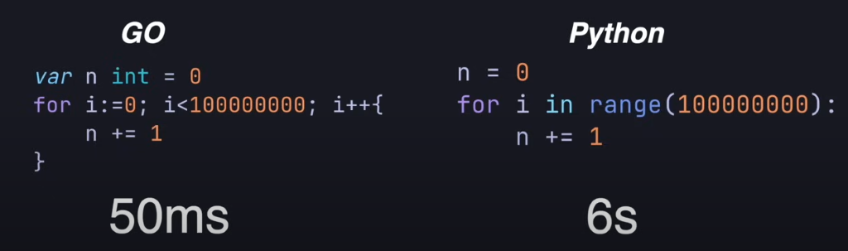

- Collection of Package is known as module
Syntax -> go mod init module_name
We get file-> go.mod having output as
module go_tutorials
go 1.18
The main package holds the code that is responsible to make the current program compilable and runnable.
Used imports cannot be declared in go
go build main.go -> to build which produces binary file main -> ls -> go.mod main main.go
then directly run the build ./main
hiteshw@metron-IdeaPad-Gaming-3-15IMH05:~/Desktop/sevenAI/golang/go_tutorial$ ./main
Hello
or
go run main.go
Arrays are of
- Fixed size
- Same type
- Indexable
- Contiguous in memory -> fmt.Println(&intArr[0]) -> 0xc0000140e0
fmt.Println(&intArr[1])- > 0xc0000140e4
fmt.Println(&intArr[2]) -> 0xc0000140e8

Slices
slices are just wrappers around arrays so under the hood slices are just a raise with some additional functionality
func slices(){
var intslice []int32 = []int32{4,5,6}
fmt.Println("slice = ",intslice, " len = ",len(intslice)," capacity= ",cap(intslice)) -> slice = [4 5 6] len = 3 capacity= 3
intslice= append(intslice,21)
fmt.Println("slice = ",intslice, " len = ",len(intslice)," capacity= ",cap(intslice)) -> slice = [4 5 6 21] len = 4 capacity= 6
}

another way to create a slice is using the make function like this we can specify the length of the slice as well as optionally specify the capacity of the slice otherwise by default the capacity will just be the length of the slice

Defer

A defer statement defers the execution of a function until the surrounding function returns.
The deferred call's arguments are evaluated immediately, but the function call is not executed until the surrounding function returns.
`
package main
import "fmt"
func main() {
defer fmt.Println("world")
fmt.Println("hello")
}

For refrence

https://www.blackbox.ai/chat/ZAvSbKr

