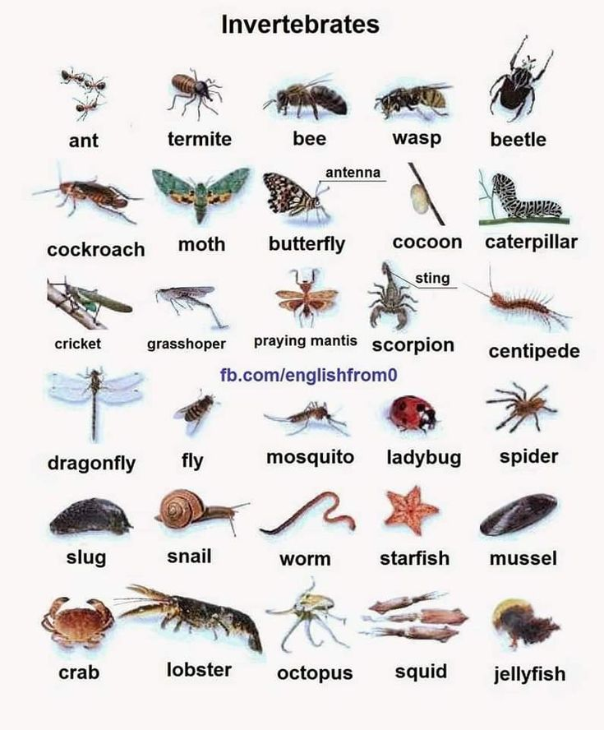
ANIMALS WITHOUT BACKBONES

