**Gym Tracker: A Workout Tracking and Exercise Guide**

**Gym Tracker** is a fitness application designed to help users track their workout progress and explore various gym exercises. Whether you're a beginner or an experienced fitness enthusiast, this app offers essential tools to monitor your training routine and stay motivated.

**Application Name & Logo:**

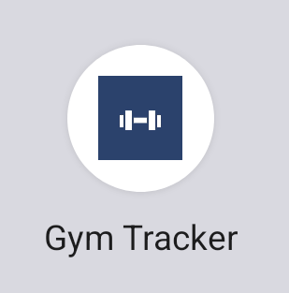

**Key Features:**

* User Authentication: Secure login and signup features that allow users to create an account and store their data.
* Workout Data Tracking: Users can input and track their daily workout stats such as pushups, bench press, body weight, and workout dates.
* Exercise Exploration: A comprehensive library of common gym exercises, with detailed descriptions on how to perform them effectively and safely.
* Dynamic Fragment Navigation: Users can easily switch between entering workout data, viewing past workouts, and exploring new exercises via simple, intuitive navigation.

**App Navigation & Functionality:**

When starting up Gym Tracker, the user is greeted with a login/signup screen. The user can input their credentials and choose to signup if they don’t have an account, or they can login into an existing account.

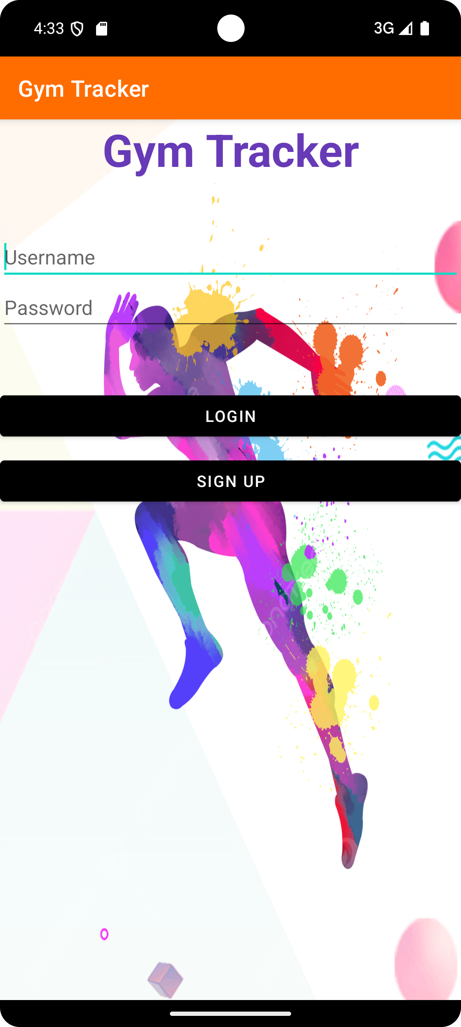

Figure 1.1

If the user picks the incorrect option, A toast notification will be displaying showing the error.

Similarly, upon successful signup, the user will be shown confirmation in a toast notification and the user credentials will be saved in the SQLite database in a separate table.  
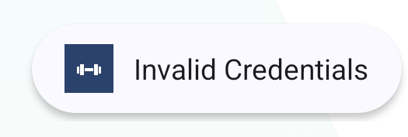 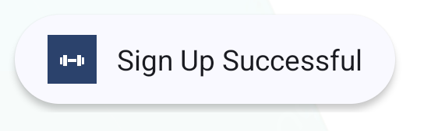

Figure 1.2 & Figure 1.3

After Logging in, the user will be shown a welcome screen that gives the user 3 options.

1) Enter Workout Data: Upon clicking, it takes the user to a data input screen where the user can add details about their workout, alongside their weight and given date of workout. The application also shows a toast notification as confirmation when data is saved.  
Check Figure 2.1 for a visual.

2)View Workout Data: Upon clicking, it shows the user data that has been input previously. It showcases the user activity, i.e. Number of pushups, Number of squats, Weight etc.   
Check Figure 2.3 for visual.

3)View Workout Exercises: Upon clicking, user will be taken to a screen that enlists other gym exercises. If the user clicks on the given exercise button, It showcases the description of the selected exercise on the same page via fragments. This allows the user to easily read about the different exercises and how to do them efficiently.  
Check Figure 2.4 for visual.

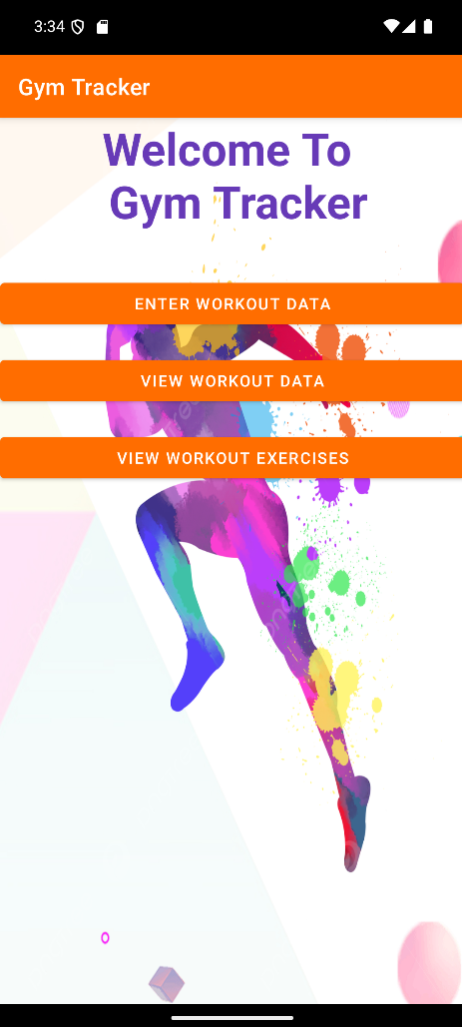

Figure 2

**Enter Workout Data:**

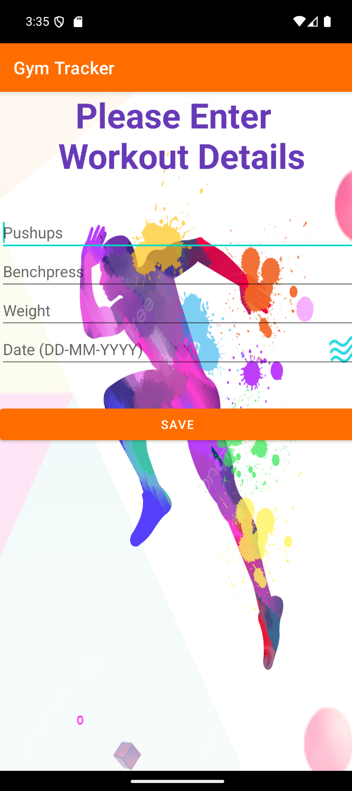 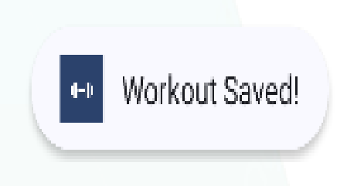

**Figure 2.1 & Figure 2.2**

**View Workout Data:**

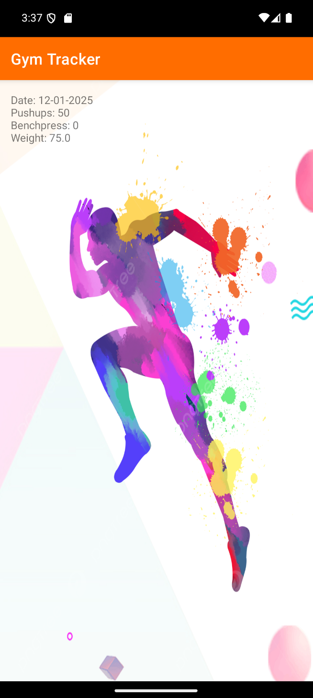

**Figure 2.3**

**View Workout Exercises:**

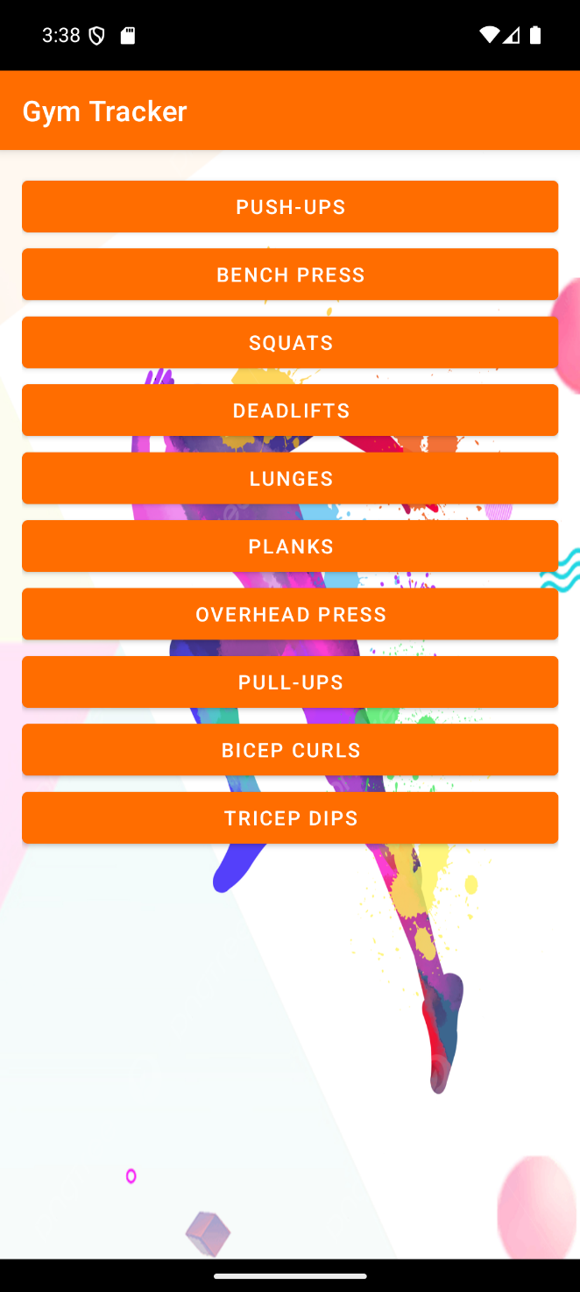 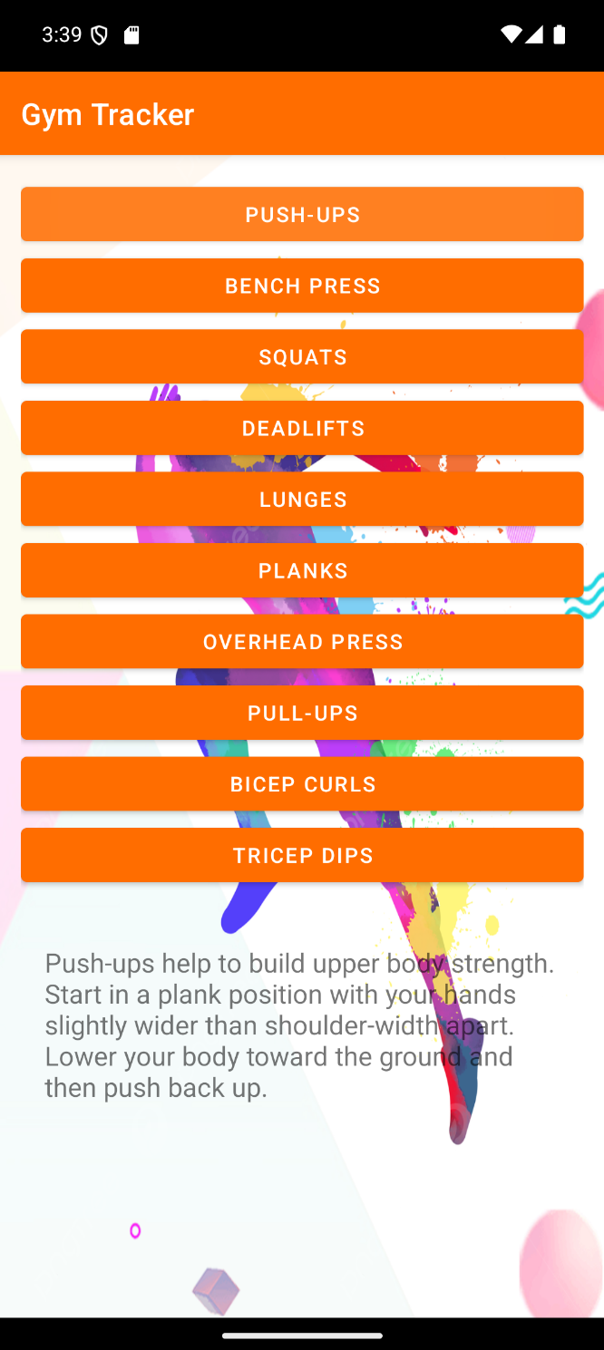

**Figure 2.4 & Figure 2.5**