CHAROTAR UNIVERSITY OF SCIENCE & TECHNOLOGY
Faculty of Technology and Engineering
Devang Patel Institute of Advance Technology and Research
Department of Information Technology

BIG DATA ANALYTICS (CSUE301)

PRACTICAL 1
Linux System Administration and File Management
for Marketing Analytics Team

Student ID: 24DIT021
Name:- Hit Goyani

1. OBJECTIVE
The objective of this practical is to understand basic Linux system administration and file management commands. In this practical, a project directory for a marketing analytics team is created and different files and directories are managed using Linux commands.
2. AIM
To perform Linux navigation, system information checking, file and directory management, searching, backup, rename, move and delete operations using the Linux terminal.

3. PROBLEM DEFINITION
A marketing analytics team needs a proper project environment to store raw customer data, processed data, reports and backup files. As a Linux system administrator, the required directories and files have to be created and managed properly. The practical includes navigation, file creation, searching, copying, renaming, moving and deleting operations.
4. BASIC SYSTEM AND NAVIGATION COMMANDS
The following commands are used for checking basic system and navigation information.
whoami # identify current user
pwd # display current working directory
uname -a # display system information
uptime # check system uptime
date # display current date and time
The working directory used for this practical was under the Practicals/BDA folder. The project directory was then created from the terminal.
5. CREATING PRACTICAL AND PROJECT DIRECTORY
First, a directory for Practical 1 was created. After that, the MarketingAnalytics project directory was created and opened.
mkdir Practical-01
cd Practical-01
pwd
mkdir MarketingAnalytics
cd MarketingAnalytics
pwd
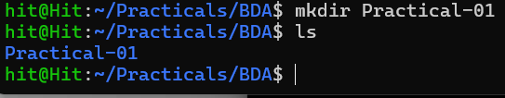

6. CREATING PROJECT SUBDIRECTORIES
The project was divided into separate directories so that the files could be managed properly.
mkdir RawData ProcessedData Reports Backup
ls
The directories RawData, ProcessedData, Reports and Backup were created.
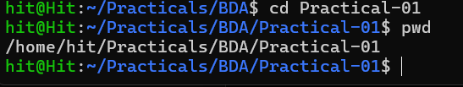
7. CREATING DATA AND REPORT FILES
A customer data file and a report file were created using the touch command.
touch RawData/customer_data.txt
touch Reports/report1.txt
find . -type f
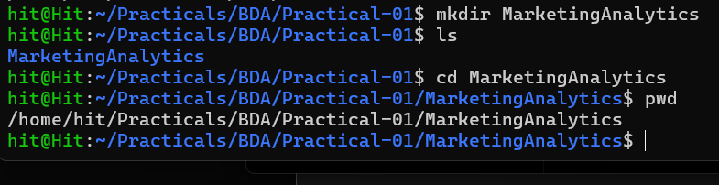
8. ADDING SAMPLE CONTENT
Sample customer data was added to customer_data.txt. A simple marketing report was also created in report1.txt.
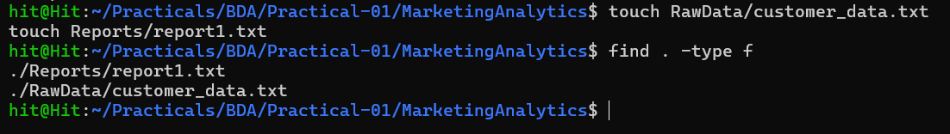
9. DISPLAYING FILE CONTENT
The cat command was used to display the contents of both files.
cat RawData/customer_data.txt
cat Reports/report1.txt
The customer data contains sample customer records with ID, name and city. The report contains the text 'Marketing Analysis Report' and 'Sales Increased by 20%'.
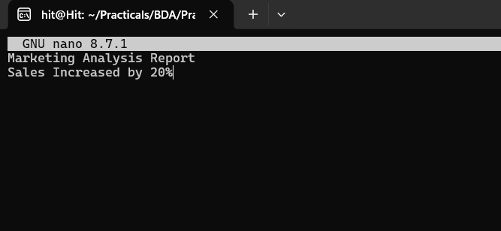
10. LISTING FILES AND DIRECTORIES
Different forms of the ls command were used to view the project structure.
ls
ls -l
ls -R
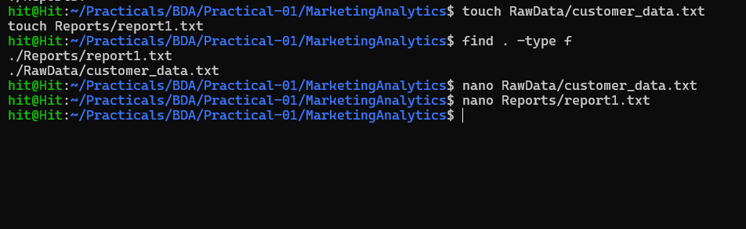
11. SEARCHING FILES AND CONTENT
The find command was used to search for text files. The grep command was used to search specific words inside the files.
find . -name "*.txt"
grep "Sales" Reports/report1.txt
grep "Raj" RawData/customer_data.txt
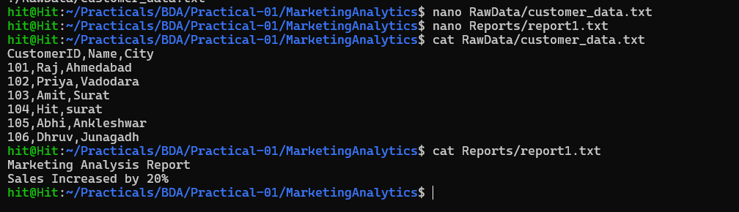
12. BACKUP OPERATION
The report file was copied to the Backup directory. This keeps a separate copy of the original report.
cp Reports/report1.txt Backup/
ls Backup
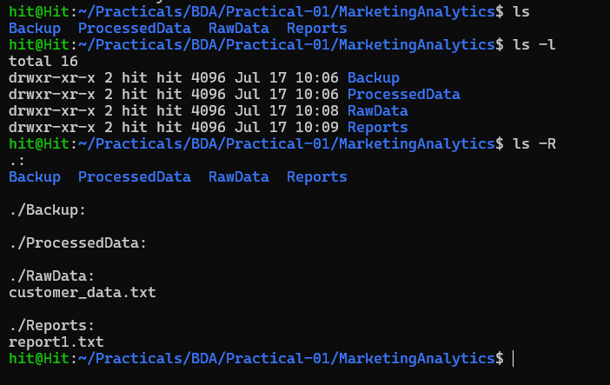
13. RENAMING THE REPORT FILE
The report file was renamed from report1.txt to final_report.txt using the mv command.
mv Reports/report1.txt Reports/final_report.txt
ls Reports
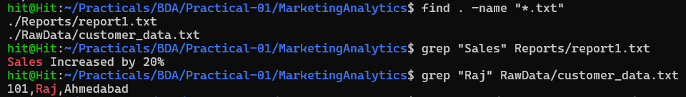
14. MOVING DATA FILE
The customer data file was moved from RawData to ProcessedData.
mv RawData/customer_data.txt ProcessedData/
ls RawData
ls ProcessedData
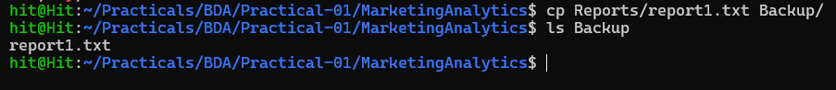

15. DELETING A FILE AND EMPTY DIRECTORY
After moving the data file, the empty RawData directory was removed. The customer data file in ProcessedData was also deleted using rm.
rm ProcessedData/customer_data.txt
ls ProcessedData
rmdir RawData
ls -R
16. FINAL PROJECT STRUCTURE
After completing all operations, the project structure contains the following main directories:
- Backup – contains the copied report file.
- ProcessedData – remains after the data file operation.
- Reports – contains final_report.txt.
The RawData directory was removed after it became empty.
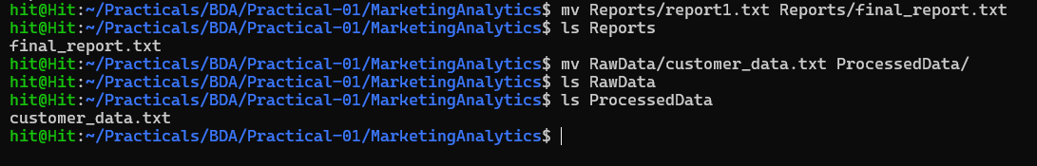
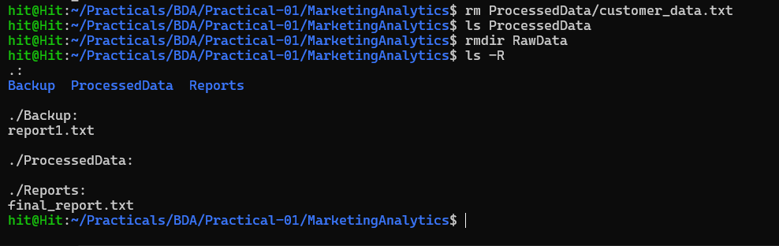

17. KEY QUESTIONS / ANALYSIS
Q1. What is the difference between absolute and relative paths?
An absolute path starts from the root directory and gives the complete location of a file or directory. For example, /home/hit/Practicals/BDA/Practical-01. A relative path is written with respect to the current directory, such as Reports/final_report.txt.
Q2. Why are Linux permissions important for file security?
Linux permissions control who can read, write or execute a file. This helps in protecting important files and prevents unauthorized users from changing or deleting data.
Q3. What is the purpose of the grep command?
The grep command is used to search for specific text or patterns inside files. In this practical, grep was used to search for 'Sales' in the report file and 'Raj' in the customer data file.
Q4. How does Linux support efficient file management?
Linux provides commands such as mkdir, touch, ls, find, cp, mv, rm and rmdir. These commands make it easy to create, organize, search, copy, move and remove files from the terminal.
Q5. Why are backups important in enterprise environments?
Backups provide another copy of important files. If the original file is deleted, corrupted or lost, the backup can be used to recover the required data.
18. SUPPLEMENTARY COMMANDS
Some additional Linux operations related to this practical are given below.
# Top 10 largest files
find / -type f -printf '%s %p\n' 2>/dev/null | sort -nr | head -10
# Monitor CPU and processes
top
# Check disk usage of project directories
du -sh *
# Example cron entry for daily backup at 6 PM
0 18 * * * cp -r /path/to/MarketingAnalytics /path/to/Backup
19. TOOLS / TECHNOLOGY USED
- Ubuntu Linux
- Linux Terminal
- Bash Shell
- Basic Linux file management commands

20. CONCLUSION
In this practical, basic Linux system administration and file management operations were performed successfully. The MarketingAnalytics project directory was created with separate directories for data, reports and backups. Sample files were created and their contents were displayed. Files were searched using find and grep, copied for backup, renamed and moved between directories. Finally, a file and an empty directory were deleted. This practical helped in understanding how Linux commands can be used for managing project data in an organized way.
21. FINAL RESULT
The required Linux file and directory management operations for the MarketingAnalytics project were performed successfully using the Linux terminal.

