CHAROTAR UNIVERSITY OF SCIENCE & TECHNOLOGY
Faculty of Technology & Engineering
Devang Patel Institute of Advance Technology and Research (DEPSTAR)
CSUE301 - BIG DATA ANALYTICS
PRACTICAL FILE - ODD SEMESTER 2026-27
PRACTICAL 12
Student Name: HIT GOYANI
Student ID: 24DIT021
Academic Year 2026-27

Practical 12:

1. Problem Definition
A retail business collects a large amount of information from customer orders, products, regions, and sales channels. Reading this information only through spreadsheets makes it difficult to notice patterns quickly. In this practical, a sales dataset is prepared and explored through a dashboard so that a manager can review important measures, compare performance, and investigate areas that need attention.
The goal is to create a clear, interactive dashboard that presents sales and profit information through summary indicators and visual comparisons. The dashboard also supports filtering and drill-down exploration, allowing users to move from an overall view to a specific category, region, or customer segment.

PART A - Practical Execution

Step 1: Set up the project folder and files
The project folder keeps the main Python script, dashboard application, sales dataset, data-generation script, and report outputs together. This makes the practical easier to run again and keeps the supporting files in one place.
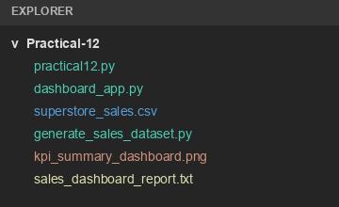

Step 2: Load and validate the sales dataset
The dataset is loaded into the program and checked before analysis begins. The validation output confirms that the expected columns are present, missing values in the selected core fields are checked, and the clean records are ready for the next stage.
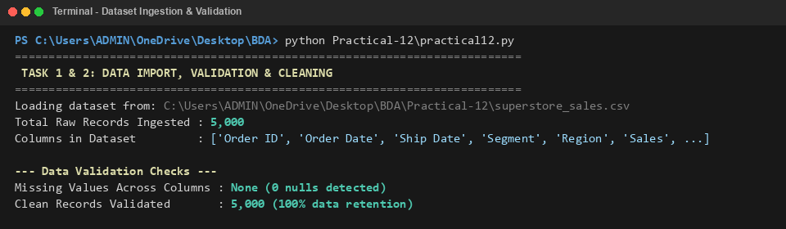

Step 3: Review the schema and prepare fields
Date fields are converted into usable date values, and additional time-based fields such as year, quarter, and year-month are derived. Numeric fields including sales, quantity, discount, and profit are also checked so that calculations and charts use consistent data types.
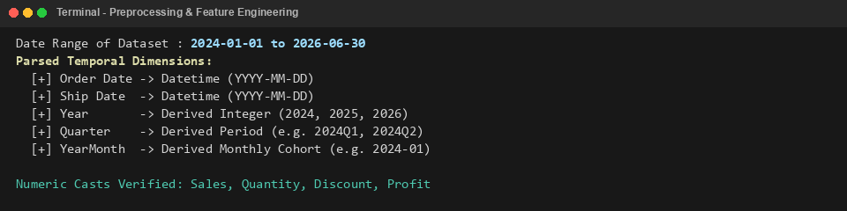

Step 4: Calculate the main performance indicators
The summary brings together sales, net profit, margin, orders, customers, average order value, and loss-making transactions.
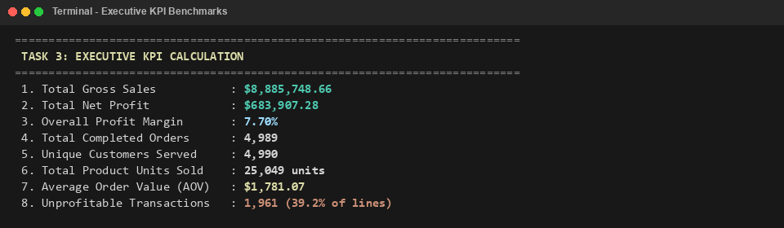

Step 5: Compare sales and profit by category
The category view compares revenue, profit, and margin for Technology, Furniture, and Office Supplies.
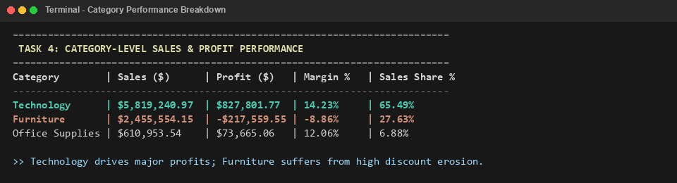

Step 6: Inspect sub-category profitability
The sub-category view compares revenue, profit or loss, discount, and margin to show which product groups drive results.
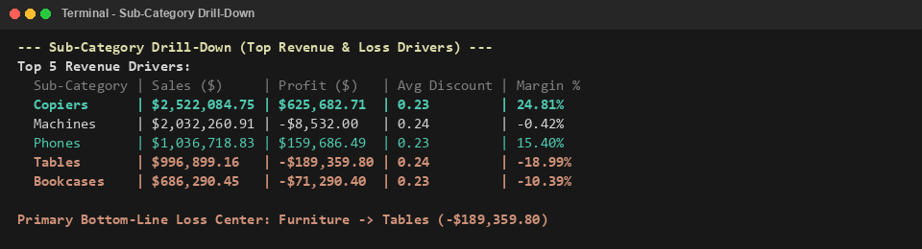

Step 7: Compare regional performance
Regional sales, profit, and margin are compared to show where results are strongest.
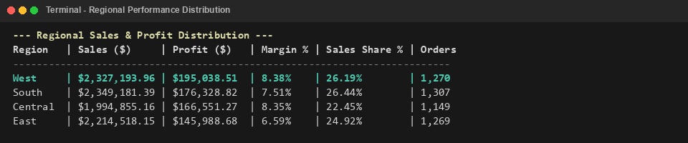

Step 8: Explore customer segments and order value
The final comparison reviews Consumer, Corporate, and Home Office sales, profit, margin, orders, and average order value.
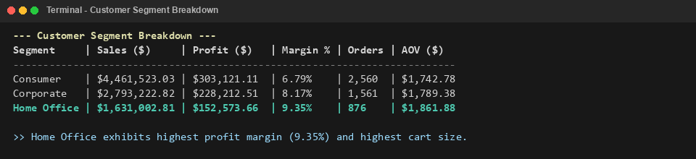

Step 9: Review quarter-by-quarter performance
Quarterly sales, profit, and order counts are arranged in time order. The quarter-on-quarter growth measure makes it easier to spot periods of improvement or decline and gives the business a starting point for asking why a change occurred.
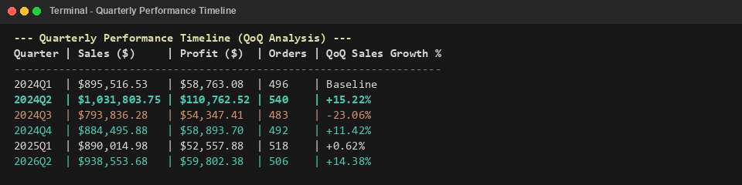

Step 10: Start the interactive dashboard application
The dashboard is launched through Streamlit. Once the local server is ready, the application can be opened in a browser and used to filter the results by dimensions such as region, category, and customer segment.
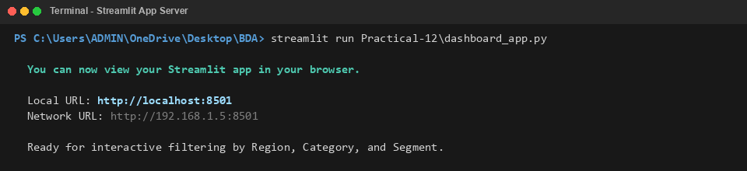

Step 11: View the executive KPI dashboard
The main dashboard brings the summary figures and core charts into one view. It includes headline KPIs, a monthly sales and profit trend, category share, regional comparisons, and sales by customer segment. This arrangement helps users move from a high-level summary to more specific questions.
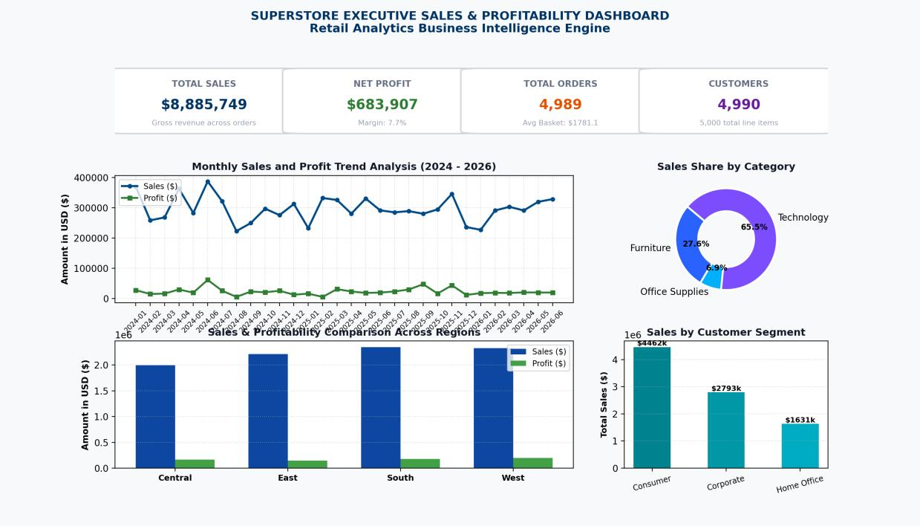

Step 12: Visualize category and sub-category profitability
The drill-down chart places sub-category sales volume beside net profit or loss. Reading both charts together is important: a product group may generate substantial revenue yet still perform poorly after discounts and other costs are considered.
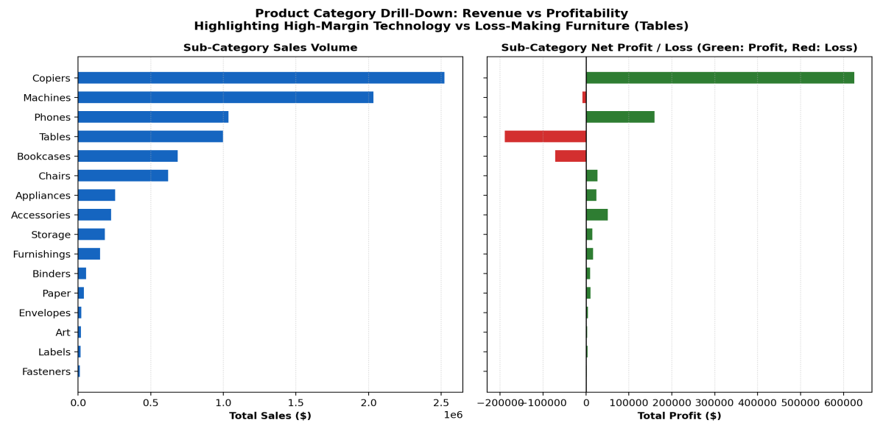

Step 13: Compare regions and leading states
The state-level chart compares sales with profit for the leading states in the dataset. It provides a more detailed geographical view and can help identify locations that contribute strongly to revenue as well as locations where profit performance deserves further review.
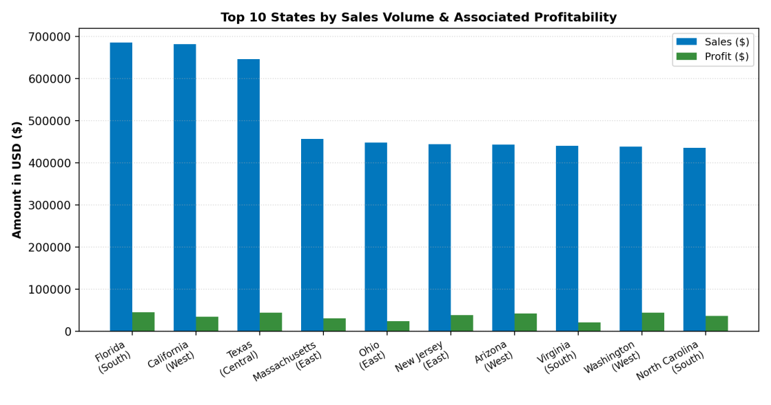

Step 14: Track quarterly trends and growth
Quarterly sales, profit, and growth are shown together to make changes between periods easier to compare.
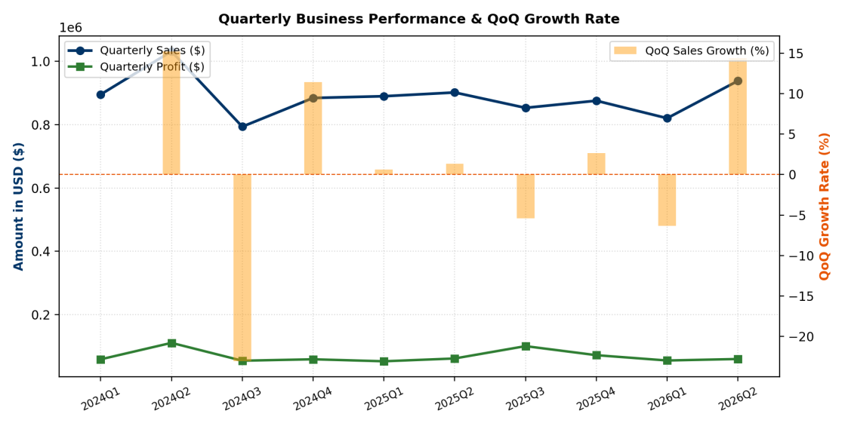

Step 15: Review the customer segment mix
These charts compare each customer group’s sales share with its profit margin.
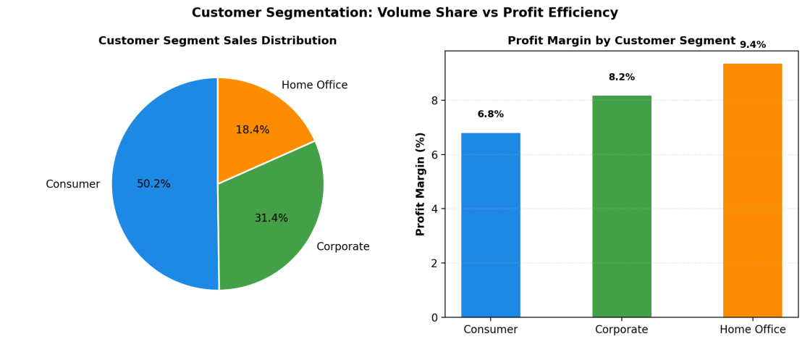

Step 16: Generate the final dashboard summary report
The report summarizes data checks, core KPIs, leading profit contributors, and product groups that need attention.
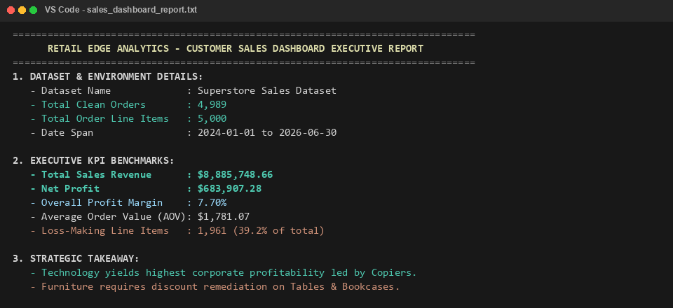

3. Key Questions and Analysis

Q1. How does an interactive dashboard support business analysis?
An interactive dashboard turns a large dataset into a set of visual summaries that are easier to understand. Managers can monitor key indicators, compare different parts of the business, and investigate an unexpected result without having to inspect every row of a spreadsheet. The dashboard is most useful when its visuals are linked to the questions the business needs to answer.

Q2. How do filters help users explore the data?
Filters let a user focus on a particular region, product category, customer segment, or time period. Instead of viewing every record at once, the user can narrow the results and compare the selected group with the overall picture. This makes differences and trends easier to spot and helps users ask more focused follow-up questions.

Q3. What are KPIs, and which ones are useful in this dashboard?
Key Performance Indicators are measurable values used to check progress against business goals. For this retail dashboard, useful indicators include total sales, net profit, profit margin, completed orders, unique customers, average order value, and the number of loss-making transactions. Together, they show both the scale of sales and whether those sales are generating a healthy return.

Key Questions and Analysis (continued)

Q4. Why can a dashboard be more useful than a static report?
A static report presents a fixed view of the data. An interactive dashboard allows users to change filters, inspect specific categories, and follow a result into more detail. For example, a low profit margin in Furniture can be investigated at sub-category level to see whether Tables or Bookcases are contributing to the loss. That direct exploration helps turn an observation into a practical question.

Q5. How can user-driven exploration improve decision-making?
User-driven exploration lets managers follow up on patterns as they notice them. They can check whether a result is limited to one region, customer segment, or product group instead of making a decision from the overall total alone. This supports more targeted actions, such as reviewing discounts on poorly performing items or studying the practices used by more profitable categories.

4. Conclusion
This practical demonstrated how sales data can be prepared and presented through an interactive dashboard. The dataset was checked and cleaned, useful time fields were derived, and the analysis calculated key business indicators before comparing categories, sub-categories, regions, quarters, and customer segments.
The results in the supplied execution output report approximately $8.89 million in sales and about $683.9 thousand in net profit, with an overall profit margin close to 7.7%. The category and sub-category views point to Technology as a strong profit contributor, while Furniture requires closer attention because some sub-categories show losses associated with discounting. The regional and segment charts add context to these findings.
Overall, the practical shows the value of combining clear KPIs with interactive charts. Rather than relying on one static summary, a user can filter the data, investigate an unusual result, and use the findings to guide the next business question.

GitHub Link:- https://github.com/hitgoyani/24DIT021-BDA.git

