PRACTICAL 2
Hadoop Installation, Configuration and HDFS Operations
Subject: Big Data Analytics (BDA)

1. Aim
The aim of this practical was to check the Hadoop installation and perform basic HDFS operations. The work included creating HDFS directories, uploading a file, viewing its contents, copying, moving, renaming, downloading and deleting files, and finally checking the health and storage status of HDFS.

2. Software and Environment Used
The practical was performed in an Ubuntu/WSL Linux environment using the terminal and Bash shell. The setup already had OpenJDK 11.0.31 and Hadoop 3.4.1 installed. A single-node Hadoop cluster was used for the HDFS operations.

3. Test Data Used
A small sales data file named sales_data.txt was used so that the HDFS commands could be tested easily. The file contained the following sample records:
ProductA 120
ProductB 80
ProductC 150
ProductA 200
ProductB 90

4. Creating the Working Folder
Before starting the HDFS operations, I created a separate local folder for this practical. This made it easier to keep the sample file and downloaded file in one place.
mkdir -p ~/Practicals/Practical_02_Hadoop_Installation_and_HDFS
cd ~/Practicals/Practical_02_Hadoop_Installation_and_HDFS
pwd
ls -la
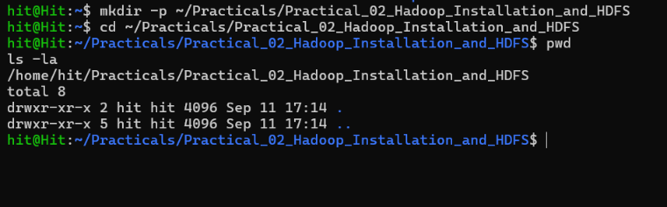

5. Checking Java and Hadoop Installation
Next, I checked whether Java and Hadoop were available correctly. I also checked the Hadoop and Java environment variables and opened the Hadoop configuration folder.
java -version
hadoop version
echo $HADOOP_HOME
echo $JAVA_HOME
cd $HADOOP_HOME/etc/hadoop
ls
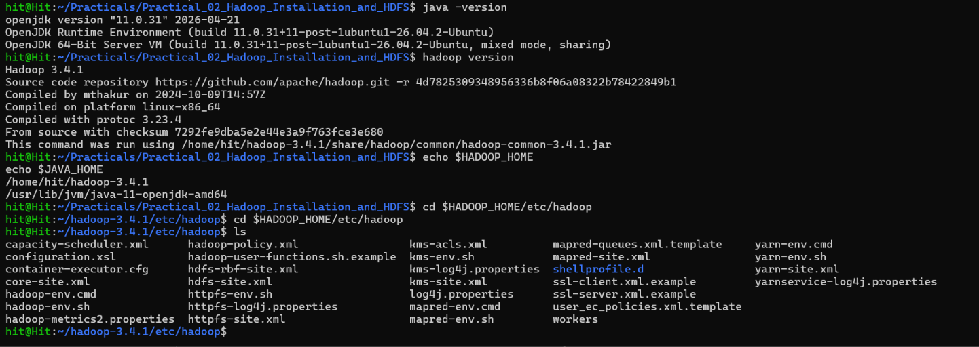

6. Checking Hadoop Configuration
The main configuration files were checked to confirm the current single-node setup. I did not change the files at this stage; I only verified the values already configured.

6.1 core-site.xml
cat core-site.xml
The file showed fs.defaultFS as hdfs://localhost:9000, which is the HDFS address used in this setup.
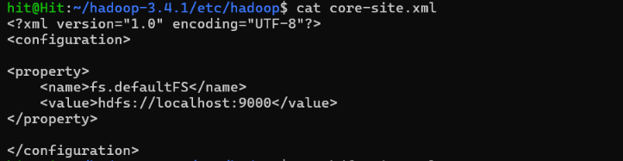

6.2 hdfs-site.xml
cat hdfs-site.xml
The replication factor was set to 1 because this practical used one DataNode. The NameNode and DataNode storage locations were also visible in the file.
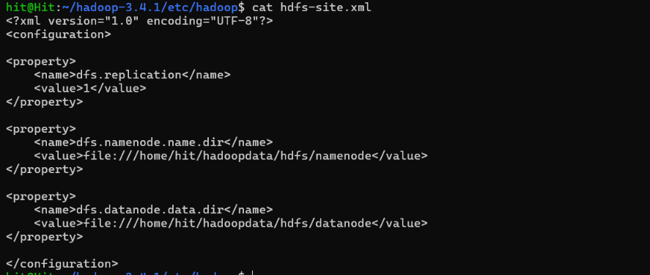

6.3 yarn-site.xml
cat yarn-site.xml
The YARN configuration file was also checked as part of verifying the Hadoop configuration.
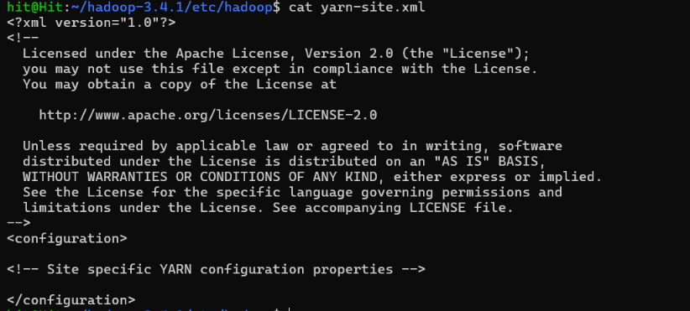

7. Returning to the Practical Folder
After checking the configuration files, I returned to the local practical folder before creating the sample data file.
cd ~/Practicals/Practical_02_Hadoop_Installation_and_HDFS
pwd

8. Starting and Checking Hadoop Services
The Hadoop services were started using the configured start command. After that, jps was used to see whether the required Java processes were running.
start-hadoop
jps
The output showed NameNode, DataNode, SecondaryNameNode, ResourceManager and NodeManager. This confirmed that the main services required for the single-node practical were running.
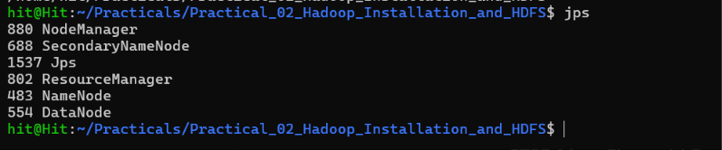

9. Checking the Existing HDFS Structure
Before creating the practical folder in HDFS, I checked the root directory and the user directory.
hdfs dfs -ls /
hdfs dfs -ls /user
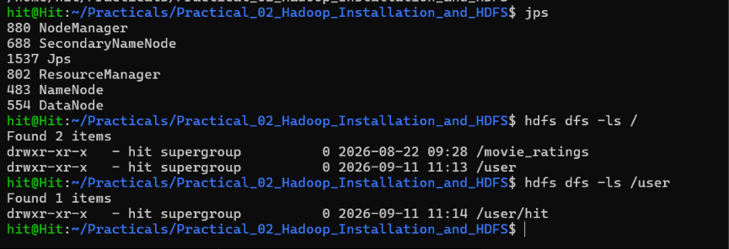

10. Creating the HDFS Directory
For a clean run, the old practical2 directory was removed first if it existed. Then a new practical2 directory was created under /user/hit.
hdfs dfs -rm -r -f /user/hit/practical2
hdfs dfs -mkdir -p /user/hit/practical2
hdfs dfs -ls /user/hit
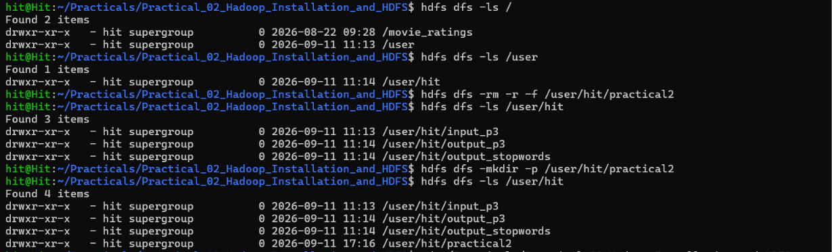

11. Creating and Checking the Local Sales Data File
The sample file was created locally. After creating it, I displayed the contents, checked the file size and counted the number of lines.
cat << 'EOF' > sales_data.txt
ProductA 120
ProductB 80
ProductC 150
ProductA 200
ProductB 90
EOF
cat sales_data.txt
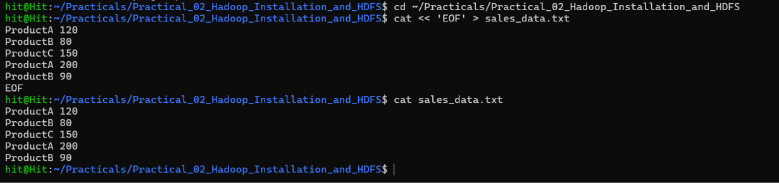
ls -lh sales_data.txt
wc -l sales_data.txt

12. Uploading the File to HDFS
Once the local file was ready, it was uploaded into the practical2 directory in HDFS. The directory was listed afterwards to confirm that the upload worked.
hdfs dfs -put sales_data.txt /user/hit/practical2/
hdfs dfs -ls /user/hit/practical2

13. Displaying the File Directly from HDFS
The cat command was used with HDFS to confirm that the uploaded file could be read correctly.
hdfs dfs -cat /user/hit/practical2/sales_data.txt
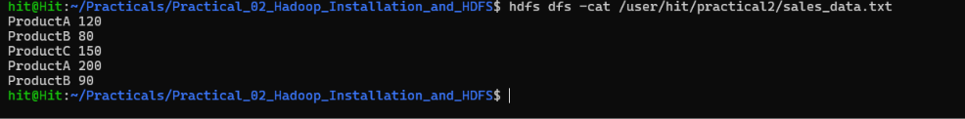

14. Copying a File Inside HDFS
A copy of the sales file was created inside the same HDFS directory. The directory was listed again so both files could be seen.
hdfs dfs -cp /user/hit/practical2/sales_data.txt /user/hit/practical2/sales_backup.txt
hdfs dfs -ls /user/hit/practical2

15. Moving and Renaming the Backup File
An archive directory was created to test moving files. The backup file was moved into the archive directory and then renamed to final_sales_backup.txt.
hdfs dfs -mkdir /user/hit/practical2/archive
hdfs dfs -mv /user/hit/practical2/sales_backup.txt /user/hit/practical2/archive/
hdfs dfs -ls /user/hit/practical2/archive
hdfs dfs -mv /user/hit/practical2/archive/sales_backup.txt /user/hit/practical2/archive/final_sales_backup.txt
hdfs dfs -ls /user/hit/practical2/archive
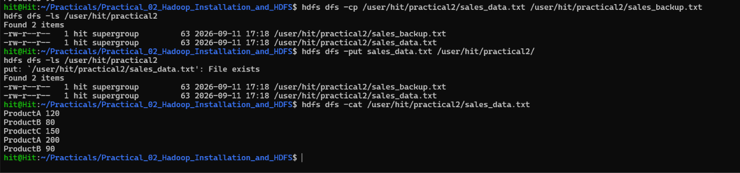

16. Downloading the File Back to Local Storage
To check the reverse operation, the original sales file was downloaded from HDFS into a local folder. The downloaded file was then listed and displayed.
mkdir -p downloaded_files
hdfs dfs -get /user/hit/practical2/sales_data.txt downloaded_files/
ls -lh downloaded_files/sales_data.txt
cat downloaded_files/sales_data.txt
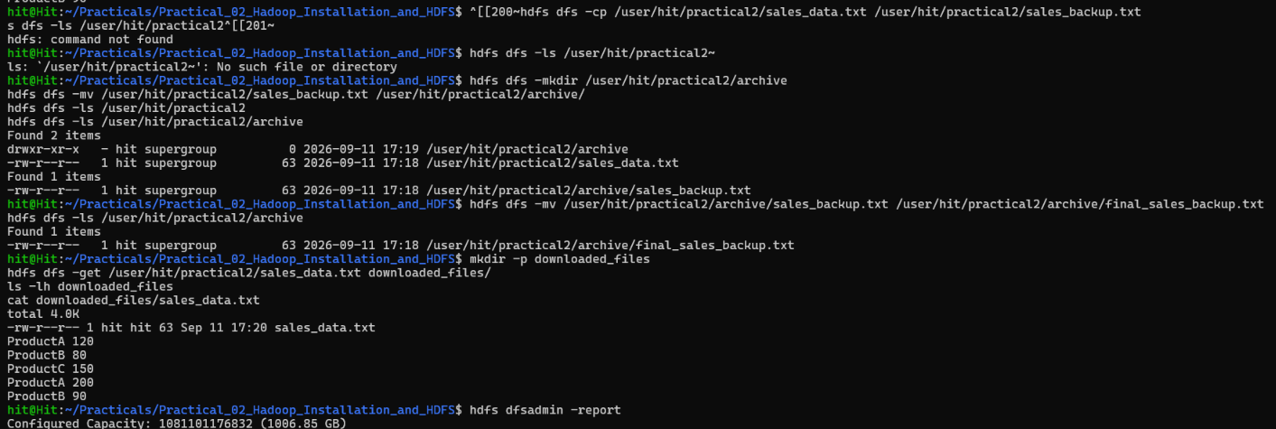

17. Deleting a File and an Empty Directory
After testing the move and rename operations, the temporary backup file was no longer required. It was deleted first, and then the now-empty archive directory was removed.
hdfs dfs -rm /user/hit/practical2/archive/final_sales_backup.txt
hdfs dfs -rmdir /user/hit/practical2/archive
hdfs dfs -ls /user/hit/practical2
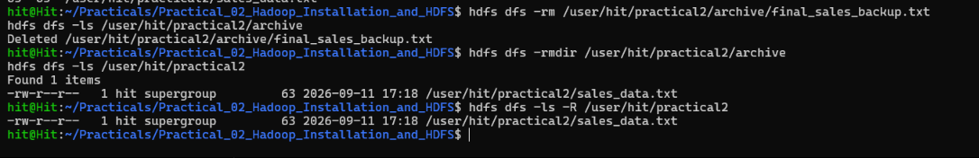

18. Checking HDFS Block and File Health
The fsck command was used to check the stored file. The output showed the file status as HEALTHY and also displayed its block-related information.
hdfs fsck /user/hit/practical2/sales_data.txt -files -blocks -locations
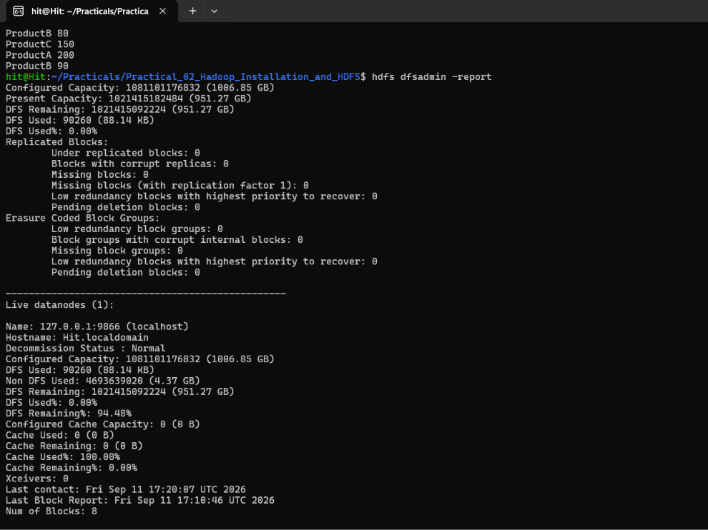

19. Checking HDFS Storage and DataNode Status
The HDFS administration report was checked to see the storage details and the live DataNode information.
hdfs dfsadmin -report
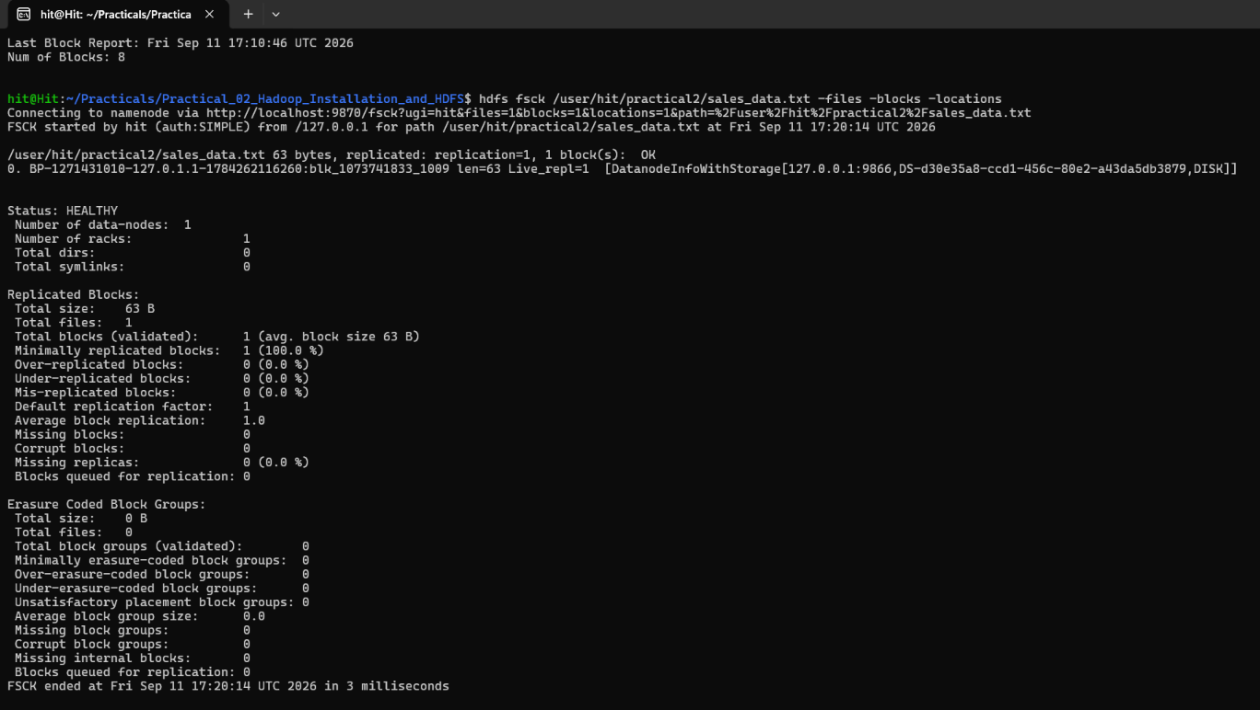

20. Checking Cluster Health and Storage Utilization
Finally, I checked the YARN node, running Hadoop processes, Linux disk usage and the size of the practical2 HDFS directory.
yarn node -list
jps
df -h
hdfs dfs -du -h /user/hit/practical2
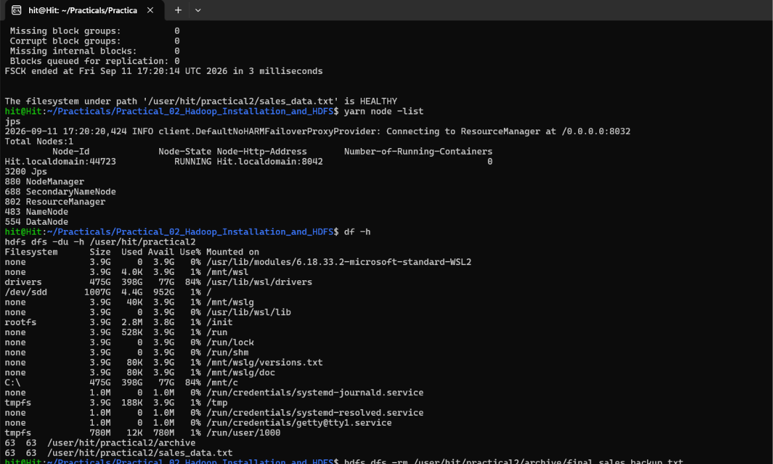

21. Result
The Hadoop single-node setup was checked successfully, and the required HDFS operations were performed. The practical covered directory creation, file upload, listing, viewing file contents, copying, moving, renaming, downloading and deleting files. The fsck output showed the main file as HEALTHY, and the HDFS report showed one live DataNode.

22. Key Questions / Analysis

Q1. Why is Hadoop preferred for Big Data storage?
Hadoop is useful for Big Data because it is designed to store and process large amounts of data. Instead of depending on one machine, Hadoop can work with data across multiple machines in a larger cluster.

Q2. What is the role of NameNode and DataNode in HDFS?
The NameNode manages information about files and directories, such as file names and block locations. The DataNode stores the actual data blocks. In this practical, both services were part of the single-node Hadoop setup.

Q3. What is the difference between HDFS and a traditional file system?
A normal file system is generally used on a single computer or server. HDFS is designed for distributed storage, where a file can be divided into blocks and stored across DataNodes in a cluster.

Q4. What are the advantages of distributed storage?
Distributed storage can handle larger amounts of data and can use storage from multiple machines. In a larger Hadoop cluster, replication can also help improve availability. For this single-node practical, the replication factor was set to 1.

23. Conclusion
This practical gave a basic understanding of how Hadoop and HDFS are used from the command line. The commands were performed one by one, starting from checking the installation and services, then managing files in HDFS, and finally checking file health and storage details. The practical was useful for understanding how common file operations are performed in an HDFS environment.

