CHAROTAR UNIVERSITY OF SCIENCE & TECHNOLOGY
Faculty of Technology and Engineering
Devang Patel Institute of Advance Technology and Research
Department of Information Technology

BIG DATA ANALYTICS (CSUE301)

PRACTICAL 3
Implement Word Count / Frequency Program using MapReduce

Student ID: 24DIT021
Name:-Hit Goyani

1. OBJECTIVE
The objective of this practical is to implement a Word Count program using Hadoop MapReduce. The program reads text files, counts how many times each word occurs and stores the final result in HDFS. This practical also helps in understanding the basic working of Mapper, Reducer and HDFS.
2. AIM
To implement Word Count / Word Frequency program using Hadoop HDFS and MapReduce.

3. PROBLEM DEFINITION
A digital publishing company has a large number of news articles and blog posts. The company wants to know which words are used frequently in the articles. For this, the text files are stored in HDFS and processed using MapReduce. The Mapper reads the words and the Reducer adds their counts to generate the final word frequency.
4. INPUT DATA USED
For this practical, two text files were created:
- article1.txt – contains text related to Big Data, Hadoop, HDFS and digital publishing.
- article2.txt – contains text related to publishing platforms, MapReduce, HDFS, YARN and reader trends.
Both files were used together as input for the MapReduce program.
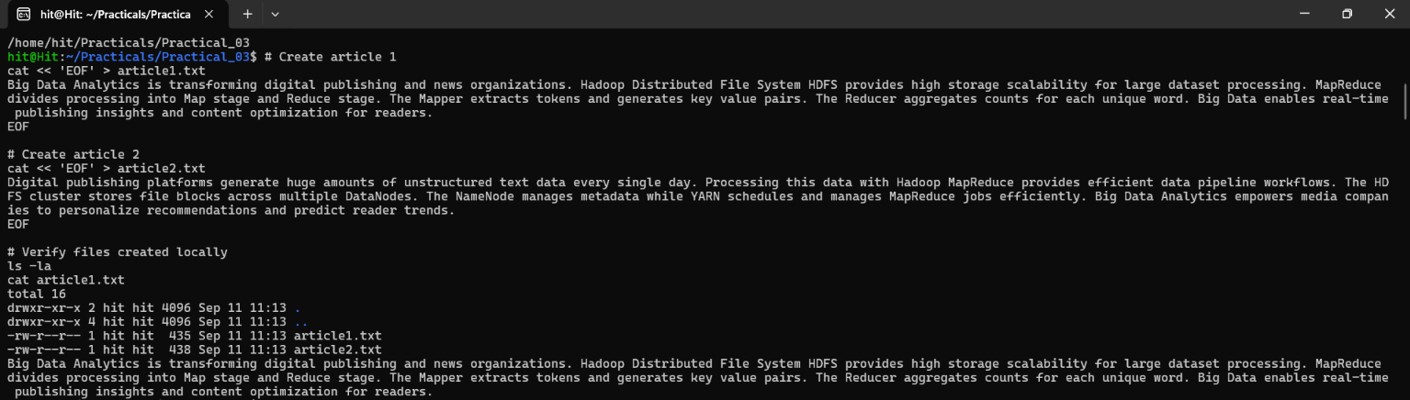

5. STARTING HADOOP
First, the Hadoop cluster was started. After starting Hadoop, the running Java processes were checked using the jps command. The NameNode, DataNode, SecondaryNameNode, ResourceManager and NodeManager processes were running.
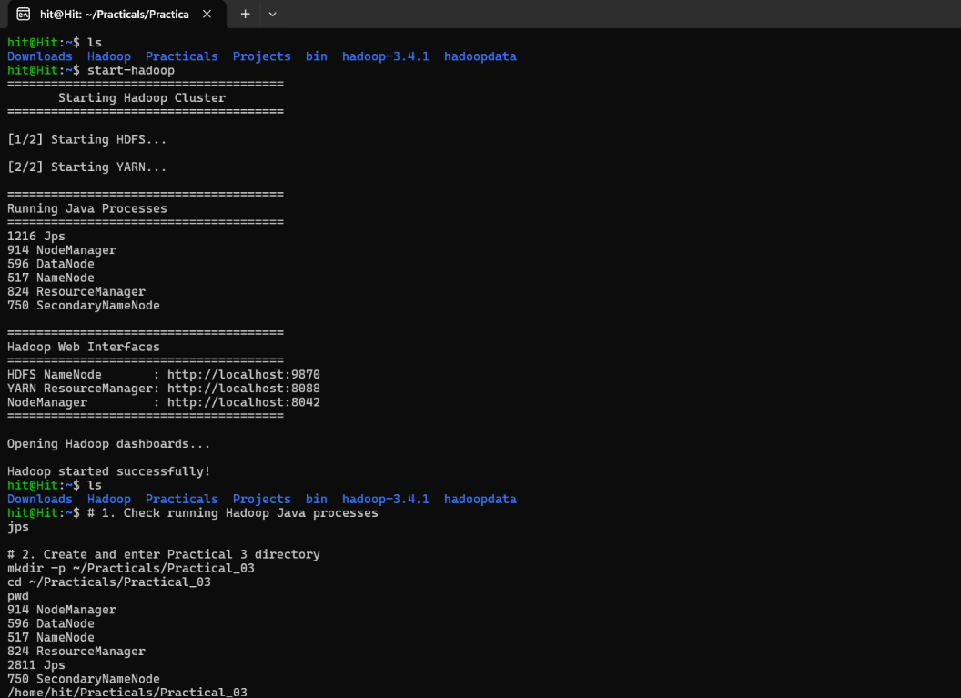

6. UPLOADING INPUT FILES TO HDFS
An input directory was created in HDFS and both article files were uploaded.
hdfs dfs -mkdir -p /user/hit/input_p3
hdfs dfs -put article1.txt article2.txt /user/hit/input_p3/
hdfs dfs -ls /user/hit/input_p3/
The files article1.txt and article2.txt were successfully visible inside the HDFS input directory.
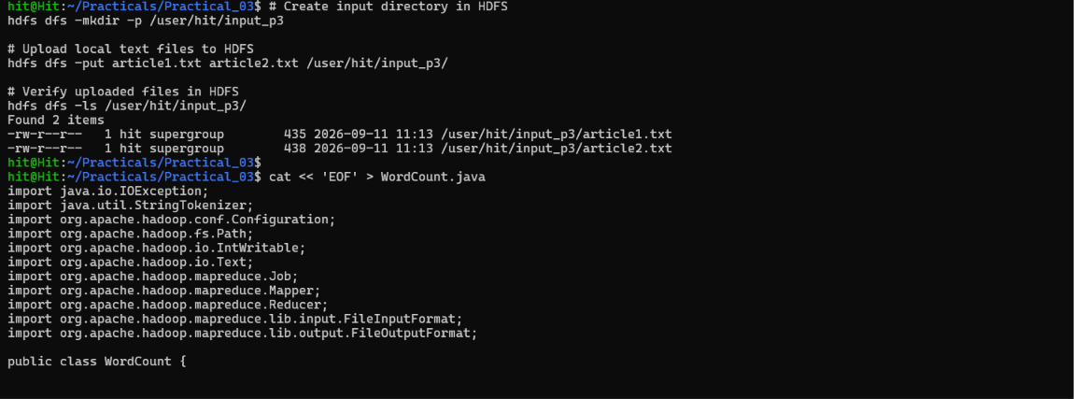.
7. MAPPER AND REDUCER PROGRAM
The program was written in Java. The Mapper reads one line at a time, converts the text to lowercase and separates the words. Common stop words were ignored. For every remaining word, the Mapper generates the pair (word, 1).
The Reducer receives the same word together with all its values and adds the values. For example, if the Mapper produces (data,1), (data,1) and (data,1), the Reducer produces (data,3).
Mapper Logic
- Read input text.
- Convert text to lowercase.
- Remove punctuation.
- Split the text into words.
- Ignore common stop words.
- Write each valid word with value 1.
Reducer Logic
- Receive the same word and its values.
- Add all the values.
- Write the final word count.
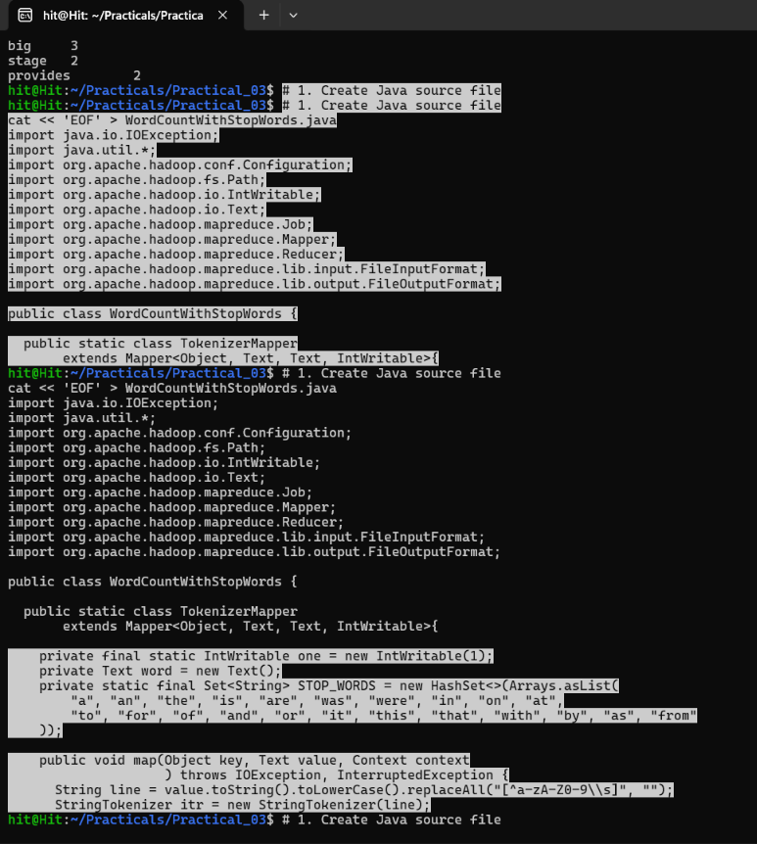
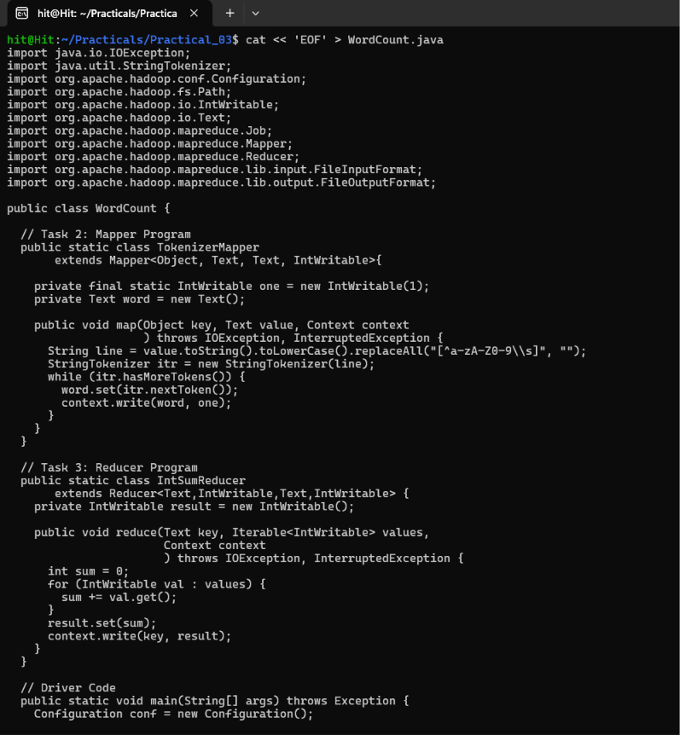

8. COMPILATION AND JAR CREATION
After writing the Java program, it was compiled and a JAR file was created.
hadoop com.sun.tools.javac.Main WordCount.java
jar cf wc.jar WordCount*.class
ls -la wc.jar
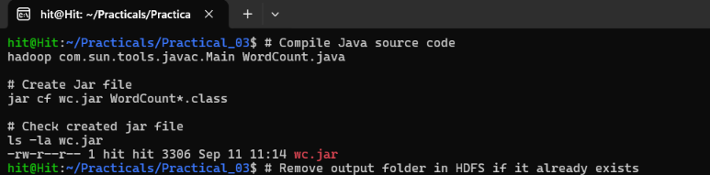

9. EXECUTION OF MAPREDUCE PROGRAM
Before running the program, the old output folder was removed if it already existed. Then the MapReduce job was executed using the input directory and a new output directory.
hdfs dfs -rm -r /user/hit/output_p3
hadoop jar wc.jar WordCount /user/hit/input_p3 /user/hit/output_p3
hdfs dfs -cat /user/hit/output_p3/part-r-00000
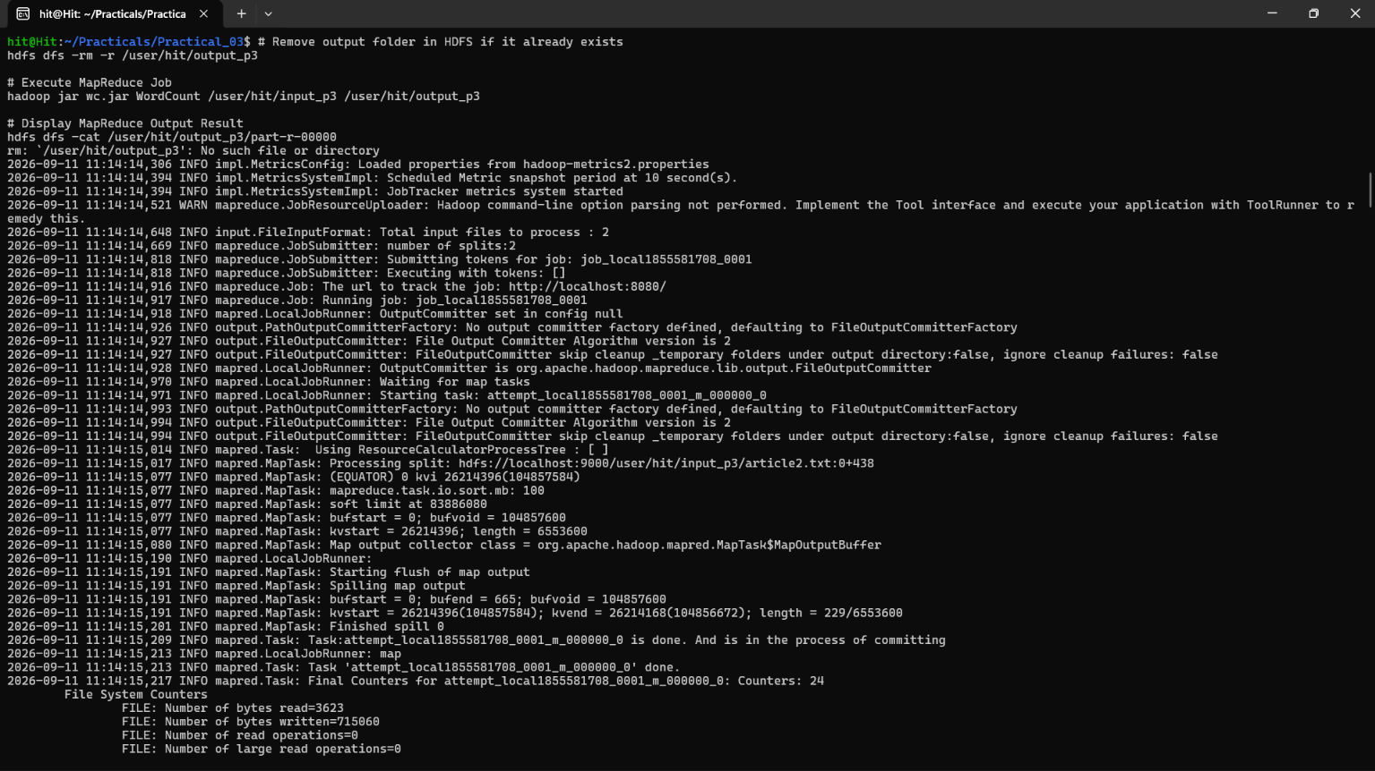

10. OUTPUT
The MapReduce job completed successfully and the output was stored in HDFS. The output contains each word and its total frequency.
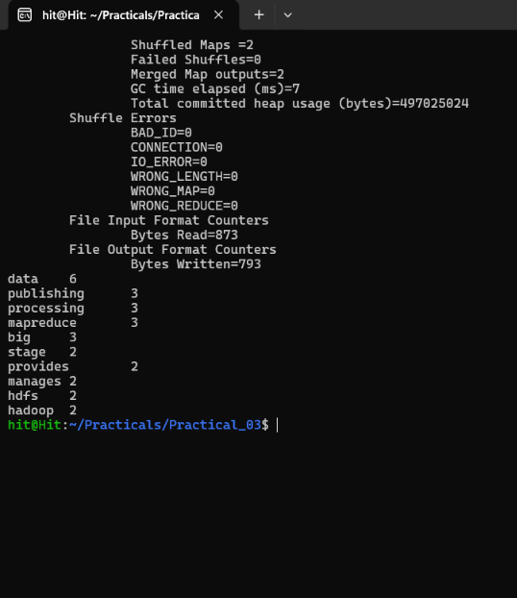

11. TOP 10 FREQUENT WORDS
From the output shown in the execution screenshot, the frequently occurring meaningful words were:
- data – 6
- big – 3
- publishing – 3
- processing – 3
- mapreduce – 3
- hadoop – 2
- hdfs – 2
- manages – 2
- provides – 2
- stage – 2
The word data occurred the highest number of times in the final output.
12. PERFORMANCE OBSERVATION
The MapReduce job was executed successfully on the given two input files. The screenshots show the successful job execution and Hadoop counters. A separate benchmark with small, medium and large datasets was not performed in the available execution record, so exact timing values for different dataset sizes are not included.
In general, for very small files, Hadoop can take extra time because the framework has to start and schedule the job. When the amount of data becomes large, distributed processing becomes more useful.
13. KEY QUESTIONS / ANALYSIS
Q1. What is the role of Mapper and Reducer in the Word Count application?
The Mapper reads the text and generates (word, 1) for each valid word. The Reducer receives the same words together and adds their values to get the final count.
Q2. How are intermediate key-value pairs generated and processed?
For every word found by the Mapper, a pair such as (data, 1) is generated. Hadoop groups the same words during Shuffle and Sort. The Reducer then adds the values of each group.
Q3. How does HDFS store and distribute the input dataset?
HDFS stores files in blocks. In a Hadoop cluster, blocks can be stored on different DataNodes. The NameNode keeps information about the files and blocks. In this practical, Hadoop was running on a single local machine.
Q4. What advantages does MapReduce offer for processing large datasets?
MapReduce can process data in parallel and can work with large datasets. It can also be scaled by adding more nodes. It is useful when the data is too large to process easily on one system.
Q5. How does execution time vary with dataset size?
For small datasets, Hadoop startup and job scheduling can take a noticeable amount of time. As the dataset size increases, the benefit of distributed processing becomes more useful. Exact time comparison was not available from the current practical execution screenshots.
14. TOOLS / TECHNOLOGY USED
- Ubuntu Linux / Terminal
- Hadoop 3.4.1
- HDFS
- YARN
- Java
- Hadoop MapReduce
15. CONCLUSION
In this practical, the Hadoop environment was started successfully and two text files were uploaded to HDFS. A Java MapReduce program was used to count the frequency of words. The Mapper generated the intermediate word and count pairs, while the Reducer added the counts of the same words. Stop words were ignored for better analysis. The final output was generated successfully in HDFS, and the top frequent words were identified.
16. FINAL RESULT
The Word Count / Frequency program using Hadoop MapReduce was implemented and executed successfully. The input files were processed from HDFS and the final word frequency output was generated successfully.

