CHAROTAR UNIVERSITY OF SCIENCE & TECHNOLOGY
Faculty of Technology & Engineering
Devang Patel Institute of Advance Technology and Research (DEPSTAR)

CSUE301 – : Big Data Analytics
Practical File – ODD Semester 2026-27

StudentID: 24DIT021
Student Name: HIT GOAYNI

1. Problem Definition

Practical 8

FinEdge Securities Ltd. receives a continuous stream of stock-price records from multiple exchanges. As the volume of market observations grows, conventional processing approaches can become slower for historical and time-based analysis. The objective of this practical is to use PySpark DataFrame aggregations and Window-based operations to summarize stock prices, measure returns and volatility, observe trends, and prepare an educational market analysis report.

PART A — Practical Execution

Step 1: Creating the Practical Workspace and Files
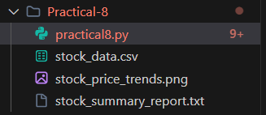

Step 2: Initializing the Spark Session

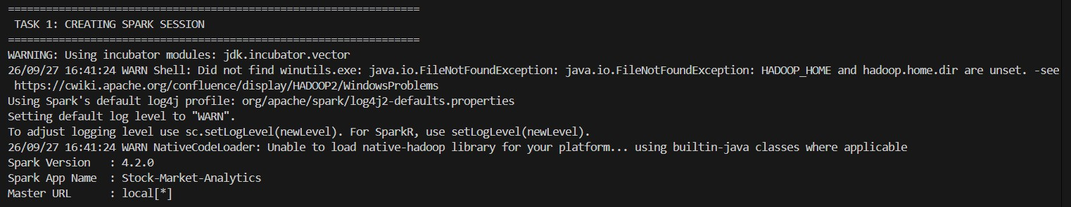

Step 3: Loading the Stock Price Dataset

Step 4: Inspecting the Dataset Schema and Records

Step 5: Grouping Observations by Stock Symbol

Step 6: Computing the Average Stock Price

Step 7: Finding the Maximum Stock Price

Step 8: Finding the Minimum Stock Price
Step 9: Preparing the Stock Summary Report
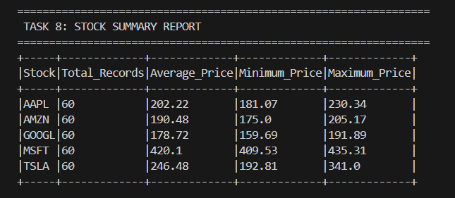

Step 10: Determining Period Performance

Step 11: Computing Daily Stock Returns with a Window
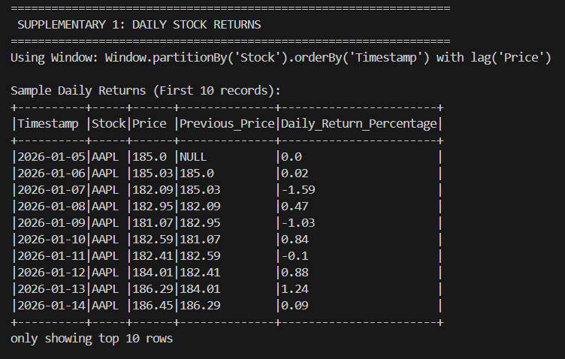

Step 12: Ranking Stocks by Period Return
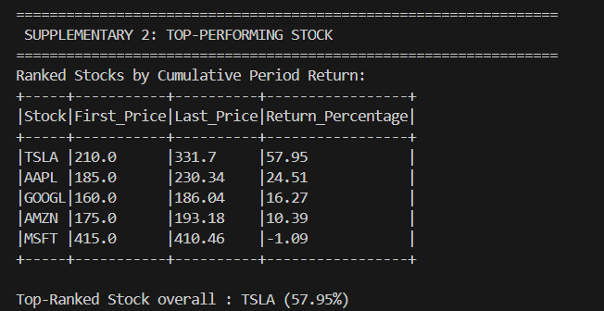

Step 13: Computing a 3-Period Moving Average

Step 14: Measuring Stock Volatility
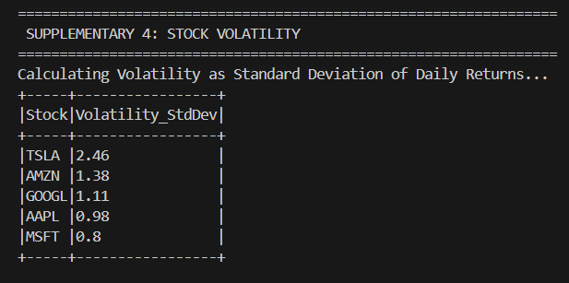

Step 15: Interpreting the Observed Market Trend
Step 16: Educational Investment Analysis
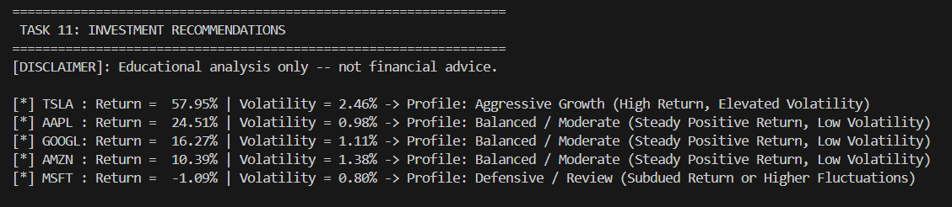

Step 17: Visualizing Stock Price Movement

Step 18: Creating the Final Stock Analysis Report

Key Questions / Analysis
Q1. Why is Apache Spark useful for financial data analysis?
Apache Spark is useful for financial analytics because it can distribute the processing of large datasets across multiple tasks. DataFrames and built-in functions support efficient filtering, aggregation and time-series calculations, which are common requirements when analysing market data.

Q2. What is the purpose of grouping stock records by symbol?
Grouping records by the Stock column separates the observations belonging to each company. This makes it possible to calculate independent statistics such as average, minimum and maximum price for every symbol.
Spark aggregation functions can then summarize the historical observations for each stock.
For example:
df.groupBy("Stock").agg(avg("Price")) produces the average price for every stock symbol.

Q3. How can average stock price be used in analysis?
The average price gives an overall measure of the typical price level during the selected period. It is more informative when considered together with returns, price range and volatility rather than being used as a standalone decision measure.

Q4. What information do maximum and minimum prices provide?
The maximum and minimum values identify the highest and lowest observed prices within the analysed period. Their range helps describe historical price movement and provides context for comparing stocks.
The values should be interpreted together with the time period and other performance measures.

Q5. How can Spark be used for ongoing stock-market monitoring?
Spark can process both historical and streaming data using distributed computation. A Spark-based pipeline can update calculations such as prices, returns, rolling averages and trends as new market records arrive.

Conclusion
The practical demonstrated stock-market analytics with PySpark using DataFrame aggregation and Window-based analysis.
The sample dataset contained 300 records for five stock symbols. The data was loaded into a Spark DataFrame, its schema and records were inspected, and average, minimum and maximum prices were calculated for each stock.
Window functions were used to calculate daily returns, period returns and a 3-period moving average. Daily-return standard deviation was also used to compare volatility, while the generated report summarized the observed price behaviour.
A Matplotlib chart was created to visualize stock-price movement over time, and the final analysis was stored in the stock summary report.
Note: The dataset is a generated/sample dataset intended for academic demonstration. The calculated performance profiles are historical observations from the sample and should not be treated as financial advice.

