CHAROTAR UNIVERSITY OF SCIENCE & TECHNOLOGY
Faculty of Technology & Engineering
Devang Patel Institute of Advance Technology and Research (DEPSTAR)

CSUE301 – : Big Data Analytics
Practical File – ODD Semester 2026-27

StudentID: 24DIT021
Student Name: HIT GOAYNI

1. Problem Definition

Practical 9

TrendPulse Social Media Analytics tracks social media activity from platforms including Twitter/X, Instagram, Facebook, and LinkedIn. Large numbers of posts contain hashtags related to technology, sports, entertainment and other current topics.

The objective of this practical is to apply PySpark for processing hashtag data and to determine frequently discussed and emerging topics.

The analysis includes hashtag grouping, occurrence counting, popularity ranking, daily and regional trend checks, category analysis and visualization.

Note: The dataset used here is a generated/sample dataset prepared for educational analysis.

PART A — Practical Execution

Step 1: Creating Folder and files
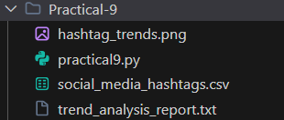

Step 2: Creating Spark Session

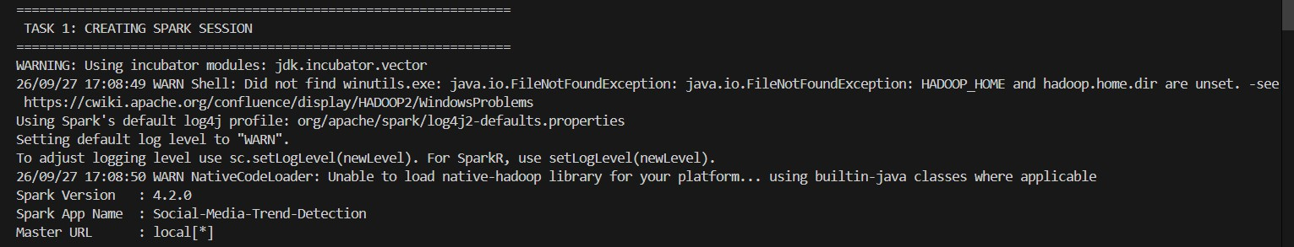

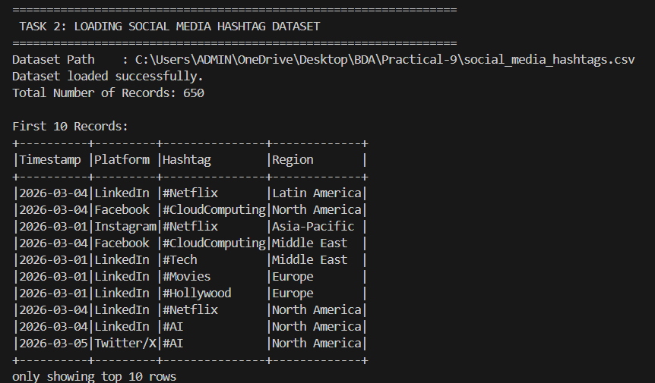
Step 3: Loading Social Media Hashtag Dataset

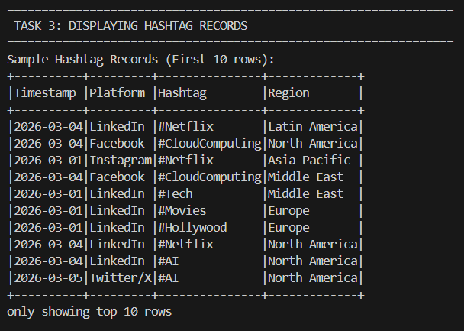
Step 4: Displaying Hashtag Records

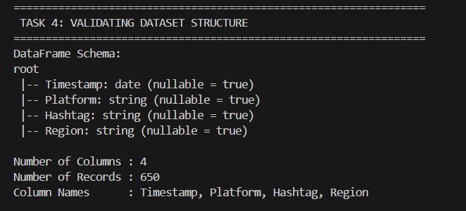
Step 5: Validating Dataset Structure

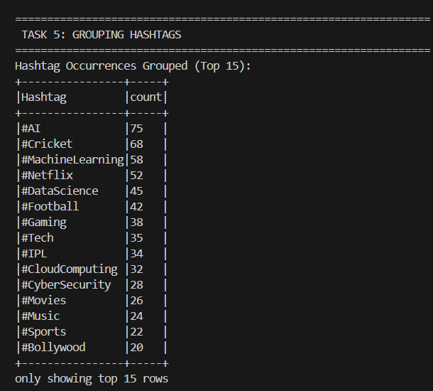
Step 6: Grouping Hashtags

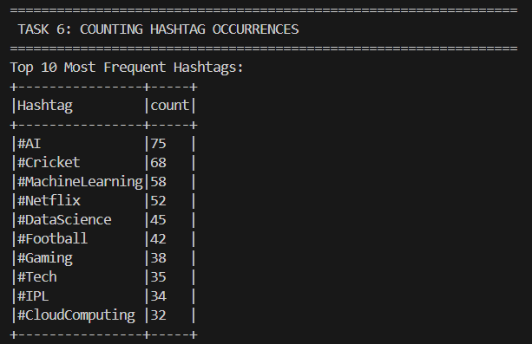
Step 7: Counting Hashtag Occurrences

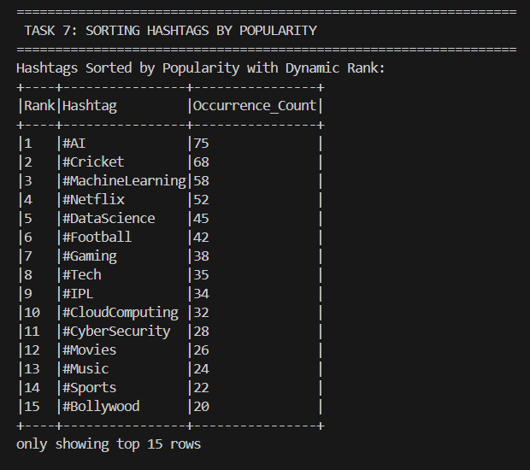
Step 8: Sorting Hashtags by Popularity

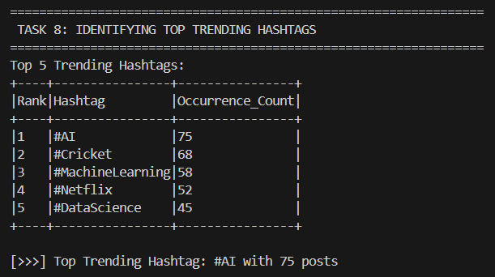
Step 9: Identifying Top Trending Hashtags

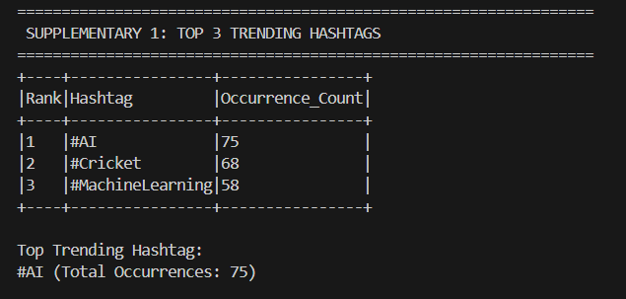
Step 10: Supplementary 1 — Top 3 Trending Hashtags

Step 11: Supplementary 2 — Daily Trend Comparison
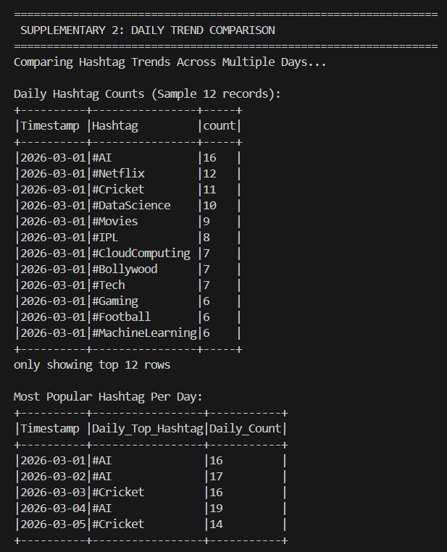

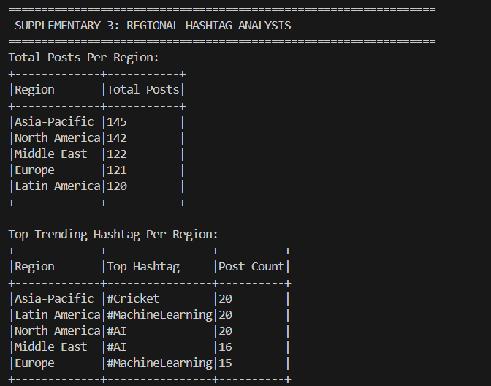
Step 12: Supplementary 3 — Regional Hashtag Analysis

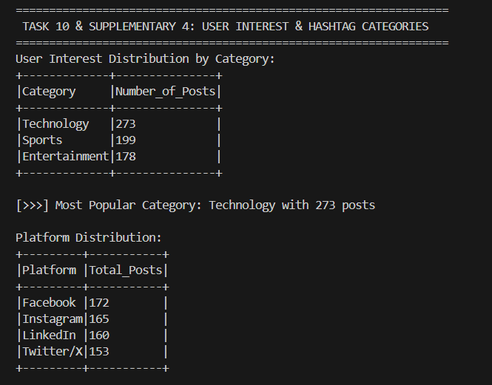
Step 13: Task 10 / Supplementary 4 — User Interest and Hashtag Categories

Step 14: Supplementary 5 — Trend Visualization
================================================================= SUPPLEMENTARY 5: TREND VISUALIZATION
=================================================================
Creating Matplotlib Bar Chart for Top 10 Trending Hashtags...
Chart successfully saved to: C:\Users\ADMIN\OneDrive\Desktop\BDA\Practical-9\hashtag_trends.png

================================================================= BUSINESS RECOMMENDATIONS
=================================================================
[DISCLAIMER]: Educational analysis based on generated/sample social media data.

- Campaign Targeting : Focus promotional analysis on high-engagement Technology and Sports hashtags.
- Platform Strategy : Adapt content distribution according to the platform where relevant technology and sports discussions are concentrated.
- Emerging Topics : Track daily changes in hashtag frequency to identify rapidly growing discussions.
- Geo-Targeted Content : Adjust campaign themes according to regional interests, such as cricket discussions in Asia-Pacific.
- Community Engagement : Use interactive content around frequently observed topics such as #AI, #Cricket and #Netflix.

================================================================= FINAL SOCIAL MEDIA TREND ANALYSIS REPORT
=================================================================
====================================================================================
====

TRENDPULSE SOCIAL MEDIA TREND DETECTION REPORT
====================================================================================
====

DATASET DETAILS:
  - Source File : social_media_hashtags.csv
  - Total Records 650
  - Schema : Timestamp (string), Platform (string), Hashtag (string), Region (string)
  - Data Nature : Generated / Sample dataset for educational evaluation

TOTAL RECORDS:
  - Total Monitored Posts 650

UNIQUE HASHTAGS:
  - Total Distinct Hashtags 18

PLATFORM DISTRIBUTION:
Platform | Total Posts

Facebook | 172
Instagram | 165
LinkedIn | 160

Twitter/X | 153

REGION DISTRIBUTION:
Region | Top Hashtag | Post Count

Asia-Pacific | #Cricket | 20
Latin America | #MachineLearning | 20 North America | #AI | 20
Middle East | #AI | 16
Europe | #MachineLearning | 15

HASHTAG FREQUENCY ANALYSIS:
  - Hashtag frequency was evaluated across the monitored sample using grouping, counting and descending frequency sorting.

TOP 10 HASHTAGS:
Rank | Hashtag | Occurrences

1 | | #AI | | 75
2 | | #Cricket | | 68
- | #MachineLearning | 58
- | #Netflix | 52
- | #DataScience | 45
- | #Football | 42
- | #Gaming | 38
- | #Tech | 35
- | #IPL | 34
- | #CloudComputing | 32

TOP 5 TRENDING HASHTAGS:
Rank | Hashtag | Occurrences

1 | | #AI | | 75
2 | | #Cricket | | 68
- | #MachineLearning | 58
- | #Netflix | 52
- | #DataScience | 45

TOP 3 TRENDING HASHTAGS:
Rank | Hashtag | Occurrences

1 | | #AI | | 75
2 | | #Cricket | | 68
3 | #MachineLearning | 58
* Top Trending Hashtag : #AI (75 occurrences)

DAILY TREND ANALYSIS:

Date | Daily Top Hashtag | Post Count

2026-03-01 | | #AI | | 16
2026-03-02 | | #AI | | 17
2026-03-03 | | #Cricket | | 16
2026-03-04 | | #AI | | 19
2026-03-05 | | #Cricket | | 14

REGIONAL ANALYSIS:
Region | Top Hashtag | Post Count

Asia-Pacific | #Cricket | 20
Latin America | #MachineLearning | 20 North America | #AI | 20
Middle East | #AI | 16
Europe | #MachineLearning | 15

CATEGORY ANALYSIS:
Category | Number of Posts

Technology | 273
Sports | 199
Entertainment | 178
* Leading Category : Technology (273 posts)

USER INTEREST ANALYSIS:
  - User attention in the sample is concentrated mainly around Technology topics such as #AI and #MachineLearning, followed by Sports discussions including #Cricket and #Football, with Entertainment topics such as #Netflix also appearing prominently.
(#Netflix).

BUSINESS RECOMMENDATIONS:
* DISCLAIMER: Educational analysis based on generated/sample social media data.
- Use high-frequency topics such as #AI, #Cricket and #MachineLearning as inputs for campaign planning.
- Select suitable platforms for different audience interests, such as professional technology content on LinkedIn and sports discussions on Twitter/X.
- Observe daily changes in hashtag activity so marketing responses can be adjusted when new topics begin to gain attention.

CONCLUSION:
PySpark DataFrame transformations, grouping and analytical operations provide a scalable way to process large social-media datasets and identify useful trends.
The results show how frequency, daily, regional and category-based analysis can support structured business interpretation of social media activity.
====================================================================================
====

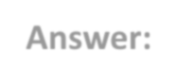
Key Questions / Analysis
Q1. Why is Apache Spark suitable for social media analytics? Answer:
Apache Spark is suitable for social media analytics because it can process large amounts of data efficiently using distributed computing. Spark DataFrames provide fast operations such as filtering, grouping, aggregation and sorting,
which are useful for analysing large social media datasets.

Real-time analytics can reveal changes in online activity as they happen. This enables organizations to react more quickly to emerging topics, customer interests and market signals.

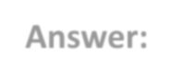
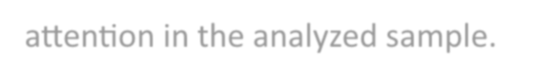
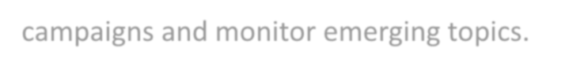
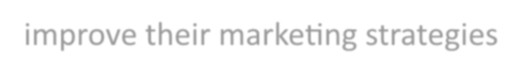

Q2. What is the significance of hashtag frequency?
Answer:
Hashtag frequency represents how many times a particular hashtag appears in the dataset. A higher frequency indicates that the topic is receiving more attention in the analyzed sample.
Q3. How can trend analysis support digital marketing campaigns? Answer:
Trend analysis helps marketers identify popular topics and changing user
interests. Businesses can use this information to create relevant content, plan campaigns and monitor emerging topics.
Q4. Why do businesses monitor social media trends? Answer:
Businesses monitor social media trends to understand customer interests,
identify emerging topics, observe discussions about products or services and improve their marketing strategies.
Q5. How can real-time analytics improve decision making? Answer:
Real-time analytics allows organizations to detect changes in trends quickly. This can help businesses respond faster to emerging topics, customer interests and market changes.
Businesses track social media trends to understand audience interests, discover emerging conversations, observe reactions to products or services and improve marketing decisions.

Trend analysis shows which subjects are gaining attention and how audience interests change. Marketers can use these observations to create timely content, plan campaigns and watch for new trends.
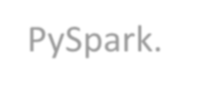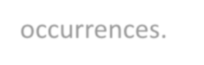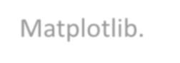
Result
The Social Media Trend Detection practical was successfully implemented using PySpark.
The dataset contained 650 social media records and 18 distinct hashtags. Hashtag frequency, popularity ranking, top trends, daily trends, regional trends and category-based user interests were successfully analyzed.
The most frequently occurring hashtag in the sample dataset was #AI with 75 occurrences.
The Technology category had the highest number of posts with 273 posts. A visualization of the top 10 hashtags was also successfully generated using Matplotlib.

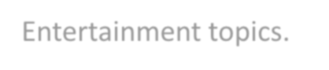
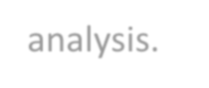
Conclusion
The practical demonstrated how PySpark DataFrame operations and aggregation techniques can be used for social media trend detection. Hashtags were grouped, counted and ranked according to their frequency.
Daily and regional analysis provided additional information about changing user interests. Category analysis showed the distribution of Technology, Sports and Entertainment topics.
The practical demonstrates that PySpark can be used to process and analyze
large-scale social media datasets efficiently and extract useful trends for business analysis.

Hashtag frequency is the number of times a particular hashtag occurs in the analyzed dataset. A larger count indicates greater attention to that topic within the sample.

Apache Spark is useful for social media analytics because distributed processing can handle large datasets efficiently. Spark DataFrames support filtering, grouping, aggregation and sorting operations needed for trend analysis.

