PRACTICAL 1
Introduction to React and Component Architecture
Roll No:- 24DIT021

1. Problem Statement
Create a React application using Vite for a student portfolio page. The application should be divided into reusable components such as Header, About, Skills and Footer. The components should be composed into a single-page layout, and props should be used to pass data from the parent component to child components.
2. Requirements
- Use Vite to create and run the React application.
- Create at least four reusable functional components: Header, About, Skills and Footer.
- Keep each component responsible for one clear part of the interface.
- Compose all components through App.jsx.
- Pass data through props to at least two components.
- Render the skill list dynamically from a prop.
- Verify that the application runs without console errors.

3. Solution Approach
The solution is kept simple so that each part of the practical can be understood separately. App.jsx works as the parent component. It stores the data needed by the page and passes that data to the child components. Header displays the student's name, Skills displays the supplied skills, and the About and Footer components handle the remaining sections.
- Create the Vite React project.
- Create the components inside src/components.
- Write one responsibility for each component.
- Pass the student's name and skill list through props.
- Compose the components inside App.jsx.
- Run the development server and verify the result.

4. Folder Structure
The project is organized so that reusable UI parts stay inside the components folder. The supplied project screenshot also shows the additional Navbar and Projects components used in the work.
student-portfolio/
├── public/
├── src/
│ ├── assets/
│ ├── components/
│ │ ├── About.jsx
│ │ ├── Footer.jsx
│ │ ├── Header.jsx
│ │ ├── Navbar.jsx
│ │ ├── Projects.jsx
│ │ └── Skills.jsx
│ ├── App.css
│ ├── App.jsx
│ ├── index.css
│ └── main.jsx
├── .gitignore
├── index.html
├── package.json
├── package-lock.json
└── vite.config.js
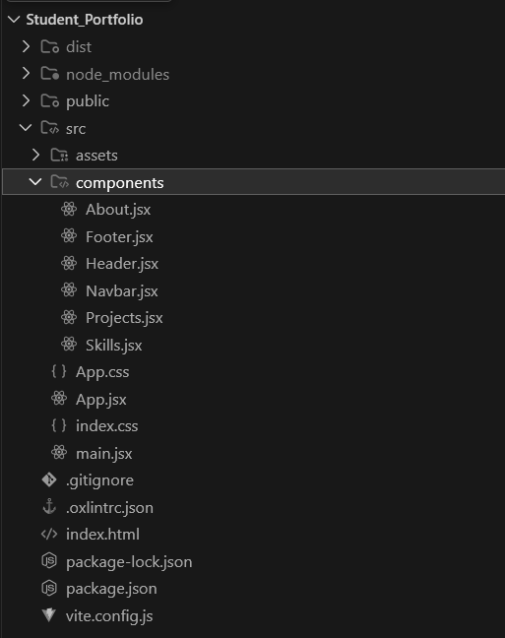
5. Environment Setup
Command 1: Check Node.js and npm.
node -v
npm -v
Command 2: Create the React application using Vite.
npm create vite@latest student-portfolio -- --template react
cd student-portfolio
npm install
npm run dev
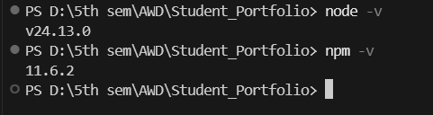
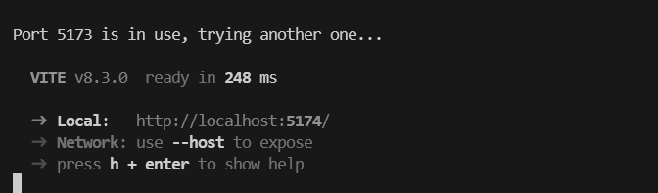
6. Component Implementation
Header.jsx
function Header({ name }) {
return (
<header>
<h1>{name}'s Student Portfolio</h1>
</header>
);
}

export default Header;
About.jsx
function About() {
return (
<section id="about">
<h2>About Me</h2>
<p>I am a student interested in technology and software development.</p>
</section>
);
}

export default About;
Skills.jsx
function Skills({ skillList }) {
return (
<section id="skills">
<h2>Skills</h2>
<ul>
{skillList.map((skill) => (
<li key={skill}>{skill}</li>
))}
</ul>
</section>
);
}

export default Skills;
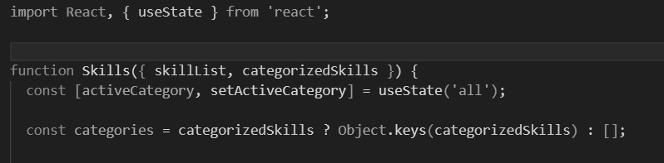
Footer.jsx
function Footer() {
return (
<footer>
<p>Student Portfolio</p>
</footer>
);
}

export default Footer;
7. App.jsx – Component Composition
App.jsx connects the components and passes the required data. The name is sent to Header and the skillList array is sent to Skills. This keeps the components reusable instead of hardcoding the same information inside them.
import Header from './components/Header';
import About from './components/About';
import Skills from './components/Skills';
import Footer from './components/Footer';

function App() {
const name = 'Student';
const skillList = ['HTML', 'CSS', 'JavaScript', 'React'];

return (
<>
<Header name={name} />
<About />
<Skills skillList={skillList} />
<Footer />
</>
);
}

export default App;
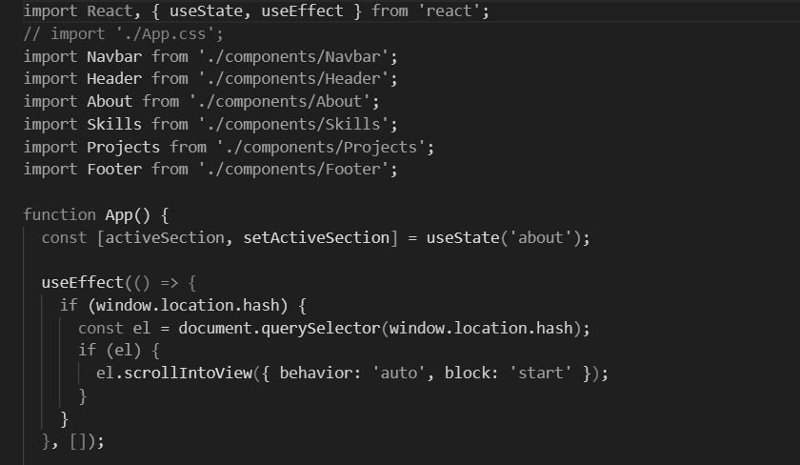
8. Working Flow
The practical follows a simple parent-to-child data flow. App.jsx creates the data, passes it through props, and the child components use those values while rendering the page.
App.jsx
│
├── name ───────────────→ Header.jsx
│
├── skillList ──────────→ Skills.jsx
│
├───────────────────────→ About.jsx
│
└───────────────────────→ Footer.jsx
9. Output and Evidence
The available evidence from the practical shows the project structure, the installed Node.js and npm versions, the Vite development server running successfully, and the React component implementation. These screenshots are included directly without adding figure titles or artificial output claims.
10. Key Questions / Answers
Q1. What is the role of each component in the overall UI structure?Each component represents one section of the page. Header handles the top part, About presents the introduction, Skills displays the skills list, and Footer contains the closing information. App.jsx combines them into the final page.
Q2. How does React re-render when props change?When a parent passes a different prop value, React updates the child component that receives the new value. The rendered UI is then updated to reflect that new data.
Q3. Why is component reusability important in large-scale applications?Reusable components reduce repeated code and make the interface easier to maintain. A component can be reused in different places without writing the same UI again.
11. Supplementary Problems / Extensions
- Add a NavBar component that highlights the active section.
- Pass an array of skills as a prop and render it dynamically.
- Pass a theme color to Header and apply it as an inline style.
- Add a Projects component containing three projects.
12. Testing and Verification
- Node.js and npm versions were checked before creating the project.
- The Vite development server was started successfully.
- The project folder contains the required React component files.
- Skills.jsx receives skillList through props and renders the values using map().
- The components are imported and composed through App.jsx.
- The browser should be checked for console errors after every major change.
13. Common Errors and Fixes
- If the Vite command does not start, check the Node.js version and network connection.
- If port 5173 is already in use, stop the previous server or use another port.
- If a component is missing, check its import path and confirm it is inside the App.jsx return block.
- If a prop is undefined, make sure the prop name in App.jsx exactly matches the name used in the child component.
14. GitHub Deliverables
- Public repository named portfolio-<rollno>.
- Working Vite + React project with four or more components.
- Clean .gitignore with node_modules excluded.
- At least one meaningful commit describing the work.
15. Learning Outcome
After completing this practical, I can set up a React project using Vite, divide a page into reusable functional components, and pass data from a parent to child components using props. I also understand why keeping each component focused on one responsibility makes the project easier to manage.
16. Student Reflection
This practical helped me understand React in a more practical way instead of treating the whole webpage as one file. I learned how App.jsx can bring smaller components together and how props can be used to send data to those components. The folder structure also made it clearer where reusable code should be kept. Running the Vite server and checking the project in the browser helped me connect the code with the actual UI.

17. Final Result
The required React component architecture has been implemented as a student portfolio solution. The solution uses Vite, separates the interface into reusable components, and demonstrates prop-based data flow. The supplied screenshots provide supporting evidence for the project setup, folder structure and implementation.

