PRACTICAL 2
State Management and Routing in React
Roll No:- 24DIT021
Subject: Advanced Web Development Frameworks (ITUE301)
Semester: 5th Semester B.Tech Information Technology
Faculty of Technology and Engineering, CHARUSAT

1. Problem Statement
Create a React application that demonstrates client-side routing and state management. The application should contain a navigation bar with three routes: Home, Projects and Contact. The Contact page should use controlled inputs with React state, show the entered information in real time, and include a UI visibility toggle. The application should behave as a single-page application without full page reloads.

2. Objective
The objective of this practical is to understand how React Router manages multiple views inside a single React application and how the useState hook manages changing data and UI behaviour. The implementation also demonstrates controlled form inputs and component-based navigation.

3. Theory / Concepts Used
- BrowserRouter provides routing context to the React application.
- Routes and Route connect URL paths with React components.
- NavLink provides client-side navigation and can identify the active route.
- useState stores values that can change while the application is running.
- A controlled input receives its value from React state and updates that state through onChange.
- Conditional rendering can show or hide UI based on a state value.
- React Router allows route changes without loading a completely new HTML document.

4. Solution Approach
The solution keeps the routing and state logic separated. main.jsx places the application inside BrowserRouter. App.jsx defines the routes and also manages the global dark/light mode. NavBar.jsx provides the three navigation links. The Contact page manages form values and the help panel with useState. A live state inspector displays the current form values so the effect of state updates can be seen directly.
- Start the Vite React application and verify the development server.
- Wrap App.jsx with BrowserRouter in main.jsx.
- Define the Home, Projects and Contact routes in App.jsx.
- Create the navigation using NavLink so the active page is visible.
- Use useState in Contact.jsx for name, email, message and help visibility.
- Bind form fields using value and onChange.
- Display the state values in the Live State Inspector.
- Test route navigation, visibility toggle, theme toggle and the 404 route.

5. Folder Structure
The project is divided into components and pages so that the routing-related files and reusable navigation component are easy to locate.
portfolio/
├── src/
│ ├── components/
│ │ └── NavBar.jsx
│ ├── pages/
│ │ ├── Contact.jsx
│ │ ├── Home.jsx
│ │ ├── NotFound.jsx
│ │ └── Projects.jsx
│ ├── App.css
│ ├── App.jsx
│ ├── index.css
│ └── main.jsx
├── package.json
└── vite.config.js
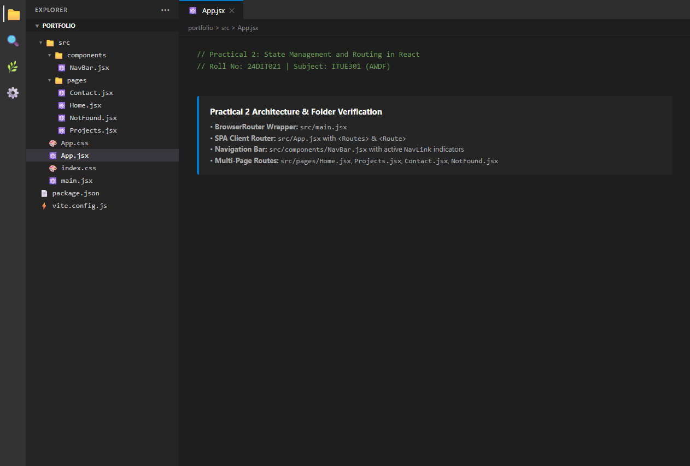

6. Router Setup
BrowserRouter is added at the application entry point. This gives the React application access to client-side routing.
main.jsx
import { StrictMode } from 'react';
import { createRoot } from 'react-dom/client';
import { BrowserRouter } from 'react-router-dom';
import App from './App.jsx';
import './index.css';

createRoot(document.getElementById('root')).render(
<StrictMode>
<BrowserRouter>
<App />
</BrowserRouter>
</StrictMode>
);
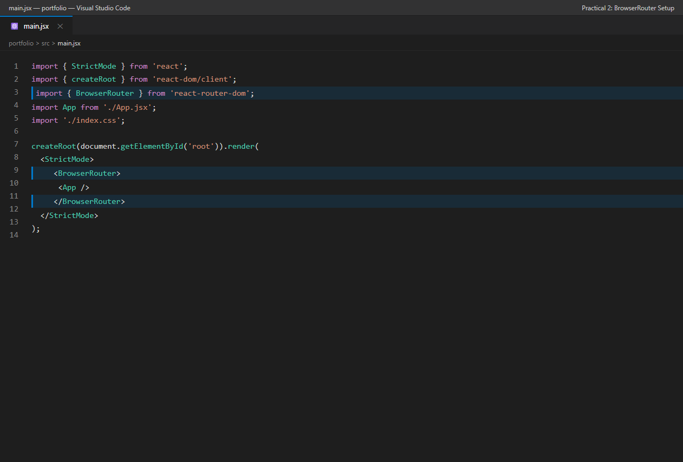

7. Route Configuration
App.jsx defines the three required routes and a wildcard route for invalid paths. The same application shell remains in place while React Router changes the page component.
App.jsx – Routing Section
import { Routes, Route } from 'react-router-dom';

<Routes>
<Route path="/" element={<Home skillList={skillList} />} />
<Route path="/projects" element={<Projects />} />
<Route path="/contact" element={<Contact />} />
<Route path="*" element={<NotFound />} />
</Routes>

8. Navigation Bar
The navigation bar uses NavLink. The active route receives an active class, which makes the current page easy to identify.
NavBar.jsx
import { NavLink } from 'react-router-dom';

const links = [
{ to: '/', label: 'Home', icon: '🏠', end: true },
{ to: '/projects', label: 'Projects', icon: '📂', end: false },
{ to: '/contact', label: 'Contact', icon: '📬', end: false },
];

<NavLink
key={link.to}
to={link.to}
end={link.end}
className={({ isActive }) =>
`nav-link ${isActive ? 'active' : ''}`
}
>

9. State Management in Contact Page
The Contact component uses separate state variables for the form values and the visibility of the information panel. This gives a clear example of how state controls both data and UI behaviour.
useState Declarations
const [name, setName] = useState('');
const [email, setEmail] = useState('');
const [message, setMessage] = useState('');
const [showHelp, setShowHelp] = useState(false);
const [submitted, setSubmitted] = useState(false);
Controlled Inputs
<input
value={name}
onChange={(e) => setName(e.target.value)}
/>

<input
value={email}
onChange={(e) => setEmail(e.target.value)}
/>

<textarea
value={message}
onChange={(e) => setMessage(e.target.value)}
/>
Visibility Toggle
<button
type="button"
onClick={() => setShowHelp(!showHelp)}
>
{showHelp ? '👁️ Hide Info' : '💡 Show Info'}
</button>

{showHelp && (
<div className="help-box">
...
</div>
)}
Live State Display
{name || '—'}
{email || '—'}
{message}

10. Practical Execution and Evidence
The following screenshots were supplied from the running Practical 2 application. They are included as direct evidence of the implementation and testing. No artificial labels or figure titles have been added to the screenshots.
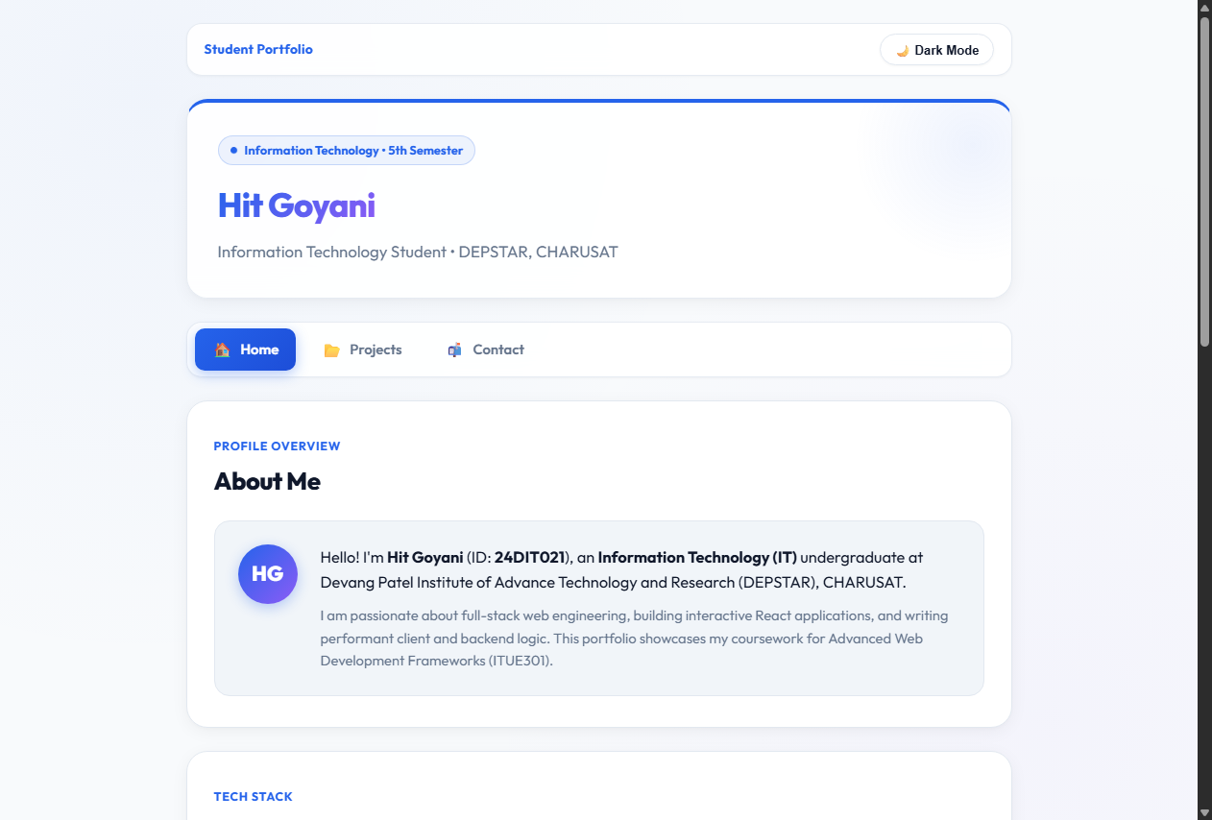
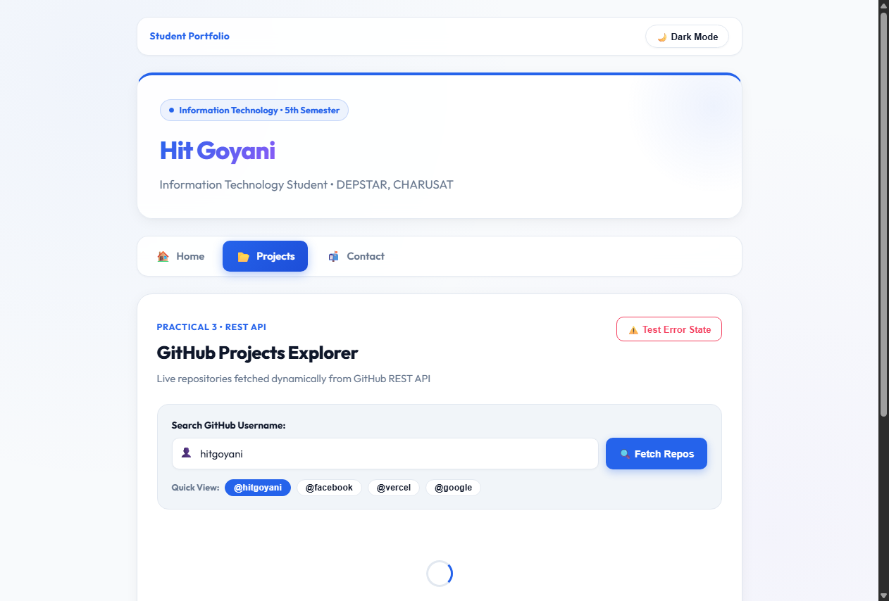
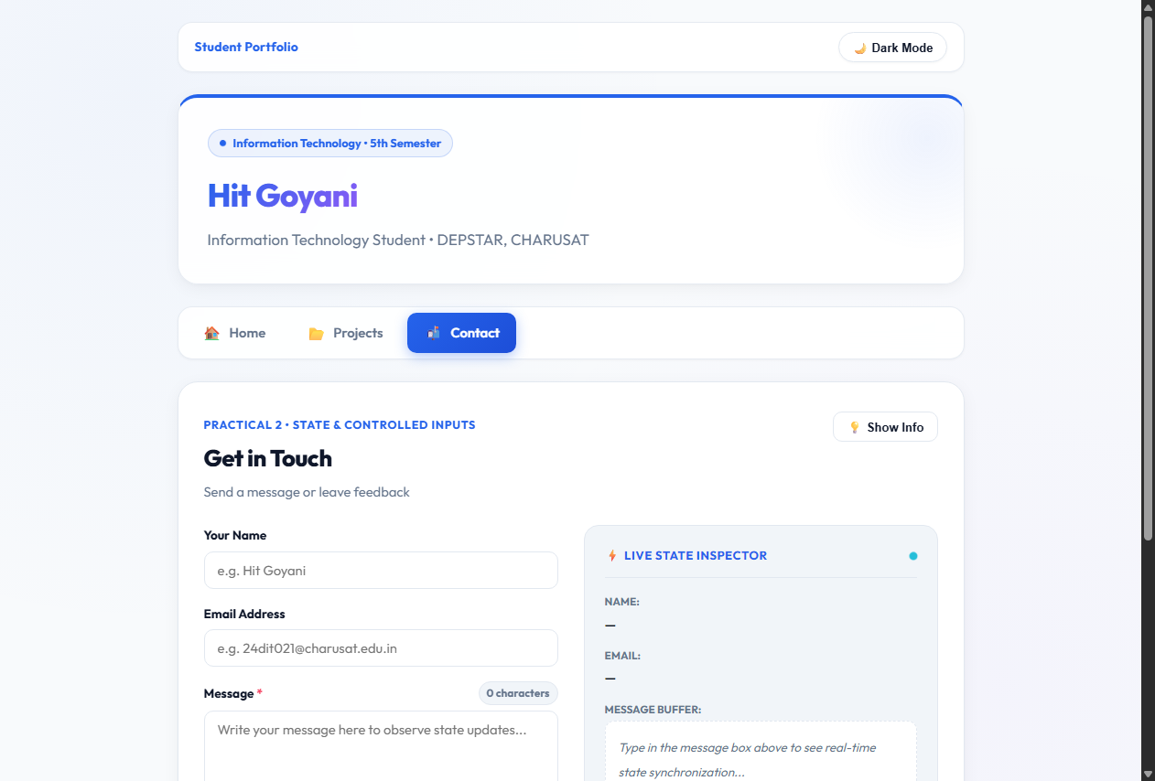
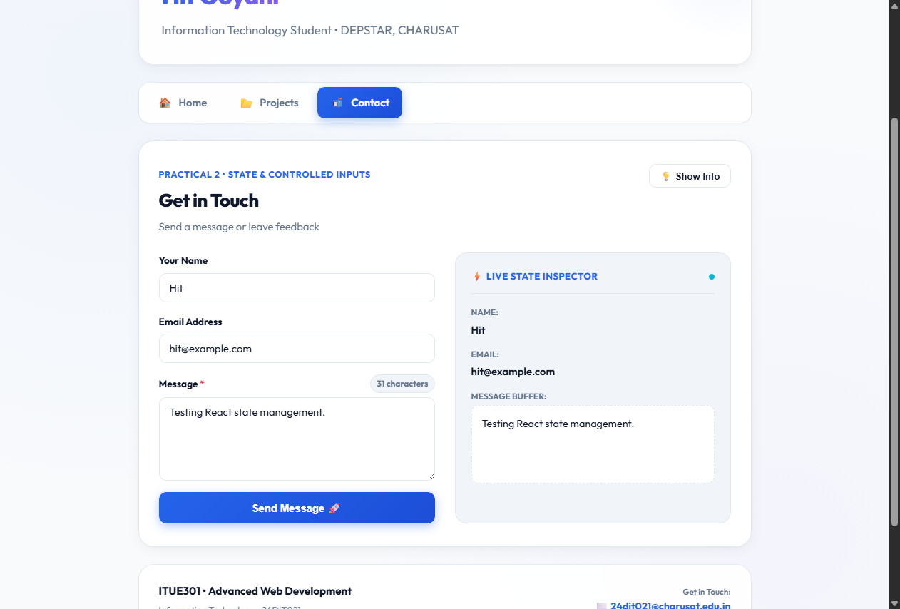
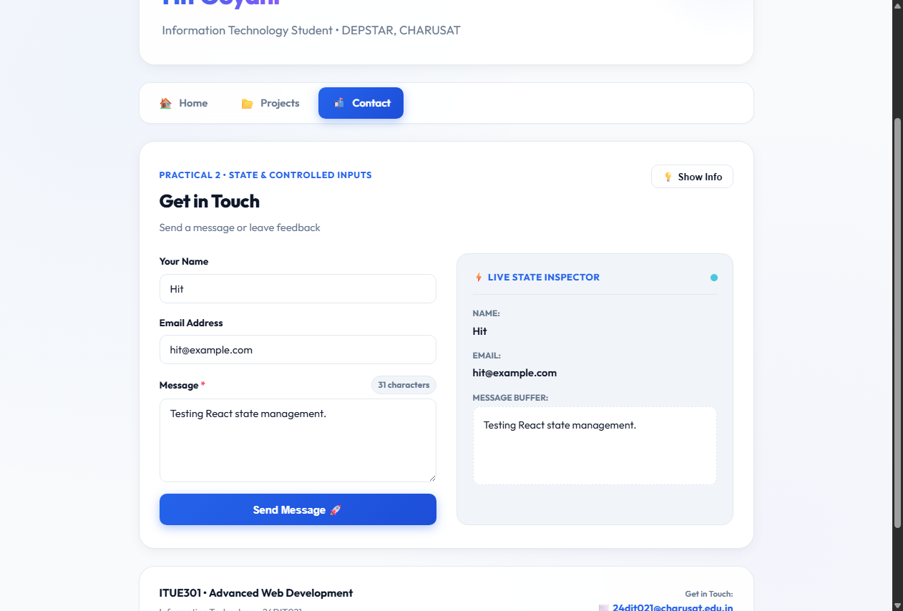
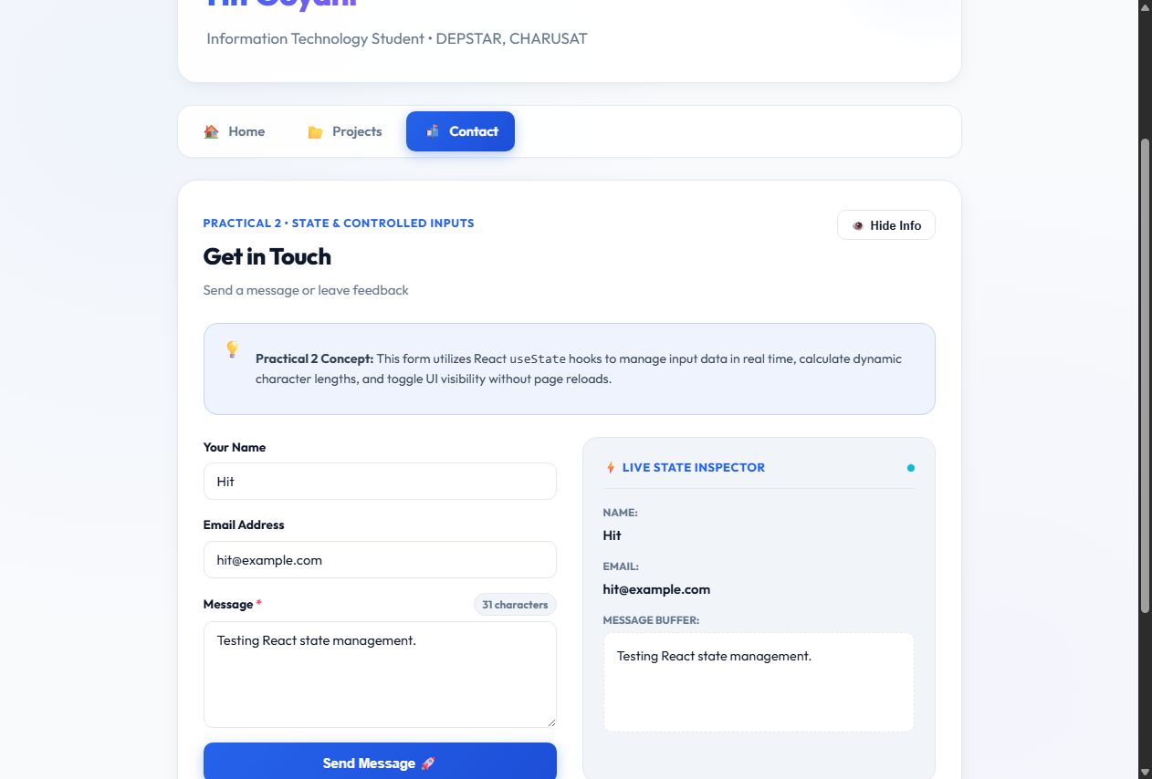
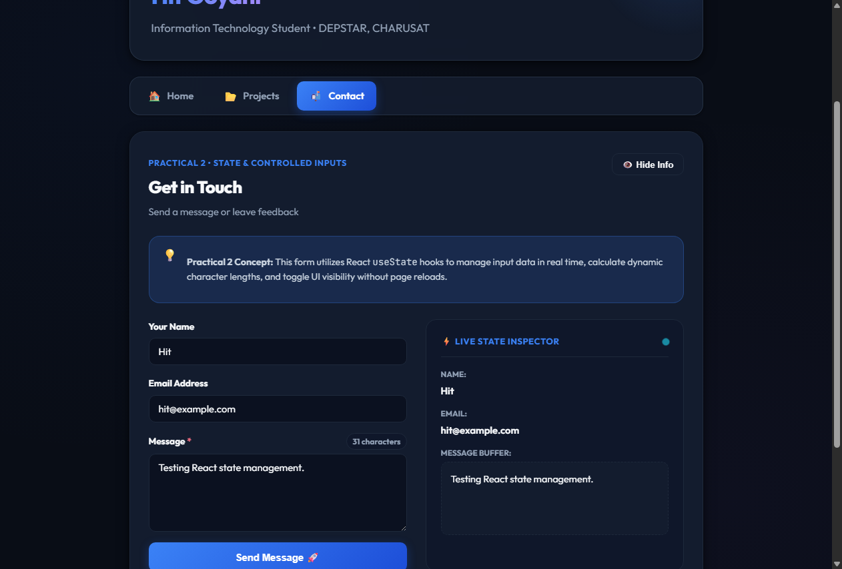
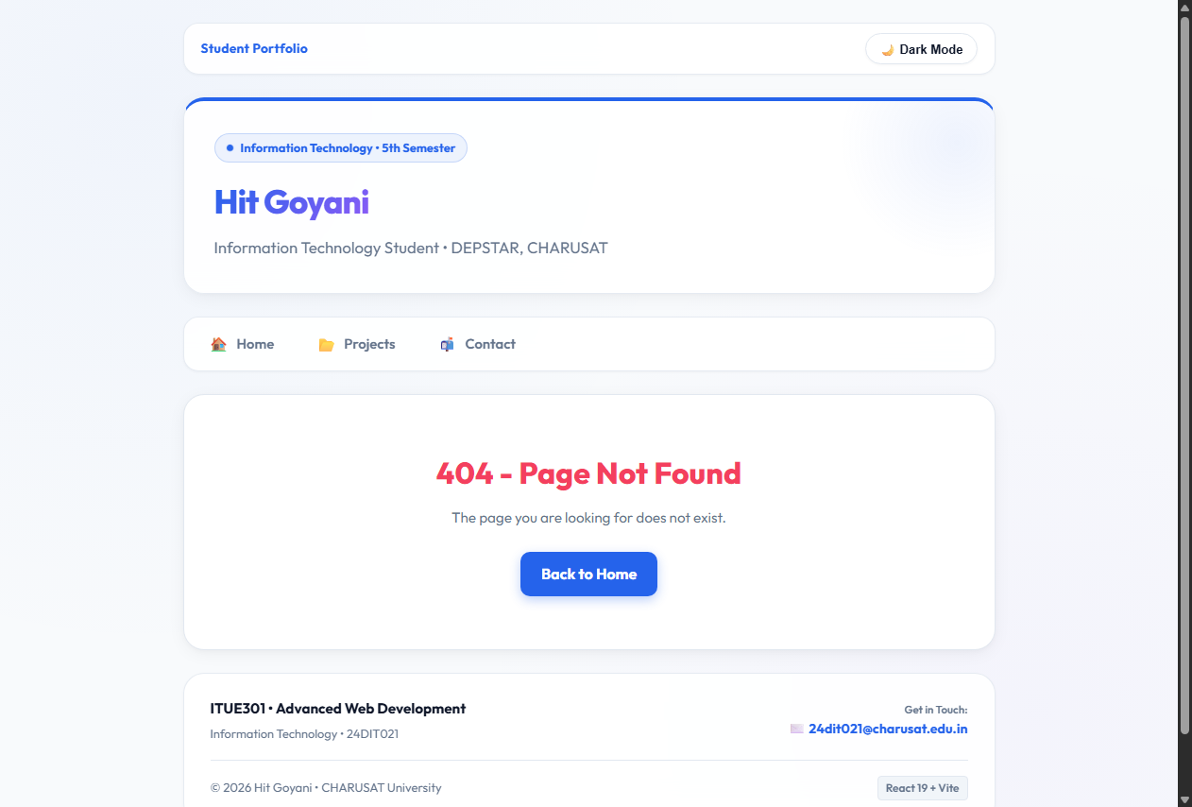

11. Working Flow
The practical works through a simple flow: the browser enters the React application through main.jsx, BrowserRouter provides routing context, App.jsx selects the page based on the URL, and NavBar changes the route through NavLink. On the Contact page, user input changes React state through onChange, and the updated state is immediately rendered in the form and Live State Inspector.
main.jsx
│
▼
BrowserRouter
│
▼
App.jsx
│
├── NavBar.jsx
│ ├── /
│ ├── /projects
│ └── /contact
│
└── Routes
├── Home.jsx
├── Projects.jsx
├── Contact.jsx
└── NotFound.jsx

Contact input
│
▼
useState → onChange → re-render
│
▼
Live State Inspector

12. Testing and Verification
- The Home route was opened at / and displayed the Home page with the Home navigation item active.
- The Projects route was opened at /projects and displayed the Projects page with Projects active.
- The Contact route was opened at /contact and displayed the Contact page with Contact active.
- Test values were entered into the Contact form and appeared in the Live State Inspector.
- The message counter updated with the entered text.
- The Show Info / Hide Info control changed the visibility of the information panel.
- Dark Mode changed the appearance of the application and the control changed to Light Mode.
- An invalid route displayed the custom 404 page.
- The supplied verification records report zero console errors and zero warnings during navigation testing.

13. Key Questions and Answers
Q1. Why is BrowserRouter used in this application?
BrowserRouter provides the routing context required by React Router. It allows the application to change views based on the URL while keeping the navigation inside the React application.
Q2. What is the purpose of Routes and Route?
Routes contains the route definitions, while each Route connects a URL path with the React component that should be rendered for that path.
Q3. Why is NavLink used instead of normal anchor tags?
NavLink is designed for React Router navigation. It changes the route inside the application and also provides isActive information, which is used here to highlight the current navigation item.
Q4. What makes the Contact fields controlled inputs?
The input value is taken from React state through the value property, and onChange updates that state. React therefore controls the current field value.
Q5. How does the Live State Inspector demonstrate React state?
Whenever a user changes the name, email or message, the corresponding state setter runs. React re-renders the component and the inspector shows the new values immediately.
Q6. How is UI visibility controlled using useState?
The showHelp state stores whether the information panel should be visible. The button changes that value, and conditional rendering displays the panel only when showHelp is true.
Q7. What is the purpose of the wildcard route?
The wildcard route catches paths that do not match the defined routes and displays the custom Not Found page instead of leaving the user with a blank or broken view.

14. Supplementary Features
- Custom 404 Not Found page using a wildcard route.
- Dark/light theme controlled through a root-level useState variable.
- Live character counter derived from message.length.
- Live State Inspector for observing state values during input.
15. Common Errors and Fixes
- If BrowserRouter is missing, add it around App in main.jsx.
- If a route does not open, check the path and component import in App.jsx.
- If NavLink does not highlight correctly, verify the to path and active class logic.
- If an input does not update, verify that value is connected to state and onChange calls the correct setter.
- If the 404 page does not appear, confirm that <Route path="*" element={<NotFound />} /> is present.
16. GitHub / Practical Deliverables
- Working Vite + React project.
- React Router implementation with the required routes.
- Reusable NavBar component.
- Contact form demonstrating controlled inputs and state management.
- Project source files and package configuration.
- Screenshots showing implementation and working output.
17. Learning Outcome
After completing this practical, I can create client-side routes in React, build navigation using NavLink, and use useState to manage changing values and UI behaviour. I can also create controlled form inputs and display their state in real time.
18. Student Reflection
This practical helped me understand the difference between simply creating multiple components and actually navigating between views in a React application. Working with the Contact form made state management easier to understand because I could immediately see the typed values in the Live State Inspector. The visibility and theme controls also showed how changing a state value can change the interface without refreshing the page.
19. Final Result
The Practical 2 requirements have been implemented and verified in the supplied React project. The application contains the required routes, React Router navigation, controlled Contact inputs, multiple meaningful useState variables, real-time state display, and additional 404, theme and character-count functionality. The included screenshots provide practical evidence of the working implementation.

