PRACTICAL 3
REST API Integration and Data Rendering in React
Roll No:- 24DIT021
Subject: Advanced Web Development Frameworks (ITUE301)
Semester: 5th Semester B.Tech Information Technology
Faculty of Technology and Engineering, CHARUSAT

1. Problem Statement
Create a React application that consumes a REST API and displays dynamically fetched data. The Projects page should request public GitHub repository information, show a loading state while the request is in progress, handle API errors, and render repository details after a successful response.
2. Objective
The objective of this practical is to understand how a React application communicates with a REST API using the Fetch API and how useEffect and useState manage asynchronous data, loading status, and errors. The implementation also demonstrates conditional rendering of API results.
3. Theory / Concepts Used
- REST API provides resources through HTTP endpoints that can be consumed by frontend applications.
- Fetch API is used in JavaScript to send an HTTP request and receive the response asynchronously.
- useEffect is used to perform the API request as a side effect when the Projects page is loaded or the selected user changes.
- useState stores repositories, loading status, and error information so React can update the interface.
- JSON response data is converted into JavaScript objects and stored in component state.
- Conditional rendering displays the loading indicator, error message, or repository list according to the current state.

4. Solution Approach
The solution keeps the API request and UI rendering logic inside the Projects page while reusable Spinner and ErrorMessage components handle request feedback. The user can enter a GitHub username or select a quick-view username. The application then fetches public repositories and renders the returned data.
- Start the Vite React application and verify the development server.
- Open the Projects page from the existing React Router navigation.
- Maintain repository, loading, and error values with useState.
- Build the GitHub REST API URL using the selected username.
- Call fetch() from a fetchRepos function and validate the HTTP response.
- Store the returned repository array in state.
- Display Spinner during the request and ErrorMessage when the request fails.
- Render repository name, description, language, star count, and GitHub URL after success.
5. Folder Structure
The API integration is added to the existing portfolio structure. Reusable request-state components are kept inside the components folder.
portfolio/
├── src/
│ ├── components/
│ │ ├── ErrorMessage.jsx
│ │ ├── Spinner.jsx
│ │ └── NavBar.jsx
│ ├── pages/
│ │ ├── Home.jsx
│ │ ├── Projects.jsx
│ │ ├── Contact.jsx
│ │ └── NotFound.jsx
│ ├── App.jsx
│ ├── App.css
│ ├── index.css
│ └── main.jsx
├── package.json
└── vite.config.js
6. API Endpoint
The Projects page requests public repositories for the selected GitHub username.
GET https://api.github.com/users/{username}/repos
?sort=updated&per_page=50
The returned JSON array is used as the source for the repository cards shown on the page.

7. API Request Implementation
The request is triggered with useEffect. The dependency array contains the active username and the error-simulation state so the data is refreshed when either value changes.
7.1 Imports
import { useState, useEffect } from 'react';
import Spinner from '../components/Spinner.jsx';
import ErrorMessage from '../components/ErrorMessage.jsx';
7.2 State Management
const [repos, setRepos] = useState([]);
const [loading, setLoading] = useState(true);
const [error, setError] = useState(null);
7.3 Fetch Function
const fetchRepos = () => {
setLoading(true);
setError(null);

const url = `https://api.github.com/users/${encodeURIComponent(activeUser)}/repos?sort=updated&per_page=50`;

fetch(url)
.then((res) => {
if (!res.ok) {
if (res.status === 404) {
throw new Error(`GitHub user "${activeUser}" not found.`);
}
if (res.status === 403) {
throw new Error('GitHub API rate limit reached. Please try again shortly.');
}
throw new Error(`Failed to fetch repositories (HTTP ${res.status}).`);
}
return res.json();
})
.then((data) => setRepos(data))
.catch((err) => setError(err.message))
.finally(() => setLoading(false));
};
7.4 useEffect
useEffect(() => {
fetchRepos();
}, [activeUser, simulateError]);

8. Request State Handling
The UI changes according to the current asynchronous request state. This prevents the application from showing an empty or confusing page while data is being fetched.
8.1 Loading State
{loading && (
<Spinner message={`Loading public repositories for @${activeUser}...`} />
)}
8.2 Error State
{!loading && error && (
<ErrorMessage message={error} onRetry={fetchRepos} />
)}
8.3 Successful Data State
{!loading && !error && (
<div className="repo-grid">
{filteredRepos.map((repo) => (
<div key={repo.id} className="repo-card-item">
<h3>{repo.name}</h3>
<p>{repo.description || 'No description provided for this repository.'}</p>
<span>{repo.language || 'General'}</span>
<span>★ {repo.stargazers_count}</span>
<a href={repo.html_url}>View on GitHub ↗</a>
</div>
))}
</div>
)}
8.4 Search / Filter
const filteredRepos = repos.filter((repo) =>
repo.name.toLowerCase().includes(searchQuery.toLowerCase()) ||
(repo.description &&
repo.description.toLowerCase().includes(searchQuery.toLowerCase()))
);
9. Error Simulation
A Test Error State control is included so that the error-handling path can be demonstrated deliberately. It requests an invalid GitHub user and allows the ErrorMessage component and Retry action to be observed.

10. Practical Execution and Evidence
The following screenshots are the actual supplied outputs from the running Practical 3 application. They are converted to grayscale for the black-and-white academic presentation, while preserving the original application content and states.

Fig. 1: Successful GitHub REST API response showing repositories loaded for the GitHub username.

10. Practical Execution and Evidence (Continued)
The successful state shows the Projects page after repository data has been received from the GitHub REST API.
Fig. 1: Successful API state — repository data is rendered dynamically.
In the supplied screenshot, the application reports 22 of 22 repositories for the selected GitHub username. Each repository card contains its name and GitHub link, with additional metadata such as language and star count.

11. Error State Verification
The error path is tested by requesting a GitHub username that cannot be found.
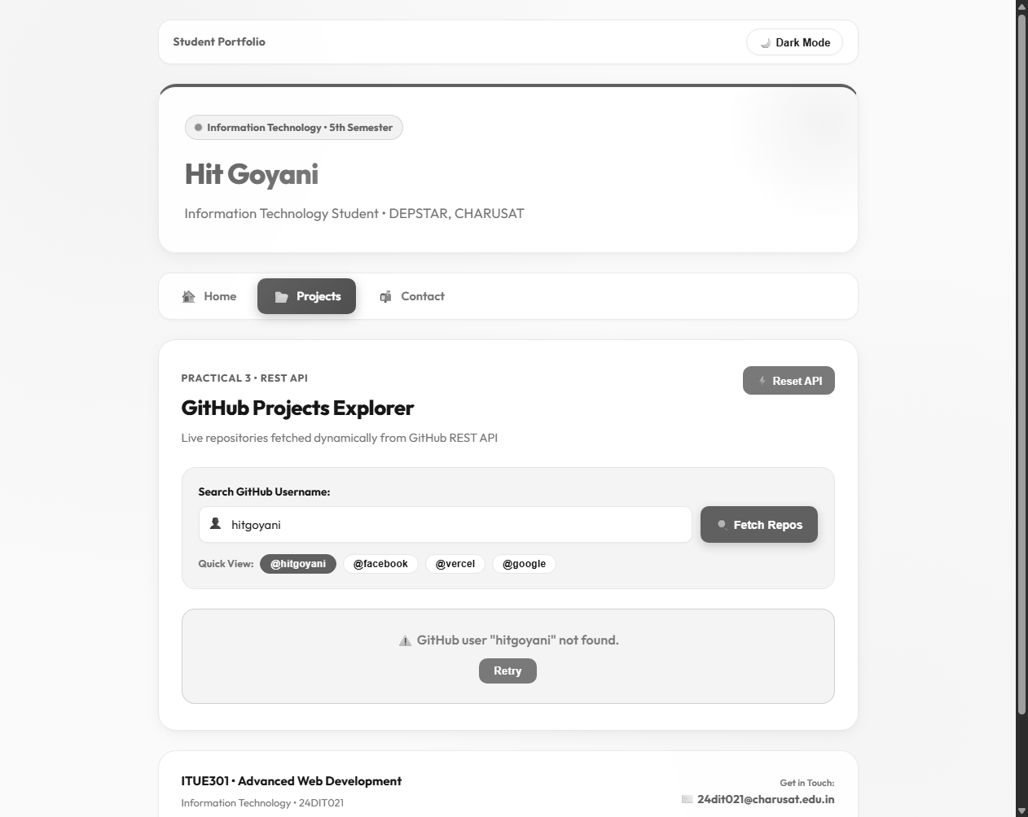
Fig. 2: API error state — the application displays the failure message and Retry button.
The supplied output shows the message "GitHub user "hitgoyani" not found." and provides a Retry action. This demonstrates that the failed HTTP request is handled by the React UI instead of leaving the page blank.

12. Loading State Verification
The loading path is visible while a repository request is in progress.
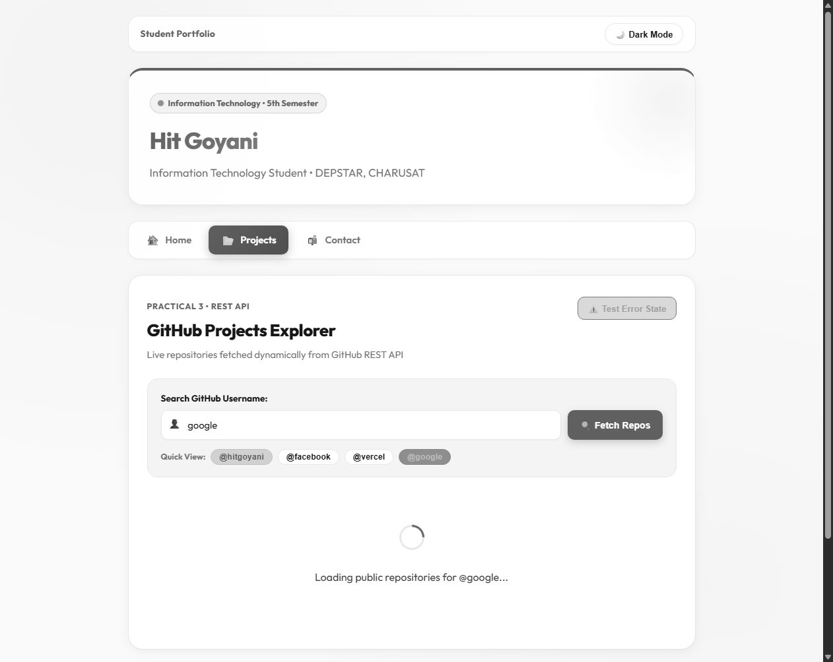
Fig. 3: Loading state — Spinner and dynamic loading text are displayed.
The supplied screenshot shows the spinner and the message indicating that public repositories for @google are being loaded. This confirms that the application provides immediate feedback during asynchronous work.

13. Working Flow
The practical works through a simple asynchronous data flow: the browser enters the React application, the Projects route renders Projects.jsx, useEffect starts the API request, and the response is stored in state. React then re-renders the page according to the request result.
Projects.jsx
│
▼
useEffect()
│
▼
fetchRepos()
│
▼
GitHub REST API
│
├───────────────┬────────────────┐
▼ ▼ ▼
Loading Error Success
│ │ │
▼ ▼ ▼
Spinner ErrorMessage setRepos(data)
│
▼
Repository Cards
14. Testing and Verification
- The Projects page was opened and the GitHub repository request was initiated.
- A successful request displayed repository cards dynamically from the API response.
- The error scenario displayed an explicit GitHub user-not-found message and Retry button.
- The loading scenario displayed a spinner and dynamic loading text while the request was active.
- The username input and Quick View controls were visible for selecting different GitHub users.
- The repository filter field was available for narrowing the loaded repository list.

15. Key Questions and Answers
Q1. Why is fetch() used in this practical?
fetch() provides a JavaScript interface for making the HTTP request to the GitHub REST API and receiving the response asynchronously.
Q2. Why is useEffect() used for the API request?
The API call is a side effect of loading the Projects page or changing the selected username. useEffect() is used to run that side effect after rendering.
Q3. Why are loading and error stored in state?
They represent the current request condition. React uses those state values to decide whether to show the spinner, error message, or repository data.
Q4. What happens when the API returns a non-success status?
The response is checked with res.ok. When it is false, an appropriate Error object is created and the error message is displayed.
Q5. Why is finally() used?
finally() runs after both successful and failed requests, so setLoading(false) reliably stops the loading indicator.
Q6. What is the purpose of the Retry button?
The Retry button calls fetchRepos() again, allowing the user to repeat the request without refreshing the whole page.
Q7. Why is a key used while rendering repositories?
The repository id is used as a key so React can track individual list items efficiently when the list changes.
Q8. How does the application render API data?
The JSON response is stored in repos state and map() creates a repository card for each object in the returned array.

16. Supplementary Features
- Retry button for failed API requests.
- Search/filter for repository names and descriptions.
- Quick View controls for predefined GitHub usernames.
- Repository star count and language information.
- Test Error State control for demonstrating API failure handling.
17. Common Errors and Fixes
- If the spinner remains visible, verify that loading is set to false in finally().
- If an error is not displayed, check that non-OK HTTP responses are converted into an Error.
- If the repository list is empty after a successful response, verify that the JSON array is stored with setRepos().
- If data does not refresh after changing the username, verify the useEffect dependency array.
- If GitHub rate limiting occurs, wait and retry the request or use another public username for demonstration.
18. GitHub / Practical Deliverables
- Working Vite + React project.
- GitHub REST API integration in Projects.jsx.
- Loading and error handling components.
- Dynamic rendering of repository data.
- Retry and filtering functionality.
- Screenshots showing successful, error, and loading states.
19. Learning Outcome
After completing this practical, I can connect a React application to a public REST API, perform an asynchronous request, manage loading and error states with useState, trigger side effects with useEffect, and render API response data dynamically.
20. Student Reflection
This practical helped me understand how frontend applications communicate with external services. Using the GitHub REST API made the purpose of asynchronous requests clearer because the interface has to handle loading, success, and failure separately. Testing all three states also helped me understand how React state controls what the user sees without requiring a full page reload.
21. Final Result
The Practical 3 implementation demonstrates REST API consumption in React using the GitHub REST API. The Projects page fetches repository information dynamically, displays a loading state during the request, handles API errors with a Retry option, and renders repository information after a successful response. The supplied screenshots provide direct evidence of the successful, error, and loading states.

