PRACTICAL 4
RESTful API Development with Node.js and Express
Roll No:- 24DIT021
Subject: Advanced Web Development Frameworks (ITUE301)
Semester: 5th Semester B.Tech Information Technology
Faculty of Technology and Engineering, CHARUSAT

1. Problem Statement
Create a RESTful Task Manager API using Node.js and Express. The application should expose CRUD endpoints for tasks, use middleware for request logging and request validation, validate task IDs, return appropriate HTTP status codes, and handle undefined routes and application errors through centralized middleware.
2. Objective
The objective of this practical is to understand how a Node.js and Express application processes HTTP requests through middleware and RESTful routes. The implementation demonstrates CRUD operations, request logging, Content-Type validation, task ID validation, custom 404 handling, and centralized error handling.
3. Theory / Concepts Used
- REST API provides resources through HTTP methods such as GET, POST, PUT, and DELETE.
- Express.js provides routing and middleware support for Node.js web applications.
- Middleware functions receive req, res, and next and can inspect or modify a request before continuing.
- express.json() parses JSON request bodies.
- Request logging records the HTTP method, requested URL, and timestamp.
- Content-Type validation ensures POST, PUT, and PATCH requests use application/json.
- CRUD represents Create, Read, Update, and Delete operations on task resources.
- Centralized error middleware uses four parameters: err, req, res, and next.
- A 404 handler responds when no defined route matches the requested endpoint.
4. Solution Approach
- Start the Node.js Express server on port 5000.
- Load environment variables and configure the MongoDB connection.
- Enable CORS and express.json() as core middleware.
- Register request logging and Content-Type validation middleware.
- Mount the /tasks router containing the RESTful CRUD endpoints.
- Validate task IDs before controller logic is executed.
- Use MongoDB/Mongoose when connected and an in-memory task collection as the Practical 4 fallback.
- Register the undefined-route handler after the API routes.
- Register the centralized global error handler as the last middleware.
- Test successful requests and error conditions using Thunder Client / Postman.
5. Folder Structure
task-manager-api/
├── middleware/
│ ├── errorHandler.js
│ ├── logger.js
│ └── validator.js
├── routes/
│ └── taskRoutes.js
├── .env.example
├── package.json
├── README.md
├── server.js
└── test-api.js
6. Server and Middleware Pipeline
The Express server first configures CORS and JSON parsing. The custom request logger then records every incoming request, while the Content-Type validator protects write operations. The task router handles CRUD requests. Undefined routes are handled by the 404 middleware, and the global error handler is kept last.
const app = express();
const PORT = process.env.PORT || 5000;
app.use(cors());
app.use(express.json());
app.use(requestLogger);
app.use(requireJsonHeader);
app.use('/tasks', taskRoutes);
app.use(notFoundHandler);
app.use(globalErrorHandler);
7. Request Logging Middleware
The request logger records the HTTP method, original URL, and an ISO timestamp for every incoming request, then passes control to the next middleware.
export const requestLogger = (req, res, next) => {
const timestamp = new Date().toISOString();
console.log(`[LOG] ${req.method} ${req.originalUrl || req.url} - ${timestamp}`);
next();
};
8. Validation Middleware
8.1 Content-Type Validation
export const requireJsonHeader = (req, res, next) => {
if (['POST', 'PUT', 'PATCH'].includes(req.method)) {
const contentType = req.headers['content-type'];
if (!contentType || !contentType.includes('application/json')) {
return res.status(400).json({
success: false,
error: 'Bad Request: Content-Type header must be application/json',
});
}
}
next();
};
8.2 Task ID Validation
export const validateTaskId = (req, res, next) => {
const { id } = req.params;
const isValidObjectId = mongoose.Types.ObjectId.isValid(id);
const isValidInteger =
!isNaN(parseInt(id, 10)) && String(parseInt(id, 10)) === id;
if (!isValidObjectId && !isValidInteger) {
return res.status(400).json({
success: false,
error: `Invalid task ID format: "${id}". ID must be a valid integer or MongoDB ObjectId.`,
});
}
next();
};
9. CRUD Operations
The Task Manager API provides the following RESTful endpoints:
• POST /tasks — creates a new task and returns 201 Created.
• GET /tasks — retrieves all tasks and returns 200 OK.
• GET /tasks/:id — retrieves a single task by ID.
• PUT /tasks/:id — updates task fields.
• DELETE /tasks/:id — deletes a task.
10. Error Handling
The API uses two related error-handling mechanisms. The custom 404 handler returns a JSON response when an endpoint does not exist. The four-parameter global error handler processes Mongoose ValidationError, CastError, malformed JSON, and unexpected server errors.
export const notFoundHandler = (req, res) => {
res.status(404).json({
success: false,
error: `404 Not Found: Cannot ${req.method} ${req.originalUrl || req.url}`,
});
};
export const globalErrorHandler = (err, req, res, next) => {
console.error('[GLOBAL ERROR HANDLER]:', err.message);
if (err.name === 'ValidationError') {
const errorDetails = Object.values(err.errors).map((val) => val.message);
return res.status(400).json({
success: false,
error: 'Validation Error',
details: errorDetails,
});
}
if (err.name === 'CastError') {
return res.status(400).json({
success: false,
error: `Invalid resource ${err.path}: "${err.value}"`,
});
}
res.status(500).json({
success: false,
error: 'Internal Server Error: Something went wrong on the server',
});
};
11. Practical Execution and Evidence
The following screenshots are the supplied outputs from the running Practical 4 application and development environment. They are converted to grayscale to match the black-and-white academic presentation style used in Practical 3.
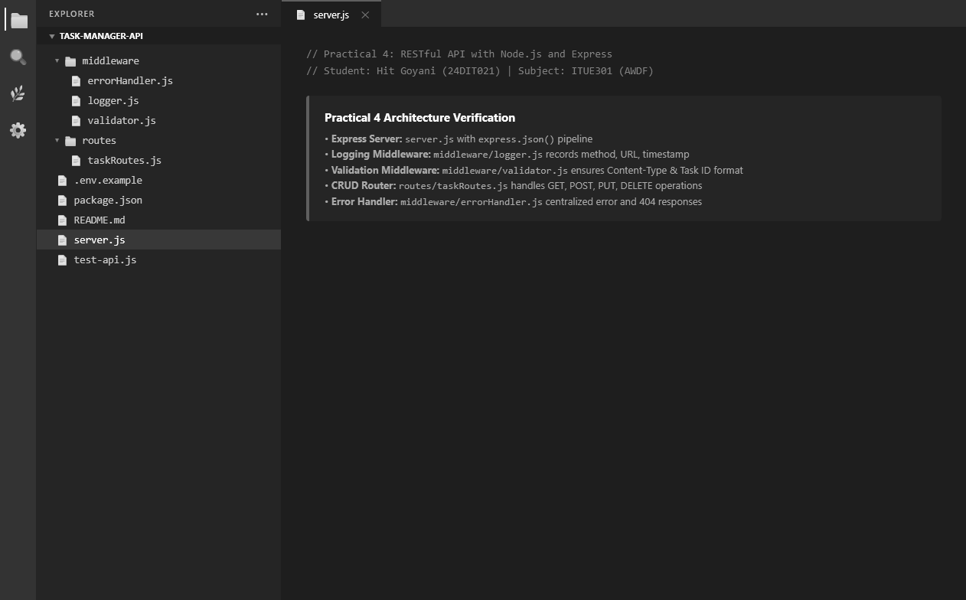
Fig. 1: Practical 4 project folder structure in Visual Studio Code.

11. Practical Execution and Evidence (Continued)
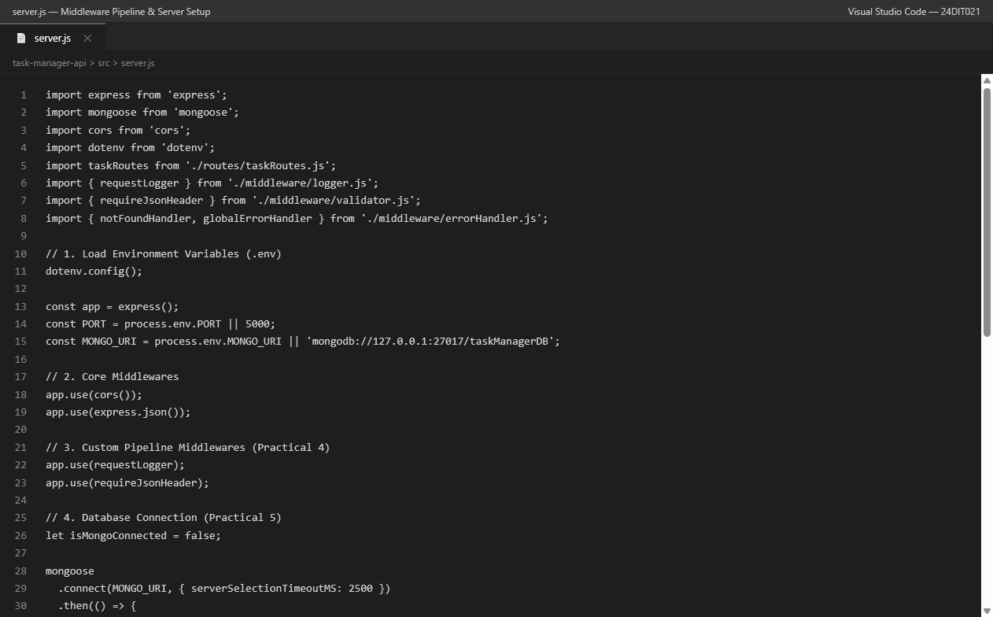
Fig. 2: Express server and middleware pipeline.

11. Practical Execution and Evidence (Continued)
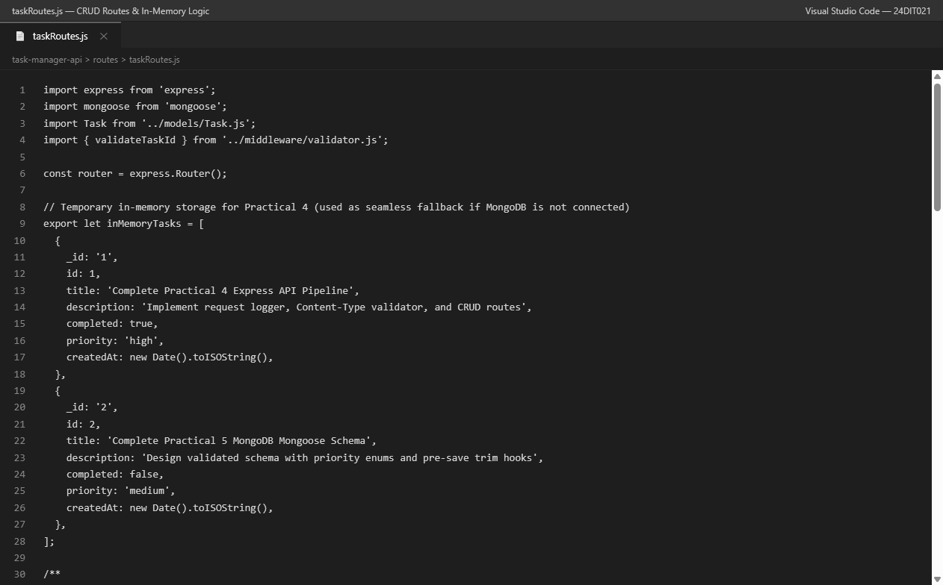
Fig. 3: CRUD route implementation for the Task Manager API.

11. Practical Execution and Evidence (Continued)
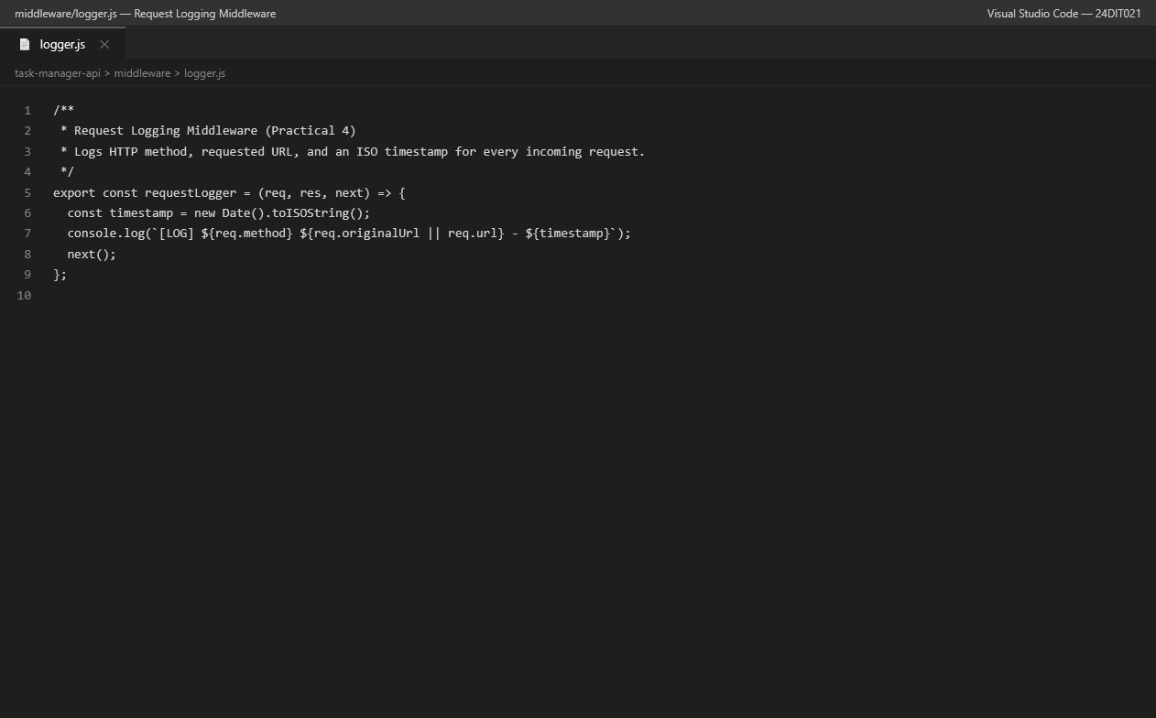
Fig. 4: Request logging middleware.

11. Practical Execution and Evidence (Continued)
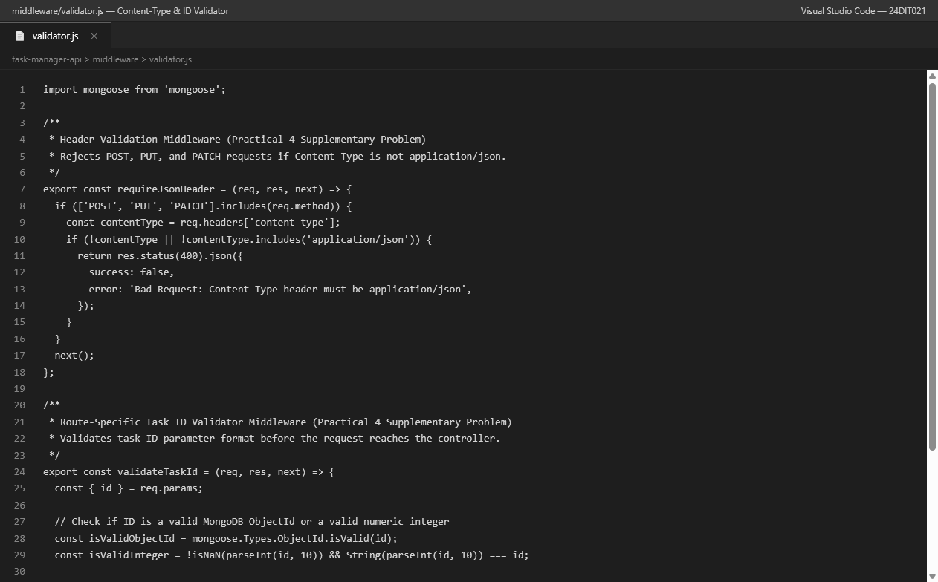
Fig. 5: Content-Type and task ID validation middleware.

11. Practical Execution and Evidence (Continued)
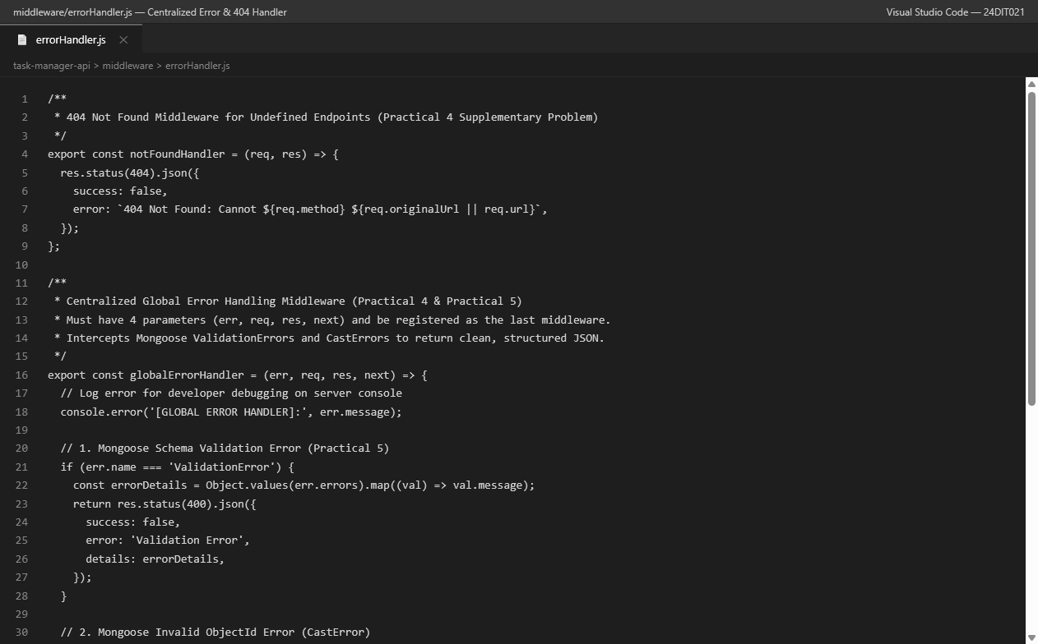
Fig. 6: Custom 404 handler and centralized global error handler.

11. Practical Execution and Evidence (Continued)
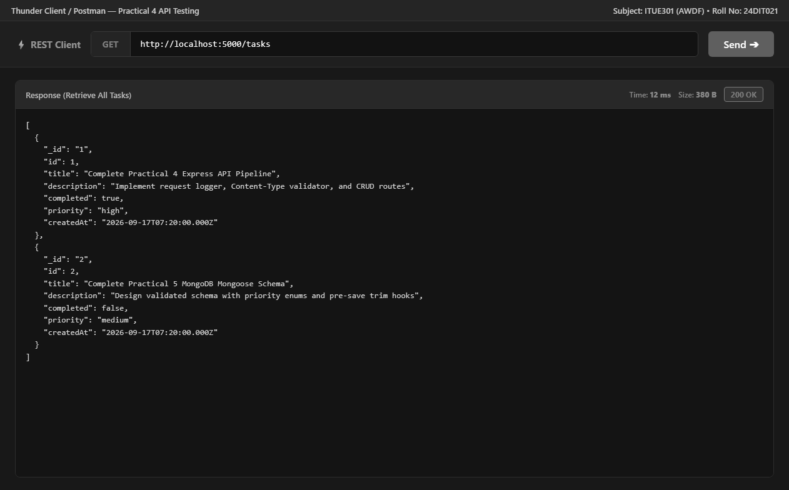
Fig. 7: GET /tasks — retrieve all tasks — 200 OK.

11. Practical Execution and Evidence (Continued)
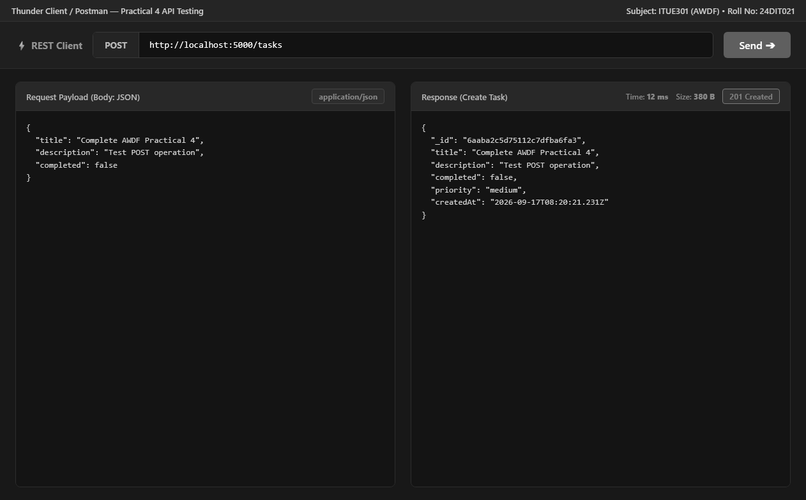
Fig. 8: POST /tasks — create task — 201 Created.

11. Practical Execution and Evidence (Continued)
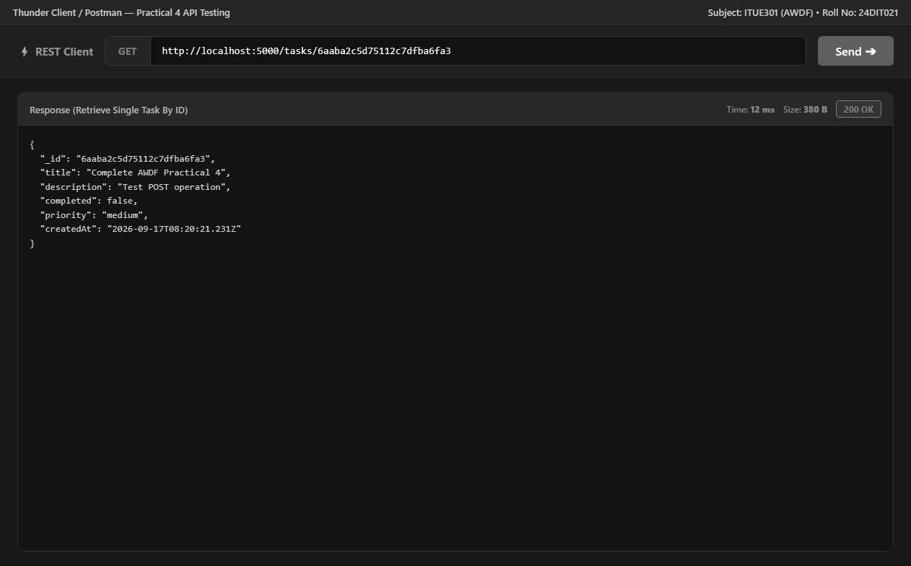
Fig. 9: GET /tasks/:id — retrieve a single task — 200 OK.

11. Practical Execution and Evidence (Continued)
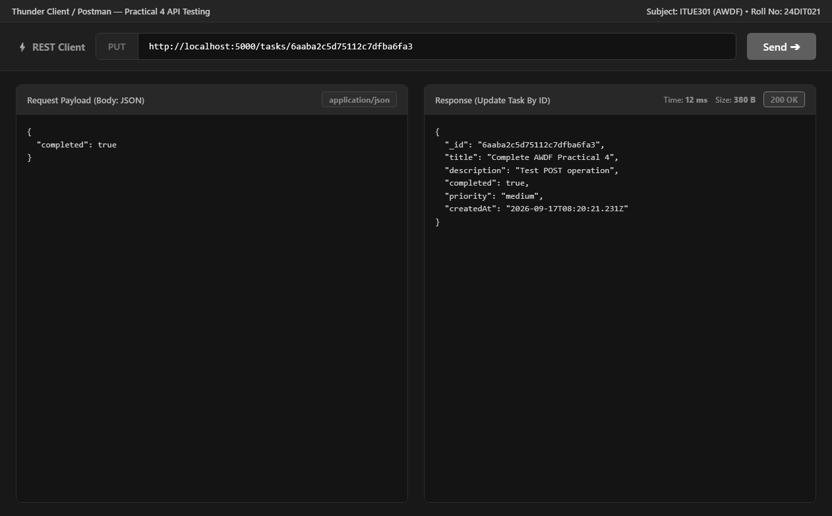
Fig. 10: PUT /tasks/:id — update task — 200 OK.

11. Practical Execution and Evidence (Continued)
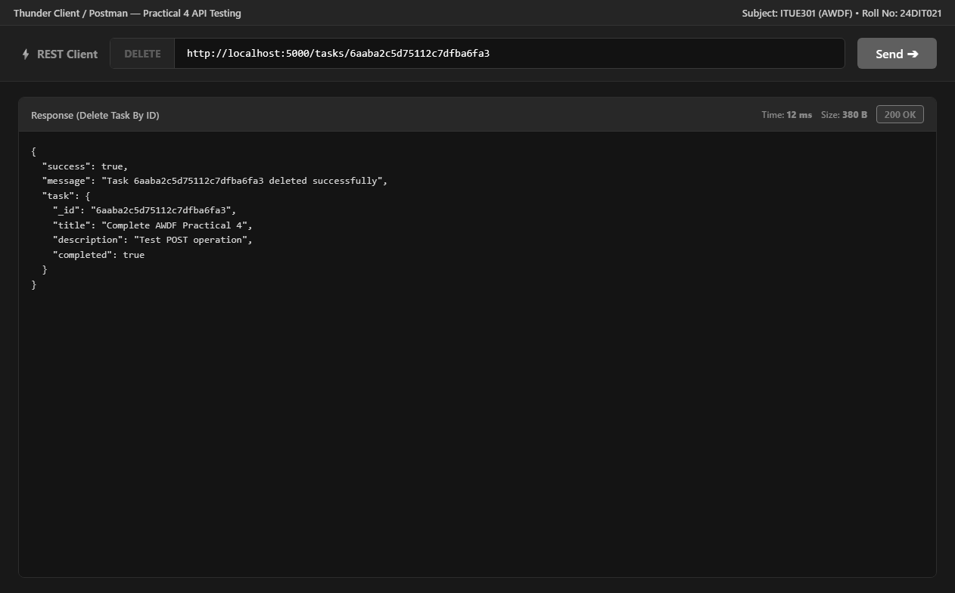
Fig. 11: DELETE /tasks/:id — delete task — 200 OK.

11. Practical Execution and Evidence (Continued)
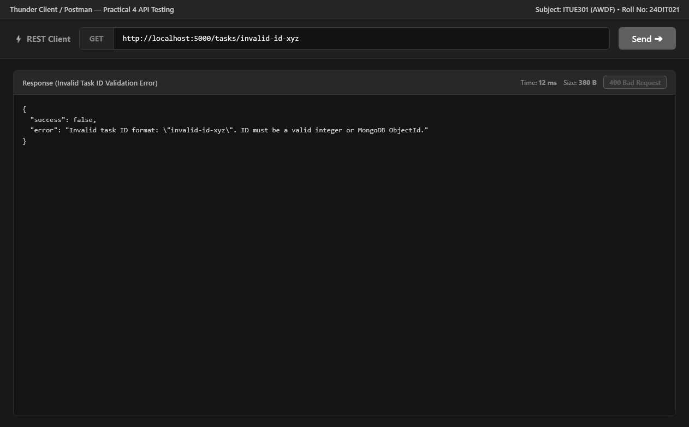
Fig. 12: Invalid task ID validation — 400 Bad Request.

11. Practical Execution and Evidence (Continued)
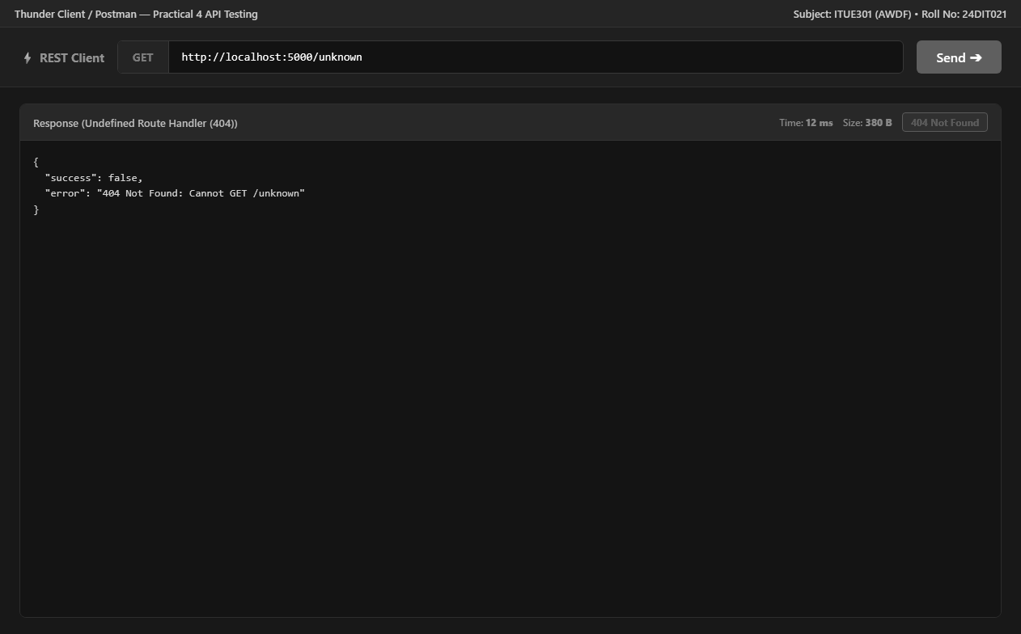
Fig. 13: Undefined endpoint — 404 Not Found.

11. Practical Execution and Evidence (Continued)
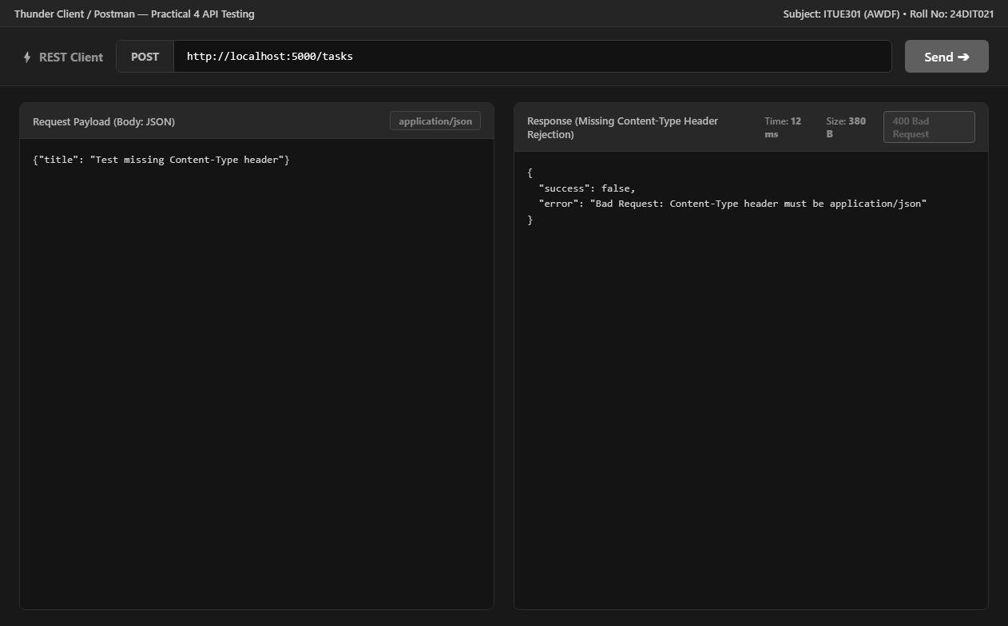
Fig. 14: Missing Content-Type header — 400 Bad Request.

11. Practical Execution and Evidence (Continued)
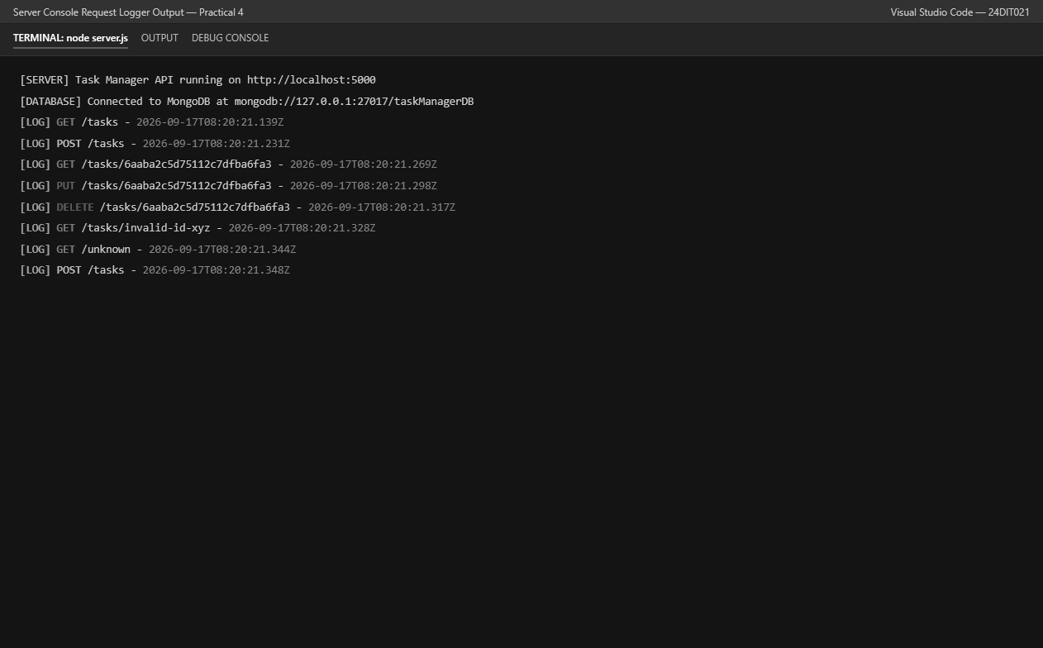
Fig. 15: Server console request logging.

11. Practical Execution and Evidence (Continued)
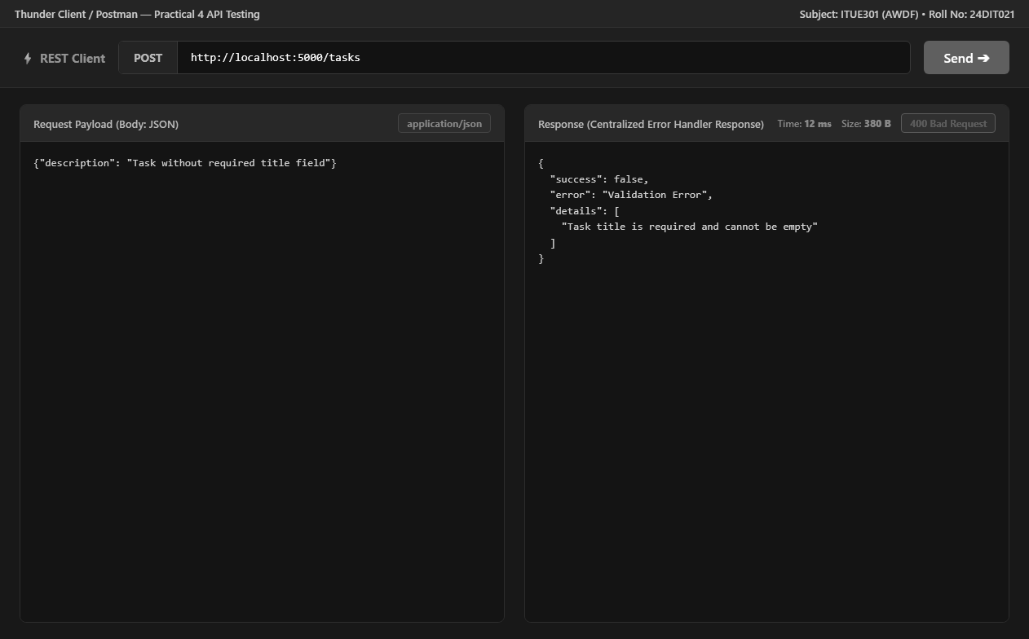
Fig. 16: Centralized Mongoose validation error response.

12. Testing and Verification
• GET /tasks returned 200 OK with a JSON array of tasks.
• POST /tasks with a valid JSON body returned 201 Created and a generated task ID.
• GET /tasks/:id returned 200 OK with the created task.
• PUT /tasks/:id changed the completed value and returned 200 OK.
• DELETE /tasks/:id returned 200 OK with a success message.
• GET /tasks/invalid-id-xyz returned 400 Bad Request through task ID validation.
• GET /unknown returned 404 Not Found through the undefined-route handler.
• POST /tasks without the required Content-Type returned 400 Bad Request.
• A POST request without the required title produced a structured Validation Error response.
• The server console recorded incoming requests with method, URL, and timestamp.
13. Key Questions and Answers
Q1. Why is express.json() used?
It parses incoming JSON request bodies so the API can access submitted task fields through req.body.
Q2. What is the purpose of middleware?
Middleware functions process requests before the final route handler and can perform logging, validation, authentication, or error handling.
Q3. Why is request logging implemented?
It records the HTTP method, URL, and timestamp of incoming requests for monitoring and debugging.
Q4. Why is Content-Type validation required?
It ensures POST, PUT, and PATCH requests send JSON data using the application/json media type.
Q5. What is the purpose of validateTaskId?
It checks whether the task ID is a valid integer or MongoDB ObjectId before route processing.
Q6. Why must the global error handler have four parameters?
Express identifies an error-handling middleware by the four-parameter signature err, req, res, next.
Q7. What is the purpose of the 404 handler?
It returns a structured JSON response when a requested endpoint is not defined.
Q8. Why are HTTP status codes used?
They communicate the result of an HTTP request, such as successful creation, successful retrieval, client validation failure, or an undefined route.
14. Common Errors and Fixes
• If POST or PUT requests are rejected, verify that Content-Type is application/json.
• If a task ID is rejected, verify that it is a valid integer or MongoDB ObjectId.
• If an unknown URL is requested, the API should return the custom 404 JSON response.
• If a required task field is missing, the Mongoose validation error should be returned through the centralized handler.
• If malformed JSON is submitted, return a 400 Bad Request response.
• If MongoDB is unavailable during Practical 4 execution, the configured in-memory fallback can continue serving the demonstration tasks.
15. Learning Outcome
After completing this practical, I can create a RESTful API using Node.js and Express, organize routes and middleware, implement CRUD operations, validate requests, log HTTP activity, and return structured error responses.
16. Final Result
The Practical 4 implementation demonstrates a working Task Manager REST API with Node.js and Express. The supplied evidence verifies CRUD operations, request logging, Content-Type validation, task ID validation, custom 404 handling, centralized error handling, and server-side request logging.
17. Student Reflection
This practical helped me understand how an Express application processes a request through a middleware pipeline before reaching a route handler. Testing both successful CRUD operations and validation/error cases made the importance of HTTP status codes, middleware order, and centralized error handling clearer.

