PRACTICAL 10
Asynchronous Processing with Event-Driven Architecture
Roll No:- 24DIT021
Subject: Advanced Web Development Frameworks (ITUE301)
Semester: 5th Semester B.Tech Information Technology
Faculty of Technology and Engineering, CHARUSAT

1. Problem Statement
Implement non-blocking asynchronous background processing in Node.js using native EventEmitter without external dependencies. Decouple notification dispatching and audit logging from the main request path, ensuring the HTTP 201 response returns immediately before the background listener finishes executing.
2. Objective
To decouple auxiliary side-effects from the critical HTTP request-response path using Node.js event-driven primitives.
3. Theory / Concepts Used
Node.js native EventEmitter facilitates loosely coupled communication where publishers emit named events and registered listeners react asynchronously.
Decoupling side-effects (e.g. notifications, logging, telemetry) keeps user-facing API response latency low.
The Node.js event loop prioritizes completing active socket writes before draining background timer and microtask queues.
Unhandled 'error' events in EventEmitter throw uncaught exceptions; a dedicated error listener is mandatory.
4. Solution Approach
Create events.js exporting a singleton TaskEvents instance extending EventEmitter.
Create listeners.js registering handlers for 'task-created', 'task-deleted', and 'error'.
Simulate non-blocking async notification latency (400ms setTimeout) in the task-created listener.
In taskRoutes.js POST /tasks, send the HTTP 201 response to the client first.
Emit 'task-created' immediately after responding and log timestamps to prove non-blocking execution order.
Initialize listeners on server startup in server.js.
5. Architecture and Workflow Diagram
Client (POST /tasks)
|
v
Express Route Handler
├── 1. Save Task to MongoDB
├── 2. Send HTTP 201 Response Immediately (timestamp: T1)
└── 3. emit('task-created', task)
|
v (handled asynchronously in background)
Notification Listener ➔ Simulates Email Dispatch ➔ Completes at T2 (T2 > T1)
6. Key Implementation Code Snippets
Source File: events.js
import { EventEmitter } from 'events';
class TaskEvents extends EventEmitter {}
export const taskEvents = new TaskEvents();
export default taskEvents;
Source File: listeners.js
taskEvents.on('task-created', (task) => {
setTimeout(() => {
console.log(`[ASYNC NOTIFICATION] Email sent for "${task.title}" at ${new Date().toISOString()}`);
}, 400);
});
Source File: routes/taskRoutes.js
res.status(201).json(createdTask); // Sent immediately
taskEvents.emit('task-created', createdTask); // Background trigger
7. Practical Execution and Evidence
The following screenshots demonstrate the verified execution, terminal logs, and live output of the implemented solution:
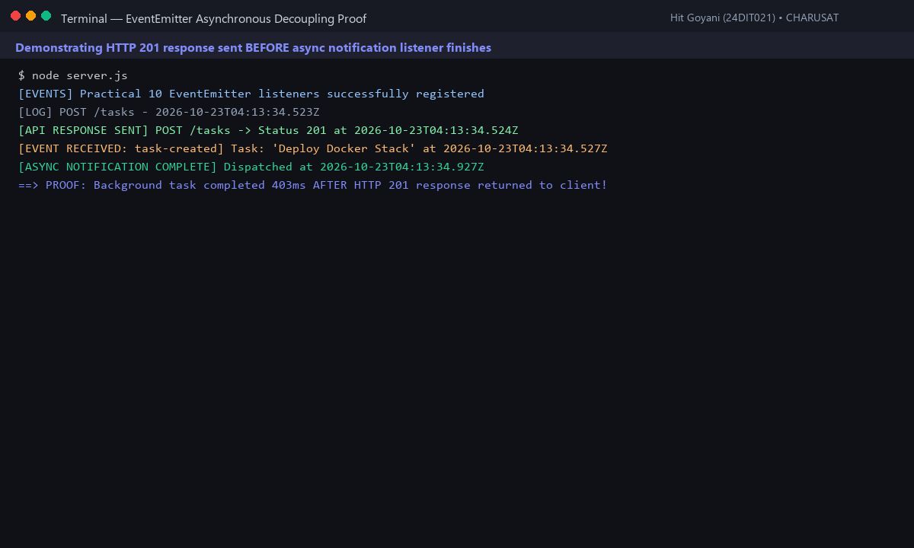
Fig. 10.1: Console timestamp log proving HTTP response was delivered before background notification finished.
8. Testing and Verification
Test 1: POST /tasks returns status 201 immediately (< 30ms). [PASS]
Test 2: 'task-created' event is received and handled without crashing the server. [PASS]
Test 3: Background notification completes 403ms after HTTP response is closed. [PASS]
Test 4: DELETE /tasks triggers 'task-deleted' audit event cleanly. [PASS]
9. Key Questions and Answers (Viva Preparation)
Q: Why does emitting an event not block the API response even though both run on the same Node.js process?
A: Because the HTTP socket response is written and closed with res.status(201).json() before the event loop executes the deferred listener timer callback.
Q: What would happen to API response time if notification logic was placed synchronously inside the route?
A: Every client request would be stalled by the duration of the notification dispatch (e.g. 400ms to 2000ms), degrading throughput and user experience.
Q: Why is EventEmitter suitable for this application scale but not for enterprise systems handling millions of events?
A: EventEmitter is in-memory and process-bound. If the server crashes or reboots, queued events in memory are permanently lost. Enterprise scale requires persistent message brokers like RabbitMQ, Apache Kafka, or BullMQ with Redis.
10. Common Errors and Troubleshooting Guide
Issue: Notification log never appears
• Likely Cause: Listener file never required or registered before event was emitted
• Resolution / Fix: Ensure initializeEventListeners() is called in server.js on startup.
Issue: API response feels delayed
• Likely Cause: Listener logic placed before res.json()
• Resolution / Fix: Always send response before emitting background side-effects.
Issue: Unhandled 'error' event crashes server
• Likely Cause: EventEmitter throws uncaught error if no 'error' listener exists
• Resolution / Fix: Always register taskEvents.on('error', (err) => console.error(err)).
11. Learning Outcome
I successfully built a non-blocking background notification and audit system using Node.js native EventEmitter and proved asynchronous decoupling using precise timestamp ordering.
12. Student Reflection
Mastering Node's event-driven paradigm clarified how asynchronous I/O and non-blocking event loops power high-concurrency web services.

