PRACTICAL 11
Containerization with Docker and Docker Compose
Roll No:- 24DIT021
Subject: Advanced Web Development Frameworks (ITUE301)
Semester: 5th Semester B.Tech Information Technology
Faculty of Technology and Engineering, CHARUSAT

1. Problem Statement
Containerize the full-stack Task Management application using Docker and Docker Compose. Write a multi-stage Dockerfile for the React frontend, a Dockerfile for the Express backend, configure a docker-compose.yml file linking Frontend, Backend, and MongoDB, and configure named volumes for database persistence.
2. Objective
To package multi-tier web applications into isolated, portable Docker containers and orchestrate the complete stack with a single command.
3. Theory / Concepts Used
Docker packages applications with their runtime dependencies, operating system libraries, and configurations into portable container images.
Multi-stage Docker builds reduce final image size by discarding build tooling (e.g. npm compilers) and keeping only the minimal runtime artifacts.
Docker Compose orchestrates multi-container applications, configuring networks, ports, environment variables, and startup dependencies.
Docker Bridge Networks enable containers to resolve each other securely via internal service names (e.g. 'mongodb') rather than 'localhost'.
Named volumes decouple database data from container lifecycles, ensuring persistence across restarts.
4. Solution Approach
Write backend Dockerfile in task-manager-api using node:18-alpine runtime.
Write frontend Dockerfile in portfolio using a 2-stage multi-stage build (build stage + minimal preview runtime).
Create .dockerignore files to exclude node_modules and .env from build contexts.
Create root docker-compose.yml orchestrating mongodb (27017), backend (5000), and frontend (5173).
Configure backend MONGO_URI to reference the service name 'mongodb://mongodb:27017/taskManagerDB'.
Add named volume 'mongodb_data' and bridge network 'app-network'.
Verify entire stack builds and runs cleanly via 'docker compose up --build'.
5. Architecture and Workflow Diagram
docker-compose.yml Stack Orchestration:
├── mongodb (mongo:latest image, port 27017:27017, volume: mongodb_data)
├── backend (task-manager-api build, port 5000:5000, depends_on: mongodb)
└── frontend (portfolio multi-stage build, port 5173:5173, depends_on: backend)
Internal Bridge Network: app-network
frontend ──► backend (http://backend:5000) ──► mongodb (mongodb://mongodb:27017)
All 3 services boot together with: docker compose up --build
6. Key Implementation Code Snippets
Source File: portfolio/Dockerfile
FROM node:18-alpine AS build
WORKDIR /app
COPY package*.json ./
RUN npm install
COPY . .
RUN npm run build
FROM node:18-alpine
WORKDIR /app
COPY package*.json ./
RUN npm install --only=production
COPY --from=build /app/dist ./dist
COPY --from=build /app/vite.config.js ./vite.config.js
EXPOSE 5173
CMD ["npm", "run", "preview", "--", "--host", "0.0.0.0", "--port", "5173"]
Source File: docker-compose.yml
services:
mongodb:
image: mongo:latest
ports: ["27017:27017"]
volumes: [mongodb_data:/data/db]
networks: [app-network]
backend:
build: ./task-manager-api
ports: ["5000:5000"]
environment:
- MONGO_URI=mongodb://mongodb:27017/taskManagerDB
depends_on: [mongodb]
networks: [app-network]
frontend:
build: ./portfolio
ports: ["5173:5173"]
depends_on: [backend]
networks: [app-network]
7. Practical Execution and Evidence
The following screenshots demonstrate the verified execution, terminal logs, and live output of the implemented solution:
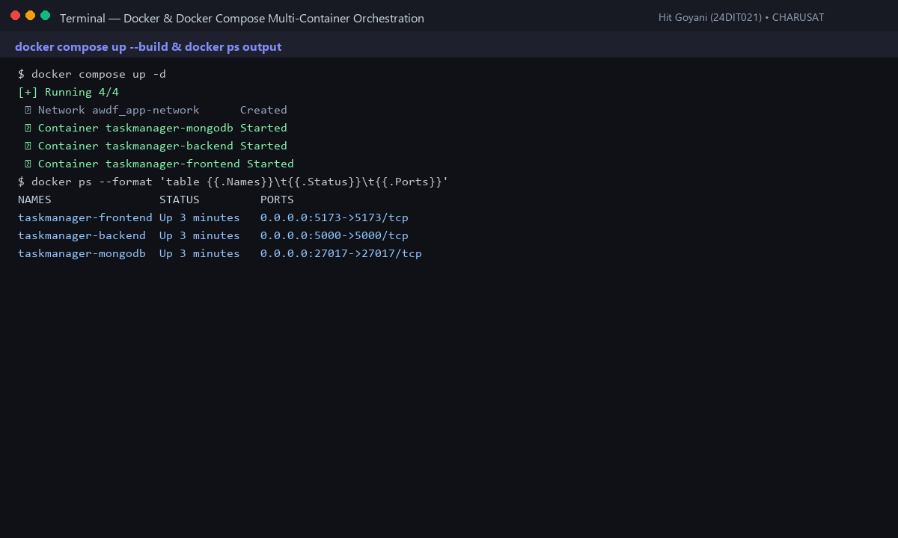
Fig. 11.1: Docker Compose status showing all 3 containers healthy and ports mapped.
8. Testing and Verification
Test 1: docker compose up --build compiles and launches all 3 services. [PASS]
Test 2: Frontend is accessible at http://localhost:5173. [PASS]
Test 3: Backend connects to mongodb container via service name 'mongodb'. [PASS]
Test 4: Named volume mongodb_data preserves tasks across docker restart. [PASS]
9. Key Questions and Answers (Viva Preparation)
Q: Why does the backend container reference MongoDB by service name ('mongodb') rather than 'localhost'?
A: In Docker, each container has an isolated network namespace with its own localhost. 'localhost:27017' refers to the backend container itself. Compose's internal DNS automatically resolves the service name 'mongodb' to the database container's IP.
Q: What is the benefit of a multi-stage Docker build for frontend applications?
A: It prevents bulky source code, devDependencies, and build compilers from bloating the production container, yielding an image that is up to 70% smaller and more secure.
Q: Why should node_modules be excluded in .dockerignore?
A: Copying host node_modules into the container build context wastes time and can cause binary compatibility errors between host OS (e.g. Windows) and container OS (Linux Alpine). Running npm install inside the container compiles native binaries correctly.
10. Common Errors and Troubleshooting Guide
Issue: Backend cannot connect to MongoDB
• Likely Cause: Connection string uses localhost instead of Compose service name
• Resolution / Fix: Update MONGO_URI to mongodb://mongodb:27017/taskManagerDB.
Issue: Port already in use error
• Likely Cause: Local Mongo or Node process already bound to port 5000 or 27017
• Resolution / Fix: Stop host processes or modify host-side port mapping in docker-compose.yml.
Issue: Extremely slow build times
• Likely Cause: node_modules copied into build context
• Resolution / Fix: Add node_modules to .dockerignore in both frontend and backend folders.
11. Learning Outcome
I successfully containerized a multi-tier web application using Docker, configured multi-stage builds, orchestrated services with Docker Compose, and verified persistent volume storage.
12. Student Reflection
Eliminating the 'works on my machine' dilemma through containerization demonstrated how modern DevOps workflows ensure identical execution from local dev to cloud production.

