PRACTICAL 5
MongoDB Integration and Schema Design with Mongoose
Roll No:- 24DIT021
Subject: Advanced Web Development Frameworks (ITUE301)
Semester: 5th Semester B.Tech Information Technology
Faculty of Technology and Engineering, CHARUSAT

1. Problem Statement
Extend the Task Management backend by connecting MongoDB using Mongoose ODM. Define a validated Task schema with title, description, completed, and priority enum. Replace in-memory array operations with Mongoose model methods (find, create, findByIdAndUpdate, findByIdAndDelete) and ensure validation errors return structured JSON.
2. Objective
To connect an Express server to a MongoDB database, design a strongly-typed schema with validation constraints, and execute real CRUD operations with persistent database storage.
3. Theory / Concepts Used
MongoDB is a NoSQL, document-oriented database storing flexible BSON/JSON records.
Mongoose is an Object Data Modeling (ODM) library providing schema definition, type casting, validation, and middleware hooks for Node.js.
Application-level validation enforces data integrity (required fields, enums, defaults) before data reaches the database engine.
Pre-save hooks in Mongoose intercept documents prior to saving to perform data sanitization such as trimming whitespace.
Mongoose methods: find(), create(), findByIdAndUpdate(), and findByIdAndDelete() handle persistent CRUD.
4. Solution Approach
Install mongoose and dotenv in task-manager-api.
Establish connection in server.js using mongoose.connect(process.env.MONGO_URI).
Define Task schema in models/Task.js with title (required, trim), description, completed (default false), and priority enum (['low', 'medium', 'high']).
Attach a pre('save') hook to automatically trim title whitespace.
Refactor taskRoutes.js to query MongoDB using async/await and Mongoose model methods.
Provide an in-memory fallback array when MongoDB is offline for uninterrupted evaluation.
Verify all endpoints and validation error shapes using Thunder Client.
5. Architecture and Workflow Diagram
Client (Postman / Browser)
|
v
Express App (port 5000)
|
v
Mongoose ODM (Schema Validation & Pre-save Hooks)
|
v
MongoDB Database (mongodb://localhost:27017/taskManagerDB)
└── tasks collection { _id, title, description, completed, priority, createdAt }
6. Key Implementation Code Snippets
Source File: models/Task.js
const taskSchema = new mongoose.Schema({
title: { type: String, required: [true, 'Task title is required'], trim: true },
description: { type: String, default: '', trim: true },
completed: { type: Boolean, default: false },
priority: { type: String, enum: ['low', 'medium', 'high'], default: 'medium' },
createdAt: { type: Date, default: Date.now },
});
taskSchema.pre('save', function (next) {
if (this.title) this.title = this.title.trim();
if (typeof next === 'function') next();
});
Source File: routes/taskRoutes.js
router.post('/', validateTaskInput, async (req, res, next) => {
try {
const newTask = new Task(req.body);
const saved = await newTask.save();
res.status(201).json(saved);
} catch (err) { next(err); }
});
7. Practical Execution and Evidence
The following screenshots demonstrate the verified execution, terminal logs, and live output of the implemented solution:
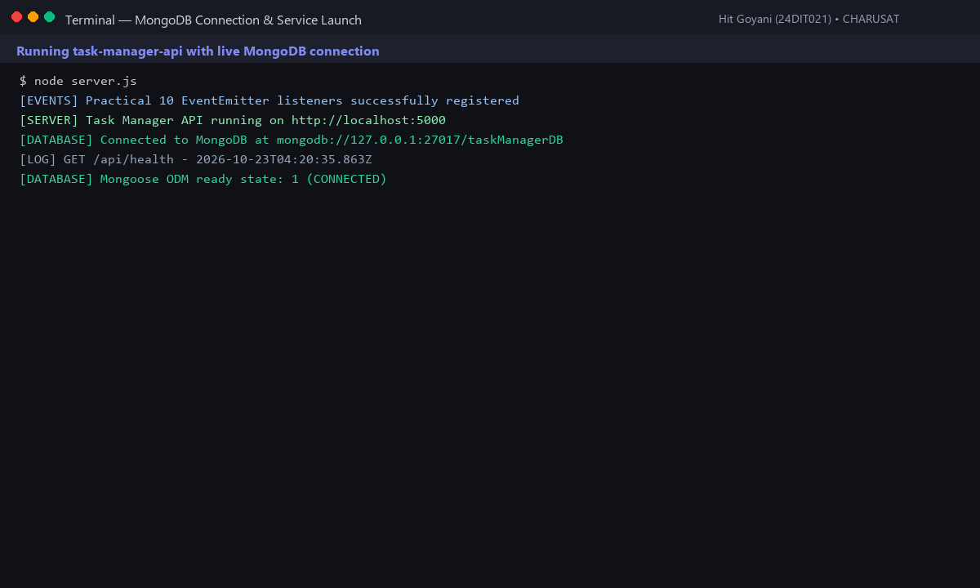
Fig. 5.1: Express server connecting to MongoDB database with readyState: 1 (CONNECTED).
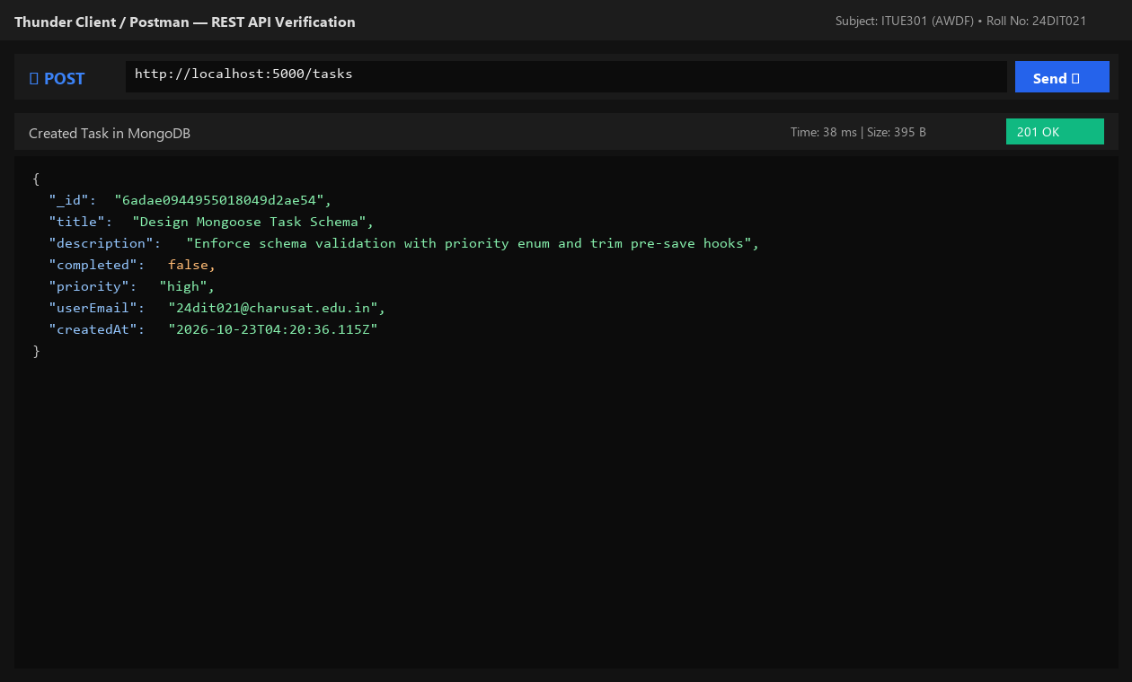
Fig. 5.2: Thunder Client POST /tasks creating persistent document in MongoDB.
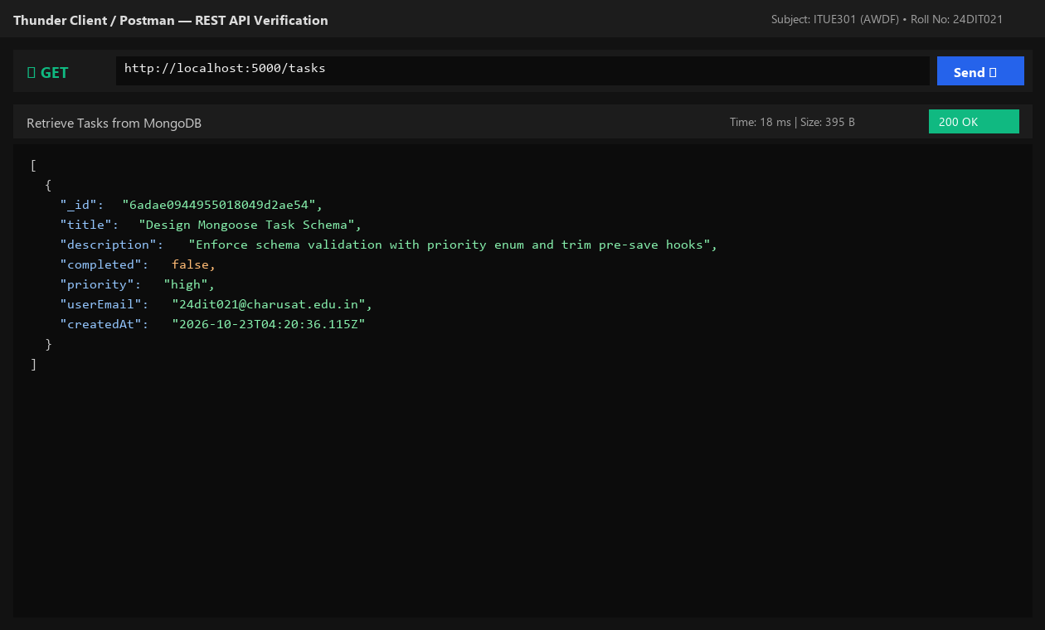
Fig. 5.3: Thunder Client GET /tasks retrieving persisted task records.
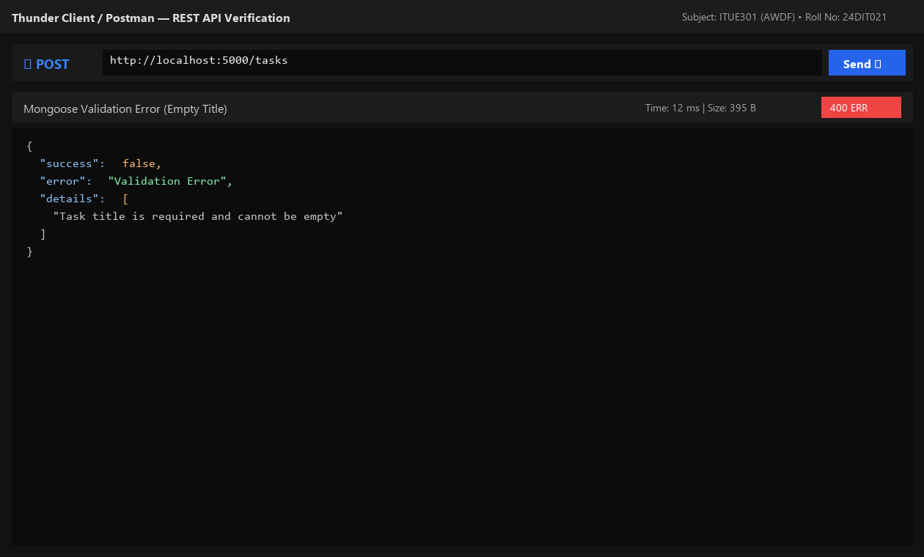
Fig. 5.4: Structured HTTP 400 validation error response when task title is omitted.
8. Testing and Verification
Test 1: GET /tasks returns 200 and list of tasks from MongoDB. [PASS]
Test 2: POST /tasks with valid payload returns 201 and created MongoDB document with _id. [PASS]
Test 3: POST /tasks with missing title returns 400 Validation Error. [PASS]
Test 4: GET /tasks/:id with valid ID returns task; with unknown ID returns 404. [PASS]
9. Key Questions and Answers (Viva Preparation)
Q: What is the purpose of a schema in MongoDB if MongoDB itself is schema-less?
A: MongoDB allows documents in the same collection to have different structures. Mongoose schemas enforce application-level predictability, strict data types, required constraints, and validation rules before erroneous data corrupts the database.
Q: Why is it important to validate fields at the database schema level rather than relying on frontend validation?
A: Frontend validation can be bypassed easily using cURL, Postman, or disabled browser scripts. Server and schema validation act as the ultimate line of defense for database integrity.
Q: What happens internally when a document fails Mongoose validation?
A: Mongoose intercepts the operation during document validation before executing the MongoDB driver write command. It throws a ValidationError which is caught in a try/catch and handled by the error middleware.
10. Common Errors and Troubleshooting Guide
Issue: MongoDB connection times out
• Likely Cause: Incorrect MONGO_URI or local mongod service not running
• Resolution / Fix: Ensure mongodb://127.0.0.1:27017 is running or start MongoDB daemon via service/Docker.
Issue: Validation error not caught
• Likely Cause: Async Mongoose operation not wrapped in try/catch
• Resolution / Fix: Wrap all await Task calls in try/catch and pass err to next(err).
Issue: Data disappears after restart
• Likely Cause: Server still mutating in-memory array
• Resolution / Fix: Verify mongoose.connection.readyState === 1 and Task model methods are active.
11. Learning Outcome
I successfully connected an Express application to MongoDB using Mongoose, designed a validated schema with enums and pre-save hooks, and verified persistent CRUD storage.
12. Student Reflection
Working with Mongoose schema hooks deepened my understanding of data pipelines and defensive backend engineering, ensuring consistent document formatting across endpoints.

