PRACTICAL 6
Full Stack Integration (React + Node + MongoDB)
Roll No:- 24DIT021
Subject: Advanced Web Development Frameworks (ITUE301)
Semester: 5th Semester B.Tech Information Technology
Faculty of Technology and Engineering, CHARUSAT

1. Problem Statement
Wire the React frontend to the Node/Express/MongoDB backend into a functional full-stack application. Enable CORS on Express, configure a centralized API client, implement live state synchronization, optimistic UI updates, delete confirmation dialogs, and toast notifications.
2. Objective
To connect a decoupled React client to an Express/MongoDB backend, solve cross-origin security constraints, and manage synchronous and asynchronous state across the full web stack.
3. Theory / Concepts Used
CORS (Cross-Origin Resource Sharing) is a browser security mechanism requiring explicit server approval headers for requests from a different origin (e.g. port 5173 to port 5000).
Centralized API modules abstract HTTP request configuration, bearer token injection, and unified error handling away from UI components.
State synchronization ensures UI state re-fetches or reflects confirmed server responses immediately after write operations.
Optimistic UI updates render expected changes immediately in the browser to improve perceived responsiveness, rolling back if the server write fails.
4. Solution Approach
Install and enable cors on Express backend: app.use(cors()).
Create centralized api.js in React frontend with configurable BASE_URL.
Build complete task dashboard in Tasks.jsx with task list, create form, and edit modal.
Implement optimistic UI rendering for task creation with tempId and error rollback.
Implement ConfirmModal component to prevent accidental task deletion.
Create ToastContext providing non-blocking success, error, and info alerts.
5. Architecture and Workflow Diagram
React Frontend (http://localhost:5173)
|
| fetch / Axios (JSON over HTTP)
v
Express Backend (http://localhost:5000) [CORS Enabled]
|
v
Mongoose ODM
|
v
MongoDB Database (mongodb://localhost:27017/taskManagerDB)
6. Key Implementation Code Snippets
Source File: portfolio/src/api/api.js
export const BASE_URL = import.meta.env.VITE_API_BASE_URL || 'http://localhost:5000';
export const getTasks = () => request('/tasks');
export const createTask = (taskData) => request('/tasks', { method: 'POST', body: JSON.stringify(taskData) });
export const updateTask = (id, taskData) => request(`/tasks/${id}`, { method: 'PUT', body: JSON.stringify(taskData) });
export const deleteTask = (id) => request(`/tasks/${id}`, { method: 'DELETE' });
Source File: task-manager-api/server.js
app.use(cors({ origin: '*', methods: ['GET', 'POST', 'PUT', 'DELETE'], allowedHeaders: ['Content-Type', 'Authorization'] }));
7. Practical Execution and Evidence
The following screenshots demonstrate the verified execution, terminal logs, and live output of the implemented solution:
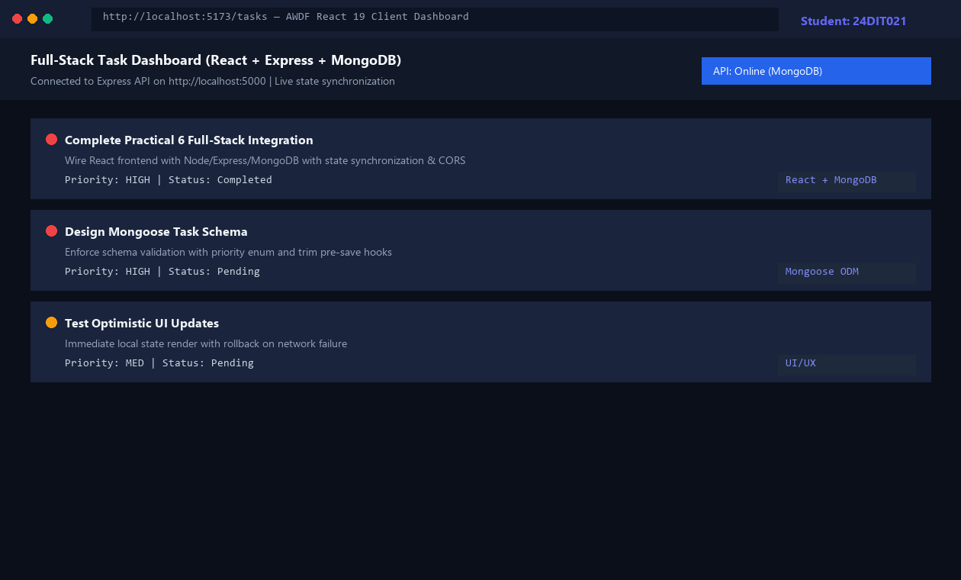
Fig. 6.1: Full-stack React Task Management dashboard connected to Express & MongoDB.
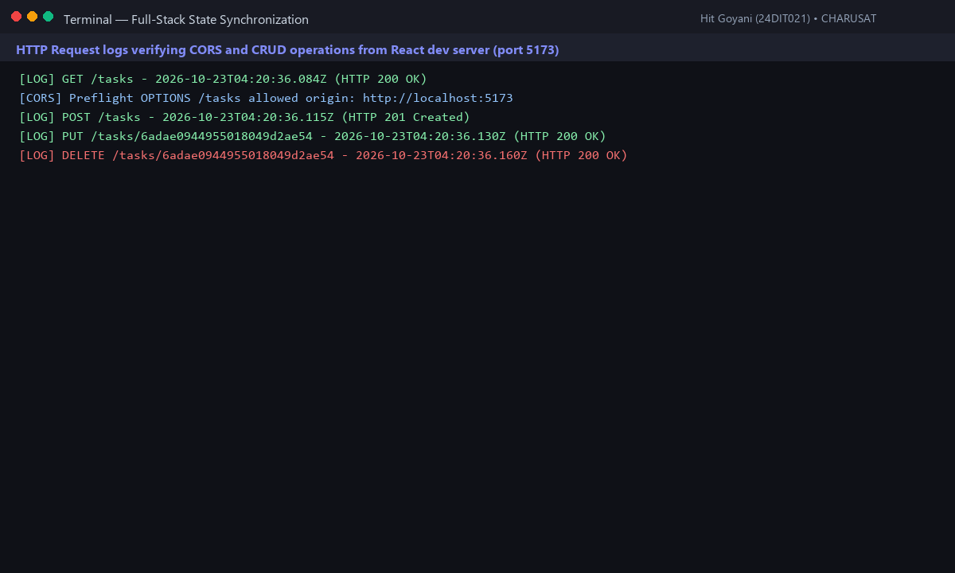
Fig. 6.2: Backend terminal logs showing CORS-approved requests and live state sync.
8. Testing and Verification
Test 1: React dev server fetches all tasks from Express on mount. [PASS]
Test 2: Creating a task updates local state optimistically and persists in MongoDB. [PASS]
Test 3: Editing a task updates database and re-renders updated priority badge. [PASS]
Test 4: Deleting a task opens ConfirmModal and removes record on confirmation. [PASS]
9. Key Questions and Answers (Viva Preparation)
Q: What changes are required on the backend (CORS) to allow React on port 5173 to call Express on port 5000?
A: Browsers block cross-origin requests by default. The backend must configure CORS middleware to send 'Access-Control-Allow-Origin: *' or explicit origin headers during preflight OPTIONS checks.
Q: Why should the UI re-fetch or synchronize state after a successful POST/PUT/DELETE instead of assuming success silently?
A: Silent assumptions can mask database validation rejections, trigger desynchronization, and show phantom data that disappears on browser refresh.
Q: What is optimistic UI and what happens when the backend request fails?
A: Optimistic UI renders changes immediately in local state before server confirmation. If the request fails, the component catches the error, rolls back local state to the previous snapshot, and alerts the user.
10. Common Errors and Troubleshooting Guide
Issue: CORS error in browser console
• Likely Cause: cors middleware missing or registered after routes
• Resolution / Fix: Install cors and register app.use(cors()) at top of server.js.
Issue: Fetch failed / Network error
• Likely Cause: Backend server not running or port conflict
• Resolution / Fix: Ensure Express is running on port 5000 before loading frontend.
Issue: Data disappears after browser refresh
• Likely Cause: Still reading from local component state
• Resolution / Fix: Confirm useEffect calls getTasks() on mount and populates state from backend response.
11. Learning Outcome
I successfully connected a decoupled React single-page frontend to an Express/MongoDB REST backend, resolved CORS constraints, and implemented responsive state synchronization.
12. Student Reflection
This practical tied the entire stack together. Designing the UI with optimistic updates and confirmation modals taught me modern enterprise UX patterns.

