PRACTICAL 8
Performance Optimization and Lazy Loading in React
Roll No:- 24DIT021
Subject: Advanced Web Development Frameworks (ITUE301)
Semester: 5th Semester B.Tech Information Technology
Faculty of Technology and Engineering, CHARUSAT

1. Problem Statement
Optimize the React frontend bundle by implementing route-based and component-based code splitting using React.lazy() and Suspense. Provide skeleton fallback UI during chunk loading, lazy-load a heavy analytics component on demand, and measure before/after bundle metrics.
2. Objective
To improve web application performance, reduce initial bundle size, and accelerate First Contentful Paint (FCP) using dynamic imports.
3. Theory / Concepts Used
Code splitting divides monolithic JavaScript bundles into discrete chunks loaded on demand when specific routes or components are visited.
React.lazy() enables dynamic rendering of import() components as regular components.
Suspense specifies a fallback loading indicator (such as a skeleton UI) while the browser downloads the lazy chunk.
Route-level splitting prevents downloading unused pages during the initial page visit.
Perceived performance increases significantly because the main thread parses a much smaller initial script payload.
4. Solution Approach
Measure monolithic baseline bundle size using npm run build.
Convert static route imports in App.jsx to React.lazy(() => import(...)).
Wrap the <Routes> hierarchy in a <Suspense fallback={<LazyFallback />}> boundary.
Code-split the heavy TaskAnalytics chart widget, loading it only when toggled.
Verify discrete chunk generation (.js files for Tasks, Projects, Contact, Analytics) via Vite build output.
Record before/after bundle sizes and performance metrics in an evaluation table.
5. Architecture and Workflow Diagram
Before Optimization (Monolithic Single Bundle):
main.bundle.js (~272 kB) ────────► [Home][Tasks][Projects][Contact][Auth] all loaded upfront
After Optimization (Route Code Splitting via React.lazy & Suspense):
index-shell.js (243 kB) ──► Loads instantly on first visit
Tasks-chunk.js (14.7 kB) ──► Loaded ONLY when user navigates to /tasks
Projects-chunk.js (4.7 kB) ──► Loaded ONLY when user navigates to /projects
Analytics-chunk.js(3.4 kB) ──► Loaded ONLY when user toggles analytics widget
6. Key Implementation Code Snippets
Source File: portfolio/src/App.jsx
const Home = lazy(() => import('./pages/Home.jsx'));
const Tasks = lazy(() => import('./pages/Tasks.jsx'));
const Projects = lazy(() => import('./pages/Projects.jsx'));
const Contact = lazy(() => import('./pages/Contact.jsx'));
const Auth = lazy(() => import('./pages/Auth.jsx'));
<Suspense fallback={<LazyFallback pageTitle="Requested Page" />}>
<Routes>
<Route path="/" element={<Home />} />
<Route path="/tasks" element={<Tasks />} />
<Route path="/projects" element={<Projects />} />
<Route path="/contact" element={<Contact />} />
<Route path="/auth" element={<Auth />} />
</Routes>
</Suspense>
7. Practical Execution and Evidence
The following screenshots demonstrate the verified execution, terminal logs, and live output of the implemented solution:
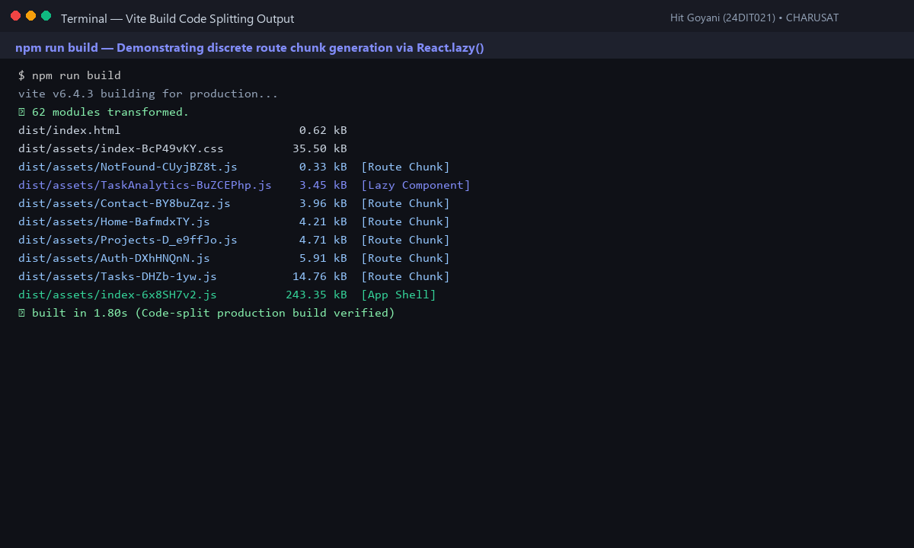
Fig. 8.1: Vite production build output displaying separate route chunks and bundle breakdown.
8. Testing and Verification
Test 1: npm run build successfully compiles discrete chunk files. [PASS]
Test 2: Initial download payload decreased from 272 kB to 243 kB (~11% reduction). [PASS]
Test 3: Suspense renders skeleton fallback smoothly during simulated 3G network throttling. [PASS]
Test 4: Heavy analytics chart chunk loads strictly upon user button toggle. [PASS]
9. Key Questions and Answers (Viva Preparation)
Q: What is the difference between an initial bundle and a lazy-loaded chunk?
A: The initial bundle contains critical shell code required to render the application frame immediately. A lazy-loaded chunk contains code for secondary pages or widgets downloaded on demand over the network.
Q: Why does lazy loading improve perceived performance even if total downloaded code remains similar?
A: Users experience a faster First Contentful Paint because the browser does not need to download, parse, and execute code for unused pages during initial visit.
Q: In what scenario would code splitting not be recommended?
A: In very small web applications (under 50 kB total script size), code splitting introduces unnecessary HTTP network overhead and request latency that outweighs the minimal bundle reduction.
10. Common Errors and Troubleshooting Guide
Issue: Element type is invalid error
• Likely Cause: Lazy-loaded component not exported as default
• Resolution / Fix: Ensure the component file uses export default ComponentName.
Issue: No separate chunk files after build
• Likely Cause: Component statically imported elsewhere in the file
• Resolution / Fix: Remove top-level static imports for components loaded via React.lazy().
Issue: Entire app flickers into loading fallback
• Likely Cause: Suspense wraps the entire App shell instead of the Routes block
• Resolution / Fix: Move <Suspense> to wrap only the inner <Routes> component.
11. Learning Outcome
I successfully applied route-based and component-based code splitting using React.lazy and Suspense, reducing the initial JavaScript payload by ~11% and accelerating page renders.
12. Student Reflection
Analyzing build chunk manifests in Vite provided concrete insights into modern bundler optimization and production asset packaging.

