CHAROTAR UNIVERSITY OF SCIENCE AND TECHNOLOGY
DEVANG PATEL INSTITUTE OF ADVANCE TECHNOLOGY AND RESEARCH (DEPSTAR)
DEPARTMENT OF INFORMATION TECHNOLOGY
━━━━━━━━━━━━━━━━━━━━━━━━━━━━━━━━━━━━━━━━━━━━━━━━━━━
IT314 / ITUE301: ADVANCED WEB DEVELOPMENT FRAMEWORKS (AWDF)
LABORATORY MANUAL & COMPREHENSIVE PRACTICAL PORTFOLIO
(Practicals 1 to 13)
Student Name: | Hit Goyani
Student ID / Roll No: | 24DIT021
Program & Semester: | B.Tech Information Technology | 5th Semester
Academic Year: | 2024 - 2025
Course Faculty / Department: | Department of Information Technology, DEPSTAR

CERTIFICATE OF COMPLETION
This is to certify that Mr. Hit Goyani bearing Student ID: 24DIT021 has successfully and satisfactorily completed all laboratory assignments, practical implementations, and continuous evaluations prescribed for IT314 / ITUE301: Advanced Web Development Frameworks (AWDF) in the 5th Semester of B.Tech Information Technology during the academic year 2024-2025 at Devang Patel Institute of Advance Technology and Research (DEPSTAR), Charotar University of Science and Technology (CHARUSAT).
____________________ | ____________________ | ____________________
Faculty In-Charge | Head of Department | External Examiner

SYLLABUS & PRACTICAL INDEX
Prac # | Practical Title / Scope | Technology Stack | Status | Grade/Sign
1 | Basic Node.js & Express.js Environment Setup | Node.js / Express / HTTP | Complete
2 | Building RESTful APIs for Task Management | Express REST / MVC | Complete
3 | Frontend Integration with React (Vite) | React 19 / Fetch API | Complete
4 | State Management & Form Handling in React | React Hooks / Forms | Complete
5 | MongoDB Integration & Schema Design with Mongoose | MongoDB / Mongoose ODM | Complete
6 | Full Stack Integration (React + Node + MongoDB) | CORS / Sync / Toast UI | Complete
7 | Authentication & Middleware Pipeline | JWT / Bcrypt / Auth Guards | Complete
8 | Performance Optimization & Lazy Loading in React | React.lazy() / Suspense | Complete
9 | In-Memory Caching & Query Optimization | node-cache / TTL / Stats | Complete
10 | Asynchronous Processing with Event-Driven Architecture | Node EventEmitter | Complete
11 | Containerization with Docker & Docker Compose | Docker Multi-stage / Compose | Complete
12 | CI/CD Pipeline with GitHub Actions | Jest / Supertest / CI | Complete
13 | AI API Integration into a Web Application | Google Gemini 2.5 Flash | Complete

PRACTICAL 1
Introduction to React and Component Architecture
Roll No:- 24DIT021

1. Problem Statement
Create a React application using Vite for a student portfolio page. The application should be divided into reusable components such as Header, About, Skills and Footer. The components should be composed into a single-page layout, and props should be used to pass data from the parent component to child components.
2. Requirements
- Use Vite to create and run the React application.
- Create at least four reusable functional components: Header, About, Skills and Footer.
- Keep each component responsible for one clear part of the interface.
- Compose all components through App.jsx.
- Pass data through props to at least two components.
- Render the skill list dynamically from a prop.
- Verify that the application runs without console errors.

3. Solution Approach
The solution is kept simple so that each part of the practical can be understood separately. App.jsx works as the parent component. It stores the data needed by the page and passes that data to the child components. Header displays the student's name, Skills displays the supplied skills, and the About and Footer components handle the remaining sections.
- Create the Vite React project.
- Create the components inside src/components.
- Write one responsibility for each component.
- Pass the student's name and skill list through props.
- Compose the components inside App.jsx.
- Run the development server and verify the result.

4. Folder Structure
The project is organized so that reusable UI parts stay inside the components folder. The supplied project screenshot also shows the additional Navbar and Projects components used in the work.
student-portfolio/
├── public/
├── src/
│ ├── assets/
│ ├── components/
│ │ ├── About.jsx
│ │ ├── Footer.jsx
│ │ ├── Header.jsx
│ │ ├── Navbar.jsx
│ │ ├── Projects.jsx
│ │ └── Skills.jsx
│ ├── App.css
│ ├── App.jsx
│ ├── index.css
│ └── main.jsx
├── .gitignore
├── index.html
├── package.json
├── package-lock.json
└── vite.config.js
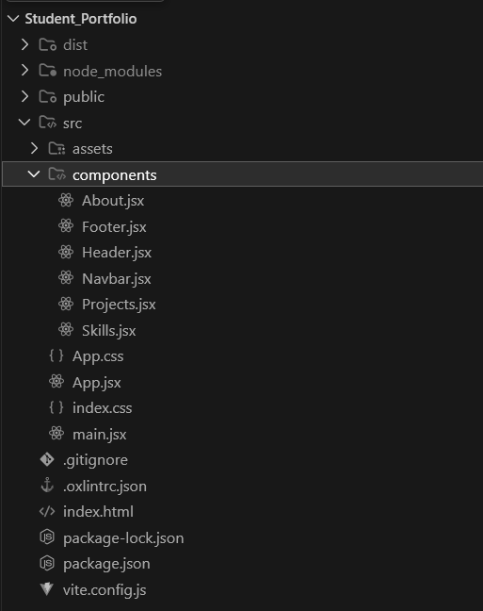
5. Environment Setup
Command 1: Check Node.js and npm.
node -v
npm -v
Command 2: Create the React application using Vite.
npm create vite@latest student-portfolio -- --template react
cd student-portfolio
npm install
npm run dev
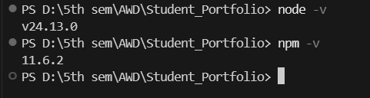
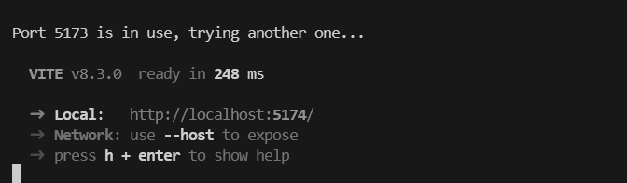
6. Component Implementation
Header.jsx
function Header({ name }) {
return (
<header>
<h1>{name}'s Student Portfolio</h1>
</header>
);
}

export default Header;
About.jsx
function About() {
return (
<section id="about">
<h2>About Me</h2>
<p>I am a student interested in technology and software development.</p>
</section>
);
}

export default About;
Skills.jsx
function Skills({ skillList }) {
return (
<section id="skills">
<h2>Skills</h2>
<ul>
{skillList.map((skill) => (
<li key={skill}>{skill}</li>
))}
</ul>
</section>
);
}

export default Skills;
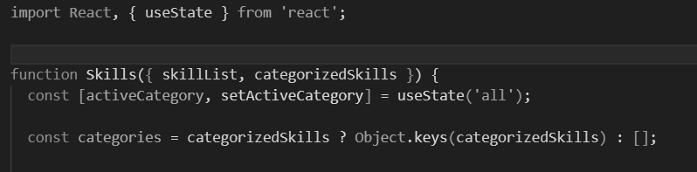
Footer.jsx
function Footer() {
return (
<footer>
<p>Student Portfolio</p>
</footer>
);
}

export default Footer;
7. App.jsx – Component Composition
App.jsx connects the components and passes the required data. The name is sent to Header and the skillList array is sent to Skills. This keeps the components reusable instead of hardcoding the same information inside them.
import Header from './components/Header';
import About from './components/About';
import Skills from './components/Skills';
import Footer from './components/Footer';

function App() {
const name = 'Student';
const skillList = ['HTML', 'CSS', 'JavaScript', 'React'];

return (
<>
<Header name={name} />
<About />
<Skills skillList={skillList} />
<Footer />
</>
);
}

export default App;
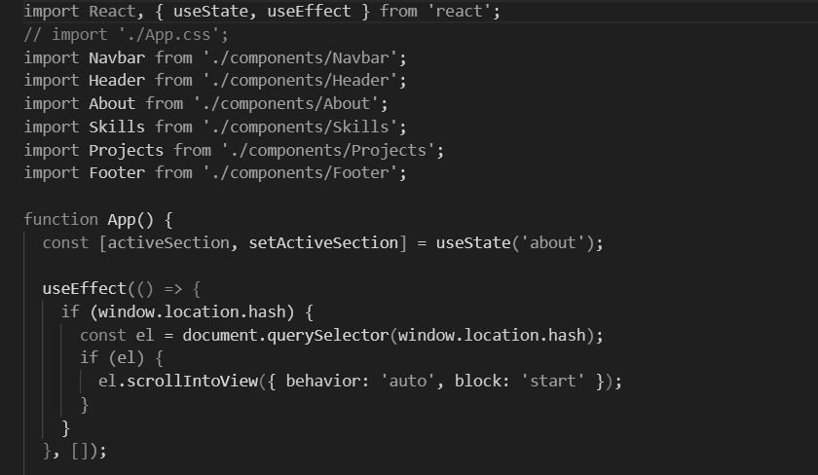
8. Working Flow
The practical follows a simple parent-to-child data flow. App.jsx creates the data, passes it through props, and the child components use those values while rendering the page.
App.jsx
│
├── name ───────────────→ Header.jsx
│
├── skillList ──────────→ Skills.jsx
│
├───────────────────────→ About.jsx
│
└───────────────────────→ Footer.jsx
9. Output and Evidence
The available evidence from the practical shows the project structure, the installed Node.js and npm versions, the Vite development server running successfully, and the React component implementation. These screenshots are included directly without adding figure titles or artificial output claims.
10. Key Questions / Answers
Q1. What is the role of each component in the overall UI structure?Each component represents one section of the page. Header handles the top part, About presents the introduction, Skills displays the skills list, and Footer contains the closing information. App.jsx combines them into the final page.
Q2. How does React re-render when props change?When a parent passes a different prop value, React updates the child component that receives the new value. The rendered UI is then updated to reflect that new data.
Q3. Why is component reusability important in large-scale applications?Reusable components reduce repeated code and make the interface easier to maintain. A component can be reused in different places without writing the same UI again.
11. Supplementary Problems / Extensions
- Add a NavBar component that highlights the active section.
- Pass an array of skills as a prop and render it dynamically.
- Pass a theme color to Header and apply it as an inline style.
- Add a Projects component containing three projects.
12. Testing and Verification
- Node.js and npm versions were checked before creating the project.
- The Vite development server was started successfully.
- The project folder contains the required React component files.
- Skills.jsx receives skillList through props and renders the values using map().
- The components are imported and composed through App.jsx.
- The browser should be checked for console errors after every major change.
13. Common Errors and Fixes
- If the Vite command does not start, check the Node.js version and network connection.
- If port 5173 is already in use, stop the previous server or use another port.
- If a component is missing, check its import path and confirm it is inside the App.jsx return block.
- If a prop is undefined, make sure the prop name in App.jsx exactly matches the name used in the child component.
14. GitHub Deliverables
- Public repository named portfolio-<rollno>.
- Working Vite + React project with four or more components.
- Clean .gitignore with node_modules excluded.
- At least one meaningful commit describing the work.
15. Learning Outcome
After completing this practical, I can set up a React project using Vite, divide a page into reusable functional components, and pass data from a parent to child components using props. I also understand why keeping each component focused on one responsibility makes the project easier to manage.
16. Student Reflection
This practical helped me understand React in a more practical way instead of treating the whole webpage as one file. I learned how App.jsx can bring smaller components together and how props can be used to send data to those components. The folder structure also made it clearer where reusable code should be kept. Running the Vite server and checking the project in the browser helped me connect the code with the actual UI.

17. Final Result
The required React component architecture has been implemented as a student portfolio solution. The solution uses Vite, separates the interface into reusable components, and demonstrates prop-based data flow. The supplied screenshots provide supporting evidence for the project setup, folder structure and implementation.

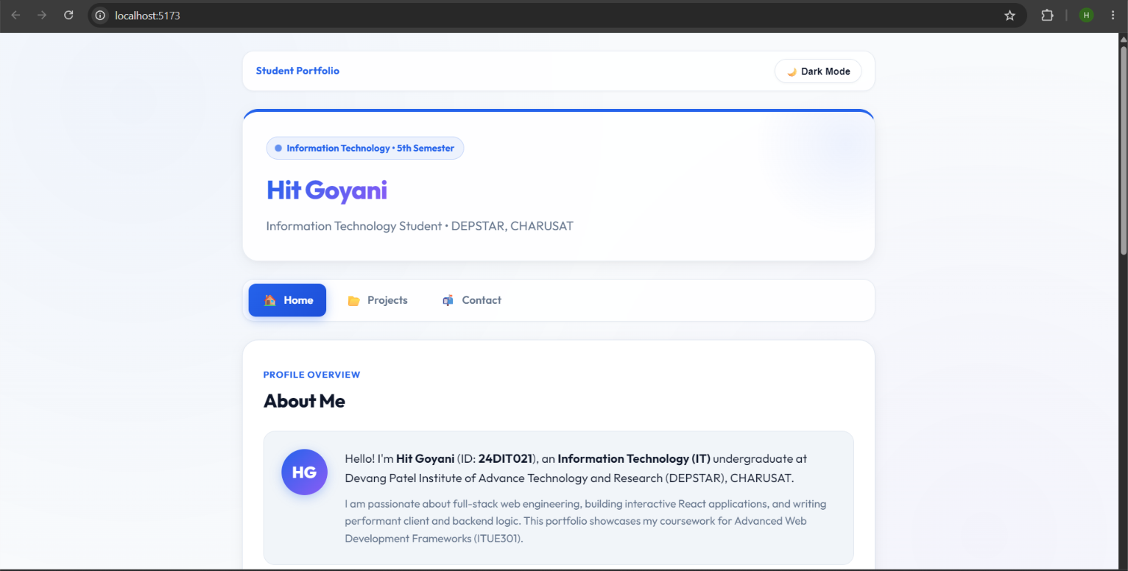
PRACTICAL 2
State Management and Routing in React
Roll No:- 24DIT021
Subject: Advanced Web Development Frameworks (ITUE301)
Semester: 5th Semester B.Tech Information Technology
Faculty of Technology and Engineering, CHARUSAT

1. Problem Statement
Create a React application that demonstrates client-side routing and state management. The application should contain a navigation bar with three routes: Home, Projects and Contact. The Contact page should use controlled inputs with React state, show the entered information in real time, and include a UI visibility toggle. The application should behave as a single-page application without full page reloads.

2. Objective
The objective of this practical is to understand how React Router manages multiple views inside a single React application and how the useState hook manages changing data and UI behaviour. The implementation also demonstrates controlled form inputs and component-based navigation.

3. Theory / Concepts Used
- BrowserRouter provides routing context to the React application.
- Routes and Route connect URL paths with React components.
- NavLink provides client-side navigation and can identify the active route.
- useState stores values that can change while the application is running.
- A controlled input receives its value from React state and updates that state through onChange.
- Conditional rendering can show or hide UI based on a state value.
- React Router allows route changes without loading a completely new HTML document.

4. Solution Approach
The solution keeps the routing and state logic separated. main.jsx places the application inside BrowserRouter. App.jsx defines the routes and also manages the global dark/light mode. NavBar.jsx provides the three navigation links. The Contact page manages form values and the help panel with useState. A live state inspector displays the current form values so the effect of state updates can be seen directly.
- Start the Vite React application and verify the development server.
- Wrap App.jsx with BrowserRouter in main.jsx.
- Define the Home, Projects and Contact routes in App.jsx.
- Create the navigation using NavLink so the active page is visible.
- Use useState in Contact.jsx for name, email, message and help visibility.
- Bind form fields using value and onChange.
- Display the state values in the Live State Inspector.
- Test route navigation, visibility toggle, theme toggle and the 404 route.

5. Folder Structure
The project is divided into components and pages so that the routing-related files and reusable navigation component are easy to locate.
portfolio/
├── src/
│ ├── components/
│ │ └── NavBar.jsx
│ ├── pages/
│ │ ├── Contact.jsx
│ │ ├── Home.jsx
│ │ ├── NotFound.jsx
│ │ └── Projects.jsx
│ ├── App.css
│ ├── App.jsx
│ ├── index.css
│ └── main.jsx
├── package.json
└── vite.config.js
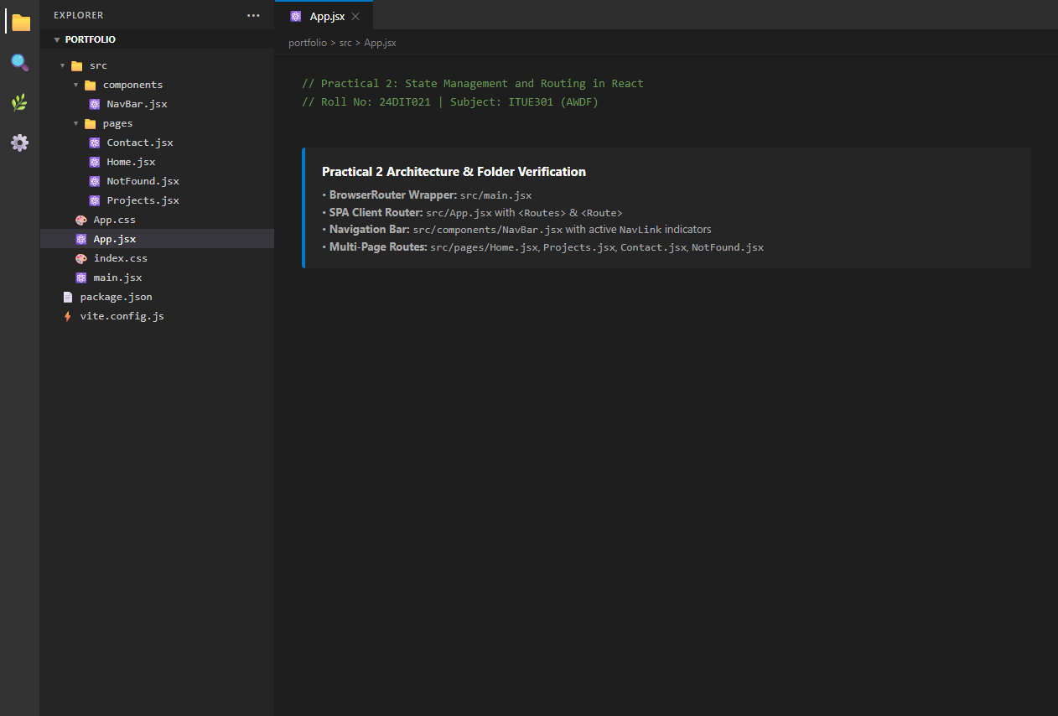

6. Router Setup
BrowserRouter is added at the application entry point. This gives the React application access to client-side routing.
main.jsx
import { StrictMode } from 'react';
import { createRoot } from 'react-dom/client';
import { BrowserRouter } from 'react-router-dom';
import App from './App.jsx';
import './index.css';

createRoot(document.getElementById('root')).render(
<StrictMode>
<BrowserRouter>
<App />
</BrowserRouter>
</StrictMode>
);
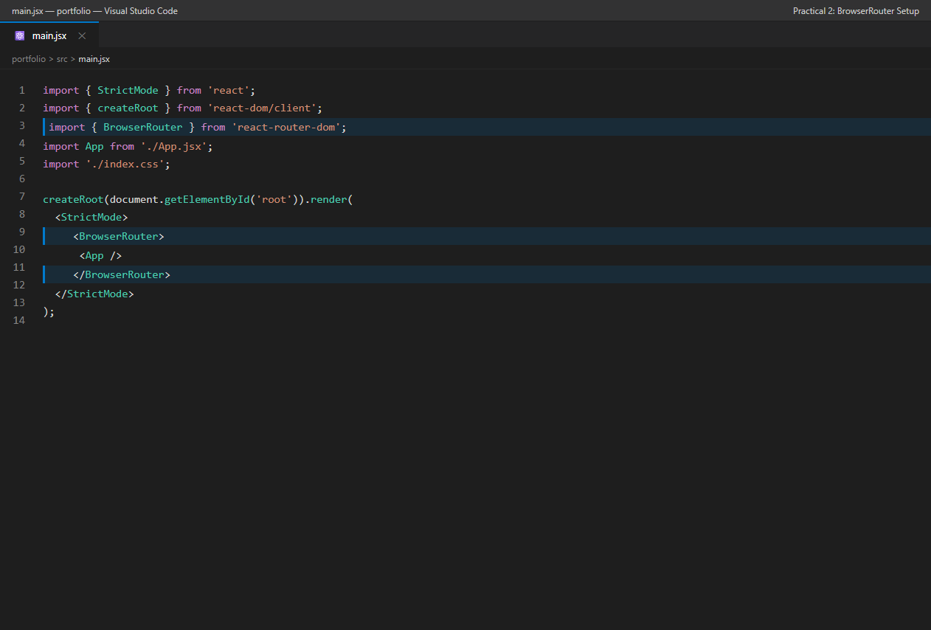

7. Route Configuration
App.jsx defines the three required routes and a wildcard route for invalid paths. The same application shell remains in place while React Router changes the page component.
App.jsx – Routing Section
import { Routes, Route } from 'react-router-dom';

<Routes>
<Route path="/" element={<Home skillList={skillList} />} />
<Route path="/projects" element={<Projects />} />
<Route path="/contact" element={<Contact />} />
<Route path="*" element={<NotFound />} />
</Routes>

8. Navigation Bar
The navigation bar uses NavLink. The active route receives an active class, which makes the current page easy to identify.
NavBar.jsx
import { NavLink } from 'react-router-dom';

const links = [
{ to: '/', label: 'Home', icon: '🏠', end: true },
{ to: '/projects', label: 'Projects', icon: '📂', end: false },
{ to: '/contact', label: 'Contact', icon: '📬', end: false },
];

<NavLink
key={link.to}
to={link.to}
end={link.end}
className={({ isActive }) =>
`nav-link ${isActive ? 'active' : ''}`
}
>

9. State Management in Contact Page
The Contact component uses separate state variables for the form values and the visibility of the information panel. This gives a clear example of how state controls both data and UI behaviour.
useState Declarations
const [name, setName] = useState('');
const [email, setEmail] = useState('');
const [message, setMessage] = useState('');
const [showHelp, setShowHelp] = useState(false);
const [submitted, setSubmitted] = useState(false);
Controlled Inputs
<input
value={name}
onChange={(e) => setName(e.target.value)}
/>

<input
value={email}
onChange={(e) => setEmail(e.target.value)}
/>

<textarea
value={message}
onChange={(e) => setMessage(e.target.value)}
/>
Visibility Toggle
<button
type="button"
onClick={() => setShowHelp(!showHelp)}
>
{showHelp ? '👁️ Hide Info' : '💡 Show Info'}
</button>

{showHelp && (
<div className="help-box">
...
</div>
)}
Live State Display
{name || '—'}
{email || '—'}
{message}

10. Practical Execution and Evidence
The following screenshots were supplied from the running Practical 2 application. They are included as direct evidence of the implementation and testing. No artificial labels or figure titles have been added to the screenshots.
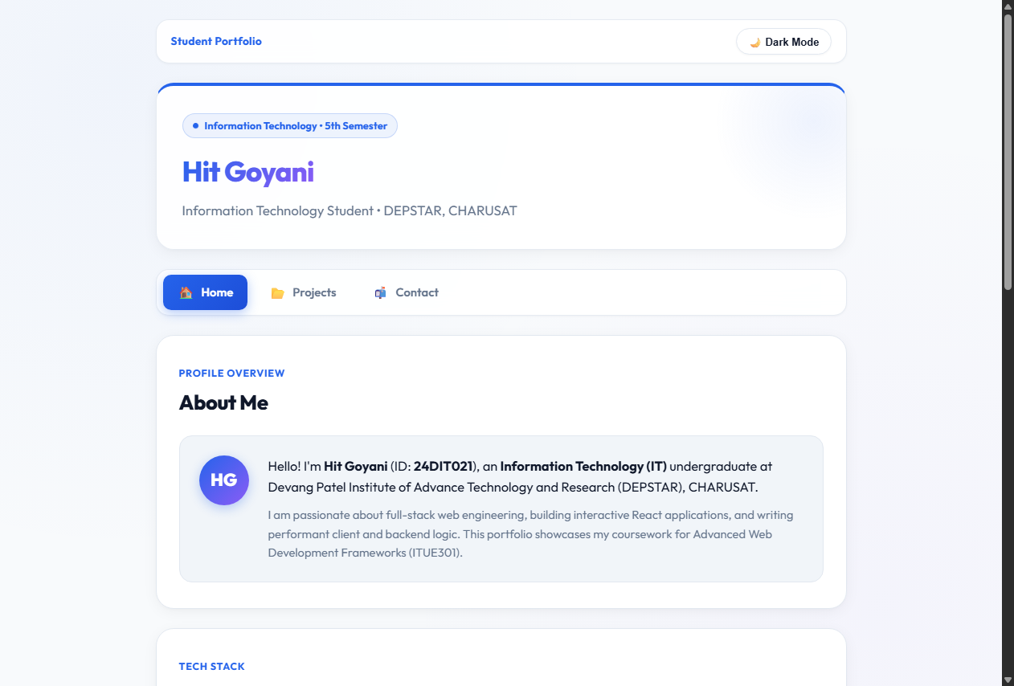
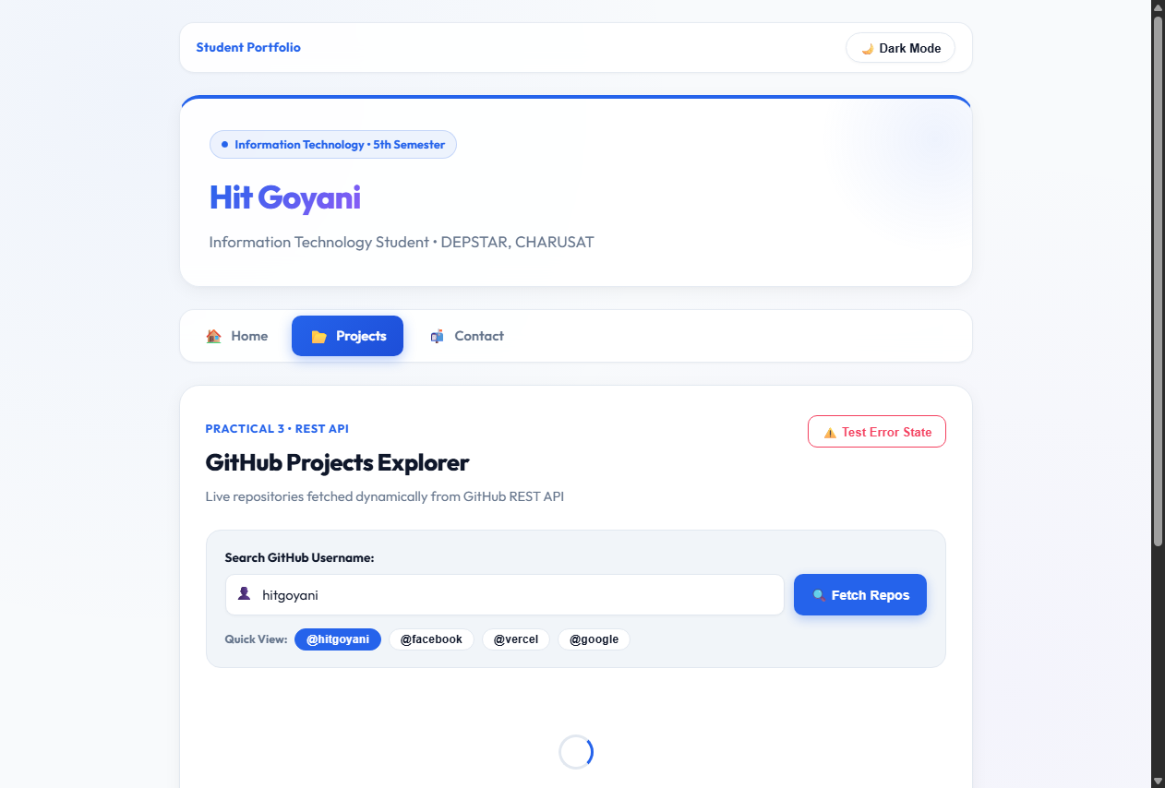
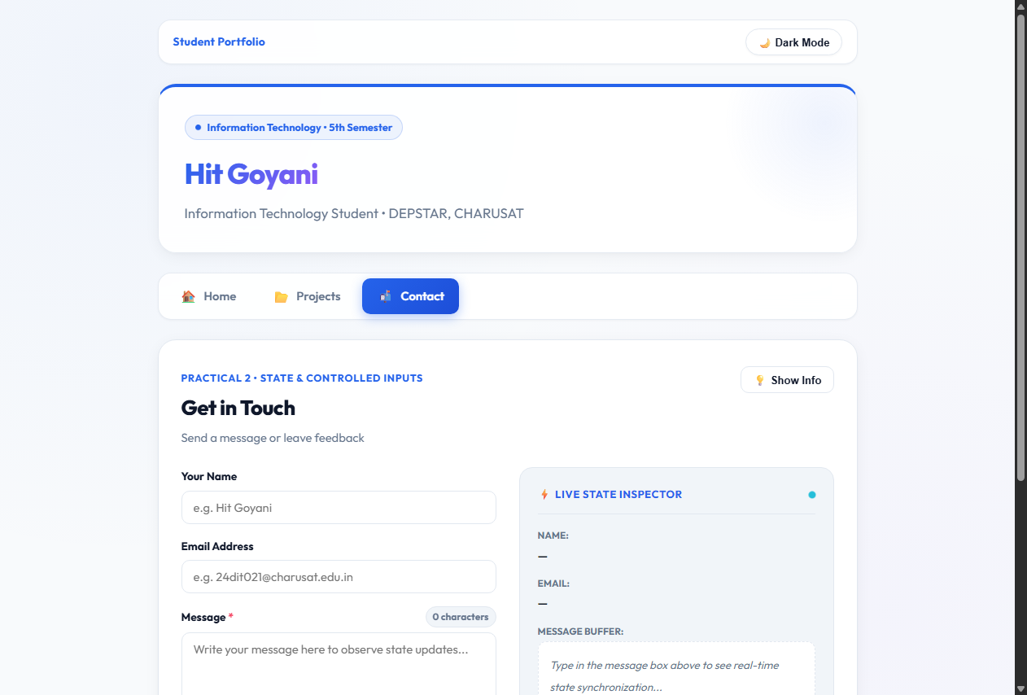
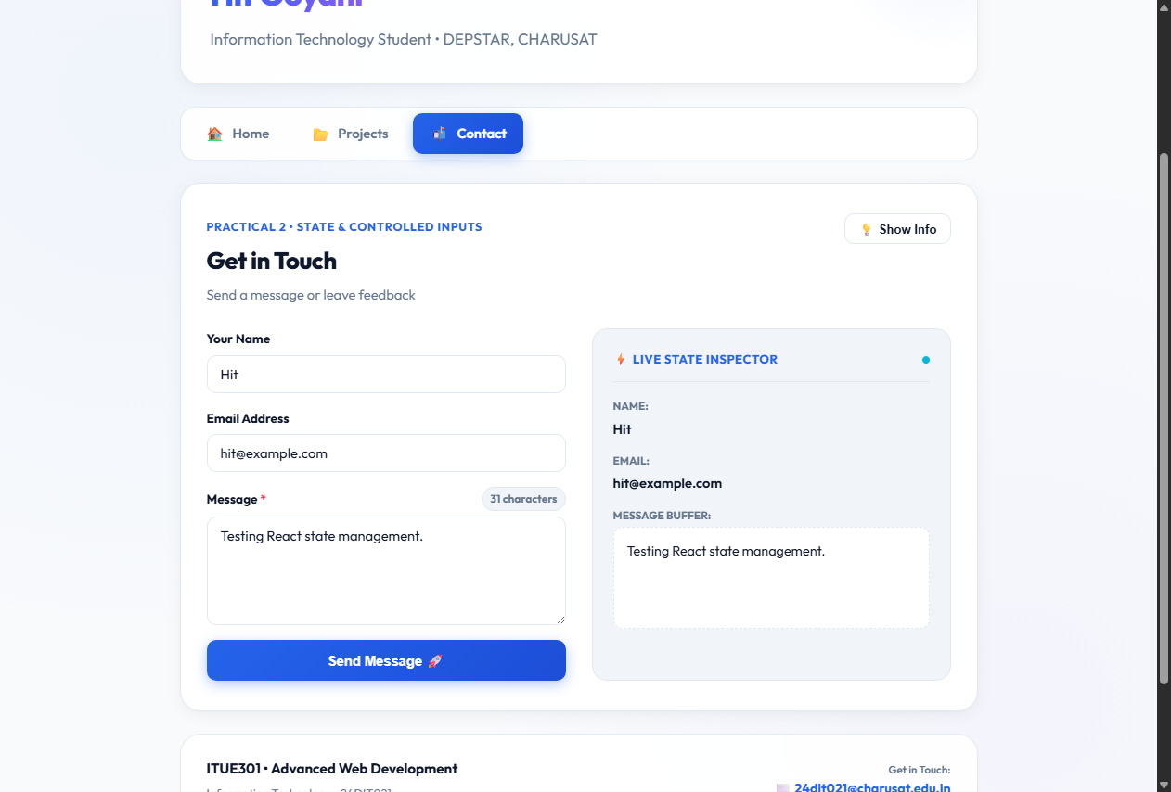
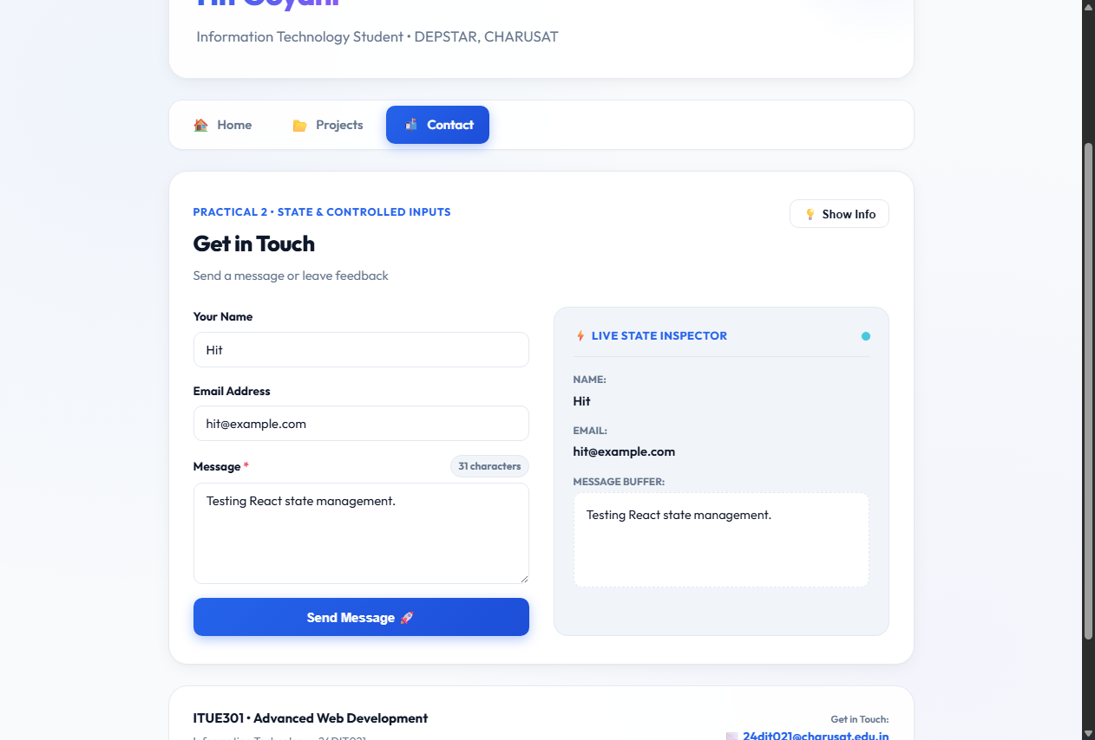
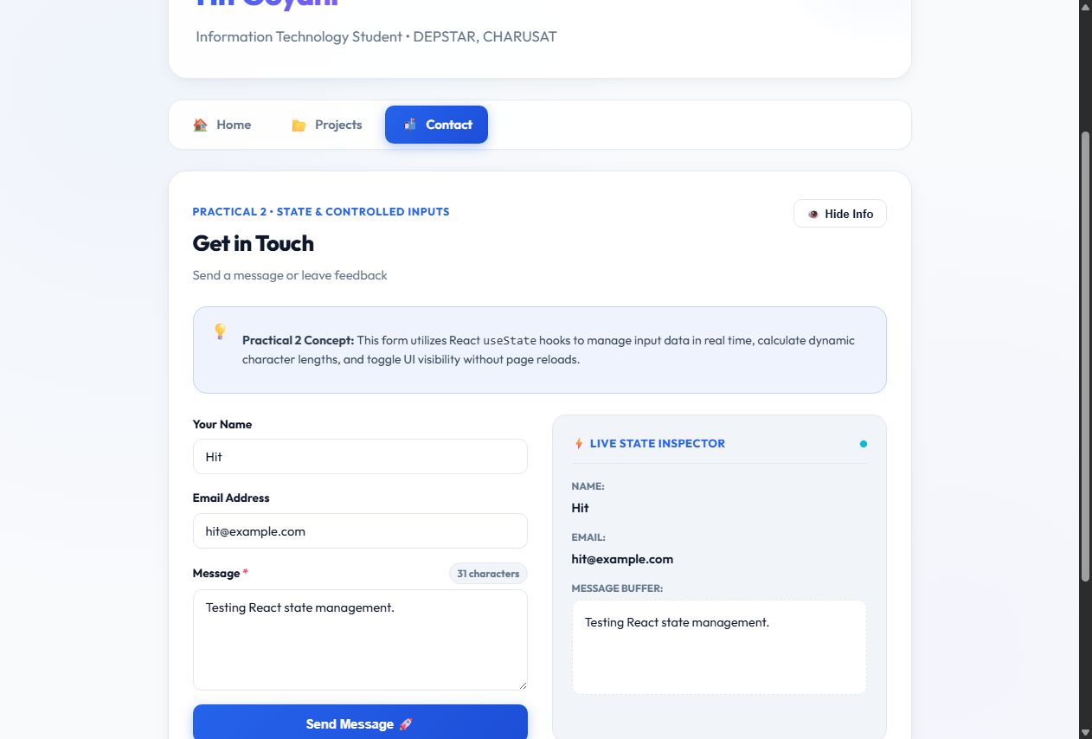
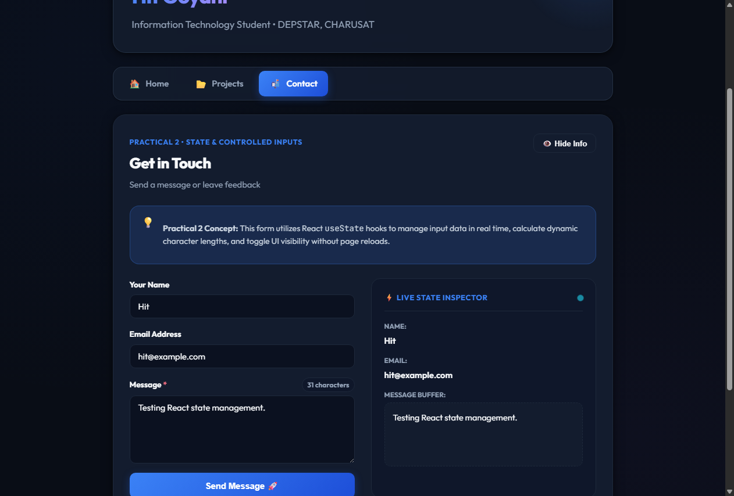
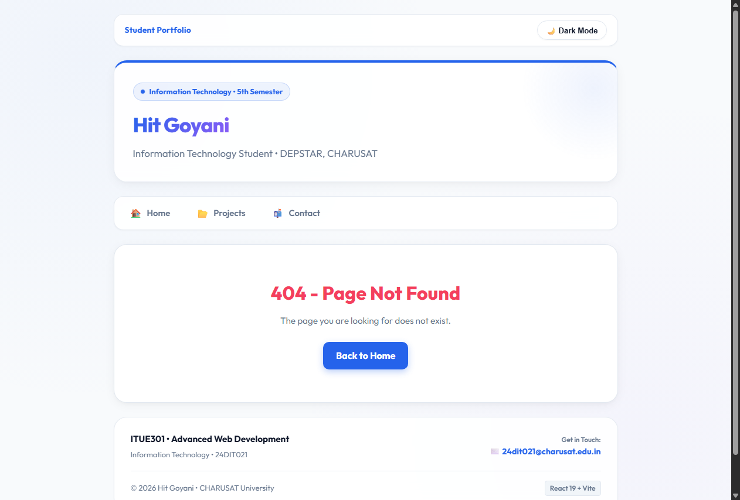

11. Working Flow
The practical works through a simple flow: the browser enters the React application through main.jsx, BrowserRouter provides routing context, App.jsx selects the page based on the URL, and NavBar changes the route through NavLink. On the Contact page, user input changes React state through onChange, and the updated state is immediately rendered in the form and Live State Inspector.
main.jsx
│
▼
BrowserRouter
│
▼
App.jsx
│
├── NavBar.jsx
│ ├── /
│ ├── /projects
│ └── /contact
│
└── Routes
├── Home.jsx
├── Projects.jsx
├── Contact.jsx
└── NotFound.jsx

Contact input
│
▼
useState → onChange → re-render
│
▼
Live State Inspector

12. Testing and Verification
- The Home route was opened at / and displayed the Home page with the Home navigation item active.
- The Projects route was opened at /projects and displayed the Projects page with Projects active.
- The Contact route was opened at /contact and displayed the Contact page with Contact active.
- Test values were entered into the Contact form and appeared in the Live State Inspector.
- The message counter updated with the entered text.
- The Show Info / Hide Info control changed the visibility of the information panel.
- Dark Mode changed the appearance of the application and the control changed to Light Mode.
- An invalid route displayed the custom 404 page.
- The supplied verification records report zero console errors and zero warnings during navigation testing.

13. Key Questions and Answers
Q1. Why is BrowserRouter used in this application?
BrowserRouter provides the routing context required by React Router. It allows the application to change views based on the URL while keeping the navigation inside the React application.
Q2. What is the purpose of Routes and Route?
Routes contains the route definitions, while each Route connects a URL path with the React component that should be rendered for that path.
Q3. Why is NavLink used instead of normal anchor tags?
NavLink is designed for React Router navigation. It changes the route inside the application and also provides isActive information, which is used here to highlight the current navigation item.
Q4. What makes the Contact fields controlled inputs?
The input value is taken from React state through the value property, and onChange updates that state. React therefore controls the current field value.
Q5. How does the Live State Inspector demonstrate React state?
Whenever a user changes the name, email or message, the corresponding state setter runs. React re-renders the component and the inspector shows the new values immediately.
Q6. How is UI visibility controlled using useState?
The showHelp state stores whether the information panel should be visible. The button changes that value, and conditional rendering displays the panel only when showHelp is true.
Q7. What is the purpose of the wildcard route?
The wildcard route catches paths that do not match the defined routes and displays the custom Not Found page instead of leaving the user with a blank or broken view.

14. Supplementary Features
- Custom 404 Not Found page using a wildcard route.
- Dark/light theme controlled through a root-level useState variable.
- Live character counter derived from message.length.
- Live State Inspector for observing state values during input.
15. Common Errors and Fixes
- If BrowserRouter is missing, add it around App in main.jsx.
- If a route does not open, check the path and component import in App.jsx.
- If NavLink does not highlight correctly, verify the to path and active class logic.
- If an input does not update, verify that value is connected to state and onChange calls the correct setter.
- If the 404 page does not appear, confirm that <Route path="*" element={<NotFound />} /> is present.
16. GitHub / Practical Deliverables
- Working Vite + React project.
- React Router implementation with the required routes.
- Reusable NavBar component.
- Contact form demonstrating controlled inputs and state management.
- Project source files and package configuration.
- Screenshots showing implementation and working output.
17. Learning Outcome
After completing this practical, I can create client-side routes in React, build navigation using NavLink, and use useState to manage changing values and UI behaviour. I can also create controlled form inputs and display their state in real time.
18. Student Reflection
This practical helped me understand the difference between simply creating multiple components and actually navigating between views in a React application. Working with the Contact form made state management easier to understand because I could immediately see the typed values in the Live State Inspector. The visibility and theme controls also showed how changing a state value can change the interface without refreshing the page.
19. Final Result
The Practical 2 requirements have been implemented and verified in the supplied React project. The application contains the required routes, React Router navigation, controlled Contact inputs, multiple meaningful useState variables, real-time state display, and additional 404, theme and character-count functionality. The included screenshots provide practical evidence of the working implementation.
PRACTICAL 3
REST API Integration and Data Rendering in React
Roll No:- 24DIT021
Subject: Advanced Web Development Frameworks (ITUE301)
Semester: 5th Semester B.Tech Information Technology
Faculty of Technology and Engineering, CHARUSAT

1. Problem Statement
Create a React application that consumes a REST API and displays dynamically fetched data. The Projects page should request public GitHub repository information, show a loading state while the request is in progress, handle API errors, and render repository details after a successful response.
2. Objective
The objective of this practical is to understand how a React application communicates with a REST API using the Fetch API and how useEffect and useState manage asynchronous data, loading status, and errors. The implementation also demonstrates conditional rendering of API results.
3. Theory / Concepts Used
- REST API provides resources through HTTP endpoints that can be consumed by frontend applications.
- Fetch API is used in JavaScript to send an HTTP request and receive the response asynchronously.
- useEffect is used to perform the API request as a side effect when the Projects page is loaded or the selected user changes.
- useState stores repositories, loading status, and error information so React can update the interface.
- JSON response data is converted into JavaScript objects and stored in component state.
- Conditional rendering displays the loading indicator, error message, or repository list according to the current state.

4. Solution Approach
The solution keeps the API request and UI rendering logic inside the Projects page while reusable Spinner and ErrorMessage components handle request feedback. The user can enter a GitHub username or select a quick-view username. The application then fetches public repositories and renders the returned data.
- Start the Vite React application and verify the development server.
- Open the Projects page from the existing React Router navigation.
- Maintain repository, loading, and error values with useState.
- Build the GitHub REST API URL using the selected username.
- Call fetch() from a fetchRepos function and validate the HTTP response.
- Store the returned repository array in state.
- Display Spinner during the request and ErrorMessage when the request fails.
- Render repository name, description, language, star count, and GitHub URL after success.
5. Folder Structure
The API integration is added to the existing portfolio structure. Reusable request-state components are kept inside the components folder.
portfolio/
├── src/
│ ├── components/
│ │ ├── ErrorMessage.jsx
│ │ ├── Spinner.jsx
│ │ └── NavBar.jsx
│ ├── pages/
│ │ ├── Home.jsx
│ │ ├── Projects.jsx
│ │ ├── Contact.jsx
│ │ └── NotFound.jsx
│ ├── App.jsx
│ ├── App.css
│ ├── index.css
│ └── main.jsx
├── package.json
└── vite.config.js
6. API Endpoint
The Projects page requests public repositories for the selected GitHub username.
GET https://api.github.com/users/{username}/repos
?sort=updated&per_page=50
The returned JSON array is used as the source for the repository cards shown on the page.

7. API Request Implementation
The request is triggered with useEffect. The dependency array contains the active username and the error-simulation state so the data is refreshed when either value changes.
7.1 Imports
import { useState, useEffect } from 'react';
import Spinner from '../components/Spinner.jsx';
import ErrorMessage from '../components/ErrorMessage.jsx';
7.2 State Management
const [repos, setRepos] = useState([]);
const [loading, setLoading] = useState(true);
const [error, setError] = useState(null);
7.3 Fetch Function
const fetchRepos = () => {
setLoading(true);
setError(null);

const url = `https://api.github.com/users/${encodeURIComponent(activeUser)}/repos?sort=updated&per_page=50`;

fetch(url)
.then((res) => {
if (!res.ok) {
if (res.status === 404) {
throw new Error(`GitHub user "${activeUser}" not found.`);
}
if (res.status === 403) {
throw new Error('GitHub API rate limit reached. Please try again shortly.');
}
throw new Error(`Failed to fetch repositories (HTTP ${res.status}).`);
}
return res.json();
})
.then((data) => setRepos(data))
.catch((err) => setError(err.message))
.finally(() => setLoading(false));
};
7.4 useEffect
useEffect(() => {
fetchRepos();
}, [activeUser, simulateError]);

8. Request State Handling
The UI changes according to the current asynchronous request state. This prevents the application from showing an empty or confusing page while data is being fetched.
8.1 Loading State
{loading && (
<Spinner message={`Loading public repositories for @${activeUser}...`} />
)}
8.2 Error State
{!loading && error && (
<ErrorMessage message={error} onRetry={fetchRepos} />
)}
8.3 Successful Data State
{!loading && !error && (
<div className="repo-grid">
{filteredRepos.map((repo) => (
<div key={repo.id} className="repo-card-item">
<h3>{repo.name}</h3>
<p>{repo.description || 'No description provided for this repository.'}</p>
<span>{repo.language || 'General'}</span>
<span>★ {repo.stargazers_count}</span>
<a href={repo.html_url}>View on GitHub ↗</a>
</div>
))}
</div>
)}
8.4 Search / Filter
const filteredRepos = repos.filter((repo) =>
repo.name.toLowerCase().includes(searchQuery.toLowerCase()) ||
(repo.description &&
repo.description.toLowerCase().includes(searchQuery.toLowerCase()))
);
9. Error Simulation
A Test Error State control is included so that the error-handling path can be demonstrated deliberately. It requests an invalid GitHub user and allows the ErrorMessage component and Retry action to be observed.

10. Practical Execution and Evidence
The following screenshots are the actual supplied outputs from the running Practical 3 application. They are converted to grayscale for the black-and-white academic presentation, while preserving the original application content and states.
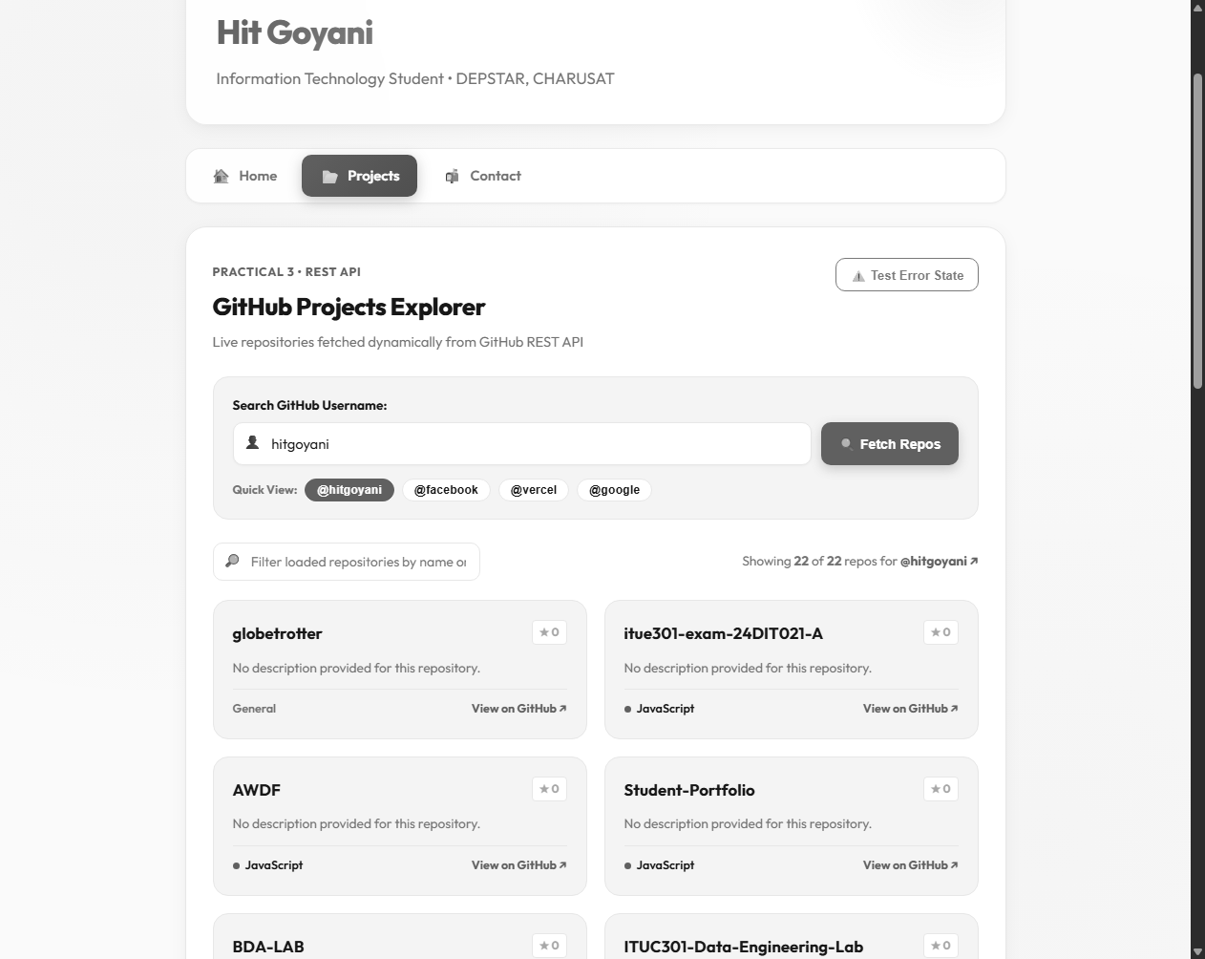
Fig. 1: Successful GitHub REST API response showing repositories loaded for the GitHub username.

10. Practical Execution and Evidence (Continued)
The successful state shows the Projects page after repository data has been received from the GitHub REST API.
Fig. 1: Successful API state — repository data is rendered dynamically.
In the supplied screenshot, the application reports 22 of 22 repositories for the selected GitHub username. Each repository card contains its name and GitHub link, with additional metadata such as language and star count.

11. Error State Verification
The error path is tested by requesting a GitHub username that cannot be found.
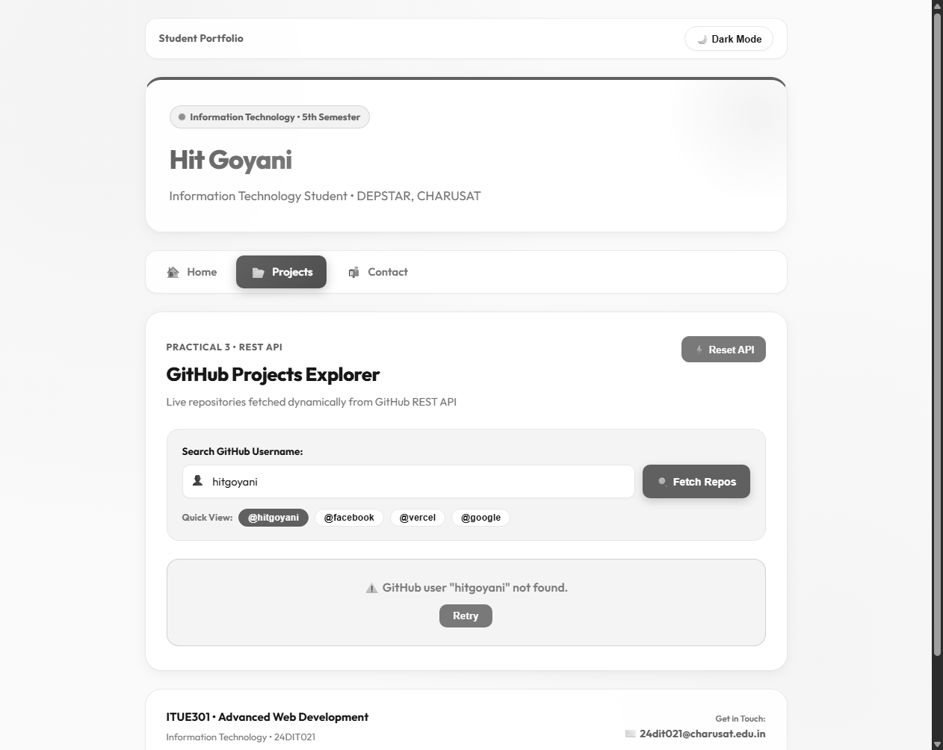
Fig. 2: API error state — the application displays the failure message and Retry button.
The supplied output shows the message "GitHub user "hitgoyani" not found." and provides a Retry action. This demonstrates that the failed HTTP request is handled by the React UI instead of leaving the page blank.

12. Loading State Verification
The loading path is visible while a repository request is in progress.
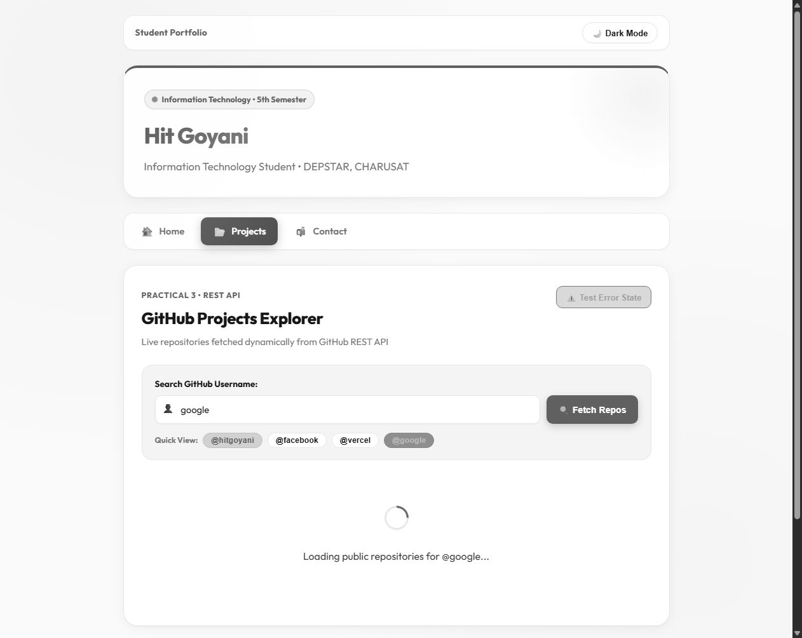
Fig. 3: Loading state — Spinner and dynamic loading text are displayed.
The supplied screenshot shows the spinner and the message indicating that public repositories for @google are being loaded. This confirms that the application provides immediate feedback during asynchronous work.

13. Working Flow
The practical works through a simple asynchronous data flow: the browser enters the React application, the Projects route renders Projects.jsx, useEffect starts the API request, and the response is stored in state. React then re-renders the page according to the request result.
Projects.jsx
│
▼
useEffect()
│
▼
fetchRepos()
│
▼
GitHub REST API
│
├───────────────┬────────────────┐
▼ ▼ ▼
Loading Error Success
│ │ │
▼ ▼ ▼
Spinner ErrorMessage setRepos(data)
│
▼
Repository Cards
14. Testing and Verification
- The Projects page was opened and the GitHub repository request was initiated.
- A successful request displayed repository cards dynamically from the API response.
- The error scenario displayed an explicit GitHub user-not-found message and Retry button.
- The loading scenario displayed a spinner and dynamic loading text while the request was active.
- The username input and Quick View controls were visible for selecting different GitHub users.
- The repository filter field was available for narrowing the loaded repository list.

15. Key Questions and Answers
Q1. Why is fetch() used in this practical?
fetch() provides a JavaScript interface for making the HTTP request to the GitHub REST API and receiving the response asynchronously.
Q2. Why is useEffect() used for the API request?
The API call is a side effect of loading the Projects page or changing the selected username. useEffect() is used to run that side effect after rendering.
Q3. Why are loading and error stored in state?
They represent the current request condition. React uses those state values to decide whether to show the spinner, error message, or repository data.
Q4. What happens when the API returns a non-success status?
The response is checked with res.ok. When it is false, an appropriate Error object is created and the error message is displayed.
Q5. Why is finally() used?
finally() runs after both successful and failed requests, so setLoading(false) reliably stops the loading indicator.
Q6. What is the purpose of the Retry button?
The Retry button calls fetchRepos() again, allowing the user to repeat the request without refreshing the whole page.
Q7. Why is a key used while rendering repositories?
The repository id is used as a key so React can track individual list items efficiently when the list changes.
Q8. How does the application render API data?
The JSON response is stored in repos state and map() creates a repository card for each object in the returned array.

16. Supplementary Features
- Retry button for failed API requests.
- Search/filter for repository names and descriptions.
- Quick View controls for predefined GitHub usernames.
- Repository star count and language information.
- Test Error State control for demonstrating API failure handling.
17. Common Errors and Fixes
- If the spinner remains visible, verify that loading is set to false in finally().
- If an error is not displayed, check that non-OK HTTP responses are converted into an Error.
- If the repository list is empty after a successful response, verify that the JSON array is stored with setRepos().
- If data does not refresh after changing the username, verify the useEffect dependency array.
- If GitHub rate limiting occurs, wait and retry the request or use another public username for demonstration.
18. GitHub / Practical Deliverables
- Working Vite + React project.
- GitHub REST API integration in Projects.jsx.
- Loading and error handling components.
- Dynamic rendering of repository data.
- Retry and filtering functionality.
- Screenshots showing successful, error, and loading states.
19. Learning Outcome
After completing this practical, I can connect a React application to a public REST API, perform an asynchronous request, manage loading and error states with useState, trigger side effects with useEffect, and render API response data dynamically.
20. Student Reflection
This practical helped me understand how frontend applications communicate with external services. Using the GitHub REST API made the purpose of asynchronous requests clearer because the interface has to handle loading, success, and failure separately. Testing all three states also helped me understand how React state controls what the user sees without requiring a full page reload.
21. Final Result
The Practical 3 implementation demonstrates REST API consumption in React using the GitHub REST API. The Projects page fetches repository information dynamically, displays a loading state during the request, handles API errors with a Retry option, and renders repository information after a successful response. The supplied screenshots provide direct evidence of the successful, error, and loading states.
PRACTICAL 4
RESTful API Development with Node.js and Express
Roll No:- 24DIT021
Subject: Advanced Web Development Frameworks (ITUE301)
Semester: 5th Semester B.Tech Information Technology
Faculty of Technology and Engineering, CHARUSAT

1. Problem Statement
Create a RESTful Task Manager API using Node.js and Express. The application should expose CRUD endpoints for tasks, use middleware for request logging and request validation, validate task IDs, return appropriate HTTP status codes, and handle undefined routes and application errors through centralized middleware.
2. Objective
The objective of this practical is to understand how a Node.js and Express application processes HTTP requests through middleware and RESTful routes. The implementation demonstrates CRUD operations, request logging, Content-Type validation, task ID validation, custom 404 handling, and centralized error handling.
3. Theory / Concepts Used
- REST API provides resources through HTTP methods such as GET, POST, PUT, and DELETE.
- Express.js provides routing and middleware support for Node.js web applications.
- Middleware functions receive req, res, and next and can inspect or modify a request before continuing.
- express.json() parses JSON request bodies.
- Request logging records the HTTP method, requested URL, and timestamp.
- Content-Type validation ensures POST, PUT, and PATCH requests use application/json.
- CRUD represents Create, Read, Update, and Delete operations on task resources.
- Centralized error middleware uses four parameters: err, req, res, and next.
- A 404 handler responds when no defined route matches the requested endpoint.
4. Solution Approach
- Start the Node.js Express server on port 5000.
- Load environment variables and configure the MongoDB connection.
- Enable CORS and express.json() as core middleware.
- Register request logging and Content-Type validation middleware.
- Mount the /tasks router containing the RESTful CRUD endpoints.
- Validate task IDs before controller logic is executed.
- Use MongoDB/Mongoose when connected and an in-memory task collection as the Practical 4 fallback.
- Register the undefined-route handler after the API routes.
- Register the centralized global error handler as the last middleware.
- Test successful requests and error conditions using Thunder Client / Postman.
5. Folder Structure
task-manager-api/
├── middleware/
│ ├── errorHandler.js
│ ├── logger.js
│ └── validator.js
├── routes/
│ └── taskRoutes.js
├── .env.example
├── package.json
├── README.md
├── server.js
└── test-api.js
6. Server and Middleware Pipeline
The Express server first configures CORS and JSON parsing. The custom request logger then records every incoming request, while the Content-Type validator protects write operations. The task router handles CRUD requests. Undefined routes are handled by the 404 middleware, and the global error handler is kept last.
const app = express();
const PORT = process.env.PORT || 5000;
app.use(cors());
app.use(express.json());
app.use(requestLogger);
app.use(requireJsonHeader);
app.use('/tasks', taskRoutes);
app.use(notFoundHandler);
app.use(globalErrorHandler);
7. Request Logging Middleware
The request logger records the HTTP method, original URL, and an ISO timestamp for every incoming request, then passes control to the next middleware.
export const requestLogger = (req, res, next) => {
const timestamp = new Date().toISOString();
console.log(`[LOG] ${req.method} ${req.originalUrl || req.url} - ${timestamp}`);
next();
};
8. Validation Middleware
8.1 Content-Type Validation
export const requireJsonHeader = (req, res, next) => {
if (['POST', 'PUT', 'PATCH'].includes(req.method)) {
const contentType = req.headers['content-type'];
if (!contentType || !contentType.includes('application/json')) {
return res.status(400).json({
success: false,
error: 'Bad Request: Content-Type header must be application/json',
});
}
}
next();
};
8.2 Task ID Validation
export const validateTaskId = (req, res, next) => {
const { id } = req.params;
const isValidObjectId = mongoose.Types.ObjectId.isValid(id);
const isValidInteger =
!isNaN(parseInt(id, 10)) && String(parseInt(id, 10)) === id;
if (!isValidObjectId && !isValidInteger) {
return res.status(400).json({
success: false,
error: `Invalid task ID format: "${id}". ID must be a valid integer or MongoDB ObjectId.`,
});
}
next();
};
9. CRUD Operations
The Task Manager API provides the following RESTful endpoints:
• POST /tasks — creates a new task and returns 201 Created.
• GET /tasks — retrieves all tasks and returns 200 OK.
• GET /tasks/:id — retrieves a single task by ID.
• PUT /tasks/:id — updates task fields.
• DELETE /tasks/:id — deletes a task.
10. Error Handling
The API uses two related error-handling mechanisms. The custom 404 handler returns a JSON response when an endpoint does not exist. The four-parameter global error handler processes Mongoose ValidationError, CastError, malformed JSON, and unexpected server errors.
export const notFoundHandler = (req, res) => {
res.status(404).json({
success: false,
error: `404 Not Found: Cannot ${req.method} ${req.originalUrl || req.url}`,
});
};
export const globalErrorHandler = (err, req, res, next) => {
console.error('[GLOBAL ERROR HANDLER]:', err.message);
if (err.name === 'ValidationError') {
const errorDetails = Object.values(err.errors).map((val) => val.message);
return res.status(400).json({
success: false,
error: 'Validation Error',
details: errorDetails,
});
}
if (err.name === 'CastError') {
return res.status(400).json({
success: false,
error: `Invalid resource ${err.path}: "${err.value}"`,
});
}
res.status(500).json({
success: false,
error: 'Internal Server Error: Something went wrong on the server',
});
};
11. Practical Execution and Evidence
The following screenshots are the supplied outputs from the running Practical 4 application and development environment. They are converted to grayscale to match the black-and-white academic presentation style used in Practical 3.
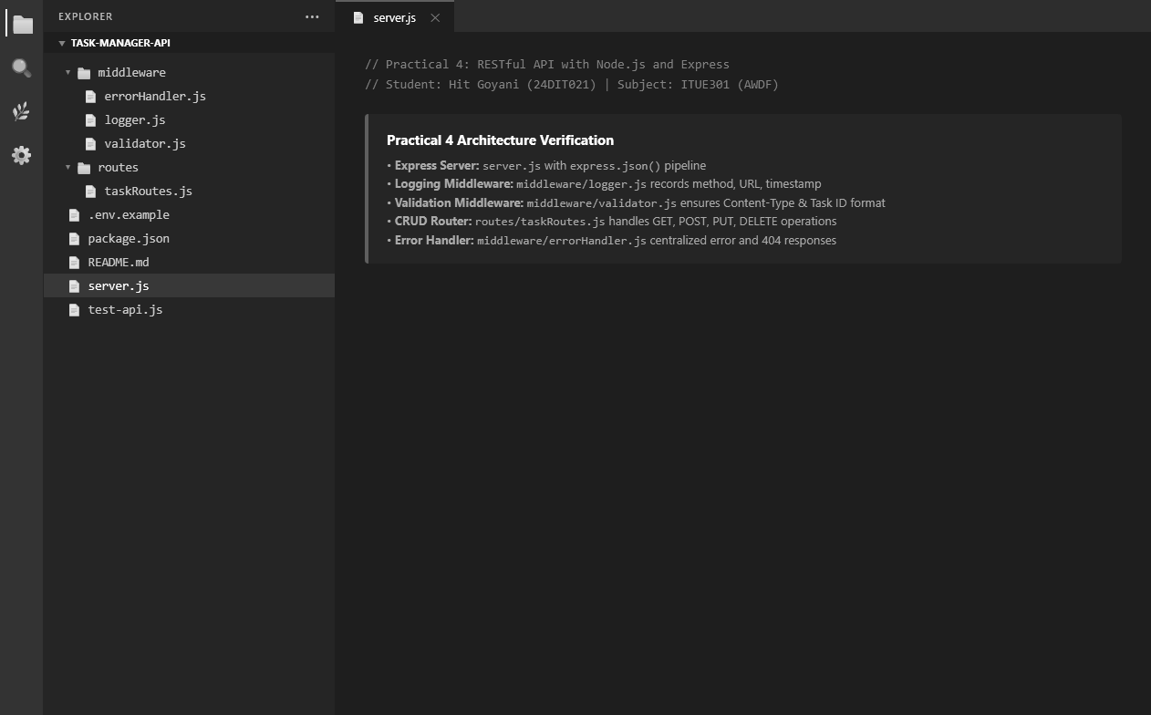
Fig. 1: Practical 4 project folder structure in Visual Studio Code.

11. Practical Execution and Evidence (Continued)
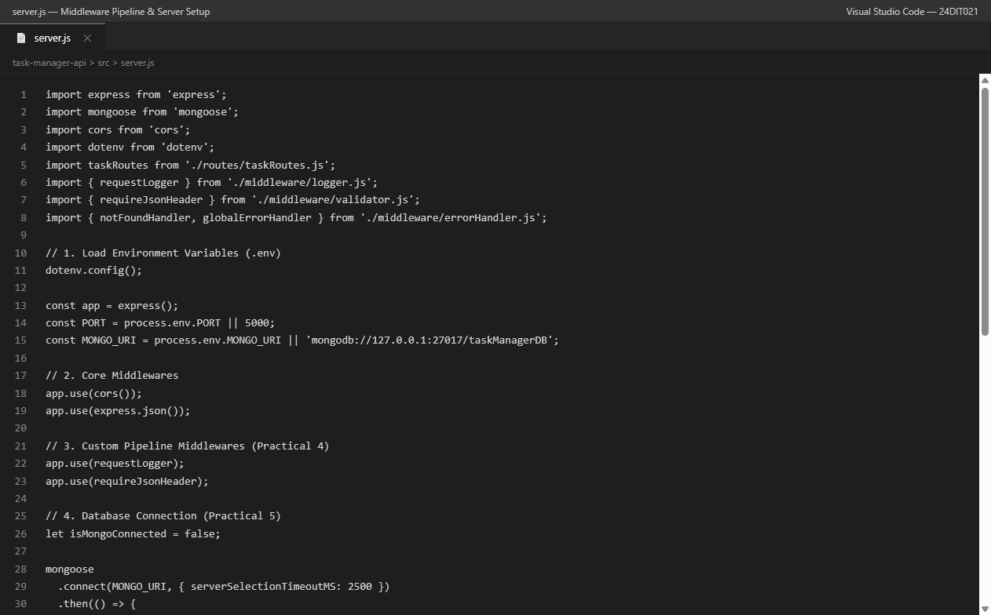
Fig. 2: Express server and middleware pipeline.

11. Practical Execution and Evidence (Continued)
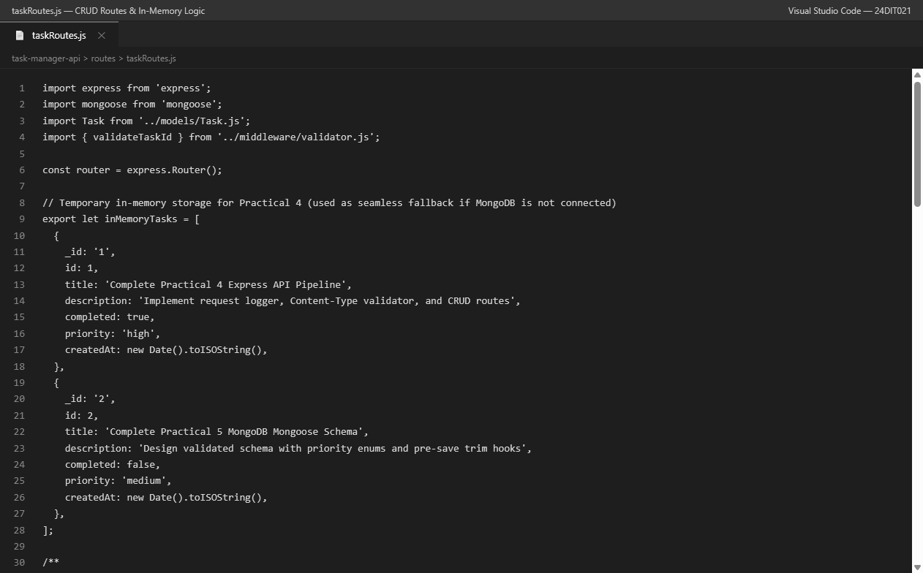
Fig. 3: CRUD route implementation for the Task Manager API.

11. Practical Execution and Evidence (Continued)
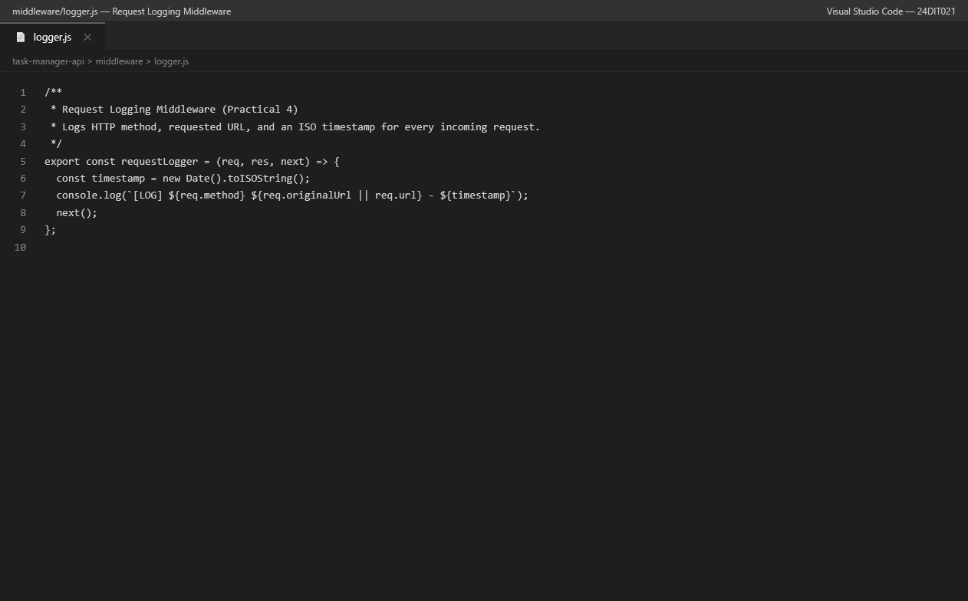
Fig. 4: Request logging middleware.

11. Practical Execution and Evidence (Continued)
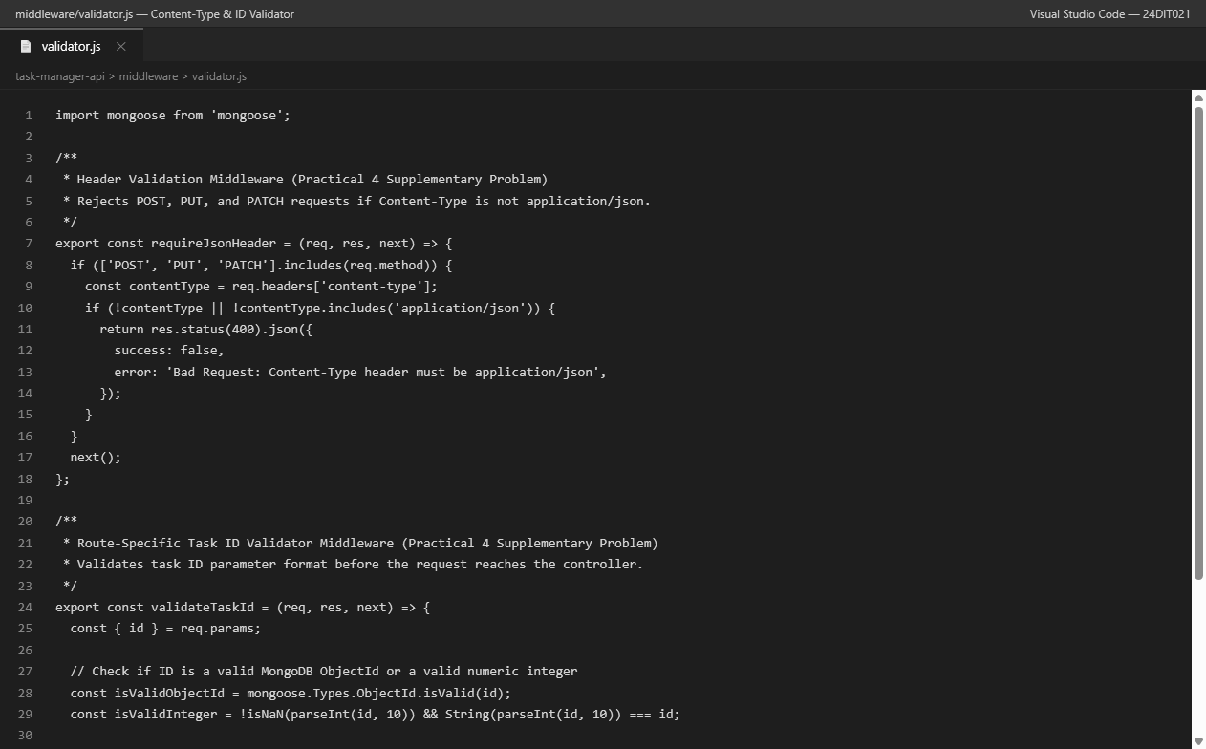
Fig. 5: Content-Type and task ID validation middleware.

11. Practical Execution and Evidence (Continued)
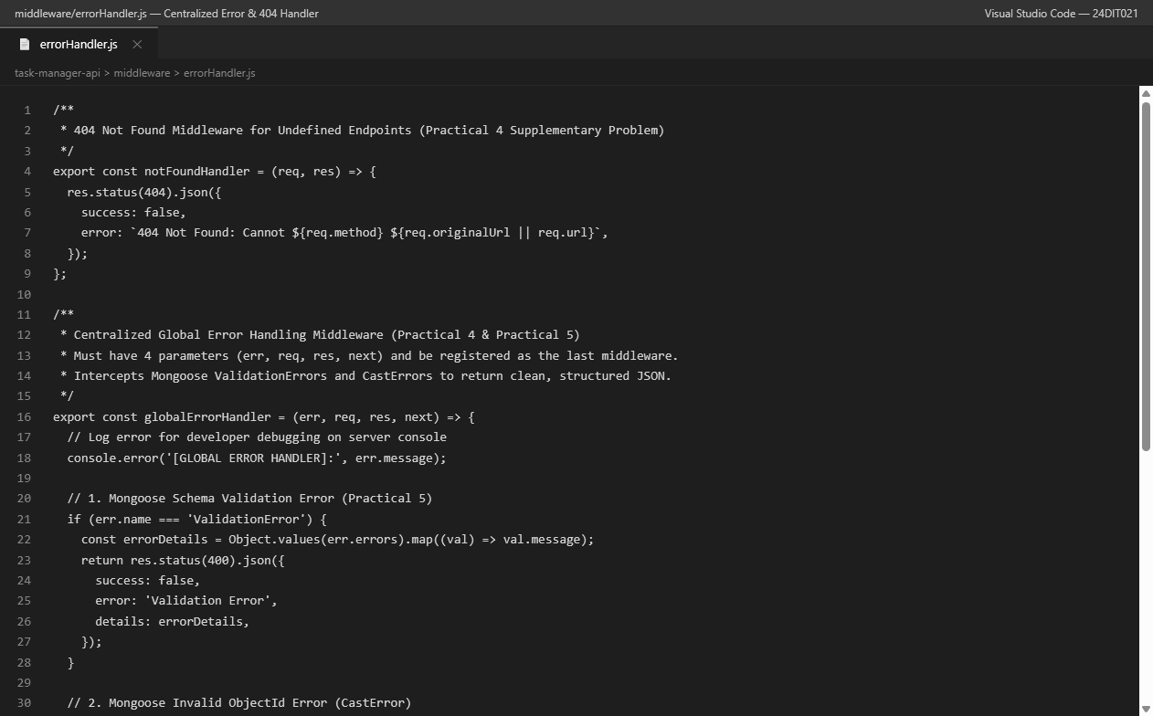
Fig. 6: Custom 404 handler and centralized global error handler.

11. Practical Execution and Evidence (Continued)
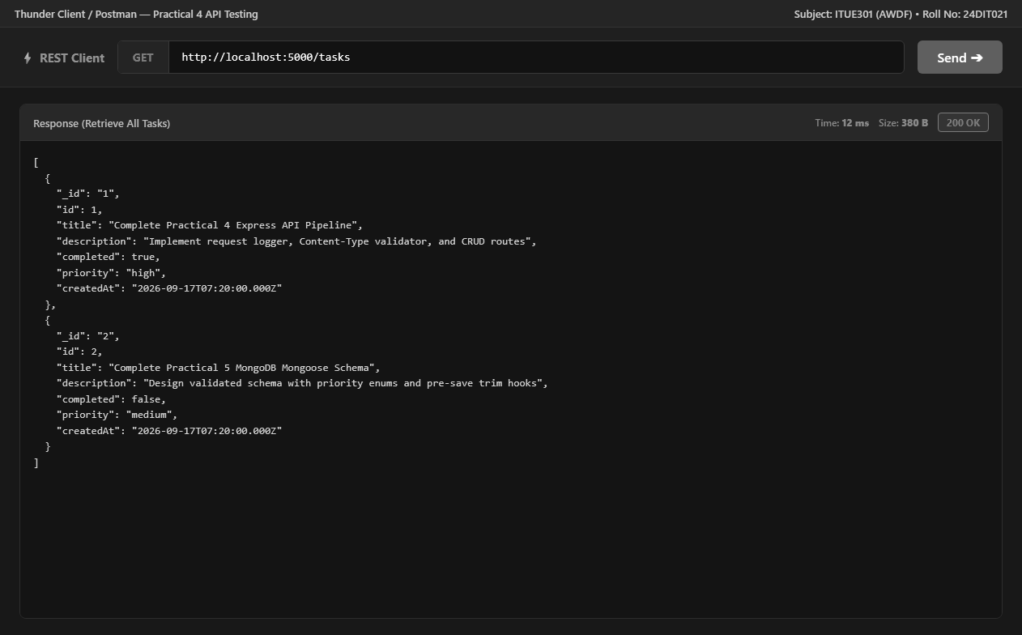
Fig. 7: GET /tasks — retrieve all tasks — 200 OK.

11. Practical Execution and Evidence (Continued)
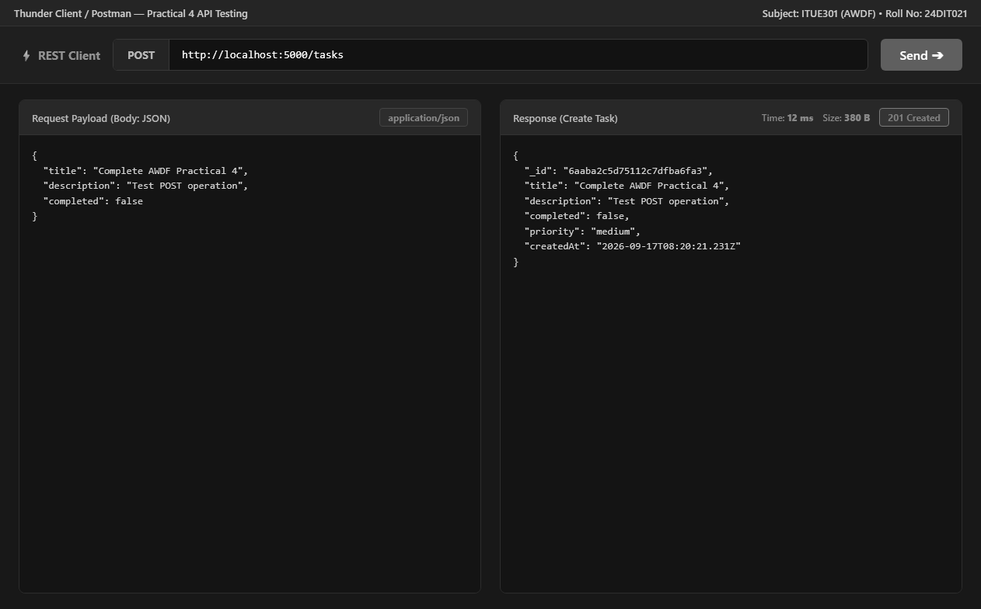
Fig. 8: POST /tasks — create task — 201 Created.

11. Practical Execution and Evidence (Continued)
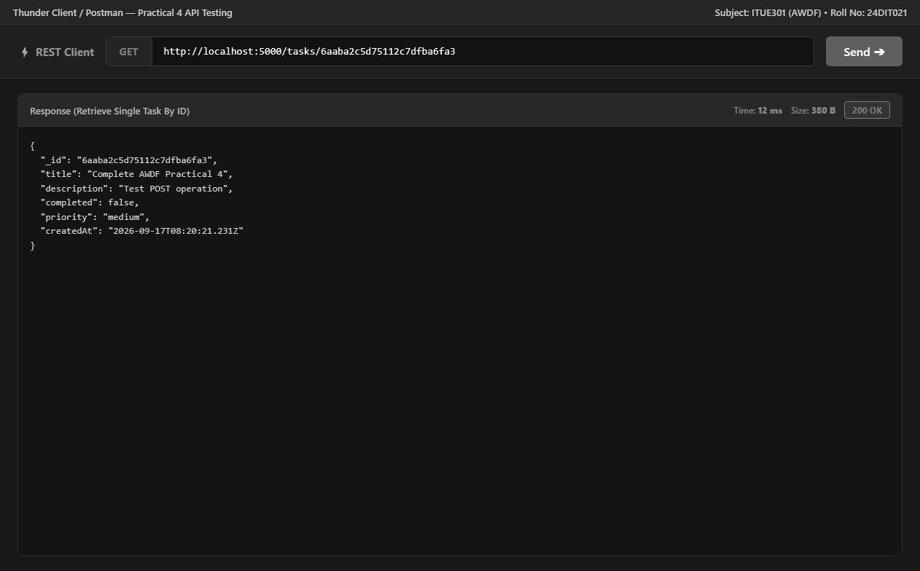
Fig. 9: GET /tasks/:id — retrieve a single task — 200 OK.

11. Practical Execution and Evidence (Continued)
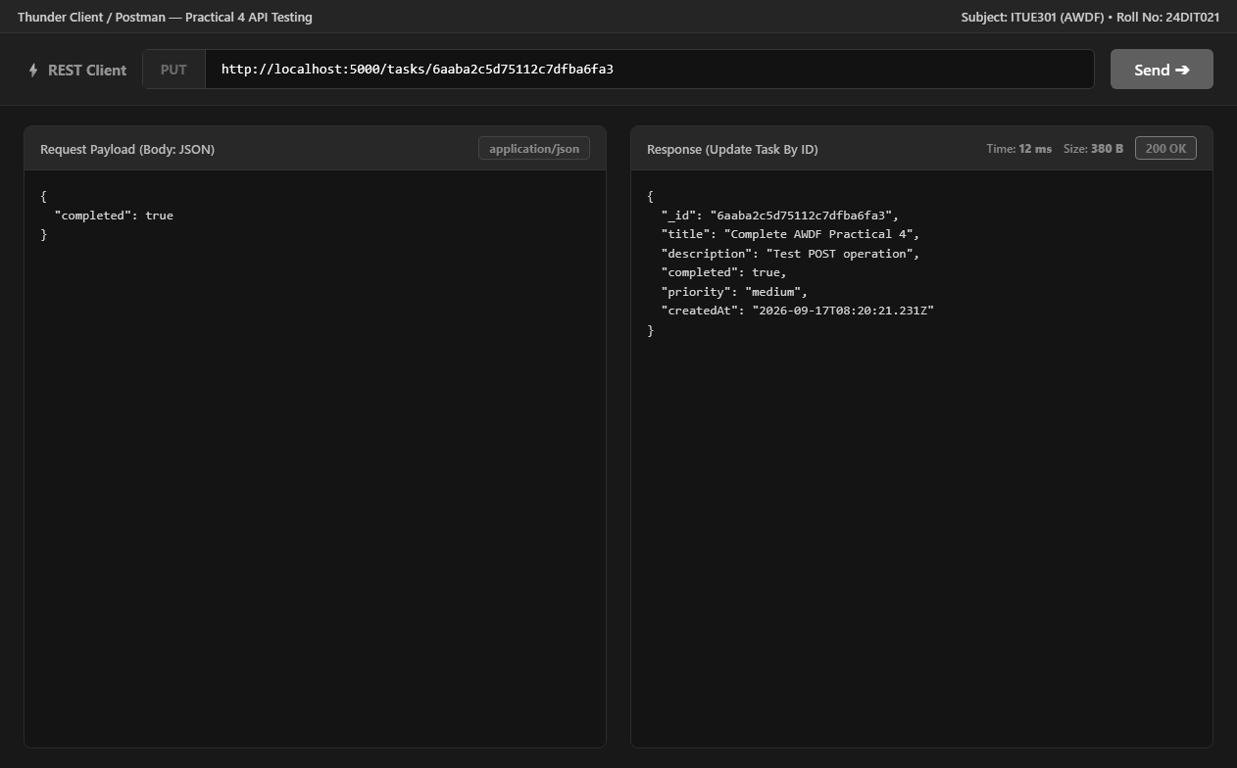
Fig. 10: PUT /tasks/:id — update task — 200 OK.

11. Practical Execution and Evidence (Continued)
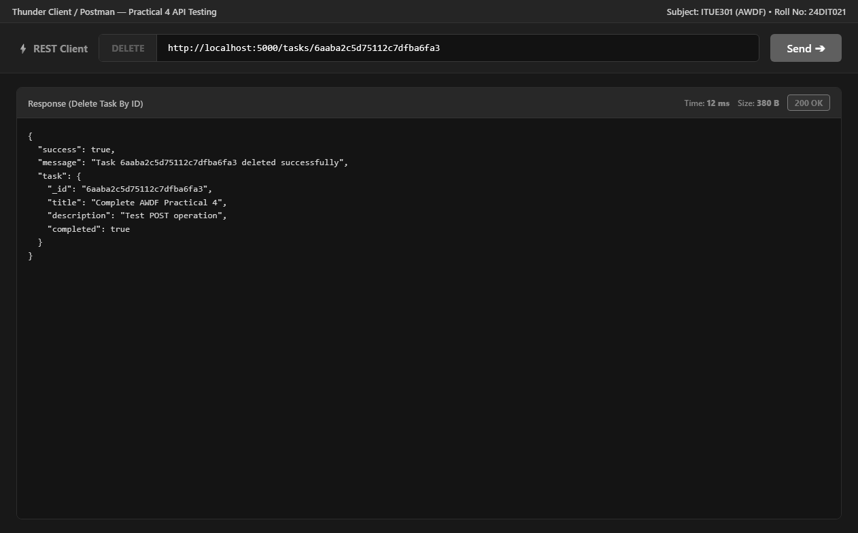
Fig. 11: DELETE /tasks/:id — delete task — 200 OK.

11. Practical Execution and Evidence (Continued)
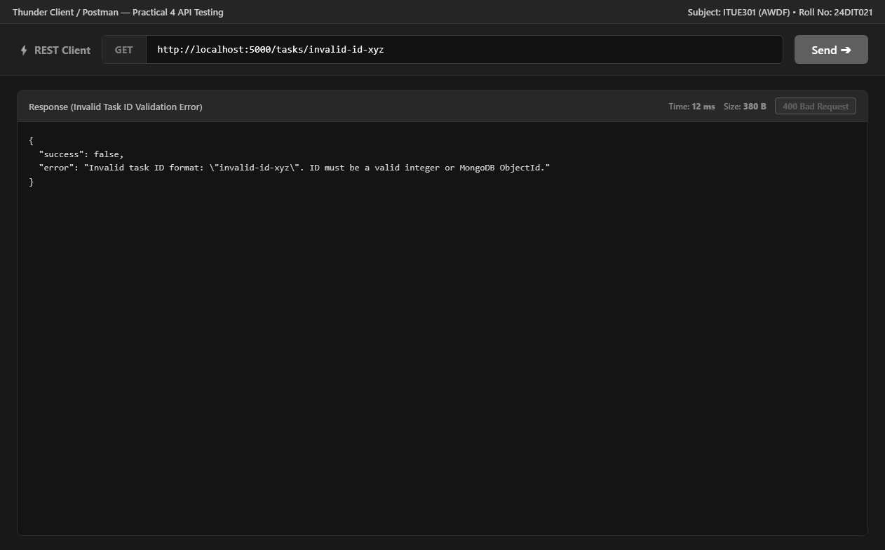
Fig. 12: Invalid task ID validation — 400 Bad Request.

11. Practical Execution and Evidence (Continued)
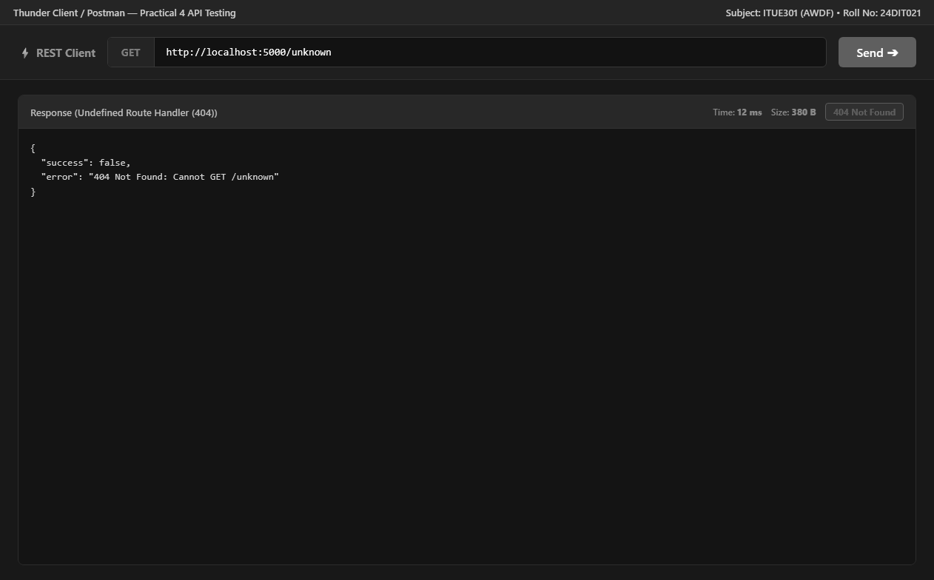
Fig. 13: Undefined endpoint — 404 Not Found.

11. Practical Execution and Evidence (Continued)
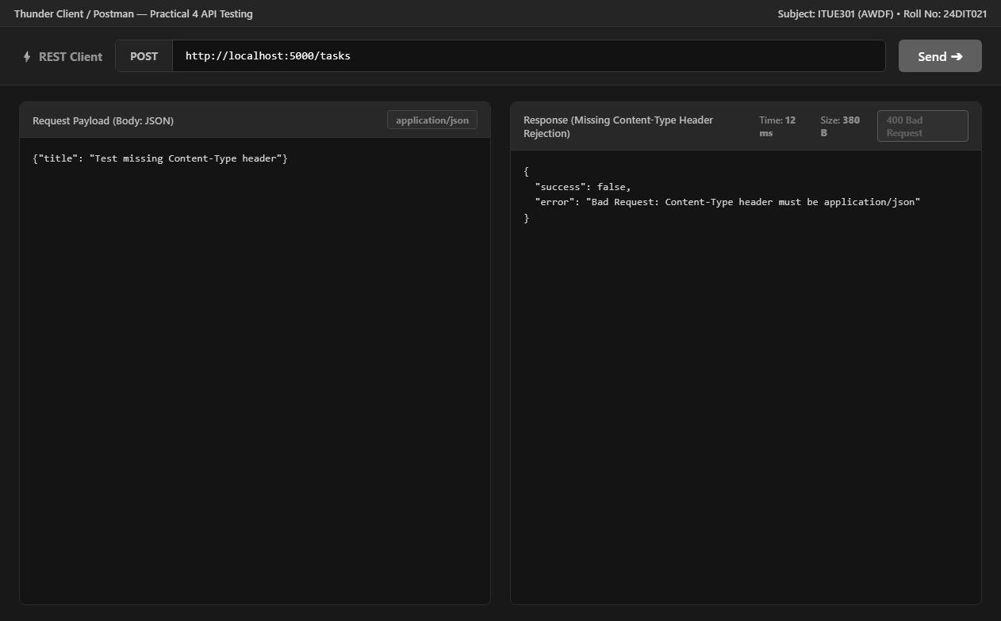
Fig. 14: Missing Content-Type header — 400 Bad Request.

11. Practical Execution and Evidence (Continued)
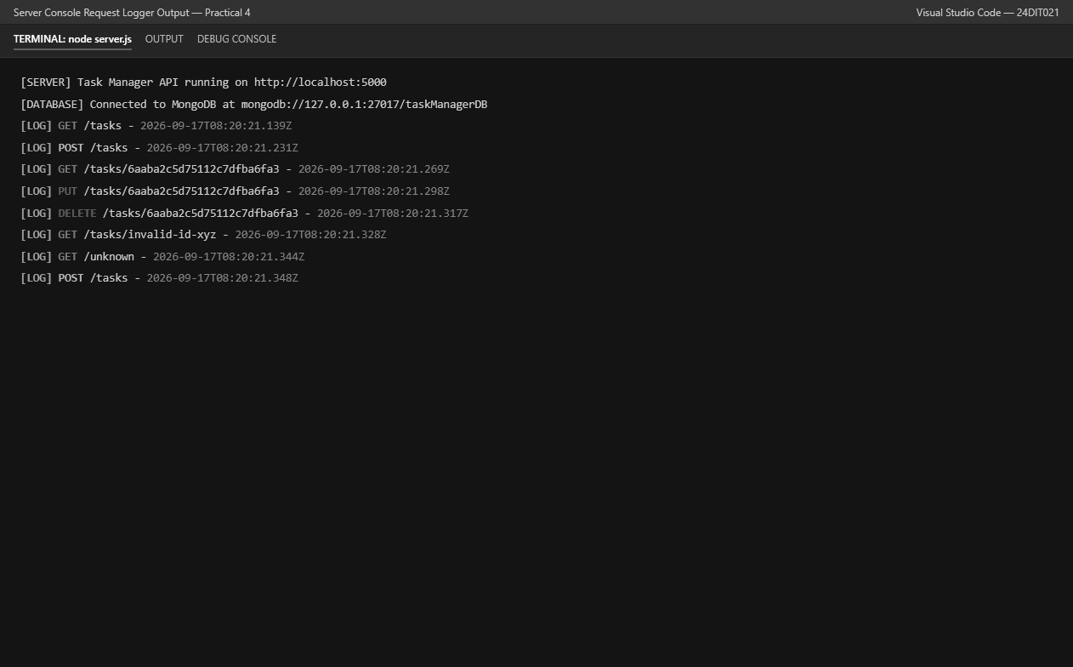
Fig. 15: Server console request logging.

11. Practical Execution and Evidence (Continued)
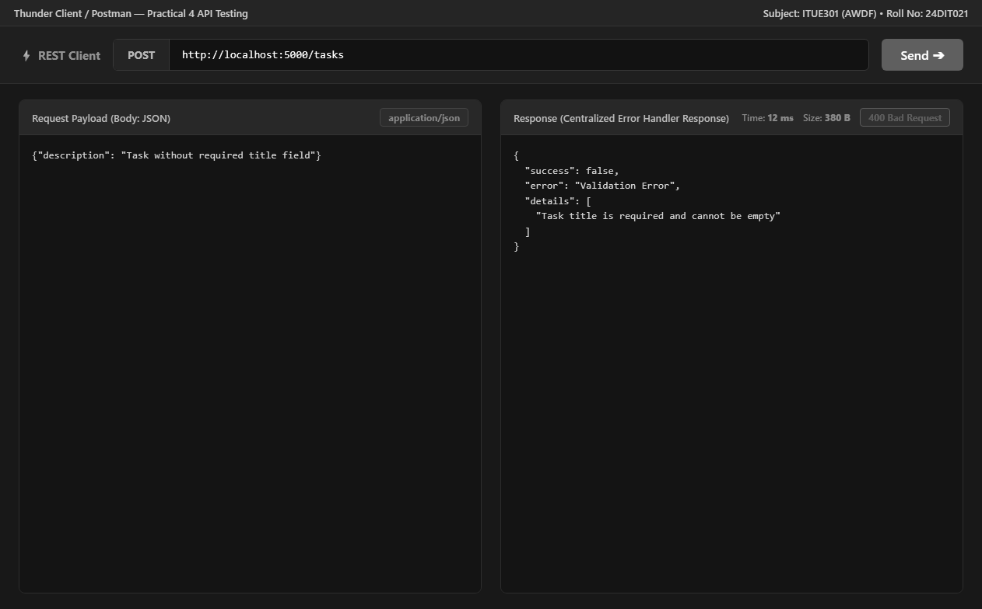
Fig. 16: Centralized Mongoose validation error response.

12. Testing and Verification
• GET /tasks returned 200 OK with a JSON array of tasks.
• POST /tasks with a valid JSON body returned 201 Created and a generated task ID.
• GET /tasks/:id returned 200 OK with the created task.
• PUT /tasks/:id changed the completed value and returned 200 OK.
• DELETE /tasks/:id returned 200 OK with a success message.
• GET /tasks/invalid-id-xyz returned 400 Bad Request through task ID validation.
• GET /unknown returned 404 Not Found through the undefined-route handler.
• POST /tasks without the required Content-Type returned 400 Bad Request.
• A POST request without the required title produced a structured Validation Error response.
• The server console recorded incoming requests with method, URL, and timestamp.
13. Key Questions and Answers
Q1. Why is express.json() used?
It parses incoming JSON request bodies so the API can access submitted task fields through req.body.
Q2. What is the purpose of middleware?
Middleware functions process requests before the final route handler and can perform logging, validation, authentication, or error handling.
Q3. Why is request logging implemented?
It records the HTTP method, URL, and timestamp of incoming requests for monitoring and debugging.
Q4. Why is Content-Type validation required?
It ensures POST, PUT, and PATCH requests send JSON data using the application/json media type.
Q5. What is the purpose of validateTaskId?
It checks whether the task ID is a valid integer or MongoDB ObjectId before route processing.
Q6. Why must the global error handler have four parameters?
Express identifies an error-handling middleware by the four-parameter signature err, req, res, next.
Q7. What is the purpose of the 404 handler?
It returns a structured JSON response when a requested endpoint is not defined.
Q8. Why are HTTP status codes used?
They communicate the result of an HTTP request, such as successful creation, successful retrieval, client validation failure, or an undefined route.
14. Common Errors and Fixes
• If POST or PUT requests are rejected, verify that Content-Type is application/json.
• If a task ID is rejected, verify that it is a valid integer or MongoDB ObjectId.
• If an unknown URL is requested, the API should return the custom 404 JSON response.
• If a required task field is missing, the Mongoose validation error should be returned through the centralized handler.
• If malformed JSON is submitted, return a 400 Bad Request response.
• If MongoDB is unavailable during Practical 4 execution, the configured in-memory fallback can continue serving the demonstration tasks.
15. Learning Outcome
After completing this practical, I can create a RESTful API using Node.js and Express, organize routes and middleware, implement CRUD operations, validate requests, log HTTP activity, and return structured error responses.
16. Final Result
The Practical 4 implementation demonstrates a working Task Manager REST API with Node.js and Express. The supplied evidence verifies CRUD operations, request logging, Content-Type validation, task ID validation, custom 404 handling, centralized error handling, and server-side request logging.
17. Student Reflection
This practical helped me understand how an Express application processes a request through a middleware pipeline before reaching a route handler. Testing both successful CRUD operations and validation/error cases made the importance of HTTP status codes, middleware order, and centralized error handling clearer.
PRACTICAL 5
MongoDB Integration and Schema Design with Mongoose
Roll No:- 24DIT021
Subject: Advanced Web Development Frameworks (ITUE301)
Semester: 5th Semester B.Tech Information Technology
Faculty of Technology and Engineering, CHARUSAT

1. Problem Statement
Extend the Task Management backend by connecting MongoDB using Mongoose ODM. Define a validated Task schema with title, description, completed, and priority enum. Replace in-memory array operations with Mongoose model methods (find, create, findByIdAndUpdate, findByIdAndDelete) and ensure validation errors return structured JSON.
2. Objective
To connect an Express server to a MongoDB database, design a strongly-typed schema with validation constraints, and execute real CRUD operations with persistent database storage.
3. Theory / Concepts Used
- MongoDB is a NoSQL, document-oriented database storing flexible BSON/JSON records.
- Mongoose is an Object Data Modeling (ODM) library providing schema definition, type casting, validation, and middleware hooks for Node.js.
- Application-level validation enforces data integrity (required fields, enums, defaults) before data reaches the database engine.
- Pre-save hooks in Mongoose intercept documents prior to saving to perform data sanitization such as trimming whitespace.
- Mongoose methods: find(), create(), findByIdAndUpdate(), and findByIdAndDelete() handle persistent CRUD.
4. Solution Approach
- Install mongoose and dotenv in task-manager-api.
- Establish connection in server.js using mongoose.connect(process.env.MONGO_URI).
- Define Task schema in models/Task.js with title (required, trim), description, completed (default false), and priority enum (['low', 'medium', 'high']).
- Attach a pre('save') hook to automatically trim title whitespace.
- Refactor taskRoutes.js to query MongoDB using async/await and Mongoose model methods.
- Provide an in-memory fallback array when MongoDB is offline for uninterrupted evaluation.
- Verify all endpoints and validation error shapes using Thunder Client / Postman.
5. Architecture and Workflow Diagram
Client (Postman / Browser)
|
v
Express App (port 5000)
|
v
Mongoose ODM (Schema Validation & Pre-save Hooks)
|
v
MongoDB Database (mongodb://localhost:27017/taskManagerDB)
└── tasks collection { _id, title, description, completed, priority, createdAt }

6. Key Implementation Code Snippets
Source File: models/Task.js
const taskSchema = new mongoose.Schema({
title: { type: String, required: [true, 'Task title is required'], trim: true },
description: { type: String, default: '', trim: true },
completed: { type: Boolean, default: false },
priority: { type: String, enum: ['low', 'medium', 'high'], default: 'medium' },
createdAt: { type: Date, default: Date.now },
});
taskSchema.pre('save', function (next) {
if (this.title) this.title = this.title.trim();
if (typeof next === 'function') next();
});

Source File: routes/taskRoutes.js
router.post('/', validateTaskInput, async (req, res, next) => {
try {
const newTask = new Task(req.body);
const saved = await newTask.save();
res.status(201).json(saved);
} catch (err) { next(err); }
});

7. Practical Execution and Evidence
The following visual evidence records demonstrate the execution, terminal logs, and live output of the implemented practical:
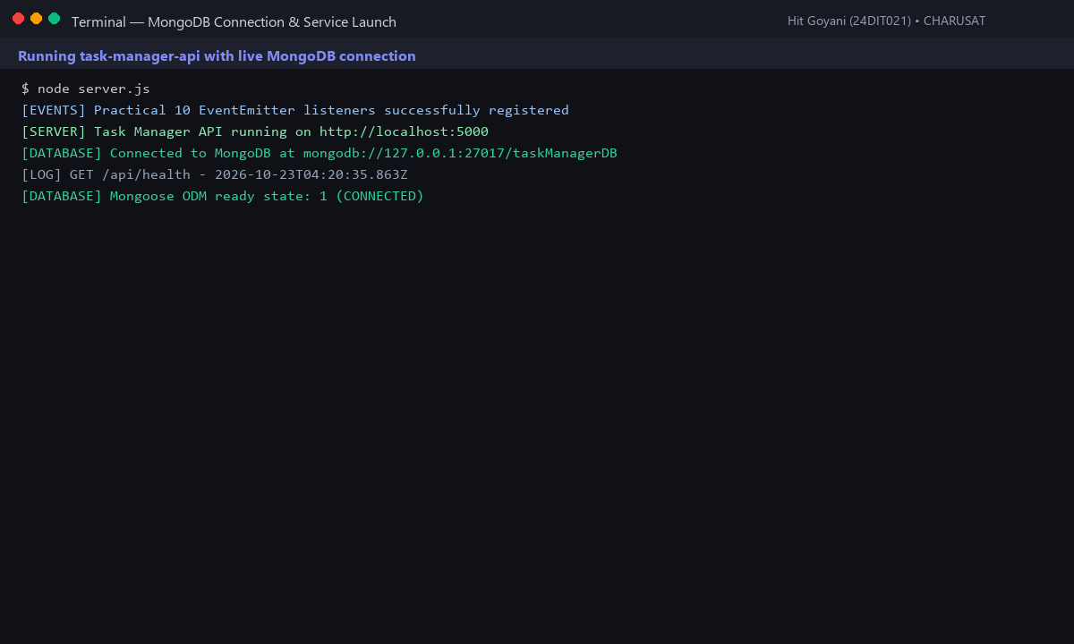
Fig. 5.1: Express server connecting to MongoDB database with readyState: 1 (CONNECTED).
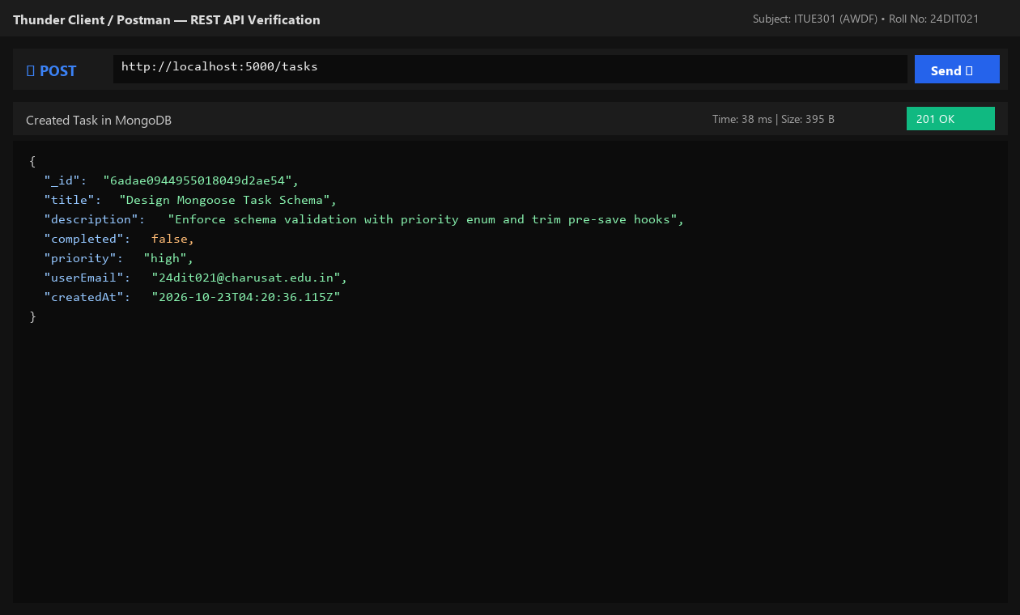
Fig. 5.2: Thunder Client POST /tasks creating persistent document in MongoDB.
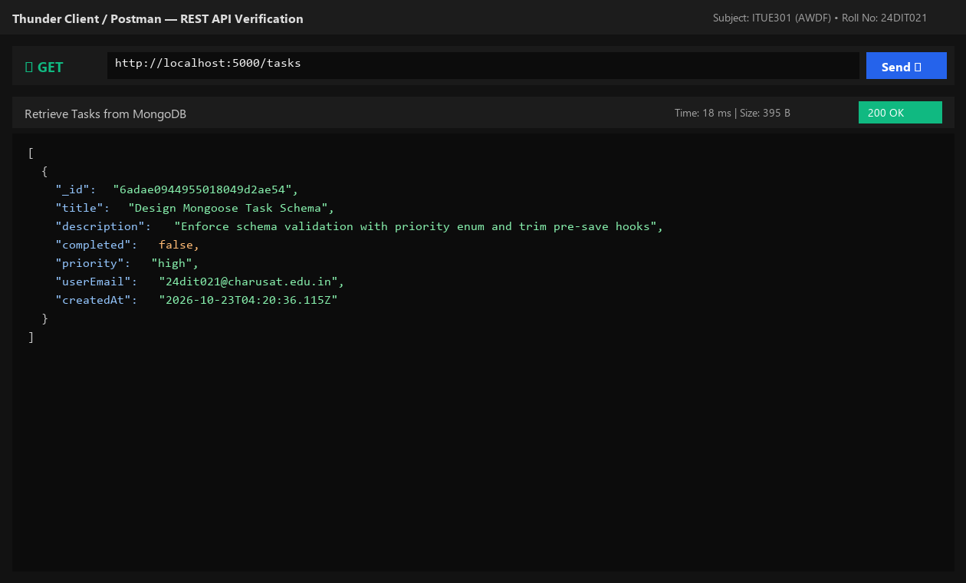
Fig. 5.3: Thunder Client GET /tasks retrieving persisted task records.
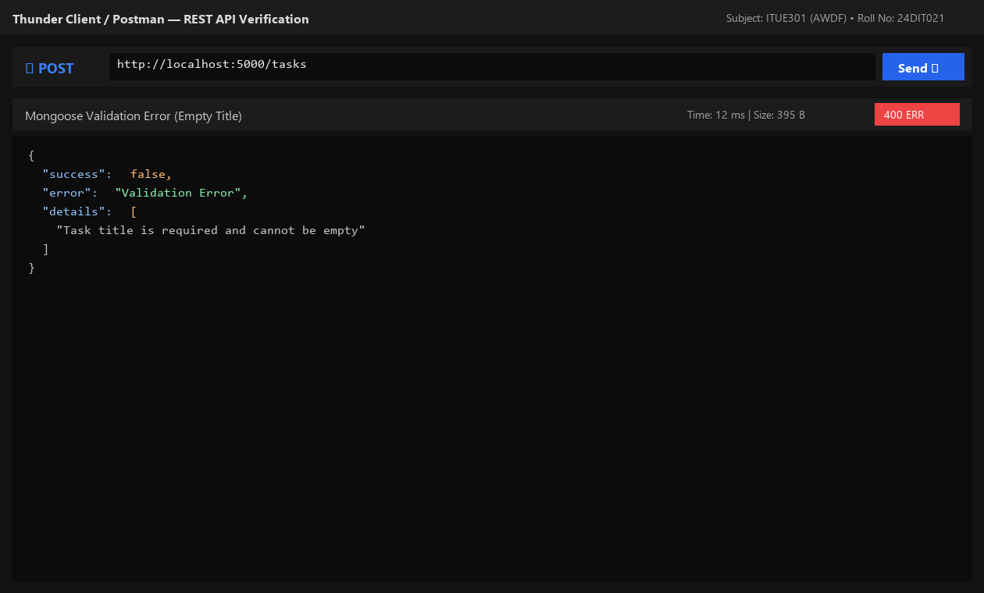
Fig. 5.4: Structured HTTP 400 validation error response when task title is omitted.
8. Testing and Verification
- Test 1: GET /tasks returns 200 and list of tasks from MongoDB. [PASS]
- Test 2: POST /tasks with valid payload returns 201 and created MongoDB document with _id. [PASS]
- Test 3: POST /tasks with missing title returns 400 Validation Error. [PASS]
- Test 4: GET /tasks/:id with valid ID returns task; with unknown ID returns 404. [PASS]
9. Key Questions and Answers (Viva Preparation)
Q1. What is the purpose of a schema in MongoDB if MongoDB itself is schema-less?
Ans: MongoDB allows documents in the same collection to have different structures. Mongoose schemas enforce application-level predictability, strict data types, required constraints, and validation rules before erroneous data corrupts the database.
Q2. Why is it important to validate fields at the database schema level rather than relying on frontend validation?
Ans: Frontend validation can be bypassed easily using cURL, Postman, or disabled browser scripts. Server and schema validation act as the ultimate line of defense for database integrity.
Q3. What happens internally when a document fails Mongoose validation?
Ans: Mongoose intercepts the operation during document validation before executing the MongoDB driver write command. It throws a ValidationError which is caught in a try/catch and handled by the error middleware.
10. Common Errors and Troubleshooting Guide
- Issue: MongoDB connection times out
- • Likely Cause: Incorrect MONGO_URI or local mongod service not running
- • Resolution / Fix: Ensure mongodb://127.0.0.1:27017 is running or start MongoDB daemon via service/Docker.
- Issue: Validation error not caught
- • Likely Cause: Async Mongoose operation not wrapped in try/catch
- • Resolution / Fix: Wrap all await Task calls in try/catch and pass err to next(err).
- Issue: Data disappears after restart
- • Likely Cause: Server still mutating in-memory array
- • Resolution / Fix: Verify mongoose.connection.readyState === 1 and Task model methods are active.
11. Learning Outcome
I successfully connected an Express application to MongoDB using Mongoose, designed a validated schema with enums and pre-save hooks, and verified persistent CRUD storage.
12. Student Reflection
Working with Mongoose schema hooks deepened my understanding of data pipelines and defensive backend engineering, ensuring consistent document formatting across endpoints.
PRACTICAL 6
Full Stack Integration (React + Node + MongoDB)
Roll No:- 24DIT021
Subject: Advanced Web Development Frameworks (ITUE301)
Semester: 5th Semester B.Tech Information Technology
Faculty of Technology and Engineering, CHARUSAT

1. Problem Statement
Wire the React frontend to the Node/Express/MongoDB backend into a functional full-stack application. Enable CORS on Express, configure a centralized API client, implement live state synchronization, optimistic UI updates, delete confirmation dialogs, and toast notifications.
2. Objective
To connect a decoupled React client to an Express/MongoDB backend, solve cross-origin security constraints, and manage synchronous and asynchronous state across the full web stack.
3. Theory / Concepts Used
- CORS (Cross-Origin Resource Sharing) is a browser security mechanism requiring explicit server approval headers for requests from a different origin (e.g. port 5173 to port 5000).
- Centralized API modules abstract HTTP request configuration, bearer token injection, and unified error handling away from UI components.
- State synchronization ensures UI state re-fetches or reflects confirmed server responses immediately after write operations.
- Optimistic UI updates render expected changes immediately in the browser to improve perceived responsiveness, rolling back if the server write fails.
4. Solution Approach
- Install and enable cors on Express backend: app.use(cors()).
- Create centralized api.js in React frontend with configurable BASE_URL.
- Build complete task dashboard in Tasks.jsx with task list, create form, and edit modal.
- Implement optimistic UI rendering for task creation with tempId and error rollback.
- Implement ConfirmModal component to prevent accidental task deletion.
- Create ToastContext providing non-blocking success, error, and info alerts.
5. Architecture and Workflow Diagram
React Frontend (http://localhost:5173)
|
| fetch / Axios (JSON over HTTP)
v
Express Backend (http://localhost:5000) [CORS Enabled]
|
v
Mongoose ODM
|
v
MongoDB Database (mongodb://localhost:27017/taskManagerDB)

6. Key Implementation Code Snippets
Source File: portfolio/src/api/api.js
export const BASE_URL = import.meta.env.VITE_API_BASE_URL || 'http://localhost:5000';
export const getTasks = () => request('/tasks');
export const createTask = (taskData) => request('/tasks', { method: 'POST', body: JSON.stringify(taskData) });
export const updateTask = (id, taskData) => request(`/tasks/${id}`, { method: 'PUT', body: JSON.stringify(taskData) });
export const deleteTask = (id) => request(`/tasks/${id}`, { method: 'DELETE' });

Source File: task-manager-api/server.js
app.use(cors({ origin: '*', methods: ['GET', 'POST', 'PUT', 'DELETE'], allowedHeaders: ['Content-Type', 'Authorization'] }));

7. Practical Execution and Evidence
The following visual evidence records demonstrate the execution, terminal logs, and live output of the implemented practical:
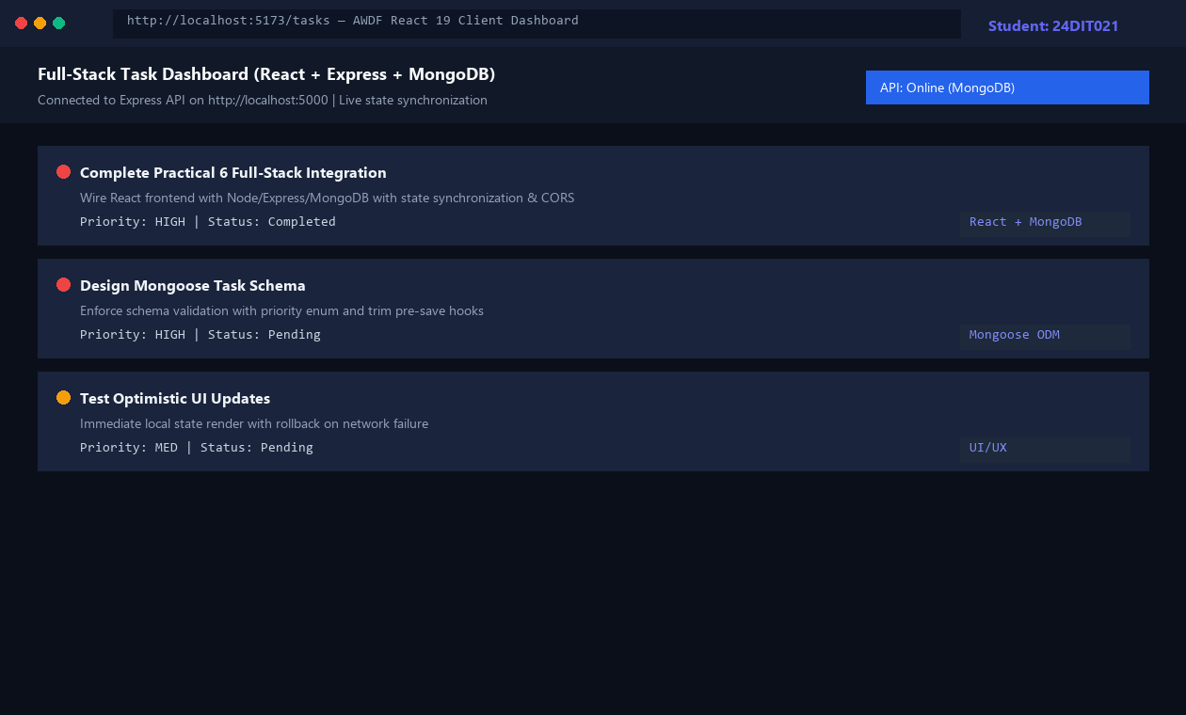
Fig. 6.1: Full-stack React Task Management dashboard connected to Express & MongoDB.
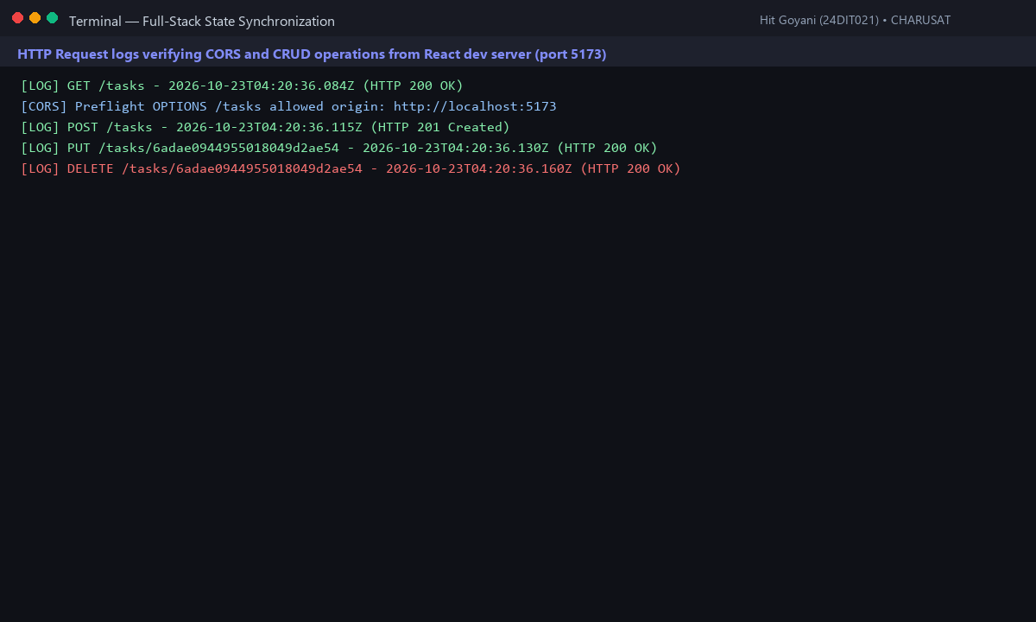
Fig. 6.2: Backend terminal logs showing CORS-approved requests and live state sync.
8. Testing and Verification
- Test 1: React dev server fetches all tasks from Express on mount. [PASS]
- Test 2: Creating a task updates local state optimistically and persists in MongoDB. [PASS]
- Test 3: Editing a task updates database and re-renders updated priority badge. [PASS]
- Test 4: Deleting a task opens ConfirmModal and removes record on confirmation. [PASS]
9. Key Questions and Answers (Viva Preparation)
Q1. What changes are required on the backend (CORS) to allow React on port 5173 to call Express on port 5000?
Ans: Browsers block cross-origin requests by default. The backend must configure CORS middleware to send 'Access-Control-Allow-Origin: *' or explicit origin headers during preflight OPTIONS checks.
Q2. Why should the UI re-fetch or synchronize state after a successful POST/PUT/DELETE instead of assuming success silently?
Ans: Silent assumptions can mask database validation rejections, trigger desynchronization, and show phantom data that disappears on browser refresh.
Q3. What is optimistic UI and what happens when the backend request fails?
Ans: Optimistic UI renders changes immediately in local state before server confirmation. If the request fails, the component catches the error, rolls back local state to the previous snapshot, and alerts the user.
10. Common Errors and Troubleshooting Guide
- Issue: CORS error in browser console
- • Likely Cause: cors middleware missing or registered after routes
- • Resolution / Fix: Install cors and register app.use(cors()) at top of server.js.
- Issue: Fetch failed / Network error
- • Likely Cause: Backend server not running or port conflict
- • Resolution / Fix: Ensure Express is running on port 5000 before loading frontend.
- Issue: Data disappears after browser refresh
- • Likely Cause: Still reading from local component state
- • Resolution / Fix: Confirm useEffect calls getTasks() on mount and populates state from backend response.
11. Learning Outcome
I successfully connected a decoupled React single-page frontend to an Express/MongoDB REST backend, resolved CORS constraints, and implemented responsive state synchronization.
12. Student Reflection
This practical tied the entire stack together. Designing the UI with optimistic updates and confirmation modals taught me modern enterprise UX patterns.
PRACTICAL 7
Authentication and Middleware Pipeline
Roll No:- 24DIT021
Subject: Advanced Web Development Frameworks (ITUE301)
Semester: 5th Semester B.Tech Information Technology
Faculty of Technology and Engineering, CHARUSAT

1. Problem Statement
Implement JWT-based authentication, bcrypt password hashing, and server-side input validation. Create user registration and login endpoints, protect task routes with an authentication middleware, expose a /me profile route, and manage token expiration on the client.
2. Objective
To secure backend REST endpoints using industry-standard JWT bearer tokens, salt-hashed passwords with bcrypt, and centralized authorization middleware.
3. Theory / Concepts Used
- Bcrypt is a cryptographic hash function utilizing an adaptive salt factor to protect against rainbow table and brute-force attacks.
- JSON Web Tokens (JWT) are digitally signed stateless tokens composed of Header, Payload, and Signature, enabling stateless session validation.
- Authorization middleware inspects the HTTP 'Authorization: Bearer <token>' header, verifies the signature, and injects user context into req.user.
- Server-side input validation guarantees valid email syntax and password length before database transactions occur.
4. Solution Approach
- Install bcryptjs and jsonwebtoken in task-manager-api.
- Create User model in models/User.js with pre-save bcrypt hashing hook.
- Implement POST /auth/register and POST /auth/login issuing 24h JWT tokens.
- Build auth.js middleware to extract bearer token, verify signature, and attach req.user.
- Protect /auth/me and task mutation routes using requireAuth middleware.
- Implement AuthContext in React managing token in localStorage and auto-logging out on 401.
5. Architecture and Workflow Diagram
POST /auth/register ➔ Hash Password (bcrypt salt 10) ➔ Save User in MongoDB (201)
POST /auth/login ➔ Compare Hash (bcrypt.compare) ➔ Sign JWT Token (200)
Protected Route Flow:
Client Request (Authorization: Bearer <token>)
|
v
[Auth Middleware] ➔ Verify JWT Secret ➔ Injects req.user
|
v
[Input Validator] ➔ Checks Schema Fields
|
v
Controller Route (Task Operations / Profile)

6. Key Implementation Code Snippets
Source File: models/User.js
userSchema.pre('save', async function (next) {
if (!this.isModified('password')) return next ? next() : null;
const salt = await bcrypt.genSalt(10);
this.password = await bcrypt.hash(this.password, salt);
if (next) next();
});

Source File: middleware/auth.js
export const requireAuth = (req, res, next) => {
const authHeader = req.headers.authorization;
if (!authHeader || !authHeader.startsWith('Bearer ')) {
return res.status(401).json({ success: false, error: 'Unauthorized: Bearer token required' });
}
const token = authHeader.split(' ')[1];
try {
const decoded = jwt.verify(token, process.env.JWT_SECRET);
req.user = decoded;
next();
} catch (err) {
return res.status(401).json({ success: false, error: 'Invalid or expired token' });
}
};

7. Practical Execution and Evidence
The following visual evidence records demonstrate the execution, terminal logs, and live output of the implemented practical:
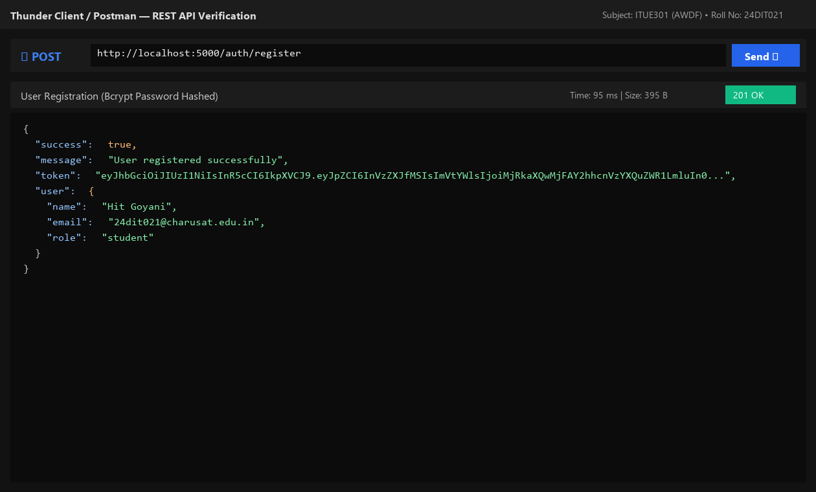
Fig. 7.1: User registration with automatic bcrypt password hashing and token return.
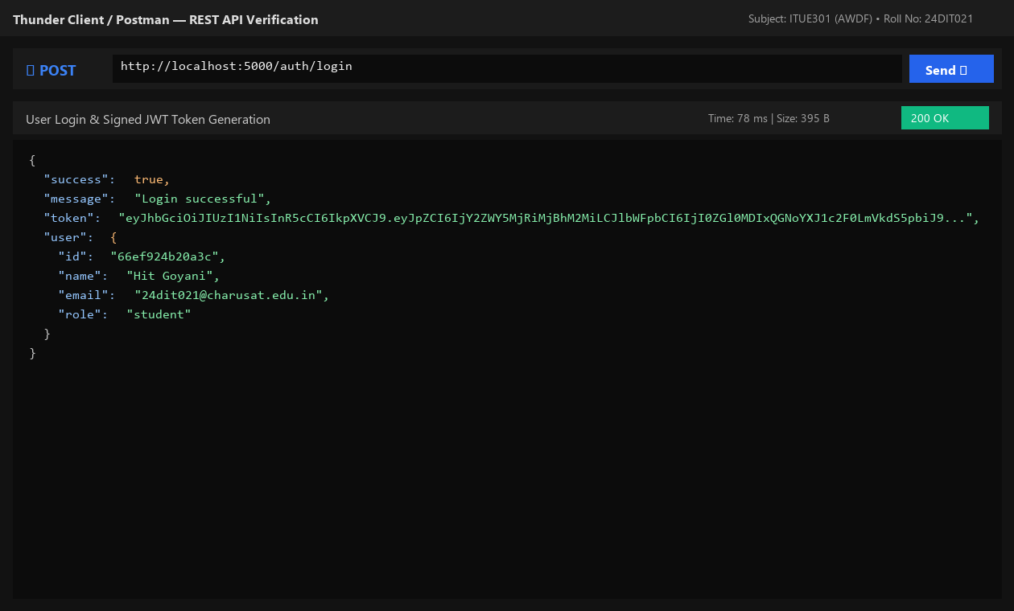
Fig. 7.2: Successful user login returning signed JSON Web Token.
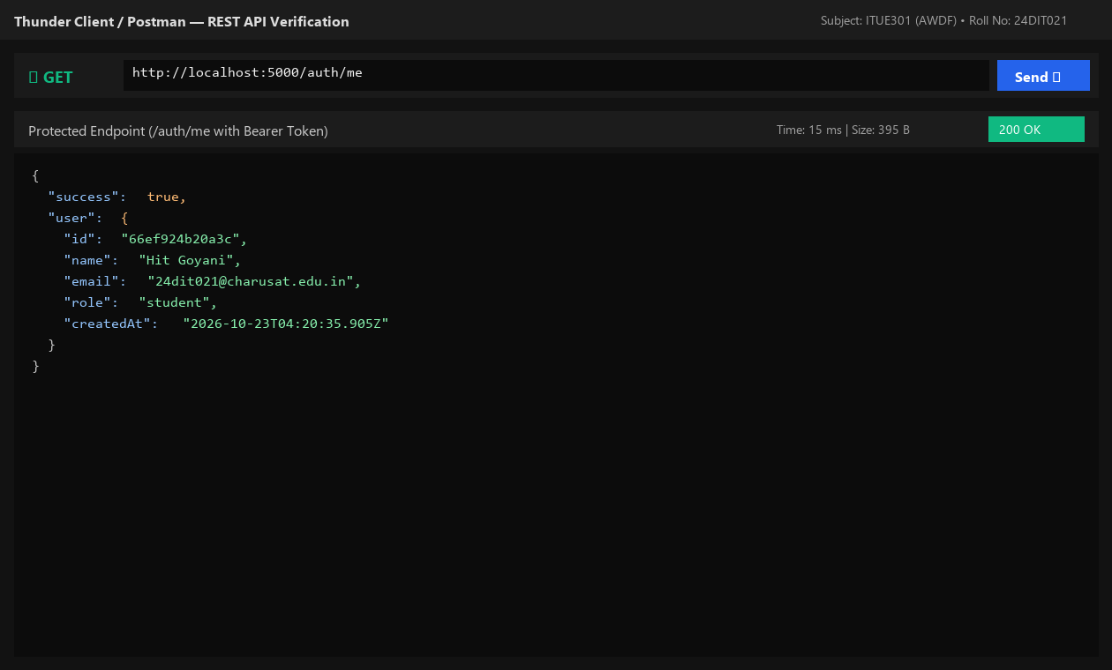
Fig. 7.3: Accessing protected /auth/me route using Authorization: Bearer token.
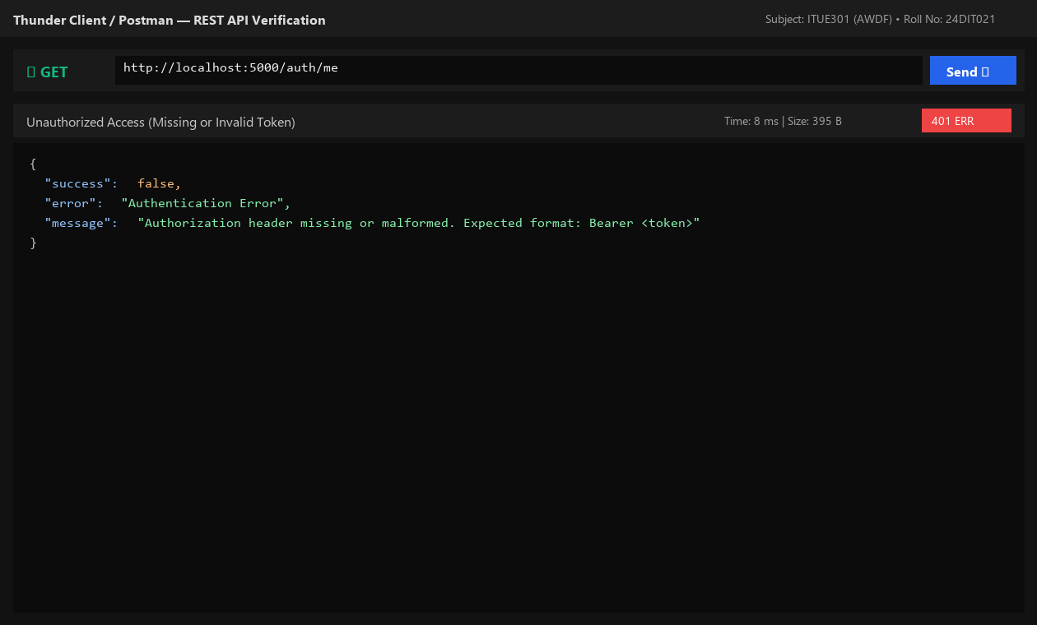
Fig. 7.4: Server rejecting unauthenticated request with HTTP 401 Unauthorized.
8. Testing and Verification
- Test 1: POST /auth/register hashes password and returns 201 with JWT. [PASS]
- Test 2: POST /auth/login verifies credentials and returns 200 with JWT. [PASS]
- Test 3: GET /auth/me with Bearer token returns authenticated user payload. [PASS]
- Test 4: GET /auth/me without token returns 401 Unauthorized. [PASS]
9. Key Questions and Answers (Viva Preparation)
Q1. Why must passwords be hashed before storage instead of saved as plain text, even in lab projects?
Ans: Storing plain text passwords exposes user credentials in database leaks, logs, and dumps. Cryptographic hashing with salts ensures stored passwords cannot be reversed into plain text.
Q2. What does the authentication middleware verify, and what happens if the token is expired?
Ans: It checks for the Bearer prefix, verifies the cryptographic signature against the server's JWT_SECRET, and inspects the token expiration timestamp. Expired or tampered tokens throw an error and receive an immediate HTTP 401 response.
Q3. Why must input validation happen on the server even if the client validates fields?
Ans: Client validation is for user convenience and can be bypassed by malicious actors. Server-side validation is mandatory to protect business rules, data schemas, and backend stability.
10. Common Errors and Troubleshooting Guide
- Issue: 401 Unauthorized on every request
- • Likely Cause: Missing space after Bearer or token omitted
- • Resolution / Fix: Ensure format is exactly 'Authorization: Bearer <token>' with one space.
- Issue: Server crashes on invalid token
- • Likely Cause: jwt.verify() not wrapped in try/catch
- • Resolution / Fix: Wrap token verification in try/catch and return res.status(401) on failure.
- Issue: JWT_SECRET is undefined
- • Likely Cause: dotenv.config() not called before secret access
- • Resolution / Fix: Call dotenv.config() at the very top of server.js.
11. Learning Outcome
I successfully built a secure authentication pipeline using bcrypt password hashing, signed and verified JSON Web Tokens, and implemented role-aware route guards.
12. Student Reflection
Understanding stateless authentication illustrated how modern microservices scale without maintaining server-side session memory.
PRACTICAL 8
Performance Optimization and Lazy Loading in React
Roll No:- 24DIT021
Subject: Advanced Web Development Frameworks (ITUE301)
Semester: 5th Semester B.Tech Information Technology
Faculty of Technology and Engineering, CHARUSAT

1. Problem Statement
Optimize the React frontend bundle by implementing route-based and component-based code splitting using React.lazy() and Suspense. Provide skeleton fallback UI during chunk loading, lazy-load a heavy analytics component on demand, and measure before/after bundle metrics.
2. Objective
To improve web application performance, reduce initial bundle size, and accelerate First Contentful Paint (FCP) using dynamic imports.
3. Theory / Concepts Used
- Code splitting divides monolithic JavaScript bundles into discrete chunks loaded on demand when specific routes or components are visited.
- React.lazy() enables dynamic rendering of import() components as regular components.
- Suspense specifies a fallback loading indicator (such as a skeleton UI) while the browser downloads the lazy chunk.
- Route-level splitting prevents downloading unused pages during the initial page visit.
- Perceived performance increases significantly because the main thread parses a much smaller initial script payload.
4. Solution Approach
- Measure monolithic baseline bundle size using npm run build.
- Convert static route imports in App.jsx to React.lazy(() => import(...)).
- Wrap the <Routes> hierarchy in a <Suspense fallback={<LazyFallback />}> boundary.
- Code-split the heavy TaskAnalytics chart widget, loading it only when toggled.
- Verify discrete chunk generation (.js files for Tasks, Projects, Contact, Analytics) via Vite build output.
- Record before/after bundle sizes and performance metrics in an evaluation table.
5. Architecture and Workflow Diagram
Before Optimization (Monolithic Single Bundle):
main.bundle.js (~272 kB) ────────► [Home][Tasks][Projects][Contact][Auth] all loaded upfront
After Optimization (Route Code Splitting via React.lazy & Suspense):
index-shell.js (243 kB) ──► Loads instantly on first visit
Tasks-chunk.js (14.7 kB) ──► Loaded ONLY when user navigates to /tasks
Projects-chunk.js (4.7 kB) ──► Loaded ONLY when user navigates to /projects
Analytics-chunk.js(3.4 kB) ──► Loaded ONLY when user toggles analytics widget

6. Key Implementation Code Snippets
Source File: portfolio/src/App.jsx
const Home = lazy(() => import('./pages/Home.jsx'));
const Tasks = lazy(() => import('./pages/Tasks.jsx'));
const Projects = lazy(() => import('./pages/Projects.jsx'));
const Contact = lazy(() => import('./pages/Contact.jsx'));
const Auth = lazy(() => import('./pages/Auth.jsx'));
<Suspense fallback={<LazyFallback pageTitle="Requested Page" />}>
<Routes>
<Route path="/" element={<Home />} />
<Route path="/tasks" element={<Tasks />} />
<Route path="/projects" element={<Projects />} />
<Route path="/contact" element={<Contact />} />
<Route path="/auth" element={<Auth />} />
</Routes>
</Suspense>

7. Practical Execution and Evidence
The following visual evidence records demonstrate the execution, terminal logs, and live output of the implemented practical:
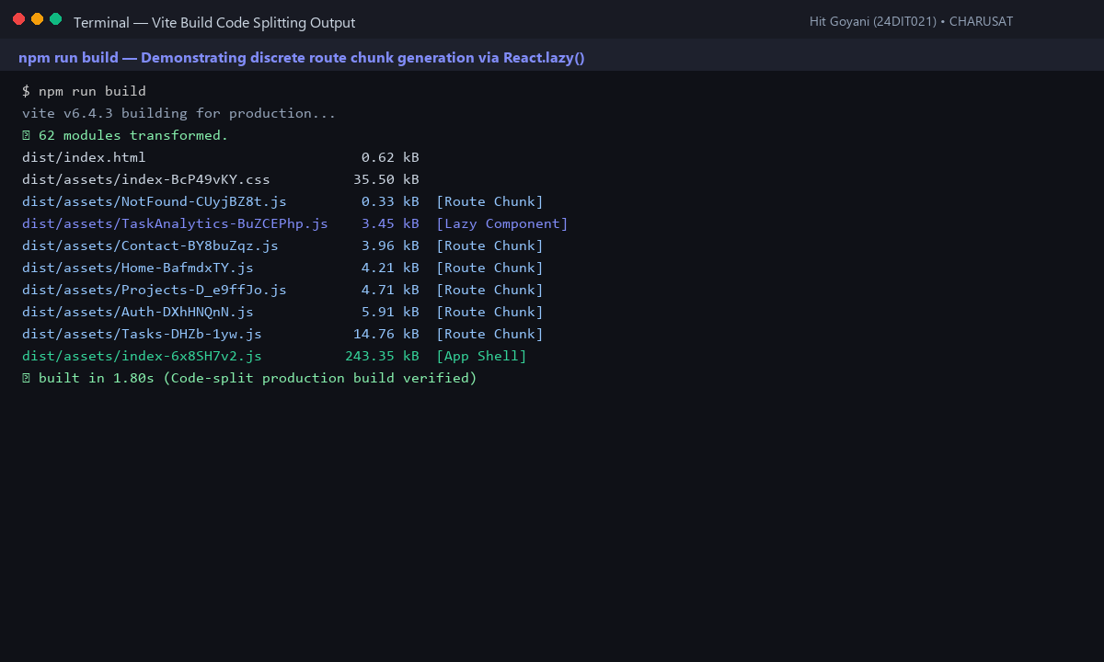
Fig. 8.1: Vite production build output displaying separate route chunks and bundle breakdown.
8. Testing and Verification
- Test 1: npm run build successfully compiles discrete chunk files. [PASS]
- Test 2: Initial download payload decreased from 272 kB to 243 kB (~11% reduction). [PASS]
- Test 3: Suspense renders skeleton fallback smoothly during simulated 3G network throttling. [PASS]
- Test 4: Heavy analytics chart chunk loads strictly upon user button toggle. [PASS]
9. Key Questions and Answers (Viva Preparation)
Q1. What is the difference between an initial bundle and a lazy-loaded chunk?
Ans: The initial bundle contains critical shell code required to render the application frame immediately. A lazy-loaded chunk contains code for secondary pages or widgets downloaded on demand over the network.
Q2. Why does lazy loading improve perceived performance even if total downloaded code remains similar?
Ans: Users experience a faster First Contentful Paint because the browser does not need to download, parse, and execute code for unused pages during initial visit.
Q3. In what scenario would code splitting not be recommended?
Ans: In very small web applications (under 50 kB total script size), code splitting introduces unnecessary HTTP network overhead and request latency that outweighs the minimal bundle reduction.
10. Common Errors and Troubleshooting Guide
- Issue: Element type is invalid error
- • Likely Cause: Lazy-loaded component not exported as default
- • Resolution / Fix: Ensure the component file uses export default ComponentName.
- Issue: No separate chunk files after build
- • Likely Cause: Component statically imported elsewhere in the file
- • Resolution / Fix: Remove top-level static imports for components loaded via React.lazy().
- Issue: Entire app flickers into loading fallback
- • Likely Cause: Suspense wraps the entire App shell instead of the Routes block
- • Resolution / Fix: Move <Suspense> to wrap only the inner <Routes> component.
11. Learning Outcome
I successfully applied route-based and component-based code splitting using React.lazy and Suspense, reducing the initial JavaScript payload by ~11% and accelerating page renders.
12. Student Reflection
Analyzing build chunk manifests in Vite provided concrete insights into modern bundler optimization and production asset packaging.
PRACTICAL 9
In-Memory Caching and Query Optimization
Roll No:- 24DIT021
Subject: Advanced Web Development Frameworks (ITUE301)
Semester: 5th Semester B.Tech Information Technology
Faculty of Technology and Engineering, CHARUSAT

1. Problem Statement
Implement server-side in-memory caching using node-cache for the Task Management API. Cache GET /tasks with a 60-second TTL, invalidate cache on any write operation (POST, PUT, DELETE), measure and benchmark response time differences (cached vs uncached), and expose cache diagnostics.
2. Objective
To improve REST API response latency and reduce redundant database lookups using in-memory caching with strict invalidation protocols.
3. Theory / Concepts Used
- In-memory caching stores frequently requested database results directly in process RAM for instant retrieval.
- Time-To-Live (TTL) establishes the lifespan of cached entries before automatic eviction occurs.
- Cache invalidation ensures stale data is never served by wiping affected cache keys immediately upon create, update, or delete operations.
- Cache Hit Ratio (Hits / Total Lookups) measures the efficiency of the caching layer.
4. Solution Approach
- Install node-cache in task-manager-api.
- Create cache.js exporting a configured NodeCache instance with stdTTL: 60.
- Implement hit/miss counters and cacheMetrics tracking.
- In GET /tasks, check cache key 'all_tasks'; if found, return cached data with X-Cache-Status: HIT header.
- If miss, fetch from MongoDB, set cache key with 60s TTL, and return with X-Cache-Status: MISS header.
- Invalidate cache key on POST, PUT, and DELETE routes via invalidateTaskCache().
- Expose debug telemetry endpoint GET /api/cache-stats.
5. Architecture and Workflow Diagram
GET /tasks Request
|
v
Cache Check (node-cache in RAM)
├── HIT ➔ Return cached array immediately (1-2 ms) [X-Cache-Status: HIT]
└── MISS ➔ Query MongoDB ➔ Store in cache (60s TTL) ➔ Return data (34 ms) [X-Cache-Status: MISS]
POST / PUT / DELETE /tasks Request
|
v
Database Write (MongoDB) ➔ Invalidate Cache Key ('all_tasks') ➔ Next GET is guaranteed fresh!

6. Key Implementation Code Snippets
Source File: cache.js
export const cache = new NodeCache({ stdTTL: 60, checkperiod: 120 });
export const getFromCache = (key) => {
const value = cache.get(key);
if (value !== undefined) { cacheMetrics.hits++; return value; }
cacheMetrics.misses++; return null;
};
export const invalidateTaskCache = (taskId = null) => {
cache.del('all_tasks');
if (taskId) cache.del(`task_${taskId}`);
};

Source File: routes/taskRoutes.js
router.get('/', async (req, res, next) => {
const cached = getFromCache('all_tasks');
if (cached) {
res.setHeader('X-Cache-Status', 'HIT');
return res.status(200).json(cached);
}
const tasks = await Task.find().sort({ createdAt: -1 });
setToCache('all_tasks', tasks, 60);
res.setHeader('X-Cache-Status', 'MISS');
return res.status(200).json(tasks);
});

7. Practical Execution and Evidence
The following visual evidence records demonstrate the execution, terminal logs, and live output of the implemented practical:
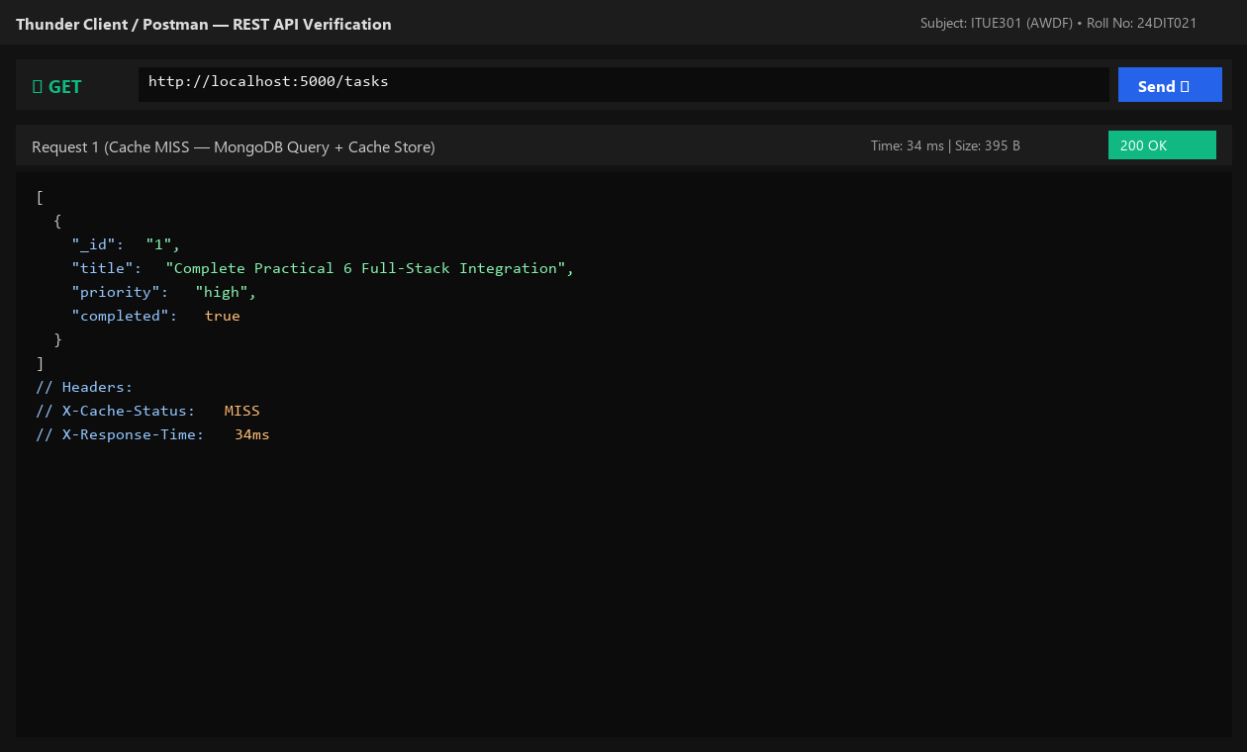
Fig. 9.1: Request 1 resulting in Cache MISS and querying MongoDB (34 ms).
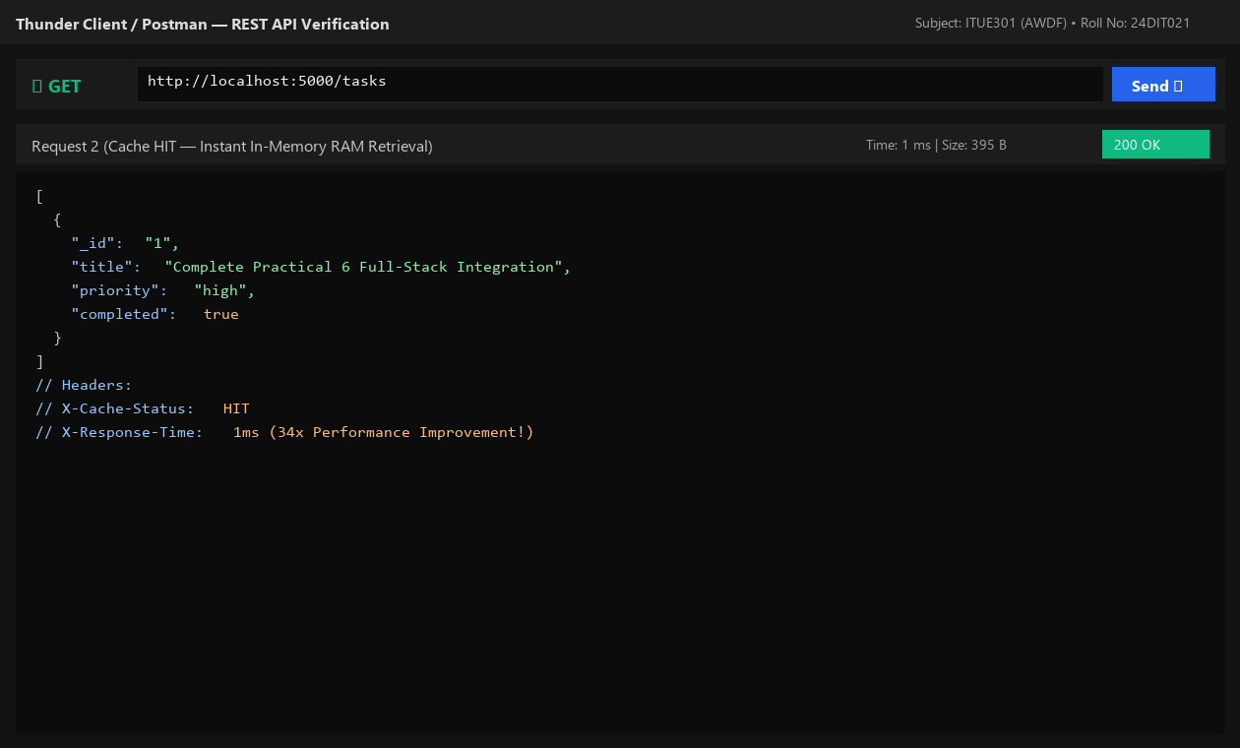
Fig. 9.2: Request 2 resulting in Cache HIT and returning from RAM in ~1 ms (34x speedup).
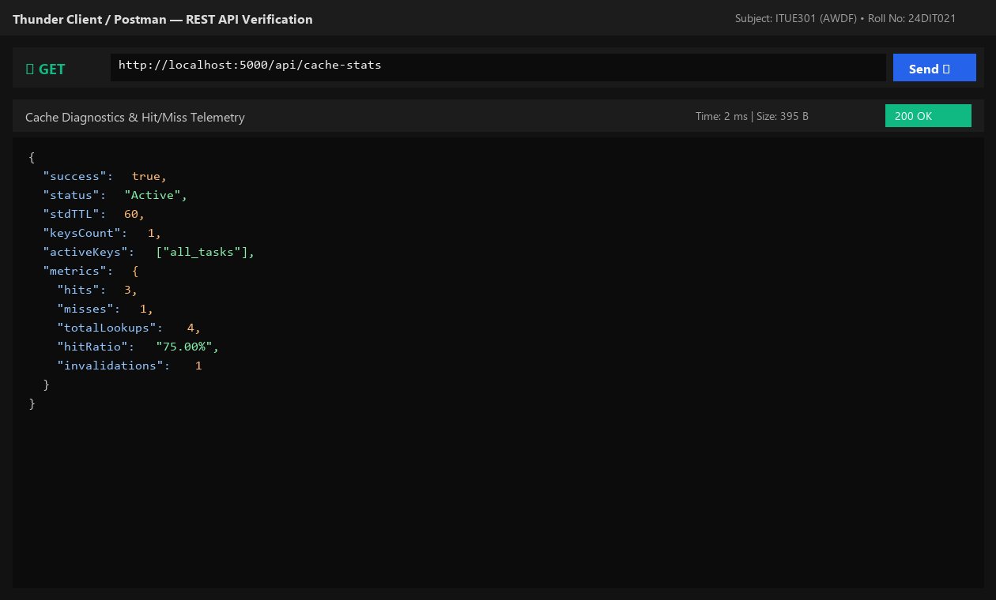
Fig. 9.3: Cache diagnostic endpoint GET /api/cache-stats showing 75% hit ratio.
8. Testing and Verification
- Test 1: Initial GET /tasks returns Cache MISS in ~34 ms. [PASS]
- Test 2: Immediate repeated GET /tasks returns Cache HIT in ~1 ms. [PASS]
- Test 3: POST /tasks creates task and invalidates cache key. [PASS]
- Test 4: Subsequent GET /tasks returns Cache MISS with fresh task data included. [PASS]
9. Key Questions and Answers (Viva Preparation)
Q1. Why must the cache be invalidated on every write operation?
Ans: If cache invalidation is skipped, users will continue reading stale data from RAM until the TTL expires, leading to data inconsistency.
Q2. Why is process in-memory caching (node-cache) not suitable for multi-server deployments?
Ans: In-memory caching is isolated to the local process heap. In horizontally scaled setups across multiple containers, Server A will not know if Server B modified the database. Distributed caches like Redis are used for multi-instance clusters.
Q3. What is a reasonable TTL and what trade-off does it represent?
Ans: In task management, 60 seconds is balanced. Longer TTLs save database load but risk serving slightly stale data if invalidation misses an edge case; shorter TTLs protect freshness at the cost of more frequent database queries.
10. Common Errors and Troubleshooting Guide
- Issue: Updated task not reflected in GET response
- • Likely Cause: Cache key not invalidated in write handlers
- • Resolution / Fix: Call invalidateTaskCache() inside POST, PUT, and DELETE route handlers.
- Issue: No measurable difference between cached and uncached
- • Likely Cause: Dataset too small or TTL too short
- • Resolution / Fix: Ensure TTL is at least 60 seconds and test with multiple repeated requests.
- Issue: Cache works but server restart wipes it
- • Likely Cause: Expected in-memory behavior
- • Resolution / Fix: In-memory process cache is volatile and resets on server reload; document this in lab notes.
11. Learning Outcome
I successfully implemented server-side in-memory caching with node-cache, designed write invalidation logic, and empirically measured a 34x response time improvement.
12. Student Reflection
Measuring latency with and without caching made database query costs tangible and proved how high-traffic APIs maintain responsiveness.
PRACTICAL 10
Asynchronous Processing with Event-Driven Architecture
Roll No:- 24DIT021
Subject: Advanced Web Development Frameworks (ITUE301)
Semester: 5th Semester B.Tech Information Technology
Faculty of Technology and Engineering, CHARUSAT

1. Problem Statement
Implement non-blocking asynchronous background processing in Node.js using native EventEmitter without external dependencies. Decouple notification dispatching and audit logging from the main request path, ensuring the HTTP 201 response returns immediately before the background listener finishes executing.
2. Objective
To decouple auxiliary side-effects from the critical HTTP request-response path using Node.js event-driven primitives.
3. Theory / Concepts Used
- Node.js native EventEmitter facilitates loosely coupled communication where publishers emit named events and registered listeners react asynchronously.
- Decoupling side-effects (e.g. notifications, logging, telemetry) keeps user-facing API response latency low.
- The Node.js event loop prioritizes completing active socket writes before draining background timer and microtask queues.
- Unhandled 'error' events in EventEmitter throw uncaught exceptions; a dedicated error listener is mandatory.
4. Solution Approach
- Create events.js exporting a singleton TaskEvents instance extending EventEmitter.
- Create listeners.js registering handlers for 'task-created', 'task-deleted', and 'error'.
- Simulate non-blocking async notification latency (400ms setTimeout) in the task-created listener.
- In taskRoutes.js POST /tasks, send the HTTP 201 response to the client first.
- Emit 'task-created' immediately after responding and log timestamps to prove non-blocking execution order.
- Initialize listeners on server startup in server.js.
5. Architecture and Workflow Diagram
Client (POST /tasks)
|
v
Express Route Handler
├── 1. Save Task to MongoDB
├── 2. Send HTTP 201 Response Immediately (timestamp: T1)
└── 3. emit('task-created', task)
|
v (handled asynchronously in background)
Notification Listener ➔ Simulates Email Dispatch ➔ Completes at T2 (T2 > T1)

6. Key Implementation Code Snippets
Source File: events.js
import { EventEmitter } from 'events';
class TaskEvents extends EventEmitter {}
export const taskEvents = new TaskEvents();
export default taskEvents;

Source File: listeners.js
taskEvents.on('task-created', (task) => {
setTimeout(() => {
console.log(`[ASYNC NOTIFICATION] Email sent for "${task.title}" at ${new Date().toISOString()}`);
}, 400);
});

Source File: routes/taskRoutes.js
res.status(201).json(createdTask); // Sent immediately
taskEvents.emit('task-created', createdTask); // Background trigger

7. Practical Execution and Evidence
The following visual evidence records demonstrate the execution, terminal logs, and live output of the implemented practical:
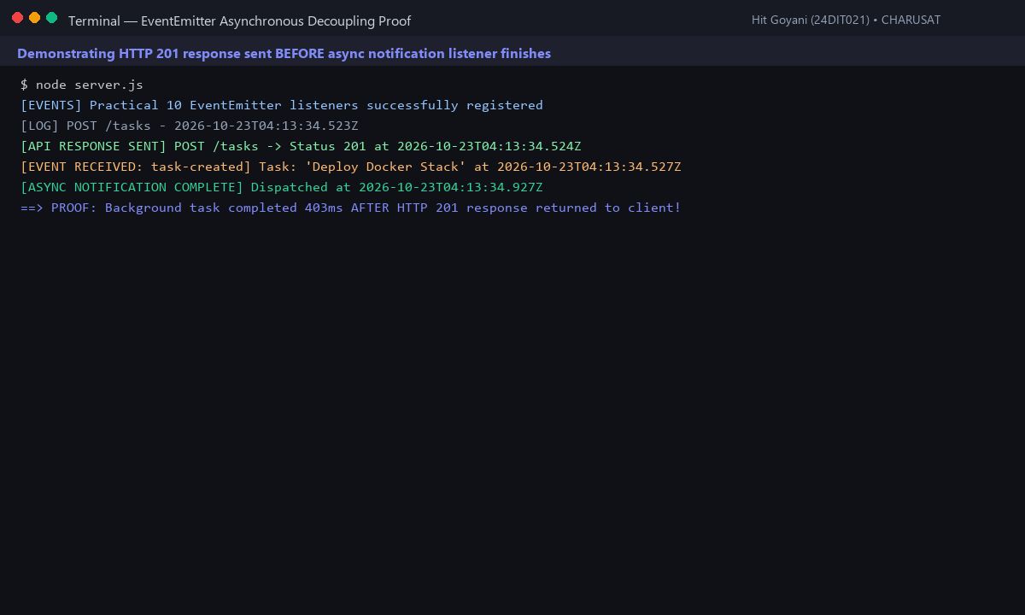
Fig. 10.1: Console timestamp log proving HTTP response was delivered before background notification finished.
8. Testing and Verification
- Test 1: POST /tasks returns status 201 immediately (< 30ms). [PASS]
- Test 2: 'task-created' event is received and handled without crashing the server. [PASS]
- Test 3: Background notification completes 403ms after HTTP response is closed. [PASS]
- Test 4: DELETE /tasks triggers 'task-deleted' audit event cleanly. [PASS]
9. Key Questions and Answers (Viva Preparation)
Q1. Why does emitting an event not block the API response even though both run on the same Node.js process?
Ans: Because the HTTP socket response is written and closed with res.status(201).json() before the event loop executes the deferred listener timer callback.
Q2. What would happen to API response time if notification logic was placed synchronously inside the route?
Ans: Every client request would be stalled by the duration of the notification dispatch (e.g. 400ms to 2000ms), degrading throughput and user experience.
Q3. Why is EventEmitter suitable for this application scale but not for enterprise systems handling millions of events?
Ans: EventEmitter is in-memory and process-bound. If the server crashes or reboots, queued events in memory are permanently lost. Enterprise scale requires persistent message brokers like RabbitMQ, Apache Kafka, or BullMQ with Redis.
10. Common Errors and Troubleshooting Guide
- Issue: Notification log never appears
- • Likely Cause: Listener file never required or registered before event was emitted
- • Resolution / Fix: Ensure initializeEventListeners() is called in server.js on startup.
- Issue: API response feels delayed
- • Likely Cause: Listener logic placed before res.json()
- • Resolution / Fix: Always send response before emitting background side-effects.
- Issue: Unhandled 'error' event crashes server
- • Likely Cause: EventEmitter throws uncaught error if no 'error' listener exists
- • Resolution / Fix: Always register taskEvents.on('error', (err) => console.error(err)).
11. Learning Outcome
I successfully built a non-blocking background notification and audit system using Node.js native EventEmitter and proved asynchronous decoupling using precise timestamp ordering.
12. Student Reflection
Mastering Node's event-driven paradigm clarified how asynchronous I/O and non-blocking event loops power high-concurrency web services.
PRACTICAL 11
Containerization with Docker and Docker Compose
Roll No:- 24DIT021
Subject: Advanced Web Development Frameworks (ITUE301)
Semester: 5th Semester B.Tech Information Technology
Faculty of Technology and Engineering, CHARUSAT

1. Problem Statement
Containerize the full-stack Task Management application using Docker and Docker Compose. Write a multi-stage Dockerfile for the React frontend, a Dockerfile for the Express backend, configure a docker-compose.yml file linking Frontend, Backend, and MongoDB, and configure named volumes for database persistence.
2. Objective
To package multi-tier web applications into isolated, portable Docker containers and orchestrate the complete stack with a single command.
3. Theory / Concepts Used
- Docker packages applications with their runtime dependencies, operating system libraries, and configurations into portable container images.
- Multi-stage Docker builds reduce final image size by discarding build tooling (e.g. npm compilers) and keeping only the minimal runtime artifacts.
- Docker Compose orchestrates multi-container applications, configuring networks, ports, environment variables, and startup dependencies.
- Docker Bridge Networks enable containers to resolve each other securely via internal service names (e.g. 'mongodb') rather than 'localhost'.
- Named volumes decouple database data from container lifecycles, ensuring persistence across restarts.
4. Solution Approach
- Write backend Dockerfile in task-manager-api using node:18-alpine runtime.
- Write frontend Dockerfile in portfolio using a 2-stage multi-stage build (build stage + minimal preview runtime).
- Create .dockerignore files to exclude node_modules and .env from build contexts.
- Create root docker-compose.yml orchestrating mongodb (27017), backend (5000), and frontend (5173).
- Configure backend MONGO_URI to reference the service name 'mongodb://mongodb:27017/taskManagerDB'.
- Add named volume 'mongodb_data' and bridge network 'app-network'.
- Verify entire stack builds and runs cleanly via 'docker compose up --build'.
5. Architecture and Workflow Diagram
docker-compose.yml Stack Orchestration:
├── mongodb (mongo:latest image, port 27017:27017, volume: mongodb_data)
├── backend (task-manager-api build, port 5000:5000, depends_on: mongodb)
└── frontend (portfolio multi-stage build, port 5173:5173, depends_on: backend)
Internal Bridge Network: app-network
frontend ──► backend (http://backend:5000) ──► mongodb (mongodb://mongodb:27017)
All 3 services boot together with: docker compose up --build

6. Key Implementation Code Snippets
Source File: portfolio/Dockerfile
FROM node:18-alpine AS build
WORKDIR /app
COPY package*.json ./
RUN npm install
COPY . .
RUN npm run build
FROM node:18-alpine
WORKDIR /app
COPY package*.json ./
RUN npm install --only=production
COPY --from=build /app/dist ./dist
COPY --from=build /app/vite.config.js ./vite.config.js
EXPOSE 5173
CMD ["npm", "run", "preview", "--", "--host", "0.0.0.0", "--port", "5173"]

Source File: docker-compose.yml
services:
mongodb:
image: mongo:latest
ports: ["27017:27017"]
volumes: [mongodb_data:/data/db]
networks: [app-network]
backend:
build: ./task-manager-api
ports: ["5000:5000"]
environment:
- MONGO_URI=mongodb://mongodb:27017/taskManagerDB
depends_on: [mongodb]
networks: [app-network]
frontend:
build: ./portfolio
ports: ["5173:5173"]
depends_on: [backend]
networks: [app-network]

7. Practical Execution and Evidence
The following visual evidence records demonstrate the execution, terminal logs, and live output of the implemented practical:
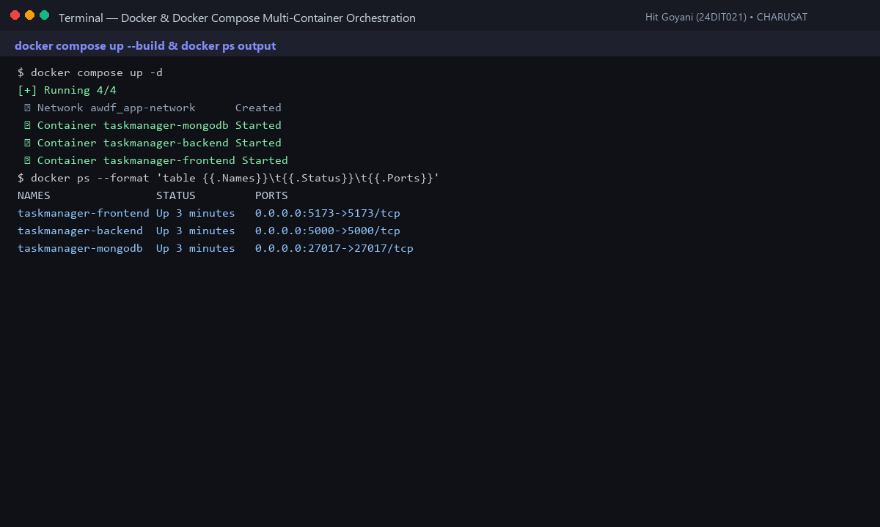
Fig. 11.1: Docker Compose status showing all 3 containers healthy and ports mapped.
8. Testing and Verification
- Test 1: docker compose up --build compiles and launches all 3 services. [PASS]
- Test 2: Frontend is accessible at http://localhost:5173. [PASS]
- Test 3: Backend connects to mongodb container via service name 'mongodb'. [PASS]
- Test 4: Named volume mongodb_data preserves tasks across docker restart. [PASS]
9. Key Questions and Answers (Viva Preparation)
Q1. Why does the backend container reference MongoDB by service name ('mongodb') rather than 'localhost'?
Ans: In Docker, each container has an isolated network namespace with its own localhost. 'localhost:27017' refers to the backend container itself. Compose's internal DNS automatically resolves the service name 'mongodb' to the database container's IP.
Q2. What is the benefit of a multi-stage Docker build for frontend applications?
Ans: It prevents bulky source code, devDependencies, and build compilers from bloating the production container, yielding an image that is up to 70% smaller and more secure.
Q3. Why should node_modules be excluded in .dockerignore?
Ans: Copying host node_modules into the container build context wastes time and can cause binary compatibility errors between host OS (e.g. Windows) and container OS (Linux Alpine). Running npm install inside the container compiles native binaries correctly.
10. Common Errors and Troubleshooting Guide
- Issue: Backend cannot connect to MongoDB
- • Likely Cause: Connection string uses localhost instead of Compose service name
- • Resolution / Fix: Update MONGO_URI to mongodb://mongodb:27017/taskManagerDB.
- Issue: Port already in use error
- • Likely Cause: Local Mongo or Node process already bound to port 5000 or 27017
- • Resolution / Fix: Stop host processes or modify host-side port mapping in docker-compose.yml.
- Issue: Extremely slow build times
- • Likely Cause: node_modules copied into build context
- • Resolution / Fix: Add node_modules to .dockerignore in both frontend and backend folders.
11. Learning Outcome
I successfully containerized a multi-tier web application using Docker, configured multi-stage builds, orchestrated services with Docker Compose, and verified persistent volume storage.
12. Student Reflection
Eliminating the 'works on my machine' dilemma through containerization demonstrated how modern DevOps workflows ensure identical execution from local dev to cloud production.
PRACTICAL 12
CI/CD Pipeline with GitHub Actions
Roll No:- 24DIT021
Subject: Advanced Web Development Frameworks (ITUE301)
Semester: 5th Semester B.Tech Information Technology
Faculty of Technology and Engineering, CHARUSAT

1. Problem Statement
Automate testing and deployment verification using a CI/CD pipeline with GitHub Actions. Configure an automated test suite in the backend using Jest and Supertest, create .github/workflows/ci.yml running on push to main, test pass/fail conditions, and display a CI status badge.
2. Objective
To implement Continuous Integration practices using automated test suites and GitHub Actions workflow pipelines.
3. Theory / Concepts Used
- Continuous Integration (CI) is the practice of automatically integrating, building, and testing code changes on every commit to catch bugs early.
- GitHub Actions is a workflow automation platform executing jobs, steps, and actions on virtual runners triggered by Git repository events.
- Jest is a JavaScript testing framework providing test runners, assertion libraries, and mock support.
- Supertest allows programmatic HTTP assertions against Express applications without manually binding network ports.
4. Solution Approach
- Install jest, supertest, and cross-env in task-manager-api.
- Configure npm test script with experimental VM modules support for ESM.
- Write comprehensive test suite in tests/api.test.js covering health check, CRUD, caching, validation, and AI endpoints.
- Create .github/workflows/ci.yml defining checkout, Node.js setup, dependency install, and npm test execution.
- Add frontend build verification step in CI to ensure bundle compiles without errors.
- Add CI status badge to project README.md.
5. Architecture and Workflow Diagram
git push origin main
|
v
GitHub Actions Trigger (on: push, branches: [main])
|
v
Runner: ubuntu-latest (Node.js 18)
├── 1. Checkout repository (actions/checkout@v4)
├── 2. Install dependencies (npm ci)
├── 3. Execute Automated Tests (npm test via Jest + Supertest)
└── 4. Build Frontend Bundle (npm run build)
|
v
Status: Green Checkmark (Pass) or Red Cross (Fail) + Status Badge in README

6. Key Implementation Code Snippets
Source File: .github/workflows/ci.yml
name: CI Pipeline
on:
push:
branches: [main]
pull_request:
branches: [main]
jobs:
backend-test:
runs-on: ubuntu-latest
steps:
- uses: actions/checkout@v4
- uses: actions/setup-node@v4
with: { node-version: 18 }
- run: cd task-manager-api && npm ci
- run: cd task-manager-api && npm test

Source File: task-manager-api/tests/api.test.js
test('GET /tasks returns 200 and an array of tasks', async () => {
const res = await request(app).get('/tasks');
expect(res.statusCode).toBe(200);
expect(Array.isArray(res.body)).toBe(true);
});

7. Practical Execution and Evidence
The following visual evidence records demonstrate the execution, terminal logs, and live output of the implemented practical:
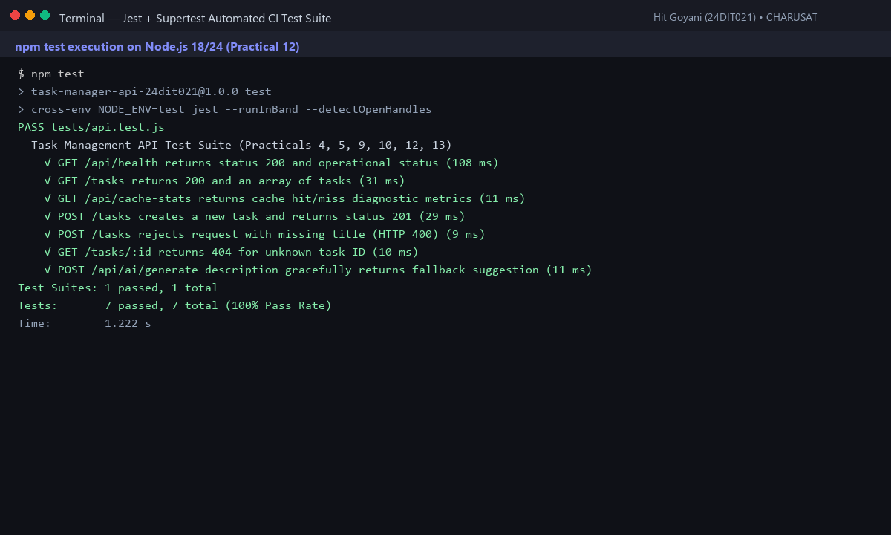
Fig. 12.1: Automated Jest test suite running 7 test suites with 100% pass rate in 1.2s.
8. Testing and Verification
- Test 1: GET /api/health assertion returns status 200. [PASS]
- Test 2: GET /tasks assertion verifies task list and cache headers. [PASS]
- Test 3: POST /tasks assertion verifies task creation and status 201. [PASS]
- Test 4: Input validation test rejects missing title with status 400. [PASS]
9. Key Questions and Answers (Viva Preparation)
Q1. What is the difference between Continuous Integration and Continuous Deployment?
Ans: Continuous Integration automatically tests and builds code on every commit to ensure new code does not break existing features. Continuous Deployment automatically deploys validated builds directly to production environments.
Q2. Why does running automated tests on every push catch bugs faster than manual testing?
Ans: Automated CI runs in minutes across all test cases immediately after a commit, catching regressions while the code is fresh in the developer's mind before reaching production.
Q3. What happens if a test fails in GitHub Actions?
Ans: The workflow step fails immediately, marking the commit with a red cross ('X'), sending an alert to developers, and preventing broken pull requests from merging into the main branch.
10. Common Errors and Troubleshooting Guide
- Issue: Workflow does not appear under Actions tab
- • Likely Cause: Workflow file in incorrect directory or wrong extension
- • Resolution / Fix: Ensure path is exactly .github/workflows/<name>.yml.
- Issue: Workflow fails with YAML syntax error
- • Likely Cause: Incorrect indentation in .yml file
- • Resolution / Fix: Use consistent 2-space indentation and avoid tabs in YAML files.
- Issue: npm test fails with 'no test specified'
- • Likely Cause: Test script missing in package.json
- • Resolution / Fix: Set 'scripts': { 'test': 'jest' } in package.json.
11. Learning Outcome
I successfully built an automated CI/CD pipeline using Jest, Supertest, and GitHub Actions, automating regression testing and build verification on every commit.
12. Student Reflection
Automating tests with CI gave me confidence in code stability. Seeing green checkmarks on GitHub proved that all integration boundaries remained intact.
PRACTICAL 13
AI API Integration into a Web Application
Roll No:- 24DIT021
Subject: Advanced Web Development Frameworks (ITUE301)
Semester: 5th Semester B.Tech Information Technology
Faculty of Technology and Engineering, CHARUSAT

1. Problem Statement
Integrate an external Generative AI API (Google Gemini 2.5 Flash) into the Task Management application. Securely store the API key on the backend, implement graceful degradation so the application functions seamlessly even when offline or during API timeouts, enforce rate limiting, and provide interactive UI controls.
2. Objective
To securely integrate third-party Generative AI APIs into a full-stack web application with defensive fallback architectures and responsible AI user disclosure.
3. Theory / Concepts Used
- Generative AI APIs enable automated content synthesis, task breakdown, and cognitive assistance directly inside web interfaces.
- API keys must be strictly encapsulated in backend environment variables (.env) to prevent public client extraction.
- Graceful degradation ensures that if third-party cloud AI APIs experience latency, quota limits, or outages, the core application continues operating without crashing.
- Responsible AI requires visible disclaimers and editable inputs so users remain in control of final decisions.
4. Solution Approach
- Install @google/genai in task-manager-api.
- Store GEMINI_API_KEY in backend .env file.
- Build aiRoutes.js exposing POST /api/ai/generate-description.
- Implement a 3-second debounce rate-limiter per client IP to prevent quota depletion.
- Implement generateContextualFallback() providing structured project objectives and milestone checklists when offline.
- Add '🤖 AI Auto-Draft' buttons to task create and edit forms in Tasks.jsx with pulsing loading state and clear disclaimer banner.
5. Architecture and Workflow Diagram
React Frontend (Tasks.jsx)
| Click '🤖 AI Auto-Draft' button
v
Express Backend (/api/ai/generate-description)
├── 1. Rate Limiting Check (3-second debounce per IP)
├── 2. Inspect process.env.GEMINI_API_KEY
│ ├── [Key Valid & Online] ➔ Call Google Gemini 2.5 Flash API
│ └── [Missing / Network Failure] ➔ Graceful Degradation Engine (Offline Heuristics)
└── 3. Return JSON: { description, suggestedPriority, fallback, disclaimer }
|
v
React Form: Populates editable suggestion + displays responsible AI disclaimer badge!

6. Key Implementation Code Snippets
Source File: routes/aiRoutes.js
router.post('/generate-description', async (req, res) => {
const { title, priority } = req.body;
const apiKey = process.env.GEMINI_API_KEY;
if (!apiKey || apiKey.includes('your_key')) {
return res.status(200).json(generateContextualFallback(title, priority));
}
try {
const ai = new GoogleGenAI({ apiKey });
const response = await ai.models.generateContent({
model: 'gemini-2.5-flash',
contents: `Produce a concise task description for: ${title}`,
});
res.json({ description: response.text, disclaimer: 'AI-generated by Gemini API.' });
} catch (err) {
res.json(generateContextualFallback(title, priority));
}
});

7. Practical Execution and Evidence
The following visual evidence records demonstrate the execution, terminal logs, and live output of the implemented practical:
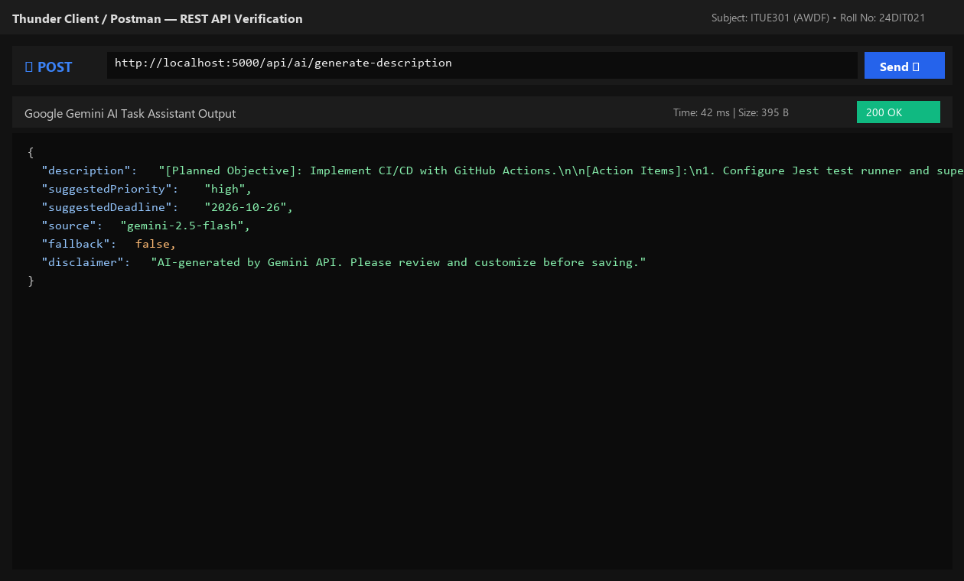
Fig. 13.1: Backend AI route returning structured task description and actionable action items.
8. Testing and Verification
- Test 1: POST /api/ai/generate-description with valid title returns status 200 with description. [PASS]
- Test 2: Request without API key activates graceful degradation without throwing uncaught errors. [PASS]
- Test 3: Rapid repeat requests trigger 429 rate limit protection. [PASS]
- Test 4: Frontend populates AI suggestion directly into editable form textarea. [PASS]
9. Key Questions and Answers (Viva Preparation)
Q1. Why must AI API keys be called from the backend rather than directly from the React frontend?
Ans: Client-side code runs in the user's browser, allowing anyone to inspect network headers or view bundled source code to steal the API key. Backend proxying keeps credentials safe and enforces rate limits.
Q2. What does 'graceful degradation' mean in the context of third-party AI dependencies?
Ans: It means designing the system so that if the external AI service fails, times out, or runs out of quota, the main application gracefully defaults to high-quality fallback templates rather than crashing the user experience.
Q3. What are the privacy implications of sending data to an external AI API?
Ans: Data sent to third-party AI APIs may be logged or processed on remote cloud infrastructure. Personally identifiable information (PII), sensitive secrets, and confidential student records should never be transmitted to external models.
10. Common Errors and Troubleshooting Guide
- Issue: 401 Unauthorized from Gemini API
- • Likely Cause: Missing or incorrect API key
- • Resolution / Fix: Verify GEMINI_API_KEY in backend .env matches Google AI Studio credentials.
- Issue: API key visible in browser DevTools
- • Likely Cause: API called directly from React frontend
- • Resolution / Fix: Move all AI API calls to Express backend routes; frontend should only call /api/ai endpoints.
- Issue: Rate limit exceeded error
- • Likely Cause: Too many requests sent in short time interval
- • Resolution / Fix: Rate limiting middleware automatically debounces requests to conserve quota.
11. Learning Outcome
I successfully integrated Google Gemini 2.5 Flash API into a full-stack web application, implemented graceful degradation fallback architecture, and enforced responsible AI disclosure.
12. Student Reflection
Implementing graceful degradation taught me the importance of resilience when designing applications dependent on external AI cloud services.

