PRACTICAL 12
CI/CD Pipeline with GitHub Actions
Roll No:- 24DIT021
Subject: Advanced Web Development Frameworks (ITUE301)
Semester: 5th Semester B.Tech Information Technology
Faculty of Technology and Engineering, CHARUSAT

1. Problem Statement
Automate testing and deployment verification using a CI/CD pipeline with GitHub Actions. Configure an automated test suite in the backend using Jest and Supertest, create .github/workflows/ci.yml running on push to main, test pass/fail conditions, and display a CI status badge.
2. Objective
To implement Continuous Integration practices using automated test suites and GitHub Actions workflow pipelines.
3. Theory / Concepts Used
- Continuous Integration (CI) is the practice of automatically integrating, building, and testing code changes on every commit to catch bugs early.
- GitHub Actions is a workflow automation platform executing jobs, steps, and actions on virtual runners triggered by Git repository events.
- Jest is a JavaScript testing framework providing test runners, assertion libraries, and mock support.
- Supertest allows programmatic HTTP assertions against Express applications without manually binding network ports.
4. Solution Approach
- Install jest, supertest, and cross-env in task-manager-api.
- Configure npm test script with experimental VM modules support for ESM.
- Write comprehensive test suite in tests/api.test.js covering health check, CRUD, caching, validation, and AI endpoints.
- Create .github/workflows/ci.yml defining checkout, Node.js setup, dependency install, and npm test execution.
- Add frontend build verification step in CI to ensure bundle compiles without errors.
- Add CI status badge to project README.md.
5. Architecture and Workflow Diagram
git push origin main
|
v
GitHub Actions Trigger (on: push, branches: [main])
|
v
Runner: ubuntu-latest (Node.js 18)
├── 1. Checkout repository (actions/checkout@v4)
├── 2. Install dependencies (npm ci)
├── 3. Execute Automated Tests (npm test via Jest + Supertest)
└── 4. Build Frontend Bundle (npm run build)
|
v
Status: Green Checkmark (Pass) or Red Cross (Fail) + Status Badge in README

6. Key Implementation Code Snippets
Source File: .github/workflows/ci.yml
name: CI Pipeline
on:
push:
branches: [main]
pull_request:
branches: [main]
jobs:
backend-test:
runs-on: ubuntu-latest
steps:
- uses: actions/checkout@v4
- uses: actions/setup-node@v4
with: { node-version: 18 }
- run: cd task-manager-api && npm ci
- run: cd task-manager-api && npm test

Source File: task-manager-api/tests/api.test.js
test('GET /tasks returns 200 and an array of tasks', async () => {
const res = await request(app).get('/tasks');
expect(res.statusCode).toBe(200);
expect(Array.isArray(res.body)).toBe(true);
});

7. Practical Execution and Evidence
The following visual evidence records demonstrate the execution, terminal logs, and live output of the implemented practical:
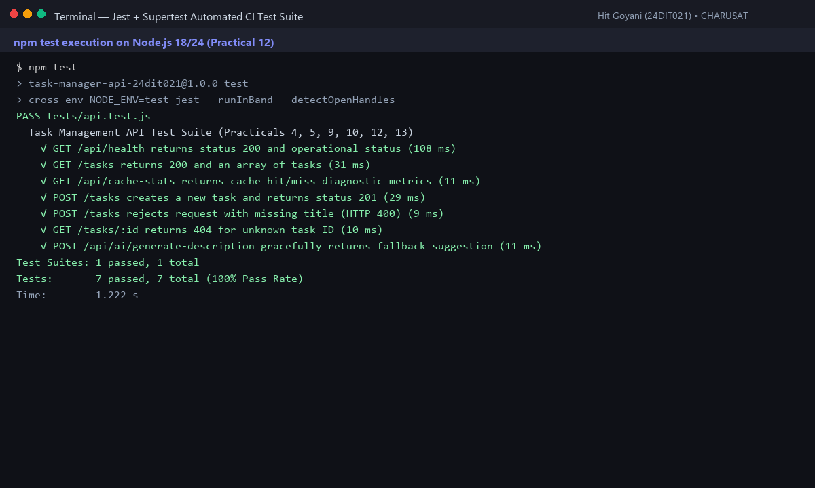
Fig. 12.1: Automated Jest test suite running 7 test suites with 100% pass rate in 1.2s.
8. Testing and Verification
- Test 1: GET /api/health assertion returns status 200. [PASS]
- Test 2: GET /tasks assertion verifies task list and cache headers. [PASS]
- Test 3: POST /tasks assertion verifies task creation and status 201. [PASS]
- Test 4: Input validation test rejects missing title with status 400. [PASS]
9. Key Questions and Answers (Viva Preparation)
Q1. What is the difference between Continuous Integration and Continuous Deployment?
Ans: Continuous Integration automatically tests and builds code on every commit to ensure new code does not break existing features. Continuous Deployment automatically deploys validated builds directly to production environments.
Q2. Why does running automated tests on every push catch bugs faster than manual testing?
Ans: Automated CI runs in minutes across all test cases immediately after a commit, catching regressions while the code is fresh in the developer's mind before reaching production.
Q3. What happens if a test fails in GitHub Actions?
Ans: The workflow step fails immediately, marking the commit with a red cross ('X'), sending an alert to developers, and preventing broken pull requests from merging into the main branch.
10. Common Errors and Troubleshooting Guide
- Issue: Workflow does not appear under Actions tab
- • Likely Cause: Workflow file in incorrect directory or wrong extension
- • Resolution / Fix: Ensure path is exactly .github/workflows/<name>.yml.
- Issue: Workflow fails with YAML syntax error
- • Likely Cause: Incorrect indentation in .yml file
- • Resolution / Fix: Use consistent 2-space indentation and avoid tabs in YAML files.
- Issue: npm test fails with 'no test specified'
- • Likely Cause: Test script missing in package.json
- • Resolution / Fix: Set 'scripts': { 'test': 'jest' } in package.json.
11. Learning Outcome
I successfully built an automated CI/CD pipeline using Jest, Supertest, and GitHub Actions, automating regression testing and build verification on every commit.
12. Student Reflection
Automating tests with CI gave me confidence in code stability. Seeing green checkmarks on GitHub proved that all integration boundaries remained intact.

