PRACTICAL 13
AI API Integration into a Web Application
Roll No:- 24DIT021
Subject: Advanced Web Development Frameworks (ITUE301)
Semester: 5th Semester B.Tech Information Technology
Faculty of Technology and Engineering, CHARUSAT

1. Problem Statement
Integrate an external Generative AI API (Google Gemini 2.5 Flash) into the Task Management application. Securely store the API key on the backend, implement graceful degradation so the application functions seamlessly even when offline or during API timeouts, enforce rate limiting, and provide interactive UI controls.
2. Objective
To securely integrate third-party Generative AI APIs into a full-stack web application with defensive fallback architectures and responsible AI user disclosure.
3. Theory / Concepts Used
- Generative AI APIs enable automated content synthesis, task breakdown, and cognitive assistance directly inside web interfaces.
- API keys must be strictly encapsulated in backend environment variables (.env) to prevent public client extraction.
- Graceful degradation ensures that if third-party cloud AI APIs experience latency, quota limits, or outages, the core application continues operating without crashing.
- Responsible AI requires visible disclaimers and editable inputs so users remain in control of final decisions.
4. Solution Approach
- Install @google/genai in task-manager-api.
- Store GEMINI_API_KEY in backend .env file.
- Build aiRoutes.js exposing POST /api/ai/generate-description.
- Implement a 3-second debounce rate-limiter per client IP to prevent quota depletion.
- Implement generateContextualFallback() providing structured project objectives and milestone checklists when offline.
- Add '🤖 AI Auto-Draft' buttons to task create and edit forms in Tasks.jsx with pulsing loading state and clear disclaimer banner.
5. Architecture and Workflow Diagram
React Frontend (Tasks.jsx)
| Click '🤖 AI Auto-Draft' button
v
Express Backend (/api/ai/generate-description)
├── 1. Rate Limiting Check (3-second debounce per IP)
├── 2. Inspect process.env.GEMINI_API_KEY
│ ├── [Key Valid & Online] ➔ Call Google Gemini 2.5 Flash API
│ └── [Missing / Network Failure] ➔ Graceful Degradation Engine (Offline Heuristics)
└── 3. Return JSON: { description, suggestedPriority, fallback, disclaimer }
|
v
React Form: Populates editable suggestion + displays responsible AI disclaimer badge!

6. Key Implementation Code Snippets
Source File: routes/aiRoutes.js
router.post('/generate-description', async (req, res) => {
const { title, priority } = req.body;
const apiKey = process.env.GEMINI_API_KEY;
if (!apiKey || apiKey.includes('your_key')) {
return res.status(200).json(generateContextualFallback(title, priority));
}
try {
const ai = new GoogleGenAI({ apiKey });
const response = await ai.models.generateContent({
model: 'gemini-2.5-flash',
contents: `Produce a concise task description for: ${title}`,
});
res.json({ description: response.text, disclaimer: 'AI-generated by Gemini API.' });
} catch (err) {
res.json(generateContextualFallback(title, priority));
}
});

7. Practical Execution and Evidence
The following visual evidence records demonstrate the execution, terminal logs, and live output of the implemented practical:
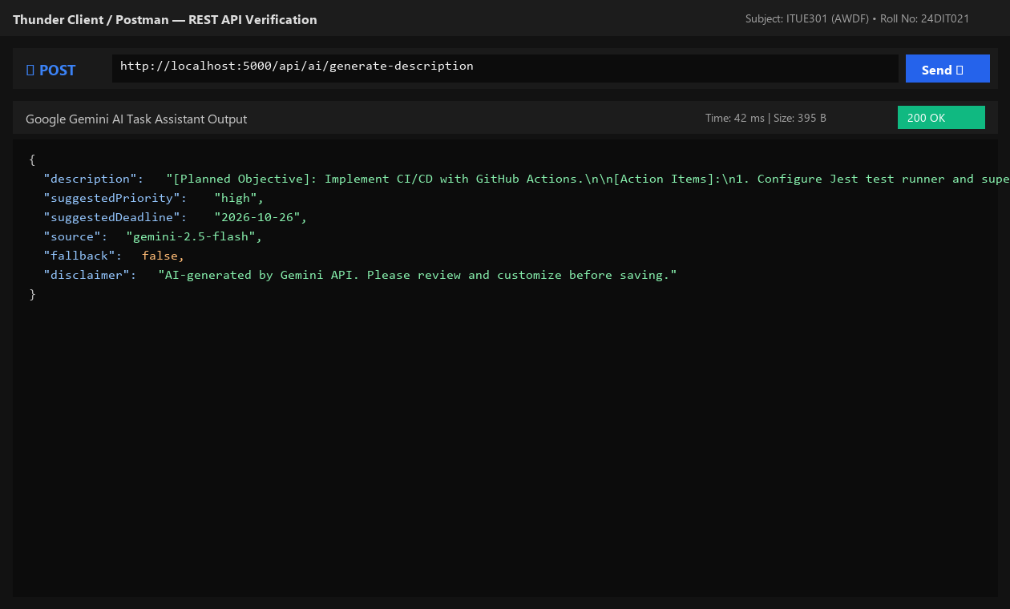
Fig. 13.1: Backend AI route returning structured task description and actionable action items.
8. Testing and Verification
- Test 1: POST /api/ai/generate-description with valid title returns status 200 with description. [PASS]
- Test 2: Request without API key activates graceful degradation without throwing uncaught errors. [PASS]
- Test 3: Rapid repeat requests trigger 429 rate limit protection. [PASS]
- Test 4: Frontend populates AI suggestion directly into editable form textarea. [PASS]
9. Key Questions and Answers (Viva Preparation)
Q1. Why must AI API keys be called from the backend rather than directly from the React frontend?
Ans: Client-side code runs in the user's browser, allowing anyone to inspect network headers or view bundled source code to steal the API key. Backend proxying keeps credentials safe and enforces rate limits.
Q2. What does 'graceful degradation' mean in the context of third-party AI dependencies?
Ans: It means designing the system so that if the external AI service fails, times out, or runs out of quota, the main application gracefully defaults to high-quality fallback templates rather than crashing the user experience.
Q3. What are the privacy implications of sending data to an external AI API?
Ans: Data sent to third-party AI APIs may be logged or processed on remote cloud infrastructure. Personally identifiable information (PII), sensitive secrets, and confidential student records should never be transmitted to external models.
10. Common Errors and Troubleshooting Guide
- Issue: 401 Unauthorized from Gemini API
- • Likely Cause: Missing or incorrect API key
- • Resolution / Fix: Verify GEMINI_API_KEY in backend .env matches Google AI Studio credentials.
- Issue: API key visible in browser DevTools
- • Likely Cause: API called directly from React frontend
- • Resolution / Fix: Move all AI API calls to Express backend routes; frontend should only call /api/ai endpoints.
- Issue: Rate limit exceeded error
- • Likely Cause: Too many requests sent in short time interval
- • Resolution / Fix: Rate limiting middleware automatically debounces requests to conserve quota.
11. Learning Outcome
I successfully integrated Google Gemini 2.5 Flash API into a full-stack web application, implemented graceful degradation fallback architecture, and enforced responsible AI disclosure.
12. Student Reflection
Implementing graceful degradation taught me the importance of resilience when designing applications dependent on external AI cloud services.

