PRACTICAL 7
Authentication and Middleware Pipeline
Roll No:- 24DIT021
Subject: Advanced Web Development Frameworks (ITUE301)
Semester: 5th Semester B.Tech Information Technology
Faculty of Technology and Engineering, CHARUSAT

1. Problem Statement
Implement JWT-based authentication, bcrypt password hashing, and server-side input validation. Create user registration and login endpoints, protect task routes with an authentication middleware, expose a /me profile route, and manage token expiration on the client.
2. Objective
To secure backend REST endpoints using industry-standard JWT bearer tokens, salt-hashed passwords with bcrypt, and centralized authorization middleware.
3. Theory / Concepts Used
- Bcrypt is a cryptographic hash function utilizing an adaptive salt factor to protect against rainbow table and brute-force attacks.
- JSON Web Tokens (JWT) are digitally signed stateless tokens composed of Header, Payload, and Signature, enabling stateless session validation.
- Authorization middleware inspects the HTTP 'Authorization: Bearer <token>' header, verifies the signature, and injects user context into req.user.
- Server-side input validation guarantees valid email syntax and password length before database transactions occur.
4. Solution Approach
- Install bcryptjs and jsonwebtoken in task-manager-api.
- Create User model in models/User.js with pre-save bcrypt hashing hook.
- Implement POST /auth/register and POST /auth/login issuing 24h JWT tokens.
- Build auth.js middleware to extract bearer token, verify signature, and attach req.user.
- Protect /auth/me and task mutation routes using requireAuth middleware.
- Implement AuthContext in React managing token in localStorage and auto-logging out on 401.
5. Architecture and Workflow Diagram
POST /auth/register ➔ Hash Password (bcrypt salt 10) ➔ Save User in MongoDB (201)
POST /auth/login ➔ Compare Hash (bcrypt.compare) ➔ Sign JWT Token (200)
Protected Route Flow:
Client Request (Authorization: Bearer <token>)
|
v
[Auth Middleware] ➔ Verify JWT Secret ➔ Injects req.user
|
v
[Input Validator] ➔ Checks Schema Fields
|
v
Controller Route (Task Operations / Profile)

6. Key Implementation Code Snippets
Source File: models/User.js
userSchema.pre('save', async function (next) {
if (!this.isModified('password')) return next ? next() : null;
const salt = await bcrypt.genSalt(10);
this.password = await bcrypt.hash(this.password, salt);
if (next) next();
});

Source File: middleware/auth.js
export const requireAuth = (req, res, next) => {
const authHeader = req.headers.authorization;
if (!authHeader || !authHeader.startsWith('Bearer ')) {
return res.status(401).json({ success: false, error: 'Unauthorized: Bearer token required' });
}
const token = authHeader.split(' ')[1];
try {
const decoded = jwt.verify(token, process.env.JWT_SECRET);
req.user = decoded;
next();
} catch (err) {
return res.status(401).json({ success: false, error: 'Invalid or expired token' });
}
};

7. Practical Execution and Evidence
The following visual evidence records demonstrate the execution, terminal logs, and live output of the implemented practical:
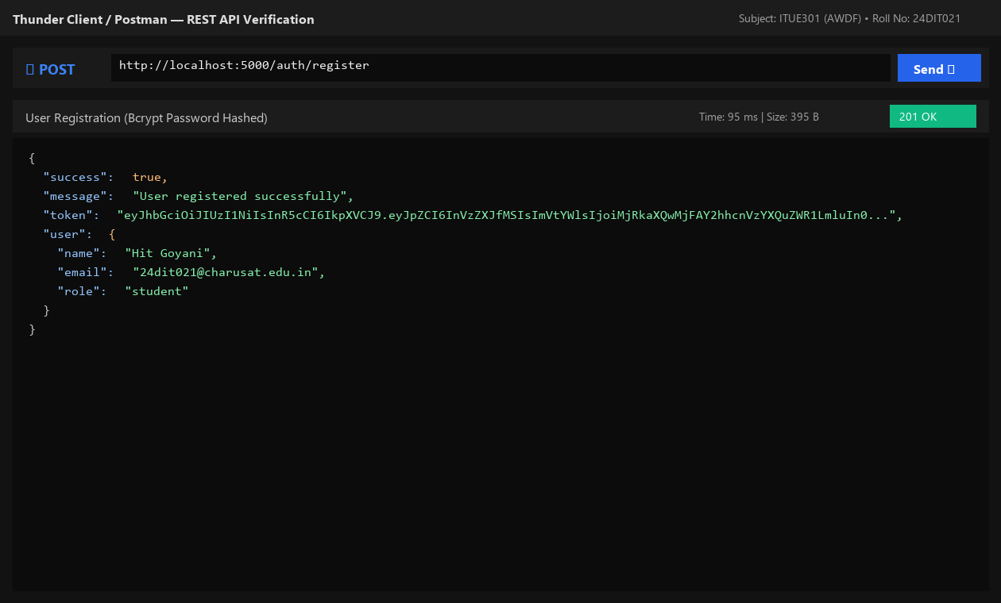
Fig. 7.1: User registration with automatic bcrypt password hashing and token return.
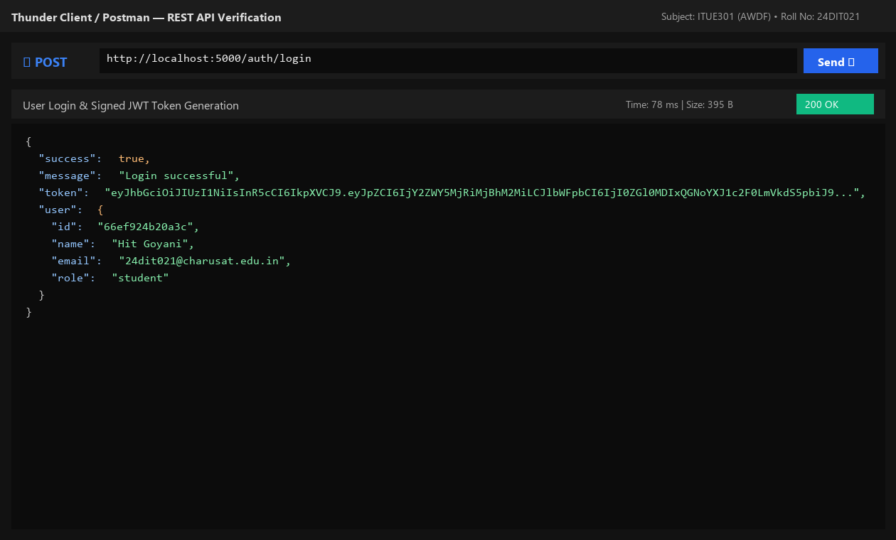
Fig. 7.2: Successful user login returning signed JSON Web Token.
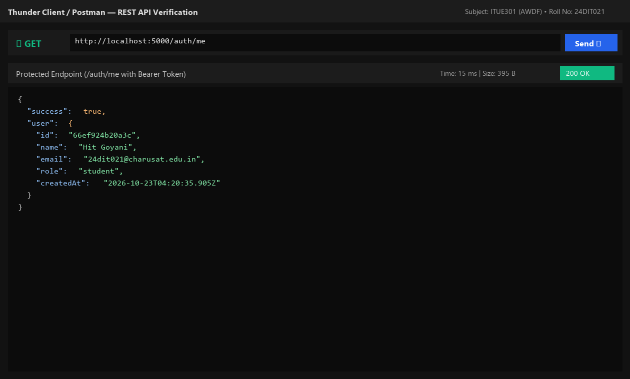
Fig. 7.3: Accessing protected /auth/me route using Authorization: Bearer token.
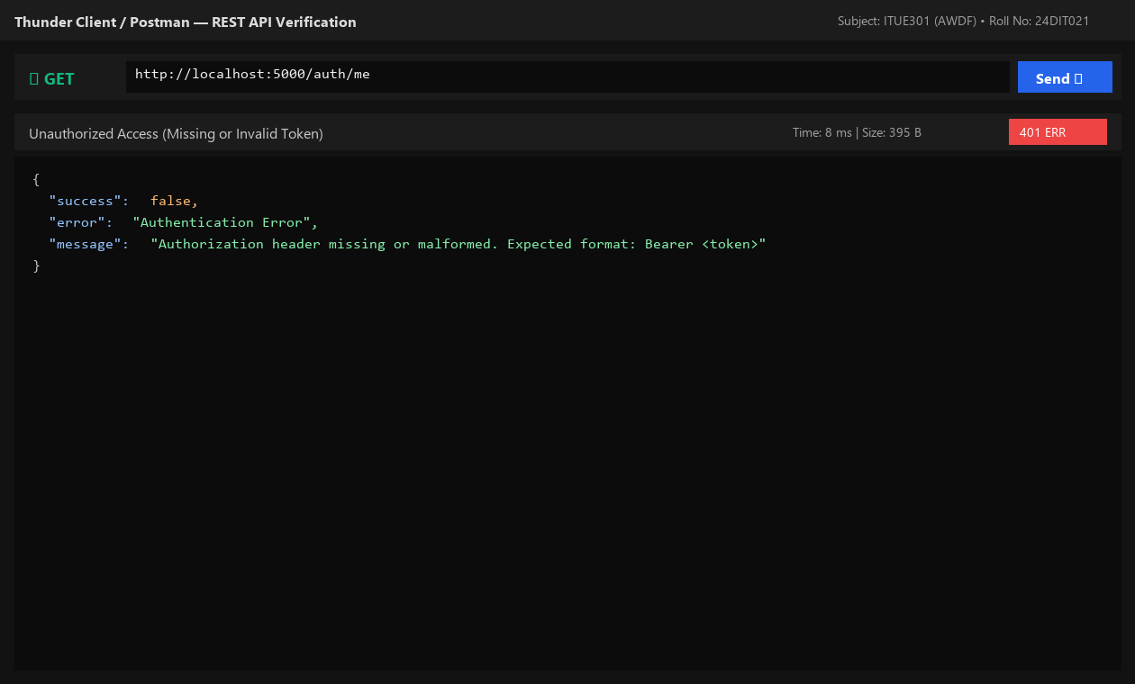
Fig. 7.4: Server rejecting unauthenticated request with HTTP 401 Unauthorized.
8. Testing and Verification
- Test 1: POST /auth/register hashes password and returns 201 with JWT. [PASS]
- Test 2: POST /auth/login verifies credentials and returns 200 with JWT. [PASS]
- Test 3: GET /auth/me with Bearer token returns authenticated user payload. [PASS]
- Test 4: GET /auth/me without token returns 401 Unauthorized. [PASS]
9. Key Questions and Answers (Viva Preparation)
Q1. Why must passwords be hashed before storage instead of saved as plain text, even in lab projects?
Ans: Storing plain text passwords exposes user credentials in database leaks, logs, and dumps. Cryptographic hashing with salts ensures stored passwords cannot be reversed into plain text.
Q2. What does the authentication middleware verify, and what happens if the token is expired?
Ans: It checks for the Bearer prefix, verifies the cryptographic signature against the server's JWT_SECRET, and inspects the token expiration timestamp. Expired or tampered tokens throw an error and receive an immediate HTTP 401 response.
Q3. Why must input validation happen on the server even if the client validates fields?
Ans: Client validation is for user convenience and can be bypassed by malicious actors. Server-side validation is mandatory to protect business rules, data schemas, and backend stability.
10. Common Errors and Troubleshooting Guide
- Issue: 401 Unauthorized on every request
- • Likely Cause: Missing space after Bearer or token omitted
- • Resolution / Fix: Ensure format is exactly 'Authorization: Bearer <token>' with one space.
- Issue: Server crashes on invalid token
- • Likely Cause: jwt.verify() not wrapped in try/catch
- • Resolution / Fix: Wrap token verification in try/catch and return res.status(401) on failure.
- Issue: JWT_SECRET is undefined
- • Likely Cause: dotenv.config() not called before secret access
- • Resolution / Fix: Call dotenv.config() at the very top of server.js.
11. Learning Outcome
I successfully built a secure authentication pipeline using bcrypt password hashing, signed and verified JSON Web Tokens, and implemented role-aware route guards.
12. Student Reflection
Understanding stateless authentication illustrated how modern microservices scale without maintaining server-side session memory.

