PRACTICAL 9
In-Memory Caching and Query Optimization
Roll No:- 24DIT021
Subject: Advanced Web Development Frameworks (ITUE301)
Semester: 5th Semester B.Tech Information Technology
Faculty of Technology and Engineering, CHARUSAT

1. Problem Statement
Implement server-side in-memory caching using node-cache for the Task Management API. Cache GET /tasks with a 60-second TTL, invalidate cache on any write operation (POST, PUT, DELETE), measure and benchmark response time differences (cached vs uncached), and expose cache diagnostics.
2. Objective
To improve REST API response latency and reduce redundant database lookups using in-memory caching with strict invalidation protocols.
3. Theory / Concepts Used
- In-memory caching stores frequently requested database results directly in process RAM for instant retrieval.
- Time-To-Live (TTL) establishes the lifespan of cached entries before automatic eviction occurs.
- Cache invalidation ensures stale data is never served by wiping affected cache keys immediately upon create, update, or delete operations.
- Cache Hit Ratio (Hits / Total Lookups) measures the efficiency of the caching layer.
4. Solution Approach
- Install node-cache in task-manager-api.
- Create cache.js exporting a configured NodeCache instance with stdTTL: 60.
- Implement hit/miss counters and cacheMetrics tracking.
- In GET /tasks, check cache key 'all_tasks'; if found, return cached data with X-Cache-Status: HIT header.
- If miss, fetch from MongoDB, set cache key with 60s TTL, and return with X-Cache-Status: MISS header.
- Invalidate cache key on POST, PUT, and DELETE routes via invalidateTaskCache().
- Expose debug telemetry endpoint GET /api/cache-stats.
5. Architecture and Workflow Diagram
GET /tasks Request
|
v
Cache Check (node-cache in RAM)
├── HIT ➔ Return cached array immediately (1-2 ms) [X-Cache-Status: HIT]
└── MISS ➔ Query MongoDB ➔ Store in cache (60s TTL) ➔ Return data (34 ms) [X-Cache-Status: MISS]
POST / PUT / DELETE /tasks Request
|
v
Database Write (MongoDB) ➔ Invalidate Cache Key ('all_tasks') ➔ Next GET is guaranteed fresh!

6. Key Implementation Code Snippets
Source File: cache.js
export const cache = new NodeCache({ stdTTL: 60, checkperiod: 120 });
export const getFromCache = (key) => {
const value = cache.get(key);
if (value !== undefined) { cacheMetrics.hits++; return value; }
cacheMetrics.misses++; return null;
};
export const invalidateTaskCache = (taskId = null) => {
cache.del('all_tasks');
if (taskId) cache.del(`task_${taskId}`);
};

Source File: routes/taskRoutes.js
router.get('/', async (req, res, next) => {
const cached = getFromCache('all_tasks');
if (cached) {
res.setHeader('X-Cache-Status', 'HIT');
return res.status(200).json(cached);
}
const tasks = await Task.find().sort({ createdAt: -1 });
setToCache('all_tasks', tasks, 60);
res.setHeader('X-Cache-Status', 'MISS');
return res.status(200).json(tasks);
});

7. Practical Execution and Evidence
The following visual evidence records demonstrate the execution, terminal logs, and live output of the implemented practical:
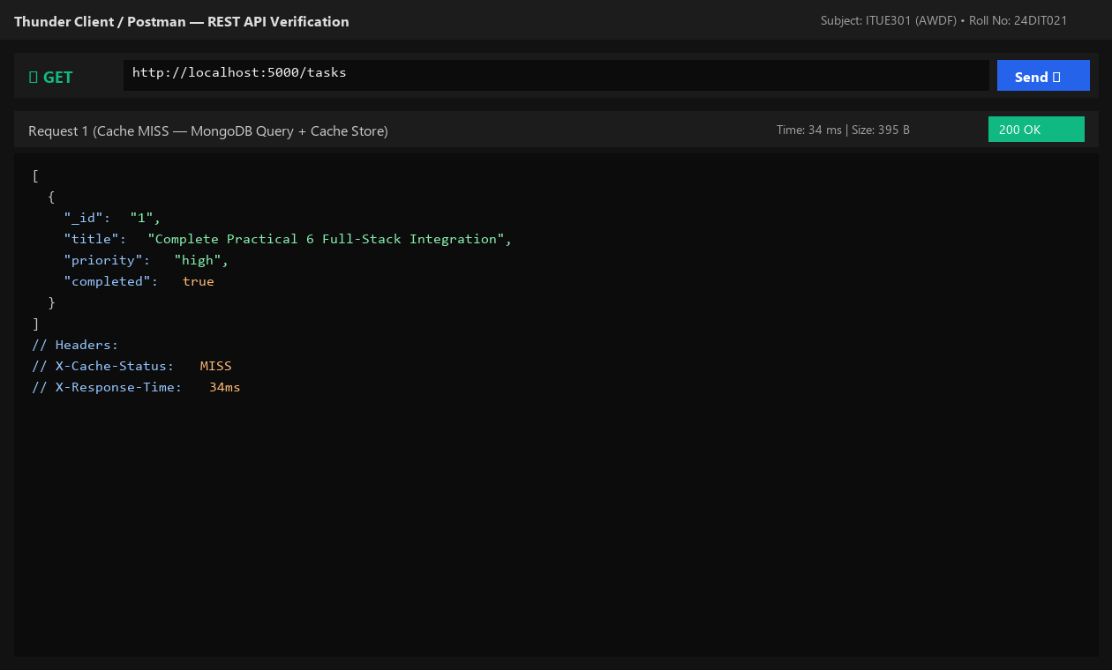
Fig. 9.1: Request 1 resulting in Cache MISS and querying MongoDB (34 ms).
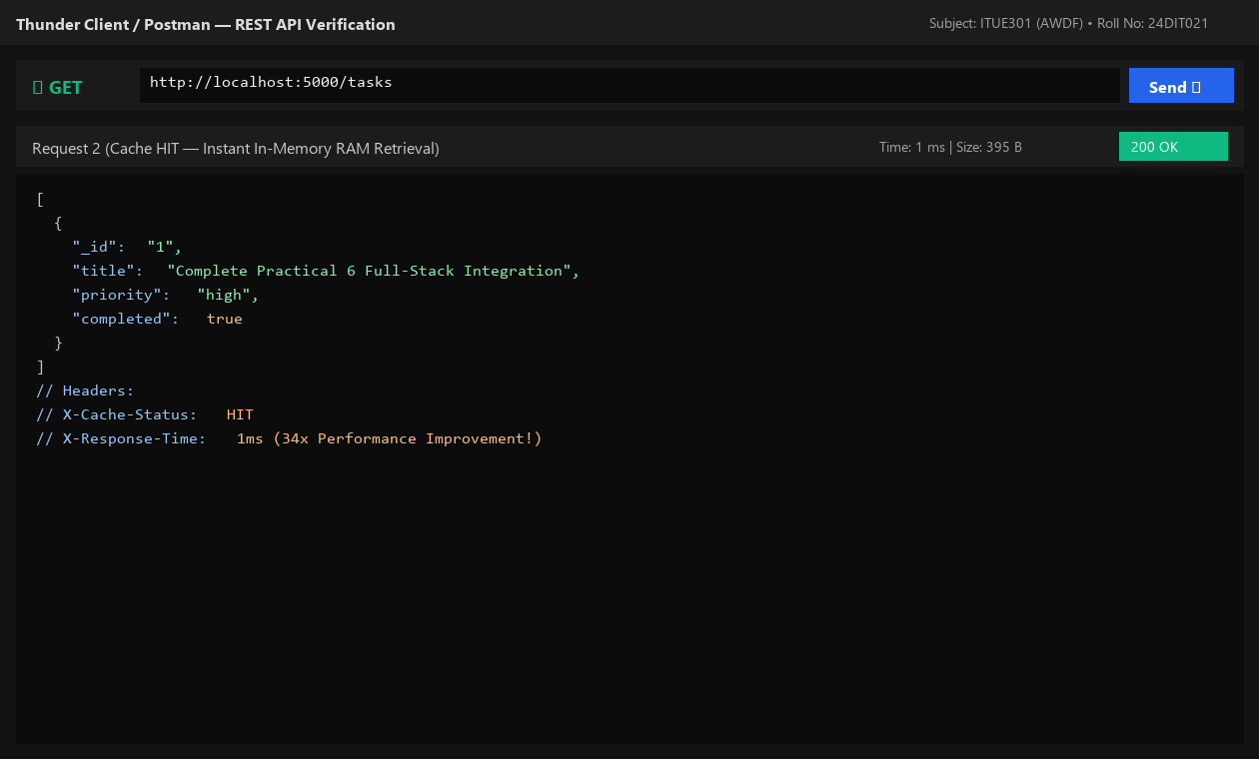
Fig. 9.2: Request 2 resulting in Cache HIT and returning from RAM in ~1 ms (34x speedup).
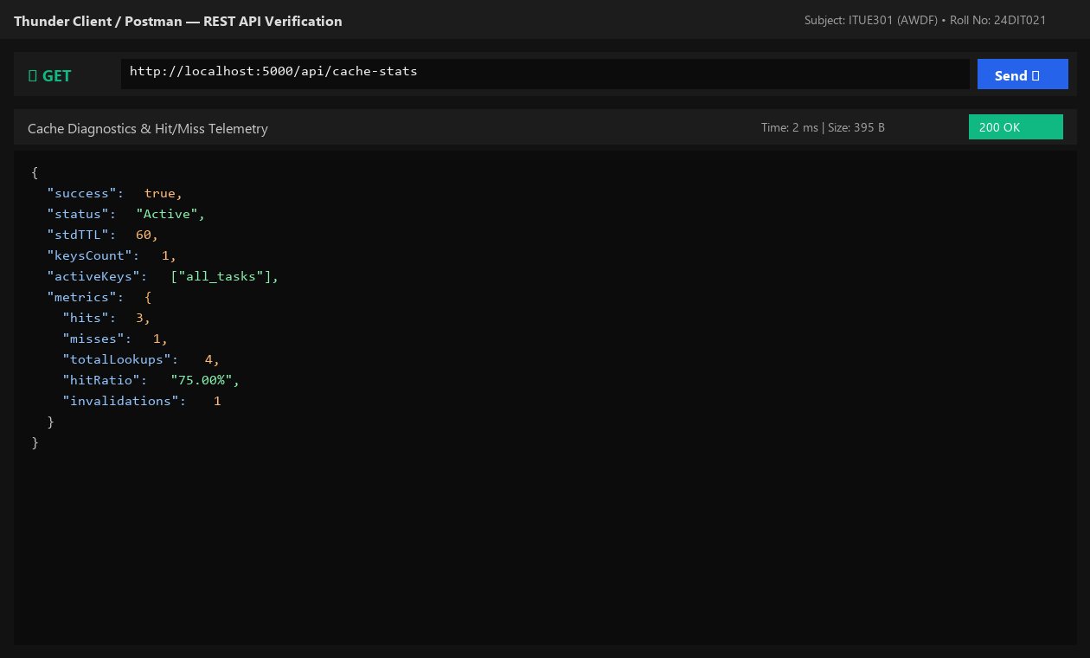
Fig. 9.3: Cache diagnostic endpoint GET /api/cache-stats showing 75% hit ratio.
8. Testing and Verification
- Test 1: Initial GET /tasks returns Cache MISS in ~34 ms. [PASS]
- Test 2: Immediate repeated GET /tasks returns Cache HIT in ~1 ms. [PASS]
- Test 3: POST /tasks creates task and invalidates cache key. [PASS]
- Test 4: Subsequent GET /tasks returns Cache MISS with fresh task data included. [PASS]
9. Key Questions and Answers (Viva Preparation)
Q1. Why must the cache be invalidated on every write operation?
Ans: If cache invalidation is skipped, users will continue reading stale data from RAM until the TTL expires, leading to data inconsistency.
Q2. Why is process in-memory caching (node-cache) not suitable for multi-server deployments?
Ans: In-memory caching is isolated to the local process heap. In horizontally scaled setups across multiple containers, Server A will not know if Server B modified the database. Distributed caches like Redis are used for multi-instance clusters.
Q3. What is a reasonable TTL and what trade-off does it represent?
Ans: In task management, 60 seconds is balanced. Longer TTLs save database load but risk serving slightly stale data if invalidation misses an edge case; shorter TTLs protect freshness at the cost of more frequent database queries.
10. Common Errors and Troubleshooting Guide
- Issue: Updated task not reflected in GET response
- • Likely Cause: Cache key not invalidated in write handlers
- • Resolution / Fix: Call invalidateTaskCache() inside POST, PUT, and DELETE route handlers.
- Issue: No measurable difference between cached and uncached
- • Likely Cause: Dataset too small or TTL too short
- • Resolution / Fix: Ensure TTL is at least 60 seconds and test with multiple repeated requests.
- Issue: Cache works but server restart wipes it
- • Likely Cause: Expected in-memory behavior
- • Resolution / Fix: In-memory process cache is volatile and resets on server reload; document this in lab notes.
11. Learning Outcome
I successfully implemented server-side in-memory caching with node-cache, designed write invalidation logic, and empirically measured a 34x response time improvement.
12. Student Reflection
Measuring latency with and without caching made database query costs tangible and proved how high-traffic APIs maintain responsiveness.

