**Business benefits**

Company will be able to quickly issue SIM to user and expected gain in volume is approximately 10 times as the manual process of verification is replaced with secure automated system

Approach to Solve

1. Read the input from command line – Reference ID
2. Check for validity – it should be 12 digits and allows on number and alphabet
3. Encrypt the Reference ID and print it for reference

Answer)

Below code is for encrypt the Reference Id and display the encrypted value.

I have hard coded the ID in below.

**import re**

**from cryptography.fernet import Fernet**

**message = "Happysunday1"**

**def is_valid_alphanumeric_password(message):**

**if len(message) != 12:**

**return False**

**if not re.search(r'^(?=.*[a-z])(?=.*[0-9])[a-z0-9]{6,12}$', message, flags=re.I):**

**return False**

**return True**

**def validate(message):**

**key = Fernet.generate_key()**

**fernet = Fernet(key)**

**encMessage = fernet.encrypt(message.encode())**

**return encMessage**

**if not is_valid_alphanumeric_password(message):**

**print("Invalid Reference ID. It should be 12 characters with alphabets and numbers.")**

**else:**

**encMessage = validate(message)**

**print("Encrypted value of Reference ID:", message, "\n", encMessage)**

Output of the above code:

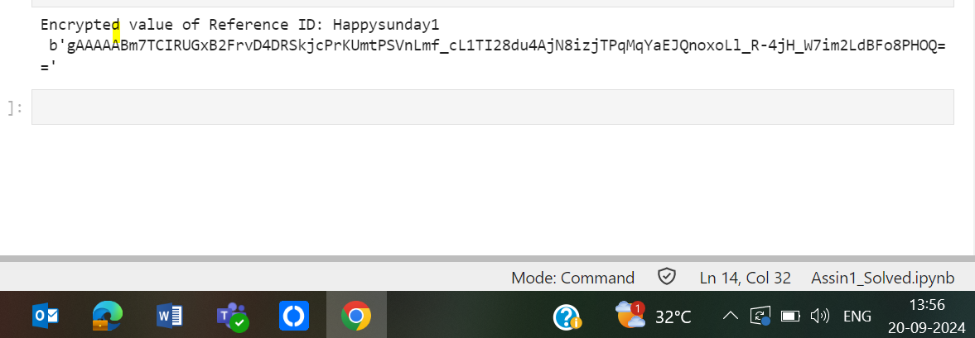

If the I have given wrong ID below error message will be generated.

