CIRCULAR QUEUE

#include <stdio.h>
#include <stdlib.h>

#define SIZE 5 // Maximum size of circular queue

int queue[SIZE];
int front = -1, rear = -1;
void enqueue(int value) {
if ((front == 0 && rear == SIZE - 1) || (rear + 1) % SIZE == front) {
printf("Queue Overflow! Cannot insert %d\n", value);
return;
}

if (front == -1) { // First element
front = rear = 0;
} else {
rear = (rear + 1) % SIZE;
}
queue[rear] = value;
printf("Deleted: %d\n", queue[front]);

if (front == rear) {
front = rear = -1;
} else {
front = (front + 1) % SIZE;
}
}

void display() {
if (front == -1) {
printf("Queue is Empty!\n");
return;
}

printf("Circular Queue Elements: ");
int i = front;
while (1) {
printf("%d ", queue[i]);
if (i == rear) break;
i = (i + 1) % SIZE;
}
printf("\n");
}

int main() {
int choice, value;
while (1) {
printf("\n--- Circular Queue Menu ---\n");
printf("1. Enqueue\n2. Dequeue\n3. Display\n4. Exit\n");
printf("Enter choice: ");
scanf("%d", &choice);

switch (choice) {
case 1:
printf("Enter value to enqueue: ");
scanf("%d", &value);
enqueue(value);
break;
case 2:
dequeue();
break;
case 3:
display();
break;
case 4:
exit(0);
default:
printf("Invalid choice!\n");
}
}
return 0;
}
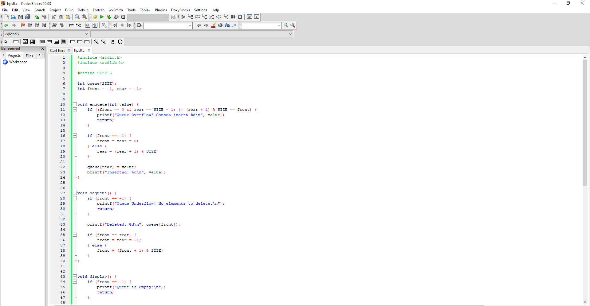
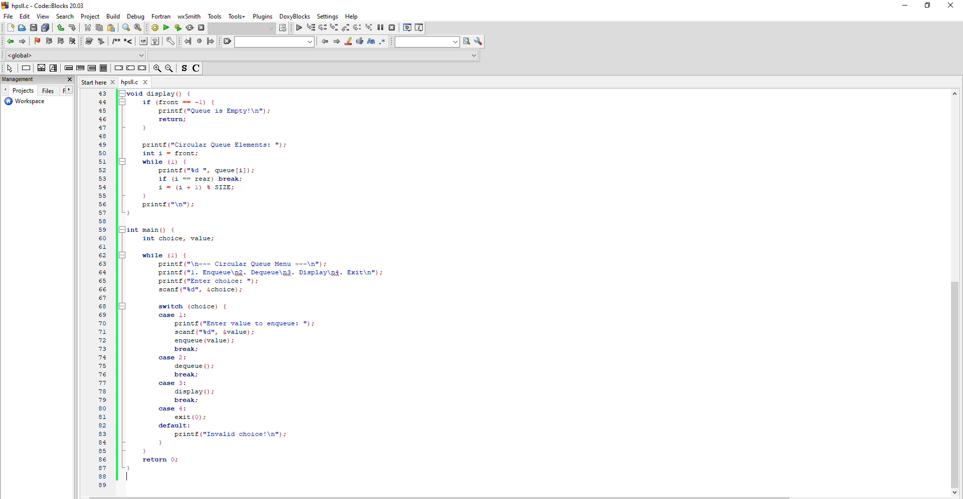
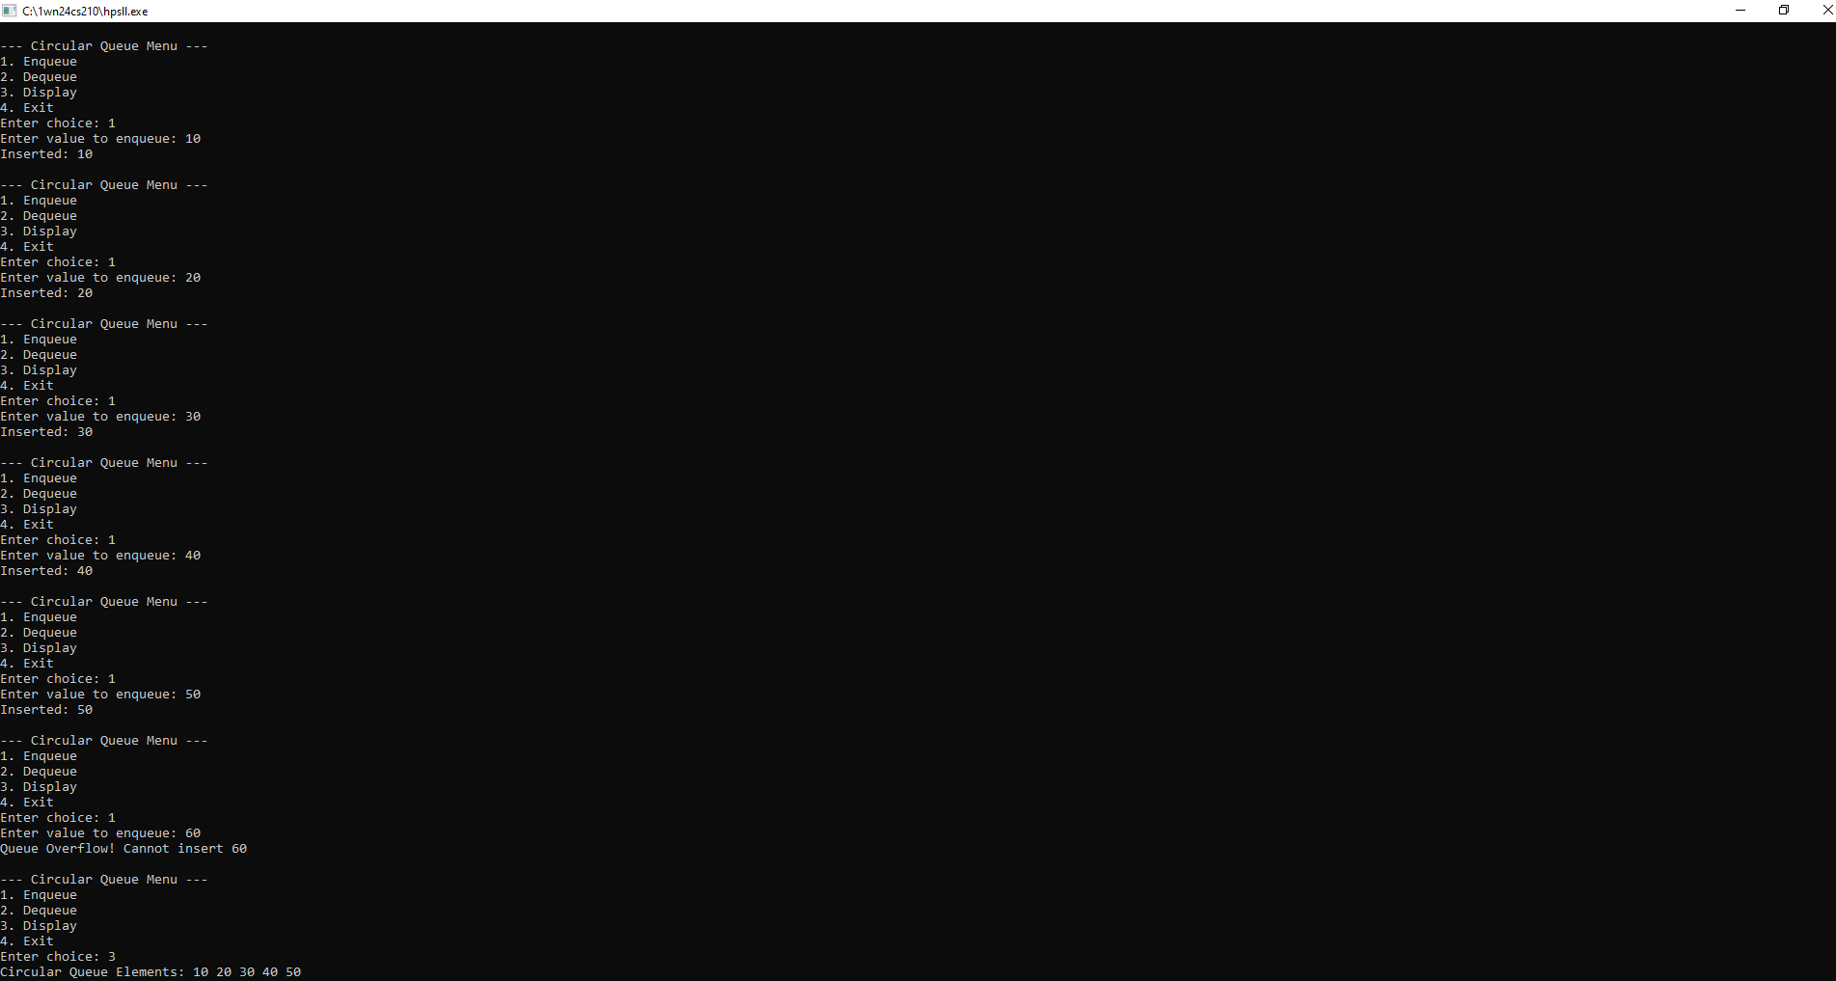

SINGLY LINKED LIST OPERATIONS:
WAP to implement Singly Linked List with following operations
- Create a linked list.
- Insertion of a node at first position , at any position and at end of the list.
Display the contents of the linked list.
#include <stdio.h>
#include <stdlib.h>

struct Node {
int data;
struct Node *next;
};
struct Node *head = NULL;
void createList(int n) {
int value;
struct Node *newNode, *temp;

for(int i = 0; i < n; i++) {
newNode = (struct Node*)malloc(sizeof(struct Node));
printf("Enter data for node %d: ", i+1);
scanf("%d", &value);
newNode->data = value;
newNode->next = NULL;
if(head == NULL) {
head = newNode;
} else {
temp = head;
while(temp->next != NULL)
temp = temp->next;
temp->next = newNode;
}
}
}
// Insert at beginning
void insertAtFirst(int value) {
struct Node *newNode = (struct Node*)malloc(sizeof(struct Node));
newNode->data = value;
newNode->next = head;
head = newNode;
}
void insertAtPosition(int value, int pos) {
struct Node *newNode = (struct Node*)malloc(sizeof(struct Node));
newNode->data = value;
if(pos == 1) {
newNode->next = head;
head = newNode;
return;
}
struct Node *temp = head;
for(int i = 1; i < pos-1 && temp != NULL; i++) {
temp = temp->next;
}
if(temp == NULL) {
printf("Invalid position!\n");
free(newNode);
return;
}
newNode->next = temp->next;
temp->next = newNode;
}
void insertAtEnd(int value) {
struct Node *newNode = (struct Node*)malloc(sizeof(struct Node));
struct Node *temp;

newNode->data = value;
newNode->next = NULL;
if(head == NULL) {
head = newNode;
return;
}
temp = head;
while(temp->next != NULL)
temp = temp->next;
temp->next = newNode;
}
void display() {
struct Node *temp = head;

if(head == NULL) {
printf("List is empty!\n");
return;
}
printf("Linked List: ");
while(temp != NULL) {
printf("%d -> ", temp->data);
temp = temp->next;
}
printf("NULL\n");
}
int main() {
int choice, value, pos, n;

while(1) {
printf("\n--- Singly Linked List Operations (Insertion) ---\n");
printf("1. Create Linked List\n2. Insert at First\n3. Insert at Position\n4. Insert at End\n5. Display\n6. Exit\n");
printf("Enter choice: ");
scanf("%d", &choice);

switch(choice) {
case 1:
printf("Enter number of nodes: ");
scanf("%d", &n);
createList(n);
break;

case 2:
printf("Enter value: ");
scanf("%d", &value);
insertAtFirst(value);
break;

case 3:
printf("Enter value: ");
scanf("%d", &value);
printf("Enter position: ");
scanf("%d", &pos);
insertAtPosition(value, pos);
break;

case 4:
printf("Enter value: ");
scanf("%d", &value);
insertAtEnd(value);
break;
case 5:
display();
break;
case 6:
exit(0);
default:
printf("Invalid Choice!\n");
}
}
return 0;
}
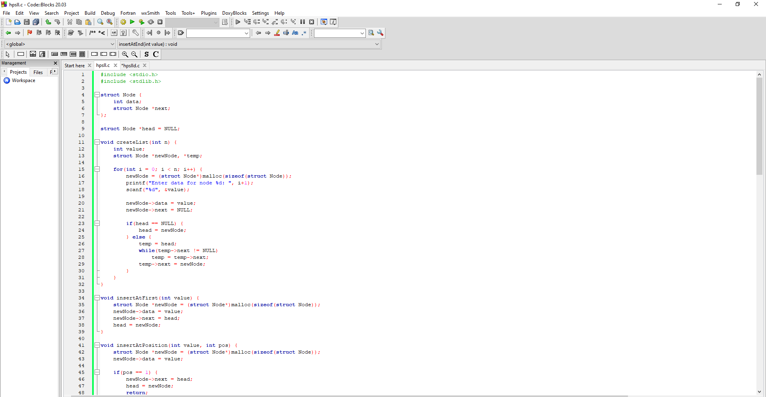
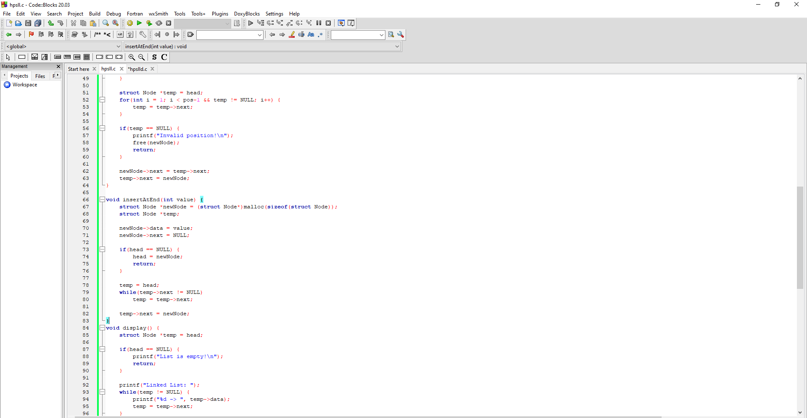
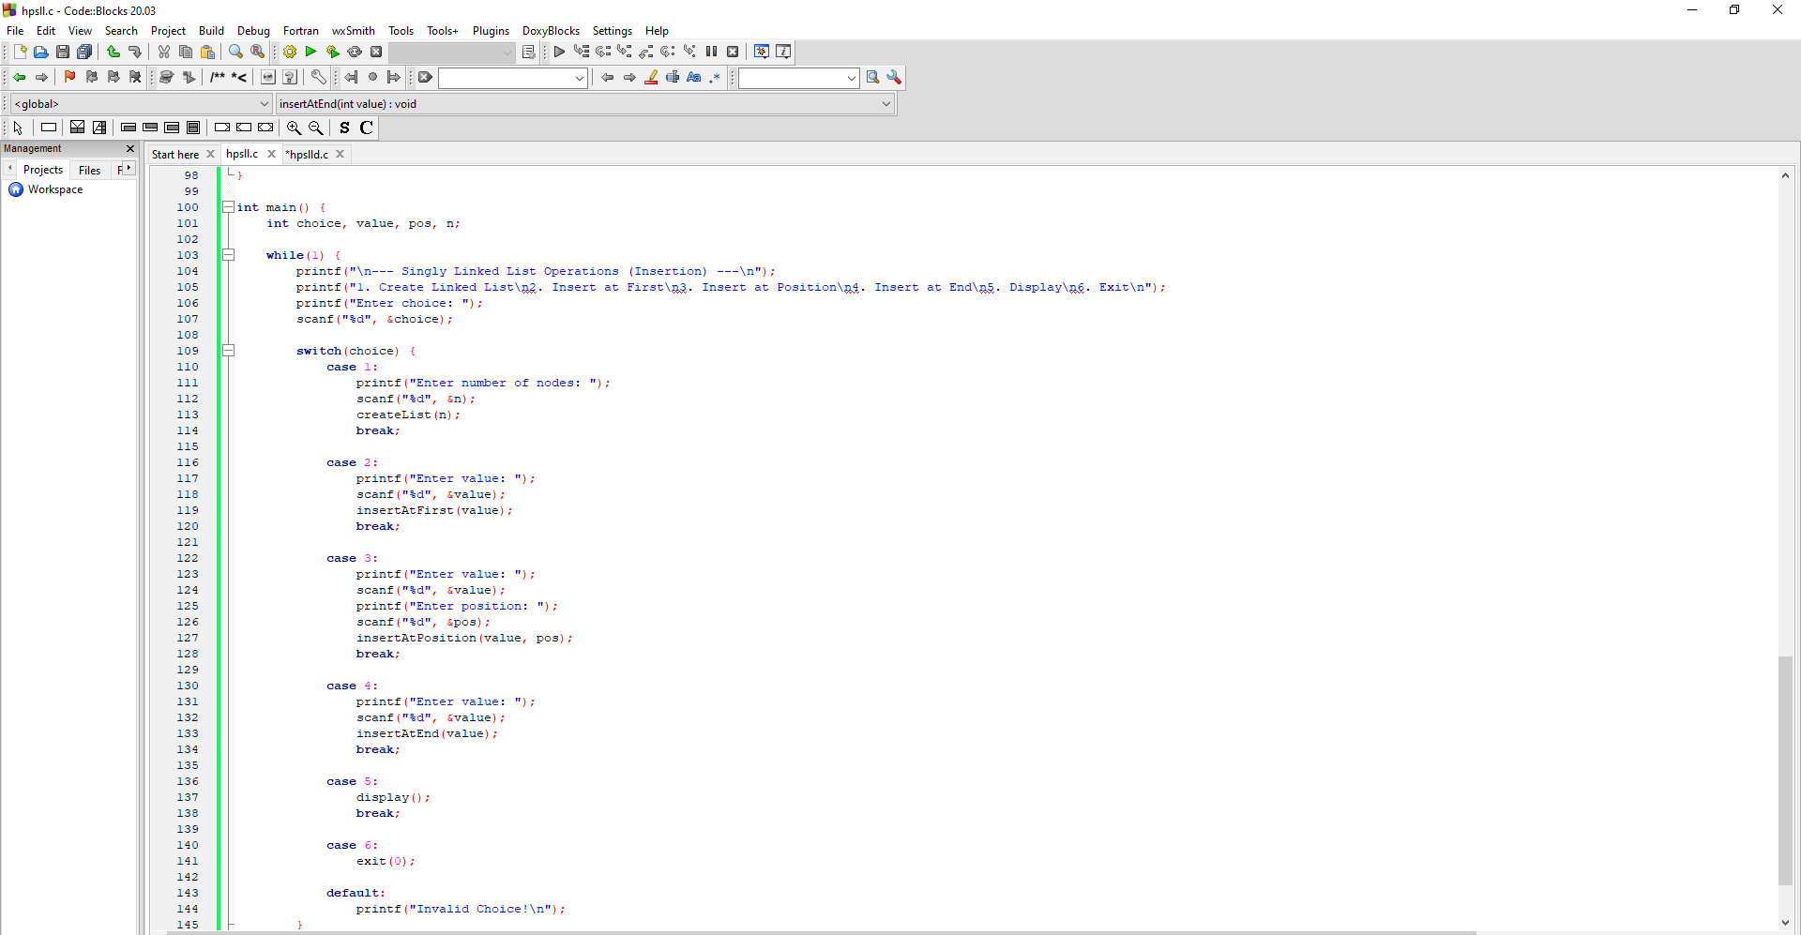
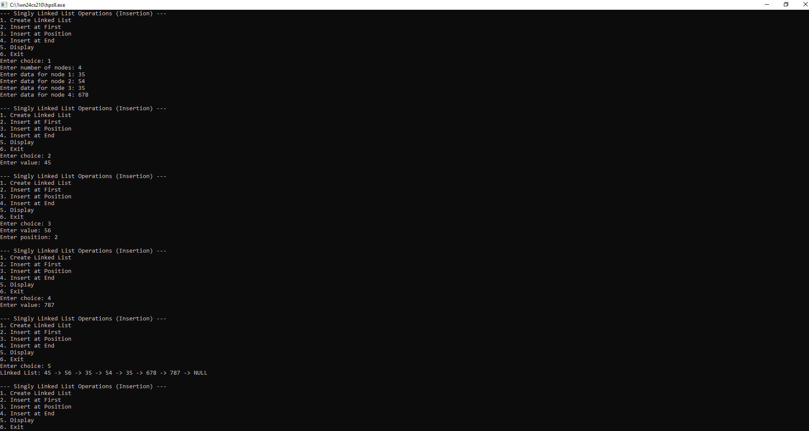

WAP to implement Singly Linked List with following operations
- Create a linked list.
- Deletion of first element, specified element and last element in the list.
- Display the contents of the linked list.
#include <stdio.h>
#include <stdlib.h>
struct Node {
int data;
struct Node *next;
};
struct Node *head = NULL;
void createList(int n) {
int value;
struct Node *newNode, *temp;
for(int i = 0; i < n; i++) {
newNode = (struct Node*)malloc(sizeof(struct Node));
printf("Enter data for node %d: ", i+1);
scanf("%d", &value);

newNode->data = value;
newNode->next = NULL;

if(head == NULL) head = newNode;
else {
temp = head;
while(temp->next != NULL) temp = temp->next;
temp->next = newNode;
}
}
}
void deleteFirst() {
if(head == NULL) {
printf("List is empty!\n");
return;
}
struct Node *temp = head;
head = head->next;
printf("Deleted: %d\n", temp->data);
free(temp);
}
void deleteSpecific(int key) {
struct Node *temp = head, *prev = NULL;

while(temp != NULL && temp->data != key) {
prev = temp;
temp = temp->next;
}
if(temp == NULL) {
printf("Element not found!\n");
return;
}
if(prev == NULL) head = temp->next;
else prev->next = temp->next;

printf("Deleted: %d\n", temp->data);
free(temp);
}
void deleteLast() {
if(head == NULL) {
printf("List is empty!\n");
return;
}
if(head->next == NULL) {
printf("Deleted: %d\n", head->data);
free(head);
head = NULL;
return;
}
struct Node *temp = head;
while(temp->next->next != NULL)
temp = temp->next;

printf("Deleted: %d\n", temp->next->data);
free(temp->next);
temp->next = NULL;
}
void display() {
struct Node *temp = head;
if(head == NULL) {
printf("List is empty!\n");
return;
}
printf("Linked List: ");
while(temp != NULL) {
printf("%d -> ", temp->data);
temp = temp->next;
}
printf("NULL\n");
}
int main() {
int choice, key, n;

while(1) {
printf("\n--- Singly Linked List Operations (Deletion) ---\n");
printf("1. Create List\n2. Delete First\n3. Delete Specific\n4. Delete Last\n5. Display\n6. Exit\n");
scanf("%d", &choice);

switch(choice) {
case 1:
printf("Enter number of nodes: ");
scanf("%d", &n);
createList(n);
break;

case 2:
deleteFirst();
break;

case 3:
printf("Enter element to delete: ");
scanf("%d", &key);
deleteSpecific(key);
break;
case 4:
deleteLast();
break;

case 5:
display();
break;
case 6:
exit(0);
break;
default:
printf("Invalid choice!\n");
}
}

return 0;
}
