Introduction
Film festivals around the world are a platform to showcase cinematic and popular films and appreciate the people in the film industry. There are many festival platforms available. In our proposed database system, we focus on all key points mentioned like the location of festival, festival information, actors, directors, studios, movies awards etc. For creating a relational database model, we connect all the tables using the relationship between them. The relationship can be one to one, one to many, many to many etc. For our proposed model, we will have 9 entities in total including one bridge entity. According to our assumption, we will have following list of entities:
- Location
- Festival
- Actor
- Director
- Studio
- Movie
- Movie Category
- Awards
- Movie Actor (Bridge)
Overview
In this project, we will have many beautiful locations for the festivals and we can pick up any for the festival depending on requirements. In one location, there can be many festival happens. Also, for each festival, we invite many studios to showcase their movies and they will get the awards based on movies rating. Actors and directors are also invited in the festival. This database project can be implemented using MS ACCESS. Using that, we can create all the tables and insert the data. According to our assumption, all the tables listed above will be connected primary keys and foreign keys.

Entity Relationship Diagram
ER (Entity Relationship) diagram is one of the models that offer a visual representation of the current database system. ERD which is developed will clearly describe the entities and attributes. In the ERD, we can see that there is total 10 entities including the bridge table. These tables are linked with each other using primary and foreign keys. All primary keys and foreign keys. Usually there are one to many or one to one relationship used in the database system.
First, we must define the project scope or scenario for the better understanding, since different issues can be solved by different designs and more than one scenario can be generated for each question. According to their thought, people build them. We are also constructing scenario so that our design can be situationally specific.

According to our proposed model, the Entity relationship diagram will look like:

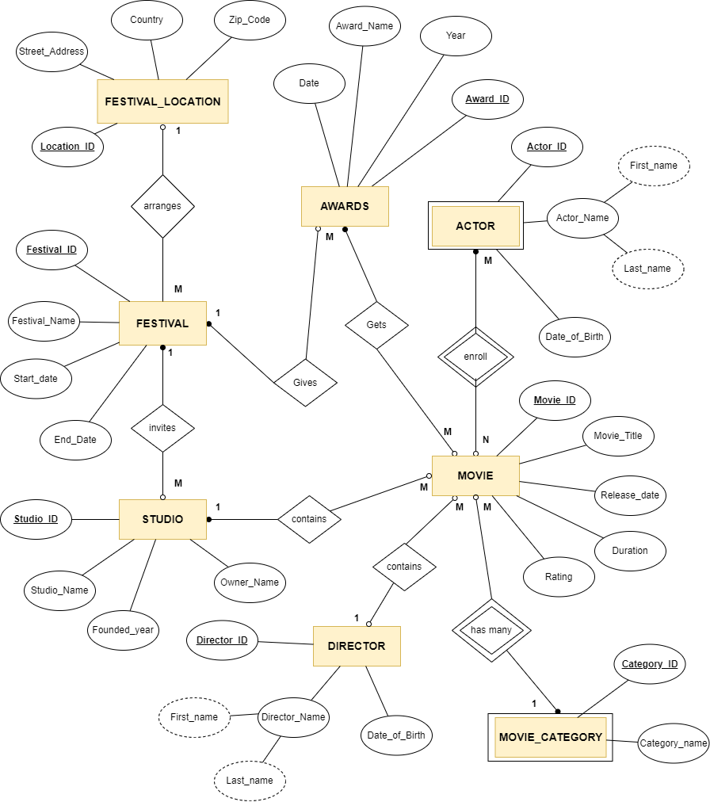
Relationships & Business Rules
According to our assumption, we will have following list of business rules that are implemented in the database design.
A location can have many festivals. (0..M)
Each festival invites many studios. (1..M)
A studio can have many movies. (1..M)
A director can have many movies. (1..M)
An actor can work on many movies.(M..N)
One movie can have many actors. (M..N)
One category can have many movies. (0..M)
Relational Schema
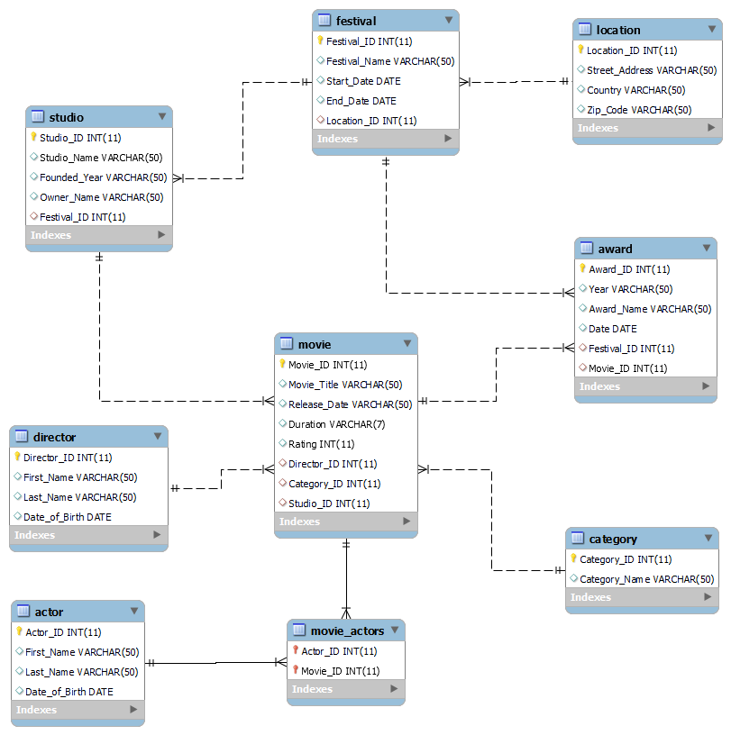
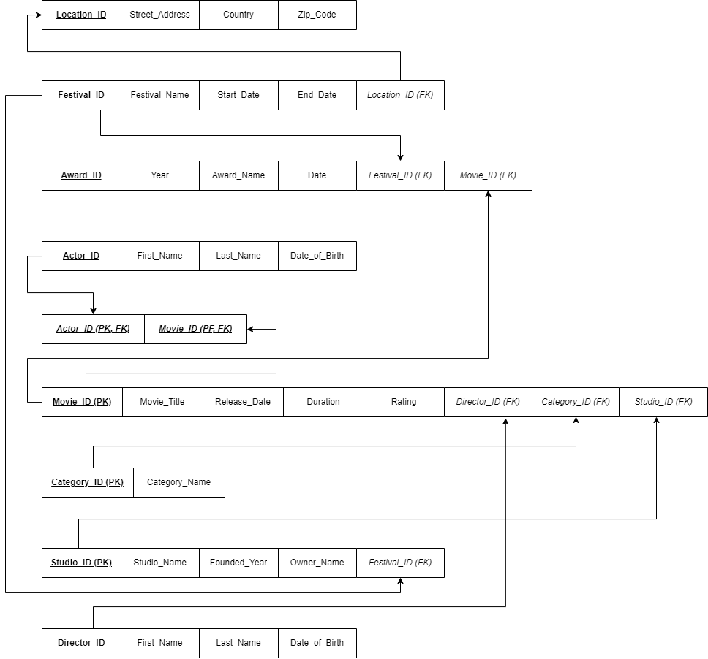

Constraints
Relationship Set | Cardinality | Participation
Arranges | One to many | Festival location , Festival (A festival should arranged in only one place)
Invites | One to many | Festival, Studio  (Festival can invite many studios in the festival)
Gives | One to many | Festival, Awards  (There can be many awards given in each festival)
Contains | One to many | Studio, Movies  (A studio can have many movies to auction in the festival)
Gets | One to many ` | Movie, Awards  (A movie can get many awards in the festival)
Enroll | Many to many | Actor, Movie  (A movie can enroll many actors and one actor can work on many movies)

Normalization
According to the assumption made, we have the list of entities along with their attributes. To identify the dependencies, we will do the following:
Functional Dependencies are:
Studio
Studio_id studio_name, founded_year, owner_name
Director
Director_id first_name, last_name, date_of_birth
Actor
Actor_id first_name, last_name, date_of_birth
Award
Award_id festival_id, movie_id
Movie_actors
Movie_id, actor_id
Festival
Festival_id location_id
Festival_id Festival_name, start_date, end_date
Movie
Movie_id Director_id, Category_id, studio_id

The normalized table will be:
LOCATION (Location_ID , Street_Address, Country, Zip_Code)
FESTIVAL (Festival_ID , Festival_name, start_date, End_Date, Location_ID)
FK Location_ID REF LOCATION (Location_ID)
STUDIO (Studio_ID, Studio_Name, Founded_Year, Owner_Name, Festival_ID)
FK Festival_ID REF FESTIVAL (Festival_ID)
DIRECTOR (Director_ID , First_Name, Last_Name, Date_of_Birth)
ACTOR (Actor_ID , First_Name, Last_Name, Date_of_Birth)
CATEGORY (Category_ID , Category_Name)
MOVIE (Movie_ID, Movie_Title, Release_Date, Duration, Rating, Director_ID, Category_ID,
Studio_ID)
FK Director_ID REF DIRECTOR (Director_ID),
FK Category_ID REF CATEGORY (Category_ID),
FK Studio_ID REF STUDIO (Studio_ID),
MOVIE_ACTORS (Actor_ID, Movie_ID)
FK Actor_ID REF ACTOR (Actor_ID),
FK Movie_ID REF MOVIE (Movie_ID)
AWARD (Award_ID , Year, Award_Name, Date, Festival_ID, Movie_ID)
FK Festival_ID REF FESTIVAL (Festival_ID),
FK Movie_ID REF MOVIE (Movie_ID)

Data Description

Actor
Column | Type | Null | Default
Actor_Id (Primary) | Int(11) | No
First_Name | Varchar(50) | No | Null
Last_Name | Varchar(50) | No | Null
Date_Of_Birth | Date | Yes | Null

Indexes
Keyname | Column | Cardinality | Collation | Null
Primary | Actor_Id | 10 | A | No

Award
Column | Type | Null | Default
Award_Id (Primary) | Int(11) | No
Year | Varchar(50) | Yes | Null
Award_Name | Varchar(50) | No | Null
Date | Date | Yes | Null
Festival_Id | Int(11) | No | Null
Movie_Id | Int(11) | No | Null

Indexes
Keyname | Column | Cardinality | Collation | Null
Primary | Award_Id | 10 | A | No
Movie_Id | Movie_Id | 10 | A | Yes
Festival_Id | Festival_Id | 10 | A | Yes

Category
Column | Type | Null | Default
Category_Id (Primary) | Int(11) | No
Category_Name | Varchar(50) | No | Null

Indexes
Keyname | Column | Cardinality | Collation | Null
Primary | Category_Id | 10 | A | No

Director
Column | Type | Null | Default
Director_Id (Primary) | Int(11) | No
First_Name | Varchar(50) | No | Null
Last_Name | Varchar(50) | No | Null
Date_Of_Birth | Date | Yes | Null

Indexes
Keyname | Column | Cardinality | Collation | Null
Primary | Director_Id | 10 | A | No

Festival
Column | Type | Null | Default
Festival_Id (Primary) | Int(11) | No
Festival_Name | Varchar(50) | No | Null
Start_Date | Date | No | Null
End_Date | Date | No | Null
Location_Id | Int(11) | Yes | Null

Indexes
Keyname | Column | Cardinality | Collation | Null
Primary | Festival_Id | 10 | A | No
Location_Id | Location_Id | 10 | A | Yes

Location
Column | Type | Null | Default
Location_Id (Primary) | Int(11) | No
Street_Address | Varchar(50) | No | Null
Country | Varchar(50) | Yes | Null
Zip_Code | Varchar(50) | Yes | Null

Indexes
Keyname | Column | Cardinality | Collation | Null
Primary | Location_Id | 5 | A | No

Movie
Column | Type | Null | Default
Movie_Id (Primary) | Int(11) | No
Movie_Title | Varchar(50) | No | Null
Release_Date | Varchar(50) | No | Null
Duration | Varchar(7) | Yes | Null
Rating | Int(11) | No | Null
Director_Id | Int(11) | Yes | Null
Category_Id | Int(11) | Yes | Null
Studio_Id | Int(11) | Yes | Null

Indexes
Keyname | Column | Cardinality | Collation | Null
Primary | Movie_Id | 10 | A | No
Director_Id | Director_Id | 10 | A | Yes
Category_Id | Category_Id | 10 | A | Yes
Studio_Id | Studio_Id | 10 | A | Yes

Movie_Actors
Column | Type | Null | Default
Actor_Id (Primary) | Int(11) | No
Movie_Id (Primary) | Int(11) | No

Indexes
Keyname | Column | Cardinality | Collation | Null
Primary | Actor_Id | 10 | A | No
 | Movie_Id | 10 | A | No
Movie_Id | Movie_Id | 10 | A | No

Studio
Column | Type | Null | Default
Studio_Id (Primary) | Int(11) | No
Studio_Name | Varchar(50) | Yes | Null
Founded_Year | Varchar(50) | Yes | Null
Owner_Name | Varchar(50) | Yes | Null
Festival_Id | Int(11) | Yes | Null

Indexes
Keyname | Column | Cardinality | Collation | Null
Primary | Studio_Id | 10 | A | No
Festival_Id | Festival_Id | 10 | A | Yes

Database Tables Creation
create table Location (
Location_ID INT PRIMARY KEY,
Street_Address VARCHAR(50),
Country VARCHAR(50) NOT NULL,
Zip_Code VARCHAR(50)
);
create table Festival (
Festival_ID INT PRIMARY KEY,
Festival_Name VARCHAR(50),
Start_Date DATE NOT NULL,
End_Date DATE NOT NULL,
Location_ID INT,
FOREIGN KEY (location_ID) REFERENCES Location(Location_ID)
);
create table Actor (
Actor_ID INT PRIMARY KEY,
First_Name VARCHAR(50) NOT NULL,
Last_Name VARCHAR(50) NOT NULL,
Date_of_Birth DATE
);
create table Director (
Director_ID INT PRIMARY KEY,
First_Name VARCHAR(50) NOT NULL,
Last_Name VARCHAR(50),
Date_of_Birth DATE
);

create table Category (
Category_ID INT PRIMARY KEY,
Category_Name VARCHAR(50) NOT NULL
);
create table Studio (
Studio_ID INT PRIMARY KEY,
Studio_Name VARCHAR(50) NOT NULL,
Founded_Year VARCHAR(50),
Owner_Name VARCHAR(50) NOT NULL,
Festival_ID INT,

FOREIGN KEY (Festival_ID) REFERENCES Festival(Festival_ID)
);
create table Movie (
Movie_ID INT PRIMARY KEY,
Movie_Title VARCHAR(50) NOT NULL,
Release_Year INT,
Duration VARCHAR(7),
Rating INT NOT NULL,
Director_ID INT,
Category_ID INT,
Studio_ID INT,

FOREIGN KEY (Director_ID) REFERENCES Director(Director_ID),
FOREIGN KEY (Category_ID) REFERENCES Category(Category_ID),
FOREIGN KEY (Studio_ID) REFERENCES Studio(Studio_ID)
);
create table Movie_Actors (
Actor_ID INT,
Movie_ID INT,

PRIMARY KEY(Actor_ID, Movie_ID),
FOREIGN KEY (Actor_ID) REFERENCES Actor(Actor_ID),
FOREIGN KEY (Movie_ID) REFERENCES Movie(Movie_ID)
);
create table Award (
Award_ID INT PRIMARY KEY,
Year VARCHAR(50),
Award_Name VARCHAR(50) NOT NULL,
Date DATE,
Festival_ID INT NOT NULL,
Movie_ID INT NOT NULL,

FOREIGN KEY (Movie_ID) REFERENCES Movie(Movie_ID),
FOREIGN KEY (Festival_ID) REFERENCES Festival(Festival_ID)
);
Database Sample Data Insertion
insert into Location (Location_ID, Street_Address, Country, Zip_Code) values (1, '013 Sunnyside Pass', 'Russia', '663330');
insert into Location (Location_ID, Street_Address, Country, Zip_Code) values (2, '2806 Susan Hill', 'Russia', '352177');
insert into Location (Location_ID, Street_Address, Country, Zip_Code) values (3, '0010 1st Plaza', 'Japan', '441-3155');
insert into Location (Location_ID, Street_Address, Country, Zip_Code) values (4, '9 3rd Way', 'Russia', '303002');
insert into Location (Location_ID, Street_Address, Country, Zip_Code) values (5, '441 Stephen Trail', 'China', null);
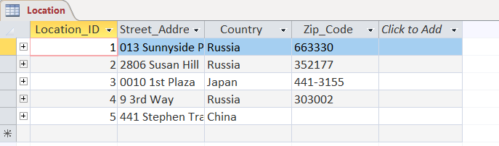
insert into Festival (Festival_ID, Festival_Name, Start_Date, End_Date, Location_ID) values (1, 'Hoppe LLC', '2021-11-19', '2021-12-26', 3);
insert into Festival (Festival_ID, Festival_Name, Start_Date, End_Date, Location_ID) values (2, 'Streich-Kessler', '2022-02-03', '2022-09-17', 4);
insert into Festival (Festival_ID, Festival_Name, Start_Date, End_Date, Location_ID) values (3, 'Thompson, Turcotte and Denesik', '2022-06-21', '2022-08-15', 4);
insert into Festival (Festival_ID, Festival_Name, Start_Date, End_Date, Location_ID) values (4, 'Kutch, Walter and Streich', '2021-09-27', '2022-09-17', 2);
insert into Festival (Festival_ID, Festival_Name, Start_Date, End_Date, Location_ID) values (5, 'Morar, Larkin and Hermann', '2021-12-08', '2022-01-21', 4);
insert into Festival (Festival_ID, Festival_Name, Start_Date, End_Date, Location_ID) values (6, 'Krajcik-Green', '2022-02-07', '2022-01-18', 3);
insert into Festival (Festival_ID, Festival_Name, Start_Date, End_Date, Location_ID) values (7, 'Breitenberg-Morar', '2021-10-31', '2022-01-19', 1);
insert into Festival (Festival_ID, Festival_Name, Start_Date, End_Date, Location_ID) values (8, 'Feest-Dickens', '2022-05-08', '2022-11-05', 4);
insert into Festival (Festival_ID, Festival_Name, Start_Date, End_Date, Location_ID) values (9, 'Bashirian-Jakubowski', '2022-07-13', '2022-06-26', 3);
insert into Festival (Festival_ID, Festival_Name, Start_Date, End_Date, Location_ID) values (10, 'Cole LLC', '2022-08-16', '2022-11-16', 4);
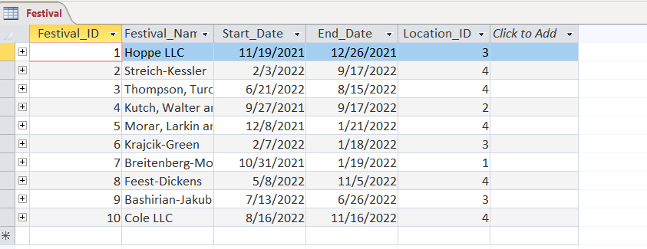

insert into Actor (Actor_ID, First_Name, Last_Name, Date_of_Birth) values (1, 'Claus', 'Balshaw', '1997-10-26');
insert into Actor (Actor_ID, First_Name, Last_Name, Date_of_Birth) values (2, 'Scot', 'Andreaccio', '1989-10-24');
insert into Actor (Actor_ID, First_Name, Last_Name, Date_of_Birth) values (3, 'Pam', 'Tabram', '1998-12-27');
insert into Actor (Actor_ID, First_Name, Last_Name, Date_of_Birth) values (4, 'Demetria', 'Youthead', '1995-04-12');
insert into Actor (Actor_ID, First_Name, Last_Name, Date_of_Birth) values (5, 'Pat', 'Klewi', '1998-04-25');
insert into Actor (Actor_ID, First_Name, Last_Name, Date_of_Birth) values (6, 'Beatrix', 'Coleford', '1996-03-24');
insert into Actor (Actor_ID, First_Name, Last_Name, Date_of_Birth) values (7, 'Gennie', 'Barthropp', '1989-11-16');
insert into Actor (Actor_ID, First_Name, Last_Name, Date_of_Birth) values (8, 'Amalita', 'Milam', '1994-10-19');
insert into Actor (Actor_ID, First_Name, Last_Name, Date_of_Birth) values (9, 'Loise', 'Syphas', '1991-08-26');
insert into Actor (Actor_ID, First_Name, Last_Name, Date_of_Birth) values (10, 'Harlen', 'Grigoliis', '1990-04-06');
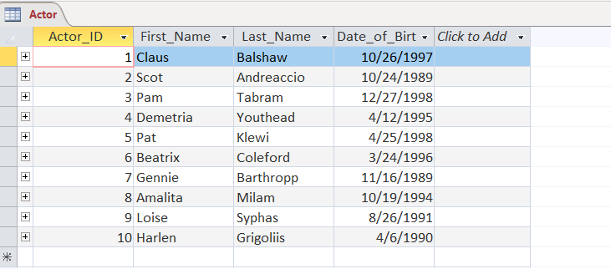
insert into Director (Director_ID, First_Name, Last_Name, Date_of_Birth) values (1, 'Tedmund', 'Perillo', '1996-01-07');
insert into Director (Director_ID, First_Name, Last_Name, Date_of_Birth) values (2, 'Sharl', 'Aulsford', '1991-07-07');
insert into Director (Director_ID, First_Name, Last_Name, Date_of_Birth) values (3, 'Harold', 'Jobbins', '1995-08-15');
insert into Director (Director_ID, First_Name, Last_Name, Date_of_Birth) values (4, 'Ameline', 'Fountaine', '1993-06-06');
insert into Director (Director_ID, First_Name, Last_Name, Date_of_Birth) values (5, 'Dana', 'Davis', '1996-04-14');
insert into Director (Director_ID, First_Name, Last_Name, Date_of_Birth) values (6, 'Joanna', 'Hugonet', '1990-02-23');
insert into Director (Director_ID, First_Name, Last_Name, Date_of_Birth) values (7, 'Cortie', 'Ferreo', '1998-08-20');
insert into Director (Director_ID, First_Name, Last_Name, Date_of_Birth) values (8, 'Florina', 'Bainbrigge', '1990-08-08');
insert into Director (Director_ID, First_Name, Last_Name, Date_of_Birth) values (9, 'Aguie', 'Pryce', '1995-10-06');
insert into Director (Director_ID, First_Name, Last_Name, Date_of_Birth) values (10, 'Willi', 'Koppes', '1998-09-20');
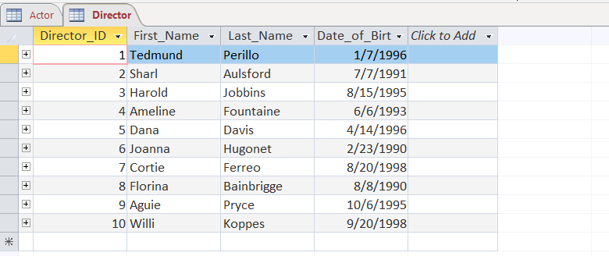
insert into Category (Category_ID, Category_Name) values (1, 'Children');
insert into Category (Category_ID, Category_Name) values (2, 'Drama');
insert into Category (Category_ID, Category_Name) values (3, 'Comedy|Romance');
insert into Category (Category_ID, Category_Name) values (4, 'Horror|Thriller');
insert into Category (Category_ID, Category_Name) values (5, 'Action|Adventure');
insert into Category (Category_ID, Category_Name) values (6, 'Comedy|Crime');
insert into Category (Category_ID, Category_Name) values (7, 'Action|Adventure|Western');
insert into Category (Category_ID, Category_Name) values (8, 'Comedy|Western');
insert into Category (Category_ID, Category_Name) values (9, 'Animation|Drama|Romance');
insert into Category (Category_ID, Category_Name) values (10, 'Comedy');
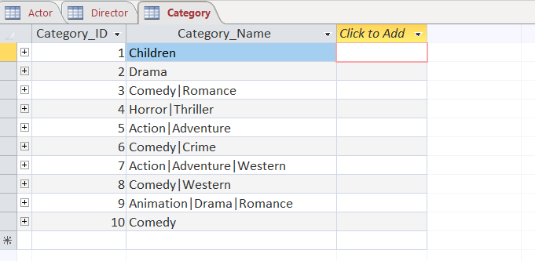
insert into Studio (Studio_ID, Studio_Name, Founded_Year, Owner_Name, Festival_ID) values (1, 'McClure LLC', 1995, 'Priscilla Bernardt', 8);
insert into Studio (Studio_ID, Studio_Name, Founded_Year, Owner_Name, Festival_ID) values (2, 'Rippin, Donnelly and Emard', 2012, 'Aggi Tale', 4);
insert into Studio (Studio_ID, Studio_Name, Founded_Year, Owner_Name, Festival_ID) values (3, 'Dooley, Williamson and McKenzie', 1990, 'Red Mizzi', 1);
insert into Studio (Studio_ID, Studio_Name, Founded_Year, Owner_Name, Festival_ID) values (4, 'Abbott, McCullough and Runolfsdottir', 2006, 'Philip Davidowich', 4);
insert into Studio (Studio_ID, Studio_Name, Founded_Year, Owner_Name, Festival_ID) values (5, 'Spinka Inc', 2004, 'Etheline Arckoll', 7);
insert into Studio (Studio_ID, Studio_Name, Founded_Year, Owner_Name, Festival_ID) values (6, 'Renner-Hirthe', 1996, 'Dyane Dore', 10);
insert into Studio (Studio_ID, Studio_Name, Founded_Year, Owner_Name, Festival_ID) values (7, 'Emmerich, West and Schmitt', 2007, 'Livvy Venables', 1);
insert into Studio (Studio_ID, Studio_Name, Founded_Year, Owner_Name, Festival_ID) values (8, 'Wisozk Inc', 1971, 'Alfy Crush', 1);
insert into Studio (Studio_ID, Studio_Name, Founded_Year, Owner_Name, Festival_ID) values (9, 'Ferry LLC', 2012, 'Jourdan Campbell-Dunlop', 3);
insert into Studio (Studio_ID, Studio_Name, Founded_Year, Owner_Name, Festival_ID) values (10, 'Farrell, Rath and Klein', 2003, 'Skippie Stanney', 2);
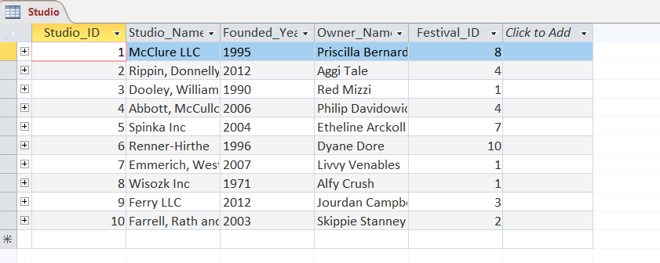
insert into Movie (Movie_ID, Movie_Title, Release_Year, Duration, Rating, Director_ID, Category_ID, Studio_ID) values (1, 'Cheap Thrills', 1997, '4 hours', 5, 1, 4, 8);
insert into Movie (Movie_ID, Movie_Title, Release_Year, Duration, Rating, Director_ID, Category_ID, Studio_ID) values (2, 'Russendisko', 1986, '3 hours', 9, 5, 3, 1);
insert into Movie (Movie_ID, Movie_Title, Release_Year, Duration, Rating, Director_ID, Category_ID, Studio_ID) values (3, 'Chasing Amy', 1997, '3 hours', 6, 9, 4, 1);
insert into Movie (Movie_ID, Movie_Title, Release_Year, Duration, Rating, Director_ID, Category_ID, Studio_ID) values (4, 'Ariel', 2005, '3 hours', 8, 2, 7, 9);
insert into Movie (Movie_ID, Movie_Title, Release_Year, Duration, Rating, Director_ID, Category_ID, Studio_ID) values (5, 'Get Carter', 2009, '3 hours', 5, 3, 8, 7);
insert into Movie (Movie_ID, Movie_Title, Release_Year, Duration, Rating, Director_ID, Category_ID, Studio_ID) values (6, 'Lovers of Hate', 2009, '4 hours', 9, 9, 2, 6);
insert into Movie (Movie_ID, Movie_Title, Release_Year, Duration, Rating, Director_ID, Category_ID, Studio_ID) values (7, 'Legend II, The (Fong Sai Yuk juk jaap)', 1993, '4 hours', 8, 2, 8, 7);
insert into Movie (Movie_ID, Movie_Title, Release_Year, Duration, Rating, Director_ID, Category_ID, Studio_ID) values (8, 'Vice', 2001, '2 hours', 5, 8, 4, 9);
insert into Movie (Movie_ID, Movie_Title, Release_Year, Duration, Rating, Director_ID, Category_ID, Studio_ID) values (9, 'Perfect Getaway, A', 1996, '2 hours', 5, 1, 10, 10);
insert into Movie (Movie_ID, Movie_Title, Release_Year, Duration, Rating, Director_ID, Category_ID, Studio_ID) values (10, 'Cousin Angelica (La prima Angélica)', 1994, '4 hours', 8, 3, 8, 1);
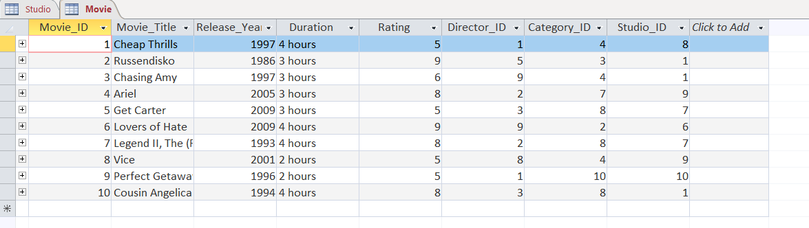
insert into Movie_Actors (Actor_ID, Movie_ID) values (1, 4);
insert into Movie_Actors (Actor_ID, Movie_ID) values (9, 8);
insert into Movie_Actors (Actor_ID, Movie_ID) values (8, 10);
insert into Movie_Actors (Actor_ID, Movie_ID) values (8, 4);
insert into Movie_Actors (Actor_ID, Movie_ID) values (7, 10);
insert into Movie_Actors (Actor_ID, Movie_ID) values (5, 2);
insert into Movie_Actors (Actor_ID, Movie_ID) values (2, 5);
insert into Movie_Actors (Actor_ID, Movie_ID) values (2, 7);
insert into Movie_Actors (Actor_ID, Movie_ID) values (3, 1);
insert into Movie_Actors (Actor_ID, Movie_ID) values (3, 10);
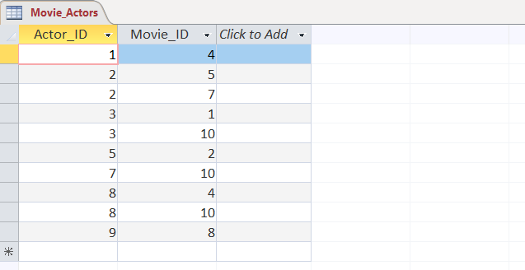
insert into Award (Award_ID, Year, Award_Name, Date, Festival_ID, Movie_ID) values (1, 1997, 'Wolff, Schmidt and Koss', '2021-12-25', 6, 10);
insert into Award (Award_ID, Year, Award_Name, Date, Festival_ID, Movie_ID) values (2, 2008, 'Okuneva, Hodkiewicz and Kulas', '2021-12-10', 10, 2);
insert into Award (Award_ID, Year, Award_Name, Date, Festival_ID, Movie_ID) values (3, 1992, 'Heathcote LLC', '2022-03-09', 5, 6);
insert into Award (Award_ID, Year, Award_Name, Date, Festival_ID, Movie_ID) values (4, 2001, 'Bailey-Olson', '2022-02-06', 5, 10);
insert into Award (Award_ID, Year, Award_Name, Date, Festival_ID, Movie_ID) values (5, 1995, 'Heidenreich Inc', '2022-03-12', 5, 10);
insert into Award (Award_ID, Year, Award_Name, Date, Festival_ID, Movie_ID) values (6, 1994, 'Runolfsdottir, Botsford and Spencer', '2022-03-12', 3, 9);
insert into Award (Award_ID, Year, Award_Name, Date, Festival_ID, Movie_ID) values (7, 1995, 'Wilkinson-Bartell', '2022-08-05', 9, 6);
insert into Award (Award_ID, Year, Award_Name, Date, Festival_ID, Movie_ID) values (8, 2008, 'Brakus and Sons', '2022-08-11', 9, 1);
insert into Award (Award_ID, Year, Award_Name, Date, Festival_ID, Movie_ID) values (9, 1994, 'Emmerich LLC', '2022-04-23', 3, 5);
insert into Award (Award_ID, Year, Award_Name, Date, Festival_ID, Movie_ID) values (10, 1995, 'Schiller-Armstrong', '2021-11-05', 9, 10);
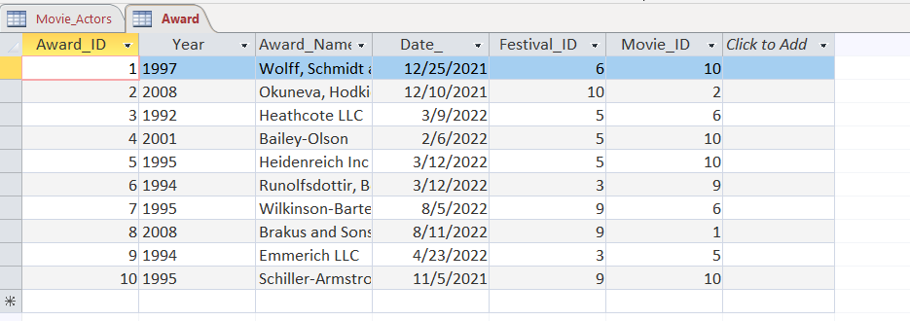

Designing and Implementation of Queries

Show all the movies who released after 2000 and have rating 5 +.

SQL:
SELECT Movie_Title, Release_Year, rating FROM Movie
WHERE Release_Year >=2000 AND Rating >5;

OUTPUT:
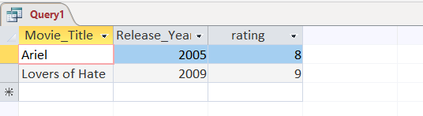

Show All festival information where festival name starts with K.
SQL:
SELECT Festival_Name, Start_Date, Location_ID FROM Festival
WHERE Festival_Name LIKE "K*";
OUTPUT:
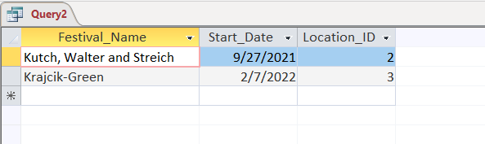

Show All the awards given between year 2000 and 2022.

SQL:
SELECT * FROM Award
WHERE year BETWEEN '2000' AND '2022'
ORDER BY Year DESC
OUTPUT:
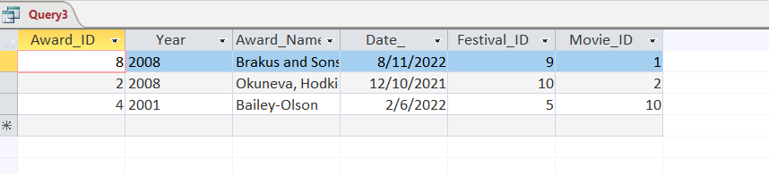
Show all the festival locations from Japan and Russia.
SQL:
SELECT * FROM Location WHERE country IN ('Russia', 'Japan');

OUTPUT:
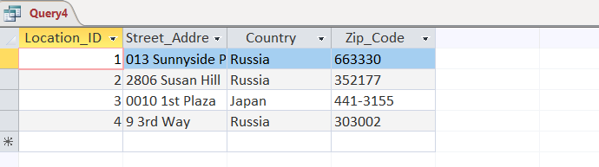

Show all the award name, and festival ID of awards given in 2022 and in the festival ID 3 and 5.

SQL:
SELECT Award_Name, Date_ , Festival_ID FROM Award
WHERE Date_ >= 01/01/2022
AND Festival_ID IN (3,5)
ORDER BY Date_ DESC;
OUTPUT:
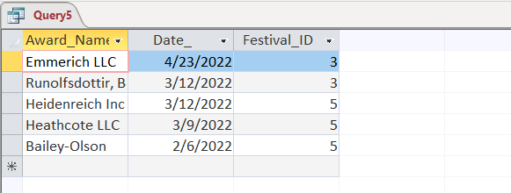

Show the movie title for all movies who have duration 2 hours or 4 hours with 5+ star rating and from category 1,2,3,4,5.

SQL:
SELECT Movie_title FROM Movie WHERE duration = '4 hours'
OR duration = '2 hours'
AND rating > 5
AND category_ID IN (1,2,3,4,5);

OUTPUT:
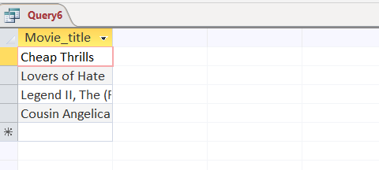
Show the festival location and number of festival arranges for each location.
SQL:
SELECT Location.Location_ID, Street_Address, Country, COUNT(Festival_ID) AS TotalFestival FROM Location INNER JOIN Festival
ON Location.Location_ID = Festival.Location_ID
GROUP BY Location.Location_ID, Street_Address, Country;

OUTPUT:
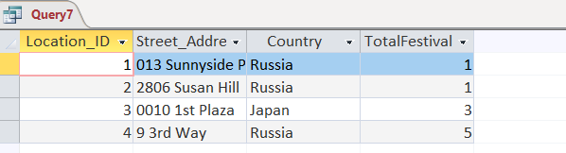

Show the Movie name who never gets any award.

SQL:
SELECT Movie_Title FROM Movie WHERE Movie_ID NOT IN
(SELECT Movie_ID FROM Award);

OUTPUT:
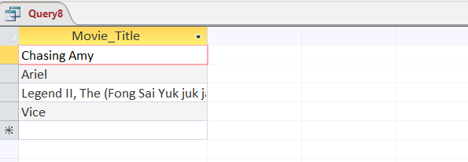

Show the Average rating of movies per category.

SQL:
SELECT Category_Name, AVG(Rating) FROM Category INNER JOIN MOVIE
ON Movie.Category_ID = Category.Category_ID
GROUP BY Category_Name;

OUTPUT:
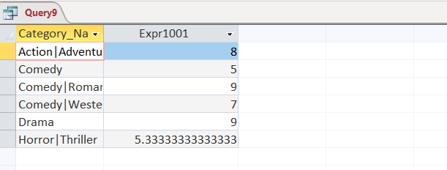
Show the director’s name and their movies having 7+ star ratings.
SQL:

SELECT director.First_Name, director.Last_Name, Movie_title, rating from director inner join movie
on director.director_ID = movie.director_ID
WHERE rating >7

OUTPUT:
