**WELCOME PAGE:**

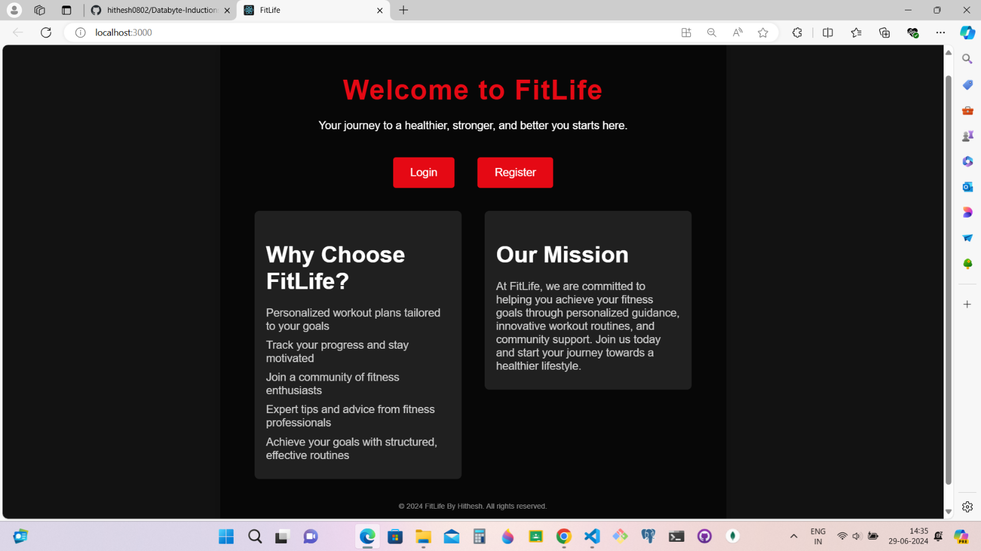

**NEW USER: REGISTER-PAGE:**

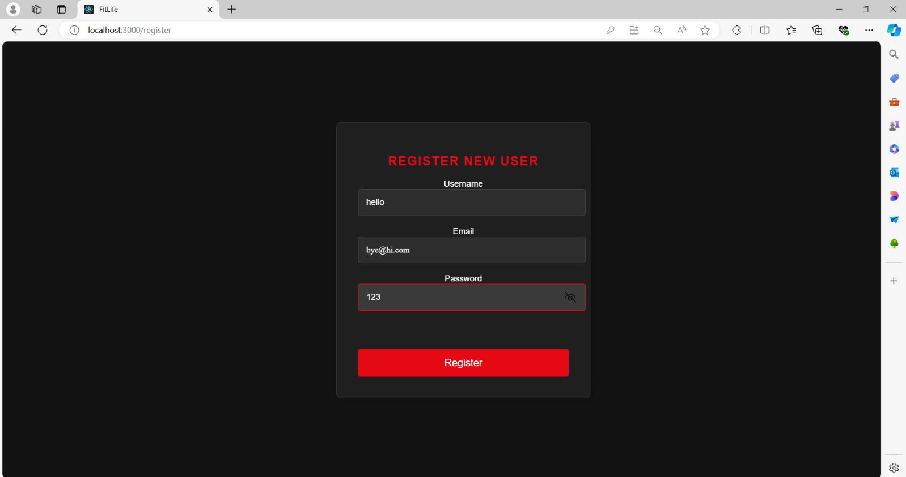

**LOGIN PAGE:** (Existing user/ redirected successfully from register page)

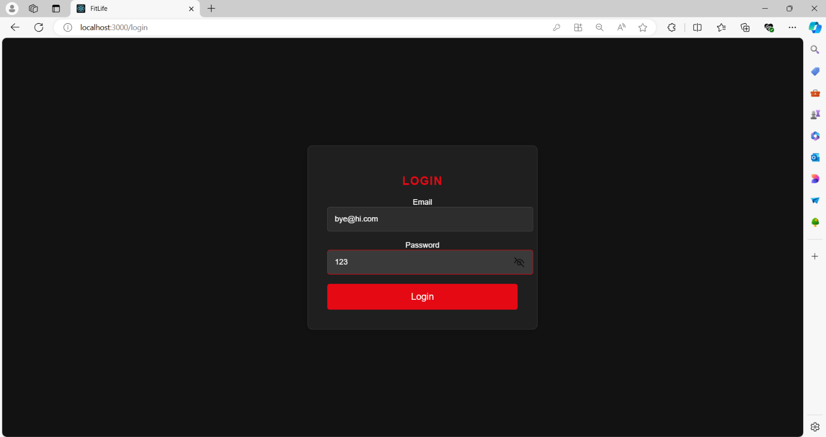

**DASHBOARD: (AFTER SUCCESSFUL LOGIN):**

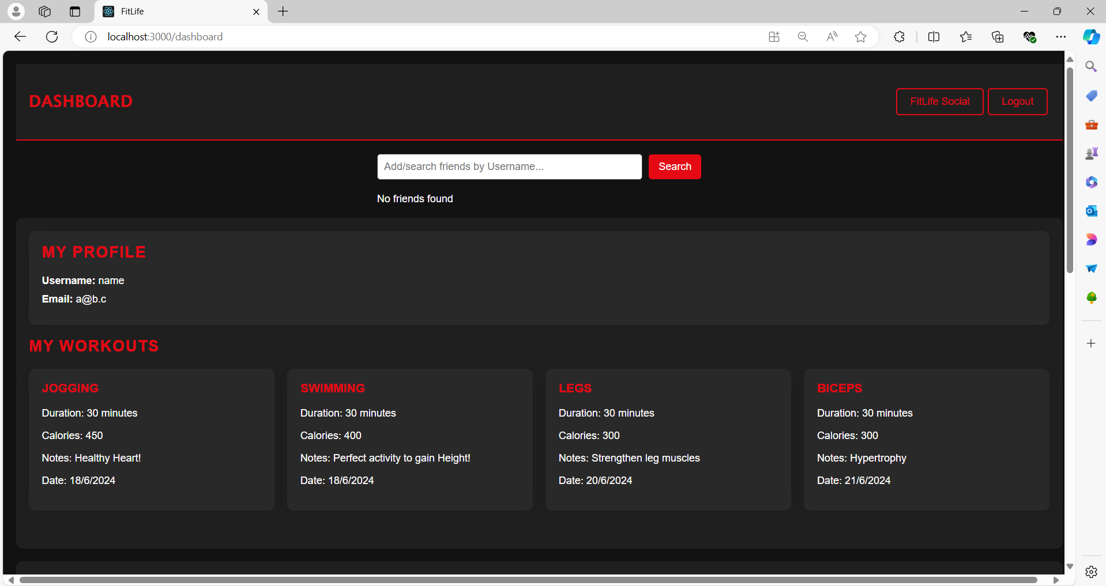

**DASHBOARD (WORKOUTS AND GOALS CONTD.) :**

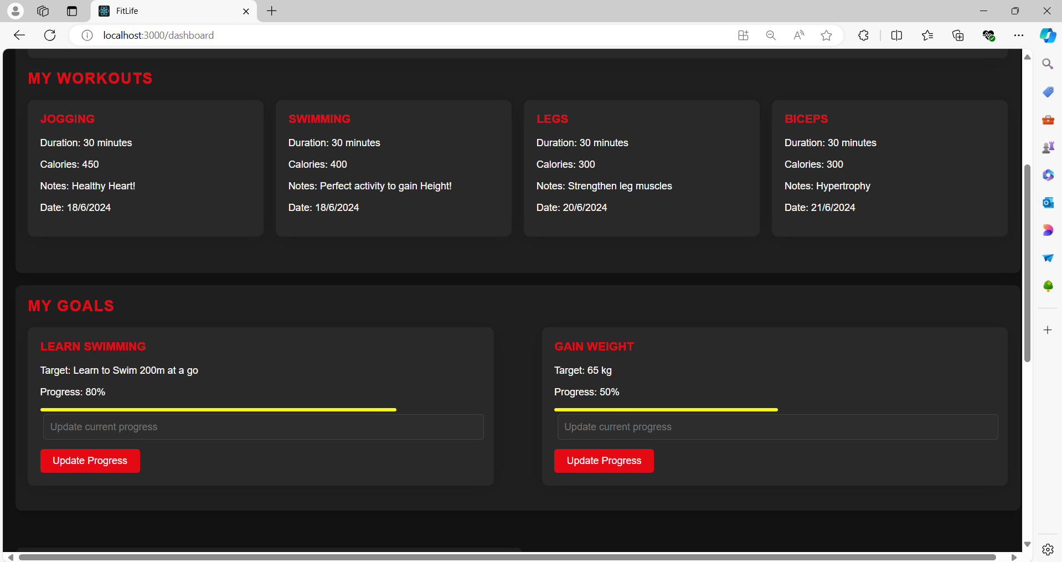

**DASHBOARD (ADD NEW WORKOUTS/GOALS) :**

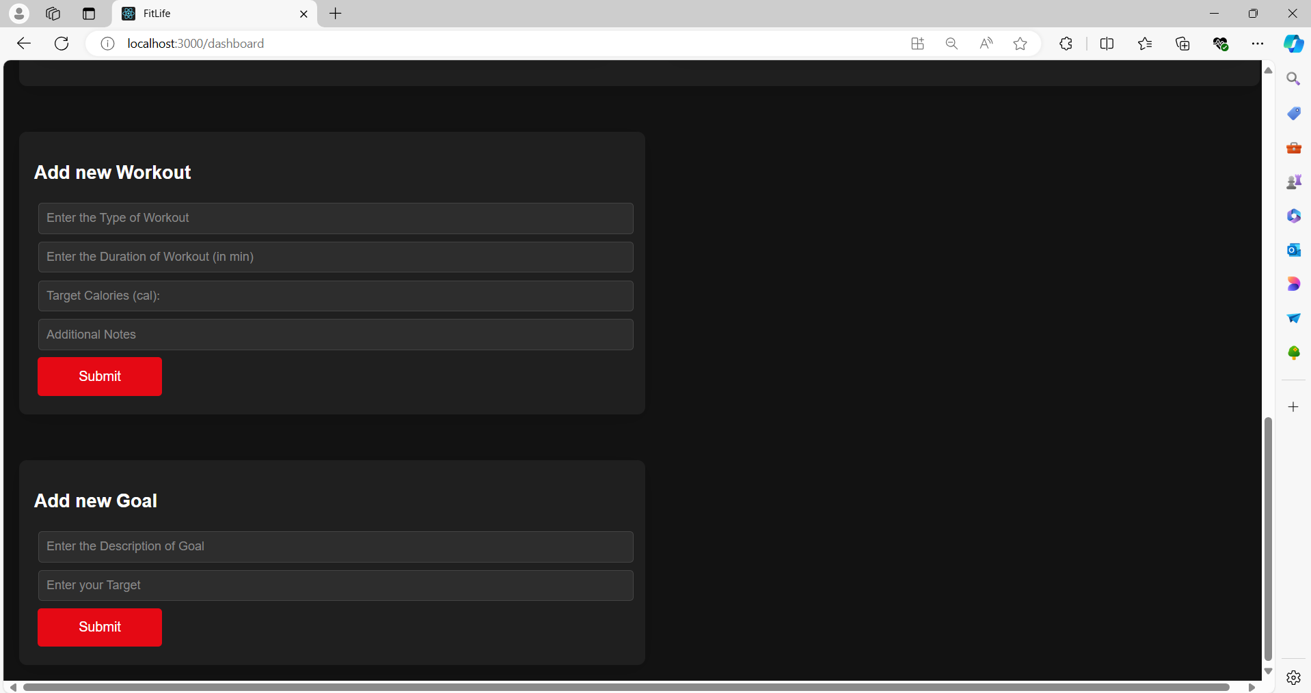

**FRIENDS-SEARCH BY USERRNAME** (AND LOGOUT/ FITLIFE- SOCIAL FROM DASHBOARD):

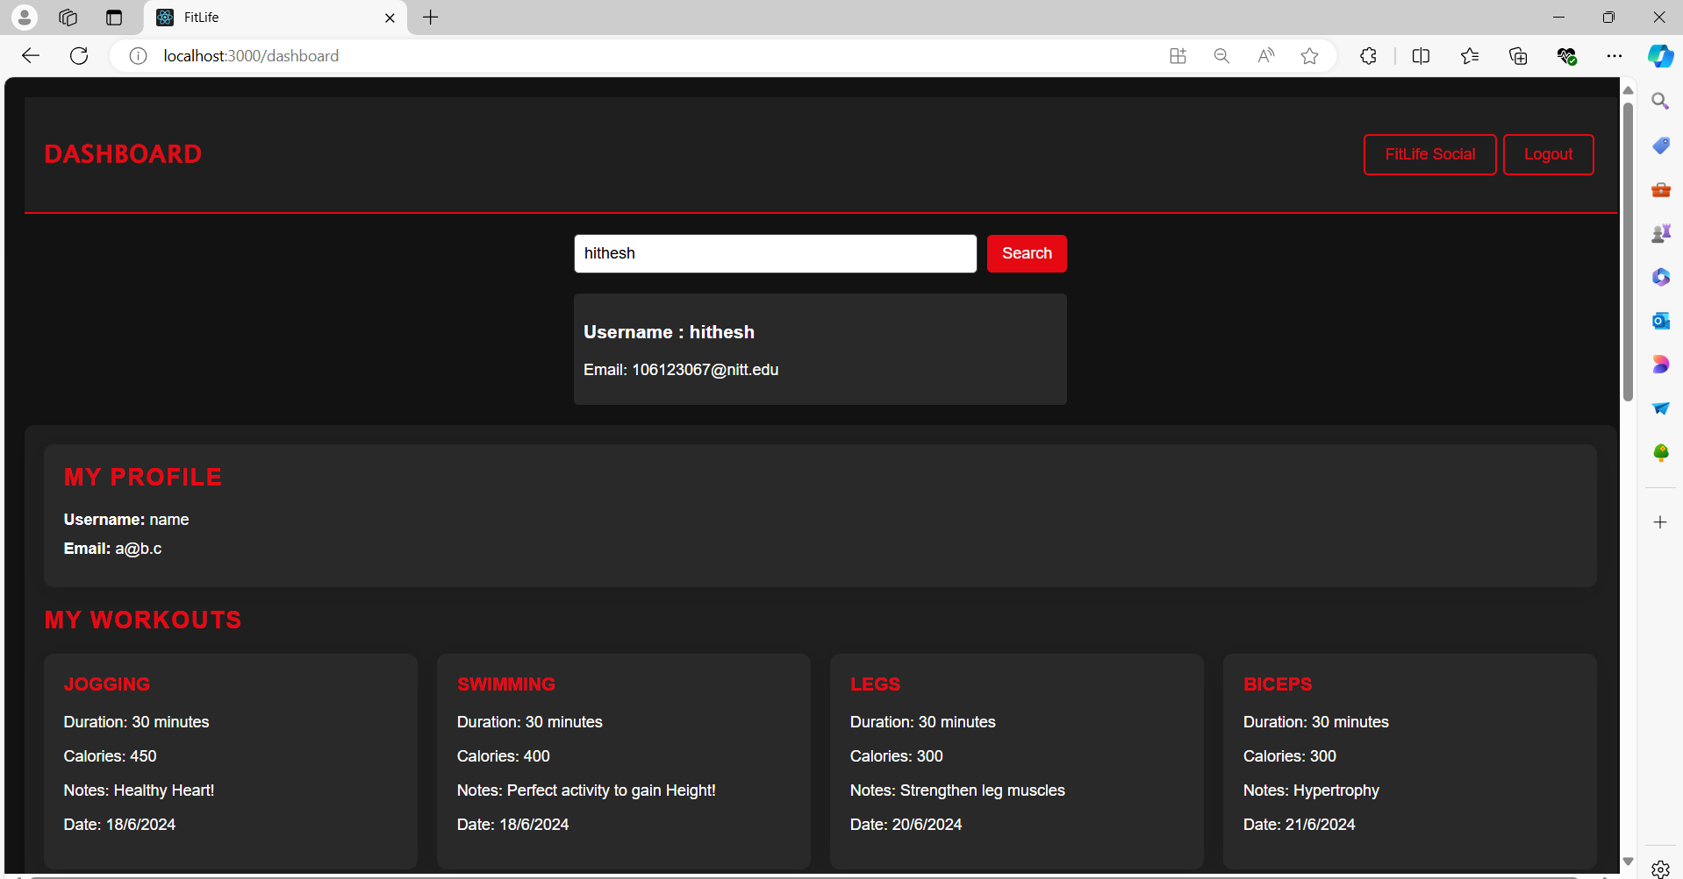

**FITLIFE-SOCIAL : SOCIAL PLATFORM FOR ALL UPDATES.**

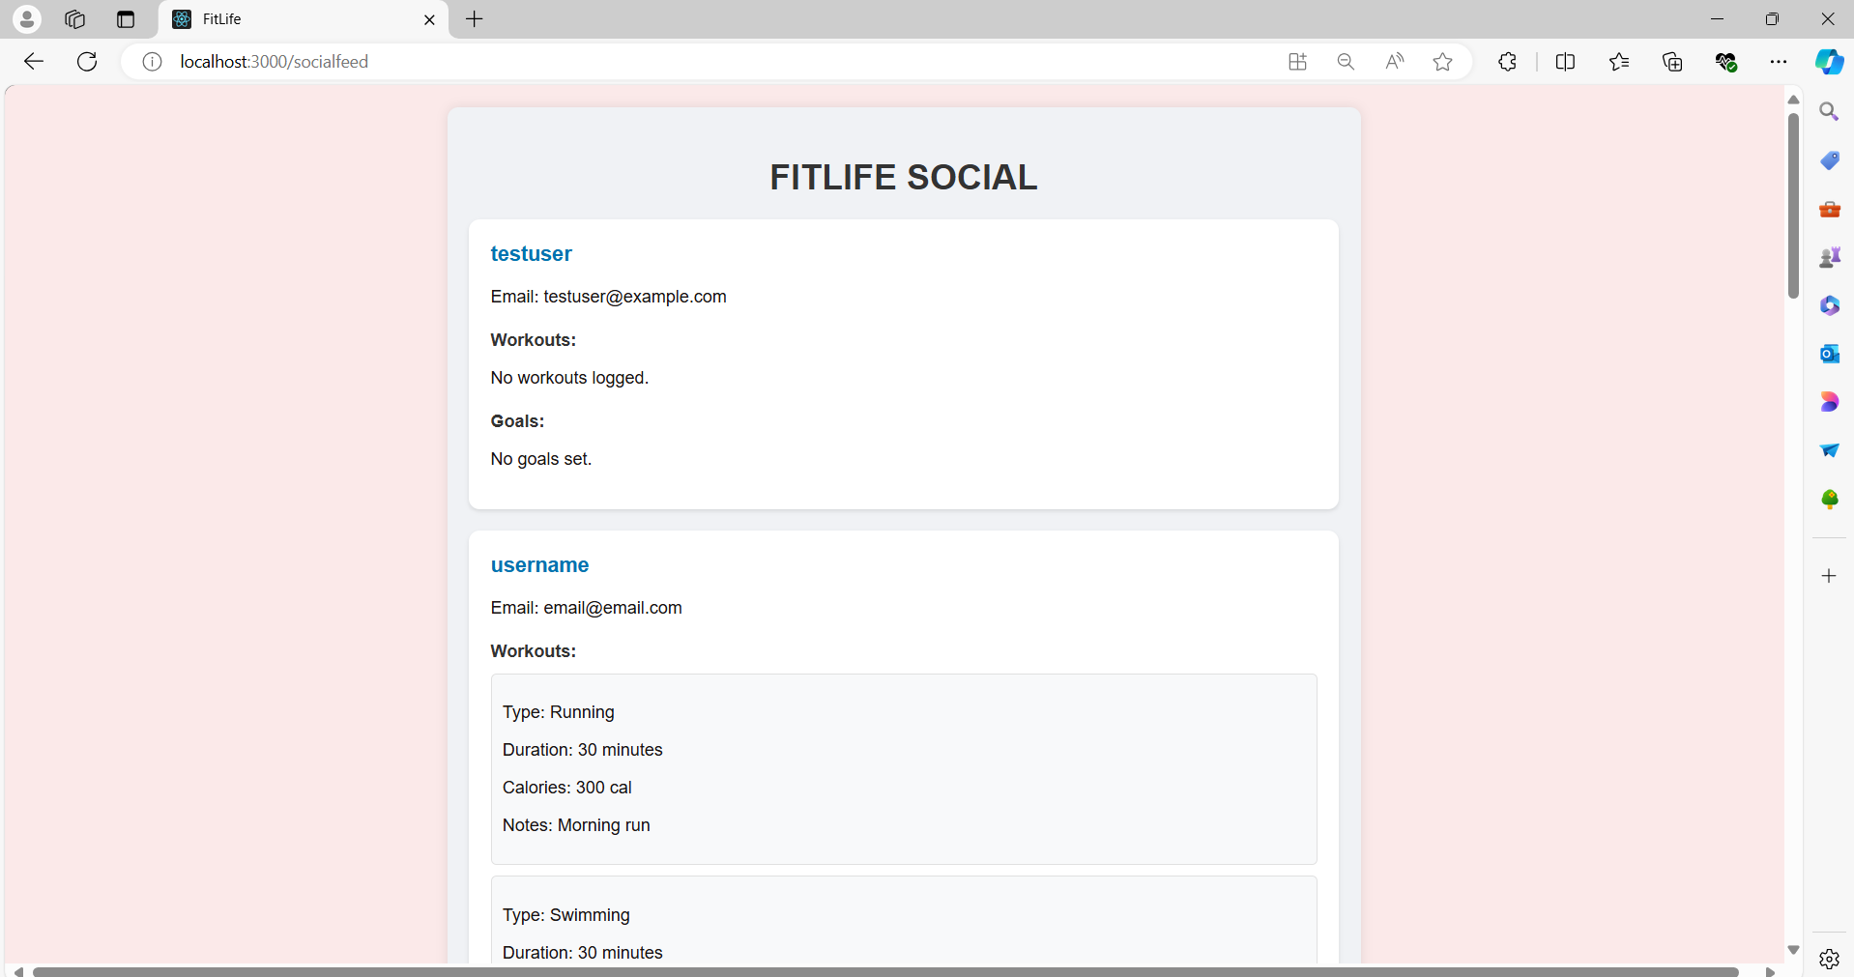

**FITLIFE-SOCIAL (CONTD. ):**

