Assignment - 1
Name :K.Hithesh
Hall Ticket No. : 2303A51291
Batch No. : 05

#Task 1
Prompt: #write a python code for fibanocci series without using functions

Code:
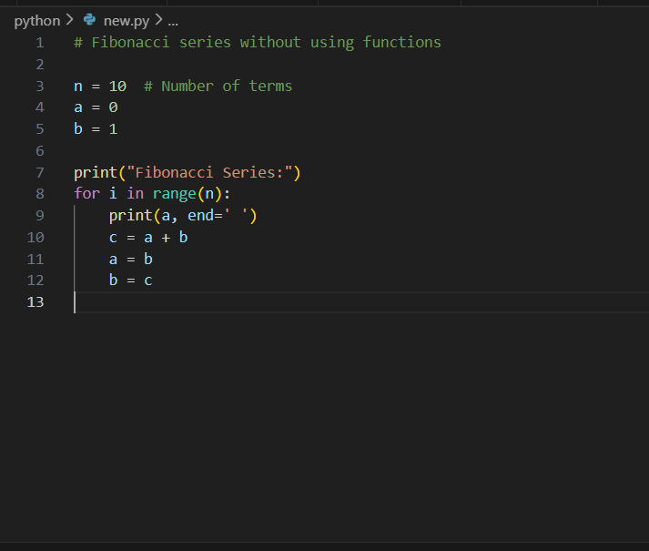
Output :

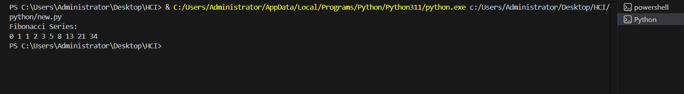

Explanation : This Python code generates the Fibonacci series using an iterative approach. The variable n specifies the number of terms to be printed, while a and b are initialized to the first two Fibonacci numbers, 0 and 1. The for loop executes n times, printing the current value of a in each iteration. After printing, the values of a and b are updated such that a takes the value of b and b becomes the sum of the previous two numbers. This process continues until all terms are generated. As a result, the program efficiently prints the first 10 Fibonacci numbers in a single line.

#Task 2
Prompt: #Optimize this code and simplyify this code

Code:

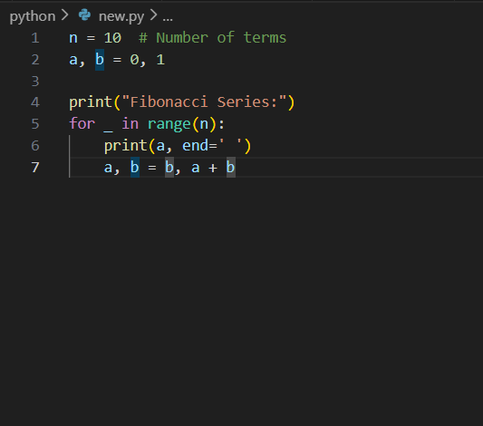

Output :

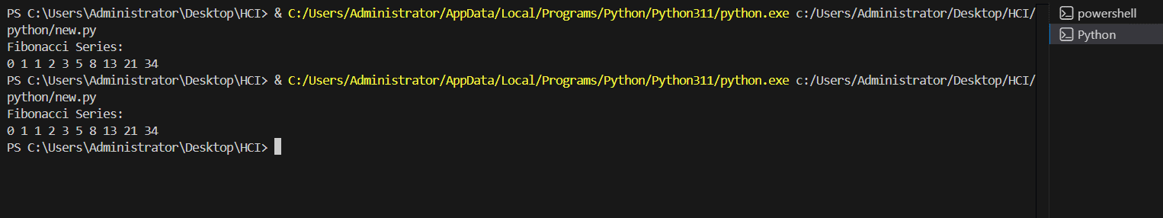

Explanation : Inefficient- Additional and not altogether necessary conditional tests. Slightly verbose variable handling. Messages for simple logic – redundancy.
Optimized - Fewer number of conditions. Cleaned up and legible loop code. Same output with reduced structure. More understandable and maintainable for programmers.

#Task 3
Prompt: #Generate a python program on fabinocci series using functions

Code:

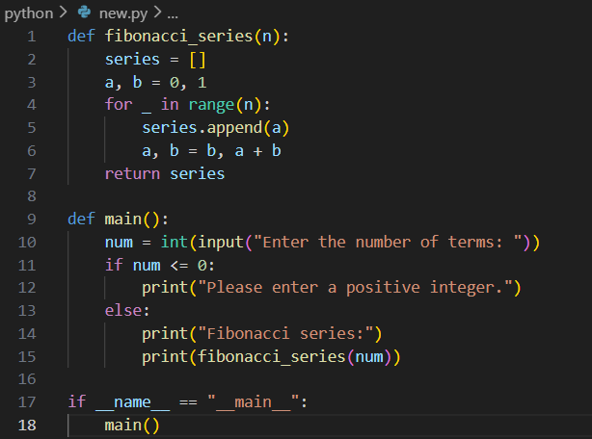

Output :

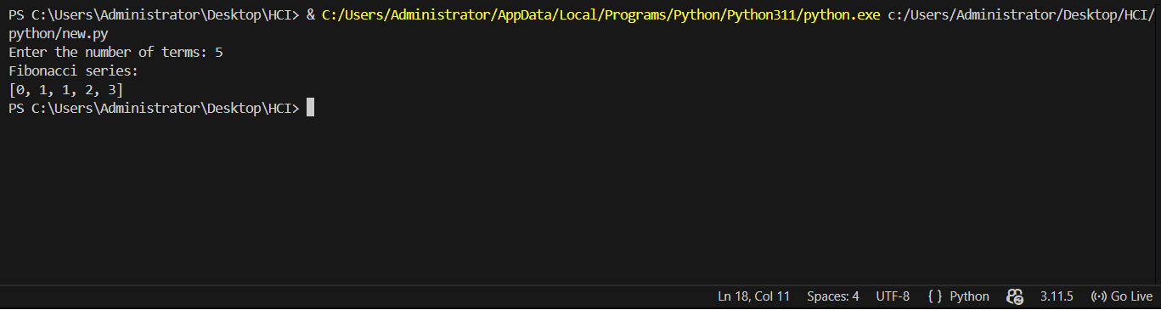

Explanation :
This Python program generates the Fibonacci series using functions. The function fibonacci_series(n) takes an integer n as input and initializes an empty list called series to store the Fibonacci numbers. The variables a and b are initialized to 0 and 1, which are the first two Fibonacci numbers. A for loop runs n times, and in each iteration, the current value of a is appended to the list. Then, the values of a and b are updated so that a becomes b and b becomes the sum of the previous two numbers. After completing the loop, the function returns the list containing the Fibonacci series. The main() function takes user input for the number of terms, checks whether the input is a positive integer, and then prints the Fibonacci series by calling the fibonacci_series function. The condition if __name__ == "__main__": ensures that the main() function runs only when the program is executed directly.

#Task 4
Prompt : #Compare the two methods and give differences
#print the differences
# Description on comparision between with functions and without functions
Code :
#Fibonacci Series without functions
n = int(input("Enter the number of terms in the Fibonacci series: "))
a, b = 0, 1
print("Fibonacci series:")
for _ in range(n):
print(a, end=' ')
a, b = b, a + b
print("\n")

#Fibinocci Series with functions
def fibonacci(n):
a, b = 0, 1
series = []
for _ in range(n):
series.append(a)
a, b = b, a + b
return series
num_terms = int(input("Enter the number of terms in the Fibonacci series: "))
fib_series = fibonacci(num_terms)
print("Fibonacci series:")
for num in fib_series:
print(num, end=' ')

#Compare the two methods and give differences
#print the differences
print("\n\nDifferences between the two methods:")
print("1. The first method does not use functions, while the second method encapsulates the logic in a function.")
print("2. The first method prints the series directly, while the second method returns a list of Fibonacci numbers.")
# Description on comparision between with functions and without functions
print("3. The function-based approach is more reusable and modular, allowing for easier testing and maintenance.")

Tabular Format:
Feature | Without Functions | With Functions
Code Clarity | Moderate | High
Reusability | No | Yes
Debugging | Difficult | Easy
Scalability | Poor | Excellent
Suitability for Large Systems | Low | High
Output :

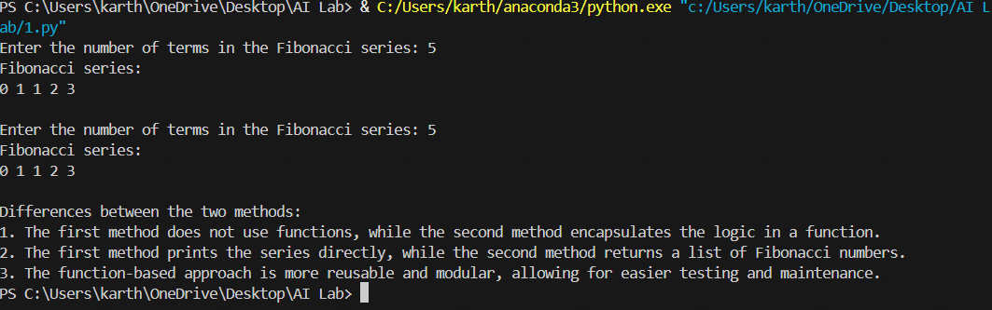

Explanation : Analysis -Procedural code is simpler to write but nastier to maintain. Function-oriented code is more cleanable. In real-world software development, it is preferred to be modular.
#Task 5
Prompt : # Generate Fibonacci series using both iterative and recursive methods. Provide code examples, explain how each approach works, and compare their efficiency.
Code :
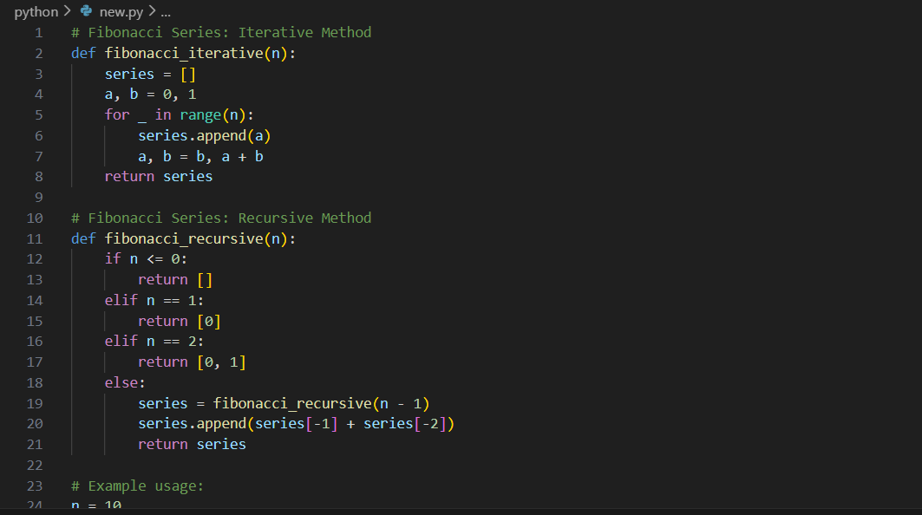

Output :

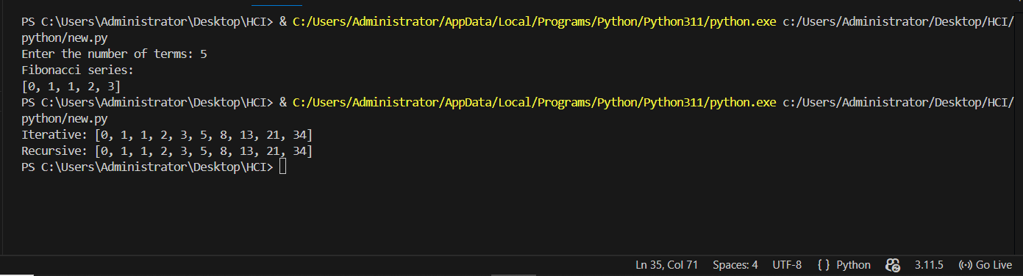
Explanation :
Iterative vs Recursive :
The iterative method uses loops to repeat steps and is fast and memory-efficient. The recursive method works by a function calling itself, which makes the logic easy to understand but uses more memory. Because of this, recursion is not suitable for large inputs, while iteration is a better and more practical choice.
.

