ASSINMENT 3.3
NAME:K.HITHESH
HALLTICKET:2303A51291
Task 1: AI-Generated Logic for Reading Consumer Details
Scenario
An electricity billing system must collect accurate consumer data.
Task Description
Use an AI tool (GitHub Copilot / Gemini) to generate a Python program that:
• Reads:
o Previous Units (PU)
o Current Units (CU)
o Type of Customer
• Calculates units consumed
• Implements logic directly in the main program (no functions)
PROMPT: Write a program to read electricity meter readings, calculate units consumed, display details, and validate the input.

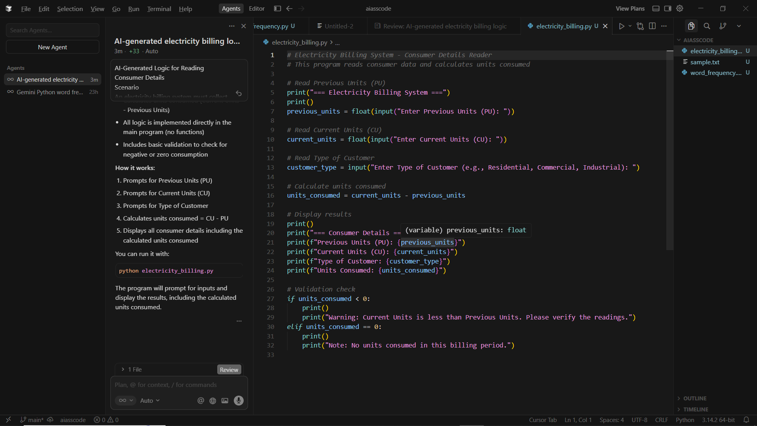

OUTPUT:
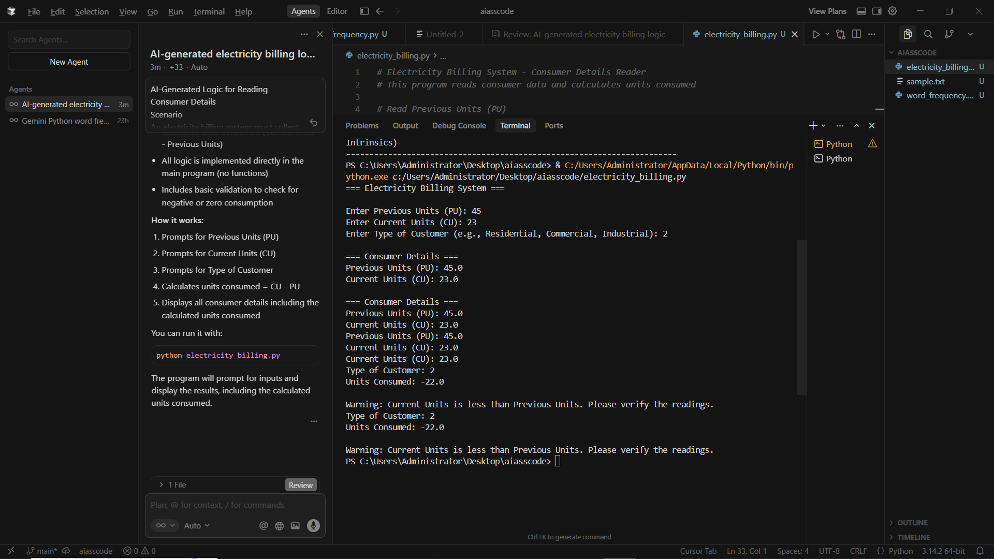
EXPLANATION: This program reads the previous and current electricity meter readings from the user, along with the type of customer. It calculates the number of units consumed by subtracting the previous reading from the current reading. The program then displays all the consumer details and checks for errors by warning the user if the current reading is less than the previous reading or noting if no units were consumed
Task 2: Energy Charges Calculation Based on Units Consumed
Scenario
Energy charges depend on the number of units consumed and customer type.
Task Description
Review the AI-generated code from Task 1 and extend it to:
• Calculate Energy Charges (EC)
• Use conditional statements based on:
o Domestic
o Commercial
o Industrial consumers
• Improve readability using AI prompts such as:
o “Simplify energy charge calculation logic”
o “Optimize conditional statements”
PROMPT:
Write a program to calculate electricity units and energy charges based on customer type and slab rates, and display the bill details.
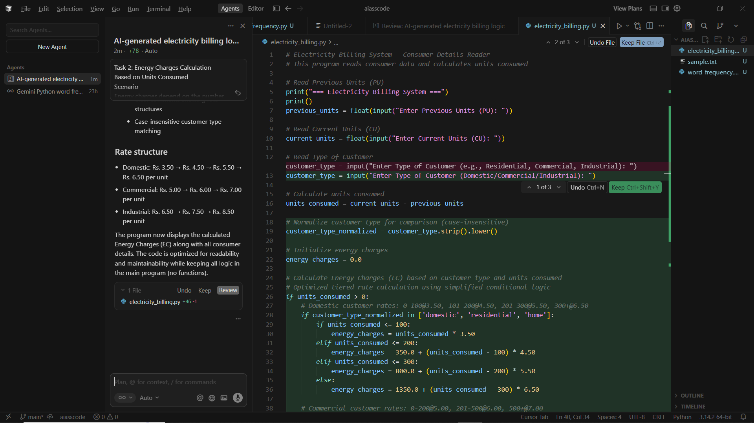
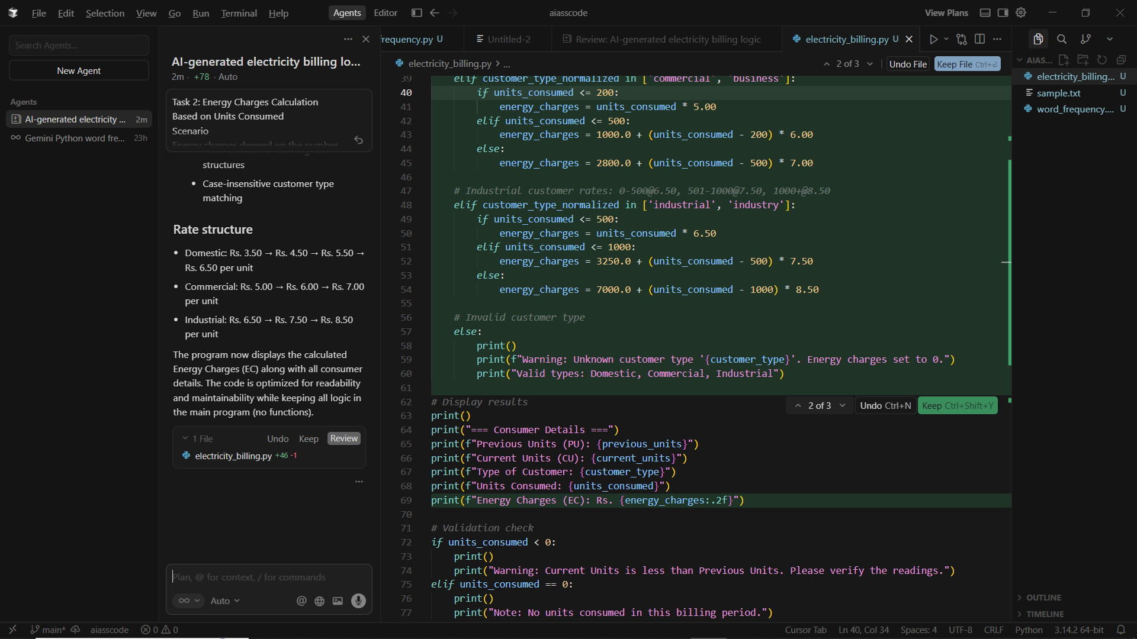

OUTPUT:
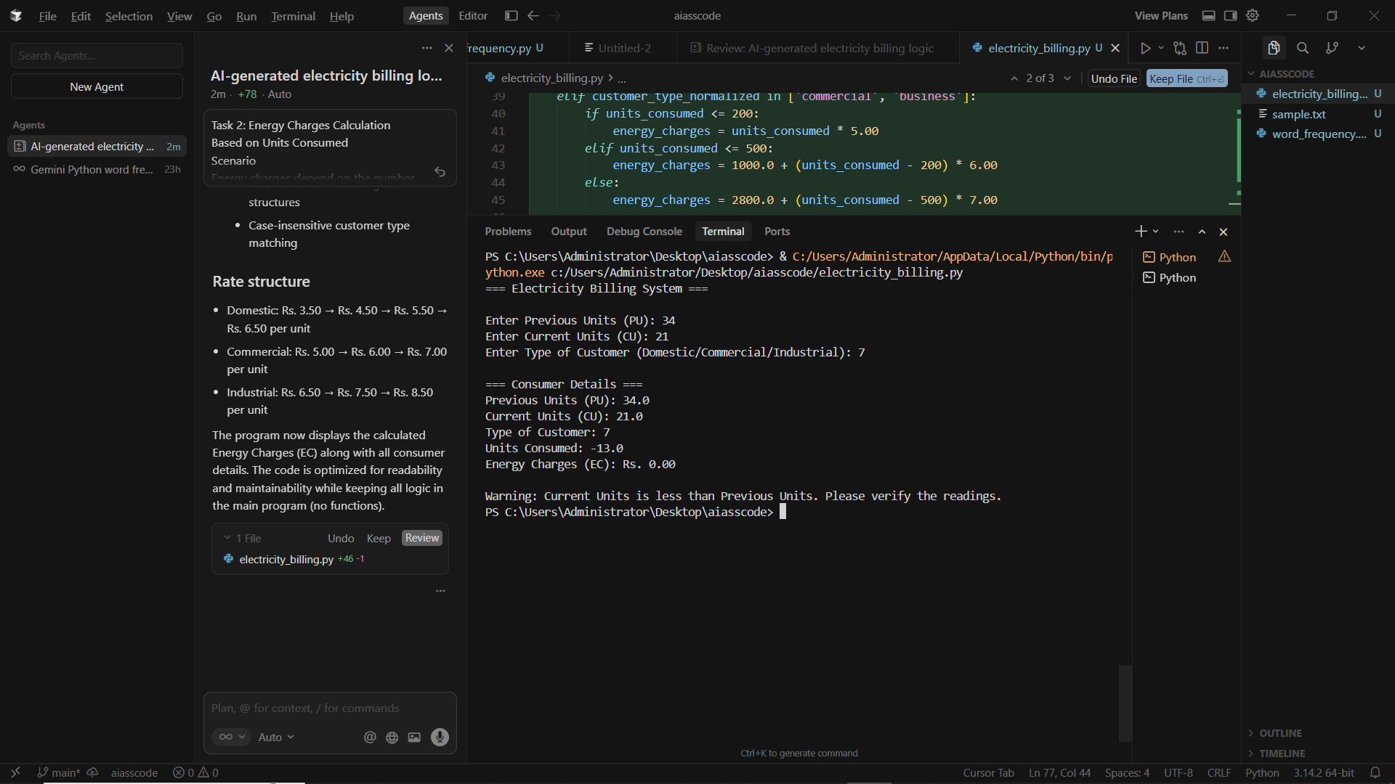
EXPLANATION:This program reads previous and current electricity meter readings and the customer type. It calculates the units consumed, applies slab-based energy charges based on the customer type (Domestic, Commercial, or Industrial), displays the bill details, and checks for invalid or zero readings.
Task 3: Modular Design Using AI Assistance (Using Functions)
Scenario
Billing logic must be reusable for multiple consumers.
Task Description
Use AI assistance to generate a Python program that:
• Uses user-defined functions to:
o Calculate Energy Charges
o Calculate Fixed Charges
• Returns calculated values
• Includes meaningful comments

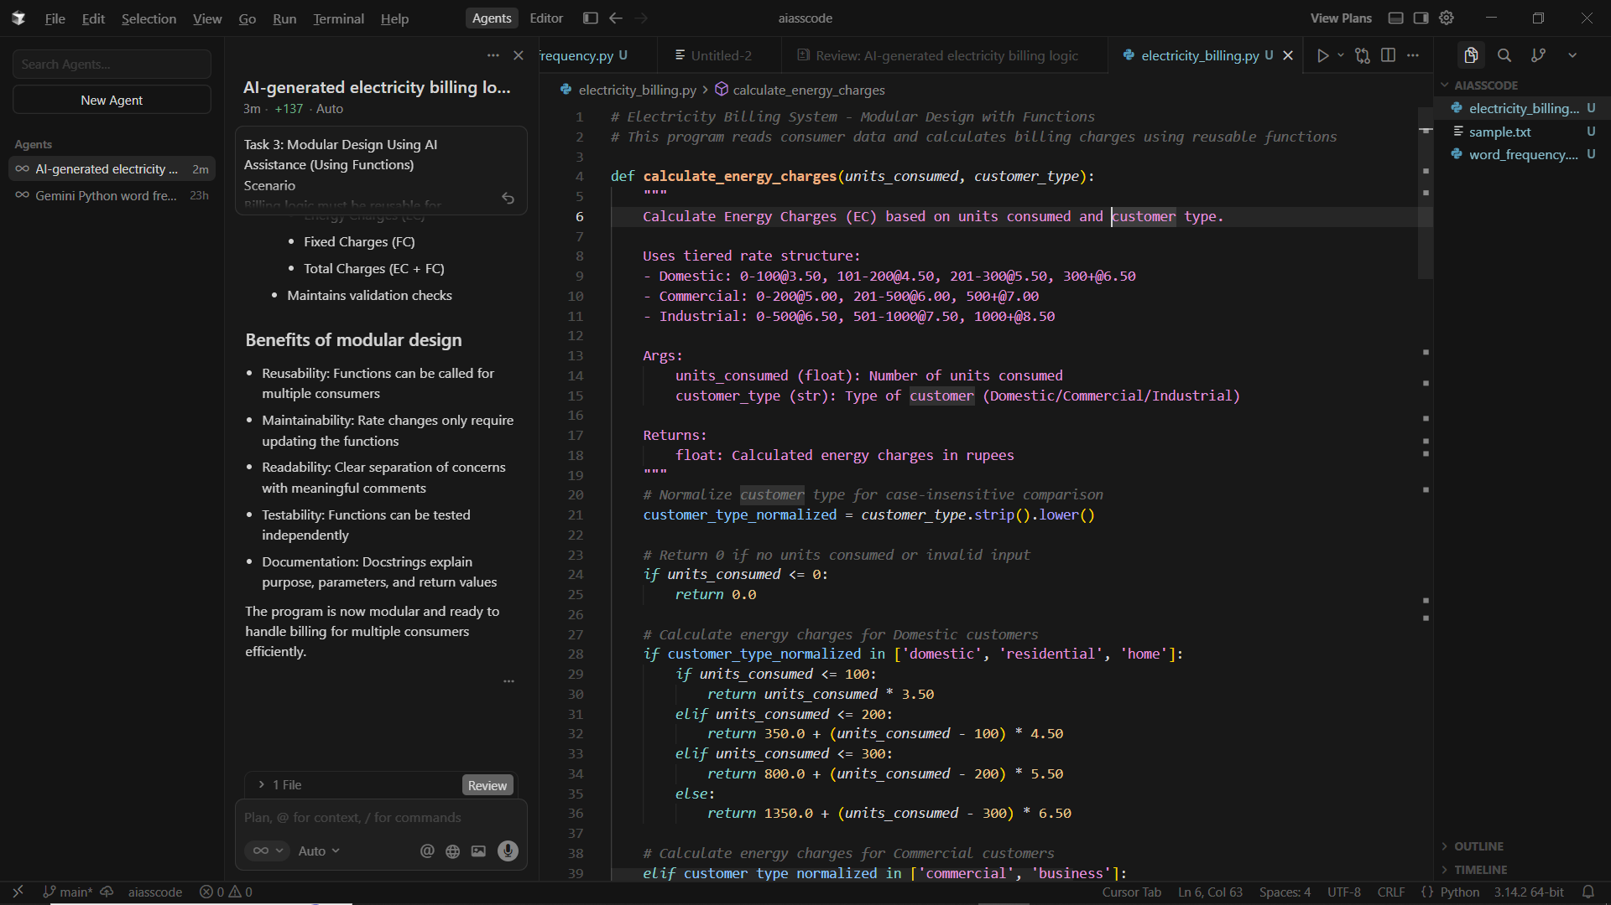
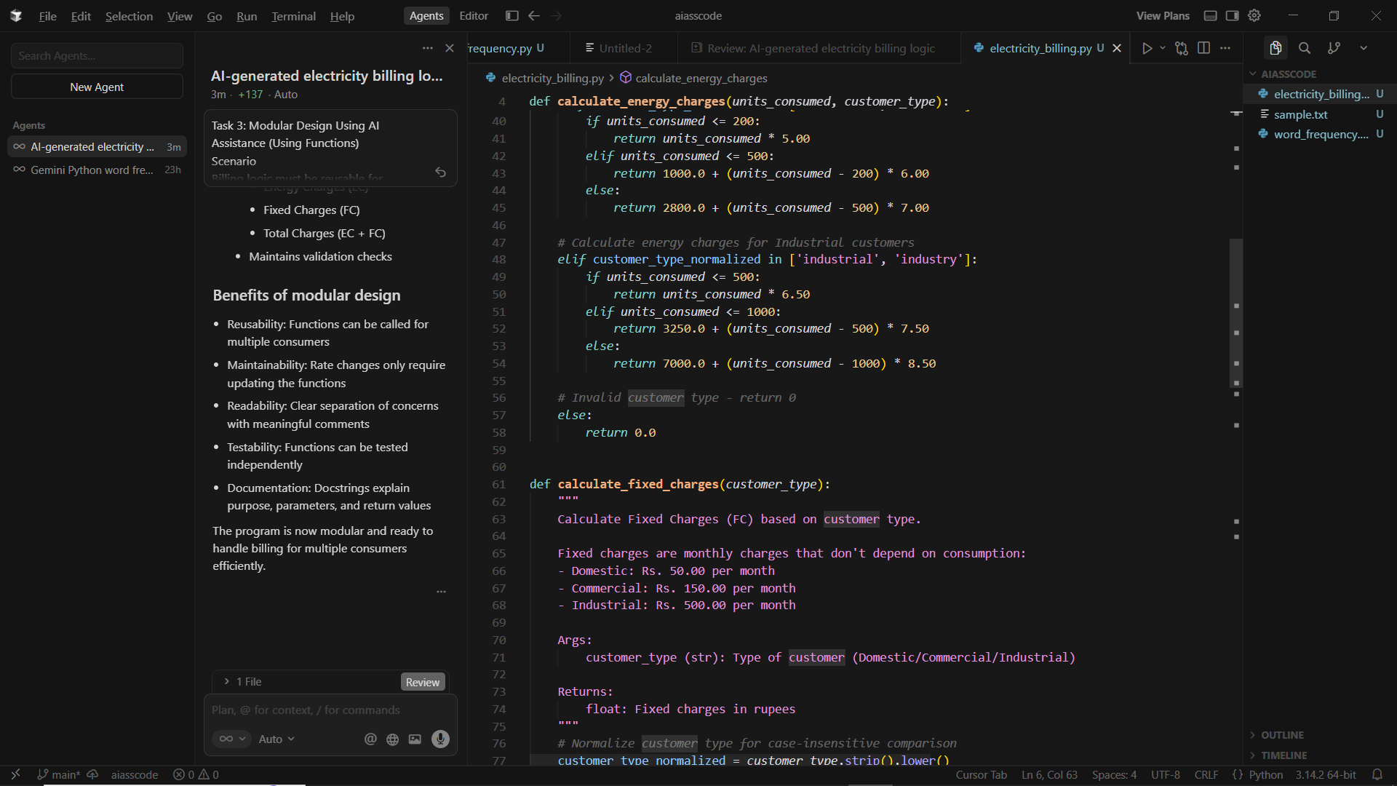

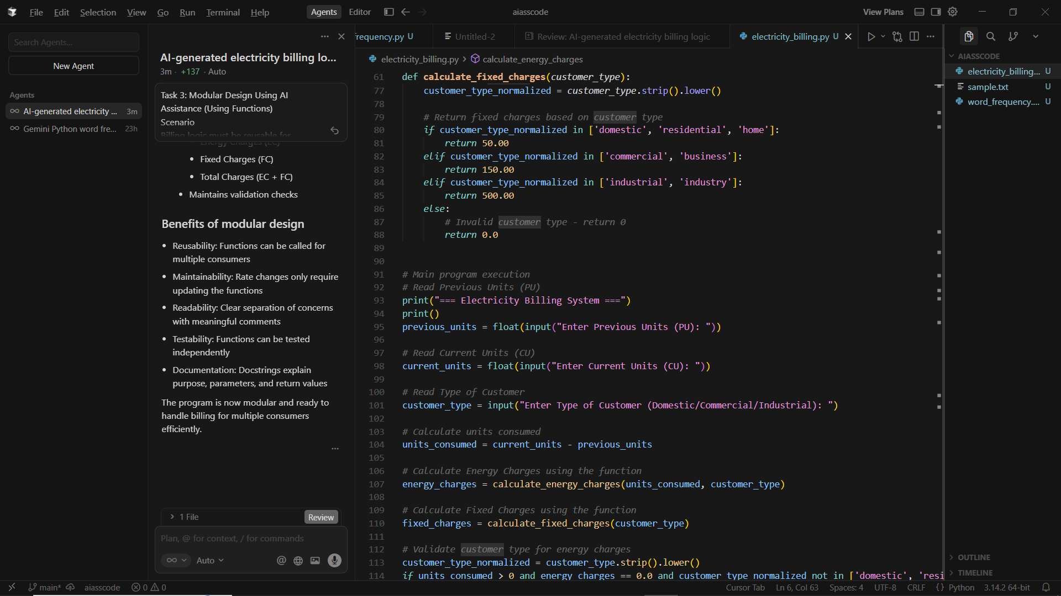
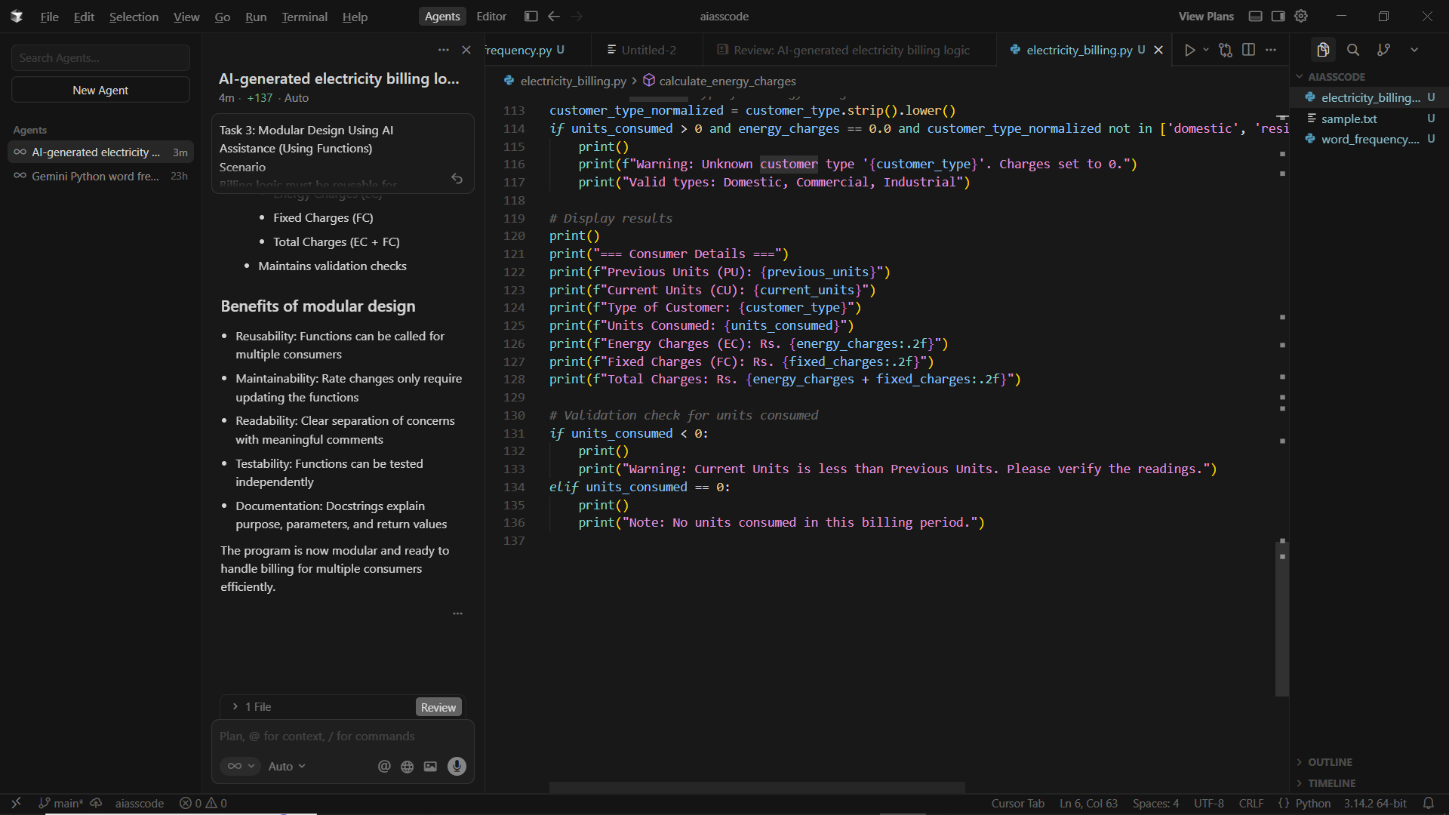

OUTPUT:
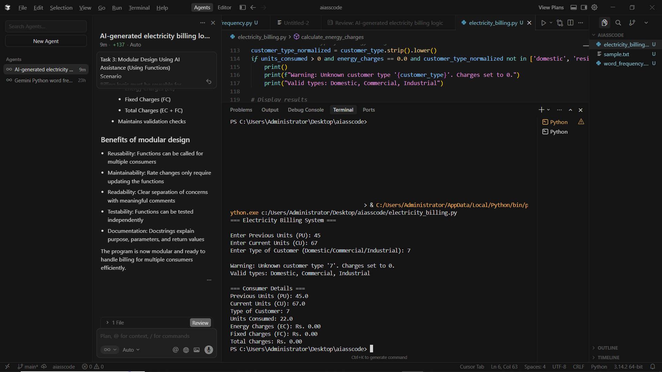
Task 4: Calculation of Additional Charges
Scenario
Electricity bills include multiple additional charges.
Task Description
Extend the program to calculate:
• FC – Fixed Charges
• CC – Customer Charges
• ED – Electricity Duty (percentage of EC)
Use AI prompts like:
• “Add electricity duty calculation”
• “Improve billing accuracy”
PROMPT:
Write a program to calculate and display an electricity bill using meter readings, customer type, and applicable charges

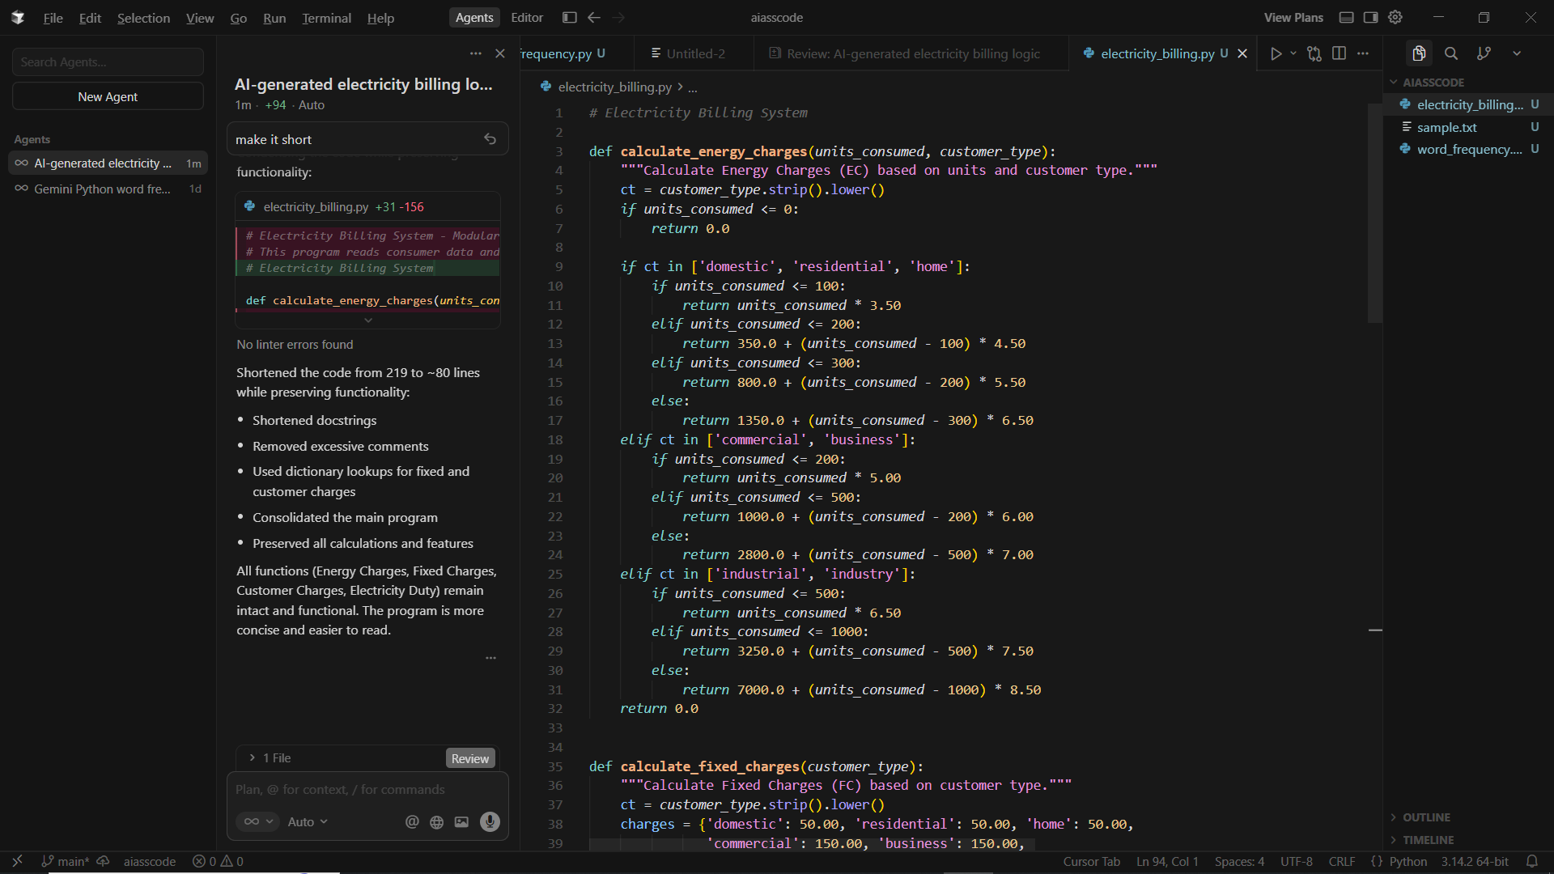
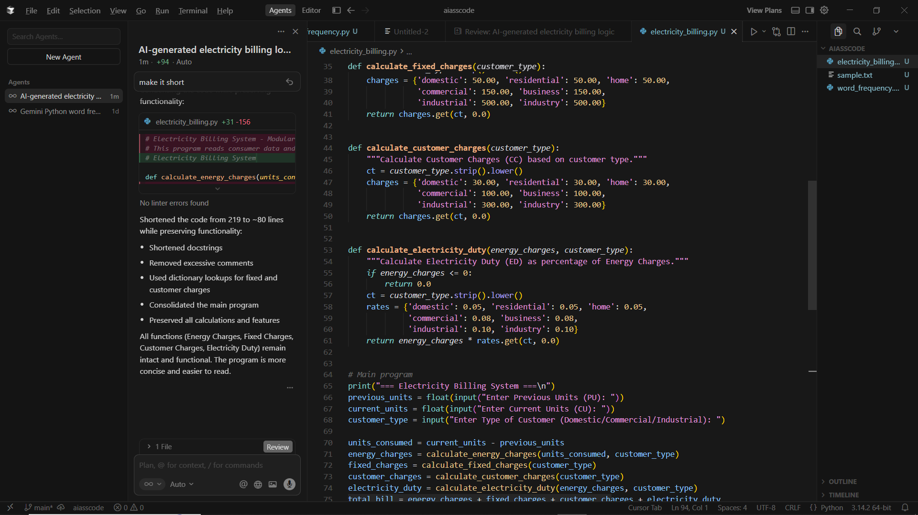
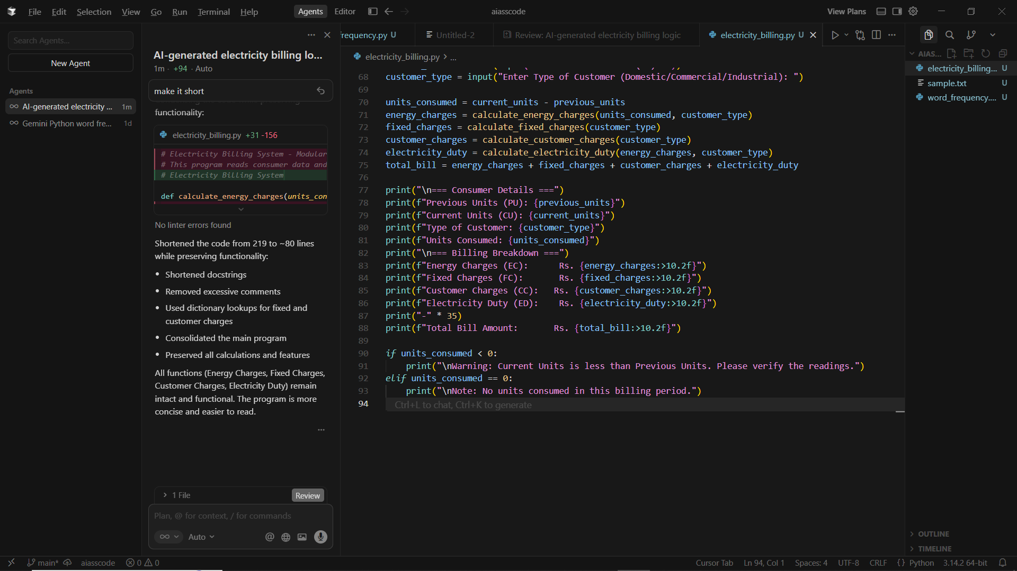
OUTPUT:
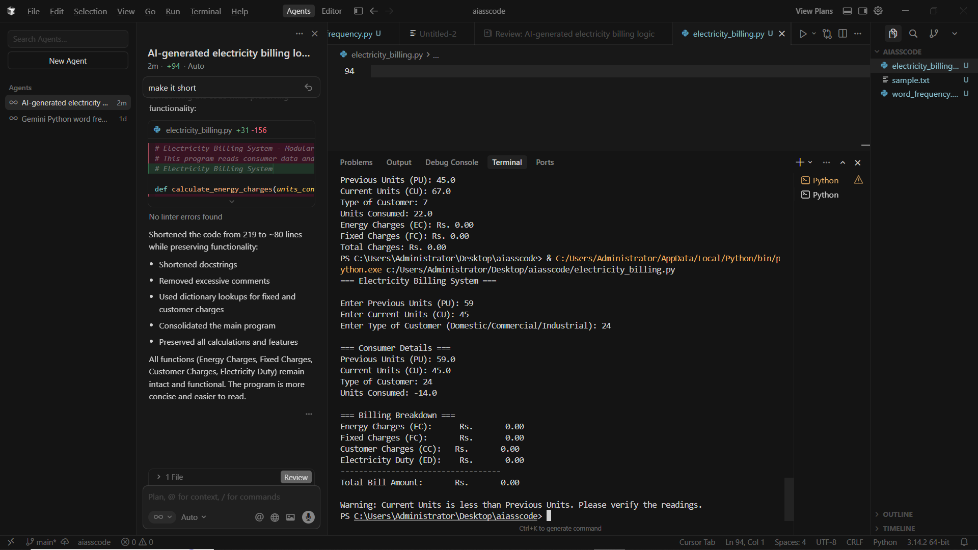
EXPLANATION:
This program calculates an electricity bill by reading previous and current meter readings and the customer type. It computes units consumed, applies slab-based energy charges, adds fixed charges, customer charges, and electricity duty, then displays a detailed bill. It also checks for invalid or zero unit consumption.

Task 5: Final Bill Generation and Output Analysis
Scenario
The final electricity bill must present all values clearly.
Task Description
Develop the final Python application to:
• Calculate total bill:
• Total Bill = EC + FC + CC + ED
• Display:
o Energy Charges (EC)
o Fixed Charges (FC)
o Customer Charges (CC)
o Electricity Duty (ED)
o Total Bill Amount
PROMPT:
Write a Python program to calculate and display an electricity bill using meter readings, customer type, and applicable charges.
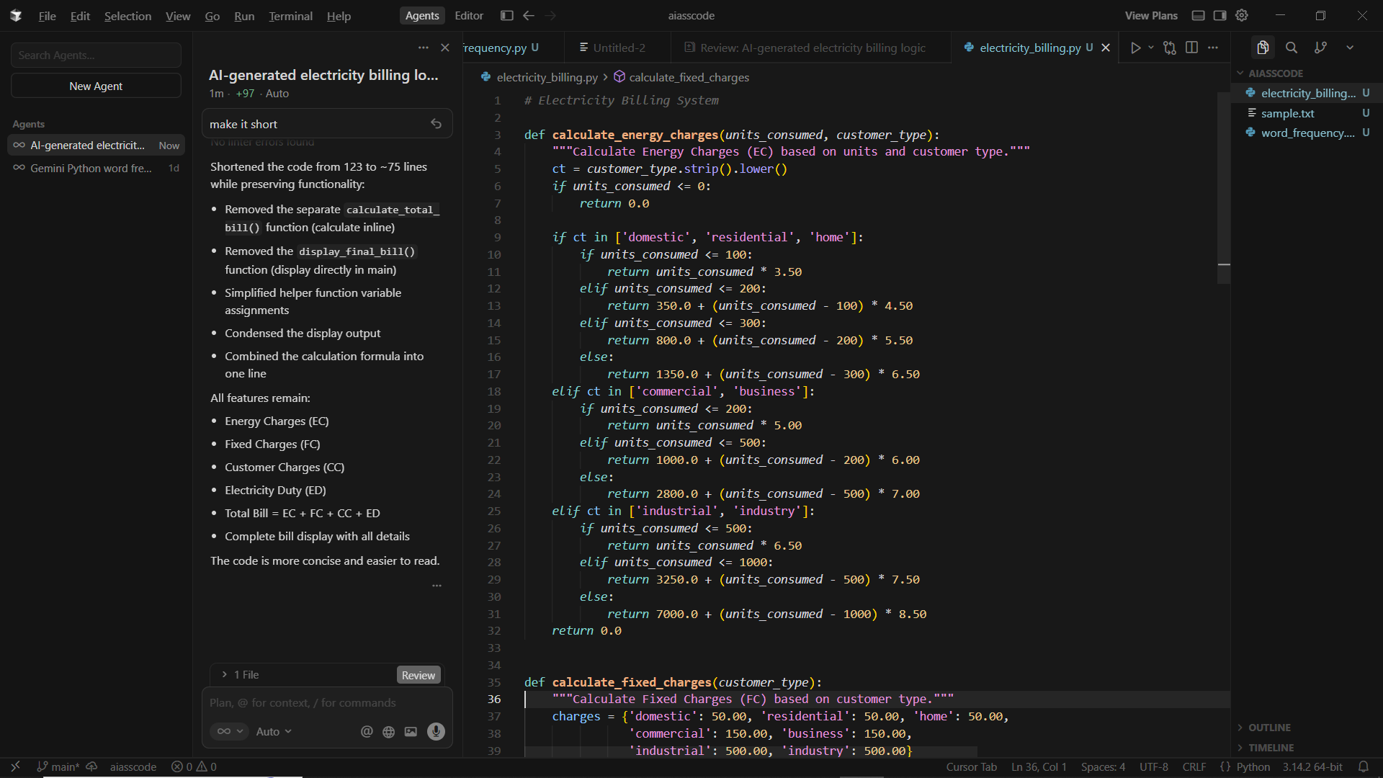

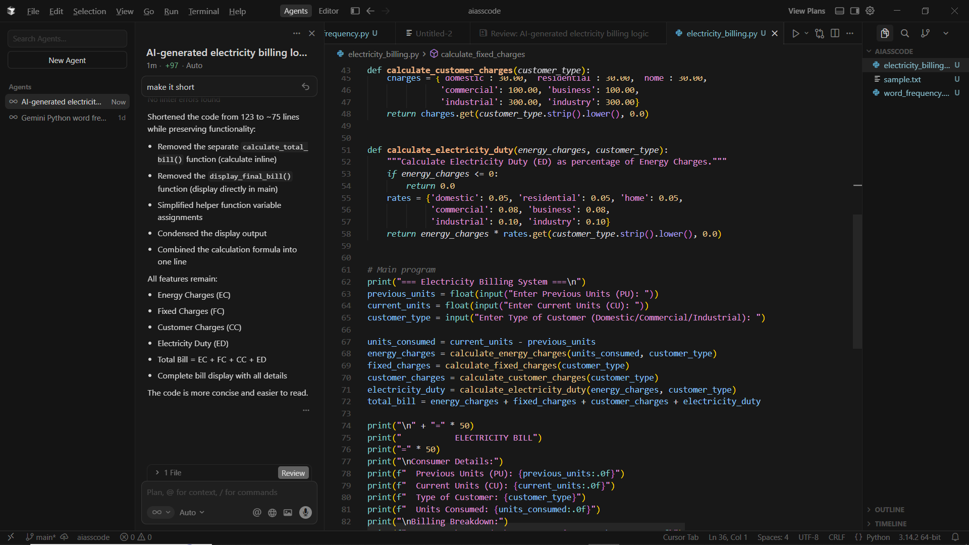
OUTPUT
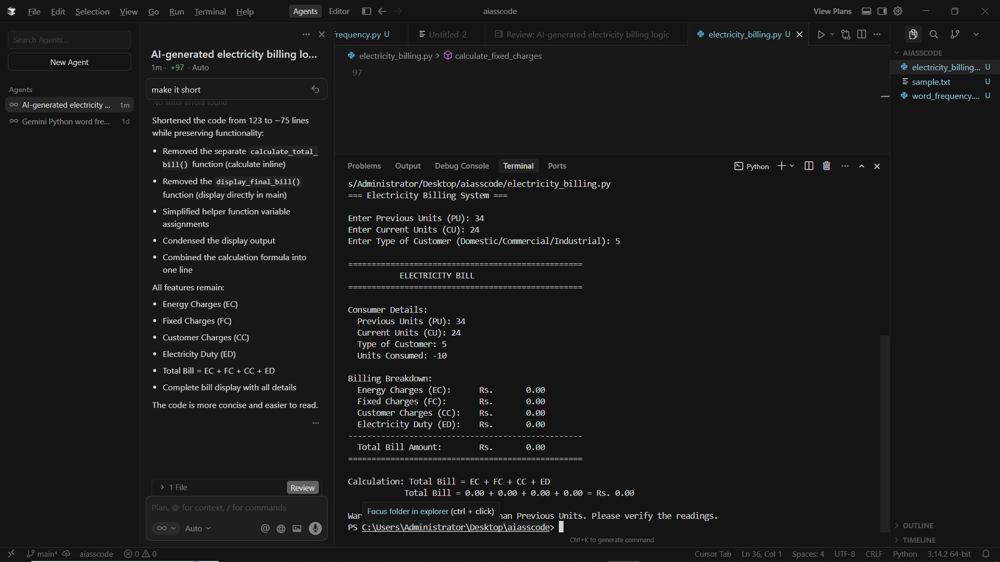
EXPLANATION:
This program calculates an electricity bill by reading meter readings and customer type, computing units consumed, applying slab-based charges, adding other charges, and displaying the total bill with basic validation

